Local List of Historic Assets of Special Interest
An extension of the Historic Environment Record (HER) for North East Lincolnshire

Draft Edition for the Northern Marshes

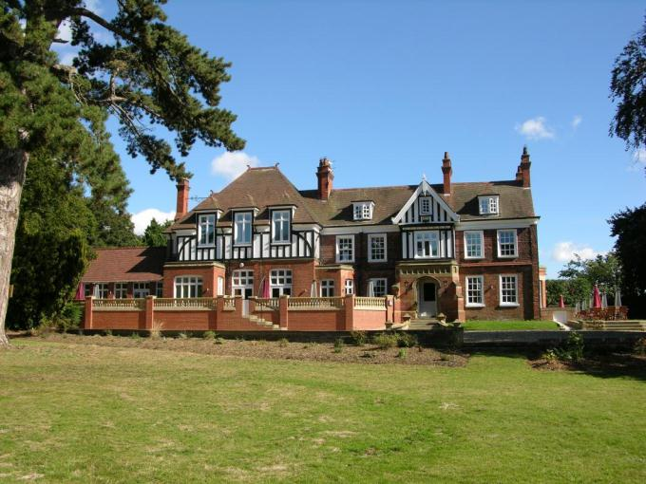

Draft October 2015

Contents

Introduction 2
A Note on Sources 2
Criteria for Listing 3
Basic Requirements for Assets 3
Aylesby 4
Habrough 13
Healing 35
Immingham 53
Stallingborough 72
Archaeological Sites in Stallingborough 86

Introduction

This Local List of Historic Assets of Special Interest has been compiled in order to act as a planning tool. The entries within the list are the historic assets taken from the North East Lincolnshire Historic Environment Record, or HER, which require the greatest attention from developers and planning officers, among others, during the development process and regeneration schemes.
Heritage assets are usually included in the list because they are the best of their kind in the authority; however some assets are included because of the contribution that they make to the character of the local area.

By their very nature, buildings will make up the bulk of the list as they are the most visible of the historic assets and contribute greatly to the character of an area. Conversely, archaeological sites will be greatly under-represented on the list due to the difficulty in establishing the nature and extent of any individual assets without first excavating, particularly within the urban environment. Designed Landscapes, pieces of art and other assets are low in overall number and so will make up a minor part of the list; they are also the least likely to be affected by development.

A Note on Sources

The majority of the text in this document has been produced from scratch by staff in the Historic Environment Record. Where text has come from a single external source, every effort has been made to show that source in the text; however, the information on some assets, particularly archaeological sites, has been compiled from numerous sources and it would not be appropriate to list them all in a document such as this. In these cases, the reader is directed to the appropriate Historic Environment Record entries for further information and a list of the sources used to compile the information.

Criteria for Listing

General:

1a – The asset is rare or unique, in terms of the Borough, due to the period it represents, extent, architectural style or technological method of construction.
1b – The asset has the potential to contribute to our information on, understanding of, and appreciation of the Borough’s history and development.
1c – The asset makes a significant contribution to the historic character of an area and conforms to a Thematic criteria.
1d – The asset is part of a group of similar examples which, together, make a significant contribution to the character of an area or have the potential to provide high quality and/or quantity of historic environment data.

Thematic:

2a – Assets which exemplify a previous character type in a settlement or area which retain sufficient structure to inform on the previous character.
2b – Assets which are/were essential infrastructure associated with the Docks and Railways that retain a good proportion of their original extent.
2c – Assets which form an integral part of the character of the Resort of Cleethorpes.
2d – Assets which exemplify the rapid expansion, wealth or the major industrial and commercial activities of Grimsby in the 19th and early 20th centuries.
2e – Assets which exemplify the early development of Immingham and Cleethorpes from Villages and/or Hamlets into Towns.
2f – Post 1850s Urban Housing that retains the majority of its original structure, components and is of a high standard of design.
2g – Ecclesiastical, Manorial, Educational, Social and Agricultural assets representing the historic functions and practices of the towns and villages.

Basic Requirements for Assets

Buildings must retain the majority of their original fabric, external design style and character.

Archaeological Sites must be definable in extent and origin and be likely to retain well preserved deposits.

Designed Landscapes must be identifiable through aerial photography and at ground level. They must also be significant features in the wider landscape.

Ship Wrecks and Historic Ships must relate to the main industries of the Borough or form a group or loose association of assets.

Memorials must commemorate events of national or significant local significance and be of architectural or artistic interest.

Complex Assets are not a category in their own right, but rather contain two or more assets of the above categories that should be considered interdependent on each other.

Aylesby

Aylesby is a small nucleated settlement which formerly clustered to the south of the church, St Lawrence’s, but is now mostly laid out along the main west-east road running through the village. It is known to have existed since at least the early medieval period (410AD to 1066AD).

Aylesby is recorded as having a population of 172 in the 1851 census according to White's directory of 1856. In the 2001 census the population is recorded as 135.

At the time of writing – 2nd October 2015 – Aylesby has:

54 Historic Environment Records of which:
2 are nationally Listed Buildings
None are nationally Scheduled Monuments
7 are proposed Locally Listed Historic Assets

Name: Home Farm
Date Designated: N/A – New Proposal
Grid Reference: TA 2068 0762
Area Designation: None
Asset Type: Building
Main Criteria Used: 1c, 2g
Description:

A post medieval farmhouse and farm buildings with frontages of the late 19th and early 20th century origins but with evidence of 18th or early 19th century structures in the rear of the earlier house.

A handsome house and outbuildings, the paired main frontages are of particular interest.

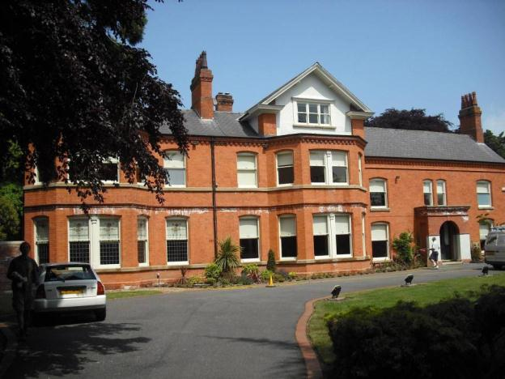

Name: Manor Farm
Date Designated: N/A – New Proposal
Grid Reference: TA 2021 0761
Area Designation: None
Asset Type: Building
Main Criteria Used: 1b, 2g
Description:

Manor House – A fine quality 19th century manor house on the site of an older manor. It has a three bay primary frontage facing south, with large parallel rear wings and detached outbuildings.

The adjacent farm range appears to be intact, showing multiple periods of build. Part converted, the site includes a central east/west courtyard split by a tall wall and surrounded by two storey barns, and a detached single storey cart shed aligned north/south. The buildings represent multiple build periods probably from the 18th century onwards, including some recent extensions. Built in chalk to the older buildings and red/brown brick to the later builds, all with pantile roofs.

An interesting group of buildings with much of the piecemeal construction character retained. The buildings are important as indicators of agricultural practices in the 18th and 19th centuries as well as the changes of the 20th century which led to the obsolescence of most farm buildings of this style (and therefore the subsequent conversion to offices).

Also associated with the manor house are the buried remains of a probable medieval moated manorial site, and the partial remains of a landscape park.

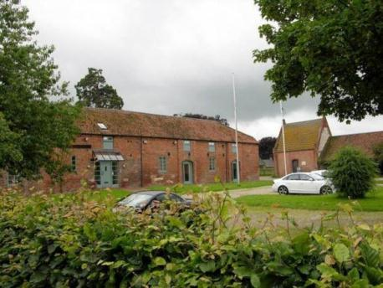

Name: 1 Main Road, 2 and 4 Manor Cottages, and The Old Cottage, Aylesby
Date Designated: N/A – New Proposal
Grid Reference: TA 2034 0764
Area Designation: None
Asset Type: Building
Main Criteria Used: 1c, 2g
Description:

Three pairs of semi-detached estate cottages, two now knocked through into single dwellings.
The Old Cottage is the oldest, being 19th century in date, and has been extended to the east, the others are 20th century in date.

Number 1 Main Road and Manor Cottages are built to the same design. They are in red brick with slate roofs, central stacks, a single bay to the front elevation with gablet above the first floor window, two bays to the side elevations. All the windows have ashlar flat arches. The design is relatively plain but they make a contribution to the rural character and visual history of the village.

The Old Cottage is three bays wide with a central projection topped by a raised gablet with parapet. It has two stacks flanking the central bay, and raised gable parapets to the end gables. The extended section to the east has two dormer windows. Although its original character has been altered, creating asymmetry, it has group value with the other estate cottages and is important to the visual history of the village.

A well preserved, although relatively late and plain, pair of estate cottages. Listed for their group value with the other Manor Farm buildings.

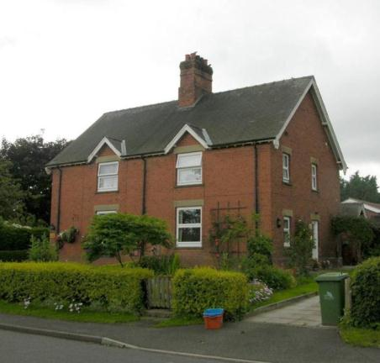

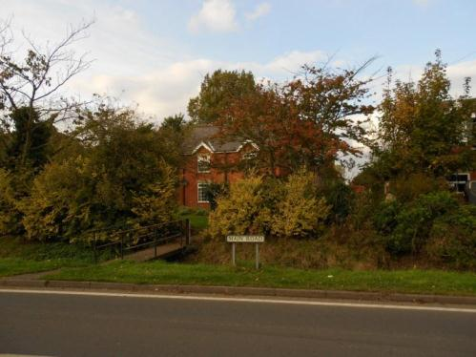

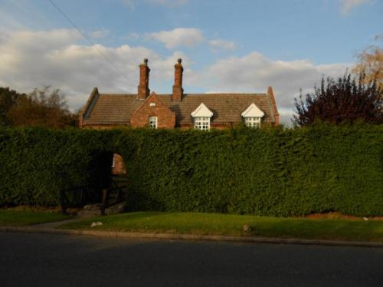

Name: Church Cottage
Date Designated: N/A – New Proposal
Grid Reference: TA 20322 07569
Area Designation: None
Asset Type: Building
Main Criteria Used: 1c, 2g
Description:

A two storey brick cottage with tile roof, possibly 17th century due to the very thin bricks used. It is three bays wide with small 2/2 windows to the front elevation and later inserted windows to the side elevation facing the church. The two stacks flank the central bay, and the larger western stack is probably for a back-to-back fireplace meaning that all three rooms would have been heated. On historic and modern maps it is shown divided in two, but this is not reflected in the external appearance of the house. To the rear is a multi-period range of outbuildings.

The building is important to the rural character and visual history of the village, however it may also be a very early brick building for the area raising its significance.

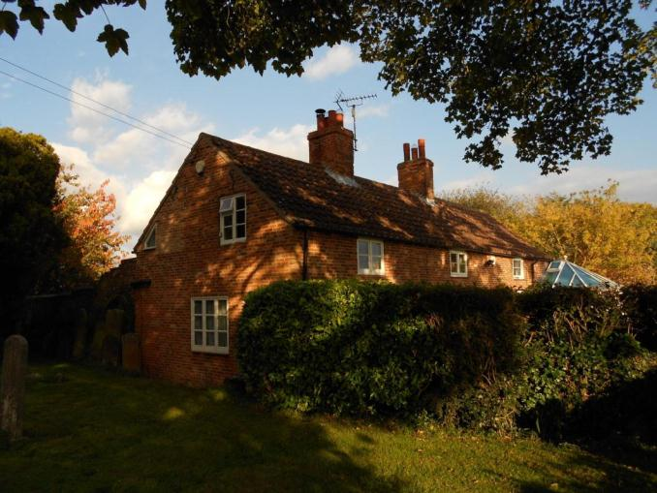

Name: Washing Dales Farm
Date Designated: N/A – New Proposal
Grid Reference: TA 18578 06337
Area Designation: None
Asset Type: Building
Main Criteria Used: 1c, 2g
Description:

A farmstead, probably 19th century, which appears to consist of a small farmhouse with outbuilding and one large farm building. Half of the buildings shown on Ordnance Survey maps of 1887-9 are present.

This site has been surveyed from aerial photographs and maps only. It is assumed from this evidence that it is of at least local interest.

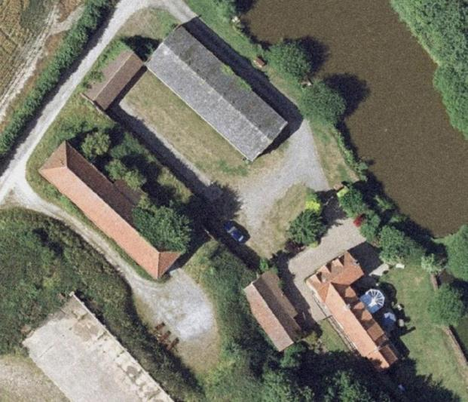
Image Taken in 2006
The GeoInformation Group Data ® copyright by The GeoInformation® Group, 2015

Name: Prehistoric or Roman enclosure 330m south of Manor Farm, Aylesby
Date Designated: N/A – New Proposal
Grid Reference: TA 2013 0716
Area Designation: None
Asset Type: Archaeological Site
Main Criteria Used: 1b, 2a
Description:

A square enclosure, centred to TA20110718, approximately 30mx30m, surrounded by linear ditches, mostly orientated NW/SE. The site is not similar in character to the medieval village traces east of Church lane, and appears to be Romano British in date. It is likely that it is connected to Romano British pottery found in the area.

Sites such as this, which pre-date the creation of most of the villages and towns in the area, are important for the archaeological deposits that they contain and the information on previous settlement and activities in the area that these deposits can provide.

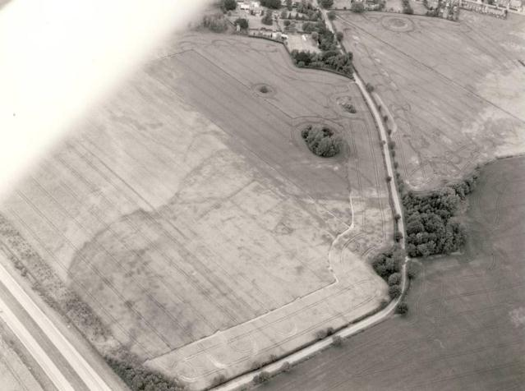
© Humber Archaeological Partnership 1991.

Name: Cropmark Enclosures of 550m south east of Pyewipe Farm
Date Designated: N/A – New Proposal
Grid Reference: TA 2284 0814
Area Designation: None
Asset Type: Archaeological Site
Main Criteria Used: 1b, 2a
Description:

Aerial photos show linear cropmarks over a large area South East of Pyewipe Farm. Although some appear to relate to medieval and post medieval farming the features to the west have a strong similarity to prehistoric/Roman features.

Sites such as this, which pre-date the creation of most of the villages and towns in the area, are important for the archaeological deposits that they contain and the information on previous settlement and activities in the area that these deposits can provide.

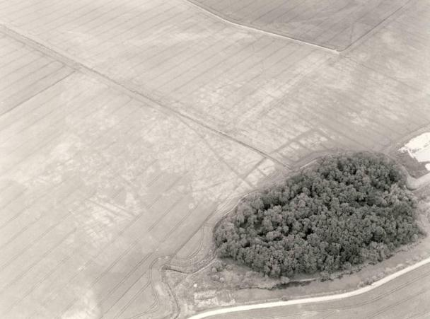
© Humber Archaeological Partnership 1991.

Habrough

Habrough is known to have existed since the early medieval period (410AD to 1066AD). The village is unusual in having two medieval cores, one to the west around the area now occupied by the 19th century train station, and the other to the east around the parish church of St Margaret.

During the 20th century a dense area of detached and semi-detached bungalows was built between Station Road and Chapel Road with the character of an urban suburb.

Habrough is recorded as having a population of 368 in the 1851 census according to White's directory of 1856. In the 2001 census the population is recorded as 648.

At the time of writing – 2nd October 2015 – Habrough has:

88 Historic Environment Records of which:
2 are nationally Listed Buildings
None are nationally Scheduled Monuments
20 are proposed Locally Listed Historic Assets

Name: Habrough School
Date Designated: N/A – New Proposal
Grid Reference: TA 1629 1437
Area Designation: None
Asset Type: Building
Main Criteria Used: 1c, 2g
Description:

A single storey school building with an ornate bell tower above the entrance. Red brick with buff brick banding, ashlar dressings and faux buttresses.
Possibly designed by James Fowler of Louth as it is similar to his schools at East Ravendale and Waltham.

An important part of the social activities of the settlement, and other nearby villages that would have been in the catchment for the school.

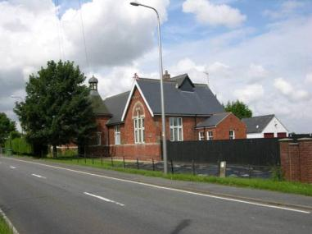

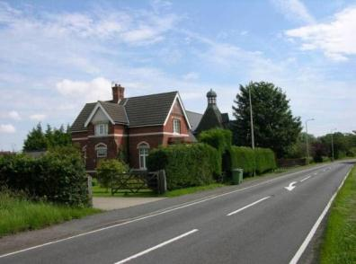

Name: The Old Farmhouse
Date Designated: N/A – New Proposal
Grid Reference: TA 1453 1390
Area Designation: None
Asset Type: Building
Main Criteria Used: 1c, 2g
Description:

18th or 19th century farmstead. The farmhouse is one and a half storey with dormers on the South East side and shows two periods of construction before the modern conversion. From its form it seems likely that the building predates the post-enclosure farms elsewhere in the parish.

The farmstead buildings appear to be later additions to the complex and form the usual three sided yard; close inspection was not possible but the size, and lack of any two storey buildings suggests a farm of modest proportions.

An important part of the agricultural development of the settlement.

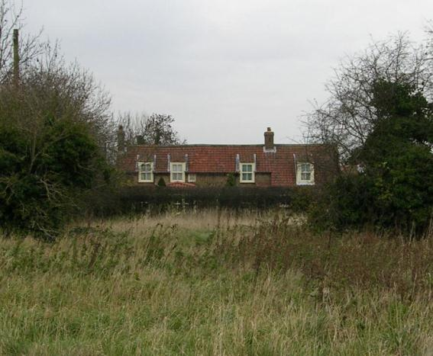

Name: Cast Iron Phone Box, Chapel Road
Date Designated: N/A – New Proposal
Grid Reference: TA 14595 13838
Area Designation: None
Asset Type: Building
Main Criteria Used: 1c, 2g
Description:

A decommissioned K6, or similar model, telephone kiosk now maintained by the parish council. Cast iron. Square kiosk with domed roof. Un-perforated crowns to top panels and margin glazing to windows and door

Although once widespread, cast-iron phone boxes have become synonymous with historic and rural areas and are therefore important to the character of the villages.

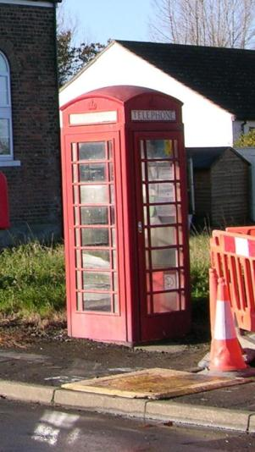

Name: The Station Public House
Date Designated: N/A – New Proposal
Grid Reference: TA 1461 1360
Area Designation: None
Asset Type: Building
Main Criteria Used: 1c, 2g
Description:

A two storey public house built in brick with stone and terracotta dressings, now painted.
The left portion of the building is of 3 bays with a wide central entrance and ground floor square bay windows. The right portion has matching first floor windows, but on the ground floor has a wide arched shop window front.

A well preserved building with probable links to the railway given the proximity of the station. An important part of the social functions of the settlement.

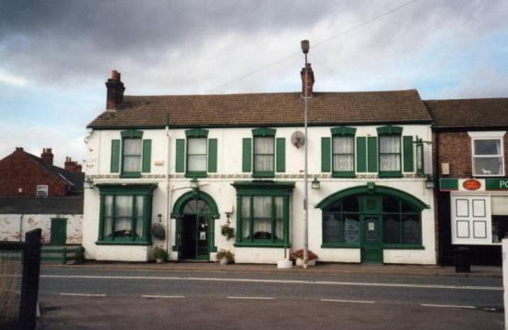
Photograph taken in 1999
Name: Semi Detached Estate Cottages, Immingham Road
Date Designated: N/A – New Proposal
Grid Reference: TA 1560 1430
Area Designation: None
Asset Type: Building
Main Criteria Used: 1c, 2g
Description:

A pair of grey/brown brick built estate cottages, in the Brocklesby Estate style with wooden pinnacles on the gables and brick quoins on one pair.
The westernmost pair appears to have retained one of their ground floor windows, which is a nine light sash.

Representative of the agricultural activities of the village, particularly the links to the Brocklesby Estate.

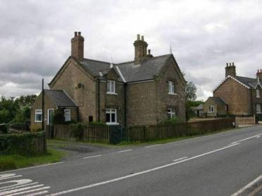

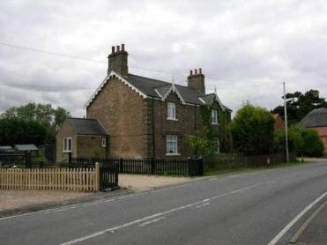

Name: New Farm Estate Cottages
Date Designated: N/A – New Proposal
Grid Reference: TA 1541 1245 and TA 1517 1267
Area Designation: None
Asset Type: Building
Main Criteria Used: 1c, 2g
Description:

A pair of estate workers cottages built for New Farm. The cottages are built of yellow brick with a red brick sting course and ashlar window dressings.
Both buildings retain their timber sash windows and slate roof.

Representative of the agricultural activities of the village.

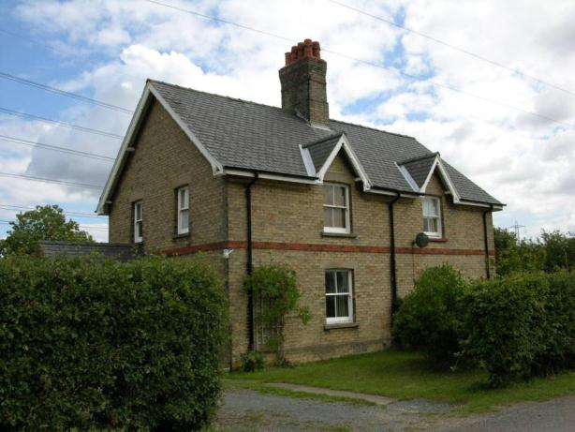

Name: New Farm, Habrough
Date Designated: N/A – New Proposal
Grid Reference: TA 15387 12472
Area Designation: None
Asset Type: Building
Main Criteria Used: 1c, 2g
Description:

A farmstead, probably 19th century, which appears to consist of a farmhouse and a C-plan range of farm buildings. All of the buildings shown on Ordnance Survey maps of 1887-9 may present, but it is not clear as the courtyard has been overbuilt with a mid-late 20th century farm building.

This site has been surveyed from aerial photographs and maps only. It is assumed from this evidence that it is of at least local interest.

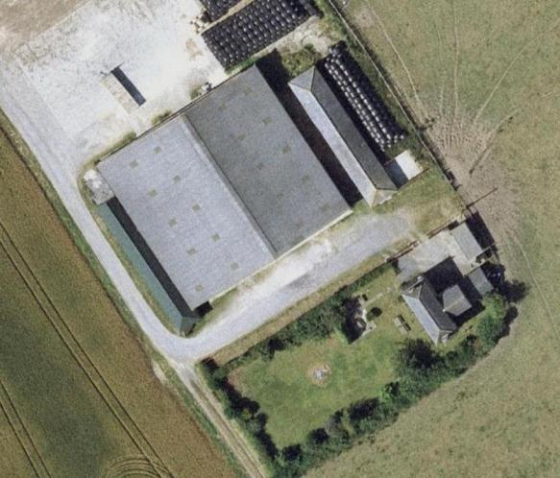
Image Taken in 2006
The GeoInformation Group Data ® copyright by The GeoInformation® Group, 2015

Name: Habrough Grange
Date Designated: N/A – New Proposal
Grid Reference: TA 1483 1302 and TA 1482 1318
Area Designation: None
Asset Type: Building
Main Criteria Used: 1c, 2g
Description:

A large farmhouse built of yellow brick with a slate roof and clay ridge tiles.
The house appears to retain its single storey stable and the farm’s two storey cart shed, along with the outer wall of what was probably the pigsty, and cattle shelter.

The cart shed would have formed the northern end of a three sided farmyard, with the pigsty and cattle shelters to the east; the western buildings have been lost.

A fine building with some of its ancillary buildings preserved to give an indication of the former character of the site. Representative of the agricultural activities of the village

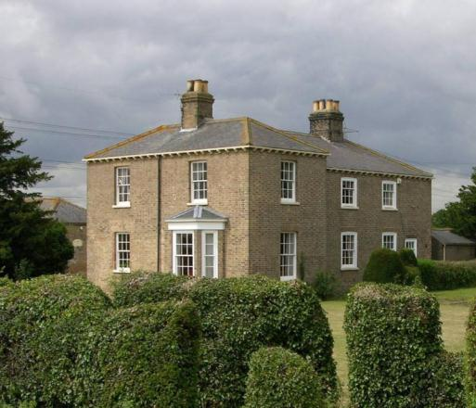

Name: Church Farm
Date Designated: N/A – New Proposal
Grid Reference: TA 1595 1434
Area Designation: None
Asset Type: Building
Main Criteria Used: 1c, 2g
Description:

An evolved farmstead with a large farmhouse and multi-period farm buildings around a central yard.
Detached cart shed with granary above; four bays with large round arched openings for the carts on the ground floor and a tile roof.
The stables, on the south of the yard, are single storey brown brick with tiled roof and some modern glazed windows.
The eastern building on the yard is a barn, probably for threshing or processing with large opposed single doors on the long sides and a pitching door on the outer wall. Extended at least twice to the south.
The northern building appears to have been enclosed cattle shelters and shows evidence of multiple periods of builds including a later outer brick skin to the north and blocked-up ventilation holes in the walls.
The western buildings of the yard are no longer standing.

The farmhouse itself is a large two storey buff brick building that faces out to the fields.

A good survival, with most of the buildings from the complex still standing with sufficient fabric remaining to show their original use and some of the development of the site over time. The site is representative of the agricultural activities of the village.

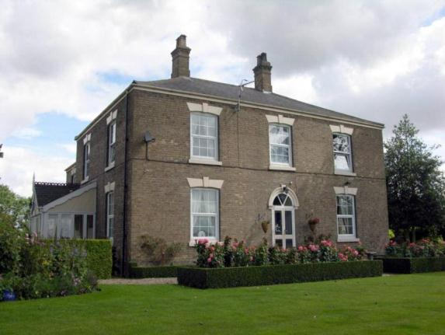

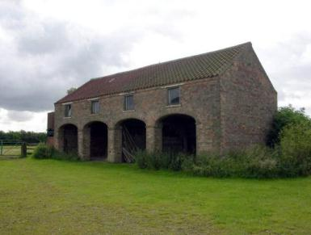

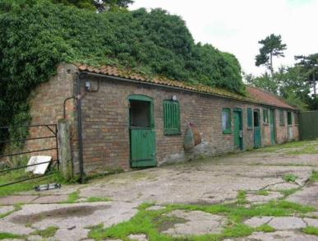

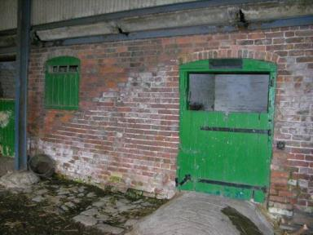

Name: Roxlyn House
Date Designated: N/A – New Proposal
Grid Reference: TA 1589 1440
Area Designation: None
Asset Type: Building
Main Criteria Used: 1c, 2g
Description:

A two storey, 3 bay buff brick house with a slate roof. The building has 2/2 timber framed sash windows and a side entrance with a wooden door and single light above. Shown on historic maps with outbuildings, possibly a small farm range.

A fine house, one of a dispersed group of similar buildings, representative of relative wealth in the village. The group probably represents the desire of business owners from nearby towns to live away from cramped urban conditions and so may be a part of the social interaction between urban and rural areas.

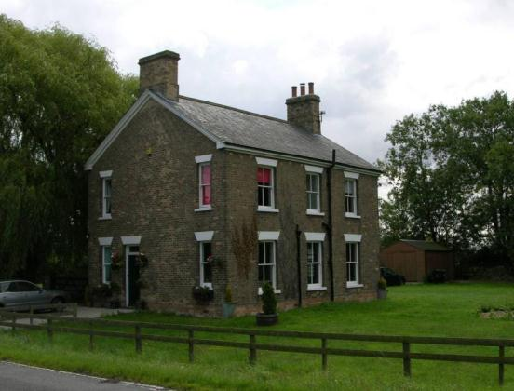

Name: Woodland View
Date Designated: N/A – New Proposal
Grid Reference: TA 1472 1336
Area Designation: None
Asset Type: Building
Main Criteria Used: 1c, 2g
Description:

A well preserved two storey 3 bay house. Built of buff brick with red brick banding, window and door surrounds.
The ground floor has original timber bays with sash windows and a central doorway with panelled front door with a plain fanlight above. The first floor also retains its timber sash windows, and the front garden is bounded by cast iron railing on a dwarf brick wall with ashlar caps.

A fine house, one of a dispersed group of similar buildings, representative of relative wealth in the village. The group probably represents the desire of business owners from nearby towns to live away from cramped urban conditions and so is a part of the social interaction between urban and rural areas.

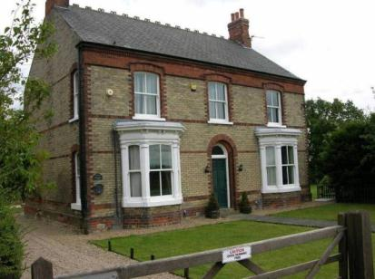

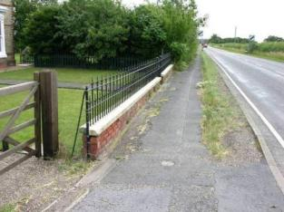

Name: The Vicarage, Killingholme Road
Date Designated: N/A – New Proposal
Grid Reference: TA 1544 1458
Area Designation: None
Asset Type: Building
Main Criteria Used: 1c, 2g
Description:

A two storey vicarage, designed by James Fowler in 1891 and so one of his last buildings before his death in 1892. Built of yellow brick with red brick dressings, a slate roof with clay ridge tiles, and timber sash windows.
The building is currently in use as a guest house, and retains at least one outbuilding.

A prominent building which represents an important part of the ecclesiastical functions of the village.

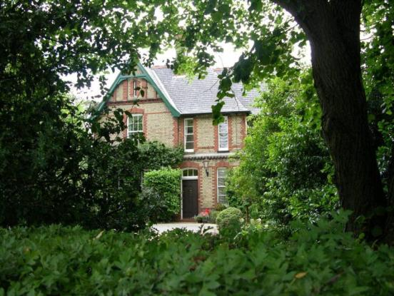

Name: Newsham Farm
Date Designated: N/A – New Proposal
Grid Reference: TA 1430 1345
Area Designation: None
Asset Type: Building
Main Criteria Used: 1c, 2g
Description:

One of the best preserved post enclosure farms in Habrough. Most of the buildings marked on the old Ordnance Survey maps are still standing.
Cart shed, with granary above, on the outside of the main yard. The cart shed has four large round arched openings. The granary is accessed by external stairs and retains its louvered windows. Built of brown brick with a pantile roof and ashlar steps to the granary.
The stables are single storey brown brick with pantile roof and vented windows with part glazing above the vents.
Other buildings, including a possible cattle shelter, are single storey.

The main farmhouse is a two storey, 3 bay, brown brick building with 8/8 light sash windows and three stacks.

A fine collection of buildings representing the agricultural activities of the village.

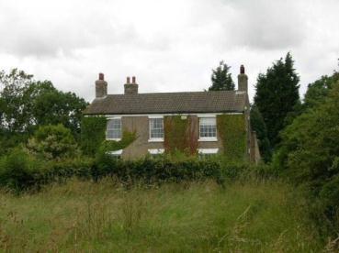

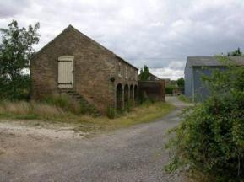

Name: Barn at Laburnum Farm
Date Designated: N/A – New Proposal
Grid Reference: TA 1468 1400
Area Designation: None
Asset Type: Building
Main Criteria Used: 1c, 2g
Description:

A two storey barn, probably 18th century. Brown brick with pantile roof, gable parapets and tumbling to the gable. It has a large central doorway and numerous ventilator slits and diamonds suggesting that it may be a threshing barn.

Despite some blocked windows and ventilators the barn appears to be intact, and is of significance due to its age and the rarity of intact, large barns from this time.

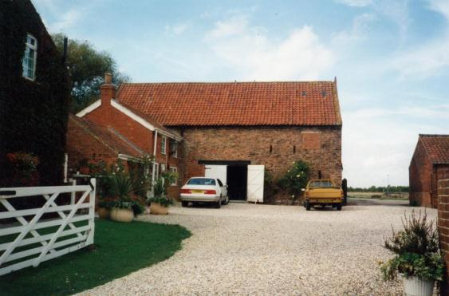

Name: Pelham House, Habrough
Date Designated: N/A – New Proposal
Grid Reference: TA 1499 1435
Area Designation: None
Asset Type: Building
Main Criteria Used: 1c, 2g
Description:

An 18th or early 19th century farmhouse built of brown brick with raised and leaded gable parapets, tumbling to the gables, end stacks and concrete tile roof. The house is three bays wide with a central doorway, two storeys high, all windows have segmental arches. The site also contains the remains of a small courtyard based farmstead.

The farmhouse is remarkably well preserved and an early example for the area.

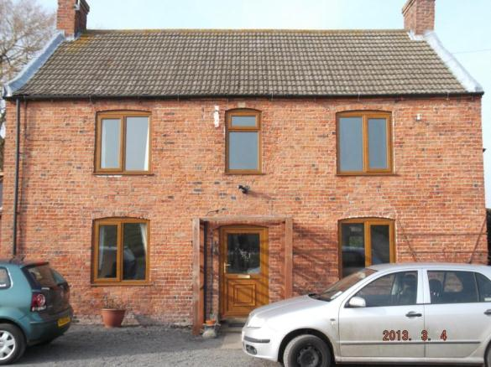

Name: Cropmark enclosures and trackways 550m south east of Rye Hill Farm
Date Designated: N/A – New Proposal
Grid Reference: TA 1322 1420
Area Designation: None
Asset Type: Archaeological Site
Main Criteria Used: 1b, 2a
Description:

Aerial photographs show irregular trackways and at least 4 combined rectangular enclosures, probably of late prehistoric or Roman origins.

One of the most regularly appearing cropmarks in the Borough. Sites such as this, which pre-date the creation of most of the villages and towns in the area, are important for the archaeological deposits that they contain and the information on previous settlement and activities in the area that these deposits can provide.

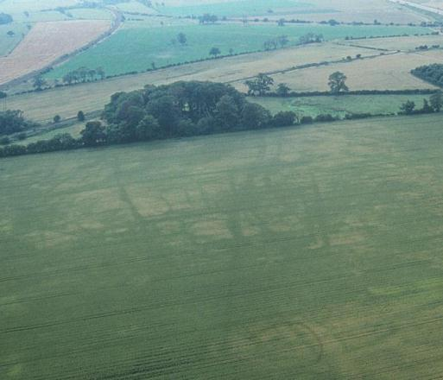
Cropmark Enclosures in Habrough. British Gas 1991

Name: Eastern area of Habrough medieval settlement and moated manorial site earthworks
Date Designated: N/A – New Proposal
Grid Reference: TA 1558 1422
Area Designation: None
Asset Type: Archaeological Site
Main Criteria Used: 1b, 2g
Description:

Earthworks and cropmarks reveal the remains of house sites, ditches/hollow ways and a moated manorial site.

Excavation of the moated site in 1991 revealed an artificial mound, overlaying pottery of the 10th century, surrounded by a substantial ditch which had been scoured clean up until the late 15th century. After this period several roof tile kilns were built on the site which appeared to be used until the 17th century; finds from this period of use of the site are of particularly high status.
The site has been identified as the manorial site of the de Saltfletby family during the 13th and 14th centuries, after which it was granted to the Skipwith family who lived there until the 16th century when they are reputed to have died out.
The moated site was ploughed over after 1991 but still stands as a noticeable earthwork.

As a landscape feature the earthworks represent the shrinking and re-organisation of the village following the medieval period, and will contain archaeological deposits which have the potential to inform the understanding of the development of the village. The site of the moated enclosure will contain further archaeological deposits relating to the village as well as the manorial site itself.

See HER Numbers - 0340/4/0 and 0340/5/0 - for further information and sources

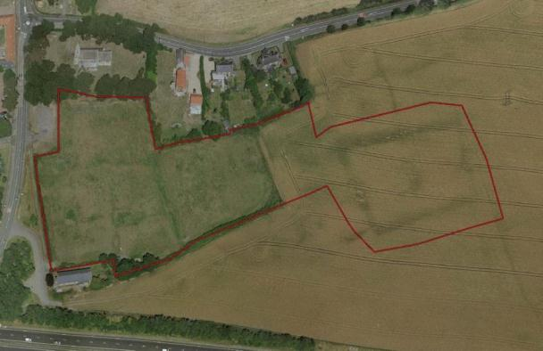
Image Taken in 2006
The GeoInformation Group Data ® copyright by The GeoInformation® Group, 2015
Name: Western area of Habrough medieval settlement earthworks and cropmarks
Date Designated: N/A – New Proposal
Grid Reference: TA 1439 1354
Area Designation: None
Asset Type: Archaeological Site
Main Criteria Used: 1b, 2g
Description:

Part of Habrough SMV, areas North and South of the road. There are house sites, toft boundaries and trackways. The southern part of the area was levelled in 1966 and is now represented by truncated deposits which cause cropmarks. There were house sites with cornerstones, cobbled areas and 13th -18th century pottery. The northern part, however, still contains significant and well defined earthworks.

As a landscape feature the earthworks represent the shrinking and re-organisation of the village following the medieval period, and will contain archaeological deposits which have the potential to inform the understanding of the development of the village. The levelled areas will also contain further archaeological deposits relating to the village which will be important to establishing the context of deposits within the earthwork area and the wider village.

See HER Number - 0340/1/0- for further information and sources

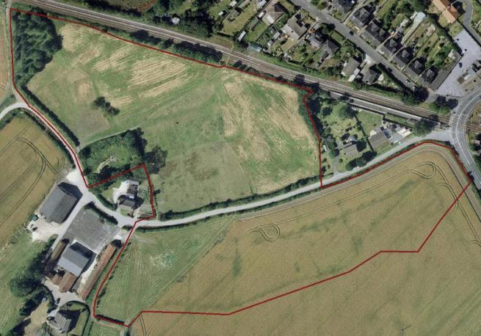
Image Taken in 2006
The GeoInformation Group Data ® copyright by The GeoInformation® Group, 2015
Name: Cropmark enclosures south east of Habrough Grange
Date Designated: N/A – New Proposal
Grid Reference: TA 1502 1297
Area Designation: None
Asset Type: Archaeological Site
Main Criteria Used: 1b, 2a
Description:

A possible enclosure located by geophysical survey and associated with either 1st to 2nd century Roman pottery and/or Neolithic/Bronze Age flints including an axe roughout found during fieldwalking.

Aerial photographs show an extensive complex, possibly relating to two adjacent settlements, either side of the farm track, orientated roughly N-S. The complex comprises a regular set of cropmarks to the west, centred at TA14911294, and a more irregular set centred at TA15001295

See HER Number - 0826/1/0 - for further information and sources

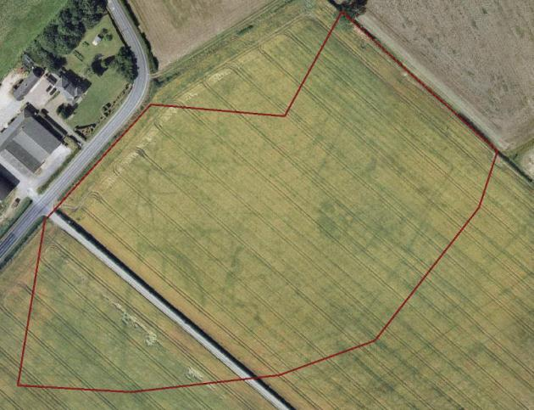
Image Taken in 2006
The GeoInformation Group Data ® copyright by The GeoInformation® Group, 2015

Name: Roman Enclosure 440m north east of Glebe Farm in Habrough
Date Designated: N/A – New Proposal
Grid Reference: TA 1610 1536
Area Designation: None
Asset Type: Archaeological Site
Main Criteria Used: 1b, 2a
Description:

An enclosure system was found during geophysical survey, prior to the laying of a pipeline, which has the appearance of a Roman site.

GSB Prospection. 2000. Conoco Gas Pipeline II, South Killingholme, Lincolnshire

A broken silver "Celtic" coin, a quantity of bronze coins and a large amount of second to fourth century Samien ware have historically been found at the site (Unknown Source).

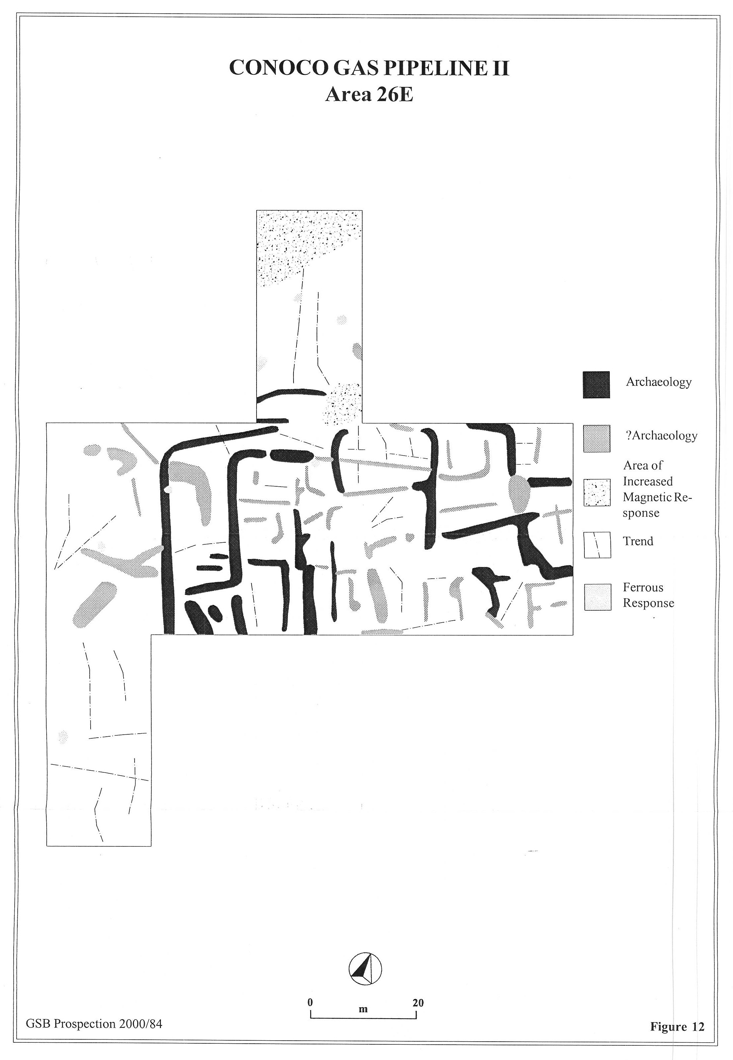
Interpretative Geophysical Plot © GSB Prospection 2000.

Healing

Healing is known to have existed since the early medieval period (410AD to 1066AD), however unlike most other settlements in the area, its historic extent is difficult to determine. The settled area appears to have lain between the moated manorial site at Healing Manor to the south and another moated site off Clematis Avenue and Westwood Road to the north.

Healing is recorded as having a population of 92 in the 1851 census according to White's directory of 1856. In the 2001 census the population is recorded as 2,606.

At the time of writing – 2nd October 2015 – Healing has:

85 Historic Environment Records of which:
3 are nationally Listed Buildings
1 is a nationally Scheduled Monument
17 are proposed Locally Listed Historic Assets

Name: Healing Manor and Outbuildings
Date Designated: N/A – New Proposal
Grid Reference: TA 2140 1003
Area Designation: None
Asset Type: Building
Main Criteria Used: 1c, 2g
Description:

The current Healing House is considered to have been built as a replacement for the original manor house which was sited with the adjacent moated site, which is a Scheduled Ancient Monument (SM21189, HOB UID 81538).
The oldest part of the current building dates to the early 18th century and faces south-west. This is thought to have been expanded in the late 18th - early 19th with the addition of a rear extension under a roof parallel to the original. Before 1888, a further much larger extension, more than doubling the size of the house, was added as a pair of parallel wings joined at ground floor level, extending back from the rear of the house. The northern wing was extended in two separate phases.
Between the 1888 and 1908 Ordnance Survey maps, the house was expanded again with the addition of a two storey cross wing to the north-west side of the original house, to the left of the original frontage. Other alterations were made with the addition of a number of canted bay windows as well as a large porch. These additions are in Arts and Crafts style and much of the interior fittings appear to date to this remodelling.
The building is of two storeys and is built of brick, with some half timbering and tile hanging, the roof is of plain tiles with slate to the north wing (National Monuments Record: Number 1457261)

The site also contains a number of outbuildings including a game pantry, 18th century barn, stables and air raid shelters.

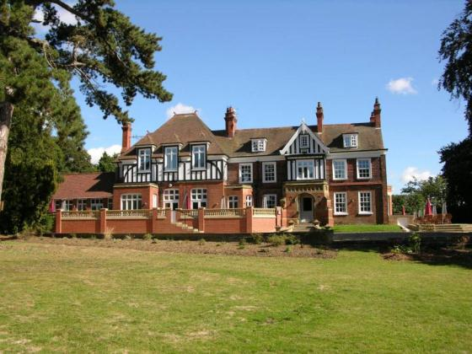

Name: Healing Methodist Church
Date Designated: N/A – New Proposal
Grid Reference: TA 2165 1064
Area Designation: None
Asset Type: Building
Main Criteria Used: 1c, 2g
Description:

An early 20th century Methodist chapel in arts and crafts style.

A prominent building which represents an important part of the ecclesiastical functions of the village.

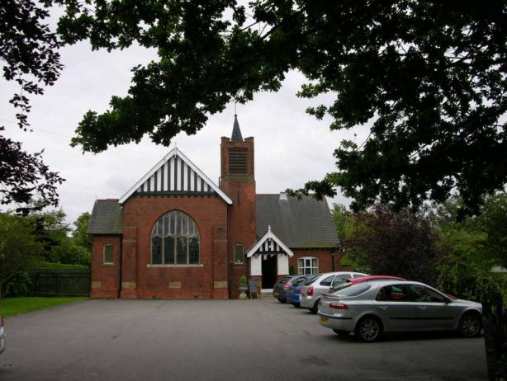

Name: 3 and 5 Stallingborough Road
Date Designated: N/A – New Proposal
Grid Reference: TA 2125 1024
Area Designation: None
Asset Type: Building
Main Criteria Used: 1c, 2g
Description:

Early 20th century estate cottages, two storey in red brick with ashlar dressings and a tile roof, buff brick string courses, original tile roofed porches suspended on carved wooden brackets, all front windows are original timber casements.

A fine village cottage with few alterations, representative of the agricultural activities of the settlement.

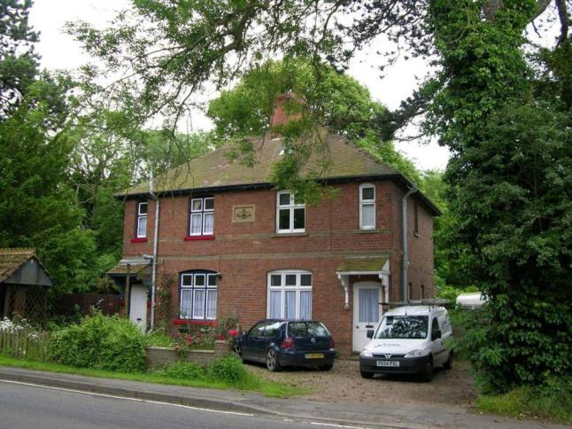

Name: Rectory Hill, 1 Stallingborough Road
Date Designated: N/A – New Proposal
Grid Reference: TA 2155 1014
Area Designation: None
Asset Type: Building
Main Criteria Used: 1c, 2g
Description:

1930s or 1940s replacement for Healing Rectory. H shaped on plan, smart Edwardian style in brown brick with tile roof, irregular fenestration, quoins.

A large and handsome house which represents an important part of the ecclesiastical functions of the village.

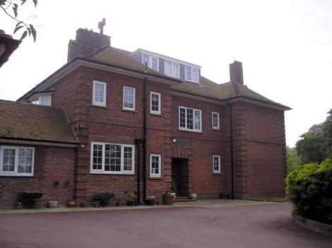
Rectory Hill in 2005 – Note that a garage is now affixed to the right side elevation

Name: Healing War Memorial
Date Designated: N/A – New Proposal
Grid Reference: TA 2156 1030
Area Designation: None
Asset Type: Memorial
Main Criteria Used: 1b, 2g
Description:

War memorial, first erected for World War 1. Plain modernist style with metal plaques.

Dedicated to the First World War (1914-1918) and the Second World War (1939 and 1945) with 11 deaths and 4 deaths recorded respectively for the village.

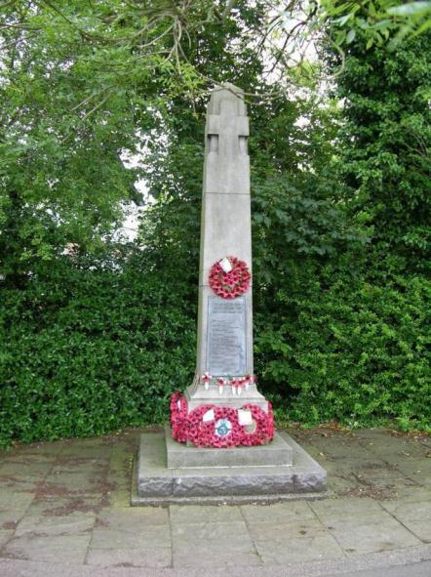

Name: Arden Court, 26 The Avenue
Date Designated: N/A – New Proposal
Grid Reference: TA 2185 1071
Area Designation: None
Asset Type: Building
Main Criteria Used: 1c, 2f
Description:

A large Edwardian villa. Two storey in red brick with extensive ashlar dressings, a large Dutch gable to the front, centre elevation with the motif replicated along a parapet and above the ground floor, outer bay, bay windows. Slate roof with clay ridge tiles. Projecting front porch, again with a parapet.

The grandest house in The Avenue and Station Road area. The house, and area, is in a sub-urban style presumably built as an early commuter settlement for Grimsby.

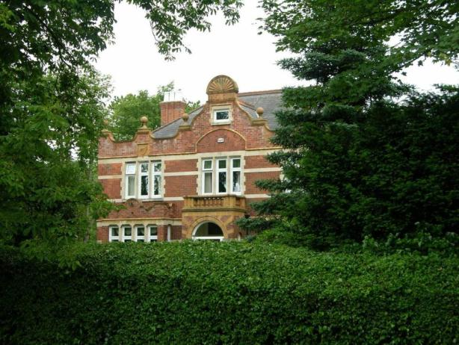

Name: Former Post Office, Healing
Date Designated: N/A – New Proposal
Grid Reference: TA 2182 1096
Area Designation: None
Asset Type: Building
Main Criteria Used: 1c, 2f
Description:

A former post office with attached house, presumably for the postmaster. Now three houses. Built by the surveying of the Ordnance Survey maps of 1906-8. Red brick with mock Tudor first floor and slate roof, notable for two large arched openings on the ground floor representing the former shop character.

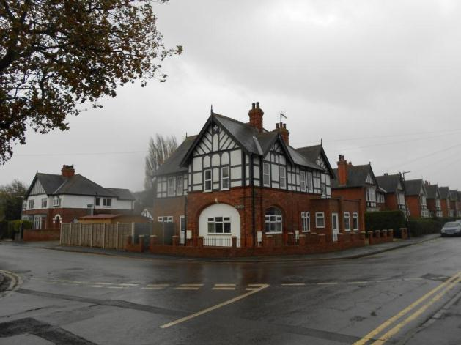

Name: 46 and 48 Station Road
Date Designated: N/A – New Proposal
Grid Reference: TA 2161 1062
Area Designation: None
Asset Type: Building
Main Criteria Used: 1c, 2g
Description:

Early 20th century estate cottages. Two storey, a pair of close set windows to the front elevation of each house at each storey. Red brick with yellow brick arches, string courses, eaves course and quoins, slate roof. Original 6/6 hung sash windows to number 48.

A fine village cottage with few alterations, representative of the agricultural activities of the settlement.

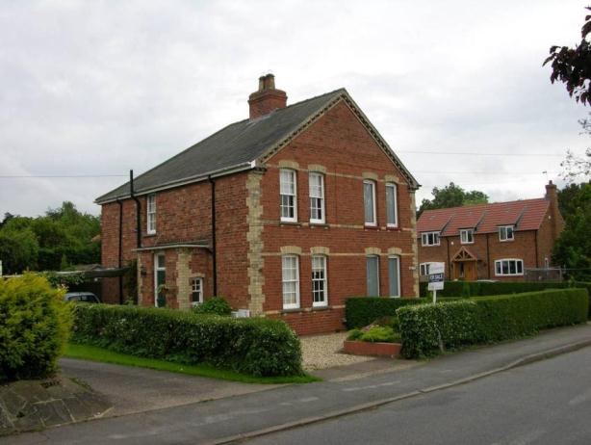

Name: Iona Cottage, Low Road
Date Designated: N/A – New Proposal
Grid Reference: TA 2154 1038
Area Designation: None
Asset Type: Building
Main Criteria Used: 1c, 2g
Description:

Early 20th century estate cottage, similar to the Sutton’s Estate cottages in Great Coates. Three bay with the right hand projecting to the front, two storey, red brick with darker brick string courses, clay tile roof.

A fine village cottage with few alterations, representative of the agricultural activities of the settlement.

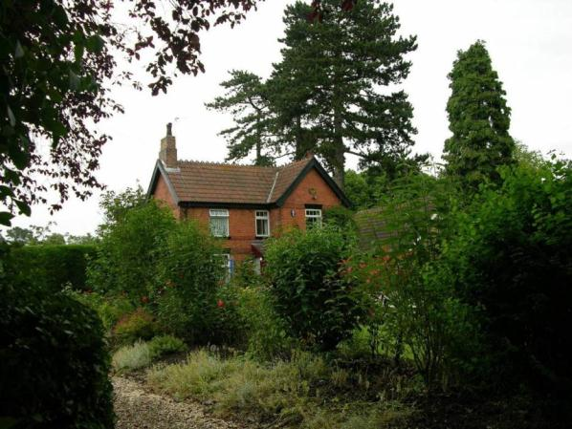
Name: Manor Farm and Cottages, Wells Road
Date Designated: N/A – New Proposal
Grid Reference: TA2087 1027
Area Designation: None
Asset Type: Building
Main Criteria Used: 1c, 2g
Description:

A pair of estate, or farm workers, cottages later converted into a single dwelling with bricked up doorways, and associated farm buildings to the rear.

A well preserved group of buildings that are an important part of the agricultural origins of the village.

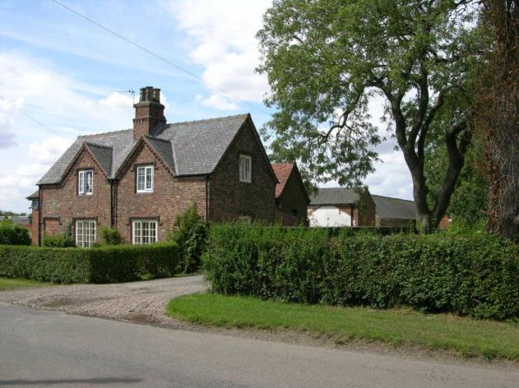

Name: The Grange, Healing
Date Designated: N/A – New Proposal
Grid Reference: TA 21509 10309
Area Designation: None
Asset Type: Building
Main Criteria Used: 1c, 2g
Description:

A large multi period farmhouse. A three bay 18th century wing faces south west with a large early-mid 19th century extension attached to the left bay and facing north west with its own three bay façade (later altered), forming an L-shaped plan. Additional extensions were added in the 20th century. Brown brick to the main 18th century façade, but rendered to the south east. Buff-grey brick to the 19th century extension. The ground floor windows are largely intact wooden sash, those to the first floor are uPVC sash.

Now called The Grange but originally Ivy House, it’s farm buildings were to the south and have been demolished. Set in large grounds with the remains of a tree-lined avenue leading to the church.

Although the building has had many alterations carried out, the evolution of the building is still clear and the external character is largely intact. It is an interesting building that adds considerably to the character of the village, and helps preserve part of the former character.

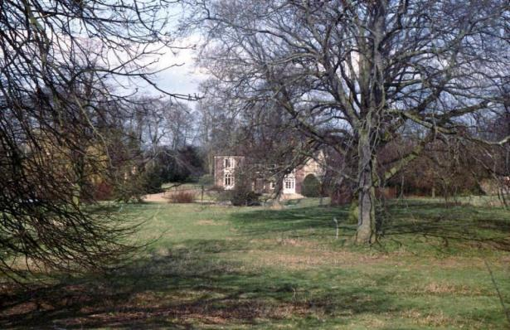

Name: Hunting Woodland, Healing
Date Designated: N/A – New Proposal
Grid Reference: TA 2248 1233
Area Designation: None
Asset Type: Designed Landscape
Main Criteria Used: 1c, 2g
Description:

An early 20th century hunting wood on the former marshland of Healing Parish. The woodland contains two areas of tall deciduous trees flanking an area which appears to have been laid out to be scrubland, with low growing bushes and trees surrounding. It is not known for certain what purpose the areas of planting served but it is clearly a deliberate act.

The layout of the planting can still be seen from a distance and within the woodland despite progressive naturalisation of the trees and shrubs. Hunting is/was part of rural life and the conversion of a large parcel of arable farmland to hunting shows the importance of the activity.

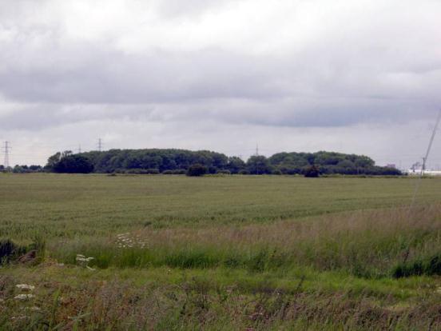

Name: Watercress Beds 100m north of Cress Cottage in Healing
Date Designated: N/A – New Proposal
Grid Reference: TA 2212 1221
Area Designation: None
Asset Type: Building
Main Criteria Used: 1a, 2g
Description:

Watercress beds marked on modern maps and aerial photographs from the late 1940s. The site comprises a series of long, thin, concrete ponds with sluices and other water control structures.

Reputedly built to aid the War Effort during World War 2 as watercress was an important addition to the nation's depleted sources of food.

The site is unique, in terms of the Borough, although it appears to have replaced an earlier set of beds closer to the village core which have since been demolished. They are an interesting addition to the agricultural production capabilities of the village.

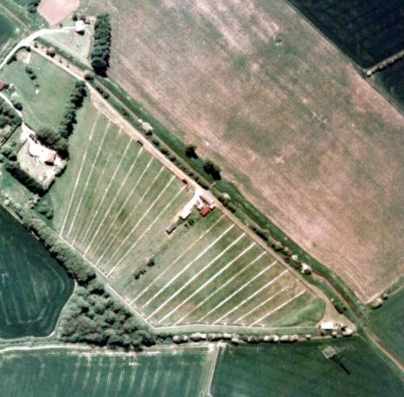
Print Copyright Humberside County Council and JAS Air 1989
Digital Scan Copyright North East Lincolnshire Council 2015

Name: Cropmark Enclosure 500m north east of Wells Farm, Healing
Date Designated: N/A – New Proposal
Grid Reference: TA 2045 1008
Area Designation: None
Asset Type: Archaeological Site
Main Criteria Used: 1b, 2a
Description:

An aerial photograph shows a rectangular enclosure and one curving ditch. Other small ditches are also visible.

Part of a group of cropmarks of probable Prehistoric or Roman date in the immediate area.
Sites such as these, which pre-date the creation of most of the villages and towns in the area, are important for the archaeological deposits that they contain and the information on previous settlement and activities in the area that these deposits can provide.

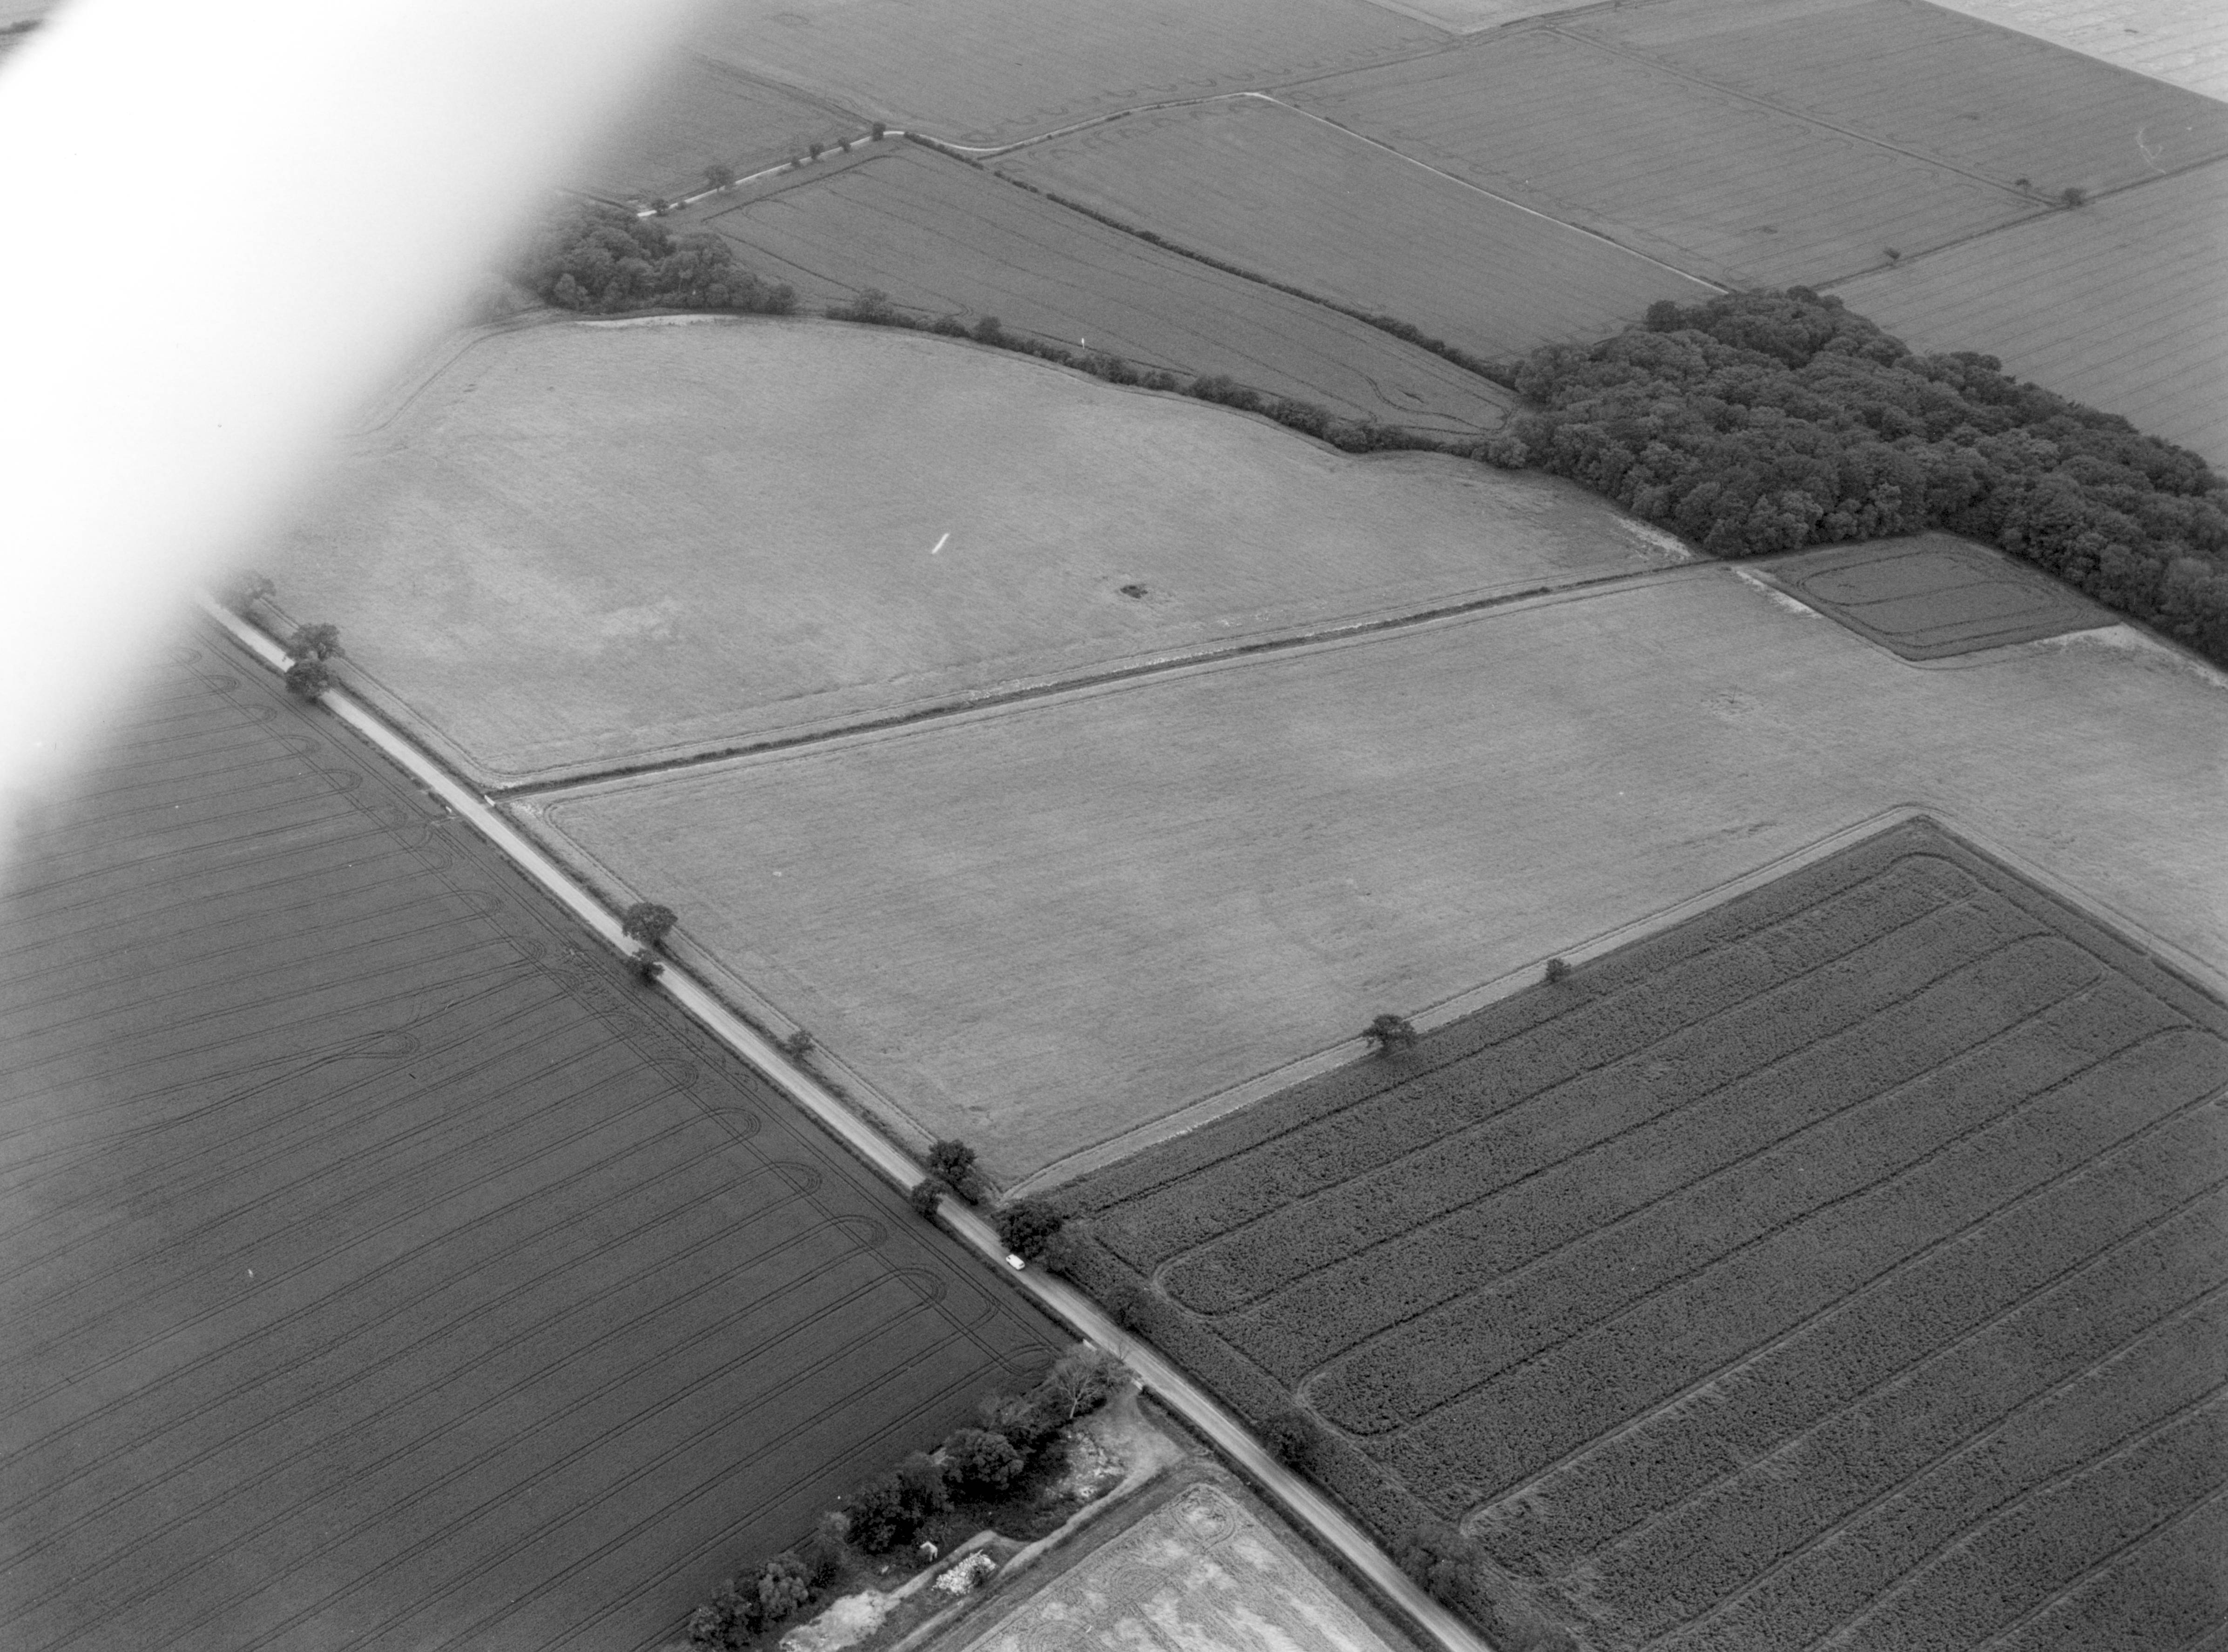
© Humberside Archaeology Partnership 1992

Name: Cropmark enclosures 130m east of Hill Crest House in Healing
Date Designated: N/A – New Proposal
Grid Reference: TA 2046 0968
Area Designation: None
Asset Type: Archaeological Site
Main Criteria Used: 1b, 2a
Description:

Partial cropmark of several conjoined enclosures, measuring c.180m x c.85m.

Part of a group of cropmarks of probable Prehistoric or Roman date in the immediate area.
Sites such as these, which pre-date the creation of most of the villages and towns in the area, are important for the archaeological deposits that they contain and the information on previous settlement and activities in the area that these deposits can provide.

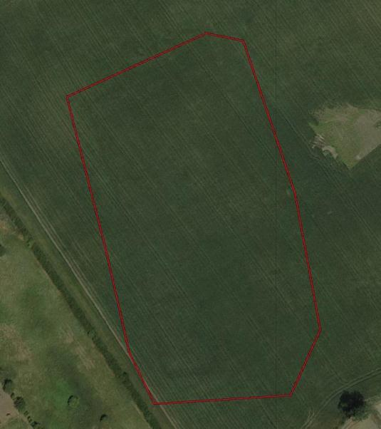
Image Taken in 2006
The GeoInformation Group Data ® copyright by The GeoInformation® Group, 2015
Name: Earthworks of a Medieval settlement enclosure or moated site off Clematis Avenue and Westwood Road
Date Designated: N/A – New Proposal
Grid Reference: TA 2138 1081
Area Designation: None
Asset Type: Archaeological Site
Main Criteria Used: 1b, 2g
Description:

A site occupied from the 11th century until the 16th, with the later phases including the creation of a moated enclosure. The site has been subject of several phases of investigation including trial trenching.

The moated enclosure is sub-rectangular and measures approximately 180m by 160m. It contains several house platforms, fishponds and various drainage features. A large balancing pond was cut into the site in the early 21st century.

The site is an important visual connection with the medieval past of the village, and makes an interesting comparison with the double-moated enclosure(s) at Healing Manor on the other side of the settlement. The site will contain important archaeological deposits relating to the growth and development of the village.

See HER Number - 0301/2/0 - for further information and sources

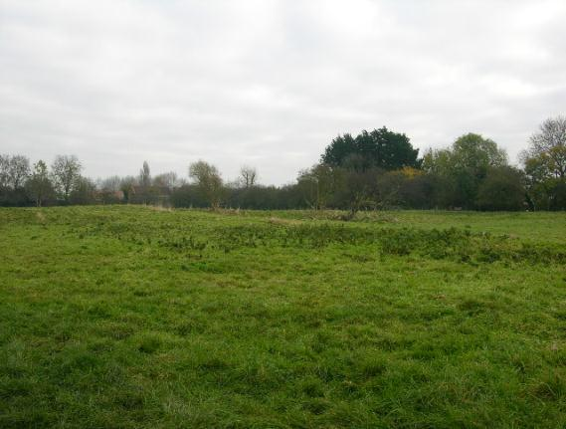
Name: Possible Bronze Age Round Barrow or Medieval prospect mound, Toot Hill, Healing
Date Designated: N/A – New Proposal
Grid Reference: TA 2159 1011
Area Designation: None
Asset Type: Archaeological Site
Main Criteria Used: 1b, 2a
Description:

A significant mound, artificial in appearance, recorded as a bowl barrow (National Monuments Record: TA 21 SW 3)

The proximity of the moated manorial site at Healing Manor suggests that this may be a related monument such as a prospect mound.

In either case the site is a highly significant part of the history of the village.

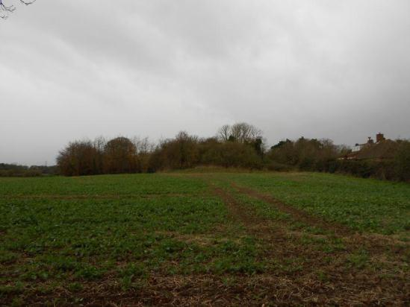

Immingham

Immingham is known to have existed since the early medieval period (410AD to 1066AD), however until the 20th century it does not appear to have grown past a large village in size in contrast to the dense urban character of the modern town. Most of the historic settlement appears to have clustered around the church of St Andrew; however former earthworks relating to medieval settlement are known to have extended as far as Highfield Farm at the southern end of the parish and just short of Manby Road to the east.

The parish also contains the hamlet of Roxton which is known to have existed since at least 1242AD but is now almost entirely depopulated.

Immingham is recorded as having a population of 242 in the 1851 census according to White's directory of 1856. In the 2001 census the population is recorded as 9961.

At the time of writing – 2nd October 2015 – Immingham has:

125 Historic Environment Records of which:
5 are nationally Listed Buildings
None are nationally Scheduled Monuments
18 are proposed Locally Listed Historic Assets

Name: County Hotel, Immingham
Date Designated: N/A – New Proposal
Grid Reference: TA 1895 1513
Area Designation: None
Asset Type: Building
Main Criteria Used: 1c, 2e
Description:

One of the most prominent buildings in Immingham is the County Hotel built in 1910 by G H Mumby.

Pevsner N and J Harris. 1989. The Buildings of England Lincolnshire. 2nd Edition. Yale University Press. New Haven and London.

The hotel was used as a temporary headquarters by Lord Mountbatten after his destroyer, HMS Kelly, was damaged by a mine in the Humber Estuary in 1939.

Grimsby Telegraph, October 28, 2013. Mountbatten memorabilia comes home to County.

An important landmark for the development of Immingham from a village to a port town, being built after the commencement but before the completion of Immingham Docks.

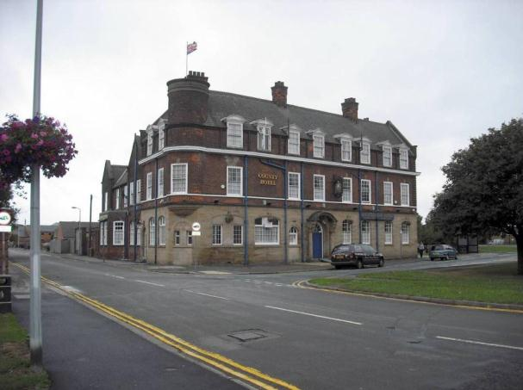

Name: Immingham Coaling Tower
Date Designated: N/A – New Proposal
Grid Reference: TA 1966 1526
Area Designation: None
Asset Type: Building
Main Criteria Used: 1a, 2b
Description:

A 20th century concrete coaling tower at Immingham docks, a prominent landmark, now disused. Built in the 1920s-40s to rapidly refuel coal trains; once a common structure at important railway sites it is now one of two left in England.

An essential part of the complex railway infrastructure built to service Immingham Docks.

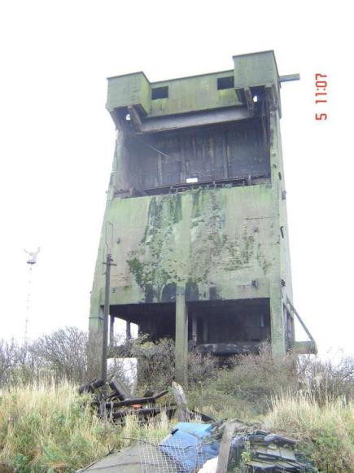

Name: Pilgrims Monument, Immingham
Date Designated: N/A – New Proposal
Grid Reference: TA 1754 1496
Area Designation: None
Asset Type: Building
Main Criteria Used: 1b
Description:

A monument to the pilgrim fathers of America who left Immingham in 1609. The base stone inscription reads:

"From this creek the pilgrim fathers first left England in 1608 in search of religious liberty. The granite top stone was taken from Plymouth Rock Mass and presented by the Sulgrave Institution of U.S.A. This monument was erected by the Anglo-American society of Hull 1924"

The top stone inscription reads:
"Pilgrim fathers
Immingham to Holland 1609
To Plymouth Rock, New England 1620"

Moved from the mouth of the former Immingham Haven at the Docks to opposite St Andrews Church c.1987. Formerly a Grade II (two) listed building.

An important reminder of society and religious practices in 17th century England and the involvement of people from the East Midlands in the founding of the first successful English settlements in the Americas.

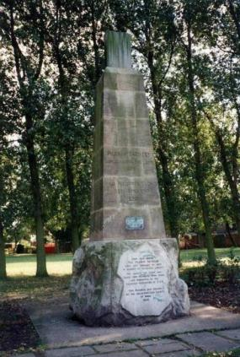

Name: Immingham War Memorial
Date Designated: N/A – New Proposal
Grid Reference: TA 1903 1515
Area Designation: None
Asset Type: Building
Main Criteria Used: 1b, 2g
Description:

A relatively plain stone obelisk shaped war memorial. Dedicated to the First World War (1914-1918) and the Second World War (1939 and 1945)

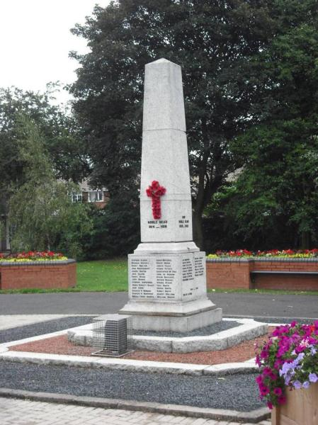

Name: Immingham Police Station
Date Designated: N/A – New Proposal
Grid Reference: TA 1899 1512
Area Designation: None
Asset Type: Building
Main Criteria Used: 1c, 2e
Description:

An Edwardian police station built to serve the developing town after the construction of the new docks. Red brick with a slate roof and corner quoins, façade is 5 bays wide with the two right bays set back creating an asymmetrical appearance.

The asset also include a probable gaol/jail.

An important landmark for the development of Immingham from a village to a town.

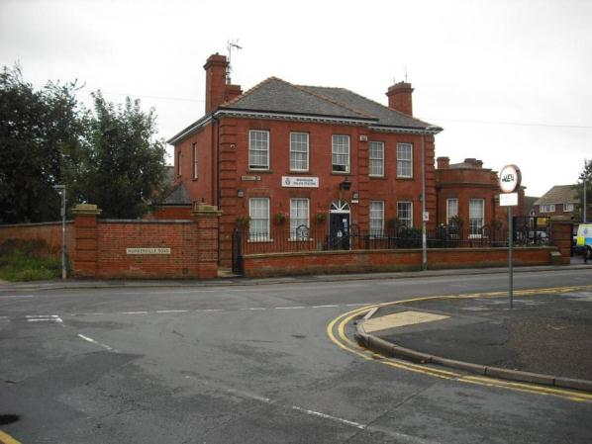

Name: Trinity Methodist Church, Immingham
Date Designated: N/A – New Proposal
Grid Reference: TA 1811 1451
Area Designation: None
Asset Type: Building
Main Criteria Used: 1c, 2g
Description:

Early 20th century Methodist chapel in red brick with stone dressings and Welsh slate roof. Symmetrical original frontage with later 20th century extensions.

A prominent building which represents an important part of the ecclesiastical functions of the village.

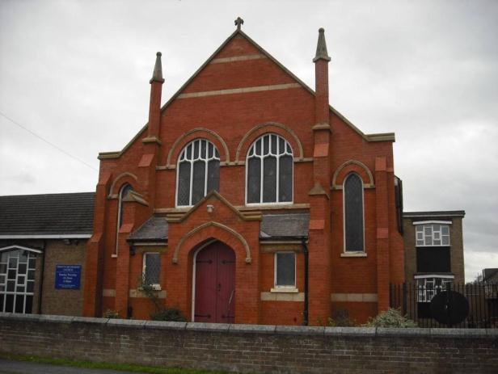

Name: Estate Cottages, 50-52 and 83-85 Stallingborough Road
Date Designated: N/A – New Proposal
Grid Reference: TA 1762 1396 and TA 1766 1396
Area Designation: None
Asset Type: Building
Main Criteria Used: 1c, 2g
Description:

Two pairs of estate cottages in Brocklesby style, both pairs in brown brick.
Numbers 83 and 85 have gablets with decorative bargeboards, quoins in grey brick, Welsh slate roof, altered ground floor windows (matched across the pair) and side extensions set back.
Numbers 50 and 52 has a central projecting single bay topped by a gablet with brick copings, raised eaves to the gables, replacement concrete tile roof and modern windows.

Many alterations to the two pairs but still a valuable reminder of the former rural nature of the village and retain enough character to be of special interest.

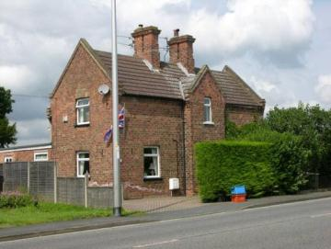

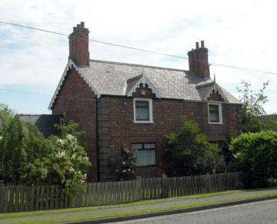
Name: Methodist Chapel, Bluestone Lane
Date Designated: N/A – New Proposal
Grid Reference: TA 1761 1437
Area Designation: None
Asset Type: Building
Main Criteria Used: 1c, 2g
Description:

Small single storey chapel in red brick with cream brick dressings. Welsh slate roof with doubled-modillions to the front facing gable.

An attractive building, now in use as a funeral parlour, an prominent due to its corner positions. Another important reminder of the former rural nature of the town.

A prominent building, given its position on a busy road, which represents an important part of the ecclesiastical functions of the village.

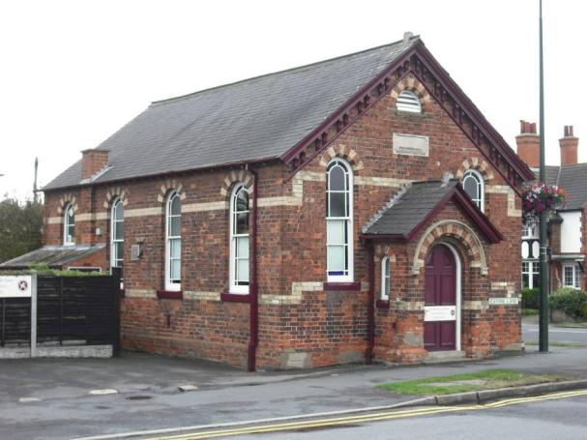

Name: Highfield Farm, Stallingborough Road, Immingham
Date Designated: N/A – New Proposal
Grid Reference: TA 1788 1386
Area Designation: None
Asset Type: Complex (Building and Archaeological Site)
Main Criteria Used: 1c, 2g
Description:

Shown on a photograph from the early 1970s as a two storey, three bay, brick farmhouse. Probably 18th century or early 19th with sliding sash windows throughout, 4/4 below segmental arches on the ground floor and 3/3 below flat arches on the first with a pantile roof, pedimented gables and end stacks. The only modern alteration appears to be a lean-to porch with corrugated iron roof. A later photograph (below) shows it in a slightly modified state with altered ground floor windows.

In addition the front garden contains a well defined earthwork, possibly a medieval building platform, surrounded by a relatively wide ditch which is considered part of the asset as it appears to have been deliberately incorporated into the garden of the house.

An important part of the former agricultural character of the town.

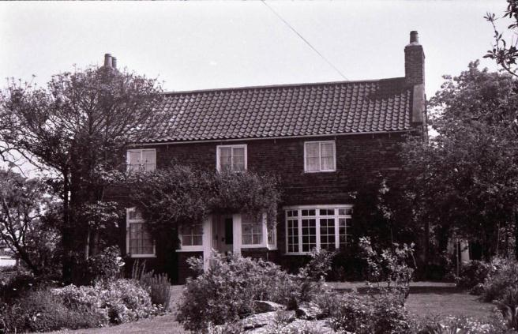

Name: Roxton Sidings Signal Box
Date Designated: N/A – New Proposal
Grid Reference: TA 1697 1286
Area Designation: None
Asset Type: Building
Main Criteria Used: 1c, 2b
Description:

Type 2 Manchester, Sheffield and Lincolnshire Railway signal box. Wood with slate roof and decorated bargeboards.
The box also contains a manual crank to open the level crossing gates.

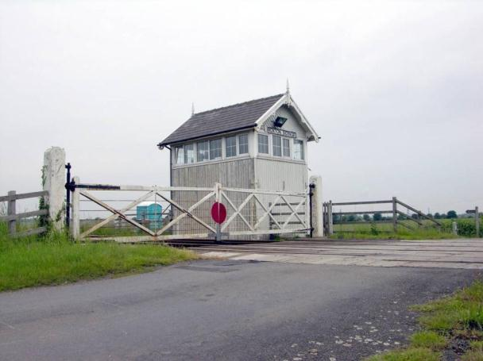

Name: Luxmore Farm, Habrough Road
Date Designated: N/A – New Proposal
Grid Reference: TA 1664 1431
Area Designation: None
Asset Type: Building
Main Criteria Used: 1c, 2g
Description:

A farmhouse and farmstead, probably mid to late 19th century. The main farmhouse is in red brick with yellow brick dressings, 3 bay with central projecting bay with gable flanked by gablets on the outer bays, all with decorated barge boards. Yellow brick quoins on the central projecting bay and outer corners. Slate roof with dark ridge tiles.
The farmstead was originally E shaped in plan but has lost one of the projecting ranges; otherwise it appears intact and in good condition judging from aerial photographs and the little that can be seen from the public highway. The central range has a gabled end facing the main entrance to the farm of three storeys with decorated barge boards and lantern style dovecote above. Ranges are in red brick with slate roofs.

A well preserved and designed example of an agricultural complex.

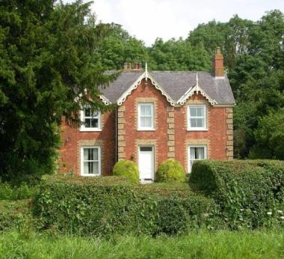

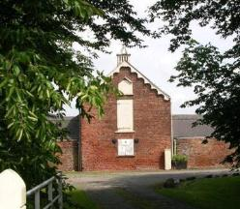
Name: Immingham Grange
Date Designated: N/A – New Proposal
Grid Reference: TA 16726 13351
Area Designation: None
Asset Type: Building
Main Criteria Used: 1c, 2g
Description:

A farmstead, probably 19th century, which consists of a large farmhouse and an E-shaped range of farm buildings. Most of the buildings shown on Ordnance Survey maps of 1887-9 are present.

This site has been surveyed from aerial photographs and maps only. It is assumed from this evidence that it is of at least local interest.

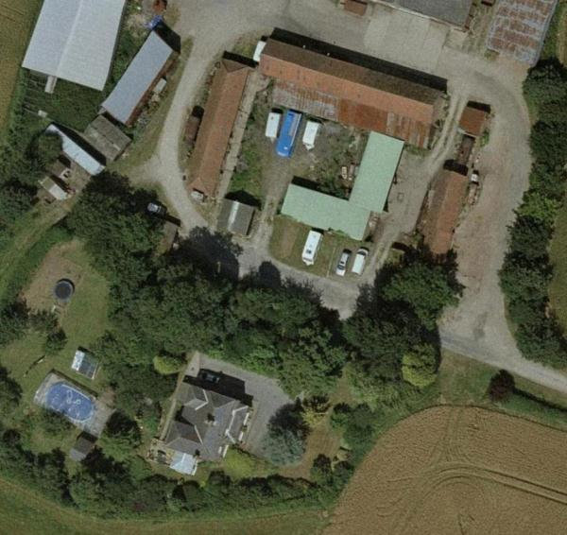
Image Taken in 2006
The GeoInformation Group Data ® copyright by The GeoInformation® Group, 2015

Name: Gatehouse Farm
Date Designated: N/A – New Proposal
Grid Reference: TA 17912 12701
Area Designation: None
Asset Type: Building
Main Criteria Used: 1c, 2g
Description:

A small farmhouse, originally part of a farmstead but now only the house survives. Two storeys in brick with a tiled roof, a catslide to the rear where it falls to a single storey, and ends stacks.

This site has been surveyed from aerial photographs and maps, and what can be seen from the distant public highway. It is assumed from this evidence that it is of at least local interest.

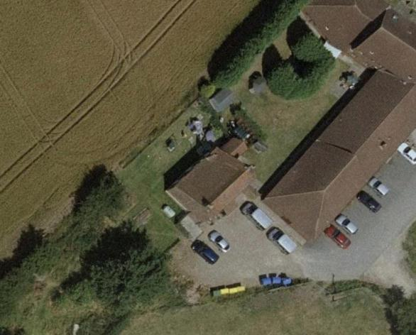
Image Taken in 2006
The GeoInformation Group Data ® copyright by The GeoInformation® Group, 2015

Name: Roxton Farm
Date Designated: N/A – New Proposal
Grid Reference: TA 16843 12529
Area Designation: None
Asset Type: Building
Main Criteria Used: 1c, 2g
Description:

A farmstead, probably 19th century, which consists of a farmhouse and an E-shaped range of farm buildings. Most of the buildings shown on Ordnance Survey maps of 1887-9 are present.

This site has been surveyed from aerial photographs and maps, and what can be seen from the public highway. It is assumed from this evidence that it is of at least local interest.

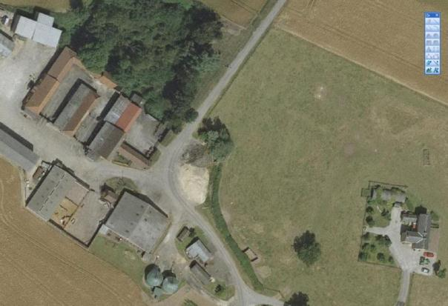
Image Taken in 2006
The GeoInformation Group Data ® copyright by The GeoInformation® Group, 2015

Name: Earthworks of medieval land drainage, possible salt making site and WW2 Anti Aircraft Battery in Immingham
Date Designated: N/A – New Proposal
Grid Reference: TA 1806 1555
Area Designation: None
Asset Type: Complex (Archaeological Site and Building)
Main Criteria Used: 1b, 2a
Description:

Earthworks apparently composed of drainage systems, trackways and enclosures. It formerly ran from the haven to the village. Works in 1994 found what appear to be waterlogged archaeological deposits which would be of very high importance. The site may be related to the salt industry which is known to have existed in Immingham area during the medieval period.

Also on the site is a magazine (ammunition store) or crew shelter building with earthen blast bank still surrounding, and an unidentified building, which were part of a World War 2 Heavy Anti Aircraft battery. The emplacements and command post may still be present under apparent dumped material. Medieval features may also survive under the World War 2 site.

Both sites are important parts of Immingham’s history and development.

See HER Numbers - 0526/0/1 and 0576/1/0 - for further information and sources

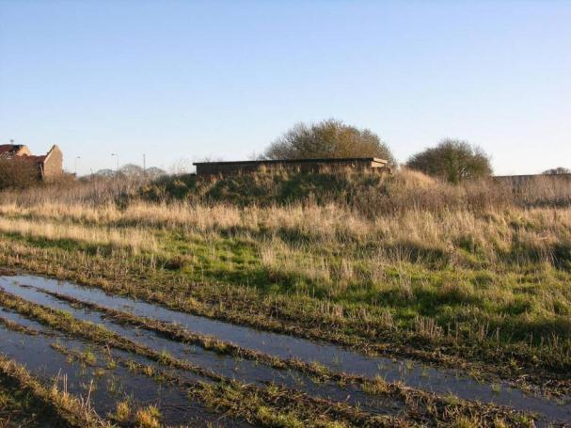
The Heavy Anti Aircraft Battery Magazine

Name: Possible Medieval Moated site 170m north west of Mauxhall Farm
Date Designated: N/A – New Proposal
Grid Reference: TA 1898 1334
Area Designation: None
Asset Type: Archaeological Site
Main Criteria Used: 1b, 2g
Description:

A site marked as "Moat and Islands" on an estate map. It has three sides and is c.100m square.

Loughlin N and K R Miller. 1979. A Survey of Archaeological Sites in Humberside. Humberside Libraries and Amenities. Hull.

The moat does have four sides, although the fourth is very much filled in. The northern pond type feature still contains water; early bricks and stones appear to have been thrown in from the field side. The platform is very small and shows no obvious signs of structures. The farmer has used the Eastern end for soaking large hay bales. The ditches are U-shaped and much wider than the drainage ditches that feed into them.

The site has a high potential to contain archaeological deposits which will contribute to the understanding of the previous landscape in the area. The site is quite unusual, moated sites are usually much larger, and so any archaeological deposits may be unique. It may also represent the remains of a much larger moated complex, as suggested by the plural “Islands” used on the estate map.
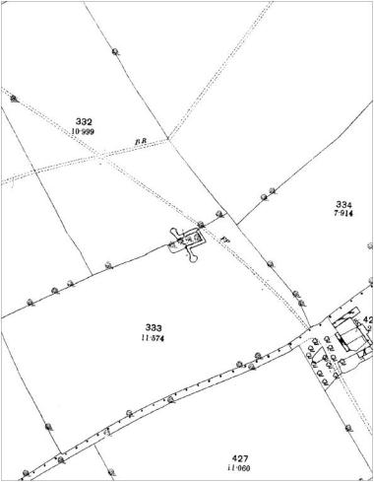
The moated site depicted on Ordnance Survey maps of 1887-9
Name: Shrunken medieval settlement earthworks at Immingham Golf Course
Date Designated: N/A – New Proposal
Grid Reference: TA 1746 1516
Area Designation: None
Asset Type: Archaeological Site
Main Criteria Used: 1b, 2a
Description:

These earthworks represent the northern edge of the medieval settlement of Immingham and are incorporated into the modern golf course. The earthworks include a small number of house platforms, small fields and trackways including an apparent sub-rectangular road system.

Although some of the earthworks have been mutilated by use of the site as a golf course, a significant amount are still intact and prominent. Those that have been altered are still likely to contain buried archaeological deposits of high significance to understanding the growth and development of the village.

See HER Number - 0526/0/0 - for further information and sources

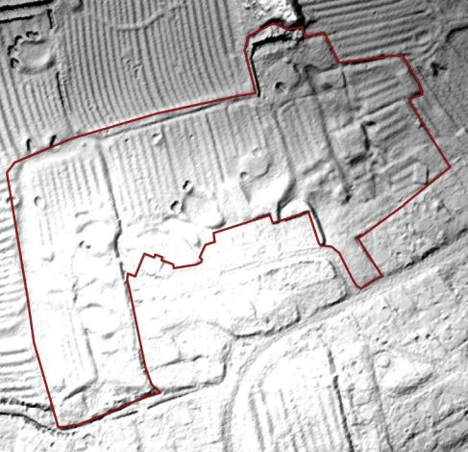
LIDAR image of the earthworks © Environment Agency 2015

Name: Roxton moated manorial site and shrunken medieval village earthworks
Date Designated: N/A – New Proposal
Grid Reference: TA 1689 1252
Area Designation: None
Asset Type: Archaeological Site
Main Criteria Used: 1b, 2g
Description:

A medieval moated manorial site, c.60x50 meters externally, with a deep partially waterlogged ditch, a single island and no signs of buildings. Adjacent to the site are the partial earthwork remains of the shrunken village/hamlet of Roxton, surrounding the 19th century farmhouse, maintained as pasture.

Both the Manorial and village parts of the site are likely to contain buried archaeological deposits of high significance to understanding the growth and development of the hamlet.

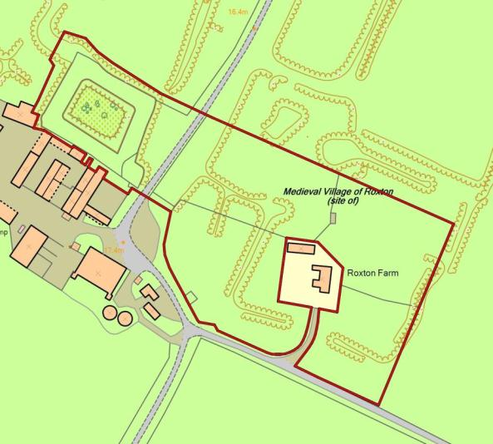
The earthworks at Roxton as mapped by the Ordnance Survey
(note that those outside of the red edge were levelled after the survey)
Reproduced from an Ordnance Survey map with the permission of the Controller of HMSO © Crown Copyright.
Licence number 100020759 North East Lincolnshire Council

Stallingborough

Stallingborough was the third largest settlement in Northern Lincolnshire at the time of Domesday (1086AD) behind Barton and Grimsby; during at least part of the medieval period it was large enough to support a regular market and fair.
Despite an apparent drop in population at the end of the medieval period, probably linked to the Black Death and climate change, the population had recovered enough in 1563 for the market and fair to be restarted.

Stallingborough is recorded as having a population of 516 in the 1851 census according to White's directory of 1856. In the 2001 census the population is recorded as 1,195.

At the time of writing – 2nd October 2015 – Stallingborough has:

141 Historic Environment Records of which:
8 are nationally Listed Buildings (one being a dual designation)
2 are nationally Scheduled Monuments (one being a dual designation)
25 are proposed Locally Listed Historic Assets

Name: Crosslands, 1 Church Lane
Date Designated: N/A – New Proposal
Grid Reference: TA 1976 1148
Area Designation: None
Asset Type: Building
Main Criteria Used: 1c, 2g
Description:

A large three bay, two storey, Edwardian villa in red/brown brick with rendered first floor and clay tile roof. Central semi-circular open porch supported on square columns with a flat roof and dentilled architrave, with shallow oriel window above. Door is glass panelled with transom light and side lights. Outer bays have two storey square section bay windows with multi-light hung sash and dentilled architraves.

A smart and handsome building. It probably represents the desire of business owners from nearby towns to live away from cramped urban conditions and so is a part of the social interaction between urban and rural areas.

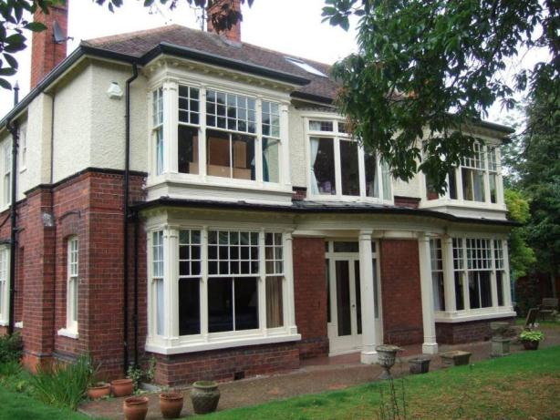

Name: Stallingborough Station House, 78 Station Road
Date Designated: N/A – New Proposal
Grid Reference: TA 2033 1159
Area Designation: None
Asset Type: Building
Main Criteria Used: 1c, 2b
Description:

Virtually identical, and probably built to the same pattern, as Great Coates Station House.
Rendered brown brick with stone dressings to windows. Welsh slate roof.

A key building in the village which gives some historic context to the shift in the centre of gravity of the settlement towards the railway, away from the parish church, in the 19th century.

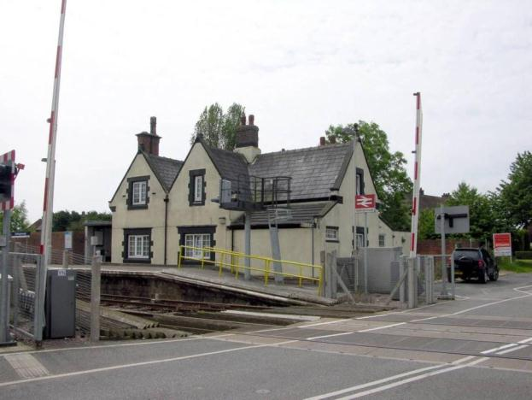

Name: Manor Farm House, 126 Station Road
Date Designated: N/A – New Proposal
Grid Reference: TA 2062 1184
Area Designation: None
Asset Type: Building
Main Criteria Used: 1c, 2g
Description:

An 18th or early 19th century farmhouse, three bays, two storeys. Painted brown brick with a slate roof, flat arched windows with small 2/2 vertical sash, multi-light door with transom light above, tumbling to side gable overbuilt to the front. The front elevation has been raised and chimneys replaced, probably in the late 19th or early 20th century.

Note – Not the actual “Manor House which was across the road.

A good quality, well preserved farmhouse, representative of the agricultural activities of the village.

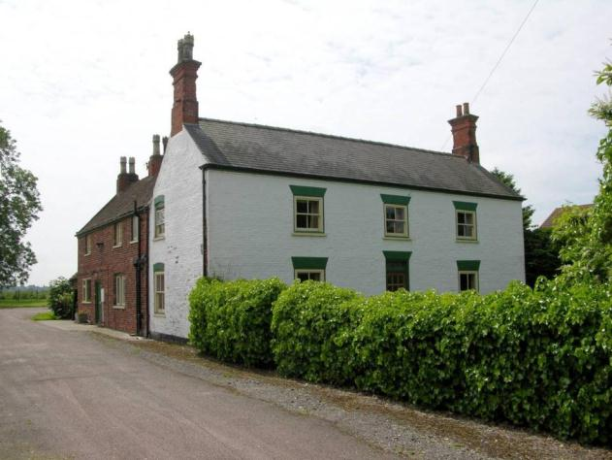

Name: Pidgeon Cote Farm House, 126 Station Road
Date Designated: N/A – New Proposal
Grid Reference: TA 2052 1181
Area Designation: None
Asset Type: Building
Main Criteria Used: 1c, 2g
Description:

Mid to late 19th century farmhouse, three bays, two storeys. Red brick with ashlar flat arches to the doors and windows, slate roof, bay windows to the outer ground floor bays with hipped roofs. Dwarf wall and iron railings to the front.

A good quality farmhouse with some surviving outbuildings, the most prominent of which being the large barn to the west. Representative of the agricultural activities of the village.

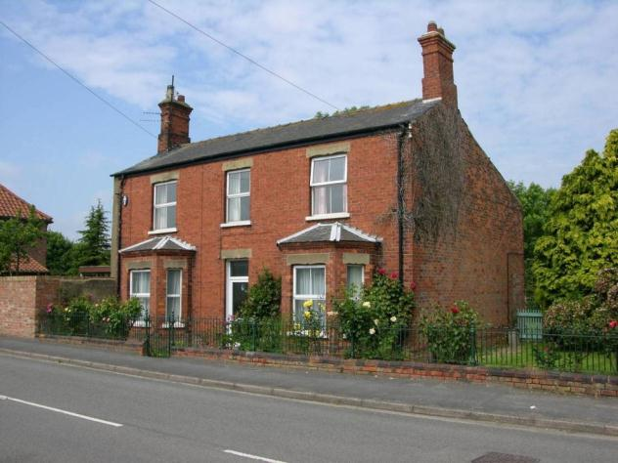

Name: Former Barn at Pidgeon Cote Farm House, Station Road
Date Designated: N/A – New Proposal
Grid Reference: TA 2051 1179
Area Designation: None
Asset Type: Building
Main Criteria Used: 1c, 2g
Description:

Long two storey barn to Pidgeon Cote Farm, possibly once attached to the very large Pigeon Cote which is present in several old photographs of this part of Stallingborough.
Brown brick with modern pantile roof, now converted into a school building.

There is a re-set sundial in the centre of the first floor wall which is dated to 1817. A prominent building, representative of the agricultural activities of the village.

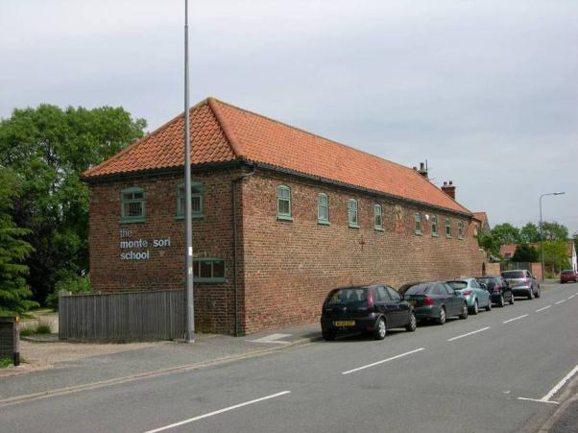

Name: Estate Cottages, 132 and 134 Station Road
Date Designated: N/A – New Proposal
Grid Reference: TA 2071 1192
Area Designation: None
Asset Type: Building
Main Criteria Used: 1c, 2g
Description:

A pair of semi detached estate cottages, early 20th century, two storey, brown brick with polychromatic brick dressings, clipped front gable, segmental arched windows, dentilled eaves course, diaper work between a string course and eaves course of the front gable..

The level of architectural detailing is quite high for a pair of estate cottages and makes up for the alterations such as the small extensions and replacement roofing materials. Representative of the agricultural and social activities of the village.

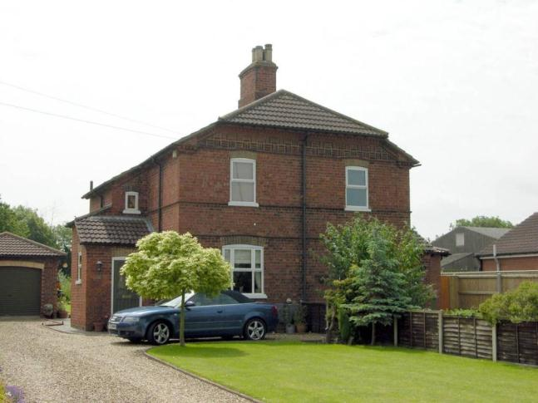

Name: Rose Cottage, 153 Station Road
Date Designated: N/A – New Proposal
Grid Reference: TA 2067 1194
Area Designation: None
Asset Type: Building
Main Criteria Used: 1c, 2g
Description:

18th or early 19th century cottage with side and rear extensions including an apparent doubling of the depth or the building. Three bays to the front with an off-centre doorway, windows and doors are flat arched, ground floor has 8/8 hung sash, first floor has 4/8.

Representative of the agricultural and social activities of the village.

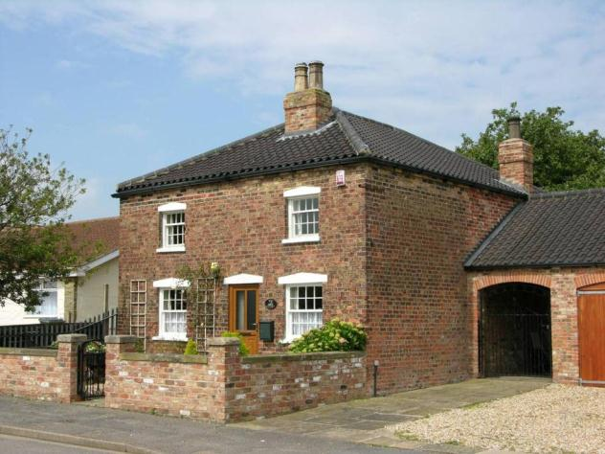

Name: Cast Iron Phone Box, Station Road
Date Designated: N/A – New Proposal
Grid Reference: TA 2023 1151
Area Designation: None
Asset Type: Building
Main Criteria Used: 1c, 2g
Description:

K6, or similar model, telephone kiosk. Cast iron. Square kiosk with domed roof. Un-perforated crowns to top panels and margin glazing to windows and door

Although once widespread, cast-iron phone boxes have become synonymous with historic and rural areas and are therefore important to the character of the villages.

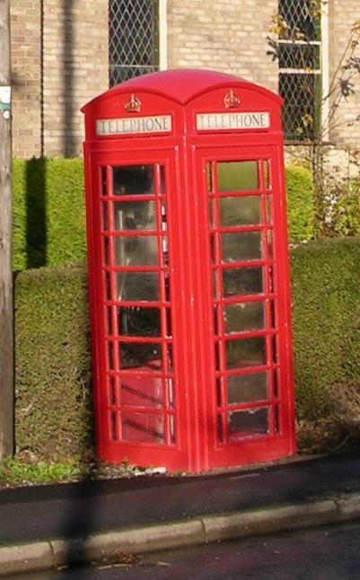

Name: Eleanor House
Date Designated: N/A – New Proposal
Grid Reference: TA 20999 12642
Area Designation: None
Asset Type: Building
Main Criteria Used: 1c, 2g
Description:

A farmhouse and outbuildings, probably 19th century. Possibly a linear farmsteads, or perhaps a subsidiary farmhouse to a larger estate.

This site has been surveyed from aerial photographs and maps. It is assumed from this evidence that it is of at least local interest.

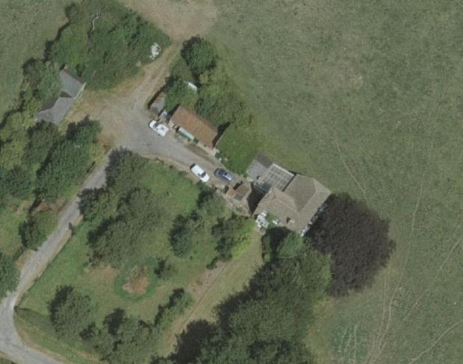
Image Taken in 2006
The GeoInformation Group Data ® copyright by The GeoInformation® Group, 2015

Name: Low Farm, Stallingborough
Date Designated: N/A – New Proposal
Grid Reference: TA 20036 11043
Area Designation: None
Asset Type: Building
Main Criteria Used: 1c, 2g
Description:

A farmstead, probably 19th century, which consists of a farmhouse and a range of farm buildings around a courtyard. Most of the buildings shown on Ordnance Survey maps of 1887-9 are present.

This site has been surveyed from aerial photographs and maps. It is assumed from this evidence that it is of at least local interest.

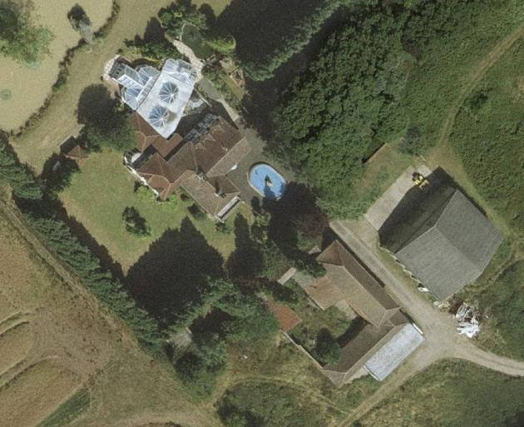
Image Taken in 2006
The GeoInformation Group Data ® copyright by The GeoInformation® Group, 2015

Name: Mauxhall Farm, Stallingborough
Date Designated: N/A – New Proposal
Grid Reference: TA 1917 1324
Area Designation: None
Asset Type: Building
Main Criteria Used: 1c, 2g
Description:

A farmstead, probably 19th century, which consists of a range of farm buildings. Most of the buildings shown on Ordnance Survey maps of 1887-9 appear to be present.

This site has been surveyed from aerial photographs and maps. It is assumed from this evidence that it is of at least local interest.

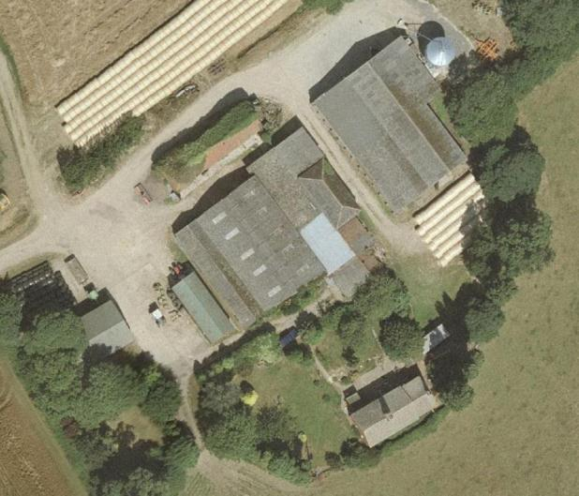
Image Taken in 2006
The GeoInformation Group Data ® copyright by The GeoInformation® Group, 2015

Name: Little London Farm
Date Designated: N/A – New Proposal
Grid Reference: TA 1881 1187
Area Designation: None
Asset Type: Building
Main Criteria Used: 1c, 2g
Description:

A very large three storey farmhouse, eight bays wide and built in phases, facing the fields to the rear and now converted into a public house. The scale would suggest that this was not just a farmhouse and may have also been an inn. Of the courtyard to the north only two buildings survive or a large complex.

Although the farmhouse has had many alterations, and very little of the courtyard survives, the unusual scale of the main building is of local interest and sufficient fabric survives for it to be considered for the local list.

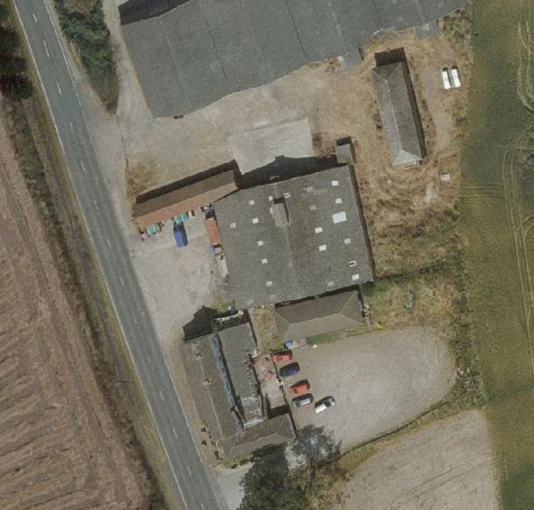
Image Taken in 2006
The GeoInformation Group Data ® copyright by The GeoInformation® Group, 2015

Name: Mill Farm, Stallingborough
Date Designated: N/A – New Proposal
Grid Reference: TA 1920 1074
Area Designation: None
Asset Type: Building
Main Criteria Used: 1c, 2g
Description:

A farmstead, probably 19th century, which consists of a C-shaped range of farm buildings around a courtyard. Most of the farmyard buildings shown on Ordnance Survey maps of 1887-9 appear to be present, but it is not clear if the farmhouse is original or a rebuild.

This site has been surveyed from aerial photographs and maps. It is assumed from this evidence that it is of at least local interest.

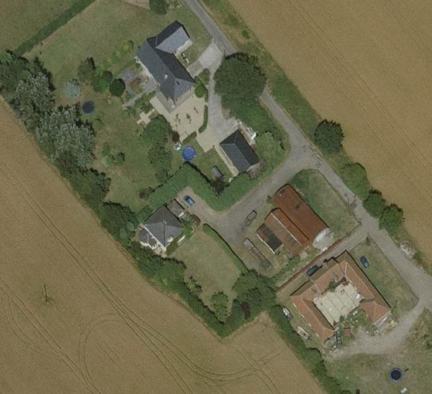
Image Taken in 2006
The GeoInformation Group Data ® copyright by The GeoInformation® Group, 2015

Archaeological Sites in Stallingborough

If any of the parishes in North East Lincolnshire had to be chosen as the most archaeologically interesting, Stallingborough would be an easy choice. Although Great Grimsby contains medieval deposits of greater significance, the range of sites in Stallingborough and the density of pre-medieval occupation are truly remarkable.

At the centre of the village is the scheduled monument known as “Stallingborough medieval settlement, post-medieval manor house and formal gardens” which contains significant archaeological remains. These remains extend beyond the scheduled area, potentially covering more than 80 hectares (200 acres). In addition to this the parish contains over a dozen sites represented by cropmarks, artefact scatters and excavated sites, most of which date to the late Iron Age and early Roman period although Saxon period remains have also been found within the village core. The settlement is therefore the most likely in the Borough to produce, in the near future, a continuous story of occupation from the late prehistoric to modern times.

From 1990 until May 2014 thirty archaeological surveys have been carried out, although several of these are different phases of works on the same site, and so the parish remains relatively poorly surveyed, making the number of identified sites even more significant.

The following sites have been selected as the most likely, of those so far identified, to contain significant archaeological deposits. It is however important to realise that more sites are likely to be found as the industrial areas of the South Humber Bank continue to development, instigating further archaeological surveys and excavations.

Name: Cropmark Enclosure between South Marsh Road, Hobson Way and Middle Drain, Stallingborough
Date Designated: N/A – New Proposal
Grid Reference: TA 2247 1356
Area Designation: None
Asset Type: Archaeological Site
Main Criteria Used: 1b, 2a
Description:

A cropmark of enclosures and a ditch of unknown date, but potentially prehistoric or Roman, shown on multiple aerial photographs.

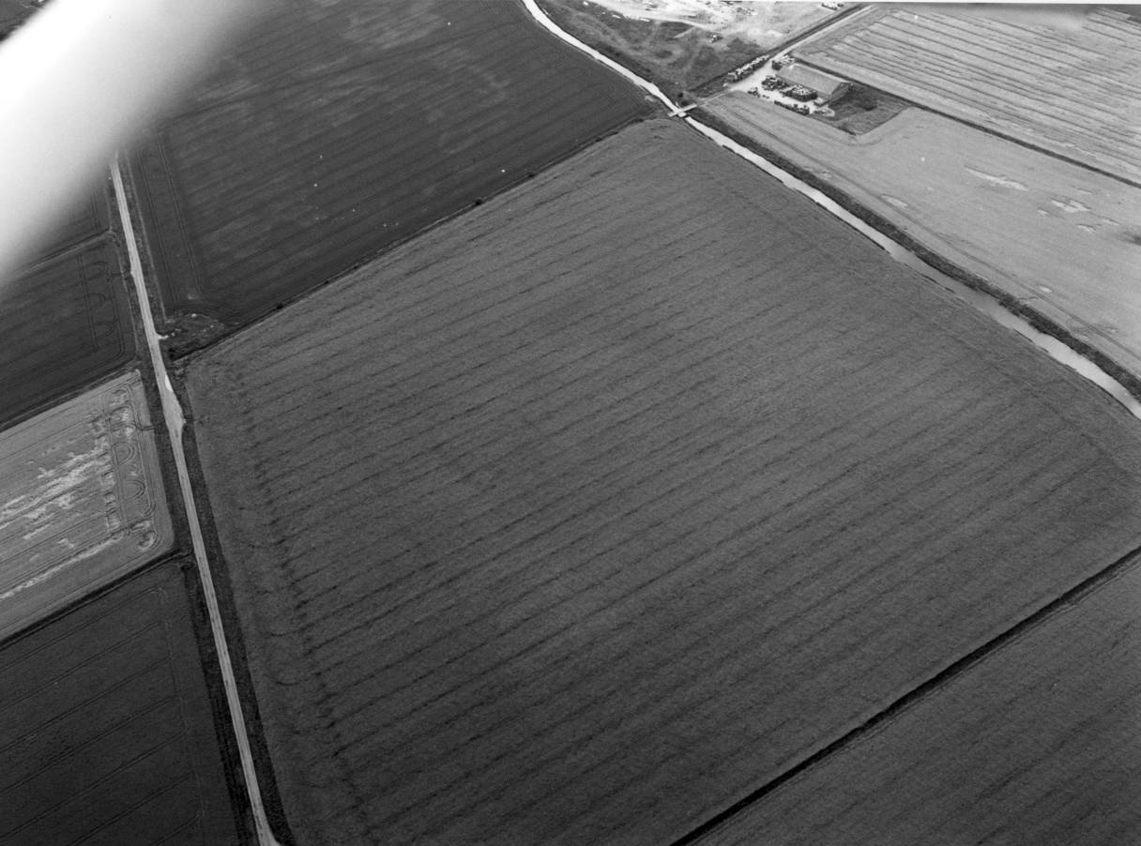
© Humber Archaeological Partnership 1991

Name: Cropmark enclosures 800m north east of Low Farm in Stallingborough
Date Designated: N/A – New Proposal
Grid Reference: TA 2081 1123
Area Designation: None
Asset Type: Archaeological Site
Main Criteria Used: 1b, 2a
Description:

Aerial photographs show a number of enclosures with other ditches and also small sub-rectangular features. Most of the features are too faint to map in detail.

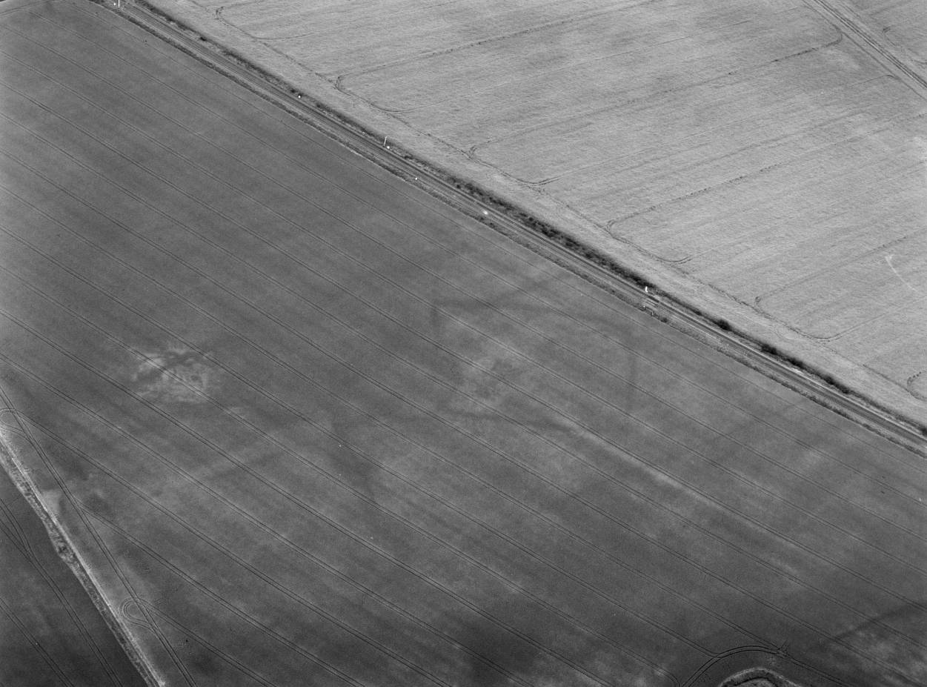
© Humber Archaeological Partnership 1991

Name: Cropmark enclosures and trackways south of Eleanor House in Stallingborough
Date Designated: N/A – New Proposal
Grid Reference: TA 2084 1239
Area Designation: None
Asset Type: Archaeological Site
Main Criteria Used: 1b, 2a
Description:

Soilmarks South of Eleanor house made up of a group of 2 or more rectangular enclosures and other features that are probably associated with drainage.

Partial excavation in 1996 found the site to be comprised of a mixture of redundant/infilled drainage ditches, waste pits/dumps associated with the nearby brick works and stratified archaeological deposits relating to ditches of unknown date and function. The features which appear to relate to the main soil/crop mark are three or four major re-cuts of a large ditch, the last being c.3m wide and 1.45m deep, U shaped profile (although the trench was cut on a skewed angle, so it may actually be V shaped). One of the earlier phases appears to have a cleaning-slot in the base. None of the lower fills produced any dateable material.

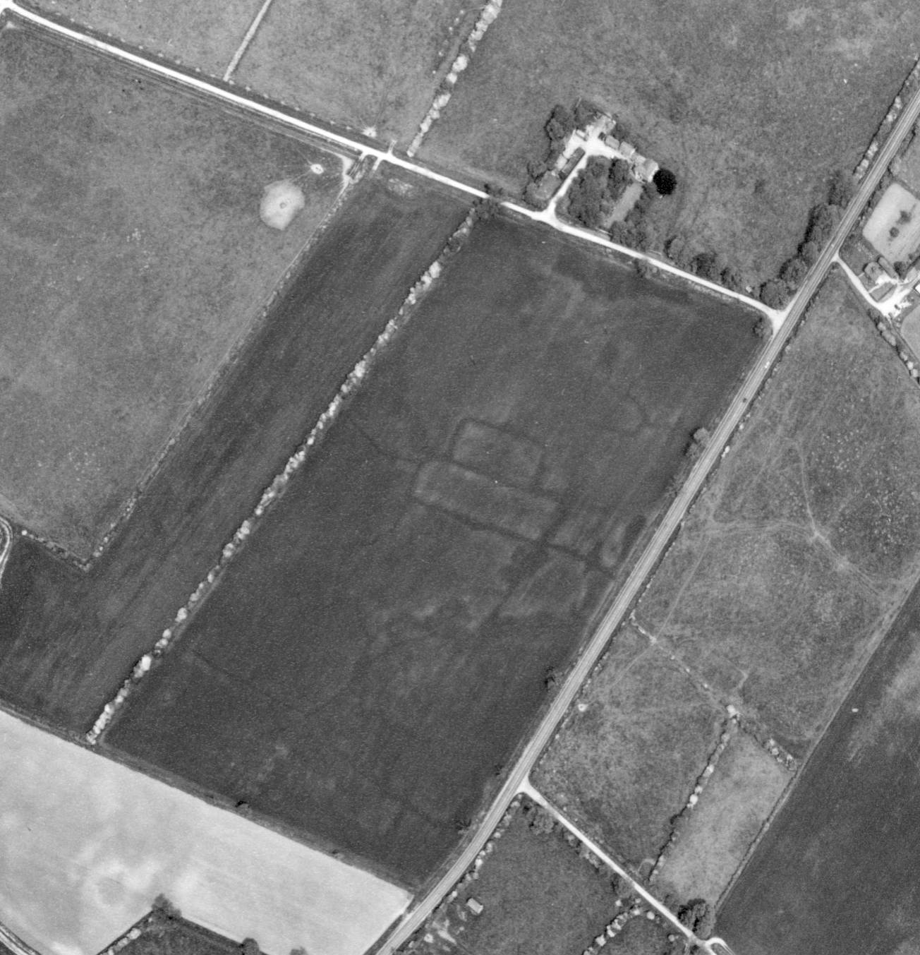
Print Copyright Humberside County Council and Meridian Airmaps Ltd 1976
Digital Scan Copyright North East Lincolnshire Council 2015

Name: Cropmark enclosures 1200m south east of Stallingborough Top Farm
Date Designated: N/A – New Proposal
Grid Reference: TA 1769 0963
Area Designation: None
Asset Type: Archaeological Site
Main Criteria Used: 1b, 2a
Description:

Probable Prehistoric or Roman enclosures were seen as cropmarks and mapped from good quality air photographs. An incomplete, asymmetric, rectilinear ditched enclosure, measuring 60m by 30m, is centred at TA 1771 0961. Two sides of another possible enclosure, 70m long, is centred at TA 1769 0965 (National Monuments Record: TA 10 NE 28).

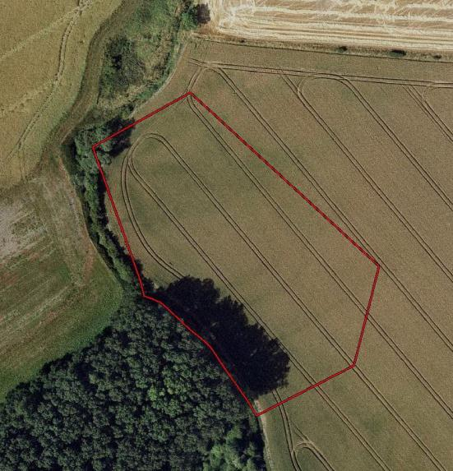
Image Taken in 2006
The GeoInformation Group Data ® copyright by The GeoInformation® Group, 2015

Name: Cropmark enclosures 400m south of Stallingborough Top Farm
Date Designated: N/A – New Proposal
Grid Reference: TA 1745 1031
Area Designation: None
Asset Type: Archaeological Site
Main Criteria Used: 1b, 2a
Description:

Probable Prehistoric or Roman conjoined enclosures were seen as cropmarks and mapped from good quality air photographs. Three conjoined enclosures, measuring on average 60m by 40m are centred at TA 1744 1031. One side of the enclosures extends east for 110m. Attached to the enclosures is a possible fourth, partially visible, conjoined enclosure with breadth of 20m (National Monuments Record: TA 11 SE 21).

Note – the site straddles the boundary with West Lindsey, however only the NE Lincs section is covered by the local designation.

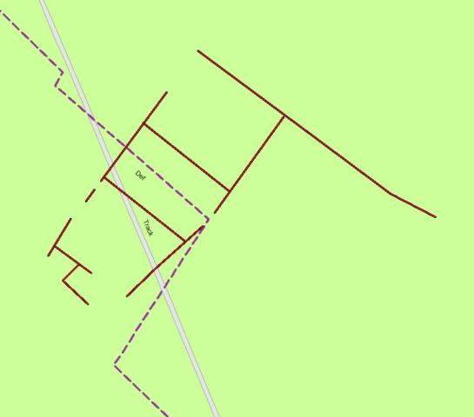
Plot of the Cropmark, as mapped by the RCHME
Reproduced from an Ordnance Survey map with the permission of the Controller of HMSO © Crown Copyright.
Licence number 100020759 North East Lincolnshire Council

Name: Cropmark enclosures 490m north of Wells House, Stallingborough
Date Designated: N/A – New Proposal
Grid Reference: TA 1986 1022
Area Designation: None
Asset Type: Archaeological Site
Main Criteria Used: 1b, 2a
Description:

Faint and partial cropmarks of a possible pair of enclosures measuring roughly 50mx70m.

Part of a group of cropmarks of probable Prehistoric or Roman date in the immediate area.

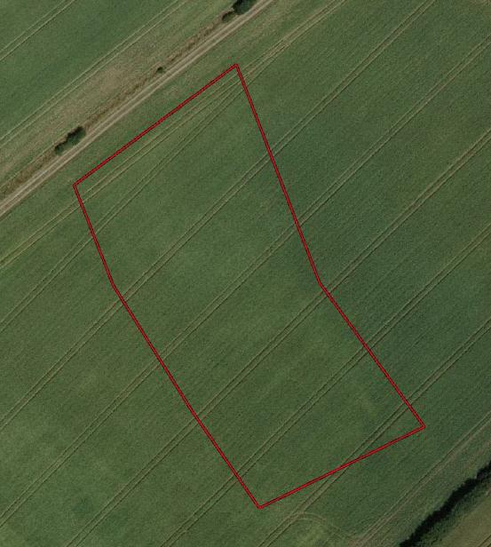
Image Taken in 2006
The GeoInformation Group Data ® copyright by The GeoInformation® Group, 2015

Name: Roman Enclosures south east of Greenlands Farm, Stallingborough
Date Designated: N/A – New Proposal
Grid Reference: TA 1811 1142
Area Designation: None
Asset Type: Archaeological Site
Main Criteria Used: 1b, 2a
Description:

Newly discovered Roman site with 2nd to 3rd century Roman wares and very limited evidence for mid 5th to mid 9th early medieval occupation. An initial evaluation of the site has been completed.

See HER Number - 0894/1/0 - for further information and sources

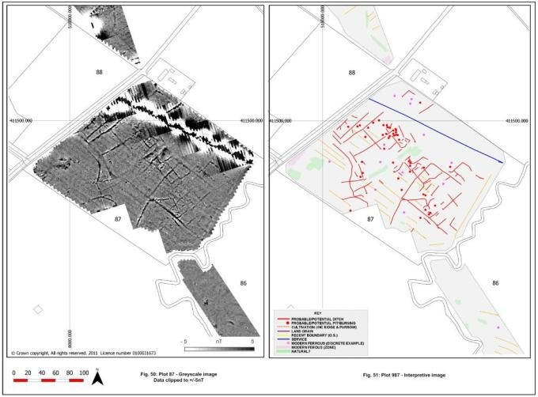
Geophysical Results © Pre-Construct Geophysics and RPS Planning and Development 2011

Name: Probable Roman Enclosure 225m north east of The Old Farmhouse, Stallingborough
Date Designated: N/A – New Proposal
Grid Reference: TA 1898 1203
Area Designation: None
Asset Type: Archaeological Site
Main Criteria Used: 1b, 2a
Description:

A complex cropmark, possible associated or overlaid by medieval field divisions, shown on aerial photographs from 2006. The cropmark appears to comprise of a sub-rectangular enclosure with numerous internal features.

The cropmark does not appear to correspond to any of the medieval field boundaries shown on oblique aerial photographs and so is likely to relate to a pre-medieval site.

See HER Number - 0836/1/0 - for further information and sources

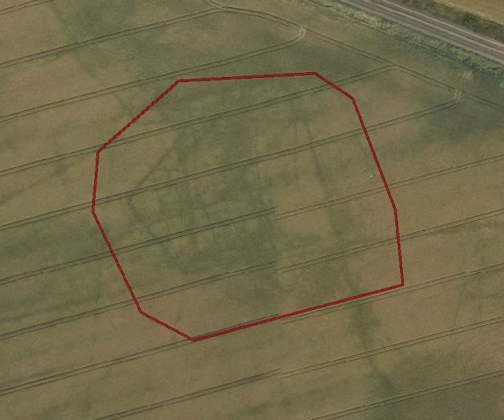
Image Taken in 2006
The GeoInformation Group Data ® copyright by The GeoInformation® Group, 2015

Name: Stallingborough medieval settlement earthworks
Date Designated: N/A – New Proposal
Grid Reference: TA 1972 1174 and TA 1962 1144
Area Designation: None
Asset Type: Archaeological Site
Main Criteria Used: 1b, 2a
Description:

Two areas of earthworks related to the medieval and post medieval shrunken settlement. These areas are directly adjacent to, but thought to be of lesser significance to, the Scheduled Monument known as “Stallingborough medieval settlement, post-medieval manor house and formal gardens”.

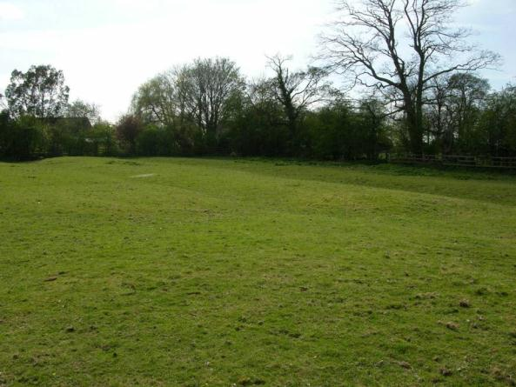
An earthwork of unknown origin east of the Scheduled Area

Name: Possible Deserted Settlement near Mauxhall Farm
Date Designated: N/A – New Proposal
Grid Reference: TA 1938 1328
Area Designation: None
Asset Type: Archaeological Site
Main Criteria Used: 1b, 2a
Description:

Earthworks indicating trackways and drainage works, ridge and furrow earthworks, and possible building platforms.

This may represent a small hamlet or outlying settlement to Stallingborough, or be related to the salt making industry given its location on the former edge of dry land adjacent to the parish’s main watercourse. The ridge and furrow is significant as one of the Borough’s largest surviving areas of this type of earthwork.

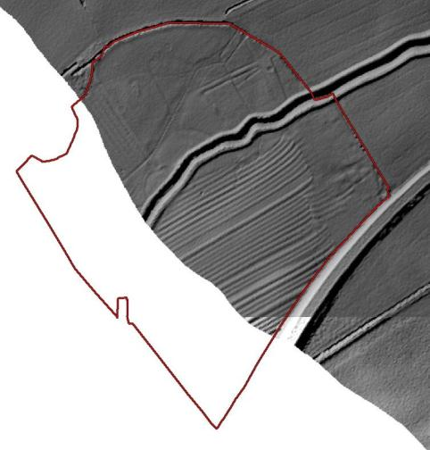
Partial LIDAR image of the site © Environment Agency 2015

Name: Stallingborough medieval settlement cropmarks
Date Designated: N/A – New Proposal
Grid Reference: TA 1919 1159
Area Designation: None
Asset Type: Archaeological Site
Main Criteria Used: 1b, 2a
Description:

A large area of cropmarks related to the medieval and post medieval shrunken settlement. These areas are directly adjacent to, but thought to be of lesser significance to, the Scheduled Monument known as “Stallingborough medieval settlement, post-medieval manor house and formal gardens”. Although a much wider area is known to produce cropmarks relating to the village, this area appears to contain the densest group of features and therefore is most likely to contain significant archaeological deposits.

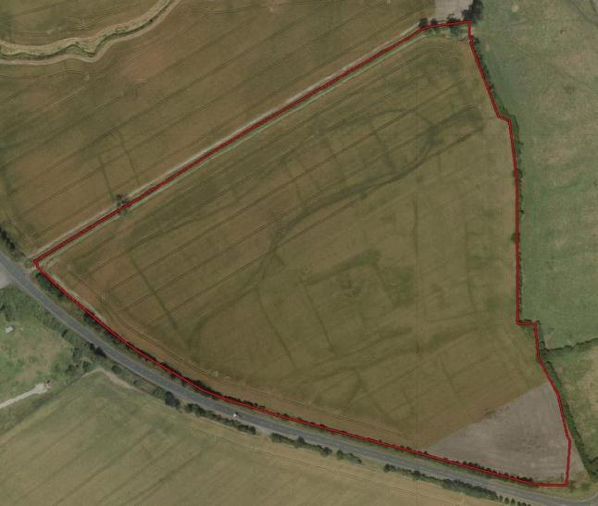
Image Taken in 2006
The GeoInformation Group Data ® copyright by The GeoInformation® Group, 2015

