Local List of Historic Assets of Special Interest
An extension of the Historic Environment Record (HER) for North East Lincolnshire

Cleethorpes

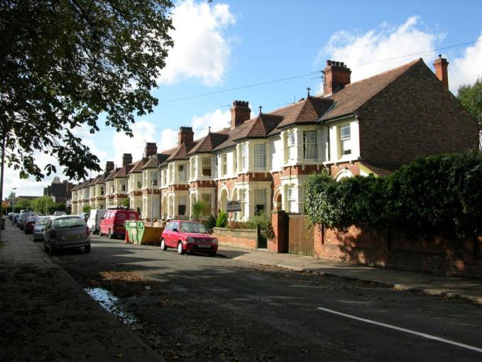

Adopted 10th June 2013
Minor Amendment 16th September 2015

Contents

Introduction: 1
A Note on Sources 1
Criteria for Listing 2
Basic Requirements for Assets 2
Cleethorpes 3
Albert Road 4
Alexandra Road 6
Balmoral Road 13
Beacon Avenue 14
Bradford Avenue 17
Brereton Avenue 22
Brooklands Avenue 24
Bursar Street 25
Central and North Promenade 26
Clee Road 29
Coronation Road 33
Elm Road 34
Grant Street 35
Grimsby Road 36
Hart Street 39
Highgate 40
High Street 42
Intertidal Foreshore 43
Isacc’s Hill 46
King’s Road 48
Kingsway 50
Mill Road 51
Oxford Street 64
Pelham Road 67
Prince’s Road 68
Reynolds Street 69
St Peter’s Avenue 70
Sea View Street 73
Taylor’s Avenue 82
Thrunscoe Road 83
Yarra Road 84

Introduction:

This Local List of Historic Assets of Special Interest has been compiled in order to act as a planning tool. The entries within the list are the historic assets taken from the North East Lincolnshire Historic Environment Record (HER), which require due consideration from property owners, developers and planning officers, during the development and planning process.

Heritage assets are usually included in the list because they are the best of their kind within a local authority area. Other assets are included because of the contribution that they make to the character of the local area.

By their very nature, buildings will make up the bulk of the list as they are the most visible of the historic assets and contribute greatly to the character of an area. Conversely, archaeological sites will be greatly under-represented on the list due to the difficulty in establishing the nature and extent of any individual assets without first excavating, particularly within the urban environment. Designed Landscapes, pieces of art and other assets are low in overall number and so will make up a minor part of the list; they are also the least likely to be affected by development.

A Note on Sources

The majority of the text in this document has been produced from scratch by staff in the Historic Environment Record. Where text has come from a single external source, every effort has been made to show that source in the text; however, the information on some assets, particularly archaeological sites, has been compiled from numerous sources and it would not be appropriate to list them all in a document such as this. In these cases, the reader is directed to the appropriate Historic Environment Record entries for further information and a list of the sources used to compile the information.

Criteria for Listing

General:
1a – The asset is rare or unique, in terms of the Borough, due to the period it represents, extent, architectural style or technological method of construction.
1b – The asset has the potential to contribute to our information on, understanding of, and appreciation of the Borough’s history and development.
1c – The asset makes a significant contribution to the historic character of an area and conforms to a Thematic criteria.
1d – The asset is part of a group of similar examples which, together, make a significant contribution to the character of an area or have the potential to provide high quality and/or quantity of historic environment data.

Thematic:
2a – Assets which exemplify a previous character type in a settlement or area which retain sufficient structure to inform on the previous character.
2b – Assets which are/were essential infrastructure associated with the Docks and Railways that retain a good proportion of their original extent.
2c – Assets which form an integral part of the character of the Resort of Cleethorpes.
2d – Assets which exemplify the rapid expansion, wealth or the major industrial and commercial activities of Grimsby in the 19th and early 20th centuries.
2e – Assets which exemplify the early development of Immingham and Cleethorpes from Villages and/or Hamlets into Towns.
2f – Post 1850s Urban Housing that retains the majority of its original structure, components and is of a high standard of design.
2g – Ecclesiastical, Manorial, Educational, Social and Agricultural assets representing the historic functions and practices of the towns and villages.

Basic Requirements for Assets
Buildings must retain the majority of their original fabric, external design style and character.
Archaeological Sites must be definable in extent and origin and be likely to retain well preserved deposits.
Designed Landscapes must be identifiable through aerial photography and at ground level. They must also be significant features in the wider landscape.
Ship Wrecks and Historic Ships must relate to the main industries of the Borough or form a group or loose association of assets.
Memorials must commemorate events of national or significant local significance and be of architectural or artistic interest.
Complex Assets are not a category in their own right, but rather contain two or more assets of the above categories that should be considered interdependent on each other.

Cleethorpes

Cleethorpes developed as a town in the 19th and 20th centuries from three hamlets within the parish of Clee. The three hamlets were Hole (or Hoole or Oole), Itterby and Thrunscoe.

Hole, the westernmost hamlet, is represented by Market Street and High Street. This hamlet does not appear to have been mentioned in Domesday.

Itterby is represented by the area around Seaview Street and Humber Street, is mentioned in the Domesday Book and so is known to have existed since the early medieval period (410AD to 1066AD). There is also a medieval chapel of ease recorded at Itterby which paid Tithe to Wellow Abbey.

Thrunscoe occupied land to the east of the modern Hardy’s Road lying roughly between Cromwell Road and Chichester Road. Thrunscoe is also mentioned in Domesday and so is known to have existed since the early medieval period (410AD to 1066AD).

With the construction of the railway and station in 1863 the villages were developed by the railway company into a resort town for the urban communities connected to the other end of the line. Most of the historic assets within the town are from this period of expansion and are directly related in some way to the railway and resort.

At the time of writing – 11th June 2013 – Cleethorpes has:

297 Historic Environment Records of which:
26 are nationally Listed Buildings
1 is a nationally Scheduled Monument
74 are Locally Listed Historic Assets

Albert Road

Name: Former Albert Road Surgery, 32 Albert Road
Date Designated: 10/06/2013
Grid Reference: TA 3063 0870
Area Designation: Central Seafront Conservation Area
Asset Type: Building
Main Criteria Used: 1c, 2c
Description:

Former house and doctor’s surgery. Three storeys with the main elevation facing north east towards the sea.

Front elevation is of 4 bays with an off-centre entrance to the right and semi-hexagonal bay windows on the ground floor outer bays. First floor has segmental arched windows with brick surrounds; second floor has flat arched windows with brick surrounds.
Secondary frontage, facing Albert Road, is of 2 blocks of 3 bays. Block to the right is of the same height as the primary frontage; ground floor has two blind windows flanking an elaborate entrance in a similar style to the bays on the primary frontage. First floor has segmental arched windows, second floor has flat arched windows and brick surrounds. Stone string courses separate each floor.

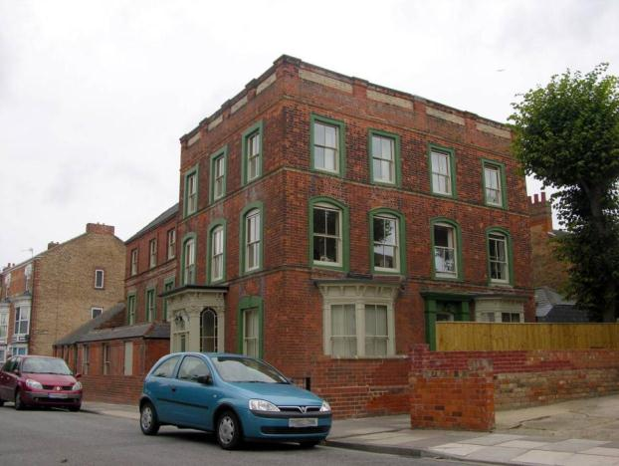

Rear wing, although also 3 storey, is significantly shorter than the main building. Ground floor has extensions of varying ages, first and second floor have brick, flat arched, surrounds. Two brick string courses below the second floor windows, one incorporating the sills.

Overall a particularly impressive building, despite alterations, that is important to the character of the resort.

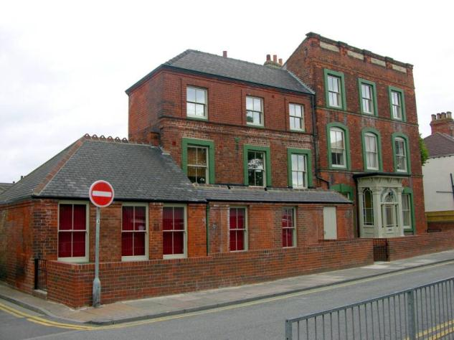

Alexandra Road

Name: Cleethorpes Baptist Church
Date Designated: 10/06/2013
Grid Reference: TA 3079 0867
Area Designation: Central Seafront Conservation Area
Asset Type: Building
Main Criteria Used: 1c, 2e
Description:

Baptist chapel of 1927, re-using the date stone of an earlier church, with the organ and pulpit coming from the Zion Baptist church in Grimsby. Built to replace a chapel of 1910 which was destroyed during a Zeppelin Raid on the 1st April 1916. At the time of the raid the church was used for the billeting of soldiers from the Manchester Regiment, around 30 of whom were killed.

Single storey with flat arched clerestory windows along the flanks of the building and segmental arched windows containing detailed stained glass in the gables. Slate roofed.
Interior retains moulded barrelled ceiling, moulded dado rail and coving, large organ and pulpit, altar and railings.

A very well preserved chapel disguised by the modern pre-fabricated church hall to the front that is an indicator of the early development of the town

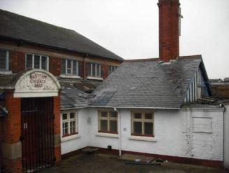

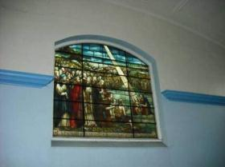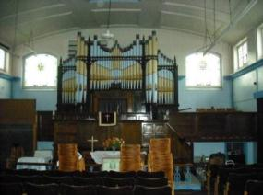

Name: The Dolphin Hotel
Date Designated: 10/06/2013
Grid Reference: TA 3062 0891
Area Designation: Central Seafront Conservation Area
Asset Type: Building
Main Criteria Used: 1c, 2c
Description:

Three storey hotel of at least two closely spaced build periods.

Main elevation, to Alexandra Road, is of three sections.
Right wing is single storey, 6 bays of recessed panels with dentilled tops.
Central section, which is probably the oldest, is of 5 bays with the central blind except for the second floor.
The left wing is of 2 bays to Alexandra Road and continues to 8 bays fronting onto Market Street. The original floor level is lower than that of the older wing allowing the ground and first floors to be set lower and an increase of the height of the second floor whilst retaining the same roof height.
Although probably the secondary frontage, or at least the second to be built, the Market Street elevation forms the most coherent façade.
A central section of four bays, reaching 3 storeys including a mansard roof, is flanked by 2 bay blocks. Above the first and second storeys are decorative blue brick courses and each flanking block continues the dentilled eaves from the Alexandra Road frontage. The second floor, formed by the Mansard, contains triangular arched dormers in a slate roof containing 2/2 hung sash.
The south west façade which would have faced a side street is of 4 bays.
The rear elevations have irregular fenestration reflecting the multiple build periods.

An important building to Cleethorpes in terms of both history and the character of the resort.

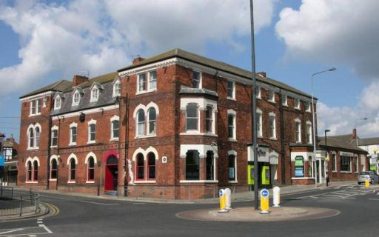

Name: 21 to 24 Alexandra Road
Date Designated: 10/06/2013
Grid Reference: TA 3081 0870
Area Designation: Central Seafront Conservation Area
Asset Type: Building
Main Criteria Used: 1c, 2c
Description:

A group of 5 balconied 3 storey terraced buildings facing the sea.
Each property is a single bay with shop fronts on the ground floor with the balcony above forming an arcade, and two storey bay windows with gablets (now lost). No original bay windows or upper fenestration survives and only a handful of features from the shop fronts are intact. The ground floor to number 23 is historically open, with glazed walls, to form a passageway both to the rear of 21-24 and also a set of small buildings, probably workshops, that have since been replaced by a large car repair centre.

The worst preserved of the balconied terraces, with significant loss of original features, the buildings are added for their group value with the other balconied terraces on Alexandra Road.

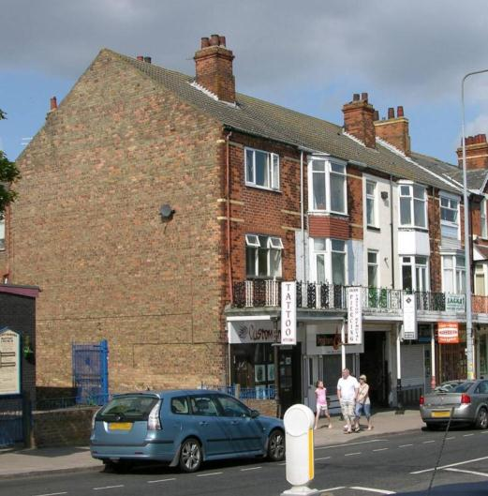

Name: 25 to 27 Alexandra Road
Date Designated: 10/06/2013
Grid Reference: TA 3079 0871
Area Designation: Central Seafront Conservation Area
Asset Type: Building
Main Criteria Used: 1c, 2c
Description:

A group of 3 balconied 3 storey terraces facing the sea with a two storey house to the rear in matching architecture.
Each property is of two bays with shop fronts on the ground floor, the balcony above forming an arcade, and bay windows originally on first floor level in alternate bays with doors in the other. The second storey has façade dormers containing two windows within the single bay with the alternate bays blind.
Many of the original timber windows survive along with at least one bay and many of the unusual Art Deco style dripmoulds are intact above the windows and doorways.

Probably the best preserved of the balconied terraces with the exception of the listed buildings. Number 27 retains much of its original fenestration and despite the additions of roller shutters the shop front is reasonably intact. An important building to the character of the resort.

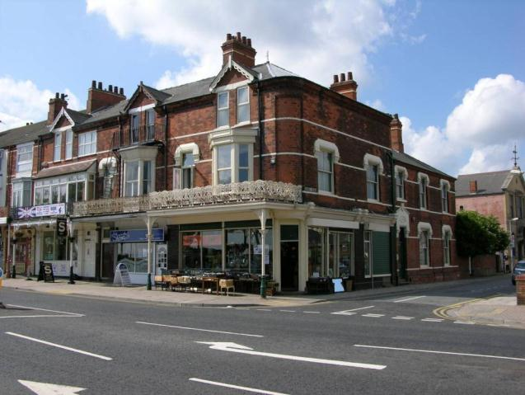

Name: 30 to 35 Alexandra Road
Date Designated: 10/06/2013
Grid Reference: TA 3073 0878
Area Designation: Central Seafront Conservation Area
Asset Type: Building
Main Criteria Used: 1c, 2c
Description:

A group of 6 balconied 3 storey terraces facing the sea.
Each property is of two bays with shop fronts on the ground floor, the balcony above forming an arcade, and bay windows and doors on first floor level in alternate pattern to the neighbour. The second storey has single segmental arched windows to each bay.

Despite alterations the building makes an important contribution to the character of the resort.

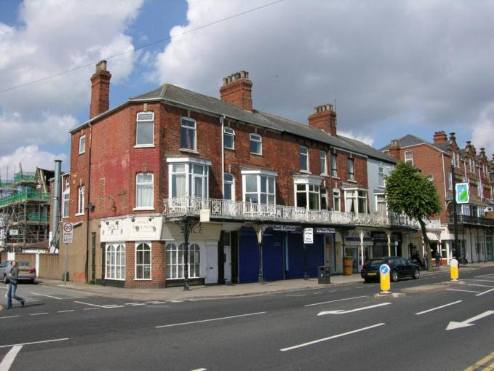

Name: 36 to 40 Alexandra Road
Date Designated: 10/06/2013
Grid Reference: TA 3071 0881
Area Designation: Central Seafront Conservation Area
Asset Type: Building
Main Criteria Used: 1c, 2c
Description:

A group of 5 balconied 4 storey terraces facing the sea, design by Ernest E. Bentley of Grimsby.
Each property is of four bays with shop fronts on the ground floor, the balcony above forming an arcade, and bay windows on first floor level taking up both central bays., the flanking bays being blind at this level.
The second storey has blind central bays and segmental arched windows to the outer bays with stone keystones and sills.
The third floor has a pair of flat arched windows under gablets in the central two bays with decorative surrounds and blind outer bays.
The shop in Number 36 retains a curved glass shop front and along with number 37 has its original entrance to the flats above which matches the shop front to number 37.
Numbers 36 and 37 have inserted windows at first floor level and the bay windows have been replaced by modern bay windows with a roof running along both frontages from the tops of the bay windows.
Numbers 39 and 40 have also lost their bay windows and have been rendered at first floor level.
This row represents the highest level of architectural detail of the seafront terraces and is the only block to reach 4 storeys. It therefore makes a significant impact upon the character of the resort.

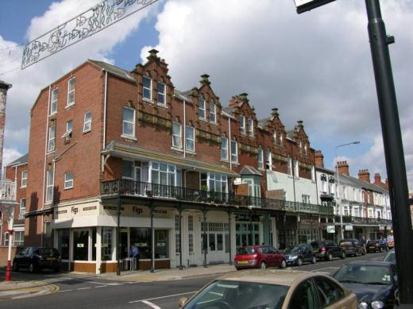

Name: 46 to 47 Alexandra Road
Date Designated: 10/06/2013
Grid Reference: TA 3067 0886
Area Designation: Central Seafront Conservation Area
Asset Type: Building
Main Criteria Used: 1c, 2c
Description:

A pair of late 19th century shops with two storeys of flats above. The buildings form part of a monument with the adjoining Listed Building (42-45B Alexandra Road – 164442). They were excluded from the national listing due to major alterations such as the removal of the arcade and balcony, but were restored in 2002 with Heritage Economic Regeneration Scheme support. Rendered red brick with Welsh slate roof. Cast and wrought iron arcade and balcony.

The pillars for the arcade were originally spaced in such a way as to flank the entrances to the flats with single pillars between the shops (2-1-2-1-2-1-2), however the pattern was changed with the removal of the arcade to 46 and 47 and was not restored properly in 2002 resulting in an uneven appearance (2-1-2-1-3-1-1).

An important building to the character of the resort.

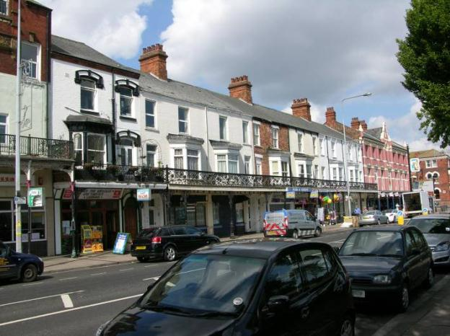
46 and 47 in context at the end of the row before the Terracotta coloured Empire Theatre

Balmoral Road

Name: Crow’s Nest Hotel, Balmoral Road
Date Designated: 10/06/2013
Grid Reference: TA 2940 0788
Area Designation: N/A
Asset Type: Building
Main Criteria Used: 1a
Description:

1957 public house by R M Bruce of Doncaster for Samuel Smith’s, built as part of a planned estate on land between the settlements of Clee, Cleethorpes and Weelsby. Buff brick with stone dressings to the ground floor windows and a clay tile roof.

A handsome 20th century public house retaining a high proportion of original features and a good representation of buildings within planned 20th century estates.

Listed as one of only 3 pubs in NE Lincolnshire for the 2011 booklet “Yorkshire’s Real Heritage Pubs” by the Campaign for Real Ale. An indicator of the development of the town

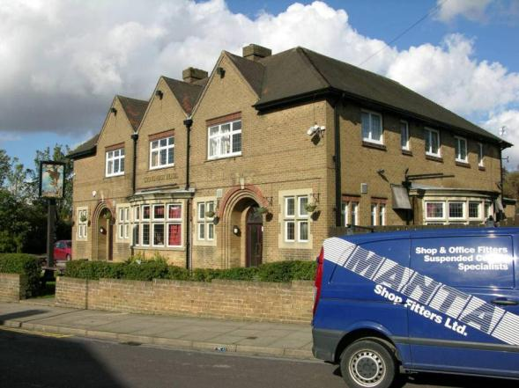

Beacon Avenue

Name: Cleethorpes Municipal Cemetery
Date Designated: 10/06/2013
Grid Reference: TA 3001 0833
Area Designation: N/A
Asset Type: Complex Asset (Designed Landscape, Building, Memorial)
Main Criteria Used: 1c, 2e
Description:

A Municipal Cemetery of 1877, shown as being 3.2 Hectares on Ordnance Survey maps of 1887-9, with an extension of 3.2 Hectares shown on Ordnance Survey maps of 1906-8.
A 2.4 hectare extension is shown on Ordnance Survey maps of 1964 however, with the exception of the World War 2 memorial and burial ground, this area is not included in the listing.

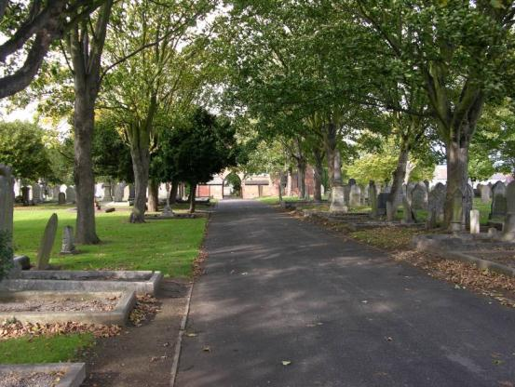

The cemetery is laid out in a grid pattern with mature trees lining most of the paths; the late 19th or early 20th century extension being integrated into the original layout.

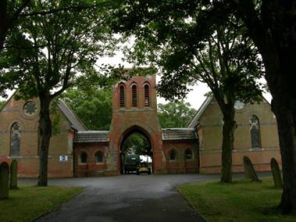

A pair of chapels flank the original central pathway through the cemetery with an arch and tower linking the two buildings in a similar way to the nationally listed chapels at Scartho Road cemetery in Grimsby.

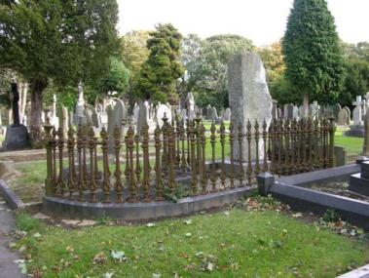

There are numerous high quality memorials, clustered mainly to the south east corner of the cemetery closest to the Beacon Avenue entrance, the most notable being the Hewitt family plot which contains a rough block of granite, faced on one side for inscriptions, enclosed by ornate cast iron railings set into marble curbs.

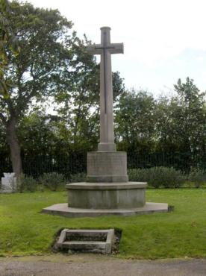

The cemetery contains a monument to the death of soldiers during World War 1 in France and Belgium, in matching style to other Great War monuments, which stands at the centre of the south west end of the first cemetery extension.

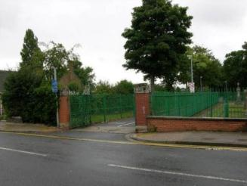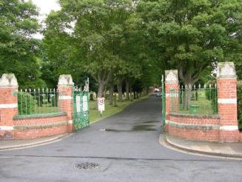
Beacon Avenue Entrance (left) and Bentley Street Entrance (right)

The cemetery has three entrances, two of which have good quality brick piers, dwarf walls, railing and ornate gates. In addition the south east boundary of the older sections of the cemetery has iron railings with gates matching the main entrances, but in a more subdued style.

The cemetery lodge has undergone significant alterations and is no longer of special interest.

The cemetery, buildings and memorials are an indicator of the early development of the town and make a strong, positive, contribution to the character of the area.

Bradford Avenue

Name: 11 to 17 (odd), 19 to 33 (odd), 10 to 26 (even) and 28 to 38 (even) Bradford Avenue
Date Designated: 10/06/2013
Grid Reference: TA 3121 0811
Area Designation: Bradford Avenue Conservation Area
Asset Type: Building
Main Criteria Used: 1d, 2f
Description:

Four rows of terraced houses with bay windows and porch doorways across the ground floor. The first floor façades have faux half timbering and bay windows to the outer pair of houses. Slate roof. Fine timber framed windows with stained glass in fanlights in the upper pane of 1/1 hung sash.

An attractive group and a major asset to the area which together with the other buildings on Bradford Avenue form an almost continuous frontage of high quality well preserved terracing.

Covered by Article 4

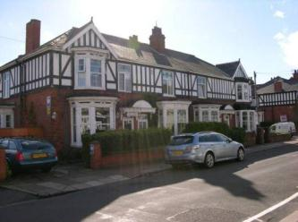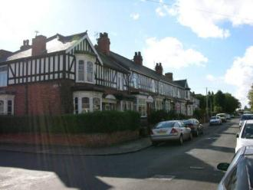

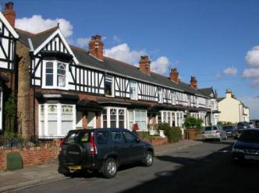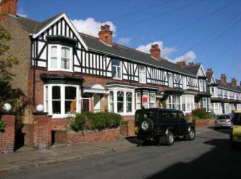

Name: 48 to 72 (even) Bradford Avenue
Date Designated: 10/06/2013
Grid Reference: TA 3096 0804
Area Designation: Bradford Avenue Conservation Area
Asset Type: Building
Main Criteria Used: 1d, 2f
Description:

A terraced row of 13 terraced houses with double height bay windows to each property with ashlar sills, pilasters and lintels. Each doorway is Roman arched with ashlar dripmould, decorative tiled inner walls and timber doors containing stained glass for the lower numbers and ground glass for the higher numbers.
The first floors are rendered and the roofs have clay tiles.
This row is almost completely intact, each has its original windows, bays, doors, dressings, roof materials (with one exception) and many retain original internal features. The row represent the best preserved and probably one of the highest architectural standards of terracing in the authority.
Together with the other buildings on Bradford Avenue these form an almost continuous frontage of high quality well preserved terracing.

Turned down for National Listing in 1996 (Cleethorpes Borough Council Planning Committee Minutes 1st May 1996)

Covered by Article 4

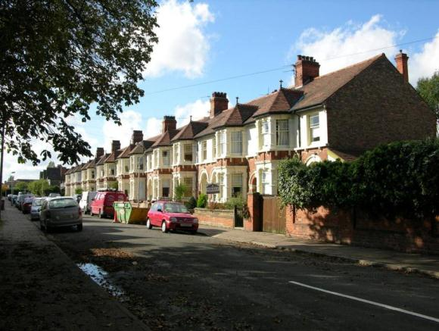

Name: 74 to 80 (even) Bradford Avenue
Date Designated: 10/06/2013
Grid Reference: TA 3090 0801
Area Designation: Bradford Avenue Conservation Area
Asset Type: Building
Main Criteria Used: 1d, 2f
Description:

Two pairs of large semi-detached houses with ground floor bays windows containing leaded casements and ribbon windows on the first floor, again with leaded casements.

Together with the other buildings on Bradford Avenue these form an almost continuous frontage of high quality well preserved terracing.

Covered by Article 4

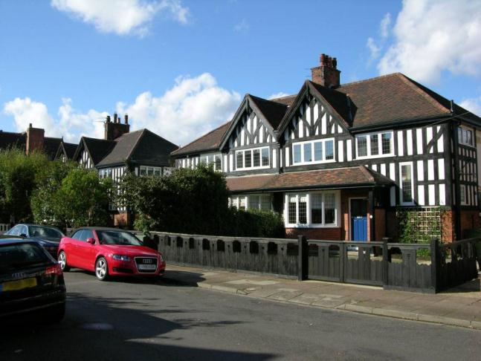

Name: 90 to 98 Bradford Avenue
Date Designated: 10/06/2013
Grid Reference: TA 3086 0799
Area Designation: Bradford Avenue Conservation Area
Asset Type: Building
Main Criteria Used: 1d, 2f
Description:

A row of 5 terraced three storey houses characterised by oriel windows at ground and first floor levels and façade dormers and gables on the second. Windows are leaded casements with 4-light ribbons in the gables and dormers.
The first floor is rendered but only the space beneath the gables is timber framed.

Together with the other buildings on Bradford Avenue these form an almost continuous frontage of high quality well preserved terracing.

Covered by Article 4

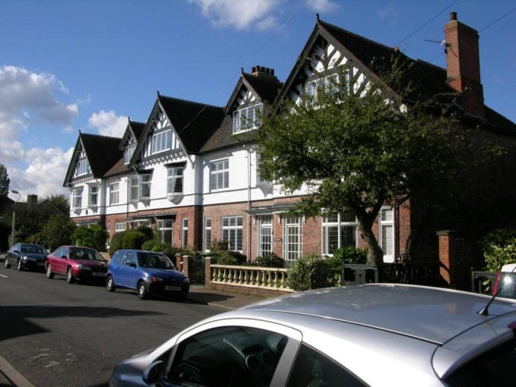

Name: Historic Street Lights, Bradford Avenue
Date Designated: 10/06/2013
Grid Reference: TA 3108 0807
Area Designation: Bradford Avenue Conservation Area
Asset Type: Building
Main Criteria Used: 1d
Description:

At present Bradford Avenue is lined by 12 street light, 9 of which have early 20th century cast-iron posts in a restrained arts and crafts style. The base is stamped REVO, as is the access panel. The lamp posts have decorated bases, plain shafts with a cross bar and swan-neck top piece. The lamps themselves are modern replacements. Historic photographs of the town appear to show that the original lamps hung from the end of the swan necks directly above the main pole.

Although the lamp posts were used throughout the town, and are still quite numerous away from the main roads, the nine posts on Bradford Avenue are one of the larger remaining groups and provide context and character to the Conservation Area. They are therefore listed as a representative example.

Note: One lamp post removed and replaced with a plain modern replica in late 2014, leaving 8 cast iron posts.

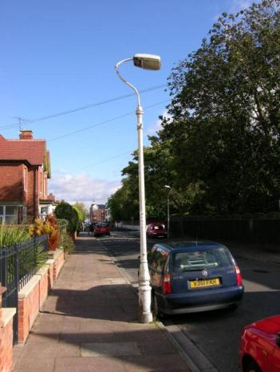
The lamp post in front of 50-52 Bradford Avenue

Brereton Avenue

Name: Sussex Recreation Ground Pavilion
Date Designated: 10/06/2013
Grid Reference: TA 2992 0888
Area Designation: None
Asset Type: Building
Main Criteria Used: 1c, 2e
Description:

A sports pavilion built for the Sussex Recreation Ground with a roofed overhang supported on brick columns surrounding the ground floor. Both storeys are rendered, with faux half timbering to the first floor and gables on each elevation creating a cross shaped roof structure.

A large and well designed pavilion building that is an indicator of the early development of the town

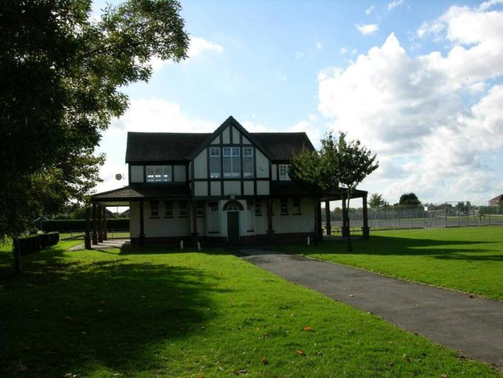

Name: Sidney Park
Date Designated: 10/06/2013
Grid Reference: TA
Area Designation: None
Asset Type: Designed Landscape
Main Criteria Used: 1c, 2e
Description:

This park, which was opened on the 4th August 1904, lies at the northern end of Cleethorpes close to the border with Grimsby and is one of nine urban parks in the Borough of North East Lincolnshire. The park was designed by the eminent landscape architect Thomas Mawson (1861 – 1933) on land owned by Sidney Sussex college, Cambridge which sold the park to the Borough of Cleethorpes in the 1960s.
The park was laid out with an essentially symmetrical pattern of paths and planting with two small formal gardens, a boating lake, bandstand and lodge house.
The park was extended in 1923 in order to provide sports pitches.
The park has been altered in recent times with the most notable difference being the loss of the mature trees around the boating lake, possible due to the age of the specimens, with patchy replacement. In addition the lodge has undergone significant alterations, some of the paths have been lost and the formal beds are no longer maintained. The grounds of the bowling green have also encroached upon the western planting bed and cause discord in the pattern of features.
Despite the alterations the original design of the park is still largely visible, it contributes to the character of the area. The connection to Sidney Sussex College, which was a prominent land owner and developer in early Cleethorpes, is of particular interest. The lodge house and extension of 1923 are not included in the designation.

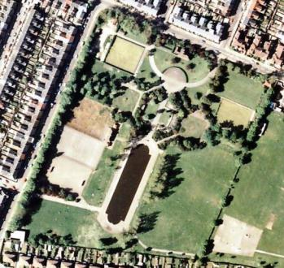
Print Copyright Humberside County Council and JAS Air 1989
Digital Scan Copyright North East Lincolnshire Council 2013

Brooklands Avenue

Name: White Lodge, 23 & 24 Brooklands Avenue
Date Designated: 10/06/2013
Grid Reference: TA 3067 0886
Area Designation: None
Asset Type: Building
Main Criteria Used: 1a
Description:

A three storey pair of houses in a style reminiscent of New Orleans with full length balconies at each upper level, the first floor balcony creating an arcade at ground level.

A particularly bold and unusual building facing the sea at one of the entrances to this private road. An important building to the character of the resort.

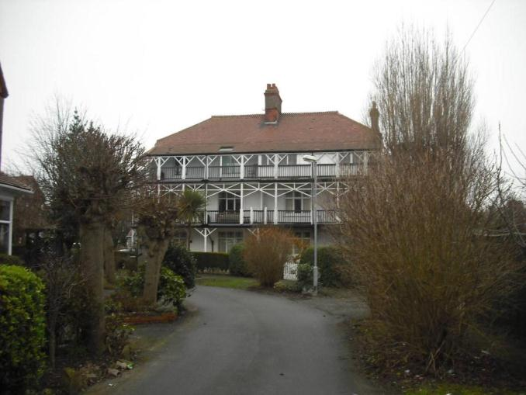

Bursar Street

Name: Bursar County Primary School and Schoolhouse
Date Designated: 10/06/2013
Grid Reference: TA 3024 0879
Area Designation: None
Asset Type: Building
Main Criteria Used: 1c, 2e
Description:

Late Victorian primary and infants schools formed by two L-shaped blocks around a courtyard playground. Single storey school blocks with a two storey villa style school house. All in red brick with ashlar dressings, slate roof with leaded gullies and ridges on the angles and clay ridge tiles on the horizontals.

A well preserved school with masters house with relatively few alterations of limited impact. A strong, positive, historic influence on an area that otherwise has little remaining unaltered and an indicator of the early development of the town

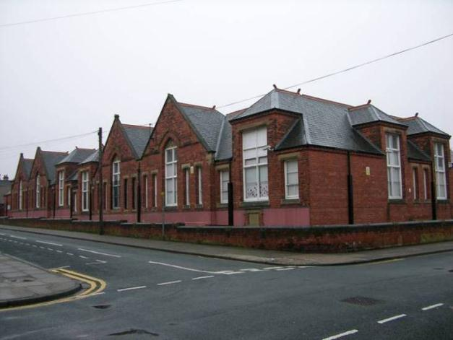

Central and North Promenade

Name: The Pier
Date Designated: 10/06/2013
Grid Reference: TA 3083 0897
Area Designation: Central Seafront Conservation Area
Asset Type: Building
Main Criteria Used:
Description: 1c, 2c

Pier pavilion of 1906 set along side the truncated remains of the Victorian pier of 1872/3.

The original pier was over 1200 feet in length but the pavilion of 1888 was destroyed by fire in 1903. Further damage was caused by the armed forces during World War 2 when a section was destroyed in order to limits its potential use as an invasion point.
A landward section was also removed including two towers which flanked the entrance.

Despite its history the pier still represents an important part of the character of the resort.

See HER Number - 0047/4/0 - for further information and sources

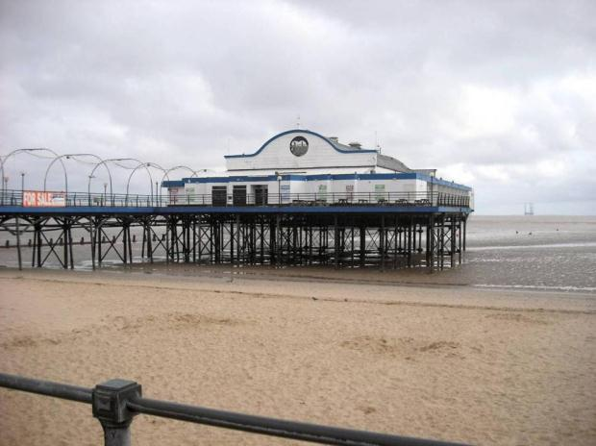

Name: Seafront Gardens, Central Promenade and North Promenade
Date Designated: 10/06/2013
Grid Reference: TA 3068 0904
Area Designation: Central Seafront Conservation Area
Asset Type: Designed Landscape
Main Criteria Used: 1c, 2c
Description:

Originally set aside for “recreational use” by an Enclosure Award of 1842, the Gardens and Promenade were built in 1883-5 by the Manchester, Sheffield and Lincoln railway company in order to consolidate the fragile clay cliff at Cleethorpes and improve the resort.
The engineering works, and possibly also the garden layout, were designed by H.B. James of Westminster, London. Most of the original layout of the gardens, as shown on Ordnance Survey maps of 1887-9, still exists with the notable exception of the former integration with the Pier which can now only be accessed from the Promenade itself rather than the Gardens. There has also been the insertion of a series of buildings in the Art Deco style dated to 1950 which are well designed additions to the Asset. Another later addition, the Dolphin Gardens, also form a valuable addition to the Asset. The straight flight of steps at the southern end of the gardens were replaced in 1939 by the existing designed by E. Prentice Mawson of Westminster, London who was son of Thomas Mawson, an influential Garden Designer.
The entrance to Ross Castle (Grade II: National List) has also been altered and is now accessed from the Gardens rather than the Promenade.
The height of the sea walls and promenade has been increased by building on top of the original walls in order to provide better flood defence. The former height of the walls is illustrated by a series of disused York Stone steps.

The Promenades and Gardens provide an important accompaniment to Nationally and Locally Listed buildings, the Conservation Area and form a vital component of the Resort in general.

See HER Numbers - 0047/1/0 and 0047/8/0 - for further information and sources

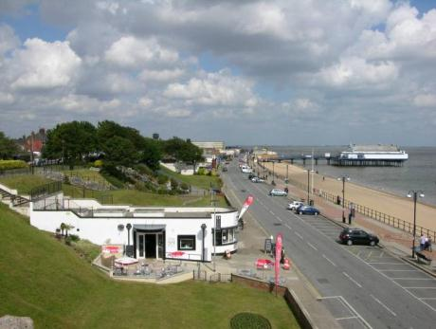
Name: RAF North Coates Strike Wing Memorial Statue
Date Designated: 10/06/2013
Grid Reference: TA 3090 0866
Area Designation: Central Seafront Conservation Area
Asset Type: Memorial
Main Criteria Used: 1b
Description:

War memorial built to commemorate the World War 2 RAF North Coates Strike Wing.

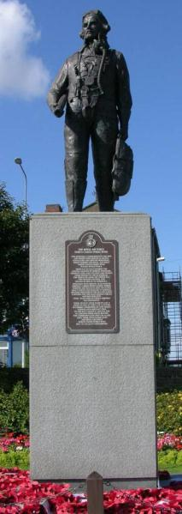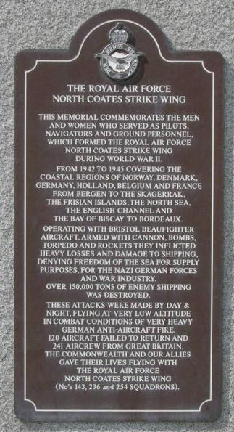

Clee Road

Name: Matthew Humberston School, Clee Road
Date Designated: 10/06/2013
Grid Reference: TA 2920 0825
Area Designation: None
Asset Type: Building
Main Criteria Used: 1c, 2d
Description:

A school of 1882 built for the Humberston Foundation, a trust set up upon the death of Matthew Humberston (Lord of the Manor of Humberston) in the early 19th century, as a replacement for the school in Humberston which was closed in 1878. Extended in 1909 and greatly expanded in 1937.

Forms an important addition to the Old Clee Conservation Area which currently stops across the road.

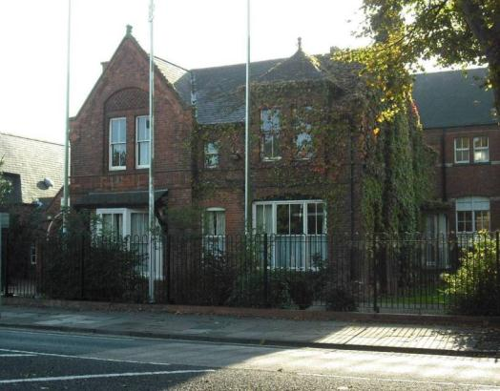

Name: 221 Clee Road
Date Designated: 10/06/2013
Grid Reference: TA 2926 0829
Area Designation: None
Asset Type: Building
Main Criteria Used: 1c, 2f
Description:

Two storey mock medieval/Tudor detached villa. Built of brown brick with faux timbering and herring bone brickwork in vertical ribbons. Gables with faux timbering and render below the eaves.

Part of a group of high quality post 1850s houses in mock Tudor/medieval style around the centre of Old Clee.

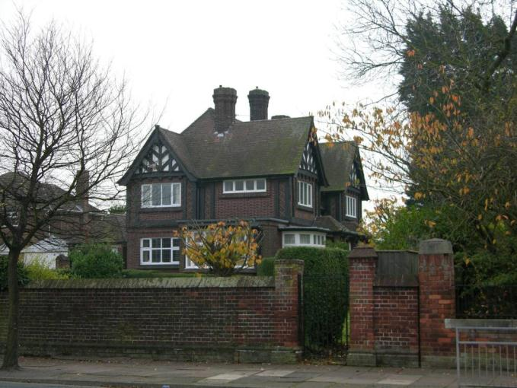

Name: Former Lindsey Lower School, Clee Road
Date Designated: 10/06/2013
Grid Reference: TA 2978 0861
Area Designation: None
Asset Type: Building
Main Criteria Used: 1c, 2e
Description:

Although the datestone over the main entrance reads 1925, Cleethorpes Secondary School for Girls was opened in October 1928. It was designed for the Local Education Authority by Henry Gilbert Gamble of the Lincoln architectural practice Scorer and Gamble, although the school as built was slightly modified from the architectural plans dated September 1926. When opened, the school was designed for 250 pupils, but with planned extensions for a further 150 students, although these extensions were not built. Set in extensive grounds, the school included a housecraft room alongside science labs. The standard classrooms could be opened up to open sided verandas overlooking grassed quadrangles: an adaptation of the approach taken by the Open Air School movement. The school underwent extension and modification in the later C20 with a series of extensions within the two former open quadrangles, as well as to the rear. These alterations included converting the open verandas into enclosed corridors. Most recently known as the Lindsey Lower School, the school is now disused.

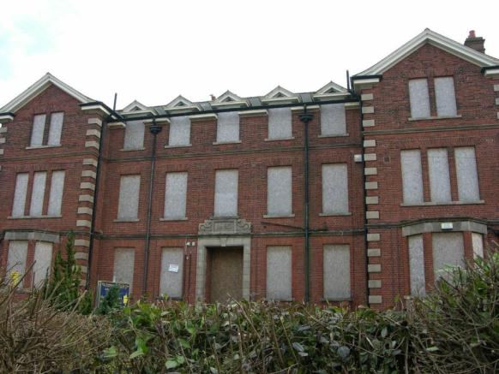

MATERIALS:
Red brick laid in English bond, artificial stone dressings, slate roofs. Retains most of its original windows which are timber with slim glazing bars, generally with the upper third being hopper opening with vertical sliding sashes below.

PLAN:
The original buildings form an E plan with the assembly hall to the centre flanked by two quadrangles that were formerly grassed, but are now largely built over with later extensions. Open fronted verandas around these quadrangles have been converted into enclosed corridors. The school is single storey apart from the three storey administration block to the centre of the north range. This was designed to house a top floor dining room served from a kitchen on the first floor.

EXTERIOR:
Neo-Georgian with an impressive northern elevation with the three storey H plan administration block to the centre, flanked by 15 bay classroom ranges that are slightly set back and link to 3 bay end blocks that break forward. The administration block is quoined, has storey bands and a pedimented doorcase incorporating the 1925 datestone. Cast iron rainwater hoppers carry the date 1926. Windows (in contrast to the much larger windows to the rest of the school) are domestic in scale. The eaves overhang with moulding to the soffits. The top floor windows of the centre range break the eaves with triangular pediments styled like the gable ends of the administration block's flanking cross ranges. The class room ranges to either side are more simply detailed with plinth and lintel bands linked by pilasters. End blocks have hipped roofs, side elevations are similarly detailed. Elevations facing into the quadrangles are much plainer and more altered. The original pillars to the verandas appear to have been replaced with the walling used to form the replacement corridors. Later extensions are a mix of designs that do not respect the original styling of the school.

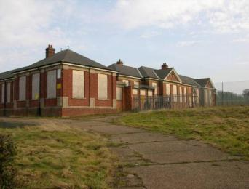

INTERIOR:
The classrooms to the north and east ranges retain their multiple double doors originally designed to open to the fresh air via the verandas. Both the assembly hall and the gymnasium have exposed roof trusses that have a degree of ornamentation such as acorn pendants. One of the toilets retains a bank of original washstands.

English Heritage. 2011: Lindsey Lower School Non Listing Report – Case Number 462624.

A very important building to the community and character of the area as well as an indicator of the early development of the town

Coronation Road

Name: 1 to 23 Coronation Cottages
Date Designated: 10/06/2013
Grid Reference: TA 3083 0838
Area Designation: None
Asset Type: Building
Main Criteria Used: 1c, 2e
Description:

A row of well preserved almshouses. Single storey in red brick with low eaves carrying a mix of Rosemary and Pan Tiles. The large bay windows are a good notable feature.
Although the houses likely date to the period where the resort was being established, they are much more rural in their architectural character and are aligned to an earlier street layout.

A particularly well preserved building in an area otherwise neglected architecturally, the houses makes an important contribution to indicating of the early development of the town.

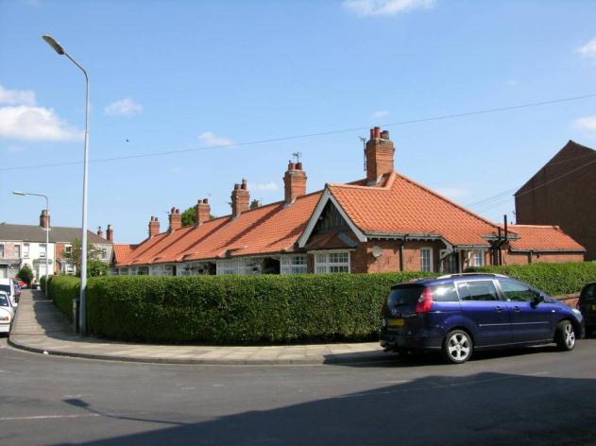

Elm Road

Name: 18 Elm Road
Date Designated: 10/06/2013
Grid Reference: TA 3036 0866
Area Designation: None
Asset Type: Building
Main Criteria Used: 2a
Description:

A well preserved building which was probably built as a large farmhouse in the mid 19th century before the growth of the resort. Many features have been retained internally in both the house and it’s main outbuilding to the rear.

A particularly well preserved building, the house makes an important contribution to the preservation of the pre-resort character of the town.

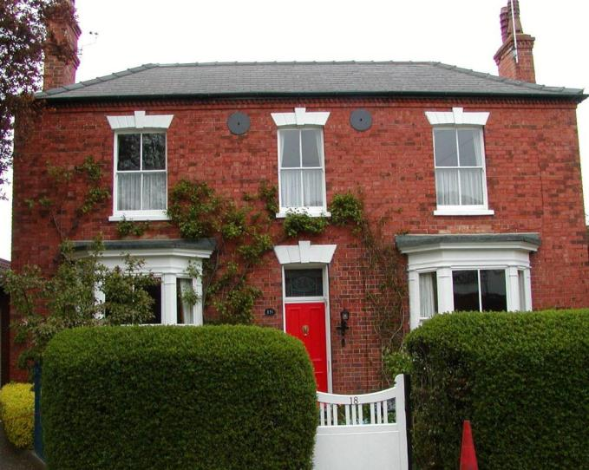

Grant Street

Name: Former Victoria Hotel
Date Designated: 10/06/2013
Grid Reference: TA 3059 0898
Area Designation: Central Seafront Conservation Area
Asset Type: Building
Main Criteria Used: 1c, 2c
Description:

A three storey building originating as part of a roughly L shaped terrace of buildings called Victoria Terrace, built sometime between 1856 and 1868. The public house formerly occupied only the most south-easterly two-bay section of the current building and was called Victoria Hotel. A large part of the terrace, which faced north west, has been demolished leaving only the south west facing section (approximately 1/2 of the original building). A large un-associated building formed the outside angle of the L.

Despite the lost elements the building is still an important reminder of the origins and character of the town particularly with its large bay windows facing out to the coast.

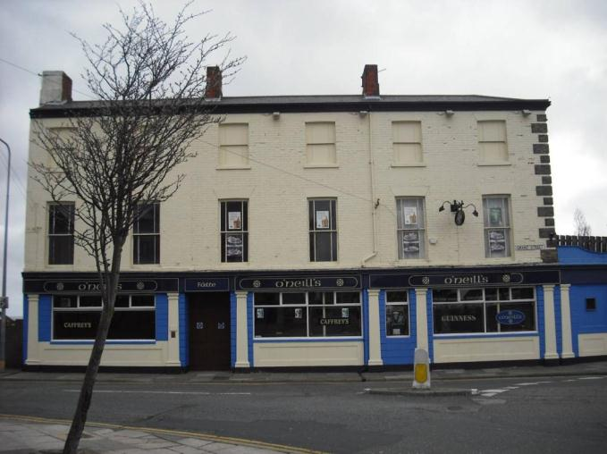

Grimsby Road

Name: Christchurch Hall, Grimsby Road
Date Designated: 10/06/2013
Grid Reference: TA 3002 0914
Area Designation: None
Asset Type: Building
Main Criteria Used: 1c, 2e
Description:

A well preserved and relatively simple chapel in red/brown brick with stone dressings and metal framed windows.

Together with other buildings in the area it is an important landmark of the expansion of early 20th century Cleethorpes.

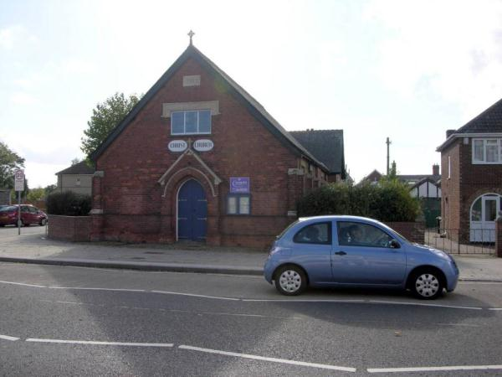

Name: Farringford, 421 Grimsby Road
Date Designated: 10/06/2013
Grid Reference: TA 3004 0920
Area Designation: None
Asset Type: Building
Main Criteria Used: 1c, 2e
Description:

A former gas showroom, two storey building with alterations to the ground floor façade.

The building is in brown brick with ashlar dressings and is more conventional in style than the Beaconthorpe Methodist chapel opposite and the electricity showroom further down Grimsby Road but nether less they form an important group.
It is not known exactly what the original ground floor façade looked like, but it is likely to have been large display windows between the existing carved pilasters.

Together with other buildings in the area it is an important landmark of the expansion of early 20th century Cleethorpes.

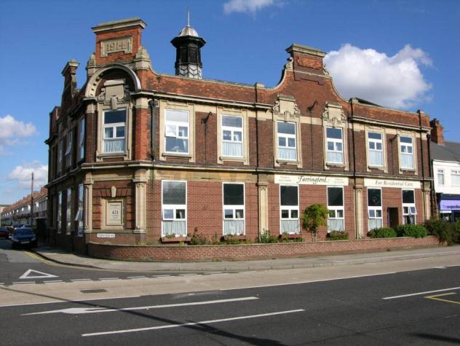

Name: Terracotta Row, 495 to 511 (odd) Grimsby Road
Date Designated: 10/06/2013
Grid Reference: TA 2947 0978
Area Designation: None
Asset Type: Building
Main Criteria Used: 1c, 2e
Description:

A terraced row of houses with finely detailed terracotta window and door surrounds and pediment. The buildings are somewhat neglected and several of the terracotta bays are beginning to subside but they still form a handsome group.

Together with other buildings in the area it is an important landmark of the expansion of early 20th century Cleethorpes.

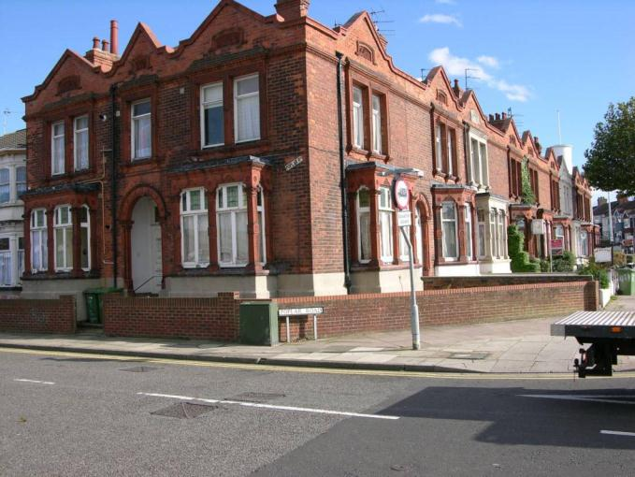

Hart Street

Name: St Aidan’s Church and Vicarage
Date Designated: 10/06/2013
Grid Reference: TA 2930 0980
Area Designation: None
Asset Type: Building
Main Criteria Used: 1c, 2e
Description:

St Aidan, Grimsby Road and Hart Street,1905-6 by C. H. Fowler. Red brick with stone dressings. Big, nave and chancel in one, aisles and clerestory. A fleche marks the division between nave and chancel. The details Perp[endicular], with a large transomed six-light w window. The interior has been divided, but the five-bay arcades with embattled capitals remain. The brick is exposed inside. Stained glass - One window in the South aisle 1918 by Jones & Willis. North chapel c. 1922 by A. K. Nicholson.

Pevsner N and J Harris. 1989. The Buildings of England Lincolnshire. 2nd Edition. Yale University Press. New Haven and London.

A large and impressive 20th century church which makes an important contribution to this area which contains other significant buildings. The vicarage is also a good quality companion building.

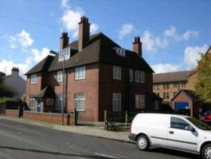
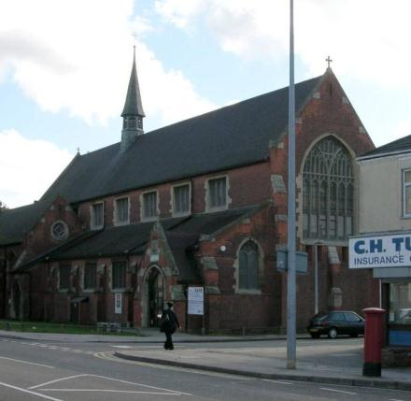

Highgate

Name: 15, 17 and 19 Highgate
Date Designated: 10/06/2013
Grid Reference: TA 3080 0837
Area Designation: None
Asset Type: Building
Main Criteria Used: 1c, 2e
Description:

A short terrace of houses with a high quality and well preserved shop front to one end.
Primarily listed for the intact shop front on number 15, but the rest of the row is reasonably well preserved and provides context to the shop.
Number 19 is of lesser importance as it survives in a less well preserved state and so is included for group value only.

The shop front is a rare survivor for the area and together with the attached houses makes a handsome block of buildings which stand out from the crowd in this island like position. An indicator of the early development of the town

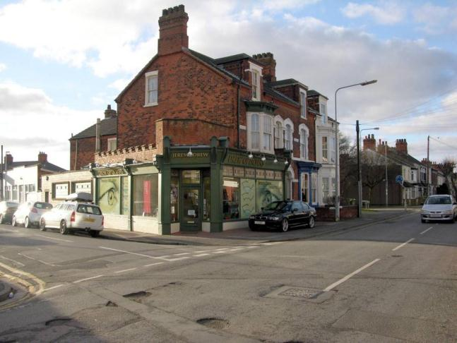

Name: 86 Highgate
Date Designated: 10/06/2013
Grid Reference: TA 3066 0830
Area Designation: None
Asset Type: Building
Main Criteria Used: 1c, 2e
Description:

A bold inter-war house in good condition with matching stained-glass windows in the front elevation windows and the garage door.
There was previously a custom built “cast in situ” re-enforced concrete air raid shelter to the rear.

A good example of 20th century arts and crafts architecture and an indicator of the early development of the town

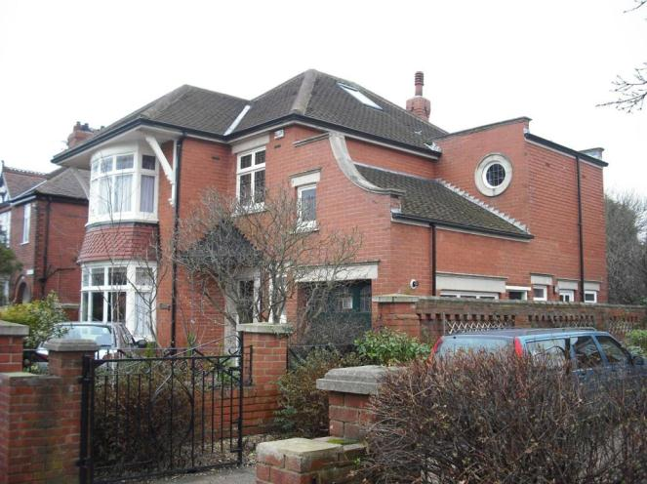

High Street

Name: 26 to 28 High Street
Date Designated: 10/06/2013
Grid Reference: TA 3050 0894
Area Designation: Central Seafront Conservation Area
Asset Type: Building
Main Criteria Used: 1c, 2c
Description:

Originally built as the Coliseum Picture Theatre in 1920 this building has also been known as Arthur’s Snooker Hall, the Baton Rouge, Amishi and now once again re-named The Coliseum Picture Theatre by new owners J D Weatherspoons .

The building makes a break from the more restrained Victorian/Edwardian architecture in the centre of the town and the dull mid 20th century buildings opposite. An important building to the character of the resort.

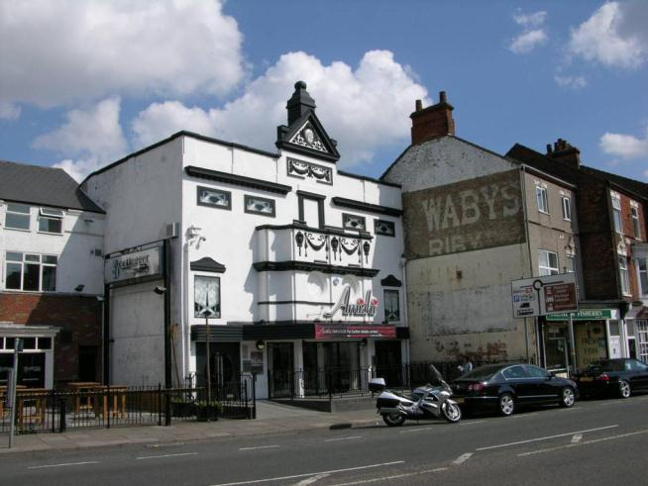

Intertidal Foreshore

Name: Four Shipwrecks on Cleethorpes Foreshore
Date Designated: 10/06/2013
Grid Reference: TA 3339 0725
Area Designation: None
Asset Type: Shipwreck
Main Criteria Used: 1b
Description:

Four shipwrecks in close proximity to each other of similar dates. The wrecks are probably all 19th and early 20th century and relate directly to the growth of Grimsby Docks as the primary fishing port in Europe.
All four appear to have enough bulk left to enable assessments of build technology and to determine the class/usage and appear to represent a variety of civil maritime industries.

Wreck One - TA 33031 07561:

Remains of a 25 metre by 6 metre vessel which may survive to a height of 2 metres up from the Keel. The remains appear to be from the keel to the turn of the bilge on the starboard side. The stern is first up the beach but there is no sign of a rudder. It is very solidly built with a Sternpost, Sternson etc and a possible iron plate at the base of the Stem/Sternpost. It appear to be Carvel built with the hold lined with ceiling planks. It is mostly treenail fastened although it has some iron nails. The frames are also closely spaced. It has a large keelson and rider keel which appears to be broken at both ends.

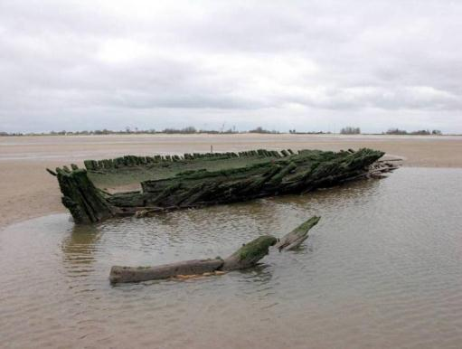
Wreck One in 2012
There are two mast steps which are set well for and aft with mortices for stanchions along its length. There are also some iron bolts along the keel structure and a large iron plate near the bow. It is flat bottomed with a distinctive shape. Probably either a Smack or a Yawl. (English Heritage NMR Number 1532568)

Re-examined at the April neap tide in 2012 (c.0.8m). Following high winds a significant amount of sand has been moved further exposing the wreck and revealing a large section of hull which appears to have broken away in antiquity. Outer hull and ceiling planks have come loose since 2007, and the ribs have degraded further; the starboard side is taking the brunt of the damage as it is on the side of the scour created by the tide, and the wreck leans to the port side

Wreck Two - TA 33187 07311

A wooden wreck shown by short lengths of timbers sticking out of the sand. The remains appear to be from a medium sized vessel, smaller than the nearby remains of a smack/yawl. The remains are well buried so detailed examination is not possible.

The remains are likely to be of post-medieval date. The wreckage is well buried, and in this location suggests that the manner of loss is most likely to have been a stranding (English Heritage NMR Number 1532594)

Examined at neap tide, April 2012 (c.0.8m). Recent strong winds have moved a significant amount of sand from the wreck and surrounding areas allowing examination of the construction of the vessel. Outer hull and ceiling planks are present and fastenings appear to all be wooden (tree-nails) with no metalwork obvious anywhere on the wreck. Construction is similar to Wreck One but apparently without the tall keelson in the hold area. A large hole in the hull has become exposed on the stem, port side, but it is not clear when this damage occurred although it does appear to have been present in 2007 judging by the lack of the same ribs showing.

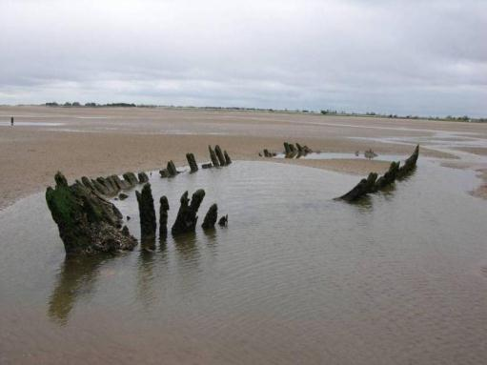
Wreck Two in 2012
Wreck Three - TA 33763 07018

Remains of wooden-hulled cargo vessel, probably a barge, which lies exposed in the inter-tidal zone on the Cleethorpes foreshore close SW of another similar wreck (908319), both of which lie east of a small creek or channel. She lies with her bows to the SW with a large pile of stones amidships, possibly cargo or ballast, and measures 28m long by 8m wide.
The vessel may be post-medieval or 20th century, being first recorded in 1989. In this location the vessel is most likely to have been lost by stranding (English Heritage NMR Number 908482)

Examined at neap tide, April 2012 (c.0.8m). Heavily built, wood with steel pins and an apparent steel framework within the hold. The stones previously recorded are large chalk boulders, apparently filling the hold so are likely to be cargo rather than ballast. Only part of the vessel was exposed, the stern section could not be seen. No outer hull timbers are apparent on the exposed sections, but ribs and ceiling planks are present along with a section of deck which has collapsed into the hold. The wood is solid, but badly attacked by boring creatures

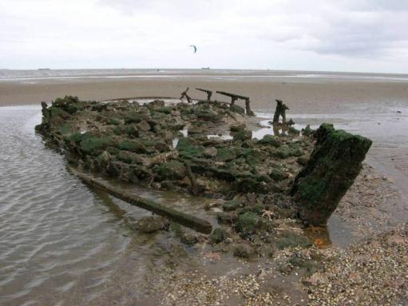
Wreck Three in 2012

Wreck Four - TA 33863 07051

Remains of wooden keel, probably of a sailing vessel, located off Cleethorpes beach east of a creek, in the intertidal zone; and close NE of a similar wreck. The vessel is likely to be of post-medieval date; the remains measure 33m long by 8m wide. In this location the manner of loss is most likely to have been by stranding (English Heritage NMR Number 908319)

****Currently re-buried by a sand bank****

Isacc’s Hill

Name: The Old Library, Isaac’s Hill
Date Designated: 10/06/2013
Grid Reference: TA 3036 0888
Area Designation: None
Asset Type: Building
Main Criteria Used: 1c, 2e
Description:

A former library of 1901-2 by F.W. Croft, built in brick with stone dressing.

Pevsner N and J Harris. 1989. The Buildings of England Lincolnshire. 2nd Edition. Yale University Press. New Haven and London.

A smart Edwardian civic building with good original detailing marred only by inappropriate window replacements and flaking of the stonework. An important building to the town’s character in a prominent location.

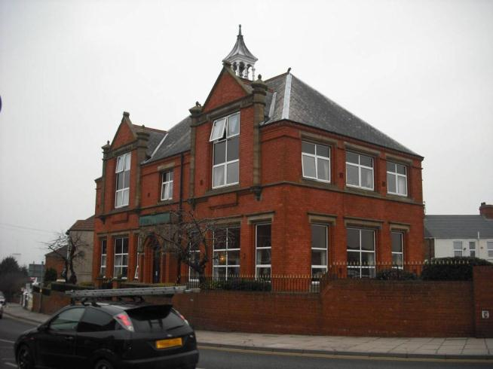

Name: 18 Isaac’s Hill
Date Designated: 10/06/2013
Grid Reference: TA 3029 0893
Area Designation: None
Asset Type: Building
Main Criteria Used: 1c, 2e
Description:

A fine Edwardian villa, built by a local builder Mr Cross as his own house in 1095. Red brick with stone dressings and a slate roof. The bold two storey square bays, the upper portions of which were added in 1989 when the property was divided into two flats, are a particularly attractive feature and the pull-down canopies on the ground floor bay windows are an interesting survival.

An indicator of the early development of the town.

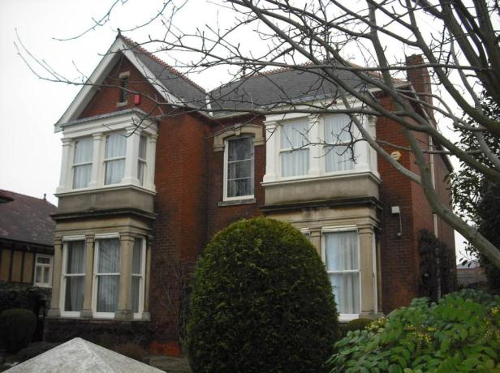

King’s Road

Name: 1 King’s Road
Date Designated: 10/06/2013
Grid Reference: TA 3139 0789
Area Designation: None
Asset Type: Building
Main Criteria Used: 1c, 2e
Description:

A Masonic Lodge and restaurant. Two storey and slightly unusual building in Arts and Crafts style with a single storey range accommodating the banqueting suite and original timber sun room or conservatory to the rear.

A handsome corner building with a more rural character than other buildings in the area, reflecting it’s once isolated position on the edge of Edwardian Cleethorpes. An indicator of the early development of the town

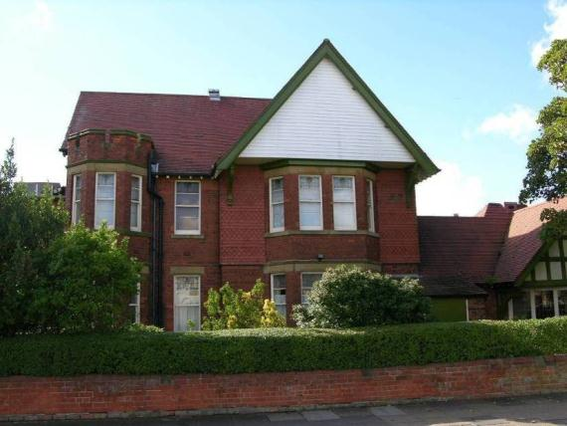

Name: Summerfield’s, 7 King’s Road
Date Designated: 10/06/2013
Grid Reference: TA 3144 0780
Area Designation: None
Asset Type: Building
Main Criteria Used: 1c, 2e
Description:

A fine Edwardian villa in Tudorbethan (mock Tudor) style built as a semi-rural residence, now subdivided into flats as part of a care home complex and overtaken by urban development..

Some alterations have been carried out in addition to the sub-division, such as replacement windows on some flats, but the house is still an important reminder of the former character of this area of town. An indicator of the early development of the town

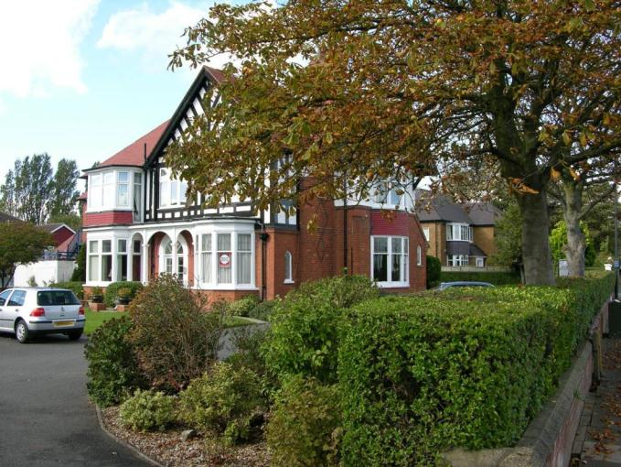

Kingsway

Name: Kingsway Gardens, Railings and Shelters
Date Designated: 10/06/2013
Grid Reference: TA31140837, TA31190829, TA31310812, TA31360805
Area Designation: None
Asset Type: Complex Asset (Designed Landscape, Building)
Main Criteria Used: 1c, 2c
Description:

A promenade and gardens built in 1902-6 on land reclaimed as part of an enclosure act. Like the promenade to the north west, flood defence was also a major consideration.
Included in the monument are a fine group of Edwardian bus shelters, cast iron railings and retaining walls built of small granite blocks, the formal promenade gardens and the sea defence walls.
The protective sea walls are of stone block construction with cement covering. The lower sections of the walls, which are often covered by sand build-up, are convex in order to break the waves during storms.

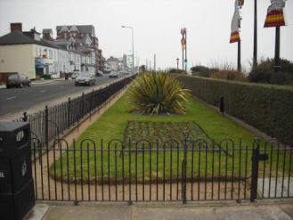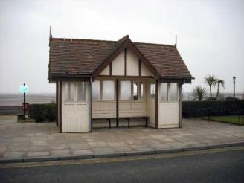
Wrought Iron railings, gardens and bus shelter
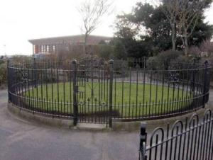
Cast and Wrought ironwork by Marshall and Sons, Grimsby

Mill Road

Name: 2 to 10 (even) Mill Road
Date Designated: 10/06/2013
Grid Reference: TA 3056 0855
Area Designation: None
Asset Type: Building
Main Criteria Used: 1c, 2e
Description:

An unusually well preserved terrace of 5 houses. Of particular note for the area is the preservation of the bay windows and original window and door apertures on all five buildings along with most of the original garden walls to the fronts and a lack of rendering or pebble-dashing.

Overall a handsome and unusually intact terrace.

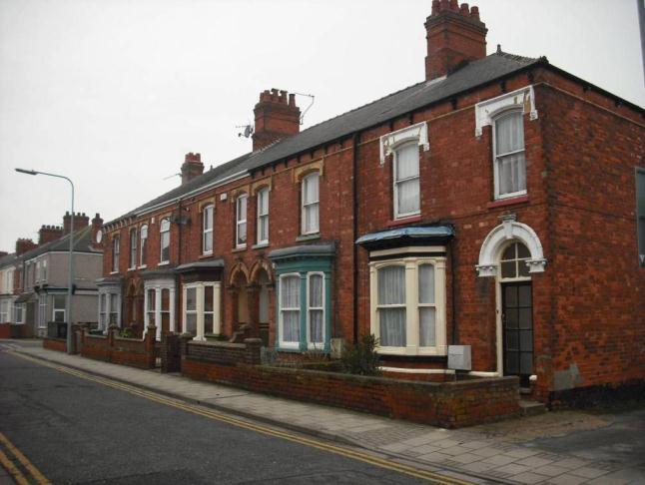

Name: Coronation Cottages, 76 to 90 Mill Road
Date Designated: 10/06/2013
Grid Reference: TA 3034 0843
Area Designation: Mill Road Conservation Area
Asset Type: Building
Main Criteria Used: 1c, 2e
Description:

Built in 1912 by G. Huskinson, Architect, with a commemorative date stone of 1911. 8 single storey almshouses in red brick with stone keystones and coping to gablets and a pantile roof.

A smart row of buildings which are important to providing the low density character to the upper section of Mill Road which was an edge of town development.

Covered by Article 4

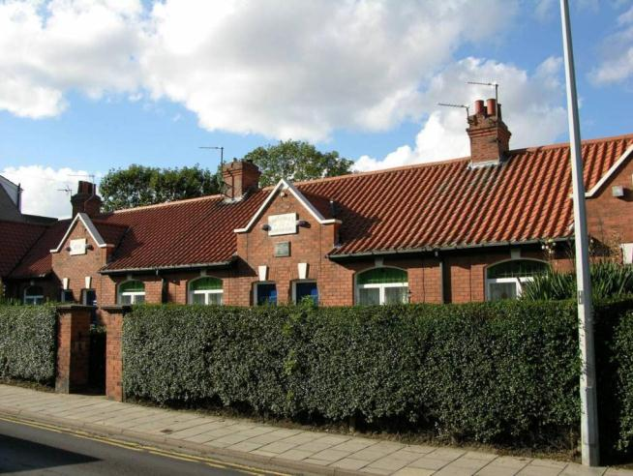

Name: 123 Mill Road
Date Designated: 10/06/2013
Grid Reference: TA 3031 0838
Area Designation: Mill Road Conservation Area
Asset Type: Building
Main Criteria Used: 1c, 2e
Description:

Built in 1912 by H. Scaping, Architect. A large two storey villa in arts and crafts style. Brick plinth but otherwise rendered with some decorative work done with terracotta tiles or half bricks. Tile roof. Leaded casements.

A fine example and a bold addition to a largely Victorian style streetscape. Taken as a group the high quality houses on the upper portion of Mill Road are illustrative of the transformation of Cleethorpes from a series of hamlets to a relatively affluent town.

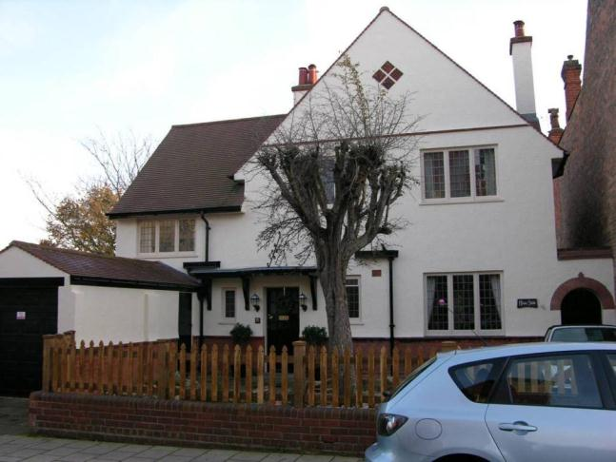

Name: 125 Mill Road
Date Designated: 10/06/2013
Grid Reference: TA 3030 0838
Area Designation: Mill Road Conservation Area
Asset Type: Building
Main Criteria Used: 1d, 2e
Description:

A small villa built of smooth red brick with decorated string course. Timber frames to windows to splay bay with moulded fascia to ground floor. Timber frames to windows to first floor. Stone arched lintels now painted, with mouldings to bases and keystone. Blue slates to roof with chimney, timber guttering.

A well preserved building and unusual in being just two bays instead of the normal symmetrical 3 bay; together these make it of higher interest than would otherwise be the case. Taken as a group the high quality houses on the upper portion of Mill Road are illustrative of the transformation of Cleethorpes from a series of hamlets to a relatively affluent town.

Covered by Article 4

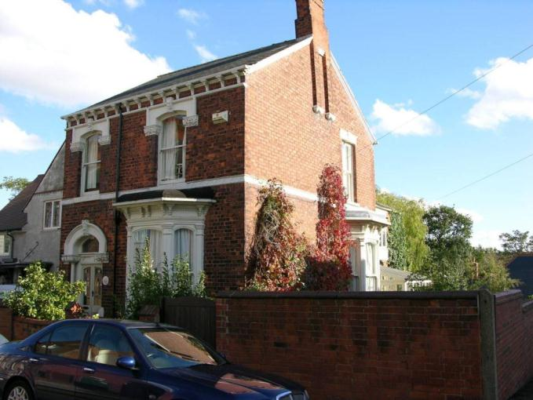

Name: Blenheim House, 131 Mill Road
Date Designated: 10/06/2013
Grid Reference: TA 3028 0837
Area Designation: Mill Road Conservation Area
Asset Type: Building
Main Criteria Used: 1d, 2e
Description:

A 3 bay villa in smooth red brick. Timber frames to windows to splayed bays with moulded fascias and lead tops to ground floor either side of central door. Timber frames to sash windows to first floor. Stone architrave to front door and moulded stone lintels to openings. Re roofed in concrete interlocking tiles, chimneys either side with black painted aluminium gutter. Marks showing modillions to previous gutter. Extension to right hand side has large semi circular bay window with timber frames to ground floor with leaded lights and matching timber frames to sash windows to first floor.

An usual building with its large extension. Taken as a group the high quality houses on the upper portion of Mill Road are illustrative of the transformation of Cleethorpes from a series of hamlets to a relatively affluent town.

Covered by Article 4

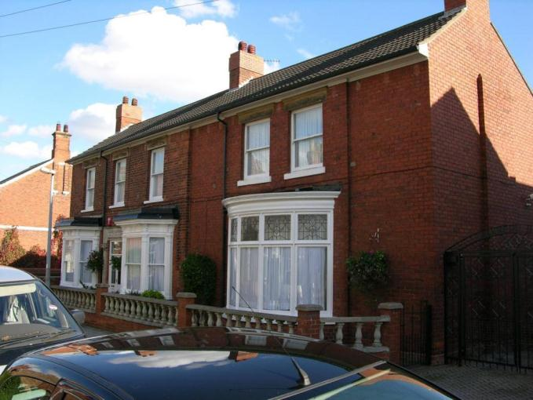

Name: Former Mill Buildings to the Rear of 130 Mill Road
Date Designated: 10/06/2013
Grid Reference: TA 3023 0838
Area Designation: Mill Road Conservation Area
Asset Type: Building
Main Criteria Used: 1b, 2a
Description:

Former warehouse and probable mill house associated with the now demolished Tower Windmill for the parish of Clee

These buildings are an important survivor of pre-resort Cleethorpes and relate directly to the origins of the town as farming hamlets to Old Clee.

Partially Covered by Article 4

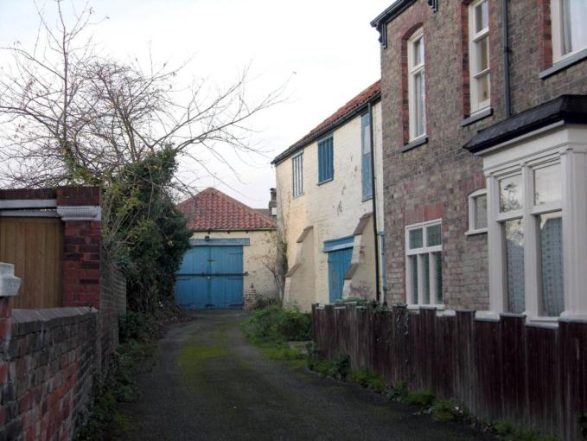

Name: Hebron House, 134 Mill Road
Date Designated: 10/06/2013
Grid Reference: TA 3021 0836
Area Designation: Mill Road Conservation Area
Asset Type: Building
Main Criteria Used: 1c, 2e
Description:

Built in 1902 for G. Kirkman. A three bay villa, smooth red brick with yellow tile banding. Timber frames to bay windows to ground floor with moulded fascias. Upvc framed windows in existing openings to first floor. Arched moulded yellow faience faced lintels to first floor. Four steps to front door with stained glass, architrave and pillars in faience with carved name. Blue slates to roof with red hip tiles and ornamental ridge tiles with finials and chimneys either side. Moulded aluminium rainwater goods with faience modillions.

A very fine example of the 3 bay standard villa with quality detailing to the bay windows, string course and door frame. Taken as a group the high quality houses on the upper portion of Mill Road are illustrative of the transformation of Cleethorpes from a series of hamlets to a relatively affluent town.

Covered by Article 4

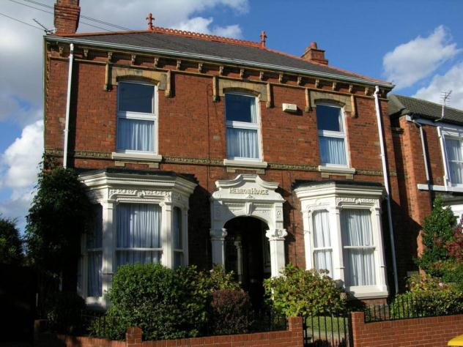

Name: Albemarle House, 136 Mill Road
Date Designated: 10/06/2013
Grid Reference: TA 3018 0838
Area Designation: Mill Road Conservation Area
Asset Type: Building
Main Criteria Used: 1c, 2e
Description:

Built in 1910 for A. Osbourne. A large manor house style villa in smooth red brick with render to first floor, some boarding between bays. Timber frames to bays and windows to both floors. Moulded fascias to bays with leaded lights. Plain red clay tiles to roof with plain bargeboards and large ornate chimneys, plastic and cast iron rainwater goods. Two storey. Brick wall and railings to front boundary.

A grand house set in reasonably large grounds and an important building to the character of this end of Mill Road as the former urban fringe. Taken as a group the high quality houses on the upper portion of Mill Road are illustrative of the transformation of Cleethorpes from a series of hamlets to a relatively affluent town.

Covered by Article 4

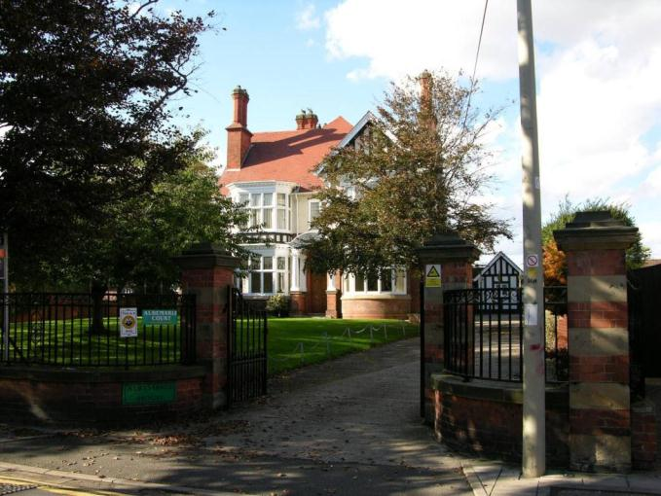

Name: Filey House, 143 Mill Road
Date Designated: 10/06/2013
Grid Reference: TA 3024 0834
Area Designation: Mill Road Conservation Area
Asset Type: Building
Main Criteria Used: 1c, 2e
Description:

Two storey villa in built in 1906. Smooth red brick with moulded brick to gutter cornice and stone string courses. Timber frames to windows to bays with moulded fascias to ground floor. Timber frames to windows to first floor. Shaped gable to left hand side with stone copings. Red brick lintels to openings, some with stone keystones. Stone quoins to front entrance. Red clay tiles to roof with ornamental ridge tiles, large chimneys and plastic guttering.

A good quality building making good use of stone for quoins, keystones, string courses and pediments to give a polychromatic appearance. Taken as a group the high quality houses on the upper portion of Mill Road are illustrative of the transformation of Cleethorpes from a series of hamlets to a relatively affluent town.

Covered by Article 4

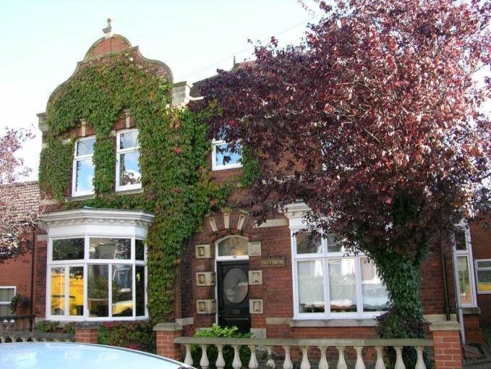

Name: Kemuel House, Agagia House, Eschol House, Hill Crest and Rugby House 145 to 153 (odd) Mill Road
Date Designated: 10/06/2013
Grid Reference: TA 3018 0838
Area Designation: Mill Road Conservation Area
Asset Type: Building
Main Criteria Used: 1d, 2e
Description:

Kemuel House - Built in 1892. Smooth red brick. Timber frames to windows to splayed bay with moulded fascia to ground floor. Timber frames to sash windows to first floor. Red brick arched lintels, painted, stone keystones with mouldings. Re roofed in artificial slate, chimney, timber gutter with block supports.

Acacia House - Built in 1887. Smooth red brick and red brick lintels to new openings. Moulded bricks to gutter cornice. Timber frames to windows to splayed bays to ground floor and timber frames to windows to first floor. Blue slates to roof with chimneys and yellow pots, cast iron gutter.

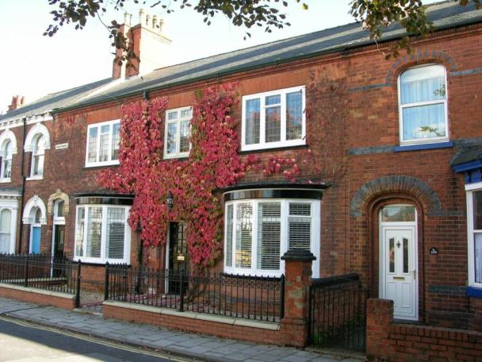
Acacia House in 2010

Eschol House - Built in 1886. Smooth red brick with blue brick banding. Arched red brick lintels with blue brick inserts. Moulded brickwork to gutter cornice. Upvc frames to windows in splay bay to ground floor and upvc frames to windows in existing openings to first floor. Bay with moulded timber fascia. Blue slates to roof, chimney with blue brick banding and yellow pots and plastic guttering.

Hillcrest - Smooth red brick with blue brick banding. Arched red brick lintels with blue brick inserts. Timber frames to windows to splayed bay with moulded fascia to ground floor. Iron baluster to bay top. Timber frames to sash windows to first floor. Blue slates to roof, chimney with blue brick banding and yellow pots, plastic guttering.

Rugby House - Smooth red brick with blue brick banding. Arched red brick lintels with blue brick inserts. Timber frames to windows to splayed bay with moulded fascia to ground floor. Iron baluster to bay top. Timber frames to sash windows to first floor. Stone hood to front entrance with marble columns. Blue slates to roof with ornamental ridge tiles, chimney with blue brick banding and yellow pots, plastic guttering. Brick wall to front boundary with panelled wall.

The buildings are all of differing but high standard designs, although Eschol, Hill Crest and Rugby are similar, which creates a pleasing effect. Of particular note is the doorway to Rugby House which has an elaborate porch and fine stained glass.
Taken as a group the high quality houses on the upper portion of Mill Road are illustrative of the transformation of Cleethorpes from a series of hamlets to a relatively affluent town.

Covered by Article 4

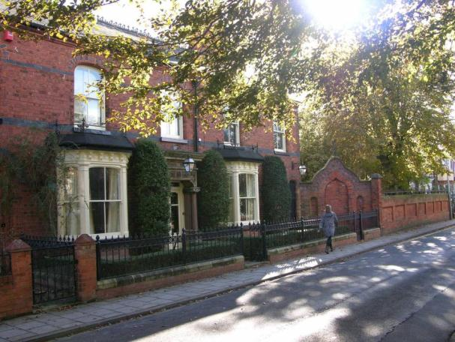
Rugby House in 2010
Name: Eskdale Villa, 161 Mill Road
Date Designated: 10/06/2013
Grid Reference: TA 3017 0831
Area Designation: Mill Road Conservation Area
Asset Type: Building
Main Criteria Used: 1d, 2e
Description:

A two storey villa built in 1894 in smooth red brick with patterned brick and yellow brick string courses. Timber frames to windows to bay with moulded fascia to ground floor. Timber frames to sash windows to first floor. Arched stone lintels, painted, with ornamental keystones. Re roofed in interlocking concrete tiles, chimney with square yellow pots, wood gutter with modillions.

An unusual interpretation of the standard villa design with the bay window central on the front elevation and flanked by doorways. Taken as a group the high quality houses on the upper portion of Mill Road are illustrative of the transformation of Cleethorpes from a series of hamlets to a relatively affluent town.

Covered by Article 4

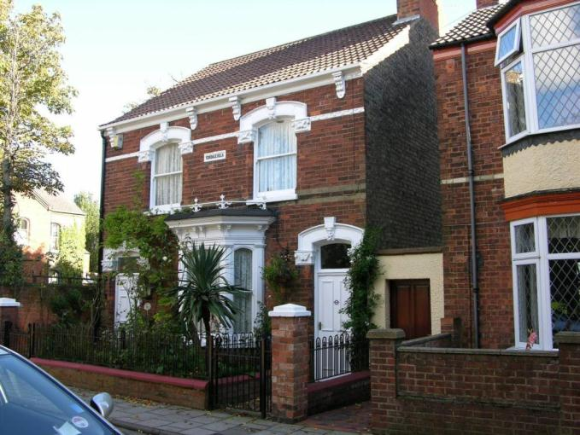

Name: The Mount, Mill Road
Date Designated: 10/06/2013
Grid Reference: TA 3011 0834
Area Designation: Mill Road Conservation Area
Asset Type: Building
Main Criteria Used: 1c, 2e
Description:

Built in 1904 by H C Scaping, Architect, for Alderman W. Grant J.P. with later additions by the same Architect.

A maternity home opened on the 14th of October 1929 by Lord Heneage; the building was a gift from Alderman Mrs. Croft Baker who also sold the adjoining property known as The Rookery in 1944 to form an annex to this building.
The building was used by expectant mothers to see private doctors but also had a consultant obstetrical service.
The site was closed as a maternity hospital in the early 1980’s when the service was transferred to the Grimsby Maternity Hospital

North East Lincolnshire NHS Trust: 1998. Grimsby Group of Hospitals: A Pictorial History

It is now in use as a private care home.
An important building not only to the history of the growth and development of Cleethorpes but also to the development of the modern National Health Service in the wider area.

Covered by Article 4

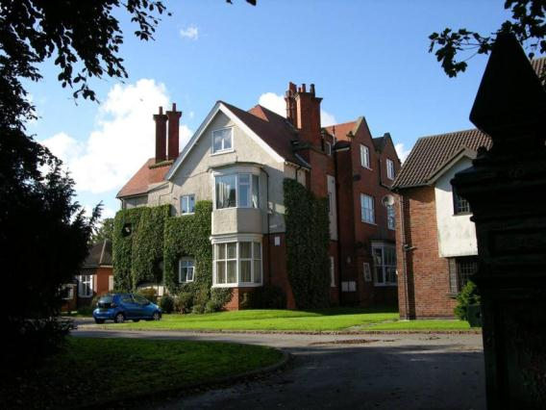

Oxford Street

Name: 20 Oxford Street
Date Designated: 10/06/2013
Grid Reference: TA 3085 0829
Area Designation: N/A
Asset Type: Building
Main Criteria Used: 1c, 2e
Description:

Two storey house, built on the end of a terrace but is self supporting and of a differing design.
Red brick with slate roof and stone dressings around the door.

An attractive house with original stained glass windows and good quality windows and an indicator of the early development of the town

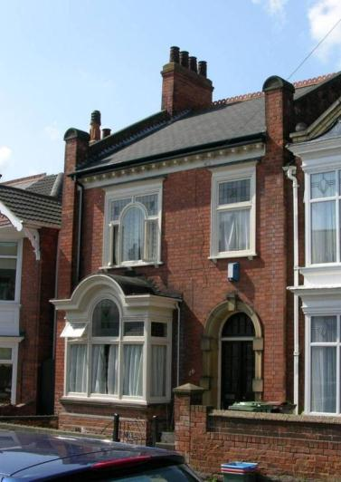

Name: 110 Oxford Street
Date Designated: 10/06/2013
Grid Reference: TA 3104 0803
Area Designation: Bradford Avenue Conservation Area
Asset Type: Building
Main Criteria Used: 1c, 2e
Description:

Two storey detached mock medieval style house, probably designed by William Wells given the similarity to 9 Great Coates Road in Little Coates. Brown brick with detailed brickwork, stone dressings around the main door, and a tiled roof.

A pleasing house on the corner of Bradford Avenue and forming part of the conservation area. The unusual triple gabled front makes for a striking property. An indicator of the early development of the town

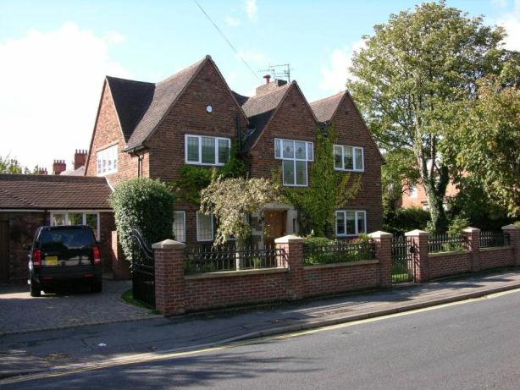

Name: Westlands, 111 Oxford Street
Date Designated: 10/06/2013
Grid Reference: TA 3107 0810
Area Designation: Bradford Avenue Conservation Area
Asset Type: Building
Main Criteria Used: 1c, 2e
Description:

A detached house in the form of a small rural manor house. In red brick with tile roof and good Edwardian features such as the tile hung first floor elevation.

A very fine house in reasonably sized grounds. The impact of the house is made especially high by its position on raised ground 2-3 foot above the surrounding pavement and its corner location. An indicator of the early development of the town

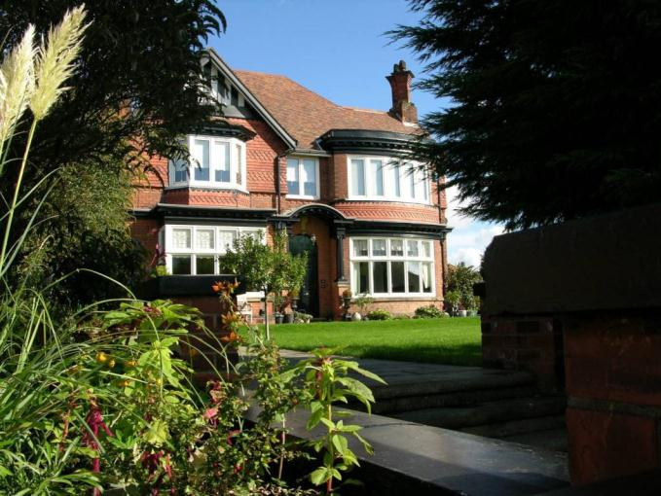

Pelham Road

Name: Cleethorpes Water Tower, Pelham Road
Date Designated: 10/06/2013
Grid Reference: TA 3015 0947
Area Designation: None
Asset Type: Building
Main Criteria Used: 1c, 2e
Description:

An early 20th century water tower, probably steel framed with concrete cladding.
String courses and round arched windows greatly soften the tone of a structure that would otherwise be oppressive. The original reservoir, which was slightly taller and narrower with modillions, pediment and cupola/lantern.
Despite the replacement of the original reservoir and attachment of untidy modern antennae, it still makes for an important local landmark particularly as it appears to have been deliberately aligned to Alexandra Road.

A very important indicator of the early development of Cleethorpes and the construction of the required infrastructure for the development of the settlement from a series of hamlets to a town.

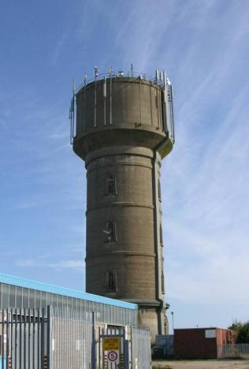

Prince’s Road

Name: Humberside Police Station, 45-47 Prince’s Road
Date Designated: 10/06/2013
Grid Reference: TA 3038 0908
Area Designation: None
Asset Type: Building
Main Criteria Used: 1c, 2e
Description:

Early 20th century Police Station and matching Police Houses to the rear.
Built of red/brown brick in a smart and formal Edwardian style with decorated re-constituted stone detailing. The main building is constructed to take advantage of a natural slope to disguise the mass of the station, which is three storeys to the rear.

Despite the loss of original windows in some of the Police Houses, the buildings make a very positive impact upon Prince’s Road and Poplar Road. The station is part of the required infrastructure for the development of the settlement from a series of hamlets to a town.

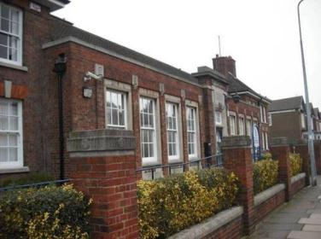

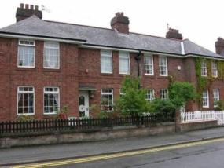

Reynolds Street

Name: Reynolds Infants and Primary Schools
Date Designated: 10/06/2013
Grid Reference: TA 2994 0911
Area Designation: None
Asset Type: Building
Main Criteria Used: 1c, 2e
Description:

Large Edwardian school, H shaped in plan with the infant’s wing facing Reynolds street and a matching primary wing facing the playing fields. The inner areas of the H form a pair of courtyard playgrounds.
Red/brown brickwork with some limited ashlar dressings and a slate roof. Reasonably well preserved in plan with only small extensions made in recent years.

An exemplar of traditional Edwardian architecture in the area, the simple detailing, strong horizontal emphasis and symmetry work well together to make a smart and orderly contribution to the street scene. An indicator of the early development of the town

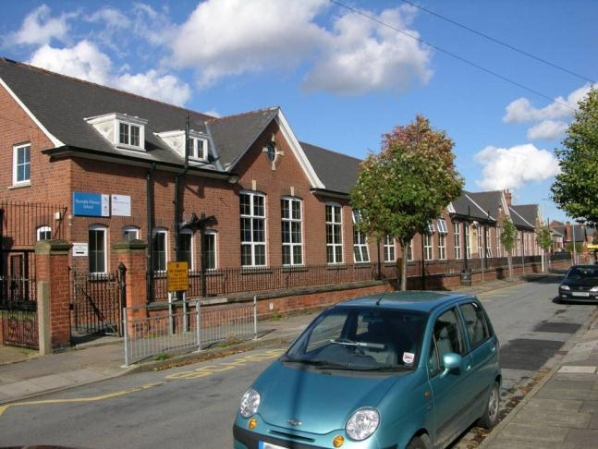

St Peter’s Avenue

Name: Memorial Cross, St Peter’s Church, St Peter’s Avenue
Date Designated: 10/06/2013
Grid Reference: TA 3056 0862
Area Designation: Central Seafront Conservation Area
Asset Type: Memorial
Main Criteria Used: 1b
Description:

Churchyard Memorial Cross in Arts and Crafts style with commemorative plaque bearing the names of the fallen inset into the Church’s wall behind.
Probably by the Imperial War Graves Commission.

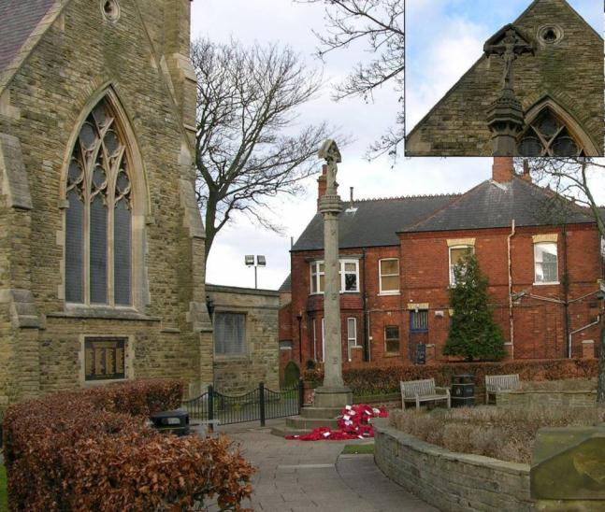

Name: 46 St Peter’s Avenue
Date Designated: 10/06/2013
Grid Reference: TA 3049 0872
Area Designation: None
Asset Type: Building
Main Criteria Used: 1c, 2e
Description:

Two storey 19th century villa house built in red brick with painted stone dressings covered by a hipped Welsh slate covered roof with ridge tiles and decorative finials of terracotta. A symmetrical frontage is a typical feature of a villa house. Bay windows flank a central arch topped door case surrounded by moulded brick pilasters and a stone and terracotta entablature containing decorative floral tiles. The same decorative terracotta tiles are found to the corbelled and dentilled eaves cornice and are repeated as a string course around the building. All window openings contain moulded brickwork and first floor has decorative shouldered arches with rubbed brick set between topped with a hood mould.

This is a good example of a Victorian villa, extant on the 1887-9 ordnance Survey mapping for Lincolnshire, now set within a townscape which during the 20th Century has developed as the principal shopping street.

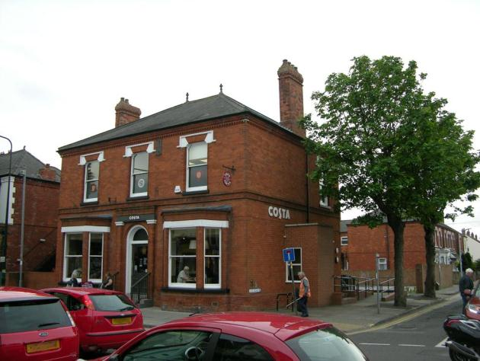

Name: St Peter’s Church Hall, St Peter’s Avenue
Date Designated: 10/06/2013
Grid Reference: TA 3063 0860
Area Designation: Central Seafront Conservation Area
Asset Type: Building
Main Criteria Used: 1a, 2e
Description:

A church hall of 1935 built in brown brick with reconstituted stone dressings. The structure is designed as a collection of cuboids with flat roofs in ascending scale reminiscent of a Ziggurat. The date stone and emblem of the National School it replaced is reset in the Cambridge Street façade.

An unusual building for the area and quite controversial, it nether less is a fine example of this type of design and is an important indicator of the early development of the town.

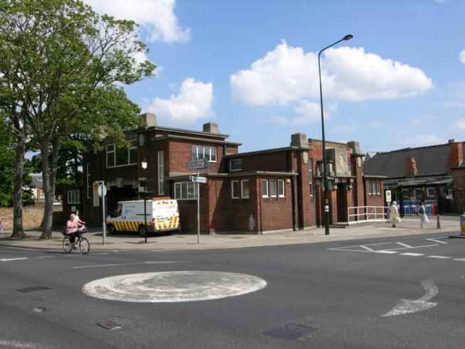

Sea View Street

Name: National Westminster Bank, Seaview Street
Date Designated: 10/06/2013
Grid Reference: TA 3089 0860
Area Designation: Central Seafront Conservation Area
Asset Type: Building
Main Criteria Used: 1c, 2c
Description:

National Westminster bank, built in 1925 by Walter F Willis in a neo-Georgian style with large round-arched windows and Tuscan columns.

Pevsner N and J Harris. 1989. The Buildings of England Lincolnshire. 2nd Edition. Yale University Press. New Haven and London.

A high quality corner building and an important building to the character of the resort.

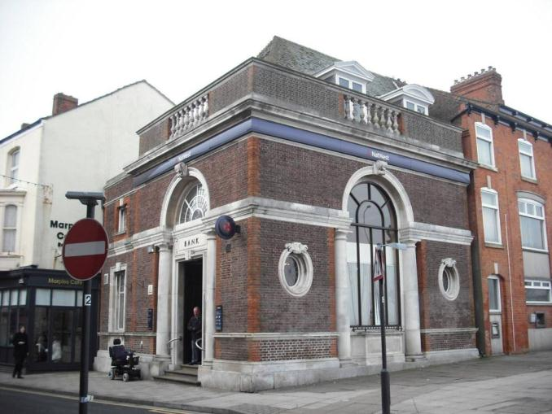

Name: The Nottingham House, 5 and 7 Seaview Street
Date Designated: 10/06/2013
Grid Reference: TA 3092 0859
Area Designation: Central Seafront Conservation Area
Asset Type: Building
Main Criteria Used: 1c, 2c
Description:

Old three roomed town pub by the seafront whose layout owes much to its remodelling, c.1950, by the Sheffield brewers Gilmour’s. A mix of good pre-war features with 1980s refurbishment works by Tetley’s.

Campaign for Real Ale. 2011. Yorkshire’s Real Heritage Pubs.

A good quality three storey building and n important building to the character of the resort and Sea View Street.

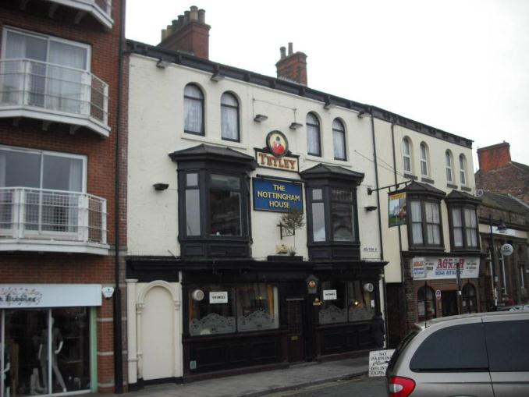

Name: HSBC, 11 and 13 Seaview Street
Date Designated: 10/06/2013
Grid Reference: TA 3090 0857
Area Designation: Central Seafront Conservation Area
Asset Type: Building
Main Criteria Used: 1c, 2c
Description:

A single storey stone dressed bank in good condition but with some alterations for the night box and cash-point which are not particularly well designed.

The building, although small, makes a significant impact upon the street scene because of its high quality design and materials. An important building to the character of the resort and Sea View Street.

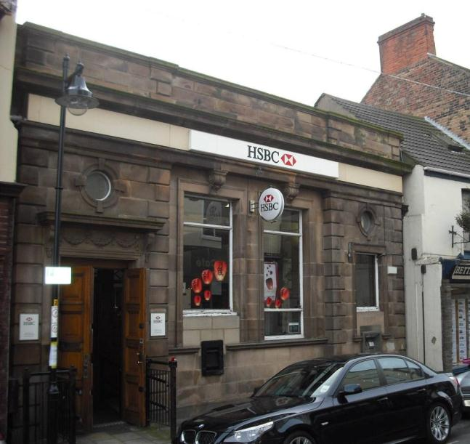
Name: 16,18, 20, 22 and 24 Seaview Street
Date Designated: 10/06/2013
Grid Reference: TA 3086 0856
Area Designation: Central Seafront Conservation Area
Asset Type: Building
Main Criteria Used: 1c, 2c
Description:

Two storey late 18th or early 19th century shops in painted brown brick, and a row of three late 18th or early 19th century shops in rendered brown brick.

Seaview Street has a number of early buildings, for Cleethorpes, and these are some of the better survivors with timber shop fronts and some with 6/6 hung sash on the first floor.

An important group of buildings to the character of the resort and Sea View Street.

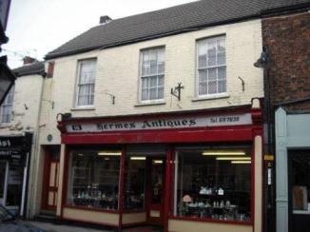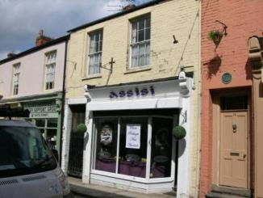

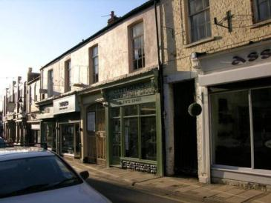

Name: Fisherman’s Arms, 29 Seaview Street
Date Designated: 10/06/2013
Grid Reference: TA 3088 0854
Area Designation: Central Seafront Conservation Area
Asset Type: Building
Main Criteria Used: 1c, 2c
Description:

3 storey 19th century public house, probably re-fronted on the ground floor in the 20th century. Built of red/brown brick, now painted, with an extension to the rear which appears to be early 20th century in origin.

A fine corner pub extended so that it fronts onto three roads making a bold impression on this part of town.

An important building to the character of the resort and Sea View Street.

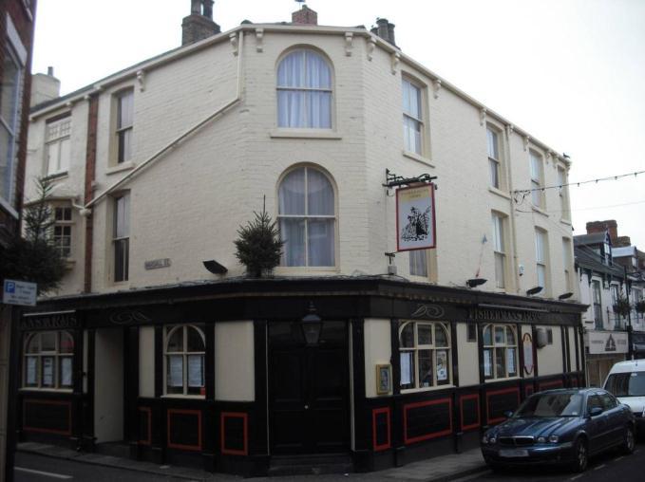

Name: Queen’s Hotel, 28 Seaview Street
Date Designated: 10/06/2013
Grid Reference: TA 3082 0854
Area Designation: Central Seafront Conservation Area
Asset Type: Building
Main Criteria Used: 1c, 2c
Description:

Two storey early 20th century public house in red brick with buff and blue/green terracotta dressings to both floors. Replaced an earlier public house. Probably designed by architect T Clayburn. In a similar style to, and forming a group, with The Humber on Cleethorpe Road and the Market Hotel on Cromwell Road.

An important building to the area and occupying a prominent street corner position the Queens is a well liked building and vital to the character of this part of town.

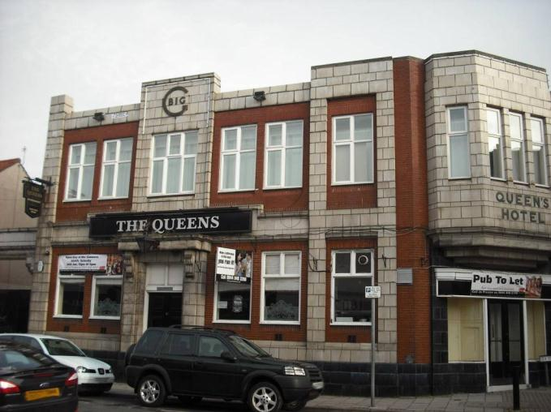

Name: 31, 33 and 35 Seaview Street
Date Designated: 10/06/2013
Grid Reference: TA 3085 0854
Area Designation: Central Seafront Conservation Area
Asset Type: Building
Main Criteria Used: 1c, 2c
Description:

A row of three probable mid to late 19th century shops with eyebrow or bell dormers.

A reasonably well preserved row, with some modern accretions such as shutter boxes but also with a good number of original features remaining. An important group of buildings to the character of the resort and Sea View Street.

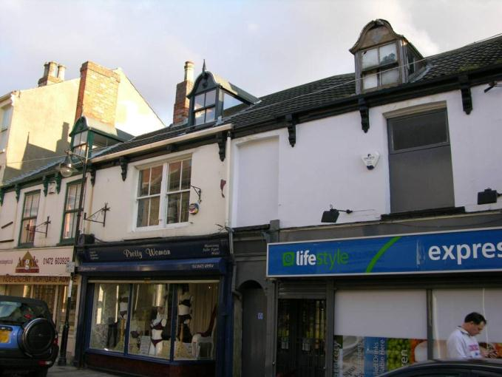

Name: 47 and 49 Seaview Street and 20 Cambridge Street
Date Designated: 10/06/2013
Grid Reference: TA 3082 0852
Area Designation: Central Seafront Conservation Area
Asset Type: Building
Main Criteria Used: 1c, 2c
Description:

Three storey late 18th or early 19th century shops in painted brown brick with an older two storey section fronting Cambridge Street.

Seaview Street has a number of early buildings, for Cleethorpes, and these are a pair of the better survivors with timber shop fronts on both frontages. An indicator of the pre-resort character of the town.

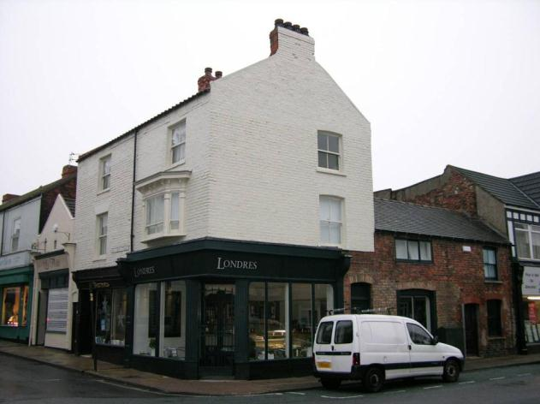

Name: The Gallery, 51 Seaview Street and 31 Cambridge Street
Date Designated: 10/06/2013
Grid Reference: TA 3080 0851
Area Designation: Central Seafront Conservation Area
Asset Type: Building
Main Criteria Used: 1c, 2c
Description:

Two storey corner shop in red brick and with a fine quality and well preserved timber shop front.

This well kept building with its tradition shop front is a good example and quality corner building which is an asset both to the conservation area but also the town and wider area.

An important building to the character of the resort and Sea View Street.

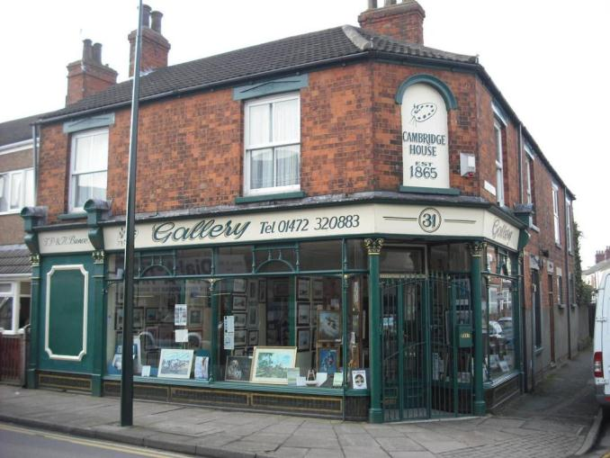

Taylor’s Avenue

Name: Haverstoe House, 1 Taylor’s Avenue
Date Designated: 10/06/2013
Grid Reference: TA 3073 0791
Area Designation: None
Asset Type: Building
Main Criteria Used: 1c, 2e
Description:

Two storey early 20th century manor house, formerly in larger grounds and the corner post of the original extent can still be seen at the entrance to Haverstoe Park which was constructed to the rear of the house sometime after its construction. The house was originally isolated from the town but has since been taken over by urban development.
Red/brown brick with stone dressings and a tile roof.

An important indicator of the rapid growth of the town and resort.

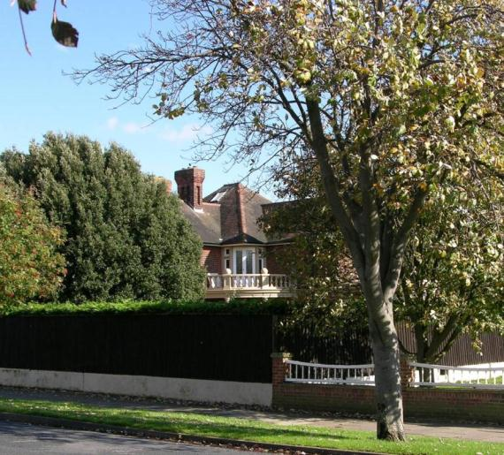

Thrunscoe Road

Name: 6 Thrunscoe Road
Date Designated: 10/06/2013
Grid Reference: TA 3067 0825
Area Designation: None
Asset Type: Building
Main Criteria Used: 1c, 2e
Description:

A large detached early 20th century villa in red brick with yellow brick and stone dressings and a Welsh slate roof with decorative red clay ridge tiles.

The polychrome brickwork, bold balcony (probably originally one of a pair) and other details make this building stand out as one of the best of its kind in the area. An indicator of the early development of the town.

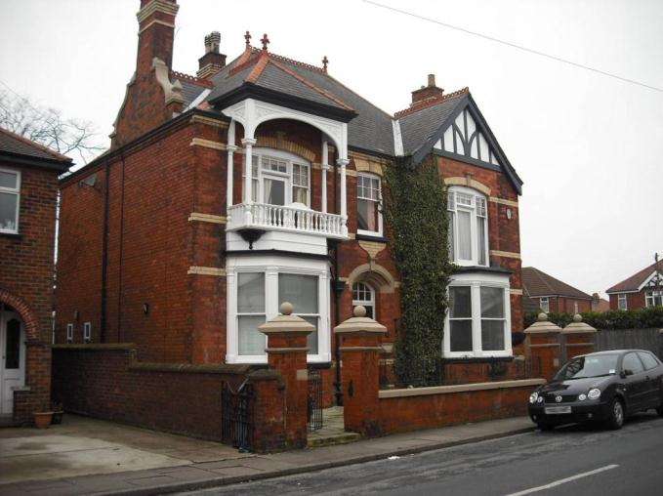

Yarra Road

Name: Hodson’s Architects, The Old Post Office, Yarra Road
Date Designated: 10/06/2013
Grid Reference: TA 3076 0869
Area Designation: Central Seafront Conservation Area
Asset Type: Building
Main Criteria Used: 1c, 2e
Description:

A two storey art-deco inspired post office in red brick but with a yellow brick and ashlar frontage.

An attractive building and an important buildings to the character of the resort and an indicator of the rising prosperity of the town in the early 20th century.

