Local List of Historic Assets of Special Interest
An extension of the Historic Environment Record (HER) for North East Lincolnshire

Draft Edition for the Southern Marshes

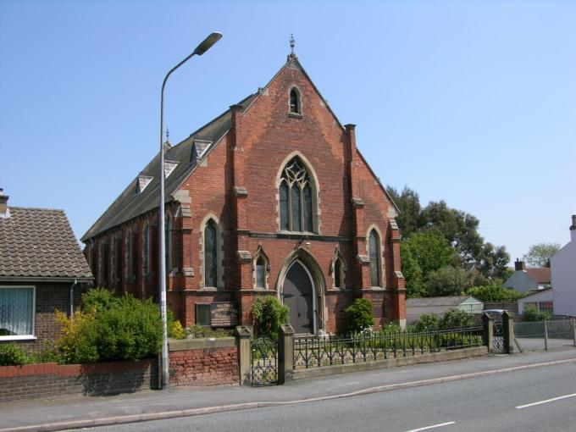

Draft August 2015

Contents

Introduction 2
A Note on Sources 2
Criteria for Listing 3
Basic Requirements for Assets 3
Ashby cum Fenby 4
Barnoldby le Beck 12
Bradley 19
Brigsley 26
Humberston 30
Laceby 51
New Waltham 75
Waltham 83

Introduction

This Local List of Historic Assets of Special Interest has been compiled in order to act as a planning tool. The entries within the list are the historic assets taken from the North East Lincolnshire Historic Environment Record, or HER, which require the greatest attention from developers and planning officers, among others, during the development process and regeneration schemes.
Heritage assets are usually included in the list because they are the best of their kind in the authority; however some assets are included because of the contribution that they make to the character of the local area.

By their very nature, buildings will make up the bulk of the list as they are the most visible of the historic assets and contribute greatly to the character of an area. Conversely, archaeological sites will be greatly under-represented on the list due to the difficulty in establishing the nature and extent of any individual assets without first excavating, particularly within the urban environment. Designed Landscapes, pieces of art and other assets are low in overall number and so will make up a minor part of the list; they are also the least likely to be affected by development.

A Note on Sources

The majority of the text in this document has been produced from scratch by staff in the Historic Environment Record. Where text has come from a single external source, every effort has been made to show that source in the text; however, the information on some assets, particularly archaeological sites, has been compiled from numerous sources and it would not be appropriate to list them all in a document such as this. In these cases, the reader is directed to the appropriate Historic Environment Record entries for further information and a list of the sources used to compile the information.

Criteria for Listing

General:

1a – The asset is rare or unique, in terms of the Borough, due to the period it represents, extent, architectural style or technological method of construction.
1b – The asset has the potential to contribute to our information on, understanding of, and appreciation of the Borough’s history and development.
1c – The asset makes a significant contribution to the historic character of an area and conforms to a Thematic criteria.
1d – The asset is part of a group of similar examples which, together, make a significant contribution to the character of an area or have the potential to provide high quality and/or quantity of historic environment data.

Thematic:

2a – Assets which exemplify a previous character type in a settlement or area which retain sufficient structure to inform on the previous character.
2b – Assets which are/were essential infrastructure associated with the Docks and Railways that retain a good proportion of their original extent.
2c – Assets which form an integral part of the character of the Resort of Cleethorpes.
2d – Assets which exemplify the rapid expansion, wealth or the major industrial and commercial activities of Grimsby in the 19th and early 20th centuries.
2e – Assets which exemplify the early development of Immingham and Cleethorpes from Villages and/or Hamlets into Towns.
2f – Post 1850s Urban Housing that retains the majority of its original structure, components and is of a high standard of design.
2g – Ecclesiastical, Manorial, Educational, Social and Agricultural assets representing the historic functions and practices of the towns and villages.

Basic Requirements for Assets

Buildings must retain the majority of their original fabric, external design style and character.

Archaeological Sites must be definable in extent and origin and be likely to retain well preserved deposits.

Designed Landscapes must be identifiable through aerial photography and at ground level. They must also be significant features in the wider landscape.

Ship Wrecks and Historic Ships must relate to the main industries of the Borough or form a group or loose association of assets.

Memorials must commemorate events of national or significant local significance and be of architectural or artistic interest.

Complex Assets are not a category in their own right, but rather contain two or more assets of the above categories that should be considered interdependent on each other.

Ashby cum Fenby

Ashby cum Fenby is a village formed by the amalgamation of two settlements, Ashby to the north and Fenby to the south.
Ashby is a nucleated settlement known to have existed since at least the early medieval period (410AD to 1066AD).
Fenby appears to have been a scattered hamlet settlement, also known to have existed since at least the early medieval period (410AD to 1066AD).

The Majority of the settlement is clustered to the south of the church, St Peter’s, and the medieval and post medieval manorial site now known as The Hall.

Ashby cum Fenby is recorded as having a population of 244 in the 1851 census according to White's directory of 1856. In the 2001 census the population was recorded as 248.

At the time of writing – 2nd October 2015 – Ashby cum Fenby has:

64 Historic Environment Records of which:
5 are nationally Listed Buildings
None are nationally Scheduled Monuments
7 are proposed Locally Listed Historic Assets
Name: Hall, Main Road, Ashby cum Fenby
Date Designated: N/A – New Proposal
Grid Reference: TA 2537 0088
Area Designation: None
Asset Type: Building
Main Criteria Used: 1c, 2g
Description:

Former Sunday school, now a village hall. Yellow brick with round arched windows and clay tile roof.

An essential part of the character and social functions of the village.

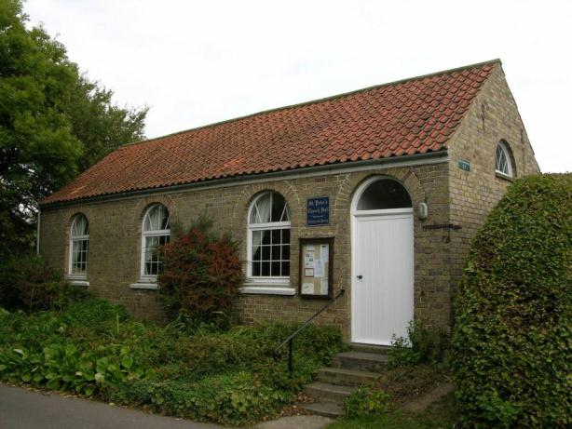

Name: Ashby House, Ashby cum Fenby
Date Designated: N/A – New Proposal
Grid Reference: TA 2545 0082
Area Designation: None
Asset Type: Building
Main Criteria Used: 1c, 2g
Description:

Ashby House, the former rectory of St. Peter's, Ashby cum Fenby. A "brick box" built in 1844 by John Carr, a builder.

Pevsner N and J Harris. 1989. The Buildings of England Lincolnshire. 2nd Edition. Yale University Press. New Haven and London.

Built in buff/yellow brick with a slate roof, a main 3 bay façade to the driveway (south west) and a secondary 3 bay façade to the garden (south east) that is blind to both central elevations and has large square section bay windows to the ground floor. A handsome house and a good survivor.

An important part of the ecclesiastical functions of the village.

Name: Cast Iron Phone Box, Post Office Lane
Date Designated: N/A – New Proposal
Grid Reference: TA 2536 0080
Area Designation: None
Asset Type: Building
Main Criteria Used: 1c, 2g
Description:

A decommissioned K6, or similar model, telephone kiosk now maintained by the parish council. Cast iron. Square kiosk with domed roof. Un-perforated crowns to top panels and margin glazing to windows and door

Although once widespread, cast-iron phone boxes have become synonymous with historic and rural areas and are therefore important to the character of the villages.

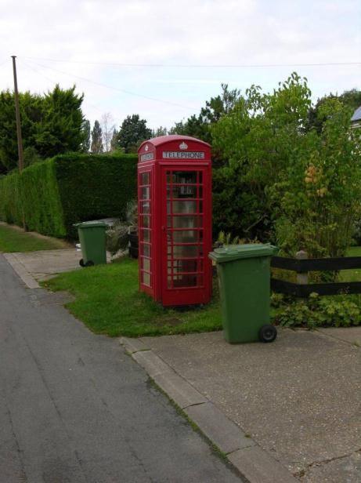

Name: Longwood, Ashby-cum-Fenby
Date Designated: N/A – New Proposal
Grid Reference: TA 2487 0131
Area Designation: None
Asset Type: Building
Main Criteria Used: 1c, 2g
Description:

A farmstead, probably 19th century, which appears to consist of a small farmhouse and L-plan range of farm buildings. All of the buildings shown on Ordnance Survey maps of 1887-9 are present.

This site has been surveyed from aerial photographs and maps only. It is assumed from this evidence that it is of at least local interest.

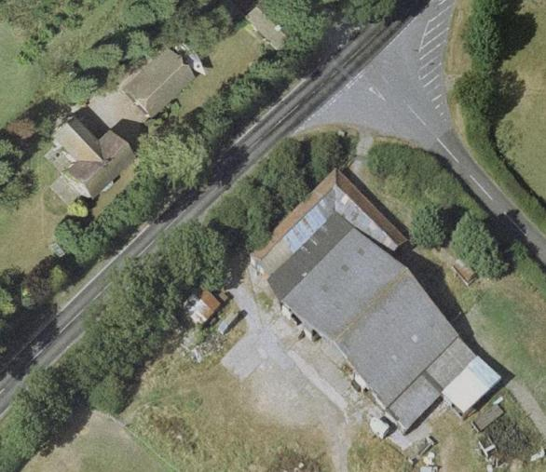
Image Taken in 2006
The GeoInformation Group Data ® copyright by The GeoInformation® Group, 2015

Name: Ashby Medieval or Post Medieval moat and formal garden
Date Designated: N/A – New Proposal
Grid Reference: TA 2531 0105
Area Designation: None
Asset Type: Archaeological Site
Main Criteria Used: 1b, 2g
Description:

The site of a moated manorial enclosure and formal gardens associated with precursors to the current manor house (“The Hall”), now largely levelled but likely to retain buried deposits of significant importance to the understanding of the growth, development and activities of the village during the medieval and early post-medieval periods.

The listing is limited to the areas currently under pasture to the north and west of The Hall, but related deposits will also exist in the arable field to the south east.

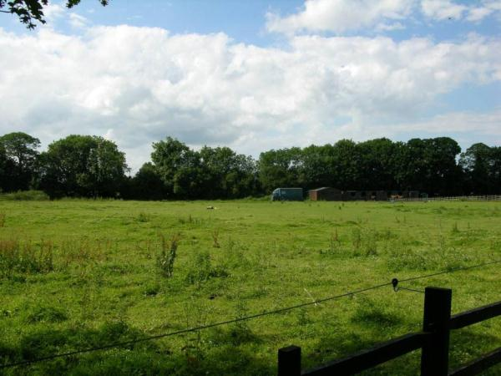

Name: Medieval Village Earthworks West and South of the Church of Saint Peter, Ashby
Date Designated: N/A – New Proposal
Grid Reference: TA 2544 0091
Area Designation: None
Asset Type: Archaeological Site
Main Criteria Used: 1b, 2g
Description:

An area of overgrown earthworks to the west and south of the parish church in Ashby. The earthworks appear to represent medieval land division closely associated with housing (crofts) and have been recorded by the RCHME National Mapping Program.

As a landscape feature the earthworks represent the shrinking and re-organisation of the village following the medieval period, and will contain archaeological deposits which have the potential to inform the understanding of the development of the village.

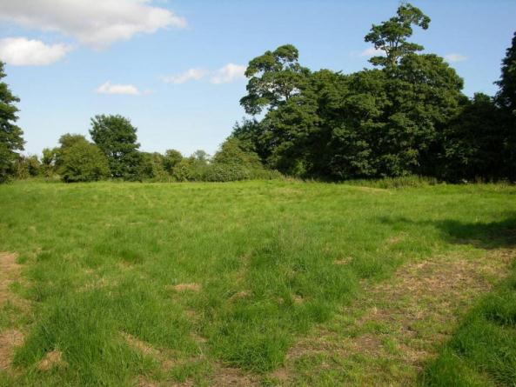

Name: Medieval Village Earthworks North of Homefield Farmhouse, Ashby
Date Designated: N/A – New Proposal
Grid Reference: TA 2534 0041
Area Designation: None
Asset Type: Archaeological Site
Main Criteria Used: 1b
Description:

An area of earthworks of limited area but substantial size, probably dating to the medieval period. The exact origin of the earthworks is unknown, but they seem likely to relate to a significant activity within the village due to their size and are likely to contain important archaeological deposits.

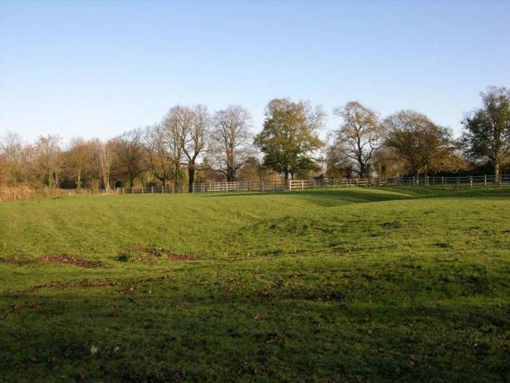

Barnoldby le Beck

Barnoldby le Beck is a settlement clustered to the south of the parish church of St Helen, for the most part laid out along the main west-east road running through the village but with scattered houses elsewhere within the historic core. The southern section of the medieval settlement area and adjacent ridge and furrow earthworks were imparked, probably in the 18th century, into two large landscape parks. It is known to have existed since at least the early medieval period (410AD to 1066AD).

Barnoldby le Beck is recorded as having a population of 269 in the 1851 census according to White's directory of 1856. In the 2001 census the population is recorded as 314.

At the time of writing – 2nd October 2015 – Barnoldby le Beck has:

51 Historic Environment Records of which:
5 are nationally Listed Buildings
None are nationally Scheduled Monuments
6 are proposed Locally Listed Historic Assets

Name: Lodge and Gardens to Beckland’s House
Date Designated: N/A – New Proposal
Grid Reference: TA 2431 0333
Area Designation: None
Asset Type: Complex (Building and Designed Landscape)
Main Criteria Used: 1c, 2g
Description:

A single storey lodge house for Beckland’s, in yellow brick with a slate roof. Built at the entrance to Beckland’s House, a large Victorian Italianate country house demolished in the mid 20th century. The gardens appear to retain their original layout and planting which is parkland in style.

Although the main house has been replaced, the lodge and gardens are still an important asset to the village indicating the presence of a substantial house and therefore indicative of social activities within the village.

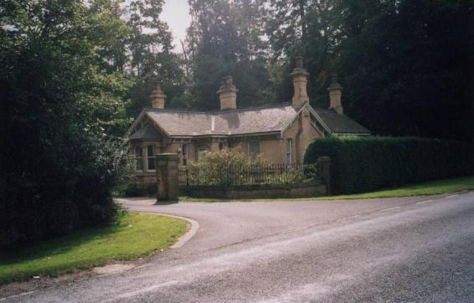

Name: Old Manor House, Waltham Road
Date Designated: N/A – New Proposal
Grid Reference: TA 2352 0315
Area Designation: None
Asset Type: Building
Main Criteria Used: 1c, 2g
Description:

An 18th century manor house, whitewashed red brick, pantiles, 2 storeys, first floor and eaves bands. Central projection, 2:1:2 flush sashes under keystones and painted rusticated flat arches.

Ministry of Housing and Local Government. 1964. List of Buildings of Special Architectural or Historic Interest - Provisional for Grimsby Rural District. Grade 3.

Since the 1964 description of the building was written the house has been converted into two houses with the central bay re-arranged into two bays and the brickwork rendered. It is still, however, an important building to the character of the village and representing part of the social activities of the settlement.

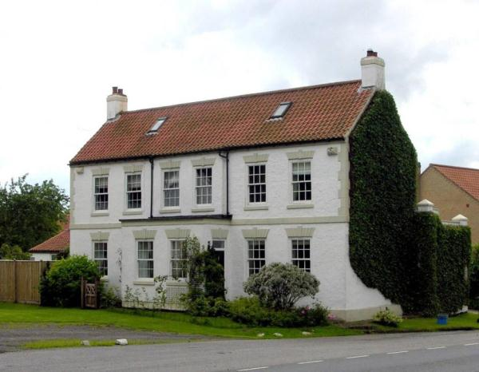

Name: The Ship Inn, Waltham Road
Date Designated: N/A – New Proposal
Grid Reference: TA 2363 0322
Area Designation: None
Asset Type: Building
Main Criteria Used: 1c, 2g
Description:

Early 19th century. Rendered and white-washed, red tile roof. 2 storeys, 3 sashes in reveals, outer first floor windows 2 light, ground floor 3 light. 6 panel door, oblong fanlight, surround of Roman Doric pilasters, entablature.

Ministry of Housing and Local Government. 1964. List of Buildings of Special Architectural or Historic Interest - Provisional for Grimsby Rural District. Grade 3.

An important building to the character of the village and representing part of the social activities of the settlement.

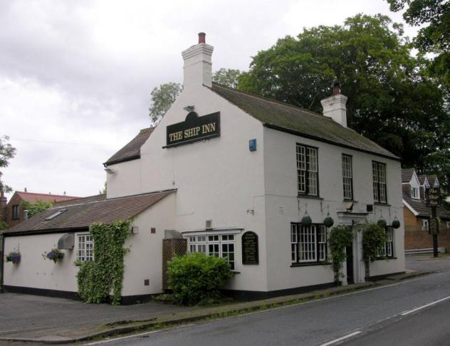

Name: Barnoldby Rectory
Date Designated: N/A – New Proposal
Grid Reference: TA 2355 0337
Area Designation: None
Asset Type: Building
Main Criteria Used: 1c, 2g
Description:

A rectory in grey-buff brick with a slate roof. Three bays wide facing the graveyard with central garden style doorway, 6/6 sash windows to the ground floor under flared arches, 3/6 sash windows to the first floor under flared arches, eaves course with corbels. Secondary frontage faces the driveway, the right bay projecting with a round-section bay window to the ground floor, central doorway with side and transom lights under a wide segmental arch.

It is recorded as having been designed or altered by James Fowler in 1885, however the present building is clearly older than this and so it seems that Fowler oversaw some modernisations of the rectory at this time rather than any major construction works.

A fine quality building with two good frontages, representative of the religious and social functions of the village.

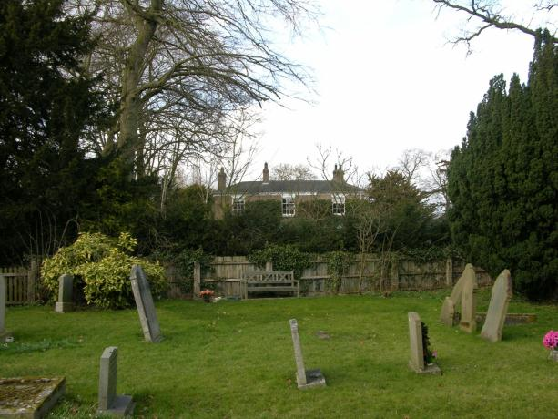

Name: Mount Pleasant West
Date Designated: N/A – New Proposal
Grid Reference: TA 23339 03516
Area Designation: None
Asset Type: Building
Main Criteria Used: 1c, 2g
Description:

An isolated farmhouse, probably late 18th or early 19th century, with outbuildings to the rear. Originally surrounded by fields the house is now set within a large area of plantations.
Two storeys, painted brick, three bays wide with a gabled tile roof and end stacks.

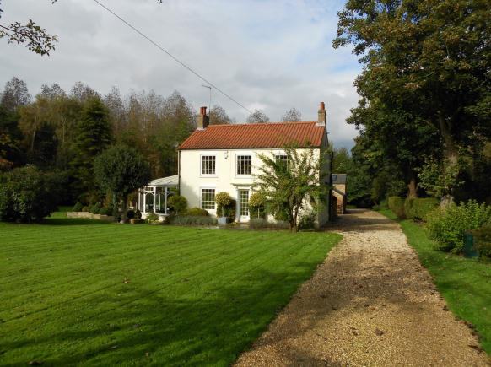

Name: Shrunken medieval village earthworks in Barnoldby le Beck
Date Designated: N/A – New Proposal
Grid Reference: TA 2351 0292
Area Designation: None
Asset Type: Complex (Archaeological Site, Designed Landscape)
Main Criteria Used: 1b, 2g
Description:

Earthworks representing the former medieval extent of Barnoldby le Beck to the south of Main Road and Waltham Road representing building platforms, paddocks and trackways.

The site is also a small part of a landscape park which seems to have been associated with the Grade II Listed country house known as Woodlands (NHLE: 1346947) and still forms an important part of the setting to the house.

As a landscape feature the earthworks represent the shrinking and re-organisation of the village following the medieval period, and will contain archaeological deposits which have the potential to inform the understanding of the development of the village. The parkland, although only representing a small portion of the original extent, forms part of the social landscape of the area, indicating the influence of the country house and it’s wealthy owners.

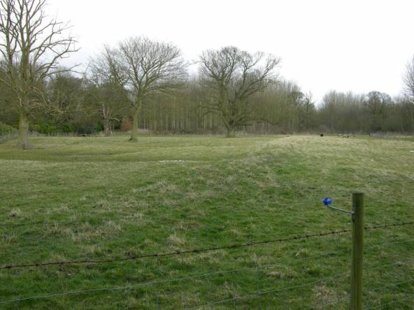

Bradley

Bradley is a small settlement clustered, for the most part, near to the parish church of St George, with the historic core arranged around a sub-rectangular road system of probable medieval origin. Bradley is known to have existed since at least the early medieval period (410AD to 1066AD).

Bradley is recorded as having a population of 97 in the 1851 census according to White's directory of 1856. In the 2001 census the population is recorded as 195.

At the time of writing – 2nd October 2015 – Bradley has:

33 Historic Environment Records of which:
4 are nationally Listed Buildings (one being a dual designation)
1 is a nationally Scheduled Monument (and is a dual designation)
6 are proposed Locally Listed Historic Assets

Name: The Old Rectory, Church Lane
Date Designated: N/A – New Proposal
Grid Reference: TA 24285 06783
Area Designation: None
Asset Type: Building
Main Criteria Used: 1c, 2g
Description:

The Old Rectory, east of the Church. Tudor style built by Daniel Foys of Scartho in 1849.

Pevsner N and J Harris. 1989. The Buildings of England Lincolnshire. 2nd Edition. Yale University Press. New Haven and London.

A prominent and well designed building which represents an important part of the ecclesiastical functions of the village.

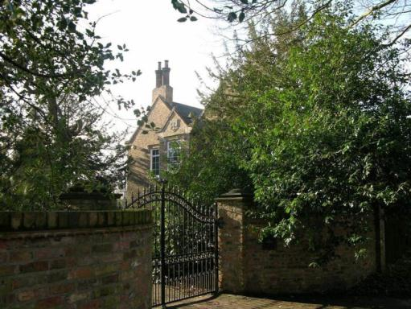

Name: The Gairs, Bradley
Date Designated: N/A – New Proposal
Grid Reference: TA 2492 0489
Area Designation: None
Asset Type: Complex (Building, Designed Landscape)
Main Criteria Used: 1c, 2g
Description:

A large 20th century country house with a formal garden and lodges in Lutchyens style. Built some time around 1924.

The house represents one of the last country houses to be built in the authority and is an important part of the social functions and practices of the area.

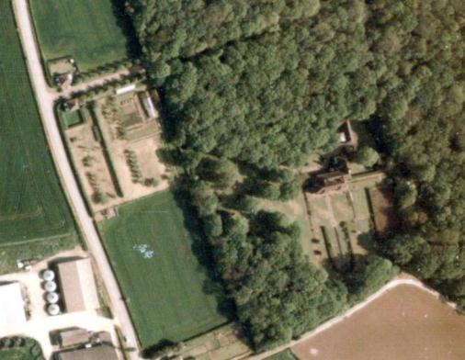
Print Copyright Humberside County Council and JAS Air 1989
Digital Scan Copyright North East Lincolnshire Council 2015
Name: Bradley Grove
Date Designated: N/A – New Proposal
Grid Reference: TA 25328 04612
Area Designation: None
Asset Type: Building
Main Criteria Used: 1c, 2g
Description:

A farmstead, probably 19th century, which appears to consist of a small farmhouse, an L-plan range of farm buildings and a single long farm building. All of the buildings shown on Ordnance Survey maps of 1887-9 are present. Formerley called Kirks Farm, and recorded at least as far back as 1828.

This site has been surveyed from aerial photographs and maps only. It is assumed from this evidence that it is of at least local interest.

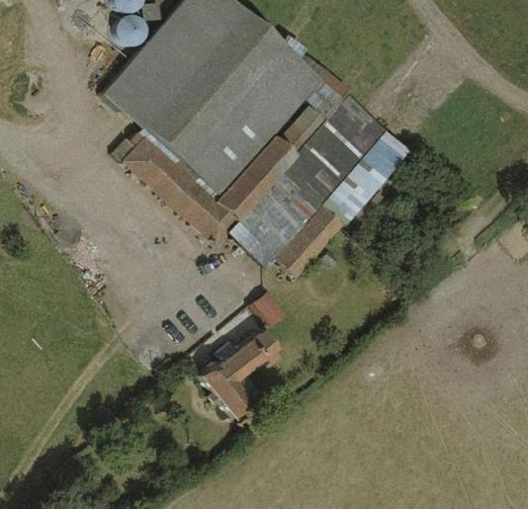
Image Taken in 2006
The GeoInformation Group Data ® copyright by The GeoInformation® Group, 2015

Name: Shrunken medieval village earthworks, Bradley
Date Designated: N/A – New Proposal
Grid Reference: TA 2421 0667
Area Designation: None
Asset Type: Archaeological Site
Main Criteria Used: 1b
Description:

An area of earthworks of medieval date comprising crofts and a hollow way.

As a landscape feature the earthworks represent the shrinking and re-organisation of the village following the medieval period, and will contain archaeological deposits which have the potential to inform the understanding of the development of the village.

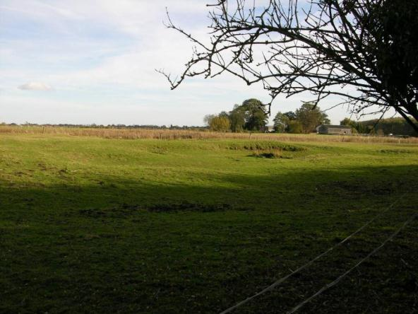

Name: Cropmark enclosures 70m south of Netherwood Cottages
Date Designated: N/A – New Proposal
Grid Reference: TA 249 046
Area Designation: None
Asset Type: Archaeological Site
Main Criteria Used: 1b
Description:

A pair of cropmark enclosures separated by a possible trackway, with a third possible but fragmentary cropmark enclosure to the south west. The most intact cropmark measures c.55mx50m.

Sites such as this, which pre-date the creation of most of the villages and towns in the area, are important for the archaeological deposits that they contain and the information on previous settlement and activities in the area that these deposits can provide.

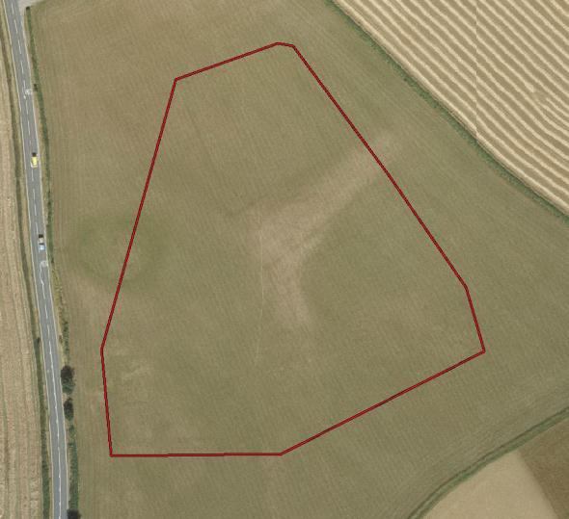
Image Taken in 2006
The GeoInformation Group Data ® copyright by The GeoInformation® Group, 2015

Name: Cropmark Enclosure 600m west of the former Low Farm in Bradley
Date Designated: N/A – New Proposal
Grid Reference: TA 2326 0501
Area Designation: None
Asset Type: Archaeological Site
Main Criteria Used: 1b
Description:

A single near-square enclosure. Aerial photographs show the ditch to be fairly narrow and it seems more likely to be of Iron Age and/or Roman date than a medieval moat. Traces of ditches to the south may indicate other associated elements

Air Photo Services. 2011. Hornsea Project 1, Onshore Cable Route, North Coates to North Killingholme, Lincolnshire: Aerial Photographic Assessment.

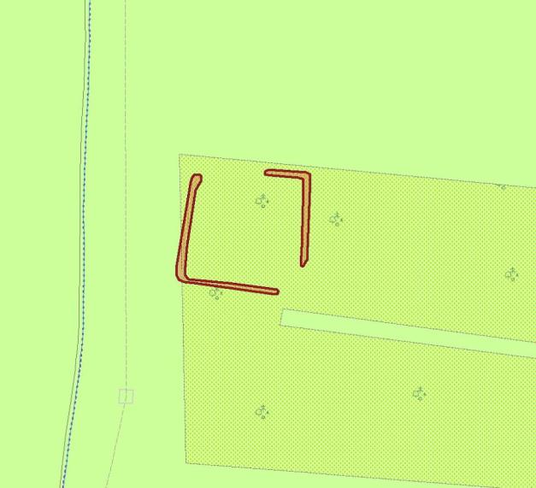
Plot of the Cropmark, as mapped by Air Photo Services
Reproduced from an Ordnance Survey map with the permission of the Controller of HMSO © Crown Copyright.
Licence number 100020759 North East Lincolnshire Council

Brigsley

Brigsley is a settlement that is known to have existed since the early medieval period (410AD to 1066AD). The majority of the settlement is arranged around a sub rectangular road system of probable medieval origin.

Brigsley is recorded as having a population of 137 in the 1851 census according to White's directory of 1856. In the 2001 census the population is recorded as 368.

At the time of writing – 2nd October 2015 – Brigsley has:

33 Historic Environment Records of which:
3 are nationally Listed Buildings
None are nationally Scheduled Monuments
3 are proposed Locally Listed Historic Assets

Name: Primitive Methodist Chapel, Waithe Lane
Date Designated: N/A – New Proposal
Grid Reference: TA 2540 0170
Area Designation: None
Asset Type: Building
Main Criteria Used: 1c, 2g
Description:

Primitive Methodist chapel built in 1873, the chapel closed in 1975 and is now a dwelling. The building is of brick, with a broad three-bay front (National Monuments Record: TA 20 SE 40)

Despite alterations, presumably made during conversion, the chapel is still an important part of the character of the village and represents part of the ecclesiastical practices of the settlement.

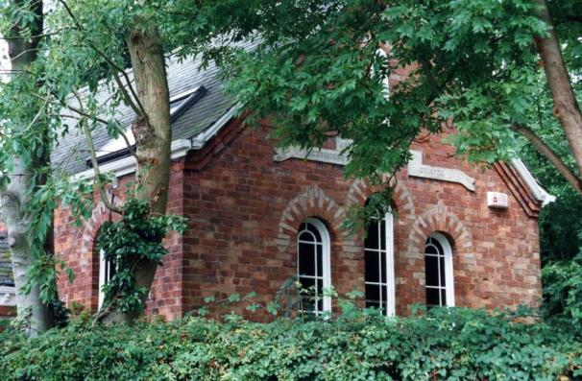

Name: Brigsley medieval settlement earthworks
Date Designated: N/A – New Proposal
Grid Reference: TA 25435 01729
Area Designation: None
Asset Type: Archaeological Site
Main Criteria Used: 1b, 2g
Description:

Three discrete, but related, areas of earthworks associated with the medieval and post medieval settlement of Brigsley. One site lies to the east of Waltham Road to the south and west of Manor House; the second lies within woodland to the west and east of a hollow way running from Green Lane to Waithe Lane; the third lies to the south of Waithe Lane adjacent to Waithe Beck.

The earthworks are likely to contain well preserved archaeological deposits which will be vital to establishing a context for other historic finds made during development works, such as the 7th to 9th century finds found during the reconstruction of Willow Cottage in 2006.

See HER Numbers - 0121/0/0 and 0121/5/0 - for further information and sources

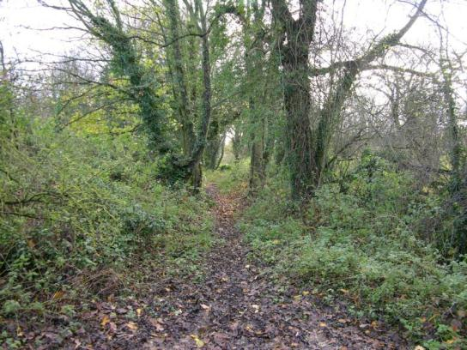
A footpath occupying the probable medieval Hollow Way within woodlands in Brigsley

Name: Hillside Farm, Brigsley
Date Designated: N/A – New Proposal
Grid Reference: TA 2736 0169
Area Designation: None
Asset Type: Building
Main Criteria Used: 1c, 2g
Description:

A farmstead, probably 19th century, which appears to consist of a small farmhouse and a C-plan range of farm buildings. All of the buildings shown on Ordnance Survey maps of 1887-9 are present.

This site has been surveyed from aerial photographs and maps only. It is assumed from this evidence that it is of at least local interest.

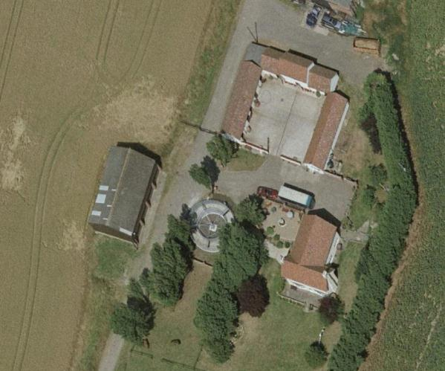
Image Taken in 2006
The GeoInformation Group Data ® copyright by The GeoInformation® Group, 2015

Humberston

Humberston is a historic settlement known to have existed since the early medieval period (410AD to 1066AD). The historic settlement pattern of the village appears to have been elongated along the roads that are now known as Church Avenue and Tetney Road with apparent cores of settlement at either end of Church Avenue.

Humberston(e) is recorded as having a population of 259 in the 1851 census according to White's directory of 1856. In the 2001 census the population is recorded as 5,384.

At the time of writing – 2nd October 2014 – Humberston has:

174 Historic Environment Records of which:
6 are nationally Listed Buildings (one being a dual designation)
1 is a nationally Scheduled Monument (part of which is also a Listed Building)
20 are proposed Locally Listed Historic Assets

Name: Almshouses, 22-26 Tetney Road and 44-48 Tetney Road
Date Designated: N/A – New Proposal
Grid Reference: TA 3091 0512 and TA 3093 0497
Area Designation: None
Asset Type: Building
Main Criteria Used: 1c, 2g
Description:

Two blocks of 19th century almshouses, c.1821, in two storey rows with utility buildings to the rear still intact and independent from the main structures. Built in buff brick with pantile roofs, small extensions to the sides and porch to the central dwelling.
Paid for by a trust set up following the death of Matthew Humberstone, lord of the manor, in the early 18th century. The charity took over a century to be properly established, by which time the original grant of around £1,100 had been increased to £21,855.

A good set of cottages, despite modern alterations, which are an important part of the social activities of the village.

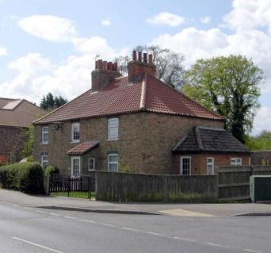

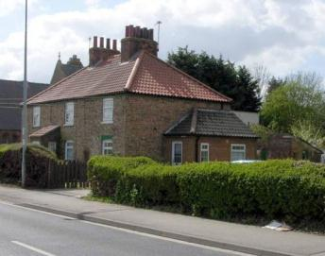
Name: Old Vicarage, Church Lane
Date Designated: N/A – New Proposal
Grid Reference: TA 3122 0541
Area Designation: Humberston Conservation Area
Asset Type: Building
Main Criteria Used: 1c, 2g
Description:

An eighteenth or early nineteenth century house named The Old Vicarage but reputedly connected to the Methodists chapels rather than the Anglican church. Two storey, brown brick but now rendered, with early 20th century alterations including an applied “plinth”, front porch, Rosemary tile roof and small extension to the rear. Recent uPVC windows and rear door.

An important part of the character of the village with an interesting history.

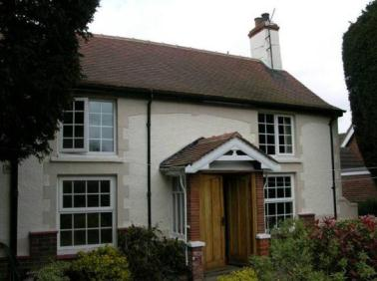

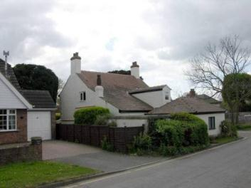
Name: Schoolhouse, Tetney Road
Date Designated: N/A – New Proposal
Grid Reference: TA 3092 0495
Area Designation: None
Asset Type: Building
Main Criteria Used: 1c, 2g
Description:

An asymmetrical schoolhouse, c.1821, built of brown brick with slate roof. The school is now two properties, presumably split between the school master’s house and the school itself.

Paid for by a trust set up following the death of Matthew Humberstone, lord of the manor, in the early 18th century. The charity took over a century to be properly established, by which time the original grant of around £1,100 had been increased to £21,855. The school was established to take a maximum of 100 free scholars, and took male pupils from Humberstone, Laceby, Clee, Cleethorpes, Weelsby, Tetney, Scartho and Holton-le-Clay.

An important part of the social and educational functions of the village.

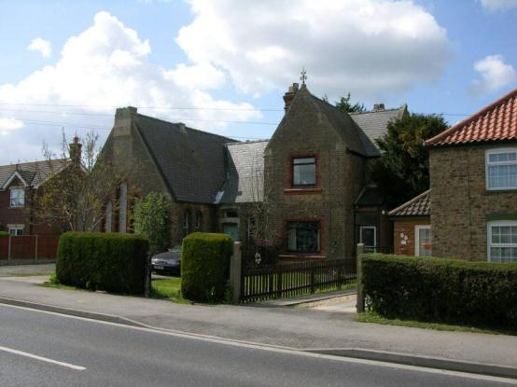

Name: South Sea Lane Farmhouse
Date Designated: N/A – New Proposal
Grid Reference: TA 3107 0478
Area Designation: None
Asset Type: Building
Main Criteria Used: 1c, 2g
Description:

A probable 18th century farmhouse with later extensions and a mix of vertical and horizontal sliding sash and historic casement windows. Square on plan, facing the fields to the south.
The majority of the associated farm buildings have survived, albeit with extensive repairs and rebuilds, and add significantly to the character of the village.

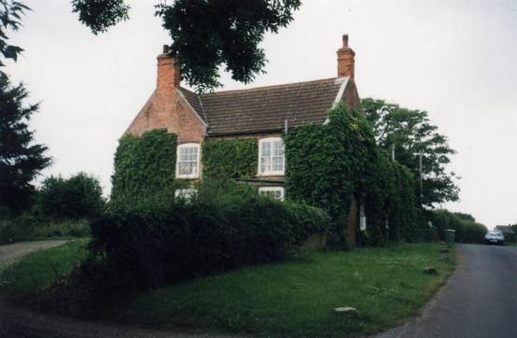

Name: The Vicarage, Tetney Road
Date Designated: N/A – New Proposal
Grid Reference: TA 3089 0505
Area Designation: None
Asset Type: Building
Main Criteria Used: 1c, 2g
Description:

A grand 19th century Vicarage built of red/brown brick with a slate roof. The front elevation is 5 bays wide with hung sash windows and the remains of a wooden porch in imitation of carved stone. The building has a large rear wing, of two storeys and also retaining original features, and large detached coach house.

A large and handsome house which represents an important part of the ecclesiastical functions of the village.

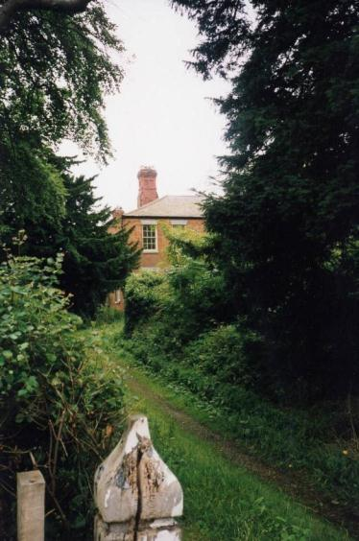

Name: Wendover Hall, Wendover Lane
Date Designated: N/A – New Proposal
Grid Reference: TA 3121 0536
Area Designation: Humberston Conservation Area
Asset Type: Building
Main Criteria Used: 1d, 2g
Description:

A Wesleyan Methodist chapel of 1835 and Sunday school of 1896 with a village or church hall of 1909 connecting them. All are built of brick with slate roofs. The entrance has been blocked and moved to the former rear of the building.

One of a number of historic buildings in the core of Humberston that represent the functions of the historic village.

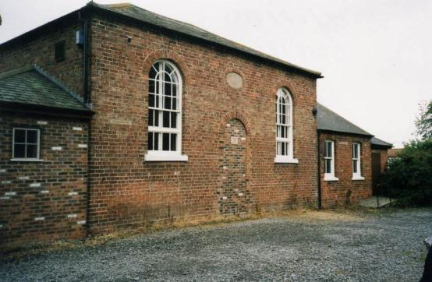

Name: Wesleyan Methodist Chapel, Humberston Avenue
Date Designated: N/A – New Proposal
Grid Reference: TA 3088 0530
Area Designation: Humberston Conservation Area
Asset Type: Building
Main Criteria Used: 1c, 2g
Description:

A 20th century Wesleyan Methodist Chapel, built to replace Wendover Hall. Red brick with stone dressings and a slate roof. Rather elaborate for a Methodist Chapel with traceried windows and spire like pinnacles on the front corners.

A prominent building which represents an important part of the ecclesiastical functions of the village.

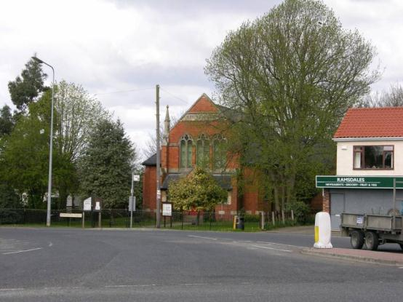

Name: The Barn, Wendover Lane
Date Designated: N/A – New Proposal
Grid Reference: TA 3128 0534
Area Designation: Humberston Conservation Area
Asset Type: Building
Main Criteria Used: 1a
Description:

A small timber framed cottage, probably originating in the 17th century, with later additions and extensions.

At the turn of the 20th century Humberston contained at least 10 timber framed buildings thought to date from the 17th and 18th centuries, roughly 15-20% of the total number within the Borough. Of these only two remain standing, with another example in ruinous condition. The original building is therefore a rare example within the area due to it’s date and method of construction.

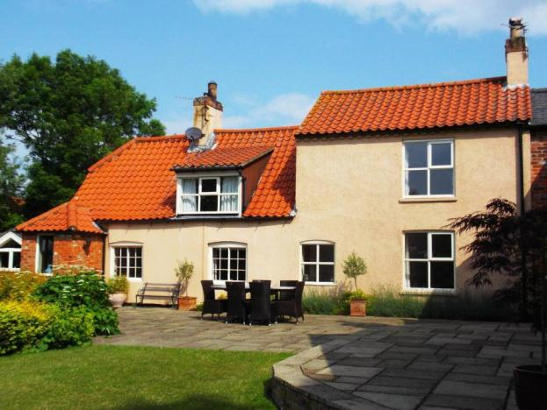

Name: Strickle Cottage, 2a Wendover Lane
Date Designated: N/A – New Proposal
Grid Reference: TA 3123 0537
Area Designation: Humberston Conservation Area
Asset Type: Building
Main Criteria Used: 1d, 2g
Description:

A small workers cottage built in brick with a concrete tile roof and wooden horizontal sliding sash windows.

One of a number of historic buildings in the core of Humberston that represent the functions of the historic village.

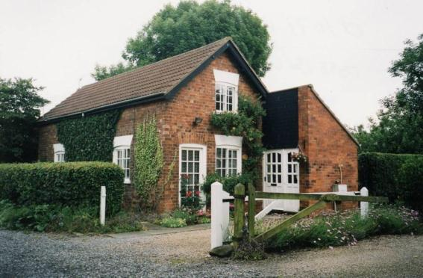

Name: The Forge, Church Lane
Date Designated: N/A – New Proposal
Grid Reference: TA 3117 0534
Area Designation: Humberston Conservation Area
Asset Type: Building
Main Criteria Used: 1d, 2g
Description:

A former blacksmith’s workshop converted into a dwelling. Brick built with a slate roof.

One of a number of historic buildings in the core of Humberston that represent the functions of the historic village.

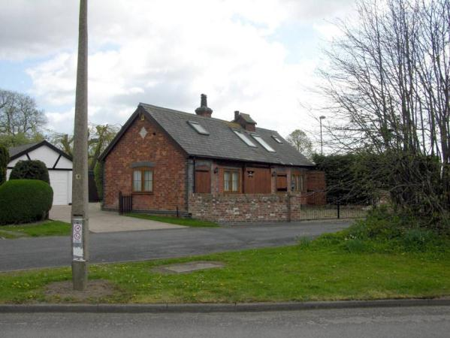
Name: War Memorial, Saint Peter’s Churchyard, Humberston
Date Designated: N/A – New Proposal
Grid Reference: TA 3108 0529
Area Designation: Humberston Conservation Area
Asset Type: Building
Main Criteria Used: 1b, 2g
Description:

War memorial, first erected for World War 1. A Celtic cross atop three blocks of ascending size within a small enclosure defined by rustic stone curbs.

Dedicated to the First World War (1914-1918) and the Second World War (1939 and 1945) with 9 deaths recorded for each war.

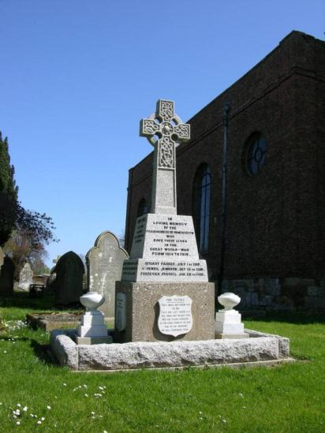

Name: Peaks Farm, Humberston
Date Designated: N/A – New Proposal
Grid Reference: TA 29134 06197
Area Designation: None
Asset Type: Building
Main Criteria Used: 1c, 2g
Description:

A farmstead, probably 18th or early 19th century, which consists of a farmhouse and a range of farm buildings around a courtyard. All of the buildings shown on Ordnance Survey maps of 1887-9 are present.

This site has been surveyed from aerial photographs and maps, and what can be seen from the public highway. It is assumed from this evidence that it is of at least local interest.

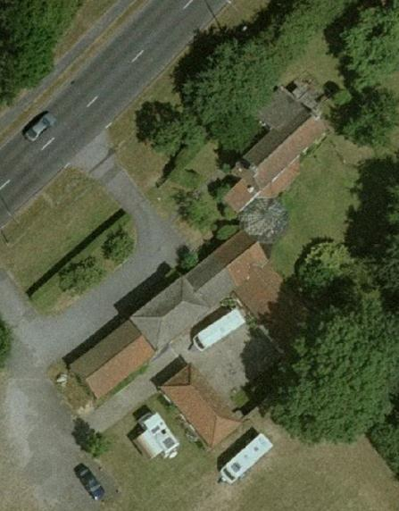
Image Taken in 2006 ©Cities Revealed The Geoinformation Group 2015

Name: Cropmark Enclosure south of the Goldbank Business Park, Humberston
Date Designated: N/A – New Proposal
Grid Reference: TA 2959 0573
Area Designation: None
Asset Type: Archaeological Site
Main Criteria Used: 1b, 2a
Description:

An enclosure visible on aerial photographs. Parts of all four sides of a sub-rectangular enclosure can be seen in a field of ripening crops, at an angle to the current field system, along with several other less distinct features some of which appear to be of modern origin.

Sites such as this, which pre-date the creation of most of the villages and towns in the area, are important for the archaeological deposits that they contain and the information on previous settlement and activities in the area that these deposits can provide.

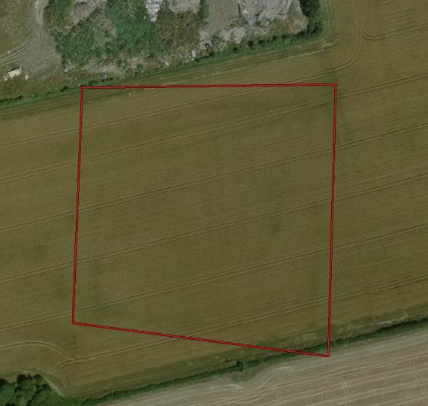
Image Taken in 2006
The GeoInformation Group Data ® copyright by The GeoInformation® Group, 2015

Name: Chalet 20, Humberston Fitties
Date Designated: N/A – New Proposal
Grid Reference: TA 3329 0589
Area Designation: Humberston Fitties Conservation Area
Asset Type: Building
Main Criteria Used: 1b
Description:

Application 326/54, approved 1954. Flat asbestos walls with corrugated asbestos roof. The original plan shows a flue style chimney but a later note on the application states that it will in fact be brick.

Pitched corrugated asbestos sheeting covered roof with brick chimney stack and asbestos gutters. Walls rough cast render finish on flat asbestos sheeting on timber beams. Timber framed windows and door. Shed to rear, timber picket fence with double gates to front, no hardstanding.

A largely unchanged post-war chalet, illustrative of the later development of the site. As with the rest of the chalet park, the building is representative of the changes in society in the 20th century with every increasing amounts of spare time and money which could then be spent on holidays. As a largely original structure, it is one of the best representations of the historic character of the site.

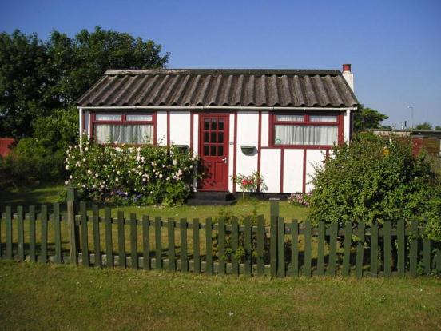

Name: Chalet 37, Humberston Fitties
Date Designated: N/A – New Proposal
Grid Reference: TA 3326 0580
Area Designation: Humberston Fitties Conservation Area
Asset Type: Building
Main Criteria Used: 1b
Description:

Application 172/53, approved 1953. Asbestos sheeting walls painted white or red with asbestos roof

Pitched corrugated asbestos sheeting covered roof with brick chimney stack and plastic gutters. Walls rendered on brick foundations. Timber framed windows and door. Timber picket fence, double metal gates. Two rows slabs and gravel for hardstanding.

A largely unchanged post-war chalet, illustrative of the later development of the site. As with the rest of the chalet park, the building is representative of the changes in society in the 20th century with every increasing amounts of spare time and money which could then be spent on holidays. As a largely original structure, it is one of the best representations of the historic character of the site.

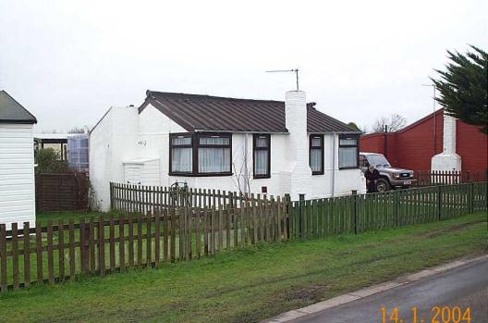
Name: Chalet 62, Humberston Fitties
Date Designated: N/A – New Proposal
Grid Reference:
Area Designation: Humberston Fitties Conservation Area
Asset Type: Building
Main Criteria Used: 1b
Description:

Application 269/53, approved 1953. Flat asbestos sheet walls painted cream or white, corrugated asbestos roof. Built by Northern Trawlers Ltd (Shipwrights Department). Possibly moved slightly east

Pitched profiled asbestos sheet covered roof with flue and plastic gutters and rainwater pipes. Walls, horizontal timber boarding on concrete block piers. Timber framed windows and door. Timber handrail to front veranda. Timber picket fence and double gates to front, no hardstanding. Shed to rear.

A largely unchanged post-war chalet, illustrative of the later development of the site. As with the rest of the chalet park, the building is representative of the changes in society in the 20th century with every increasing amounts of spare time and money which could then be spent on holidays. As a largely original structure, it is one of the best representations of the historic character of the site.

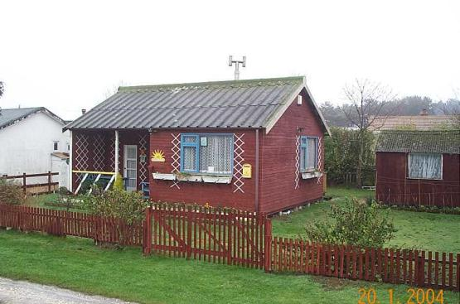

Name: Chalet 138, Humberston Fitties
Date Designated: N/A – New Proposal
Grid Reference: TA 3314 0593
Area Designation: Humberston Fitties Conservation Area
Asset Type: Building
Main Criteria Used: 1b
Description:

Application T.266, approved 1950. Modified, with a veranda either removed or not built, a small projection to the front removed and an extension to the rear

Pitched corrugated asbestos sheeting covered roof, with brick chimney stack, asbestos gutters and rainwater pipes. Walls timber horizontal boarding on brick piers. PVCu framed windows, timber door. Shed to rear, hedge with timber picket double gates to front, concrete slabs for hardstanding.

A largely unchanged post-war chalet, illustrative of the later development of the site. As with the rest of the chalet park, the building is representative of the changes in society in the 20th century with every increasing amounts of spare time and money which could then be spent on holidays. As a largely original structure, it is one of the best representations of the historic character of the site.

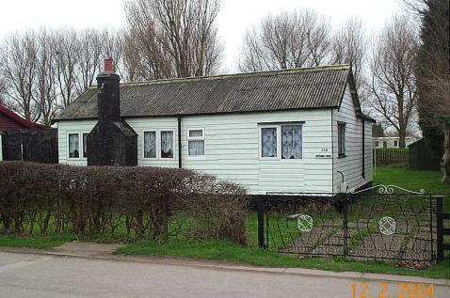
Name: Chalet 150, Humberston Fitties
Date Designated: N/A – New Proposal
Grid Reference: TA 3355 0536
Area Designation: Humberston Fitties Conservation Area
Asset Type: Building
Main Criteria Used: 1b
Description:

Built to a Ministry of Works pattern book design (see withdrawn application 273/54 – asbestos wall and roof) for the Seco Mark 3 temporary house

Flat felt covered roof with flue, plastic gutters and rainwater pipes. Walls flat asbestos sheeting on concrete block foundations. Metal framed windows and timber door. No shed, timber picket fence with double metal gates to front, no hardstanding. Windmill to side.

Illustrative of the various sources for buildings on the Fitties, which includes bespoke and pattern-book buildings. Similar Seco pre-fabricated houses have been listed at the Excalibur Estate, Persant Road in Lewisham (NHLE 1393212) and RAF Barnham (NHLE 1402343 and 1402348).

As with the rest of the chalet park, the building is representative of the changes in society in the 20th century with every increasing amounts of spare time and money which could then be spent on holidays. As a largely original structure, it is one of the best representations of the historic character of the site.

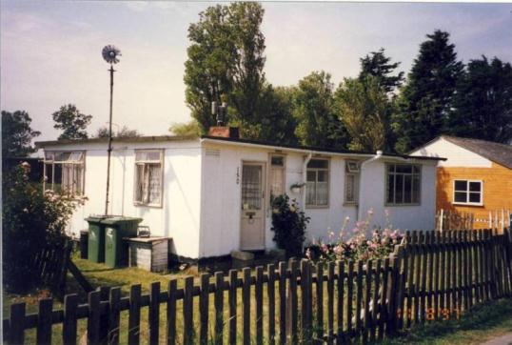

Name: Chalet 228, Humberston Fitties
Date Designated: N/A – New Proposal
Grid Reference: TA 3373 0515
Area Designation: Humberston Fitties Conservation Area
Asset Type: Building
Main Criteria Used: 1b
Description:

A holiday chalet/hut shown on Ordnance Survey maps of 1933. Shown on plans as Number 28 in the old numbering system.

Described in October 1996 as: Pitched corrugated iron sheeting covered roof with brick chimney stack. Walls timber horizontal boarding stained black, elm bobbins and concrete block piers. Timber framed windows and door. Garage to left, metal chain link fence and double metal gate to front, no hardstanding. Built in 1932 for Mr. L. Chatterton, manager of W. H. Thickett, trawler and boatyard owners of Grimsby.

One of the original chalets, built well before the site was rationalised when there were only a handful of buildings. The large scale of the building and plot are illustrative of the former character of the site before post WW2 developments. As with the rest of the chalet park, the building is representative of the changes in society in the 20th century with every increasing amounts of spare time and money which could then be spent on holidays. As a largely original structure, it is one of the best representations of the historic character of the site.

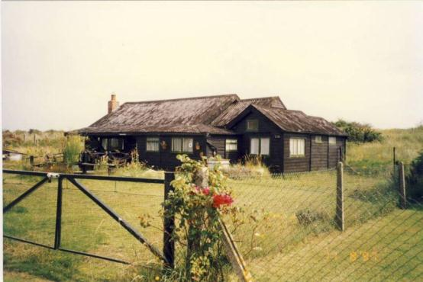
Name: Chalet 231, Humberston Fitties
Date Designated: N/A – New Proposal
Grid Reference: TA 3372 0524
Area Designation: Humberston Fitties Conservation Area
Asset Type: Building
Main Criteria Used: 1b
Description:

A holiday chalet/hut of 1935. Shown on plans as Number 25 in the old numbering system.

Described in October 1996 as: Pitched corrugated asbestos sheeting and flat asbestos tile covered roof with brick chimney stack, asbestos gutters and plastic rainwater pipes. Walls timber horizontal and vertical cedar boarding on concrete block foundations. Timber framed windows and door. Concrete steps to front doors. Metal chain link fence to front, no hardstanding.
Approved by the Rural District Council of Grimsby on the 29th. April 1935 for Mr. H. Taylor of St. Peters Avenue, Cleethorpes. A. Osbourne of Queens Parade, Cleethorpes - Architect, and H. Mashford of Cambridge Street, Cleethorpes - Builder. Materials - Brick pillars and chimney breast, weather boards outside, wood floor. Roof asbestos tiles, asbestos lined inside. Means of water supply - bore or spring. Originally plot 25.

One of the original chalets, built well before the site was rationalised when there were only a handful of buildings. The large scale of the building and plot are illustrative of the former character of the site before post WW2 developments. As with the rest of the chalet park, the building is representative of the changes in society in the 20th century with every increasing amounts of spare time and money which could then be spent on holidays. As a largely original structure, it is one of the best representations of the historic character of the site.

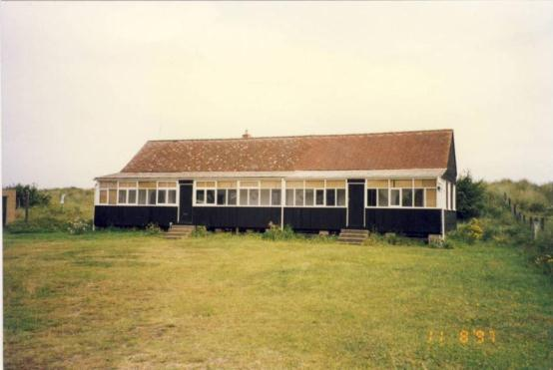

Laceby

Laceby is a large and densely settled village known to have existed since the early medieval period (410AD to 1066AD). The majority of the historic settlement was clustered around the parish church of St Margaret between New Chapel Lane and Grimsby Road.

Laceby is recorded as having a population of 368 in the census of 1801 rising to 1001 in the 1851 census according to White's directory of 1856. In the 2001 census the population is recorded as 2,888.

At the time of writing – 2nd October 2014 – Laceby has:

135 Historic Environment Records of which:
7 are nationally Listed Buildings
None are nationally Scheduled Monuments
20 are proposed Locally Listed Historic Assets

Name: 27 Church Lane, Laceby
Date Designated: N/A – New Proposal
Grid Reference: TA 2147 0662
Area Designation: Laceby Conservation Area
Asset Type: Building
Main Criteria Used: 1a
Description:

Timber framed mud and stud cottage, probably 17th century with later additions. Encased in painted brick with a part slate and part pantile roof and cast iron rainwater goods.
L-shaped on plan with a modern extension of 2004 creating a C shaped plan.

Front wing, which is aligned west/east, is 1.5 storeys with three unevenly spaced dormers and a slate roof.
The east gable of the front wing has a lozenge shaped lead plaque with brick surround.
A small single storey lean-to extension to the east of the front wing has a single casement facing south and a hipped roof. The main door to the property is behind this small extension and appears to be early 20th century in origin.
The rear wing is also 1.5 storeys but has a steep half hipped roof in pantile and an off-centre brick stack. The current roof may once have covered an older thatch roof, but it seems unlikely that the thatch survived a recent re-roofing of the building. The east elevation has a single large segmented arched window with a leaded casement. The rear gable and the western elevation, which now faces the 2004 extension, could not be seen at the time of survey.

Around the turn of the 20th century Laceby contained at least 5 timber framed buildings thought to date from the 16th and 18th centuries, roughly 8% of the total number within the Borough. Of these, three remain standing in Laceby out of a total of around 15-20 across the Borough. The building is therefore a rare example within the area due to its date and method of construction.

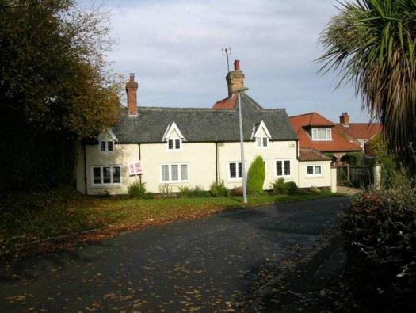

Name: The Laceby Arms, 4 Caistor Road
Date Designated: N/A – New Proposal
Grid Reference: TA 2143 0647
Area Designation: Laceby Conservation Area
Asset Type: Building
Main Criteria Used: 1c, 2g
Description:

Formerly known as the Waterloo Inn.

Three storey, three bay, 19th century public house. Red brick front with brown brick to the sides, pantile roof. Central doorway with modern wooden surround and panelled doorway.
Windows on the ground floor and first floor are 6/6 hung sash, but photographs from the original declaration of the conservation area show 6/1 hung sash; second storey windows are 3/3 in the historic and modern photographs.

A dominant building on The Square and an essential part of the village character.

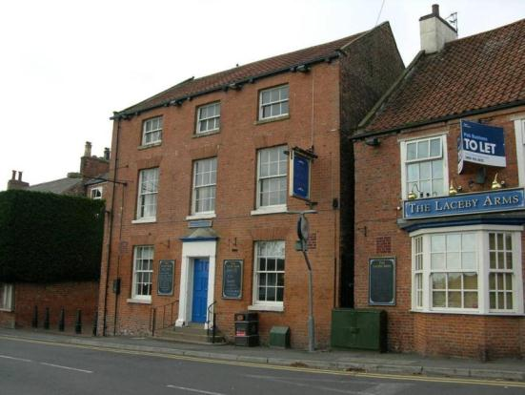

Name: 18 Caistor Road
Date Designated: N/A – New Proposal
Grid Reference: TA 2142 0640
Area Designation: Laceby Conservation Area
Asset Type: Building
Main Criteria Used: 1c, 2g
Description:

Thee bay, two storey, villa. Red brick with fine art deco style dressings and a slate roof with black ridge tiles.
Hexagon section bay windows, with hung sash, to outer bays flanking a round arched doorway with plain fanlight. First floor has 2/2 hung sash to the outer bays and a narrower 1/1 hung sash to the centre, all recessed.

A fine house representative of relative wealth in the village. It probably represents the desire of business owners from nearby towns to live away from cramped urban conditions and so is a part of the social interaction between urban and rural areas.

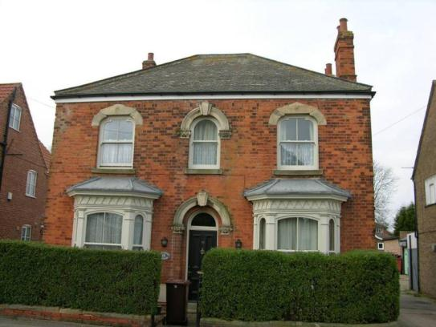

Name: Methodist Chapel, Caistor Road
Date Designated: N/A – New Proposal
Grid Reference: TA 2145 0640
Area Designation: Laceby Conservation Area
Asset Type: Building
Main Criteria Used: 1c, 2g
Description:

A large Primitive Methodist chapel of 1837, now apparently converted into housing with the windows either blocked or partially blocked.
Classical in inspiration with round arched windows and a central ashlar and cream brick porch supported by columns. Red/brown brick with cream brick and ashlar dressings and a slate roof.

Despite the alterations the building is essentially intact and is an important building in the conservation area. A prominent building which represents an important part of the ecclesiastical functions of the village.

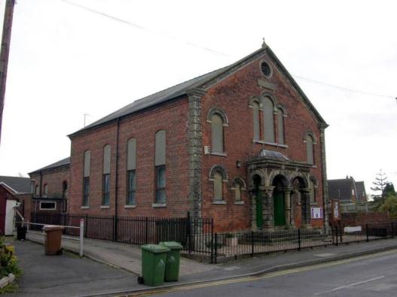

Name: Village Hall, High Street
Date Designated: N/A – New Proposal
Grid Reference: TA 2140 0652
Area Designation: Laceby Conservation Area
Asset Type: Building
Main Criteria Used: 1c, 2g
Description:

An asymmetrical building, built as a temperance hall and police station, occupying the north side of the corner between High Street and Cemetery Road. Possibly two builds indicated by differences in windows arches and roofs.
Red brick with hipped slate roofs, segmental arched windows and doorway to the Cemetery Road frontage and round arched to High Street. Recessed blank two storey panel to the corner.

A photograph of the buildings is reproduced in Baker’s 1953 study of Cleethorpes where it is mistakenly identified as the earliest Methodist Chapel in Cleethorpes.

A good example of civic buildings within villages, the space being share between various functions.

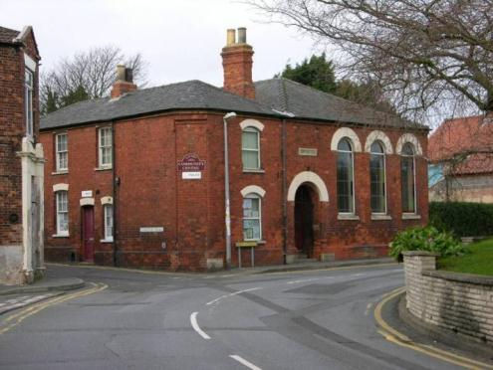

Name: Methodist Chapels, High Street and Old Chapel Lane
Date Designated: N/A – New Proposal
Grid Reference: TA 2141 0670
Area Designation: Laceby Conservation Area
Asset Type: Building
Main Criteria Used: 1c, 2g
Description:

The second and third Wesleyan Methodist chapels in Laceby joined by a chapel house of c.1900.

The original chapel fronted onto Old Chapel Lane, roughly in the position of numbers 1 and 3 Old Chapel Lane, and was built in 1810.
Work on the second chapel, which stands fronting onto New Chapel Lane, was started in 1837 and finished the same year. This chapel is Georgian in date and design following classical rules of architecture in a similarly inspired dressings. Built of brown brick with a slate roof (now concrete tile), plastic windows replacing hung sash, entrance porch has been added to the original façade, apparent stucco windows surrounds, ashlar string course and pediment to the gable.

Linking chapel house to the west of the old chapel dates to c.1900 and has a central doorway with simple plank door, large timber utilities door to the right in plain wooden planks, windows are small with plastic fittings, all openings are segmental arched.

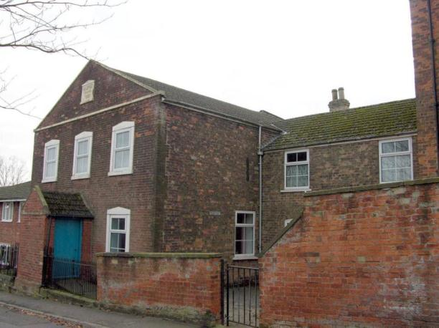

The third chapel dates to 1852 and was built at a cost of £1200 to seat 450 people with sporadic renovations. The building is a large 19th century Methodist chapel in gothic style built in red brick with ashlar dressings, replacement concrete tile roof, buttresses, pedimented porch to the front elevation and long gothic windows with a large central gothic window with traceries to the main façade.

The front and part of the side boundary is defined by a decorative brick wall comprising recessed panels of brick pillars between piers all topped with ashlar.

A very fine group of buildings.

See HER 0733/43/0 for sources.

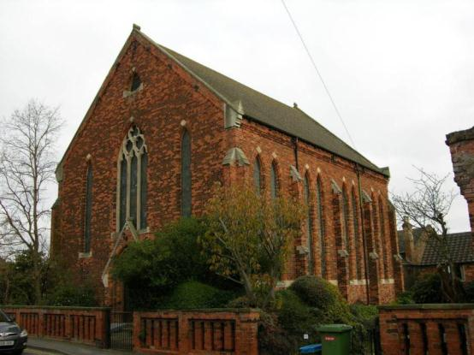

Name: The Old Rectory, High Street
Date Designated: N/A – New Proposal
Grid Reference: TA 2144 0660
Area Designation: Laceby Conservation Area
Asset Type: Building
Main Criteria Used: 1c, 2g
Description:

A rectory of 1834 in grey brick with a hipped Welsh slate roof. 2 storeys, 3 bays with a central doorway in an architrave surround and 6/6 hung sash under flat arches. Barely visible from the public highway but occupying a prominent position in the village.

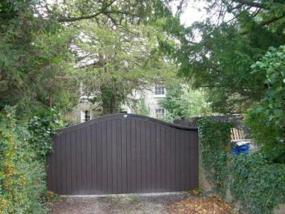

Adjoining the gardens of the vicarage are a set of barns and outbuildings which are shown with a shared access to the Vicarage on 19th century maps, probably 18th century onwards, with several build periods evident.

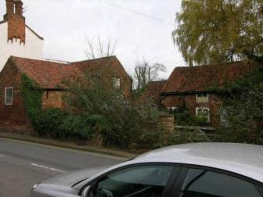

An important set of buildings which represent an important part of the ecclesiastical functions of the village.

Name: 3 to 13 (odd) Grimsby Road, Laceby
Date Designated: N/A – New Proposal
Grid Reference: TA 2150 0649
Area Designation: N/A
Asset Type: Building
Main Criteria Used: 1c, 2g
Description:

A 1930s or early 1940s row of houses and shops.

The centre two units are shops, one with an extant original bow window with bullseye glasses, project forwards and carry large half timbered gables. To each side are two houses, each two bays wide with central stacks.

It is a handsome and large building with good attention to detail and relatively few alterations. It has a significant impact upon the character of the village centre.

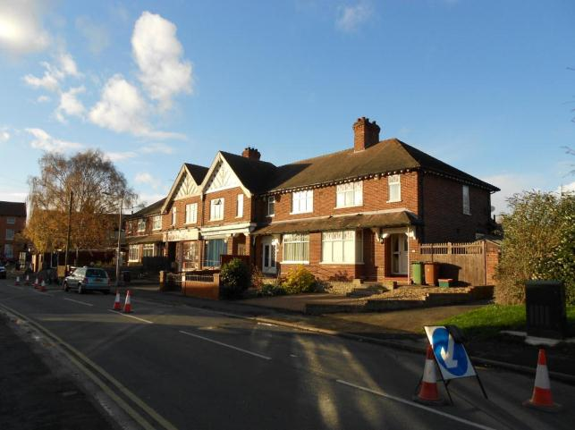

Name: Outbuilding to 25 Grimsby Road, Laceby
Date Designated: N/A – New Proposal
Grid Reference: TA 2161 0650
Area Designation: N/A
Asset Type: Building
Main Criteria Used: 1c, 2g
Description:

A long and low outbuilding to 25 Grimsby Road built sometime between 1906-8 and 1932-3. The building has a tradition timber and glass shop front in very good condition, a rarity in the borough, and an interesting addition to the village street-scene.

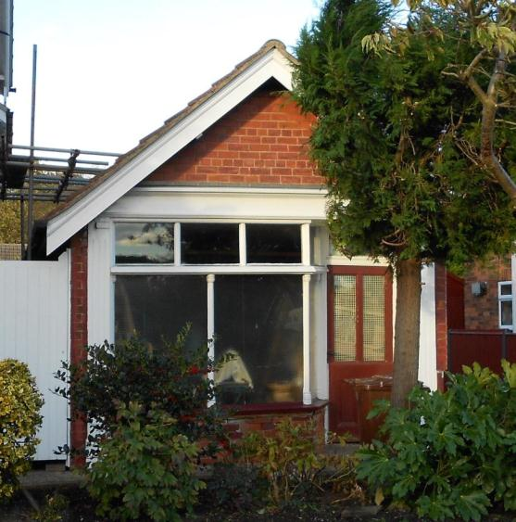

Name: Outbuildings to 1 Caistor Road, Laceby
Date Designated: N/A – New Proposal
Grid Reference: TA 2145 0643
Area Designation: Laceby Conservation Area
Asset Type: Building
Main Criteria Used: 1c, 2g
Description:

A small outbuilding, or pair of outbuildings, to 1 Caistor Road. Built in the late 19th century in red-brown brick with a slate roof and a large side chimney, possibly indicating that it was built as a blacksmith or similar. Its location alongside the Grimsby-to-Irby turnpike means that it may alternatively be a tollhouse.

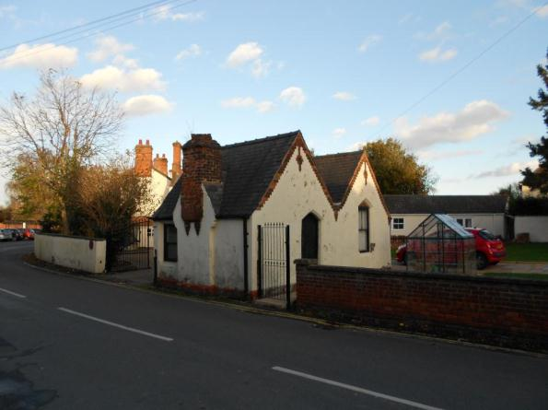

Name: Manor Farm, Laceby
Date Designated: N/A – New Proposal
Grid Reference: TA 22752 05369
Area Designation: None
Asset Type: Building
Main Criteria Used: 1c, 2g
Description:

A farmstead, probably 19th century, which consists of a pair of cottages and a double range of farm buildings around two courtyards. Most of the buildings shown on Ordnance Survey maps of 1887-9 are present.

This site has been surveyed from aerial photographs and maps, and what can be seen from the public highway. It is assumed from this evidence that it is of at least local interest.

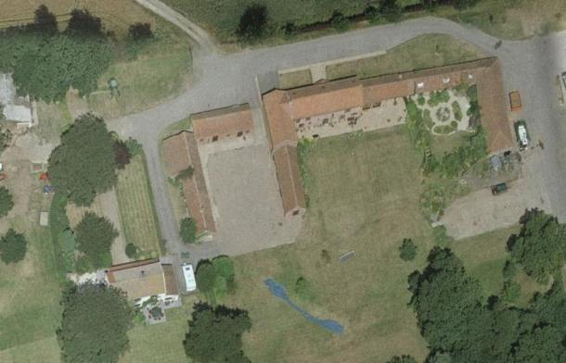
Image Taken in 2006
The GeoInformation Group Data ® copyright by The GeoInformation® Group, 2015

Name: The Limes Farm, Grimsby Road, Laceby
Date Designated: N/A – New Proposal
Grid Reference: TA 2216 0643
Area Designation: None
Asset Type: Building
Main Criteria Used: 1c, 2g
Description:

A farmstead, 19th century, which consists of a small farmhouse and a C-shaped range of farm buildings around a courtyard. One of the farm buildings is present as foundations only in 2006, but otherwise all of the buildings shown on Ordnance Survey maps of 1887-9 are present.

This site has been surveyed from aerial photographs and maps, and what can be seen from the public highway. It is assumed from this evidence that it is of at least local interest.

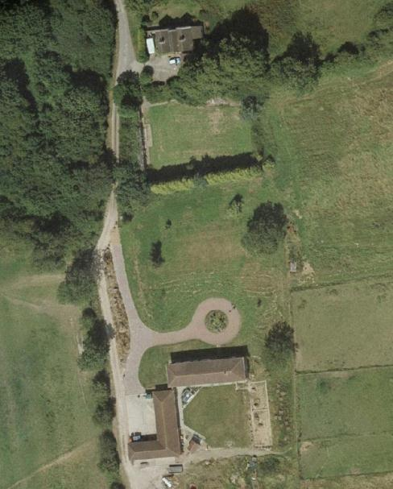
Image Taken in 2006
The GeoInformation Group Data ® copyright by The GeoInformation® Group, 2015

Name: Laceby Village Cemetery
Date Designated: N/A – New Proposal
Grid Reference: TA 2106 0660
Area Designation: N/A
Asset Type: Complex (Designed Landscape and Memorial)
Main Criteria Used: 1c, 2g
Description:

A village cemetery opened c.1875. The orientation of the monuments suggest that in addition to the existing central path, there was also a path around the perimeter of the site.

At the southern end of the site is a war memorial dedicated to the first and second world wars, originally in a high-medieval style with an octagonal plinth and shaft topped by a cross, now altered with a new base a section between the original plinth and shaft, plus new stone plaques bearing the names of the soldiers.

At the northern end of the old cemetery is an impressive Grade II listed memorial to Consul Peter and his wife Janna Haagerson (NHLE 1422159).

The site contains few sculptures, but a good number of fine headstones with many family plots.

An important part of Laceby’s historic character, indicating the relatively high population for a village and the wealth of it’s occupants.

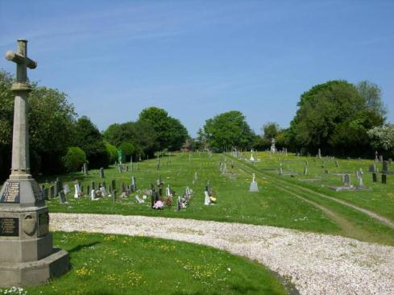

Name: Oaklands Hotel, Coach House and Landscape Park
Date Designated: N/A – New Proposal
Grid Reference: TA 2075 0539
Area Designation: None
Asset Type: Complex Asset (Building and Designed Landscape)
Main Criteria Used: 1c, 2g
Description:

Jacobethan style manor house matching the Grade II listed lodge house on Barton Street (NHLE: 1161191). The manor house itself is unfortunately marred by a large unsympathetic extension to the front, left façade.
Red brick with high quality ashlar details and a slate roof.

An elegant and impressive building which would be worthy of national listing if not for the extension on the front elevation.

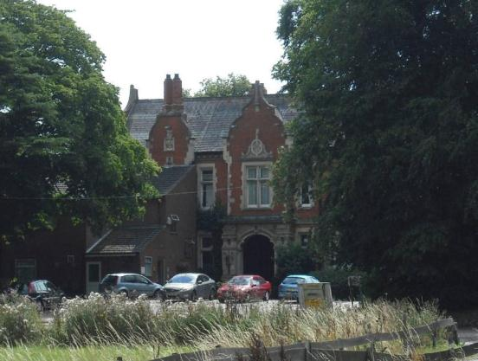

Also, a large coach house, two storeys to the main buildings with a central dovecote style tower rising to an extra three storeys. The tower is above a large archway which leads into a central yard around which the buildings are arranged. Brown brick with slate roof with brick and ashlar dressings.

An impressive building which almost eclipses the main house, but the plainer style ensures that the greater mass does not detract from the primary building.

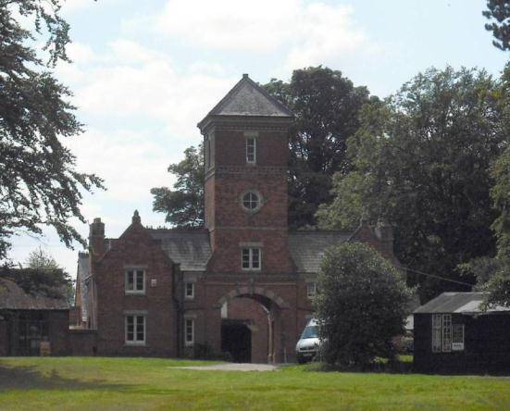

The two buildings are surrounded by an area of landscape parkland with groups of trees dispersed around the site. The layout of the parkland is largely intact and is an important part of the character of the site and general area.

The complex is a good example of a country house holding, representing the higher status social activities of the village.

Name: Manor Farmhouse, Lodge and Parkland
Date Designated: N/A – New Proposal
Grid Reference: TA 2309 0697
Area Designation: None
Asset Type: Complex Asset (Building and Designed Landscape)
Main Criteria Used: 1c, 2g
Description:

A late 18th or early 19th century manor house built in buff brick with a slate roof, four bays to the main façade flanked by single recessed bays to either side. The house is set into a possible formal garden with an apparent walled garden to the north and Ha-Ha to the west allowing views across a small area of landscape park.

The house is linked to a small lodge on Grimsby Road by a tree lined avenue. The lodge is built in brown brick with a pantile roof and has a number of modern but sympathetic extensions. The parkland has been retained as pasture, containing ridge and furrow earthworks, but has only a small number of trees dispersed through the site.

The group of assets which include the manor house, some agricultural buildings, probable formal garden, parkland, lodge house and avenue is a very good survival and a major asset to the area.

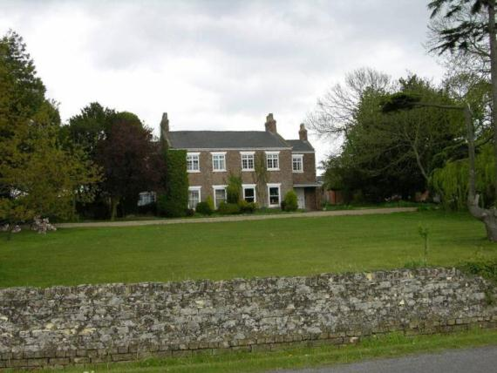
The Manor House and possible Ha-Ha
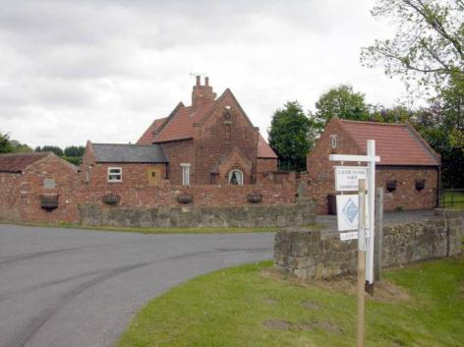
The Lodge House

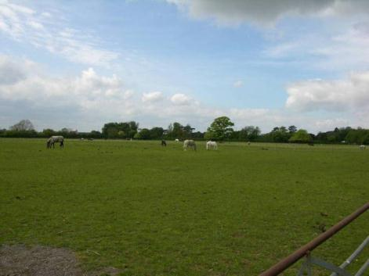
The Parkland

Name: Parkland to Little Laceby Farmhouse
Date Designated: N/A – New Proposal
Grid Reference: TA 2231 0695
Area Designation: None
Asset Type: Building
Main Criteria Used: 1c, 2g
Description:

An area of parkland retaining ridge and furrow earthworks and maintained as pasture with isolated trees dispersed around the site. The parkland is associated with the Grade II listed Little Laceby Farmhouse (NHLE: 1161227).

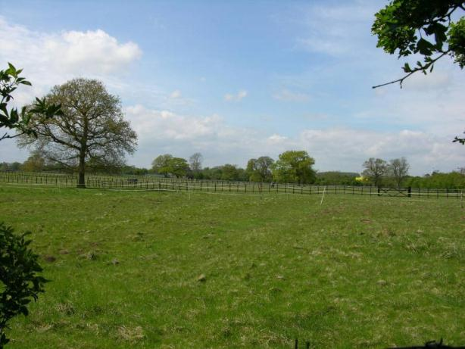

Name: Cropmark enclosures and ditches 340m north west of Little Laceby Farmhouse
Date Designated: N/A – New Proposal
Grid Reference: TA 2200 0690
Area Designation: None
Asset Type: Archaeological Site
Main Criteria Used: 1b, 2a
Description:

Enclosures and ditches shown as cropmarks, possibly part of a Prehistoric or Roman field system. A small section in the south west, which has a very regular appearance, may not be related.

Sites such as this, which pre-date the creation of most of the villages and towns in the area, are important for the archaeological deposits that they contain and the information on previous settlement and activities in the area that these deposits can provide.

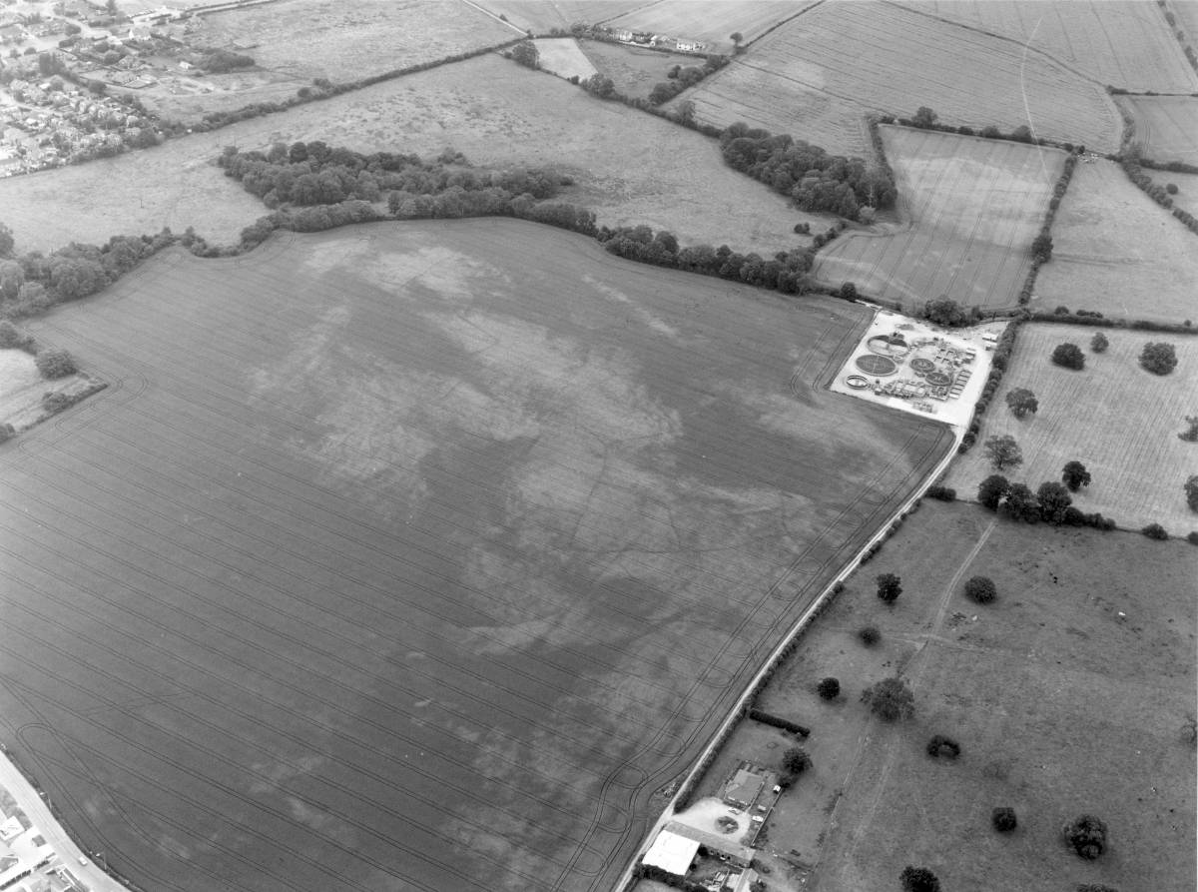
© Humber Archaeological Partnership 1991

Name: Cropmark enclosure 760m south of Manor Top farm in Laceby
Date Designated: N/A – New Proposal
Grid Reference: TA 2294 0459
Area Designation: None
Asset Type: Archaeological Site
Main Criteria Used: 1b, 2a
Description:

A small cropmark enclosure, c.60mx40m, visible in ripe crops with probable internal features, and also confirmed by geophysical survey. Probably prehistoric in date.

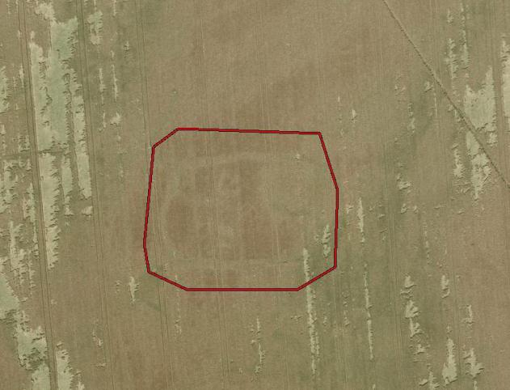
Image Taken in 2006
The GeoInformation Group Data ® copyright by The GeoInformation® Group, 2015

Name: Cropmark enclosures and trackways 200m to 360m south east of The Limes
Date Designated: N/A – New Proposal
Grid Reference: TA 2242 0618
Area Designation: None
Asset Type: Archaeological Site
Main Criteria Used: 1b, 2a
Description:

Cropmarks of several enclosures, the largest measuring c.50mx45m and the smallest c.25mx25m, apparently related and possibly connected by long boundary ditches. Possibly part of a Prehistoric or Roman field system.

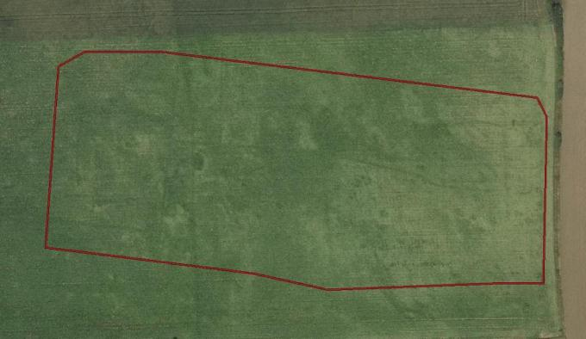
Image Taken in 2006
The GeoInformation Group Data ® copyright by The GeoInformation® Group, 2015

Name: Cropmark Enclosure 825m south of Manor Farm, Laceby
Date Designated: N/A – New Proposal
Grid Reference: TA 2284 0622
Area Designation: None
Asset Type: Archaeological Site
Main Criteria Used: 1b, 2a
Description:

A rectilinear enclosure of irregular shape with adjacent pits and a linear ditch extending north on a similar alignment. An Iron Age and/or Roman date seems most likely for these features.

Air Photo Services. 2011. Hornsea Project 1, Onshore Cable Route, North Coates to North Killingholme, Lincolnshire: Aerial Photographic Assessment.

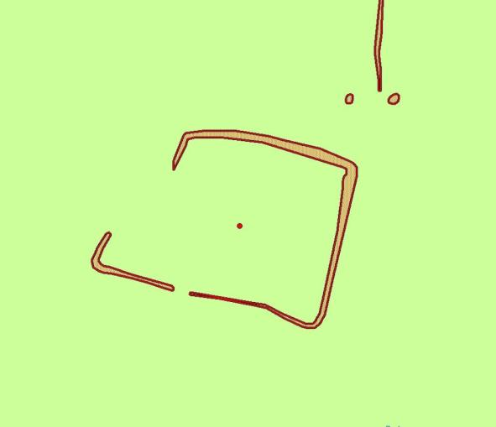
Plot of the Cropmark, as mapped by Air Photo Services
Reproduced from an Ordnance Survey map with the permission of the Controller of HMSO © Crown Copyright.
Licence number 100020759 North East Lincolnshire Council

New Waltham

New Waltham is a new village formed around the 19th century train station that was built to serve, but is distant from, Waltham. The parish area, which was formed in 1961, covers what were once parts of Waltham, Humberston, Weelsby, Scartho and Clee.

At the time of writing – 2nd October 2014 – New Waltham has:

30 Historic Environment Records of which:
None are nationally Listed Buildings
None are nationally Scheduled Monuments
7 are proposed Locally Listed Historic Assets

Name: Hall Farm, Weelsby
Date Designated: N/A – New Proposal
Grid Reference: TA 28803 06982
Area Designation: None
Asset Type: Building
Main Criteria Used: 1c, 2g
Description:

A farmstead, probably 19th century, which consists several farm buildings with less than half of the buildings shown on Ordnance Survey maps of 1887-9 still extant.

This site has been surveyed from aerial photographs and maps. It is assumed from this evidence that it is of at least local interest.

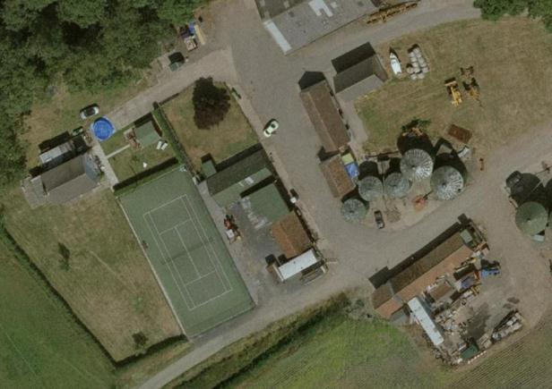
Image Taken in 2006 ©Cities Revealed The Geoinformation Group 2015

Name: Low Farm, New Waltham
Date Designated: N/A – New Proposal
Grid Reference: TA 27801 05949
Area Designation: None
Asset Type: Building
Main Criteria Used: 1c, 2g
Description:

A farmstead, probably 19th century, which consists several farm buildings with the three outer buildings of an E-shaped plan shown on Ordnance Survey maps of 1887-9 still extant.

This site has been surveyed from aerial photographs and maps. It is assumed from this evidence that it is of at least local interest.

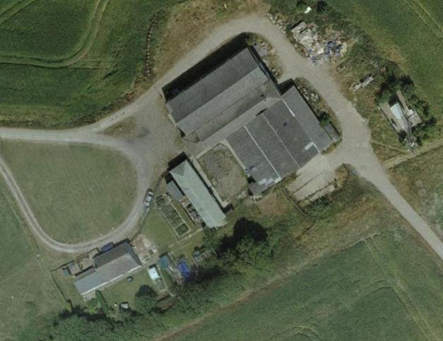
Image Taken in 2006
The GeoInformation Group Data ® copyright by The GeoInformation® Group, 2015

Name: Grove Farm, Waltham
Date Designated: N/A – New Proposal
Grid Reference: TA 27188 04373
Area Designation: None
Asset Type: Building
Main Criteria Used: 1c, 2g
Description:

A farmstead, probably 19th century, which consists of a range of historic farm buildings mostly incorporated into a modern building. Most of the farmyard buildings shown on Ordnance Survey maps of 1887-9 appear to be present, but it is not clear due to the later alterations. It is also not known if the original farmhouse is extant or has been replaced, although a later pair of cottages built for the farm across the road are still standing.

This site has been surveyed from aerial photographs and maps. It is assumed from this evidence that it is of at least local interest.

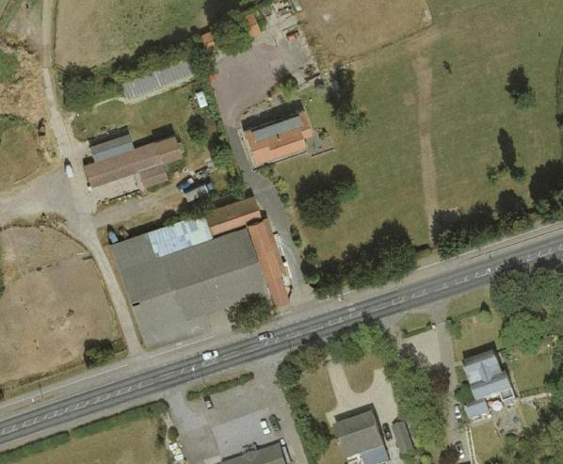
Image Taken in 2006
The GeoInformation Group Data ® copyright by The GeoInformation® Group, 2015

Name: Tollbar Farm
Date Designated: N/A – New Proposal
Grid Reference: TA 2750 0482
Area Designation: None
Asset Type: Building
Main Criteria Used: 1c, 2g
Description:

A farmstead, probably 19th century, which consists of a farmhouse, cottages and a range of historic farm buildings. Just over half of the buildings shown on Ordnance Survey maps of 1887-9 appear to be present. Originally known as Fletcher's Farm, and later as Toll Bar Farm.

This site has been surveyed from aerial photographs and maps. It is assumed from this evidence that it is of at least local interest.

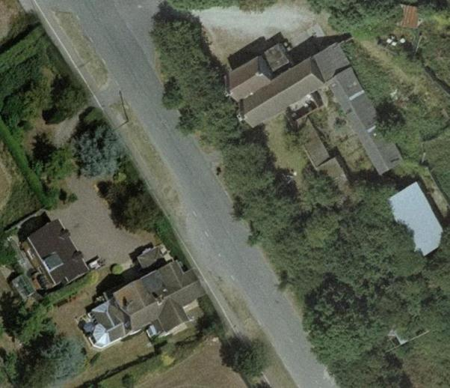
Image Taken in 2006
The GeoInformation Group Data ® copyright by The GeoInformation® Group, 2015

Name: Cropmark enclosure 510m south of Low Farm, Scartho
Date Designated: N/A – New Proposal
Grid Reference: TA 2792 0539
Area Designation: None
Asset Type: Archaeological Site
Main Criteria Used: 1b, 2a
Description:

Three sides of a probable enclosure, part of a complex of cropmarks which may represent further enclosures adjoining.

Part of a group of cropmarks of probable Prehistoric or Roman date in the immediate area.

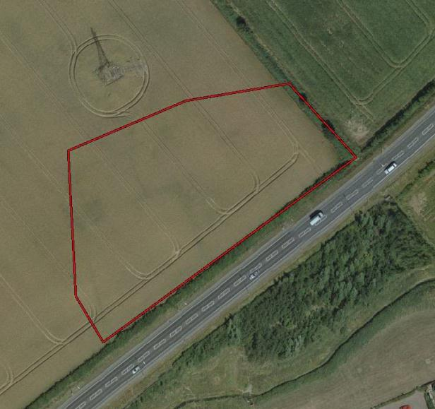
Image Taken in 2006
The GeoInformation Group Data ® copyright by The GeoInformation® Group, 2015

Name: Cropmark Enclosure 200m south of Low Farm, Scartho
Date Designated: N/A – New Proposal
Grid Reference: TA 2778 0569
Area Designation: None
Asset Type: Archaeological Site
Main Criteria Used: 1b, 2a
Description:

A sub rectangular enclosure shown as a cropmark, probably Prehistoric or Roman in date, although it appears to show some relationship with the former medieval ridge and furrow in the area.

Part of a group of cropmarks of probable Prehistoric or Roman date in the immediate area.

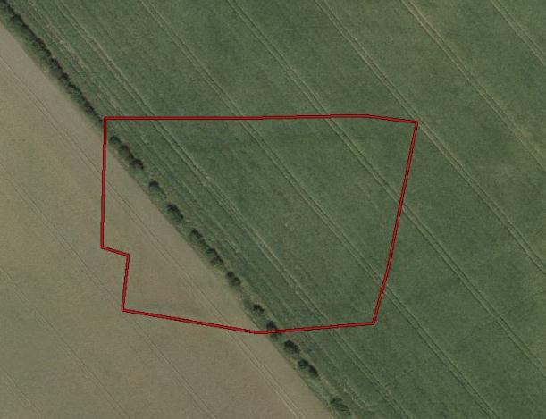
Image Taken in 2006
The GeoInformation Group Data ® copyright by The GeoInformation® Group, 2015

Name: Cropmark enclosures 210m north west of Toll Bar Farm
Date Designated: N/A – New Proposal
Grid Reference: TA 2727 0498
Area Designation: None
Asset Type: Archaeological Site
Main Criteria Used: 1b, 2a
Description:

Probable Prehistoric or Roman enclosures and boundary seen as cropmarks.

Part of a group of cropmarks of probable Prehistoric or Roman date in the immediate area.

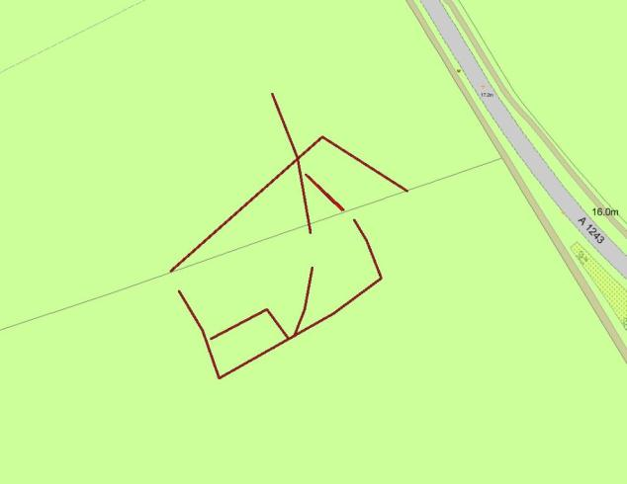
Plot of the Cropmark, as mapped by the RCHME
Reproduced from an Ordnance Survey map with the permission of the Controller of HMSO © Crown Copyright.
Licence number 100020759 North East Lincolnshire Council

Waltham

Waltham is a relatively dense village that is known to have existed since the early medieval period (410AD to 1066AD). The settlement clusters around the church of All Saints with the site of the Old Hall directly to the north and Waltham Grove with its parkland marking the southern end of the historic core.

Waltham is recorded as having a population of 782 in the 1851 census according to White's directory of 1856. In the 2001 census the population of Waltham is recorded as 6,420, with an additional 4,557 in New Waltham.

At the time of writing – 2nd October 2015 – Waltham has:

144 Historic Environment Records of which:
3 are nationally Listed Buildings
None are nationally Scheduled Monuments
22 are proposed Locally Listed Historic Assets

Name: Rose Cottage, 12 Barnoldby Road
Date Designated: N/A – New Proposal
Grid Reference: TA 2580 0380
Area Designation: Waltham Conservation Area
Asset Type: Building
Main Criteria Used: 1c, 2g
Description:

Late 18th or early 19th century farm style house. Three bays, two storeys with a hipped roof, buff brick, concrete tile roof, originally 6/6 hung sash but now replaced with uPVC, central panelled door with wooden surround and transom light.

Representative of the agricultural and social activities of the village.

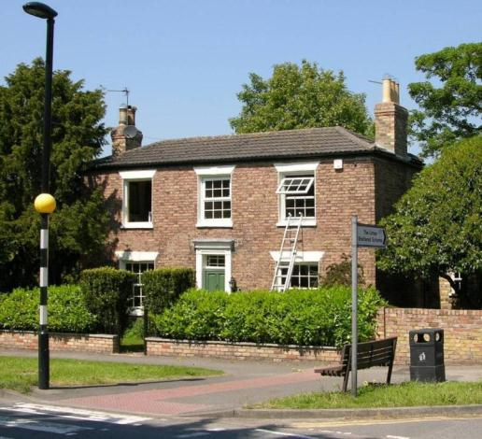

Name: Timber Framed Building and Barn, Barnoldby Road
Date Designated: N/A – New Proposal
Grid Reference: TA 2574 0378
Area Designation: N/A
Asset Type: Building
Main Criteria Used: 1a
Description:

A small building, originally timber framed but now brick encased with a half-hipped pantile roof. Internal examination found the remains of a very rough mud and stud partition wall in the roof space along with apparent wall plates and tie beams. Adjoining to the rear is a 19th century two storey barn with a hay loft above and probable threshing floor below.
The timber framed building is directly above a culverted stream, and the barn has an infilled square opening directly adjacent to the former stream tentatively suggesting the former presence of a waterwheel. The site is also known locally as “The Mill”.

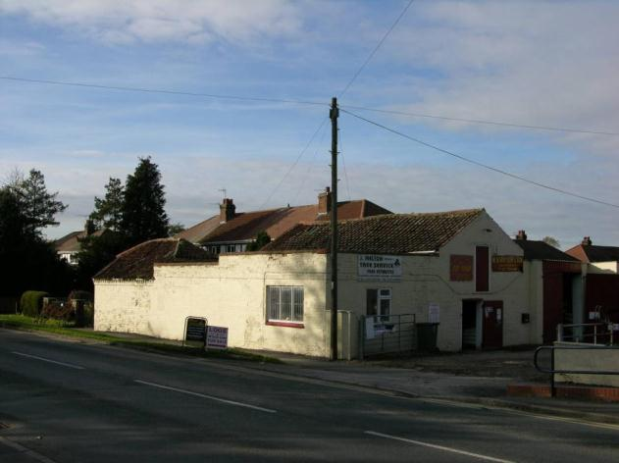

Name: Pear tree Farmhouse, Barnoldby Road
Date Designated: N/A – New Proposal
Grid Reference: TA 2565 0376
Area Designation: N/A
Asset Type: Building
Main Criteria Used: 1c, 2g
Description:

A late 18th or early 19th century farmhouse, two bays with a single bay extension; potentially an extended “half-house”. The east two bays appear to be older and the gable has truncated tumbling suggesting that there was once a pedimented gable. Central panelled doorway in architrave with transom light, 6/6 uPVC windows under flat stucco arches on the ground floor, 3/6 uPVC windows under flat stucco arches on the first.

Representative of the agricultural and social activities of the village.

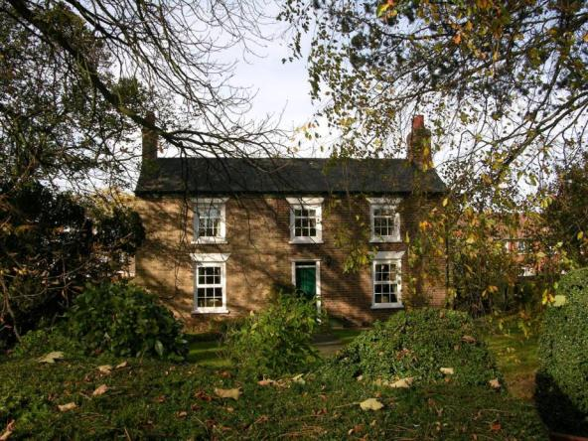

Name: The Lodge, Barnoldby Road
Date Designated: N/A – New Proposal
Grid Reference: TA 2534 0364
Area Designation: N/A
Asset Type: Building
Main Criteria Used: 1c, 2g
Description:

A lodge house to the demolished Barnoldby House, formerly linked to the house by an avenue which has been largely replaced by the road known as Carnoustie.
Single storey in buff brick with a slate roof, front windows are small timber sash with a small oriel/bay window to the left return.

Representative of the manorial and social activities of the village.

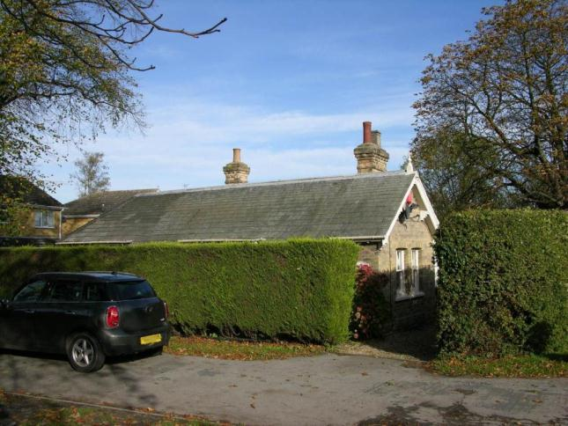
Name: 1 to 5 (odd) High Street
Date Designated: N/A – New Proposal
Grid Reference: TA 2585 0380
Area Designation: Waltham Conservation Area
Asset Type: Building
Main Criteria Used: 1c, 2g
Description:

A row of three house, late 18th or early 19th century. All painted buff brick with slate roofs. Number 1 has three bays, 6/6 hung sash, central doorway with wooden surround and transom light. 3 and 5 are both of two bays, modern 2/2 sash style uPVC windows, number 3 has a wooden panelled door with surround and transom light on the right bay, number 5 has a shop window to the left bay with signage board above.

A handsome set of houses that make an important impact due to their corner location.

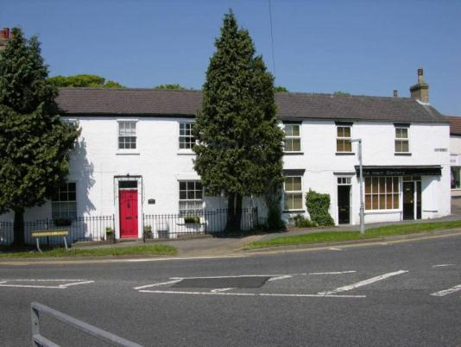

Name: 7 High Street
Date Designated: N/A – New Proposal
Grid Reference: TA 2586 0382
Area Designation: Waltham Conservation Area
Asset Type: Building
Main Criteria Used: 1c, 2g
Description:

Former village fire station, but potentially built as an agricultural building.1.5 storeys in brown brick with rendering to the front elevation. Inserted vehicle door to High Street, louvered windows to the side elevations.

An important part of the historic social/civic aspects of the village.

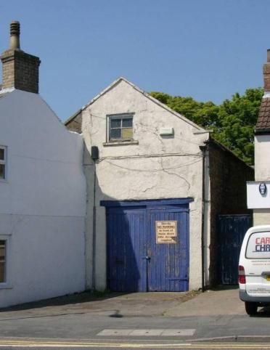

Name: 2 High Street
Date Designated: N/A – New Proposal
Grid Reference: TA 2589 0380
Area Designation: Waltham Conservation Area
Asset Type: Building
Main Criteria Used: 1c, 2g
Description:

A large two storey Edwardian villa, red brick to the ground floor, rendered to the first floor, slate roof.

A handsome and prominent early 20th century building, designed to “turn the corner”. It probably represents the desire of business owners from nearby towns to live away from cramped urban conditions and so is a part of the social interaction between urban and rural areas.

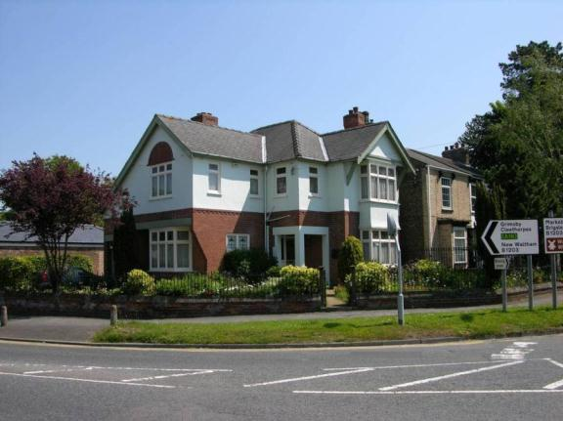

Name: War Memorial, Corner of High Street and Cheapside
Date Designated: N/A – New Proposal
Grid Reference: TA 2589 0377
Area Designation: Waltham Conservation Area
Asset Type: Memorial
Main Criteria Used: 1b, 2g
Description:

A World War 1 war memorial in the form of a Celtic Cross, bearing the inscription "Hope, Faith and Glory" and a figure ascending.

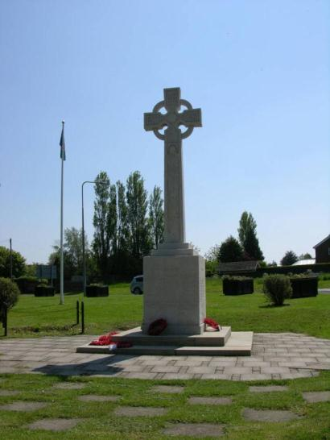

Name: Estate Building, 17 High Street
Date Designated: N/A – New Proposal
Grid Reference: TA 2589 0385
Area Designation: Waltham Conservation Area
Asset Type: Building
Main Criteria Used: 1c, 2g
Description:

A small estate building of unknown origin, possibly a blacksmith’s workshop or similar. Painted brick, single storey, brick dripmoulds over segmental arched windows, slate roof with two bands of imbrication.

Representative of the social activities of the village.

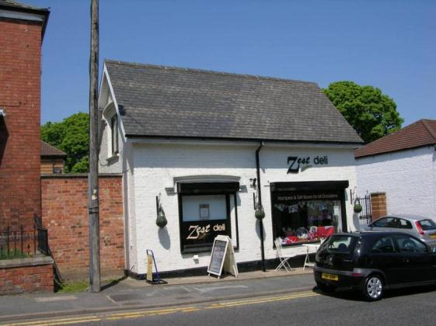

Name: 5 Cheeseman’s Lane
Date Designated: N/A – New Proposal
Grid Reference: TA 2627 0365
Area Designation: Waltham Conservation Area
Asset Type: Building
Main Criteria Used: 1c, 2g
Description:

An 18th century two storey cottage, reputedly an encased timber framed cottage which is supported by the uneven and very thick walls. Two storeys with small windows, four bays, pantile roof with lead covered raised gables.

As either a timber framed building or an 18th century cottage the building is of historic interest to the village as a whole.

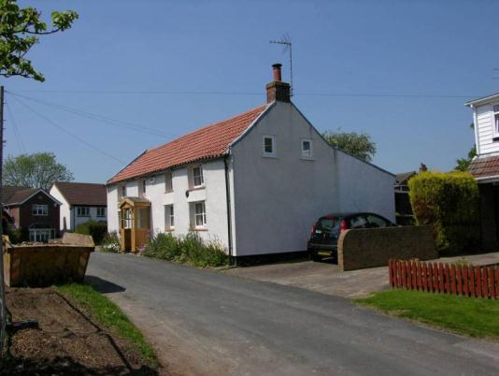

Name: Former School, New Road
Date Designated: N/A – New Proposal
Grid Reference: TA 2619 0373
Area Designation: Waltham Conservation Area
Asset Type: Building
Main Criteria Used: 1c, 2g
Description:

Methodist school of 1858 in buff brick with slate roof. Two storey front block with a tall single storey to the rear. Recessed 4/4 hung sash with triangular recessed panel above. Original railings to the front.

A fine building in a village aesthetic, converted to housing. Representative of the social and educational activities of the village.

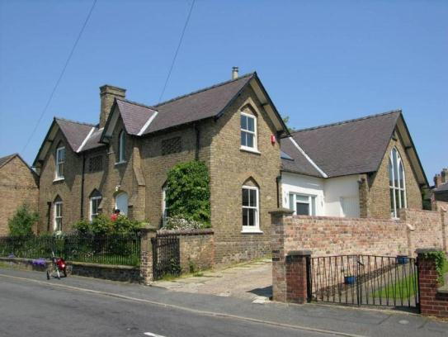

Name: 7 New Road
Date Designated: N/A – New Proposal
Grid Reference: TA 2616 0384
Area Designation: Waltham Conservation Area
Asset Type: Building
Main Criteria Used: 1c, 2g
Description:

A large 19th century villa in red brick with stone string courses and a slate roof. 3 bays with canted bay windows to the ground floor flanking a central doorway.

Together with Number 9, the house forms a fine pair of houses which make a major contribution to the conservation area. It probably represents the desire of business owners from nearby towns to live away from cramped urban conditions and so is a part of the social interaction between urban and rural areas.

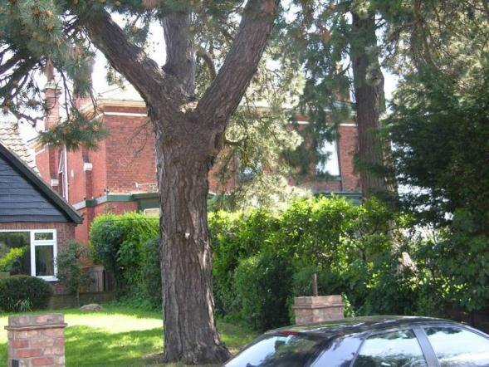

Name: 9 New Road
Date Designated: N/A – New Proposal
Grid Reference: TA 2616 0380
Area Designation: Waltham Conservation Area
Asset Type: Building
Main Criteria Used: 1c, 2g
Description:

A large 19th century villa in red brick with a stone string course, modillions and a slate roof. 3 bays with a central doorway flanked by canted bay windows.

Together with Number 7, the house forms a fine pair of houses which make a major contribution to the conservation area. It probably represents the desire of business owners from nearby towns to live away from cramped urban conditions and so is a part of the social interaction between urban and rural areas.

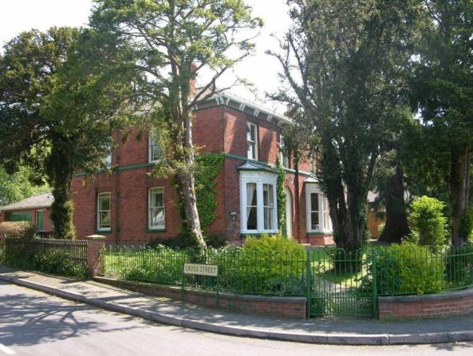

Name: The Tilted Barrel, 2 Kirkgate
Date Designated: N/A – New Proposal
Grid Reference: TA 2604 0386
Area Designation: Waltham Conservation Area
Asset Type: Building
Main Criteria Used: 1c, 2g
Description:

Late 18th or early 19th century house, now a public house, three bays, two storeys, recessed central door, painted brick with ashlar window headers, pantile roof with eaves brackets. Rear building is recent, or a major rebuild of the original rear range.

An important part of the social activities of the village.

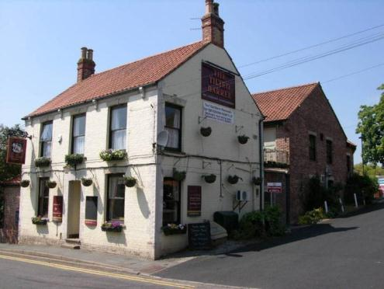

Name: Waltham Methodist Chapel, Cheapside
Date Designated: N/A – New Proposal
Grid Reference: TA 2607 0370
Area Designation: Waltham Conservation Area
Asset Type: Building
Main Criteria Used: 1c, 2g
Description:

A large Methodist church in Gothic style. Red brick with ashlar dressings, buttresses, slate roof with triangular dormers. High quality cast iron railings and gate in a lace like pattern.

A prominent building which represents an important part of the ecclesiastical functions of the village.

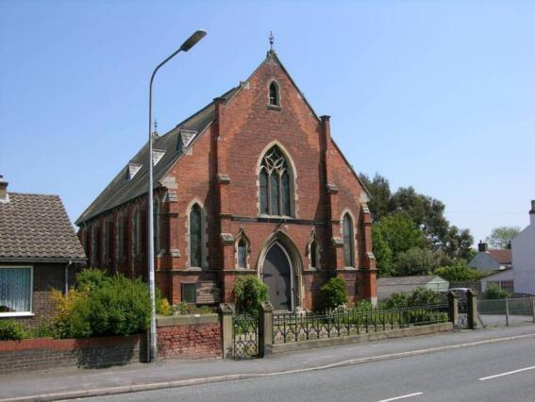

Name: Albion House, 17 Cheapside
Date Designated: N/A – New Proposal
Grid Reference: TA 2600 0375
Area Designation: Waltham Conservation Area
Asset Type: Building
Main Criteria Used: 1c, 2g
Description:

Late 18th or early 19th century house, brown brick rendered to the front and painted to the side, pantile roof (formerly slate). Three bays, two storeys, 2/2 hung sash windows, wooden panelled central door in panelled surround with plain transom light, outer ground floor bay windows.
The southern gable has partly built-over tumbling, and the northern gable has no tumbling at all, both suggesting extensions and enlargements of a smaller original build.

An important building to the character of the area and village.

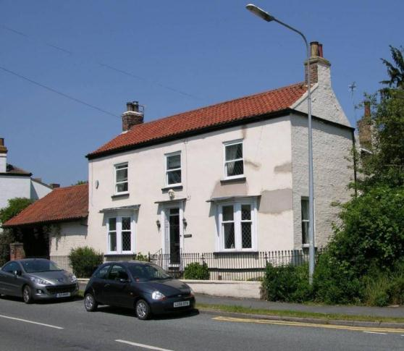

Name: Wigston Cottage
Date Designated: N/A – New Proposal
Grid Reference: TA 2626 0348
Area Designation: None
Asset Type: Building
Main Criteria Used: 1a
Description:

Number 65, Wigston Cottages, is a short cottage with a large overhang to the roof, central brick stack, small dormers and uPVC windows which appear to be mimicking horizontal sliding sash windows. Overall the appearance is that of an encased timber framed mud and stud cottage.
Timber framing and mud & stud walls confirmed on site with owner.

Although the changes to the exterior would usually exclude this property from the local list, the internal survival of the timber frame is of sufficient interest to allow an override.

Number 67 is a more standard late 19th or early 20th century estate cottage built of buff brick with red brick dressings and is not included in the list.

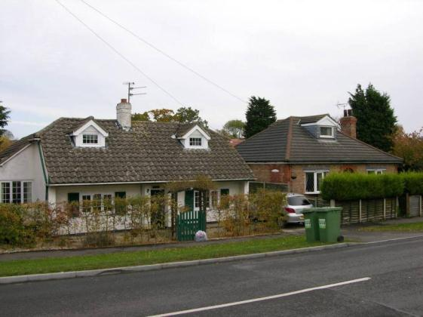

Name: Waltham Villa, Brigsley Road
Date Designated: N/A – New Proposal
Grid Reference: TA 2573 0318
Area Designation: None
Asset Type: Building
Main Criteria Used: 1c, 2g
Description:

A large 19th century farmhouse in buff brick with a slate roof. Front façade perpendicular to the road is of 3 bays with a central doorway in architrave with dripmould, however the elevation continues into the rear garden with at least one further bay well separated from the main façade. Windows are 6/6 timber sash to the ground floor and 3/6 timber sash to the first floor.

Representative of the agricultural and social activities of the village.

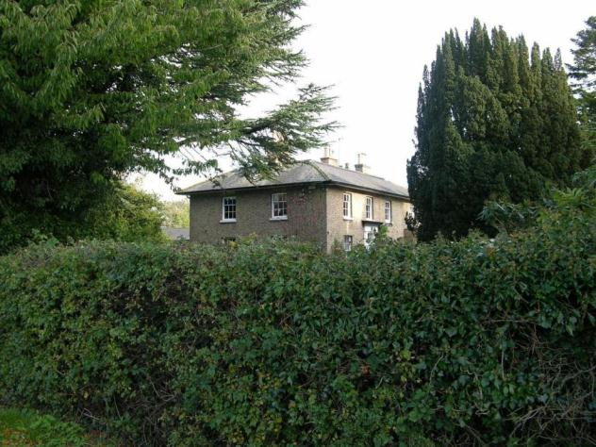

Name: Waltham House, Louth Road
Date Designated: N/A – New Proposal
Grid Reference: TA 2806 0371
Area Designation: None
Asset Type: Building
Main Criteria Used: 1c, 2g
Description:

A late 19th century farmhouse, possibly remodelled in the early 20th century. Brick built with a tile roof, three bays wide with a recessed central bay, ground floor bay windows with wide windows above all of which are casements with leaded upper parts.

Representative of the agricultural and social activities of the village.

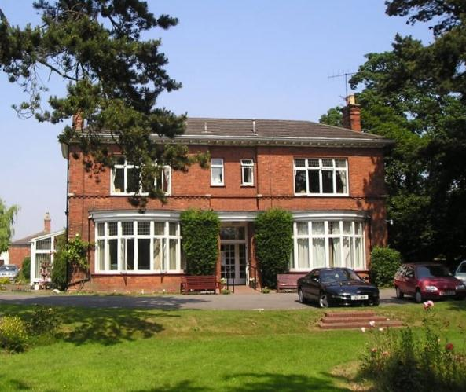

Name: Buildings and Structures at Waltham Airfield
Date Designated: N/A – New Proposal
Grid Reference: TA 2761 0266
Area Designation: None
Asset Type: Building
Main Criteria Used: 1b, 2g
Description:

The airfield in Waltham was first built in the 1930s as a civil aerodrome with a clubhouse and wooden hangars.

During the Second World War the site was taken over and converted into a heavy bomber base, named RAF Grimsby. Construction started in 1940 and involved expansion of the site across the route of the A16 to Louth. The site opened in November 1941 with Squadron 142 being the first to be accommodated, using Wellington MK IIs. From 1942 until 1945 the site was used by MK I and MK III Lancasters of 100 Squadron after which the site was used by No 35 MU for storage only.

The site has lost a great many structures and buildings, most notably the Components Store to the south of Cheapside, the control tower, the concrete surface of most of the primary runway, and all but one dispersal pad. The remaining structures are, for the most part, of local significance. They include an inter-war hangar remaining from the Civil Aerodrome, T2 and a B1 type hangars, a machine gun practice range, air raid shelters, a workshop, the watch office and admin office and the fragmentary remains of the runways and outer circuit.

Physical reminders of the impact of the two World Wars upon the home territories are becoming increasingly important; these remains are still potent symbols of the scale of warfare and the effect it had on rural England.

Part of the outer circuit, the eastern ends of the runways and a small collection of buildings, including a T2 Hangar, are outside of North East Lincolnshire in the district of East Lindsey and are not included in this listing.

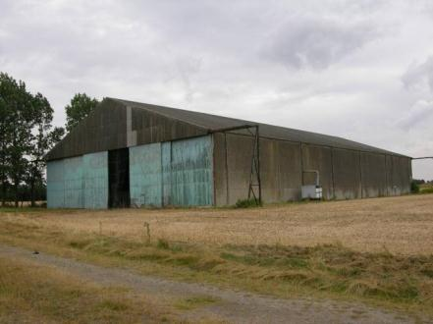
A B1 type hangar

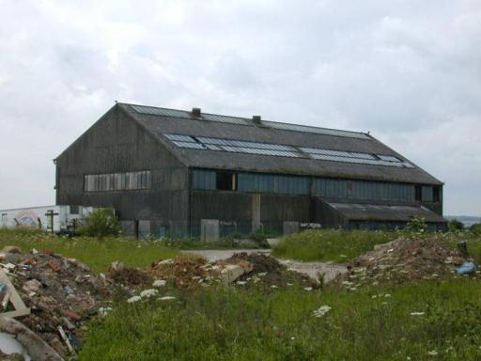
The inter-war hangar – note that it has since been re-clad

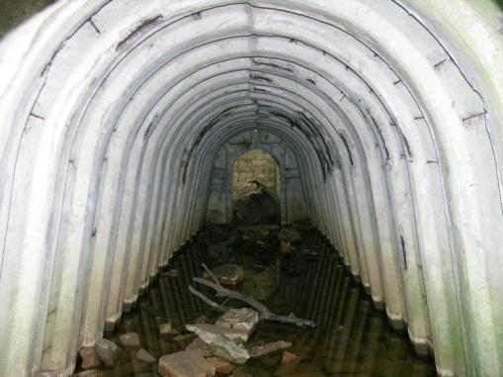
Internals of a partially pre-fabricated air raid shelter, south east of the B1 Hangar

Name: Air Raid Shelters, Ings lane
Date Designated: N/A – New Proposal
Grid Reference: TA 2703 0352
Area Designation: None
Asset Type: Building
Main Criteria Used: 1b, 2g
Description:

Two semi-sunken “Stanton” type or similar pre-fabricated air raid shelters built as part of a dispersed site associated with RAF Grimsby/Waltham Airfield during World War 2. The site also contains earthworks that appear to be related to the above-ground buildings of the camp.

Physical reminders of the impact of the two World Wars upon the home territories are becoming increasingly important; along with the remains at the airfield itself these buildings are potent symbols of the scale of warfare and the effect it had on rural England.

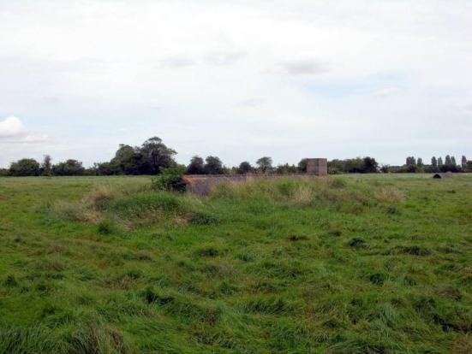

Name: Waltham medieval settlement earthworks
Date Designated: N/A – New Proposal
Grid Reference: TA 2655 0350
Area Designation: None
Asset Type: Archaeological Site
Main Criteria Used: 1b, 2a
Description:

Earthworks comprising crofts, or house platforms, related to the medieval settlement of Waltham preserved in the parkland of Waltham Grove.

As a landscape feature the earthworks represent the shrinking and re-organisation of the village following the medieval period, and will contain archaeological deposits which have the potential to inform the understanding of the development of the village.

See HER Number - 0752/0/0 - for further information and sources

