Local List of Historic Assets of Special Interest
An extension of the Historic Environment Record (HER) for North East Lincolnshire

Draft Edition for the Wolds

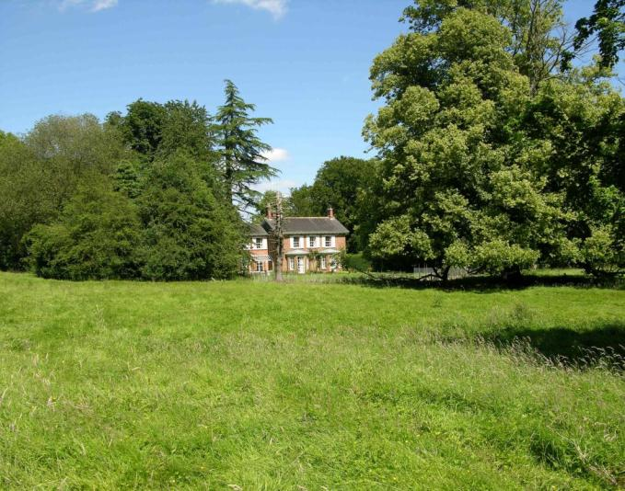

Draft October 2015

Contents

Introduction 2
A Note on Sources 2
Criteria for Listing 3
Basic Requirements for Assets 3
Beelsby 4
East Ravendale 12
Hatcliffe 18
Hawerby cum Beesby 29
Irby upon Humber 36
West Ravendale 58
Wold Newton 64

Introduction

This Local List of Historic Assets of Special Interest has been compiled in order to act as a planning tool. The entries within the list are the historic assets taken from the North East Lincolnshire Historic Environment Record, or HER, which require the greatest attention from developers and planning officers, among others, during the development process and regeneration schemes.
Heritage assets are usually included in the list because they are the best of their kind in the authority; however some assets are included because of the contribution that they make to the character of the local area.

By their very nature, buildings will make up the bulk of the list as they are the most visible of the historic assets and contribute greatly to the character of an area. Conversely, archaeological sites will be greatly under-represented on the list due to the difficulty in establishing the nature and extent of any individual assets without first excavating, particularly within the urban environment. Designed Landscapes, pieces of art and other assets are low in overall number and so will make up a minor part of the list; they are also the least likely to be affected by development.

A Note on Sources

The majority of the text in this document has been produced from scratch by staff in the Historic Environment Record. Where text has come from a single external source, every effort has been made to show that source in the text; however, the information on some assets, particularly archaeological sites, has been compiled from numerous sources and it would not be appropriate to list them all in a document such as this. In these cases, the reader is directed to the appropriate Historic Environment Record entries for further information and a list of the sources used to compile the information.

Criteria for Listing

General:

1a – The asset is rare or unique, in terms of the Borough, due to the period it represents, extent, architectural style or technological method of construction.
1b – The asset has the potential to contribute to our information on, understanding of, and appreciation of the Borough’s history and development.
1c – The asset makes a significant contribution to the historic character of an area and conforms to a Thematic criteria.
1d – The asset is part of a group of similar examples which, together, make a significant contribution to the character of an area or have the potential to provide high quality and/or quantity of historic environment data.

Thematic:

2a – Assets which exemplify a previous character type in a settlement or area which retain sufficient structure to inform on the previous character.
2b – Assets which are/were essential infrastructure associated with the Docks and Railways that retain a good proportion of their original extent.
2c – Assets which form an integral part of the character of the Resort of Cleethorpes.
2d – Assets which exemplify the rapid expansion, wealth or the major industrial and commercial activities of Grimsby in the 19th and early 20th centuries.
2e – Assets which exemplify the early development of Immingham and Cleethorpes from Villages and/or Hamlets into Towns.
2f – Post 1850s Urban Housing that retains the majority of its original structure, components and is of a high standard of design.
2g – Ecclesiastical, Manorial, Educational, Social and Agricultural assets representing the historic functions and practices of the towns and villages.

Basic Requirements for Assets

Buildings must retain the majority of their original fabric, external design style and character.

Archaeological Sites must be definable in extent and origin and be likely to retain well preserved deposits.

Designed Landscapes must be identifiable through aerial photography and at ground level. They must also be significant features in the wider landscape.

Ship Wrecks and Historic Ships must relate to the main industries of the Borough or form a group or loose association of assets.

Memorials must commemorate events of national or significant local significance and be of architectural or artistic interest.

Complex Assets are not a category in their own right, but rather contain two or more assets of the above categories that should be considered interdependent on each other.

Beelsby

Beelsby is a small settlement clustered to the south of the church, St Helen’s, mostly to the north west of a sub-rectangular road system of probable medieval origin. Beelsby is known to have existed since at least the early medieval period (410AD to 1066AD).

Beelsby is recorded as having a population of 176 in the 1851 census according to White's directory of 1856. In the 2001 census the population is recorded as 116.

At the time of writing – 2nd October 2015 – Beelsby has:

58 Historic Environment Records of which:
1 is a nationally Listed Building
1 is a nationally Scheduled Monument
6 are proposed Locally Listed Historic Assets

Name: Greenwood House, Beelsby
Date Designated: N/A – New Proposal
Grid Reference: TA 2055 0184
Area Designation: None
Asset Type: Complex (Building, Designed Landscape, Archaeological Site)
Main Criteria Used: 1c, 2g
Description:

A rectory built by T C Hine of Nottingham in 1868. Big and spreading, in red brick with a staircase in stone balustrade.

Pevsner N and J Harris. 1989. The Buildings of England Lincolnshire. 2nd Edition. Yale University Press. New Haven and London.

The house is surrounded by a small area of parkland containing faint medieval village earthworks which are also included in the listing. The site shows the development of formal landscapes around the houses of wealthy people in the 19th century, and the fossilisation of the earlier landscape of the deserted medieval village. As a vicarage the house also represents an important part of the ecclesiastical functions of the village.

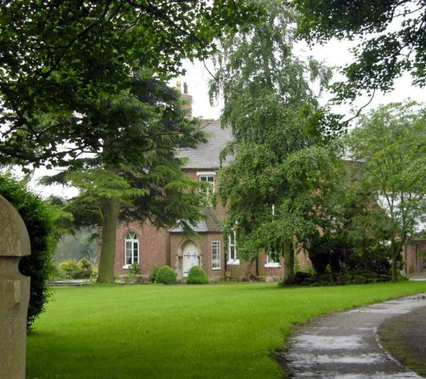

Name: 1 to 4, 6 to 13, 17 to 18, Owls Hoot, Well Garth and The Old Smithy, Main Road
Date Designated: N/A – New Proposal
Grid Reference: TA 2075 0194
Area Designation: None
Asset Type: Building
Main Criteria Used: 1d, 2g
Description:

A group of 17 estate cottages of various ages and designs forming a coherent group along the main street of Beelsby. Although all have modifications of some sort the group value and lack of too many unsympathetic alterations mean that they are of special local interest.

Groups of estate cottages such as this are important parts of landscapes like the Lincolnshire Wolds as they indicate areas where the influence of country estates was particularly strong. This group survives well with no outright loses and only one which has been too heavily altered to form part of the listing (Rosedene, 5 Main Road).

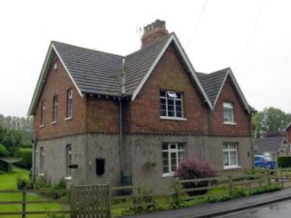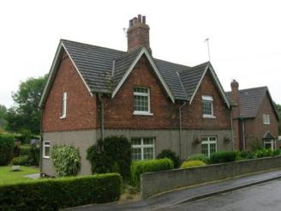
1 and 2 Main Road (left) 3 and 4 Main Road (right)

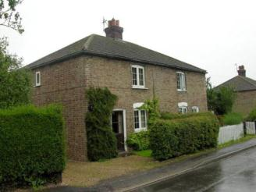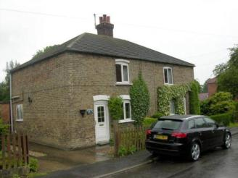
6 and 7 Main Road (left) 8 and 9 Main Road (right)

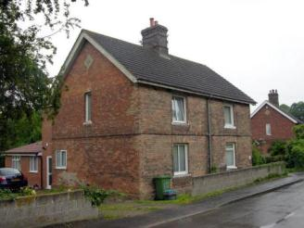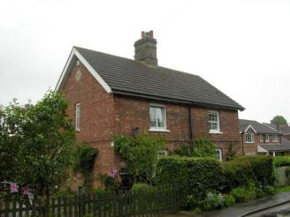
10 and 11 Main Road (left) 12 and 13 Main Road (right)

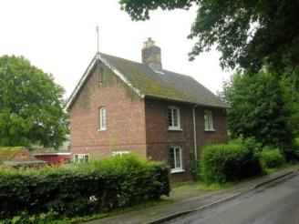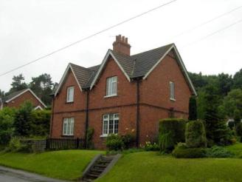
Owl’s Hoot and Well Garth, Main Road (left) 17 and 18 Main Road (right)

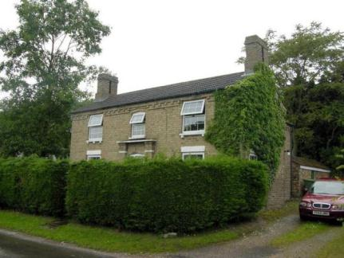
The Old Smithy, Main Road

Name: Cast Iron Phone Box, Main Road
Date Designated: N/A – New Proposal
Grid Reference: TA 2083 0205
Area Designation: None
Asset Type: Building
Main Criteria Used: 1c, 2g
Description:

K6, or similar model, telephone kiosk. Cast iron. Square kiosk with domed roof. Un-perforated crowns to top panels and margin glazing to windows and door

Although once widespread, cast-iron phone boxes have become synonymous with historic and rural areas and are therefore important to the character of the villages.

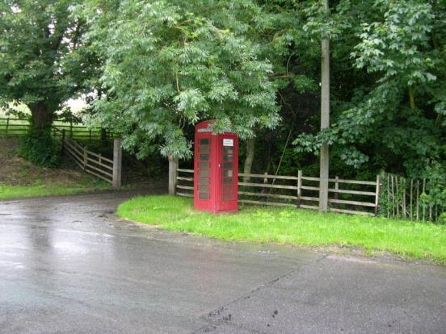

Name: Signpost, Junction of Swallow Road and Main Road, Beelsby
Date Designated: N/A – New Proposal
Grid Reference: TA 2067 0184
Area Designation: None
Asset Type: Building
Main Criteria Used: 1c, 2g
Description:

A historic road side sign post with a black and white striped post and two planks set into recesses forming three arms. The signs point to Croxby and MKT [Market] Rasen to the south, Swallow and Caistor to the north west, Caistor and Grimsby to the north east. The distances to each village are not shown.

Although once widespread, this style of sign post is now only found in the rural areas of North East Lincolnshire and form part of the less developed rural character.

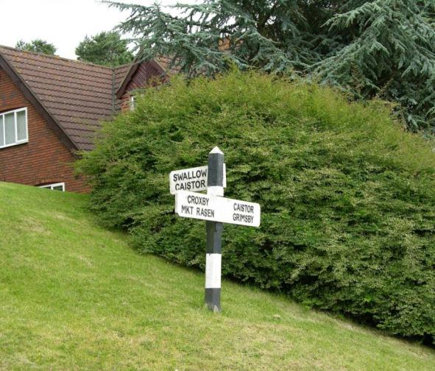

Name: Signpost, Junction of Croxby Road, Hatcliffe Road and Main Road, Beelsby
Date Designated: N/A – New Proposal
Grid Reference: TA 2063 0164
Area Designation: None
Asset Type: Building
Main Criteria Used: 1c, 2g
Description:

A historic road side sign post with a black and white striped post and two planks set into recesses forming three arms. The signs point to Croxby and MKT [Market] Rasen to the south, Swallow and Caistor to the north west, Caistor and Grimsby to the north east. The distances to each village are not shown

Although once widespread, this style of sign post is now only found in the rural areas of North East Lincolnshire and form part of the less developed rural character.

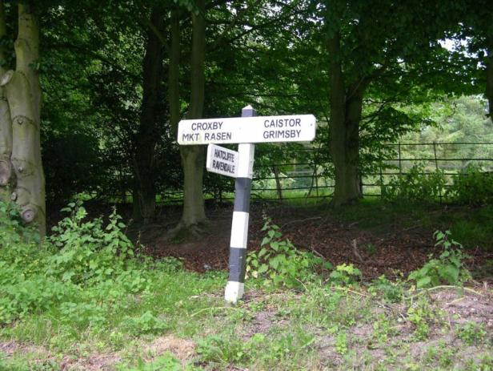

Name: Bronze Age Barrow Cemetery 180m north east of The Thatches, Beelsby
Date Designated: N/A – New Proposal
Grid Reference: TA 2003 0062
Area Designation: Lincolnshire Wolds AONB
Asset Type: Archaeological Site
Main Criteria Used: 1b
Description:

A shallow (c.20cm) earthwork of a probable Bronze Age Round Barrow and at least three further possible barrows indicated by cropmark ring-ditches. The earthwork is known to have been 100ft across and 3ft 6in high before being levelled.

Despite the levelling of the barrow(s) important paleoenvironmental deposits relating to the Bronze Age landscape and environment of Beelsby are likely to be preserved in the surrounding ring-ditches.

See HER Number - 0098/1/0 - for further information and sources

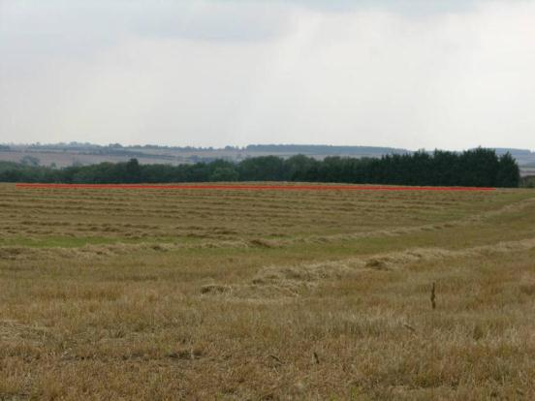
Photograph of the remains of the barrow highlighting the slight earthwork

East Ravendale

East Ravendale is a sparsely settled village with a degree of nucleation around the parish church of St Martin. At the time of Domesday (1086AD) and the Lindsey Survey (c.1115AD) Ravendale is referred to as a single entity; however the original parish had been split into East and West Ravendale by the time of the Episcopal Registers (1219AD).

East Ravendale is recorded as having a population of 76 in the 1851 census according to White's directory of 1856. In the 2001 census the population is recorded as 125.

At the time of writing – 2nd October 2015 – East Ravendale has:

51 Historic Environment Records of which:
4 are nationally Listed Buildings
None are nationally Scheduled Monuments
5 are proposed Locally Listed Historic Assets

Name: East Ravendale School
Date Designated: N/A – New Proposal
Grid Reference: TF 2385 9961
Area Designation: Lincolnshire Wolds AONB
Asset Type: Building
Main Criteria Used: 1c, 2g
Description:

School by Fowler, and built at the same time as the church. Red brick gothic, asymmetrical with a tower. Eastern wing has stone mullions. Ornate bell tower above entrance.

Pevsner N and J Harris. 1989. The Buildings of England Lincolnshire. 2nd Edition. Yale University Press. New Haven and London.

An important part of the social activities of the settlement, and other nearby villages that would have been in the catchment for the school.

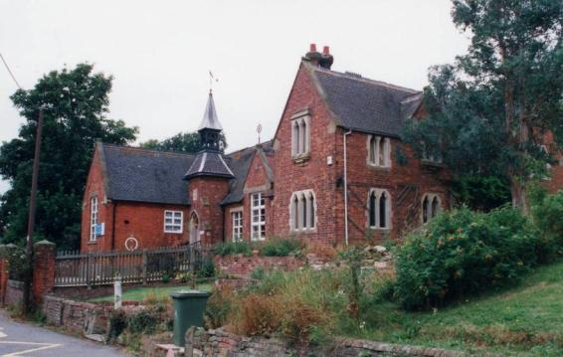

Name: The Old Rectory
Date Designated: N/A – New Proposal
Grid Reference: TF 2384 9966
Area Designation: Lincolnshire Wolds AONB
Asset Type: Building
Main Criteria Used: 1c, 2g
Description:

A vicarage of 1858. Three bays with a central projecting bay topped by a gablet with decorated barge board. End stacks and roof dormers.

A prominent building which represents an important part of the ecclesiastical functions of the village.

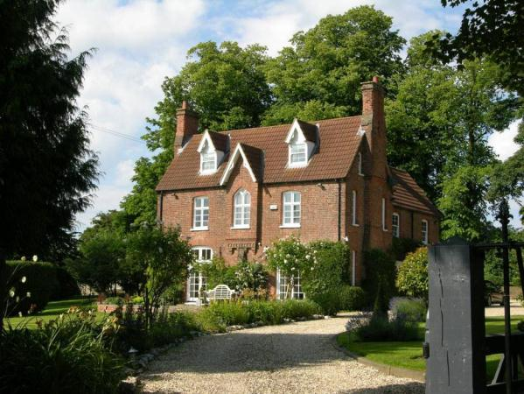

Name: Crossways
Date Designated: N/A – New Proposal
Grid Reference: TF 2372 9970
Area Designation: Lincolnshire Wolds AONB
Asset Type: Building
Main Criteria Used: 1c, 2g
Description:

A large estate style cottage. Two storeys, red brick with slate roof and central stack. Fine detailing with decorated bargeboards, gablets to the front elevation and decorative stack. Sensitively extended, giving a secondary frontage to the road to West Ravendale.

Although altered the good quality of design and prominent position on a crossroads mean that this cottage is of a high level of importance to the character and appearance of the village.

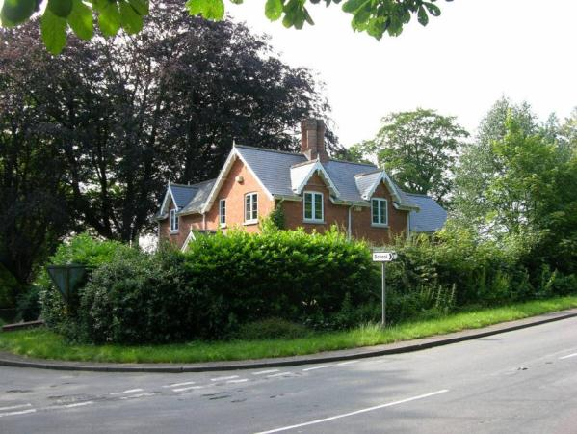

Name: Signpost, East Ravendale Crossroads
Date Designated: N/A – New Proposal
Grid Reference: TF 2374 9968
Area Designation: None
Asset Type: Building
Main Criteria Used: 1c, 2g
Description:

A historic road side sign post with a black and white striped post and two planks set into recesses forming four arms. The signs point to Hatcliffe to the west, Waltham to the north, East Ravendale to the east, Binbrook to the south. The distances to each village are not shown.

Although once widespread, this style of sign post is now only found in the rural areas of North East Lincolnshire and form part of the less developed rural character.

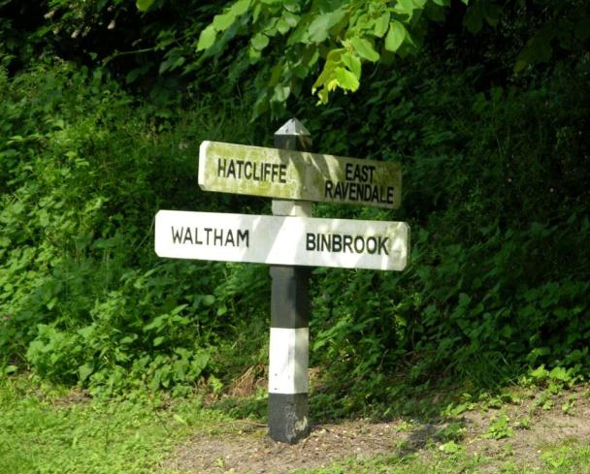

Name: Signpost, Junction of Wold Newton Road and an un-named road, East Ravendale
Date Designated: N/A – New Proposal
Grid Reference: TF 2359 9928
Area Designation: None
Asset Type: Building
Main Criteria Used: 1c, 2g
Description:

A historic road side sign post with a black and white striped post and two planks set into recesses forming three arms. The signs point to Wold Newton and Kelstern to the south, Thorganby and Binbrook to the west, Brigsley and Hatcliffe to the north. The arms also display distances to the annotated villages/towns: Brigsley 2, Hatcliffe 2, Wold Newton 2, Kelstern 6, Thorganby 2, Binbrook 4.

Although once widespread, this style of sign post is now only found in the rural areas of North East Lincolnshire and form part of the less developed rural character.

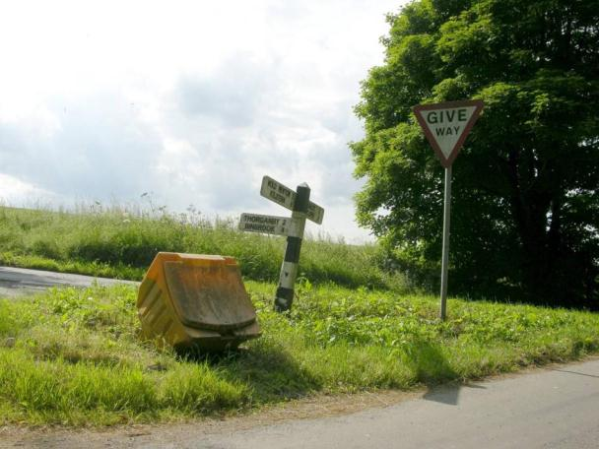

Hatcliffe

Hatcliffe is a small nucleated village, known to have existed since the early medieval period (410AD to 1066AD), which is concentrated along the main road around the church of St Mary. The village also spills across its northern border into the parish of Beelsby.

The parish also contains the hamlet of Gunnerby, to the south of Hatcliffe, which is also known to have existed since the early medieval period (410AD to 1066AD)

Hatcliffe is recorded as having a population of 147 in the 1851 census according to White's directory of 1856. In the 2001 census the population is recorded as 116.

At the time of writing – 2nd October 2015 – Hatcliffe has:

65 Historic Environment Records of which:
4 are nationally Listed Buildings
1 is a nationally Scheduled Monument
9 are proposed Locally Listed Historic Assets

Name: Hatcliffe Top Farm Cottages
Date Designated: N/A – New Proposal
Grid Reference: TA 2306 0182
Area Designation: Lincolnshire Wolds AONB
Asset Type: Building
Main Criteria Used: 1c, 2g
Description:

A model farm complex and a pair of 18th or more likely early 19th century farm cottages. The cottages have been converted into a single dwelling, although they are currently abandoned and are relatively unaltered with features such as the ladder-stairs intact to one side.

A fine collection of buildings representing the agricultural activities of the village.

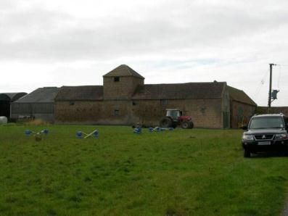

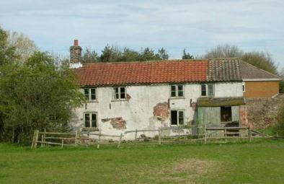

Name: Ings Cottages, Hatcliffe
Date Designated: N/A – New Proposal
Grid Reference: TA 2140 0081
Area Designation: Lincolnshire Wolds AONB
Asset Type: Building
Main Criteria Used: 1c, 2g
Description:

Probable early 19th century estate, or farm workers, cottage. Brown brick with interlocking pantile roof, ground floor left window widened historically but other apertures intact with modern windows.
Paint mark around the door indicates the former position of a 20th century wooden porch.

A fine village cottage with few alterations, representative of the agricultural activities of the settlement.

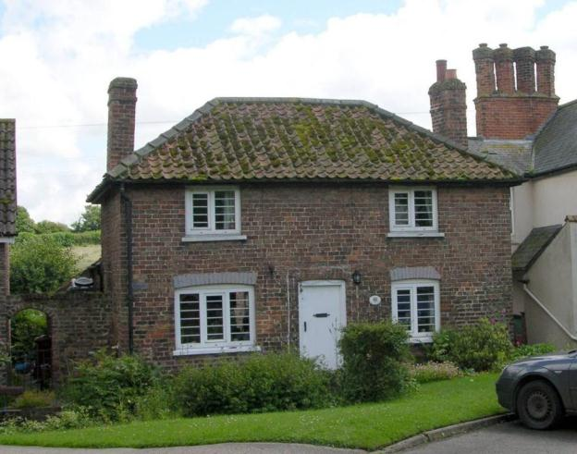
Name: Old Farm House, Hatcliffe
Date Designated: N/A – New Proposal
Grid Reference: TA 22389 01382
Area Designation: None
Asset Type: Building
Main Criteria Used: 1c, 2g
Description:

An 18th century house, two storeys, four bays, originally L-shaped on plan but now with an extension to form a square footprint. Formerly a Grade III (three) listed building. Recorded in 1824 as "manor house."
All of the buildings shown on Ordnance Survey maps of 1887-9 are present.

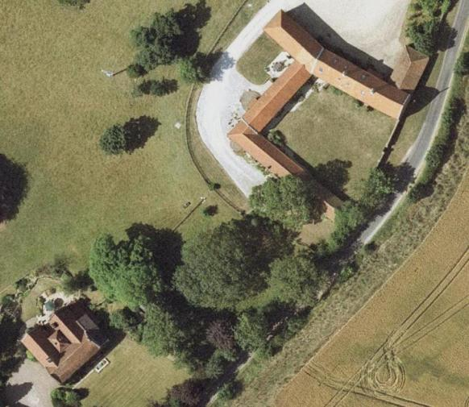
Image Taken in 2006
The GeoInformation Group Data ® copyright by The GeoInformation® Group, 2015

Name: Hatcliffe House/Hatcliffe Manor
Date Designated: N/A – New Proposal
Grid Reference: TA 21413 00028
Area Designation: None
Asset Type: Building
Main Criteria Used: 1c, 2g
Description:

A farmstead, probably 19th century, which appears to consist of a large farmhouse and a complex lose 8-plan range of farm buildings around two courtyards. All but one of the buildings shown on Ordnance Survey maps of 1887-9 are present.

This site has been surveyed from aerial photographs and maps only. It is assumed from this evidence that it is of at least local interest. The barns were photographed prior to conversion to residential but have not been re-visited.

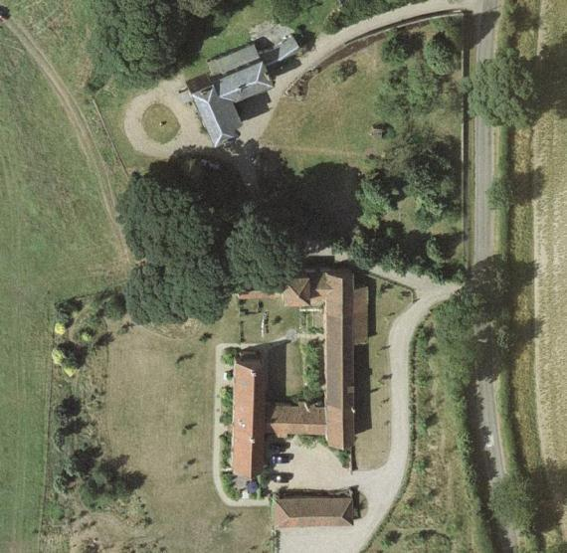
Image Taken in 2006
The GeoInformation Group Data ® copyright by The GeoInformation® Group, 2015

Name: Signpost, Junction of Low Road and Main Road, Hatcliffe
Date Designated: N/A – New Proposal
Grid Reference: TA 2149 0046
Area Designation: None
Asset Type: Building
Main Criteria Used: 1c, 2g
Description:

A historic road side sign post with a black and white striped post and two planks set into recesses forming three arms. The signs point to Hatcliffe and Beelsby to the north, Thorganby and Swinhope to the south, Barnoldby le Beck to the east. The distances to each village are not shown.

Although once widespread, this style of sign post is now only found in the rural areas of North East Lincolnshire and form part of the less developed rural character.

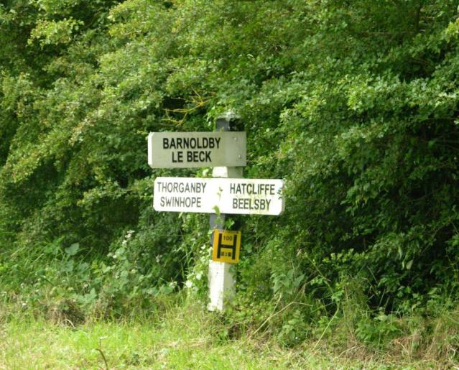

Name: Cropmark enclosures and boundaries 120m west of Gunnerby House, Hatcliffe
Date Designated: N/A – New Proposal
Grid Reference: TF 2132 9874
Area Designation: Lincolnshire Wolds AONB
Asset Type: Archaeological Site
Main Criteria Used: 1b, 2a
Description:

A possible Prehistoric or Roman settlement was seen as earthworks and mapped from good quality air photographs. The main feature of the settlement is an asymmetric, rectilinear, ditched enclosure, measuring 90m by 70m, centred at TF 2142 9875. An enclosure, measuring 20m by 20m, is formed in the corner of this enclosure. The sides of the main enclosure extend to subdivide the area around into parcels of land measuring on average 70m by 50m. Adjacent are fragments of ditches, centred at TF 2125 9872, which are probably parts of a system of enclosure associated with the settlement (National Monuments Record: TF 29 NW 33)

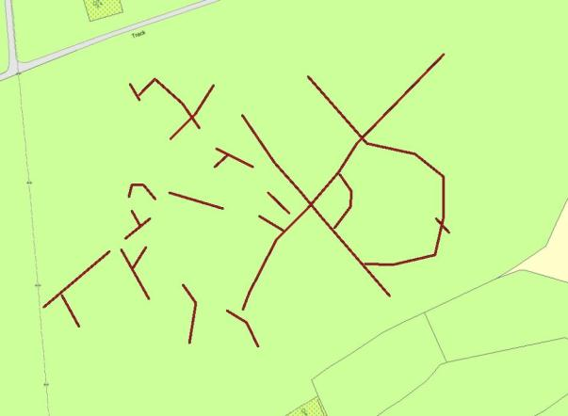
Plot of the Cropmark, as mapped by the RCHME
Reproduced from an Ordnance Survey map with the permission of the Controller of HMSO © Crown Copyright.
Licence number 100020759 North East Lincolnshire Council

Name: Cropmark ring ditches 200m east of Hatcliffe Manor
Date Designated: N/A – New Proposal
Grid Reference: TA 2160 0003
Area Designation: Lincolnshire Wolds AONB
Asset Type: Archaeological Site
Main Criteria Used: 1b, 2a
Description:

A pair of ring ditches seen on aerial photographs less than 500m from the scheduled round barrow to the west of Hatcliffe Manor. Listed due to their potential association with the scheduled site and therefore the high potential that they represent the site of further barrows.

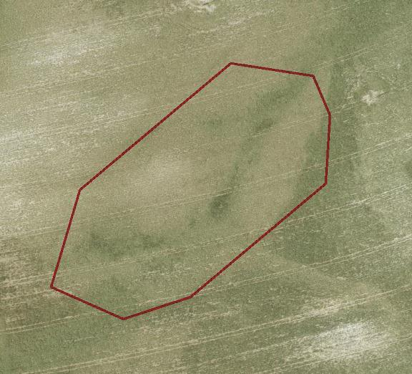
Image Taken in 2006
The GeoInformation Group Data ® copyright by The GeoInformation® Group, 2015

Name: Earthworks of enclosures, ponds, leats and trackways west of The Old Farm
Date Designated: N/A – New Proposal
Grid Reference: TA 2220 0131
Area Designation: Lincolnshire Wolds AONB
Asset Type: Archaeological Site
Main Criteria Used: 1b, 2g
Description:

A large area of archaeological earthworks relating to the medieval and post medieval settlement of Hatcliffe.
Three possible Medieval or Post Medieval ponds, two sides of a potential Medieval or Post Medieval enclosure defined by ditches and several possible Medieval or Post Medieval trackways seen as earthworks on air photographs. Also the Mill Race for Hatcliffe Mill is extant in long sections within this site.

As a landscape feature the earthworks represent long extinct activities within the village, probably water management with possible fish farming.

See HER Number - 0440/4/0 - for further information and sources

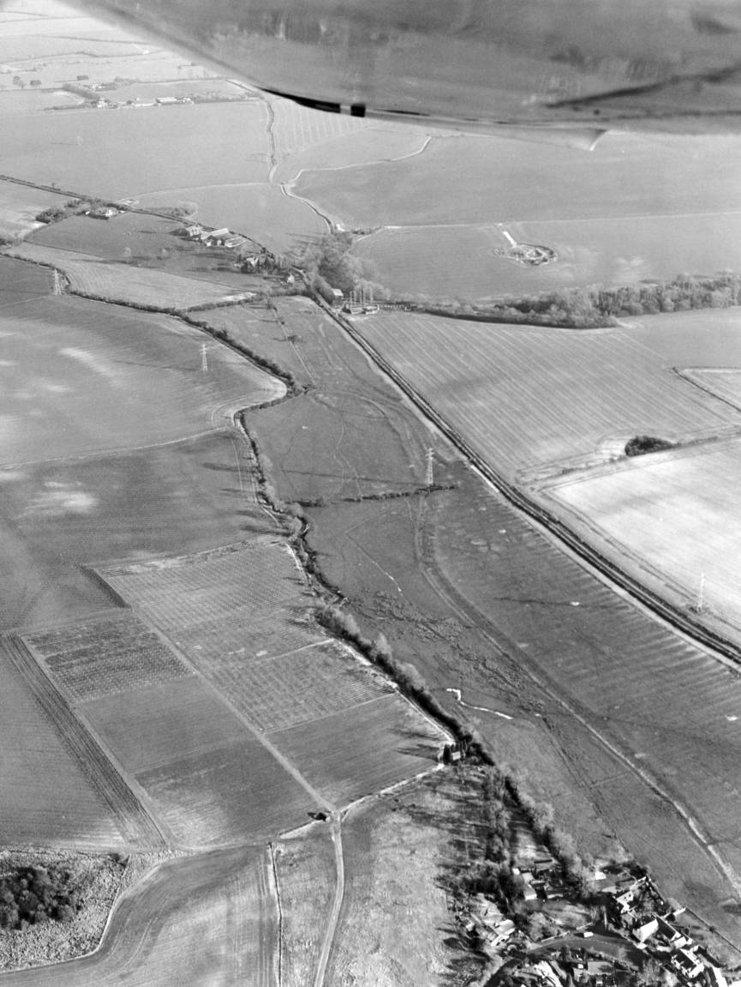
© Humber Archaeological Partnership 1991

Name: Hatcliffe Medieval shrunken village earthworks.
Date Designated: N/A – New Proposal
Grid Reference: TA 2137 0042
Area Designation: Lincolnshire Wolds AONB
Asset Type: Archaeological Site
Main Criteria Used: 1b, 2g
Description:

An area of shrunken medieval village including a possible mill site and leat shown on aerial photographs. Shown by cropmarks and earthworks.

As a landscape feature the earthworks represent the shrinking and re-organisation of the village following the medieval period, and will contain archaeological deposits which have the potential to inform the understanding of the development of the village.

See HER Number - 0440/0/0 - for further information and sources

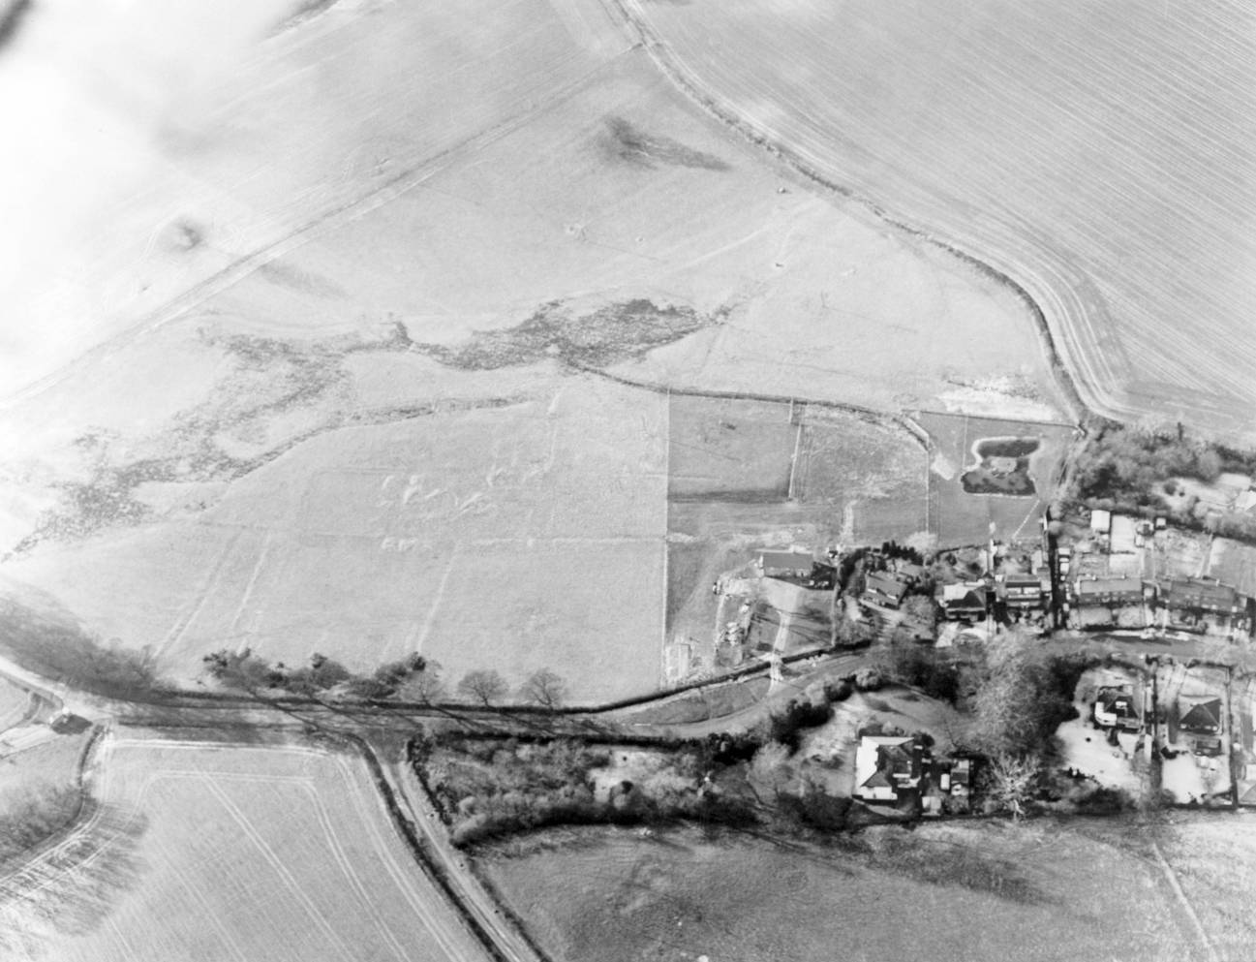
© Humber Archaeological Partnership 1991

Hawerby cum Beesby

Hawerby cum Beesby is in reality a pair of parishes which were merged together in 1450AD due to population loss. Both of the villages are known to have existed since the early medieval period (410AD to 1066AD) and both are now virtually depopulated.

Hawerby cum Beesby is recorded as having a population of 85 in the 1851 census according to White's directory of 1856. In the 2001 census the population is recorded as 24.

At the time of writing – 2nd October 2015 – Hawerby cum Beesby has:

38 Historic Environment Records of which:
2 are nationally Listed Buildings
1 is a nationally Scheduled Monument
4 are proposed Locally Listed Historic Assets

Name: Hawerby Hall Farm including Cottages
Date Designated: N/A – New Proposal
Grid Reference: TF 25667 9812
Area Designation: Lincolnshire Wolds AONB
Asset Type: Building
Main Criteria Used: 1c, 2g
Description:

A complex farmstead associated with Hawerby Hall (NHLE 1103494). The site appears to have consisted of two semi-detached cottages and one detached cottage, a slightly irregular E-shaped range of barns, a small detached cart shed and a large round pond. One of the semi-detached cottages, the detached cottage, the pond, ¾ of the range of farm buildings and the detached cart shed survive.

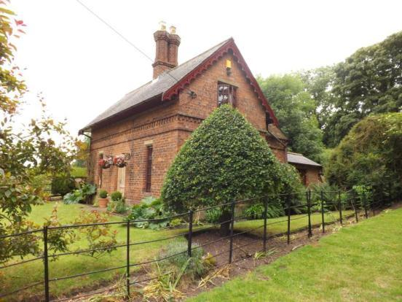
Photo taken from Rightmove, need one of our own.

The remaining semi-detached cottage is slightly detached from the main complex, and has been knocked-through into a single property. It is built of brown brick with a slate roof and central stack made of a pair of octagonal pillars topped with square pots. The original frontage, facing roughly north-east, is three bays wide with a central entrance and a shadow of a former porch in the brickwork. The flanking windows are tall and narrow with slim chamfered ashlar lintels. Above are a pair of brick string courses, one plain projecting, the next made of dentilles and a plain projecting band. The side elevation has a window at ground floor and one in the attic floor, both with ashlar lintels, and gable with decorated barge board. The rear elevation has twin gablets with decorated barge boards and ashlar lintels. The windows on the ground floor appear to be later insertions. The rear detached utility buildings appear to have been partly demolished with the remains attached to the main house with an extension.
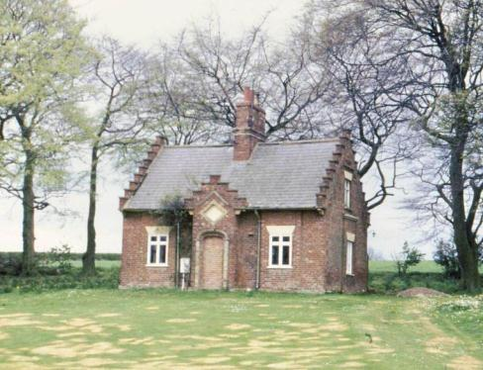

The detached cottage is within the main complex and occupies the highest ground, indicating that it was probably the house of the main farm worker. It is three bays wide and one bay deep, built of brown brick with a slate roof and central stack and rear extensions (possibly historic). The front door, which is now blocked, is in a projecting porch with ashlar architrave, ashlar surrounded lozenge plaque above, and a crow-step gable. The flanking windows are small with flared ashlar lintels. The side elevations have one window at ground floor level in a shallow projection topped with a moulded ashlar lintel, above is a smaller window in the loft floor under a flared ashlar lintel, then the gables are crow-stepped like the porch. It is currently abandoned and falling into disrepair.

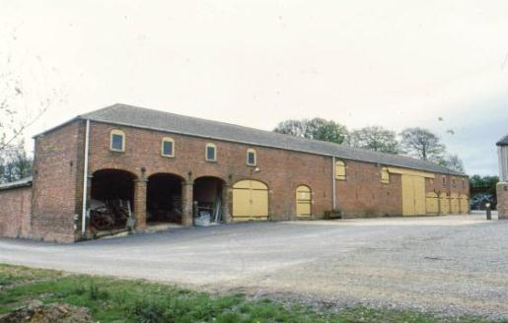

The barn complex was originally E-shaped in plan but the loss of one range has reduced this to an F-shape. Additionally mid 20th century farm buildings have been built over the courtyards obscuring the inner facades of the buildings.
The main barn runs north-east to south-west and is around 13 bays wide. Only the outer façade can be seen. At each end are four large cart openings, five of which have original timber doors fitted, with granary/hayloft windows above in the second floor. In the mid section is one very large full height door, probably a 20th century alteration, many ventilator slits, two pitching doors at first floor level and a single ground floor door. It appears that it was originally a symmetrical frontage, but the large full height door disrupts this pattern.
Of the northernmost range nothing can be said, other than the fact that it is single storey, as the outer elevation has no openings and the inner elevation is obscured.
Of the central range little can be said at it is obscured almost completely by the mid 20th century sheds. However at its apex is a two storey building with a ground floor doorway, first floor dove openings arranged in a segmental arched opening, and a pyramidal slate roof topped with a pinnacle and weathervane.

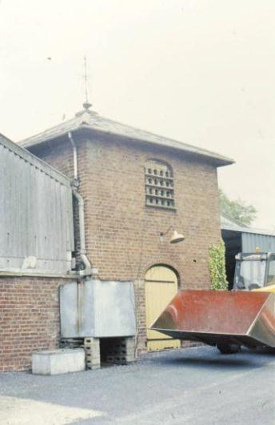

The detached cart shed is a simple brick building with piers to the open front and a corrugated iron roof. The pond is lined with stone and/or concrete and surrounded by iron railings.

Hawerby Hall Farm is the most architecturally elaborate of North East Lincolnshire’s farms, as would be expected given the association with Hawerby Hall which was, for a significant period of time, the only noble seat in the borough.
Name: Barns at Beesby Top Farm
Date Designated: N/A – New Proposal
Grid Reference: TF 25796 95872
Area Designation: None
Asset Type: Building
Main Criteria Used: 1c, 2g
Description:

A range of farm buildings, probably 19th century, which appears to consist of a single range of buildings. The farmstead originally had a courtyard based farmstead, however most of the buildings shown on Ordnance Survey maps of 1887-9 have been lost and the farmhouse is no longer of interest.

This site has been surveyed from aerial photographs, maps, and from distance only. It is assumed from this evidence that it is of at least local interest.

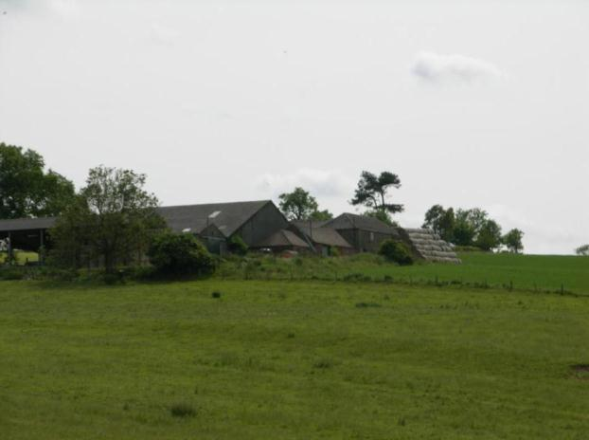

Name: Cropmark and shallow earthwork of a Bronze Age Round Barrow 550m south west of Hawerby Hall Farm
Date Designated: N/A – New Proposal
Grid Reference: TF 2534 9765
Area Designation: Lincolnshire Wolds AONB
Asset Type: Archaeological Site
Main Criteria Used: 1b, 2a
Description:

A round barrow, formerly 53 feet in diameter and up to 5 foot high, with two obvious signs of disturbance. It is now much reduced by ploughing. A number of related finds have been found, including a barb and tanged flint arrowhead.

Loughlin N and K R Miller. 1979. A Survey of Archaeological Sites in Humberside. Humberside Libraries and Amenities. Hull.

Located within Beacon Field and probably connected to the Horby Beacon of 1703.

The origin of the name of the parish of Hawerby, ("Hawarth's Farm/Village") has been linked to that of the Wapentake of Haverstoe ("Hawarth's Mound"), and further this mound/barrow has been suggested to be the meeting place for the Wapentake.

Kenneth Cameron, 1995, The Place Names of Lincolnshire. Part 4, Ludborough and Haverstoe Wapentakes.

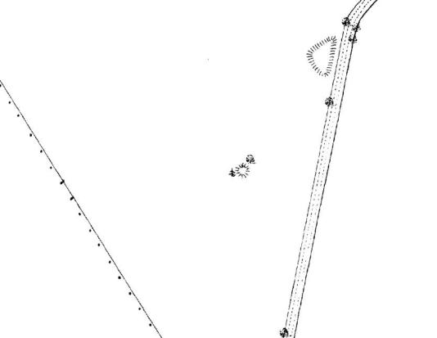
The barrow as depicted on Ordnance Survey maps of 1887-9
Name: Parkland associated with the village of Beesby
Date Designated: N/A – New Proposal
Grid Reference: TF 2675 9629
Area Designation: Lincolnshire Wolds AONB
Asset Type: Designed Landscape
Main Criteria Used: 1c, 2g
Description:

An area of post medieval parkland, shown by dispersed trees in a pasture environment, probably associated with Beesby House or Cadeby House.

The parkland forms part of the social landscape of the area, indicating the influence of the two nearby manor houses and their wealthy owners.

Note: The parkland also contains earthworks relating to the medieval settlement of Beesby which are a Scheduled Monument.

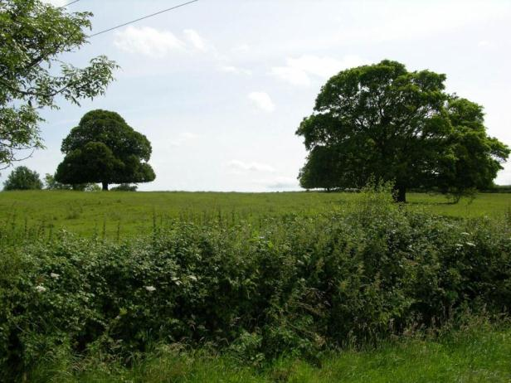

Irby upon Humber

Irby upon Humber is a historic settlement known to have existed since the early medieval period (410AD to 1066AD). The character of the village is predominantly that of a shrunken village with the historic houses scattered along several different roads but reflecting a formerly nucleated settlement.

Irby on Humber is recorded as having a population of 253 in the 1851 census according to White's directory of 1856. In the 2001 census the population is recorded as 124.

At the time of writing – 2nd October 2014 – Irby upon Humber has:

73 Historic Environment Records of which:
4 are nationally Listed Buildings
1 is a nationally Scheduled Monument
12 are proposed Locally Listed Historic Assets

Note – Irby upon Humber currently has 17 Locally Listed Buildings, these having been added as part of the 2009 Conservation Area work. It is proposed that 9 of these are removed from the list in order to concentrate resources on those assets which are the most architecturally/historically intact.

Name: Manor Farmhouse, Church Lane
Date Designated: 14/12/2009
Grid Reference: TA 1976 0493
Area Designation: Irby upon Humber Conservation Area, Lincolnshire Wolds AONB
Asset Type: Building
Main Criteria Used: 1c, 2g
Description:

Early 20th Century two storey manor house in light brown or buff brick with ashlar dressing and slate roof, set in landscaped grounds.

The adjacent model farm complex appears to retain most of the early buildings, judging purely from mapping, but cannot be seen from the highway.

An important part of the social and manorial structure of the village.

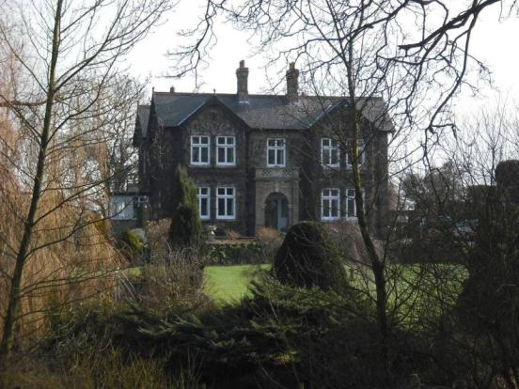

Name: Mount Farm, Church Lane
Date Designated: 14/12/2009
Grid Reference: TA 1976 0482
Area Designation: Irby upon Humber Conservation Area, Lincolnshire Wolds AONB
Asset Type: Building
Main Criteria Used: 1c, 2g
Description:

19th Century two storey farm or manor house in buff brick with ashlar dressings and a slate roof, set in landscaped grounds with contemporary wall and railings on part of the street front.

The farmstead still includes its original E-shaped model farm complex with detached cart shed; one of the best survivors in the Borough.

An important part of the social and agricultural structure of the village.

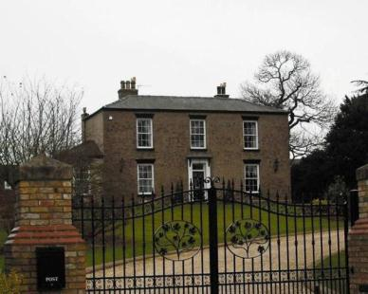

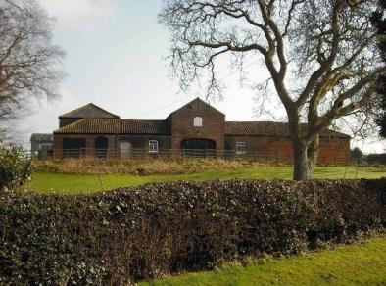

Name: Hastings and Millfield Cottages, Old Main Road
Date Designated: 14/12/2009
Grid Reference: TA 1982 0519
Area Designation: Irby upon Humber Conservation Area, Lincolnshire Wolds AONB
Asset Type: Building
Main Criteria Used: 1c, 2g
Description:

A pair of estate cottages in buff brick with slate roofs. Symmetrical with paired front bays and single side bays set back, ground and first floor segmental arched windows with brick drip moulds. Decorated bargeboards and grand central stack shared by both houses.

An important part of the social and agricultural structure of the village.

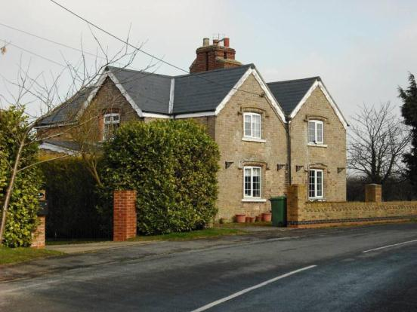

Name: Millfield and Brandybuck Cottages, Old Main Road
Date Designated: 14/12/2009
Grid Reference: TA 1976 0512
Area Designation: Irby upon Humber Conservation Area, Lincolnshire Wolds AONB
Asset Type: Building
Main Criteria Used: N/A
Description:

A pair of estate cottages in red/brown brick with slate roofs. Symmetrical with paired front bays and single side bays set back, ground and first floor square arched windows with brick drip moulds. Brick eaves cornices and central stack shared by both houses.

***This asset has been assessed against the new Criteria for Listing and is no longer thought to be of sufficient special local interest to be Locally Listed***

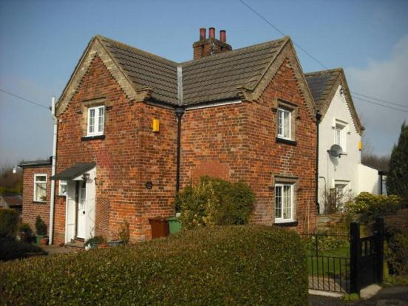

Name: Mount Cottages, Old Main Road
Date Designated: 14/12/2009
Grid Reference: TA 1961 0471
Area Designation: Irby upon Humber Conservation Area, Lincolnshire Wolds AONB
Asset Type: Building
Main Criteria Used: 1c, 2g
Description:

A pair of estate cottages in buff brick with slate roofs. Square arched windows with brick dripmoulds, brick quoins and bargeboards to the gables.

An important part of the social and agricultural structure of the village.

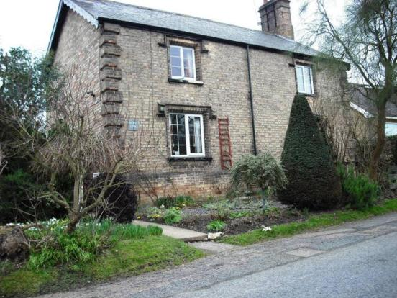

Name: Irby Dales Farmhouse, Old Main Road
Date Designated: 14/12/2009
Grid Reference: TA 1949 0462
Area Designation: Irby upon Humber Conservation Area, Lincolnshire Wolds AONB
Asset Type: Building
Main Criteria Used: N/A
Description:

Two storey, three bay 19th century farmhouse with many modern alterations, most notably a large central entrance and re-roofing.

***This asset has been assessed against the new Criteria for Listing and is no longer thought to be of sufficient special local interest to be Locally Listed***

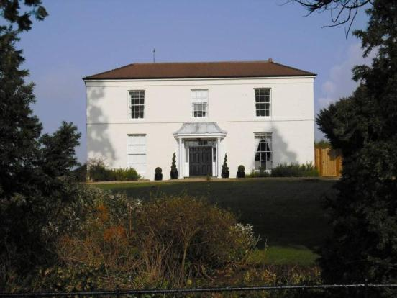

Name: Farm Buildings at Irby Dales Farm, Old Main Road
Date Designated: 14/12/2009
Grid Reference: TA 1935 0457
Area Designation: Irby upon Humber Conservation Area, Lincolnshire Wolds AONB
Asset Type: Building
Main Criteria Used: N/A
Description:

Seemingly intact, judging by map evidence, E-shaped model farm complex featuring a large integrated cart shed with granary above. Red-brown brick with slate roofs.

Fixture to the Listed Building known as “Dovecote at Irby Dales Farm approximately 150 metres west of Irby Dales Farmhouse” and therefore Local Listing is not necessary.

***This asset is no longer thought to be suitable for Local Listing***

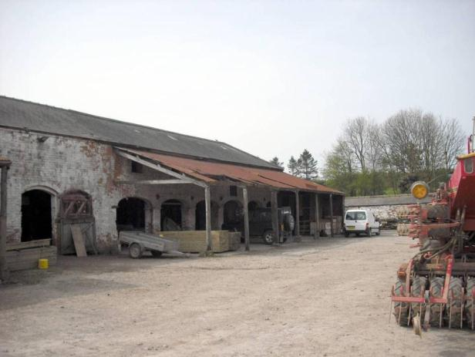

Name: Irby Dales Farm Cottage, Old Main Road
Date Designated: 14/12/2009
Grid Reference: TA 1931 0454
Area Designation: Irby upon Humber Conservation Area, Lincolnshire Wolds AONB
Asset Type: Building
Main Criteria Used: ***
Description:

A pair of estate cottages in brown brick with slate roofs. Part of the Irby Dales Farm complex.

An important part of the social and agricultural structure of the village.

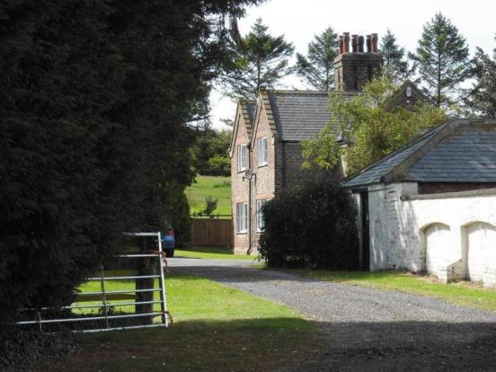

Name: St Andrew’s Church Hall, School Lane
Date Designated: 14/12/2009
Grid Reference: TA 1981 0466
Area Designation: Irby upon Humber Conservation Area, Lincolnshire Wolds AONB
Asset Type: Building
Main Criteria Used: ***
Description:

A school of 1900, now used as the village/church hall.
Built in dark buff bricks with slate roof.

An important part of the social and potentially the religious structure of the village.

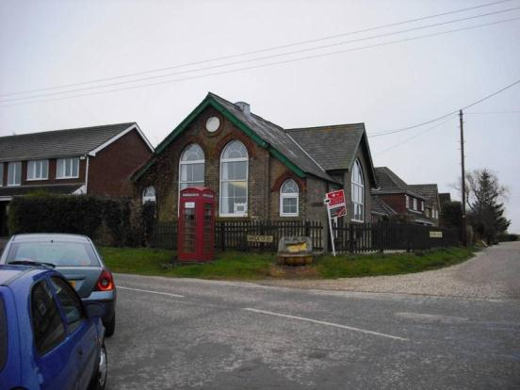

Name: End Cottage & Glenfield, School Lane
Date Designated: 14/12/2009
Grid Reference: TA 1980 0458
Area Designation: Irby upon Humber Conservation Area, Lincolnshire Wolds AONB
Asset Type: Building
Main Criteria Used: N/A
Description:

A pair of twentieth century estate cottages in light brown brick with red brick stringcourse, limited ashlar dressings and a slate roof.

***This asset has been assessed against the new Criteria for Listing and is no longer thought to be of sufficient special local interest to be Locally Listed***

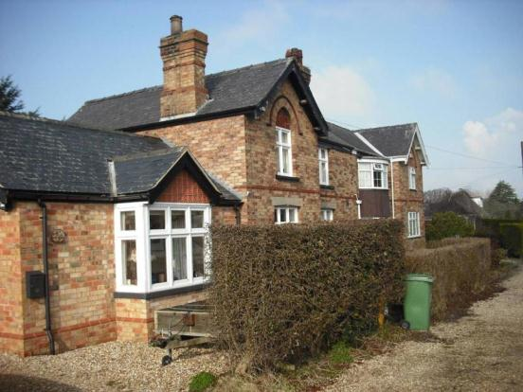

Name: Telephone Kiosk, Walk Lane
Date Designated: 14/12/2009
Grid Reference: TA 1980 0466
Area Designation: Irby upon Humber Conservation Area, Lincolnshire Wolds AONB
Asset Type: Building
Main Criteria Used: 1c, 2g
Description:

A decommissioned K6, or similar model, telephone kiosk now maintained by the parish council. Cast iron. Square kiosk with domed roof. Un-perforated crowns to top panels and margin glazing to windows and door

Although once widespread, cast-iron phone boxes have become synonymous with historic and rural areas and are therefore important to the character of the villages.

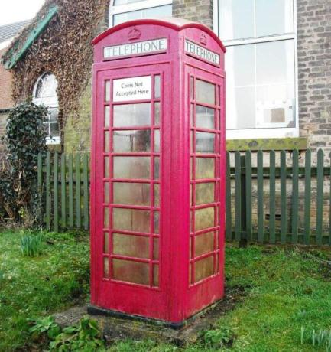

Name: Keepers Cottage, Walk Lane
Date Designated: 14/12/2009
Grid Reference: TA 1995 0466
Area Designation: Irby upon Humber Conservation Area, Lincolnshire Wolds AONB
Asset Type: Building
Main Criteria Used: N/A
Description:

A large estate cottage, probably for the game keeper given the name.
Built of red/brown bricks, painted white, with a hipped slate roof and end stacks. Two storey with ground floor bays, probably additions, and first floor segmental arched hung sash windows.

***This asset has been assessed against the new Criteria for Listing and is no longer thought to be of sufficient special local interest to be Locally Listed***

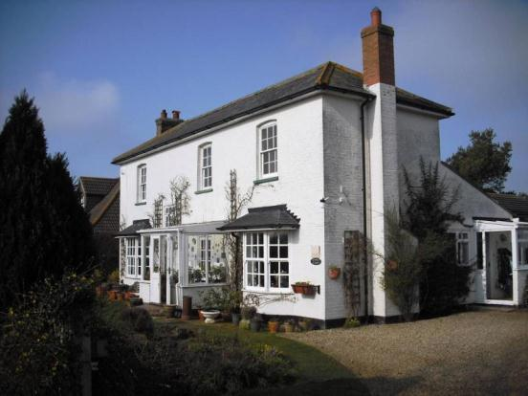

Name: The Old Chapel, Walk Lane
Date Designated: 14/12/2009
Grid Reference: TA 1991 0468
Area Designation: Irby upon Humber Conservation Area, Lincolnshire Wolds AONB
Asset Type: Building
Main Criteria Used: N/A
Description:

A poorly converted Wesleyan Methodist Chapel with a large extension, French windows cut into a side wall and front windows partly blocked.
Built of red/brown brick with ashlar dressings.

***This asset has been assessed against the new Criteria for Listing and is no longer thought to be of sufficient special local interest to be Locally Listed***

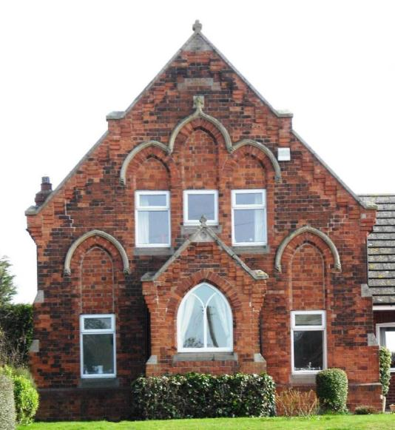

Name: Blacksmiths Cottage, Walk Lane
Date Designated: 14/12/2009
Grid Reference: TA 1976 0469
Area Designation: Irby upon Humber Conservation Area, Lincolnshire Wolds AONB
Asset Type: Building
Main Criteria Used: N/A
Description:

The cottage to a blacksmiths in the style of an estate cottage.
Roughly L-shaped on plan, ground and first floor square arched windows with brick drip moulds, Brick eaves cornices, rendered, prominent solar panels.

***This asset has been assessed against the new Criteria for Listing and is no longer thought to be of sufficient special local interest to be Locally Listed***

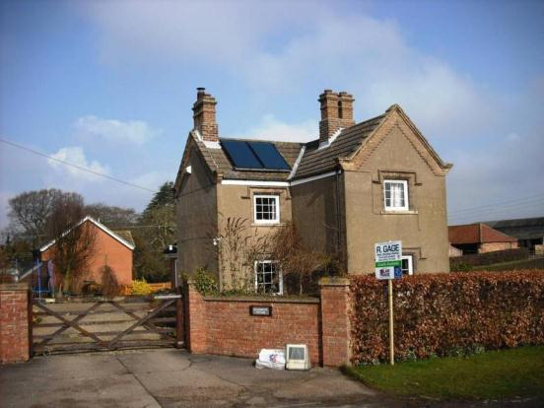

Name: Sackville Cottage, Walk Lane
Date Designated: 14/12/2009
Grid Reference: TA 1973 0467
Area Designation: Irby upon Humber Conservation Area, Lincolnshire Wolds AONB
Asset Type: Building
Main Criteria Used: N/A
Description:

A small double depth farmhouse or large estate cottage built of brown brick, now rendered, with a concrete tile roof. Many modern alterations.

***This asset has been assessed against the new Criteria for Listing and is no longer thought to be of sufficient special local interest to be Locally Listed***

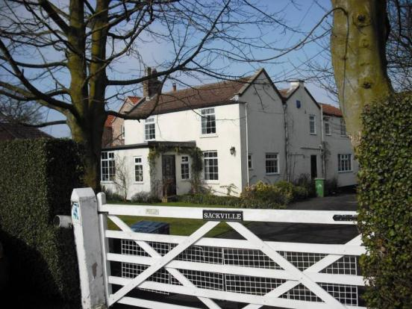

Name: Millfield Cottage & Welbeck Cottage, Walk Lane
Date Designated: 14/12/2009
Grid Reference: TA 1977 0465
Area Designation: Irby upon Humber Conservation Area, Lincolnshire Wolds AONB
Asset Type: Building
Main Criteria Used: N/A
Description:

Symmetrical estate cottages with paired front bays and single side bays set back, ground and first floor square arched windows with brick drip moulds, and brick eaves cornices. Millfield Cottage is rendered.

***This asset has been assessed against the new Criteria for Listing and is no longer thought to be of sufficient special local interest to be Locally Listed***

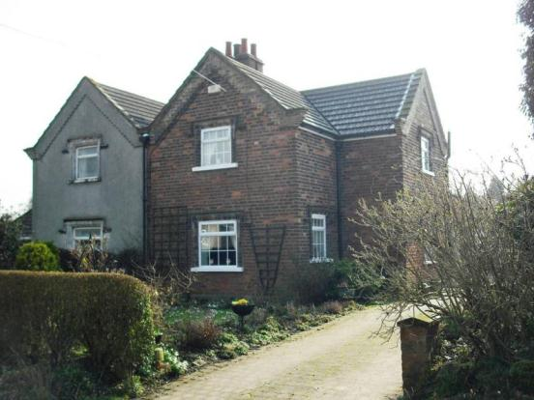

Name: Walk House Farm, Walk Lane
Date Designated: 14/12/2009
Grid Reference: TA 1967 0465
Area Designation: Irby upon Humber Conservation Area, Lincolnshire Wolds AONB
Asset Type: Building
Main Criteria Used: 1c, 2g
Description:

A large 3 bay farmhouse built of buff brick with red brick dressings and a slate roof. A small L-shaped block of outbuildings survives to the rear and has been at least partially converted.

An important part of the social and agricultural structure of the village.

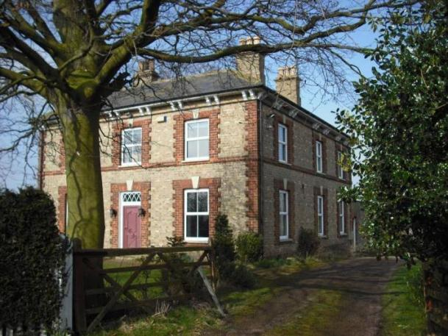

Name: Odessa Farm, Trunkass Lane
Date Designated: N/A – New Proposal
Grid Reference: TA 19980311
Area Designation: None, Lincolnshire Wolds AONB
Asset Type: Building
Main Criteria Used: 1c, 2g
Description:

Farmhouse:
A three bay farmhouse built of buff bricks with a slate roof, segmental headed windows and brick quoins.

Farmstead:
Roughly E-shaped on plan and retaining many original features such as louvered windows on the upper storey to the two storey barn and roof ventilators on the stables.
Built of a mixture of buff and red brick, suggesting two build periods, particularly in the large barn which is part red brick and part buff brick.

Generally a well preserved example and an important part of the social and agricultural structure of the village.

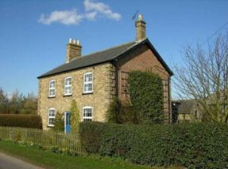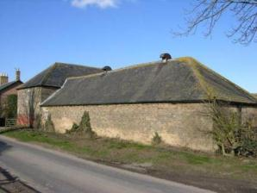

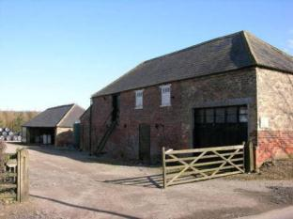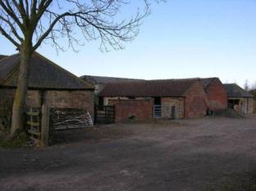

Name: Signpost, Junction of Trunkass Lane and Main Road, Irby upon Humber
Date Designated: N/A – New Proposal
Grid Reference: TA 1937 0452
Area Designation: None
Asset Type: Building
Main Criteria Used: 1c, 2g
Description:

A historic road side sign post with a black and white striped post and two planks set into recesses forming three arms. The signs point to Swallow and Caistor to the west, Laceby and Grimsby to the east, Beelsby and Hatcliffe to the south. The east and west arms carry distances to the annotated villages/towns: Swallow 2, Caistor 5, Laceby 2, Grimsby 6.

Although once widespread, this style of sign post is now only found in the rural areas of North East Lincolnshire and form part of the less developed rural character.

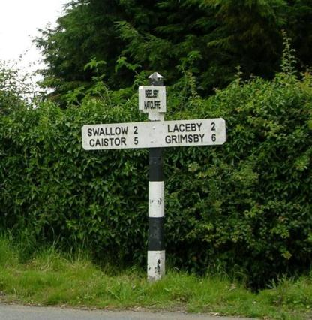

Name: Signpost, Junction of Trunkass Lane, Beelsby Road and Swallow Road
Date Designated: N/A – New Proposal
Grid Reference: TA 1987 0273
Area Designation: None
Asset Type: Building
Main Criteria Used: 1c, 2g
Description:

A historic road side sign post with a black and white striped post and two planks set into recesses forming three arms. The signs point to Beelsby and Hatcliffe to the south, Swallow and Caistor to the west, Irby and Grimsby to the east. The distances to each village are not shown.

Although once widespread, this style of sign post is now only found in the rural areas of North East Lincolnshire and form part of the less developed rural character.

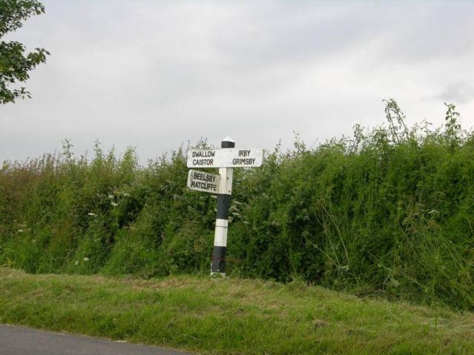

Name: Shrunken medieval village earthworks in Irby upon Humber
Date Designated: N/A – New Proposal
Grid Reference: TA 1959 0486
Area Designation: Lincolnshire Wolds AONB
Asset Type: Archaeological Site
Main Criteria Used: 1b, 2a
Description:

Four dispersed areas of shrunken medieval village earthworks, separated by extant housing and farms. The earthworks include linear property boundaries, possible croft, tofts and other enclosures, as well as a post medieval moated site with possible medieval origins.

Although some of the earthworks have been lost to 19th century and later developments, a significant amount are still intact. The extant earthworks are likely to contain buried archaeological deposits of high significance to understanding the growth and development of the village.

See HER Numbers - 0511/0/0 and 0511/2/0 - for further information and sources

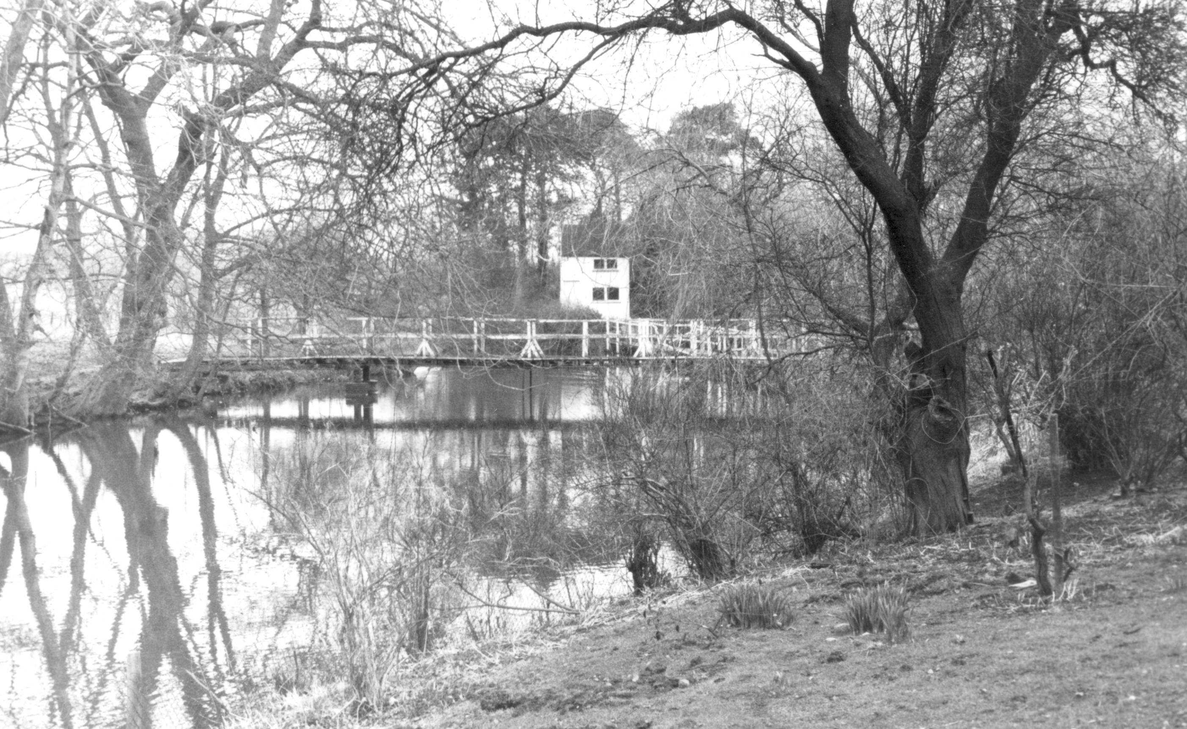
The post medieval moated site, c.1986

West Ravendale

West Ravendale is a very small hamlet which represents an almost entirely deserted village. The settlement was to the east of Priory Farm and the ruins of the Priory Chapel. The site of the medieval priory itself is not clear but is likely to lie within the settlement area.

At the time of Domesday (1086AD) and the Lindsey Survey (c.1115AD) Ravendale is referred to as a single entity; however the original parish had been split into East and West Ravendale by the time of the Episcopal Registers (1219AD).

West Ravendale is recorded as having a population of 59 in the 1851 census according to White's directory of 1856. In the 2001 census the population is recorded as 18.

At the time of writing – 2nd October 2015 – West Ravendale has:

25 Historic Environment Records of which:
1 is a nationally Listed Buildings (and is also a part of a Scheduled Monument)
1 is a nationally Scheduled Monument (part of which is also a Listed Building)
5 are proposed Locally Listed Historic Assets

West Ravendale

Name: Ravendale Top Farm
Date Designated: N/A – New Proposal
Grid Reference: TA 23370 00341
Area Designation: None
Asset Type: Building
Main Criteria Used: 1c, 2g
Description:

A farmstead, probably 19th century, which consists of a O-shaped range of farm buildings around a courtyard. Most of the farmyard buildings shown on Ordnance Survey maps of 1887-9 appear to be present, but it is not clear if the farmhouse is original or a rebuild. Recorded as Little Ravendale Farm in 1828.

This site has been surveyed from aerial photographs and maps. It is assumed from this evidence that it is of at least local interest.

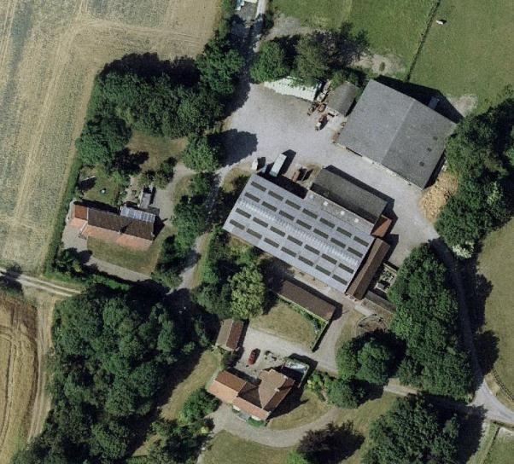
Image Taken in 2006
The GeoInformation Group Data ® copyright by The GeoInformation® Group, 2015

Name: Ravendale Priory Farm
Date Designated: N/A – New Proposal
Grid Reference: TF 22754 99759
Area Designation: None
Asset Type: Building
Main Criteria Used: 1c, 2g
Description:

A large farmhouse and farmyard buildings, with most of the buildings shown on Ordnance Survey maps of 1887-9 surviving. Despite the losses to the courtyard and alterations to the main house the group is of local interest.

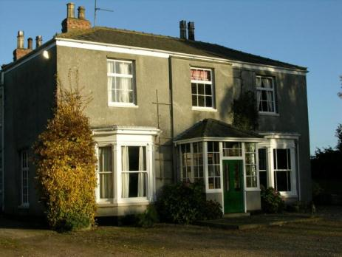

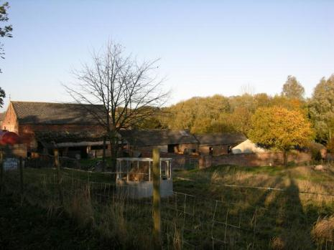
Name: Cropmark Enclosure 350m north west of Ravendale Top Farm
Date Designated: N/A – New Proposal
Grid Reference: TA 2308 0064
Area Designation: Lincolnshire Wolds AONB
Asset Type: Archaeological Site
Main Criteria Used: 1b, 2a
Description:

A potential Prehistoric or Roman enclosure was seen as cropmarks and mapped from poor quality air photographs. It is rectilinear in shape, 50m by 30m, defined by 1 ditch (National Monuments Record: TA 20 SW 33)

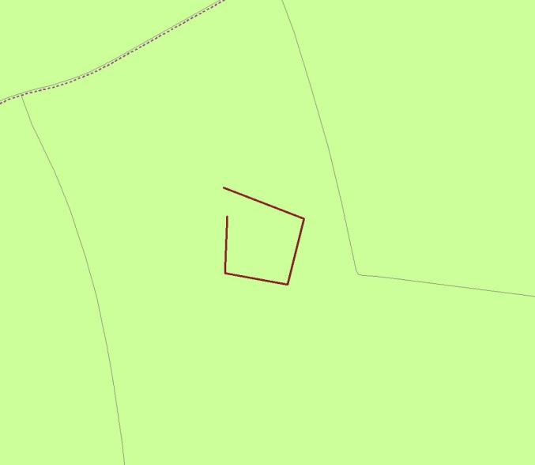
Plot of the Cropmark, as mapped by the RCHME
Reproduced from an Ordnance Survey map with the permission of the Controller of HMSO © Crown Copyright.
Licence number 100020759 North East Lincolnshire Council

Name: Medieval enclosure cropmarks 120m north of Priory Farm, West Ravendale
Date Designated: N/A – New Proposal
Grid Reference: TF 2268 9986
Area Designation: Lincolnshire Wolds AONB
Asset Type: Archaeological Site
Main Criteria Used: 1b, 2a
Description:

A large ditched enclosure seen on aerial photographs. The ditch is roughly 7m wide and enclosure a sub-rectangular area which measures c.80x50 meters (National Monuments Record: TF 29 NW 31). It has a strong potential to be related in some way to the Premonstratensians Priory chapel to the south, including the potential that this is the site of the priory itself.

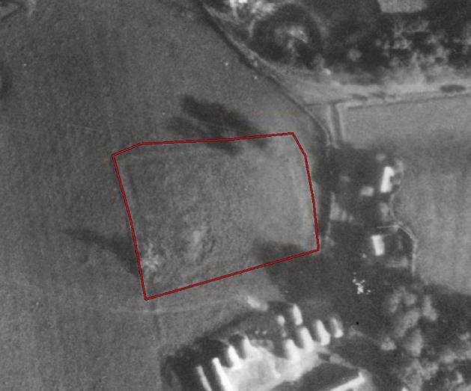
The enclosure shown on 1940s aerial photographs
The GeoInformation Group Data ® copyright by The GeoInformation® Group, 2015

Name: West Ravendale medieval settlement earthworks and cropmarks
Date Designated: N/A – New Proposal
Grid Reference: TF 2287 9962
Area Designation: Lincolnshire Wolds AONB
Asset Type: Archaeological Site
Main Criteria Used: 1b, 2a
Description:

A small area of medieval earthworks, probably toft boundaries, representing part of the medieval settlement of West Ravendale

The site also wraps around the scheduled monument known as “Premonstratensian priory chapel 170m south west of Priory Farm” including the former area of the church yard around the chapel which is not covered by the scheduling.

See HER Numbers - 0675/0/0 and 0675/1/0 - for further information and sources

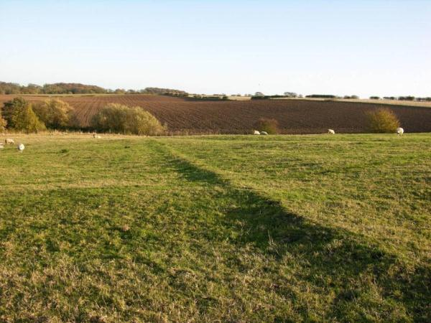
Shallow medieval village earthworks in West Ravendale

Wold Newton

Wold Newton is a long thin village arranged along the main road at the base of a valley in the Wolds. It is known to have existed since the early medieval period (410AD to 1066AD). The limits of the historic core are defined to the north by North Farm, and to the south by South Farm and The Grange.

Wold Newton is recorded as having a population of 179 in the 1851 census according to White's directory of 1856. In the 2001 census the population is recorded as 56.

At the time of writing – 2nd October 2015 – Wold Newton has:

71 Historic Environment Records of which:
4 are nationally Listed Buildings
None are nationally Scheduled Monuments
17 are proposed Locally Listed Historic Assets

Name: North Farm House
Date Designated: N/A – New Proposal
Grid Reference: TF 2432 9706
Area Designation: Lincolnshire Wolds AONB
Asset Type: Building
Main Criteria Used: 1c, 2g
Description:

Two storey farmhouse, four bays; chalk, ironstone and limestone ashlar to the ground floor front elevation and sides, brick upper portions, gables have parapets with ashlar coping, pantile roof. Adjacent agricultural building in rougher dressed stone and brick also included, as are the estate railings to the front.

The mix of stone, which is similar to that used in many local medieval churches, strongly suggests that it came from the rebuild of the nearby Church of All Hallows (NHLE 1161343) which was carried out in 1862.

The small east-west orientated barn was detached from the adjacent model farm complex and shares design features and construction materials with the farm house and so it is probable that it was the domestic stables.

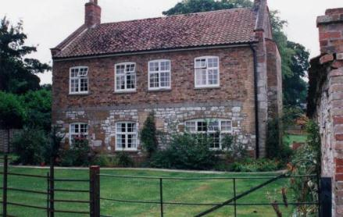

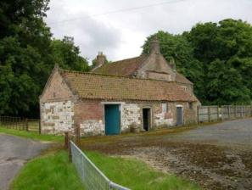

Name: Barns at North Farm
Date Designated: N/A – New Proposal
Grid Reference: TF 2428 9709
Area Designation: Lincolnshire Wolds AONB
Asset Type: Building
Main Criteria Used: 1c, 2g
Description:

A large north-south orientated barn built of chalk and brick with a pantile roof. The barn is the last survivor of a double-courtyard farm complex, probably mid to late 19th century.

Despite the loss of the other buildings in the complex, the size and unusual construction of the building means that it is still makes a significant contribution to the historic character of the village.

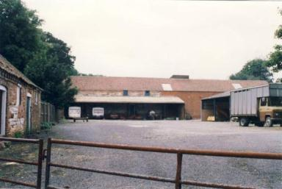

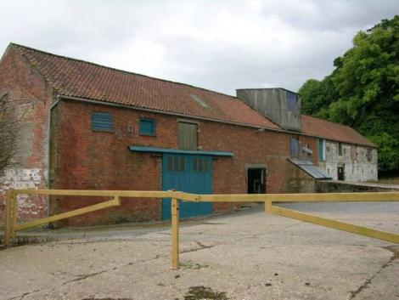

Name: The Manor, Wold Newton
Date Designated: N/A – New Proposal
Grid Reference: TF 2430 9698
Area Designation: Lincolnshire Wolds AONB
Asset Type: Building
Main Criteria Used: 1c, 2g
Description:

Two storey, 3 bay Manor House in large grounds with a landscape park to the south. Built of light brown brick with a projecting slate roof, bay windows to the ground floor with central doorways, sliding shutters to the first floor windows which are 6/6 hung sash.

Part of the manorial functions and practices of the village.

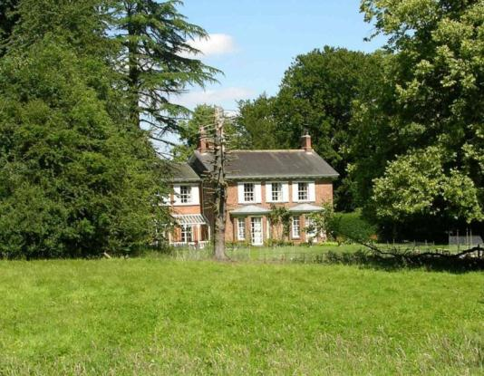

Name: North Farm, North Field, Ploughman's, Shepherd's, Groom's, The Roost, Chalk, Post Office, Gardener's, Foreman's, Garthman's and Waggoner's Cottages
Date Designated: N/A – New Proposal
Grid Reference: TF 2416 9716
Area Designation: Lincolnshire Wolds AONB
Asset Type: Building
Main Criteria Used: 1c, 2g
Description:

A group of 14 estate cottages of various ages and designs forming a coherent group along the main street of Wold Newton. Although almost all have modifications of some sort, the group value and lack of too many unsympathetic alterations mean that they are of special local interest.

Chalk Cottage and Post Office Cottage were both once semi-detached houses and have since been converted into single dwellings.

Church Path, Woodman’s and Dionard Cottages are also estate cottages but have been too extensively altered to be considered part of the group.

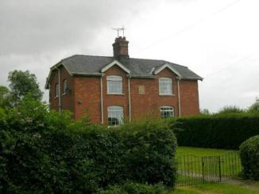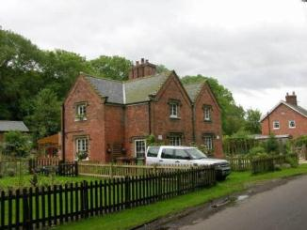
North Farm and North Field Cottages (left) Ploughman’s and Shepherd’s Cottages (right)

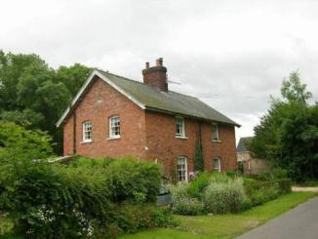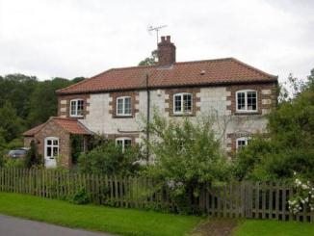
Groom’s Cottage and The Roost (left) Chalk Cottage (right)
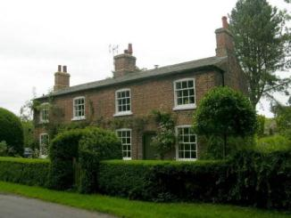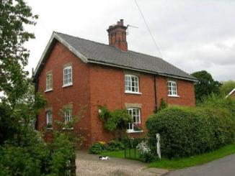
Post Office Cottage (left) Gardener’s and Foreman’s Cottages (right)

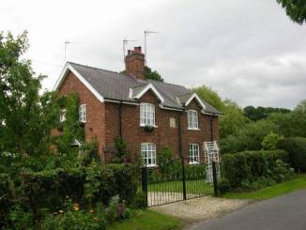
Garthman’s and Waggoner’s Cottages

Name: Wold Newton War Memorial
Date Designated: N/A – New Proposal
Grid Reference: TF 2437 9700
Area Designation: Lincolnshire Wolds AONB
Asset Type: Memorial
Main Criteria Used: 1b, 2g
Description:

Stone war memorial in high-medieval style, dwarf wall with railings to the front of the memorial forming an enclosure with the field fence to the rear.

Dedicated to loses in the Boer Wars (1880–1881 and 1899–1902) and the First World War (1914-1918) with 1 death and 4 deaths recorded respectively for the village.

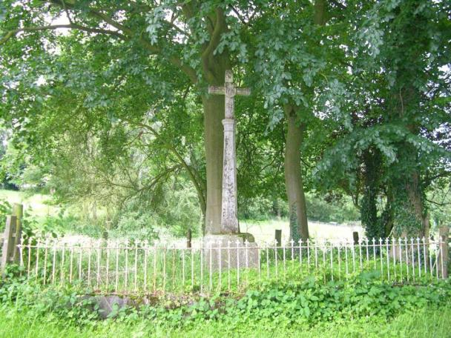

Name: Buildings at South Farm
Date Designated: N/A – New Proposal
Grid Reference: TF 2451 9616
Area Designation: Lincolnshire Wolds AONB
Asset Type: Building
Main Criteria Used: 1c, 2g
Description:

A large range of farm buildings built of mixed chalk (ashlar and rubble) and brick including barns and a horse gin.

The large north-east, south-west orientated building is a complex of builds and is the remains of an E shaped model farm complex.

Despite the loss of the other buildings in the complex, the size and unusual construction of the building means that it is still makes a significant contribution to the historic character of the village. Possibly Curtilage to The Grange (Listed Building 164416)

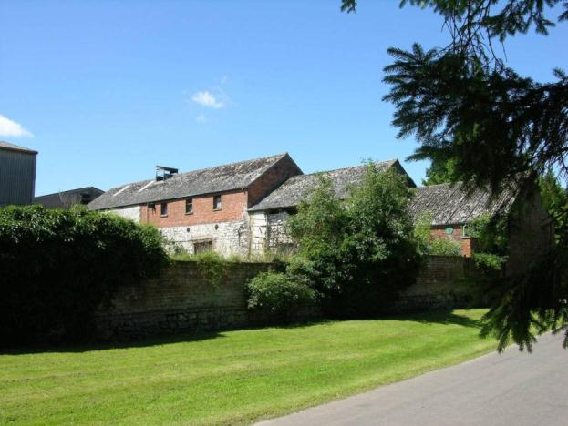

Name: Signpost, Junction of Main Road, Wold Newton Road and an Un-Named Road
Date Designated: N/A – New Proposal
Grid Reference: TF 2408 9745
Area Designation: None
Asset Type: Building
Main Criteria Used: 1c, 2g
Description:

A historic road side sign post with a black and white striped post and two planks set into recesses forming three arms. The signs point to East Ravendale and Waltham to the north, Swinhope and Binbrook to the west, Wold Newton and Louth to the south. The distances to each village are not shown.

Although once widespread, this style of sign post is now only found in the rural areas of North East Lincolnshire and form part of the less developed rural character.

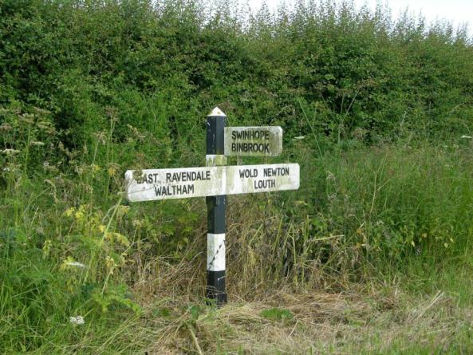

Name: Signpost, Junction of Main Road, Wold Newton Road and an Un-Named Road
Date Designated: N/A – New Proposal
Grid Reference: TF 2436 9702
Area Designation: None
Asset Type: Building
Main Criteria Used: 1c, 2g
Description:

A historic road side sign post with a black and white striped post and two planks set into recesses forming three arms. The signs point to Grimsby to the north, Louth to the south, N[orth] Thoresby to the east. The arms also display distances to the annotated villages/towns: Grimsby 9, Louth 9, North Thoresby 3 ½.

Although once widespread, this style of sign post is now only found in the rural areas of North East Lincolnshire and form part of the less developed rural character.

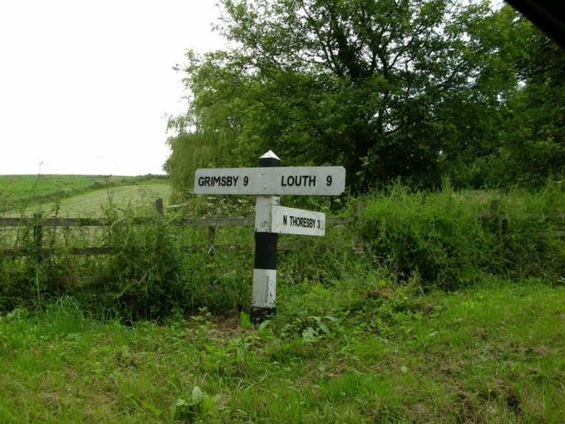

Name: Signpost, Junction of Main Road, Brats Lane, Beesby Lane, and an Un-named Road
Date Designated: N/A – New Proposal
Grid Reference: TF 2436 9702
Area Designation: None
Asset Type: Building
Main Criteria Used: 1c, 2g
Description:

A historic road side sign post with a black and white striped post and two planks set into recesses forming four arms. The signs point to Wold Newton to the north, Louth and Kelstern to the south, N[orth] Thoresby to the east, Binbrook to the west. The distances to each village/town are not shown.

Recently repaired following damaged caused by a collision.

Although once widespread, this style of sign post is now only found in the rural areas of North East Lincolnshire and form part of the less developed rural character.

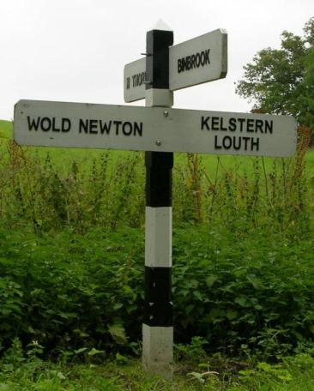

Name: Cropmark enclosures 650m north west of Scallows Hall, Wold Newton
Date Designated: N/A – New Proposal
Grid Reference: TF 2413 9522
Area Designation: Lincolnshire Wolds AONB
Asset Type: Archaeological Site
Main Criteria Used: 1b, 2a
Description:

Faint and partial cropmarks of a series of possible enclosures. Probably prehistoric or Roman in date.

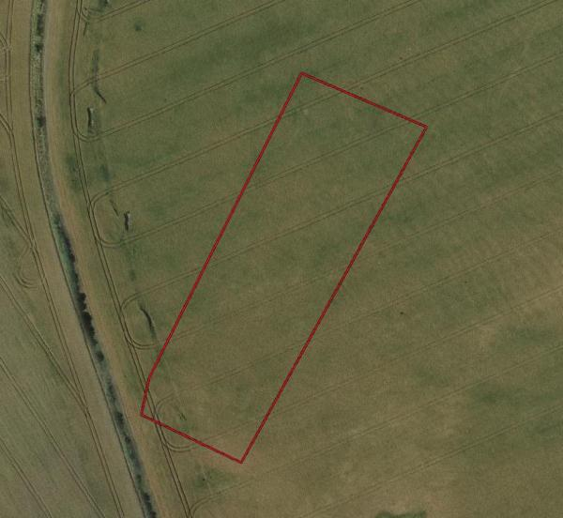
Image Taken in 2006
The GeoInformation Group Data ® copyright by The GeoInformation® Group, 2015

Name: Cropmark enclosures 300m north east of Cold Harbour, Wold Newton
Date Designated: N/A – New Proposal
Grid Reference: TF 2338 9577
Area Designation: Lincolnshire Wolds AONB
Asset Type: Archaeological Site
Main Criteria Used: 1b, 2a
Description:

Possible ditched enclosures and boundaries of unknown date were seen as cropmarks and mapped from good quality air photographs. Perpendicular sinuous boundaries, up to 100m long, are centred at TF 2346 9570. Attached to the south side of one of the boundaries is a subcircular enclosure, with a diameter of 10m and centred at TF 2348 9570. Another boundary to the south, centred at TF 2349 9565, could be related to the enclosures (National Monuments Record: TF 29 NW 38)

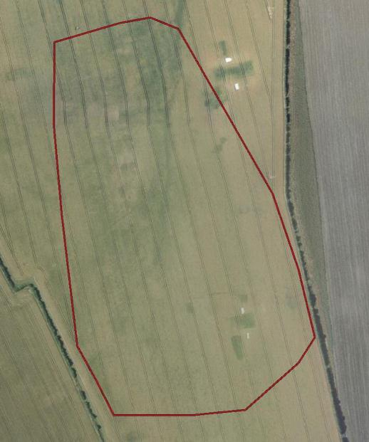
Image Taken in 2006
The GeoInformation Group Data ® copyright by The GeoInformation® Group, 2015

Name: Cropmark enclosures 300m north east of The Grange, Wold Newton
Date Designated: N/A – New Proposal
Grid Reference: TF 2484 9649
Area Designation: Lincolnshire Wolds AONB
Asset Type: Archaeological Site
Main Criteria Used: 1b, 2a
Description:

Probable Prehistoric or Roman enclosures and boundaries were seen as cropmarks and mapped from good quality air photographs. A NE-SW oriented linear arrangement of four conjoined rectilinear enclosures are visible, on a west facing slope overlooking a dry valley. They measure on average 40m by 25m and are centred at TF 2482 9646. The enclosures are attached to a ditched boundary 220m long. Another boundary, perpendicular to the first one partially encloses the enclosures. Fragments of boundaries to the south, measuring on average 40m, may relate to the enclosures (National Monuments Record: TF 29 NW 37)

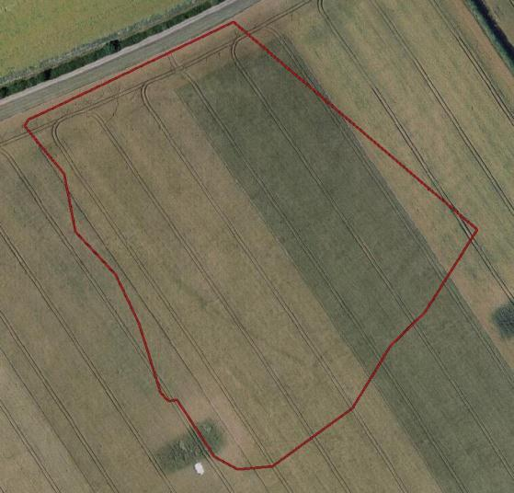
Image Taken in 2006
The GeoInformation Group Data ® copyright by The GeoInformation® Group, 2015
Name: Cropmark enclosures, boundaries and a trackway 520m west of North Farm, Wold Newton
Date Designated: N/A – New Proposal
Grid Reference: TF 2349 9692
Area Designation: Lincolnshire Wolds AONB
Asset Type: Archaeological Site
Main Criteria Used: 1b, 2a
Description:

Probable Prehistoric enclosures and boundaries, possibly the remains of a settlement, were seen as cropmarks and mapped form air photographs. An asymmetric polygonal enclosure with a possible funnel entrance, or droveway, in its east side, is centred at TF 2356 9700. Attached to the inside of its west side is a rectangular enclosure, 50m by 15m. The settlement is situated on a north and west facing slope of a dry valley. Fragments of a boundary cross the valley from the settlement, and are centred at TF 2340 9697. An incomplete subcircular enclosure, (see TF 29 NW 36), is partially visible directly across the valley from the settlement but no obvious association between the features is visible (National Monuments Record: TF 29 NW 35)

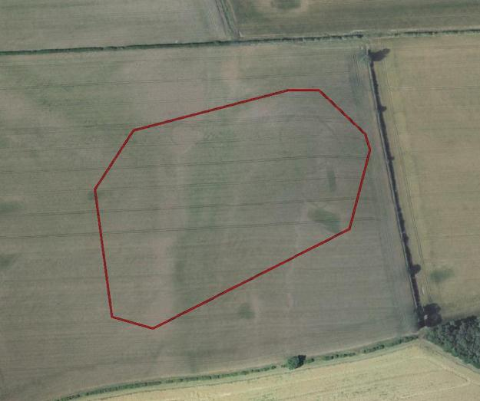
Image Taken in 2006
The GeoInformation Group Data ® copyright by The GeoInformation® Group, 2015

Name: Cropmark of a probable Neolithic Long Barrow 950m west south west of All Saints' Church, Wold Newton
Date Designated: N/A – New Proposal
Grid Reference: TF 2331 9626
Area Designation: Lincolnshire Wolds AONB
Asset Type: Archaeological Site
Main Criteria Used: 1b, 2a
Description:

Cropmark of a probable long barrow, measuring c.90m in length, with a 35m wide end facing roughly SW and a c.15m wide end facing roughly NE.

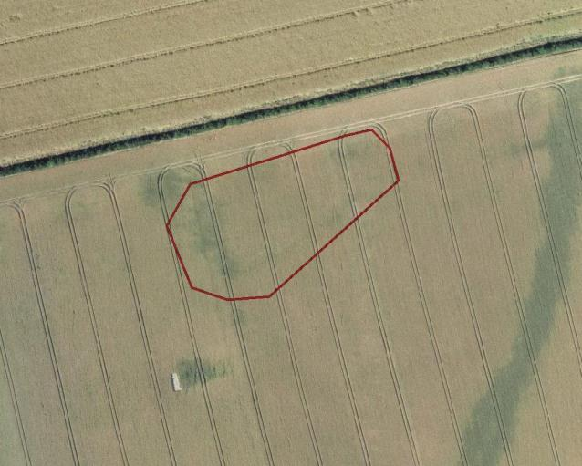
Image Taken in 2006
The GeoInformation Group Data ® copyright by The GeoInformation® Group, 2015

Name: Cropmark ring ditches 420m north of Scallows Hall, Wold Newton
Date Designated: N/A – New Proposal
Grid Reference: TF 2448 9511
Area Designation: Lincolnshire Wolds AONB
Asset Type: Archaeological Site
Main Criteria Used: 1b, 2a
Description:

Cropmarks of three possible ring ditches, all roughly 20m in diameter.

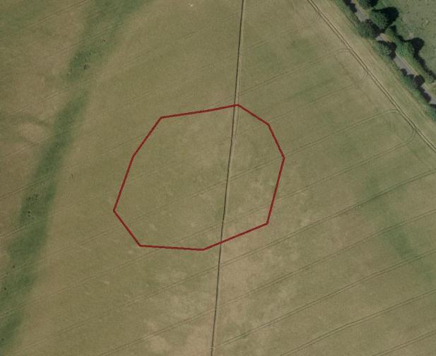
Image Taken in 2006
The GeoInformation Group Data ® copyright by The GeoInformation® Group, 2015
Name: Wold Newton medieval settlement earthworks
Date Designated: N/A – New Proposal
Grid Reference: TF 2441 9663
Area Designation: Lincolnshire Wolds AONB
Asset Type: Complex (Archaeological Site and Designed Landscape)
Main Criteria Used: 1c, 2g
Description:

Earthworks to the South and West of the present village. Interrupted in places by modern houses and gardens. The earthworks include toft boundaries, possible house sites and an old lane West of the present main street.

The area to the north west, to the south of the Manor, is also a landscape park with significant mature trees.

See HER Number - 0745/0/0- for further information and sources

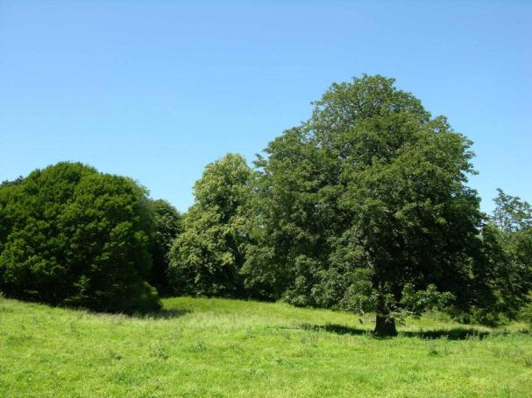
The parkland and earthworks to the south of The Manor

