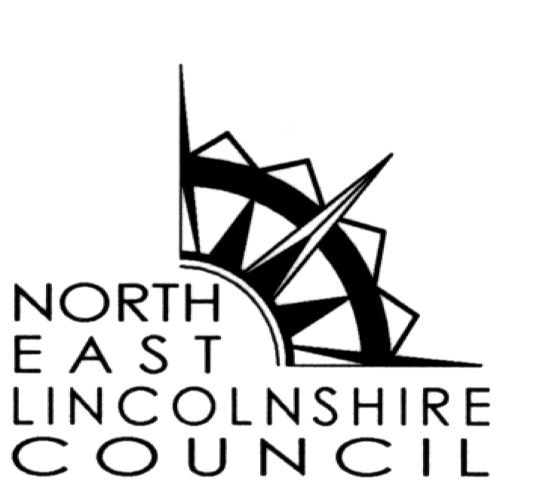
www.nelincs.gov.uk

BYELAWS FOR GOOD RULE AND GOVERNMENT

Byelaws made under section 235 of the Local Government Act 1972 by the Council of North East Lincolnshire for the good rule and government of the Borough of North East Lincolnshire and for the prevention and suppression of nuisances.

General Interpretation

1. In these byelaws:

“carriageway” means a way constituting or comprised in a highway, being a way(other than a cycle track) over which the public have a right of way for the passage of vehicles;

“”the Council” means the Council of North East Lincolnshire Borough Council;

“designated areas” means those areas designated in byelaw 2(3) and in Schedule 1 to these byelaws;

“footway” means a way comprised in a highway which also comprises a carriageway, being way over which the public have a right of way on foot only;

“highway” means the whole or part of a highway other than a ferry or waterway;

“road margin or verge” means land which is –

(a) adjacent to the carriageway of a highway or between two carriageways of a highway, other than the carriageway of a trunk road vested in the Secretary of State, and

(b) laid or sown with grass or planted with trees, shrubs or plants, and mown or otherwise maintained in an ornamental condition by the Council;

“self propelled vehicle” means a vehicle other than a cycle, wheelchair or pram which is propelled by the weight or force of one or more persons skating, sliding or riding on the vehicle or by one or more other persons pulling or pushing the vehicle;

“trunk road” means a highway, or a proposed highway, which is a trunk road by virtue of section 10(1) or section 19 of the Highways Act 1980 or by virtue of an order or direction under section 10 of that Act.

Application

2. (1) These byelaws apply throughout the Borough of North East Lincolnshire except as set out in byelaws 2(2) to 2(3)
(2) Byelaws 3 and 4 apply to any road margin or verge which is indicated to be a road margin or verge to which these byelaws apply by means of a notice conspicuously displayed on or near the said road margin or verge
(3) Byelaw 5 applies to the areas of North East Lincolnshire designated in Schedule 1 and delineated (where appropriate) by black hatching on the plan attached to these byelaws

Riding on Road Margins and Verges

3. No person shall without lawful authority ride or lead any horse, or cause any horse to be ridden or led upon any road margin or verge to which this byelaw applies.

Vehicles on Road Margins and Verges

4. (1) No person shall without lawful authority drive, park or leave a vehicle or cause such a vehicle to be driven or placed upon any road margin or verge to which this byelaw applies.

(2) This byelaw does not apply to a heavy commercial vehicle as defined by section 20 of the Road Traffic Act 1988.

Skateboarding Etc.

5. No person shall skate, slide or ride on rollers, skateboards or other self-propelled vehicles in the designated areas.

6. Outside the designated areas, no person shall skate, slide or ride on rollers, skateboards or other self-propelled vehicles on any footway or carriage way in such a manner as to cause danger or give reasonable grounds for annoyance to other persons using the footway or carriageway.

Dangerous games near highways

7. No person shall pay football or any other game on land adjacent to a highway in a manner likely:

(a) to cause obstruction to traffic; or

- to cause danger or give reasonable grounds for annoyance to any person on the highway.

Playing games on highways to the annoyance of local residents

8. No person shall play football or any other game on a highway or on land adjacent to a highway in such a manner as to give reasonable grounds for annoyance to any person living nearby.

Touting

9. (1) No person shall in any street or public place –

(a) advertise or solicit custom for any service; or

(b) seek to gather information for use in the supply of goods or services;

in such a manner as to cause obstruction or give reasonable grounds for annoyance to any person in that street or public place.

(2) Byelaw 9(1) does not apply to advertising or soliciting custom for services to hire vehicles to carry passengers.

Urinating, Etc.

10. No person shall urinate or defecate in any street or public place.

Interference with Road Warning Equipment

11. No person shall without lawful authority move or tamper with any lamp, reflector or other equipment used for giving warning of, or lighting, any obstruction, excavation or other danger in any road.

Interference with Life Saving Equipment

12. Except in case of emergency no person shall remove, displace or otherwise interfere with any life saving equipment placed by the Council or other competent authority in any street or public place.

Penalty

13. Any person offending against these byelaws shall be liable on summary conviction to a fine not exceeding level 2 on the standard scale.

Revocation

14. The byelaws relating to the Good Rule & Government and the Suppression of Nuisances which were made by the Great Grimsby Borough Council on the 11th February 1983 and were confirmed by the Secretary of State for the Home Department on the 28th April 1983 are hereby revoked.

SCHEDULE 1

The designated areas referred to in Byelaw 2(3) and 5 are as follows:-

1. Town Hall Square and parts of East Street and Town Hall Street adjacent to the Combined Court Centre, Municipal Offices, and the Town Hall and adjoining areas as delineated by black hatching on plan number 1 attached to these Byelaws.

2. St. James Square, Bull Ring Lane and Chantry Lane as delineated by black hatching on plan number 2 attached to these Byelaws; and

3. Car Parks managed by the Council or by any Town or Parish Council within North East Lincolnshire

THE COMMON SEAL of
NORTH EAST LINCOLNSHIRE BOROUGH COUNCIL
was hereunto affixed this
day of 2004
in the presence of

Mayor

Director of Law and Democratic Services

