SENDIASS North East Lincolnshire
Young person’s views for their Annual Review

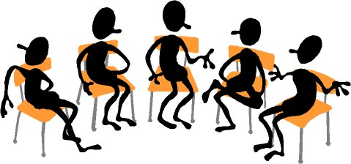
Your school has to hold a review of your Education Health and Care Plan (EHCP) at least once a year. It is important that you let people know how you feel so that they can make sure you are getting the right kind of help and support.

You can go along to the review meeting and tell everyone what you think if you want to.
But you don’t have to go if you don’t want to - you can ask your parent or carer to speak for you.

Either way, it is a good idea to put your feelings down in writing so that everyone at the meeting is very clear about how you feel. This form is to help you do that.

You can
- write straight onto this form
- ask an adult to write your answers for you
- fill in the form on a computer
- ask an adult to help you fill in the form on a computer
It’s your form – it’s up to you!

Don’t want to use this form? Why not make a PowerPoint presentation?



My Name is: ________________________

I think my school is:

Brilliant

Pretty good most of the time

OK

Not that good

I don’t like school

What are the things you enjoy most about school?

What are the things you don’t like about school?

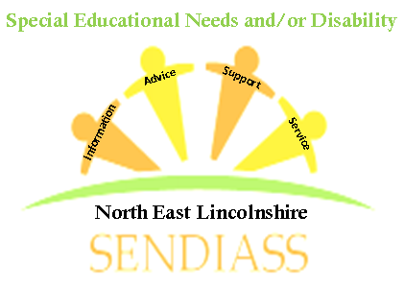

Which lessons do you find easiest? What makes them easier for you?

Which lessons do you find harder? What makes them harder for you?

What sort of extra help do you get at school?

Is this the right sort of extra help? How could it be better?

Do you have good friends at school? Would you like to say who they are?

Do you have someone you can talk to at school if you are worried about things? Who are they?

Do you think school could do anything to help you more or make things better for you?
If so, what would you like them to do?

Is there anything else you would like to say at your review?

Well done – you have almost finished!
All you have to do now is sign your form and put the date on…….

My signature: ___________________________ Date: ________________
Contact Details:
11 Dudley Street
Grimsby
North East Lincolnshire
DN31 2AW
Phone us on: 01472 355365
Email us on: nelincs@barnardos.org.uk

