North East Lincolnshire Houses in Multiple Occupation (COVID-19) Reporting Process - North East Lincolnshire Council

Introduction
Social distancing and lockdown measures have been enormously effective in reducing the transmission of COVID-19 throughout the country.
In North East Lincolnshire we have amongst the lowest rates of confirmed cases of COVID-19 anywhere in England and our ambition is to keep it that way.
To do this, we have published the North East Lincolnshire COVID-19 Outbreak Control Plan which aims to prevent future outbreaks of COVID-19 and to respond quickly and effectively if cases occur in order to prevent significant outbreaks from developing.
This requires cooperation between public health authorities and many sectors of the economy who will be expected to play their part in keeping COVID-19 at bay.
COVID-19 has brought unprecedented challenges to landlords and agents who manage or own properties throughout the borough.
Local landlords have shown professionalism and commitment throughout the pandemic by adhering to Government guidance and working with their tenants and the Council to help house some of the most vulnerable members of our society.
This document is a handy guide for landlords, agents, managers and tenants of houses in multiple occupation (HMOs) to prevent outbreaks of coronavirus (COVID-19) and explain the process to be followed if tenants develop symptoms of COVID-19.
It also explains what to do if confirmed cases emerge amongst tenants in the setting or tenants are identified as potential contacts of cases elsewhere.
Potential and confirmed cases should be reported to the local Public Health team as early as possible to help reduce the risk of a wider spread.

Preventing COVID-19 in your property
As a landlord or agent you should wherever possible take steps to limit the possibility of transmission and help make tenants feel safer. The following measures are therefore strongly advised:
- Social distancing- you should encourage your tenants to maintain a 2 metre social distance from other people outside their immediate household within the HMO. This is particularly important in all communal areas such as kitchens, bathrooms and shared living spaces.
- Hand Washing- you should promote regular hand washing for 20 seconds with soap and water to reduce transmission of the virus.
- Cleaning- you should make arrangements for the cleaning and disinfecting of surfaces like front-door handles, as well as common rooms and laundry rooms. You could also have hand-sanitizer located around the property. All residents in the house should be advised to clean the bathroom and kitchen after each use by wiping surfaces they have come in contact with.

In addition other measures such as ensuring good ventilation in communal areas of the property, the use of rotas for shared facilities and the display of public health information around the property can reduce the risk of outbreaks in your properties.

The Coronavirus Act (2020) provides the Local Authority with powers to contain and prevent the spread of COVID-19. The ability to undertake these roles at the time when needed is most critical. As a local authority we continue to respond to the changing situation rapidly and robustly to support our local population.
If you have any queries regarding who this guidance applies to or how it should be interpreted or applied you should contact North East Lincolnshire Council Public Health
publichealthoncall@nelincs.gov.uk

Potential Scenarios in HMO settings
Appendix 1 illustrates four different scenarios where landlords or agents may be made aware of possible COVID-19 cases amongst their tenants or when a tenant is required to self-isolate due to being a confirmed contact of a COVID-19 case elsewhere. The flow charts illustrate the process that we are asking North East Lincolnshire landlords to follow in relation to these scenarios.

Informing and reporting process
Anyone with responsibility for managing a house in multiple occupation should report any instance where a tenant reports symptoms of the COVID-19 virus.
Landlords or agents should contact the North East Lincolnshire Public Health team as soon as they suspect cases of COVID-19 in their properties to discuss the situation and agree if any actions are needed.
If there is more than one case suspected they should call Public Health England.
It is useful to have the information below available before this discussion as it will help to inform the size and nature of the outbreak however as a minimum the following details should be available:
  - Details of the property: number of tenants, presence of communal areas, social distancing arrangements, nationalities etc
  - Details of case(s), date(s) of onset, date last in setting etc.
  - Numbers tested and confirmed
  - Numbers suspected i.e. showing symptoms
  - Number and details of contacts requiring follow up if known
  - Information on any other suspected/ confirmed cases in setting, severity, control measures, anxiety or media interest
  - Have the tenants been self-isolating?

Details should be sent to the North East Lincolnshire Public Health team via the following email address:
publichealthoncall@nelincs.gov.uk

Additional information within this document
Appendix 2 identifies key messages relating to COVID-19.
Appendix 3 provides some answers to frequently asked questions.
Appendix 4 provides links to additional guidance and information sources for staff and businesses.

Appendix 1: Flowcharts showing the process to follow during different scenarios:

Flow chart 1
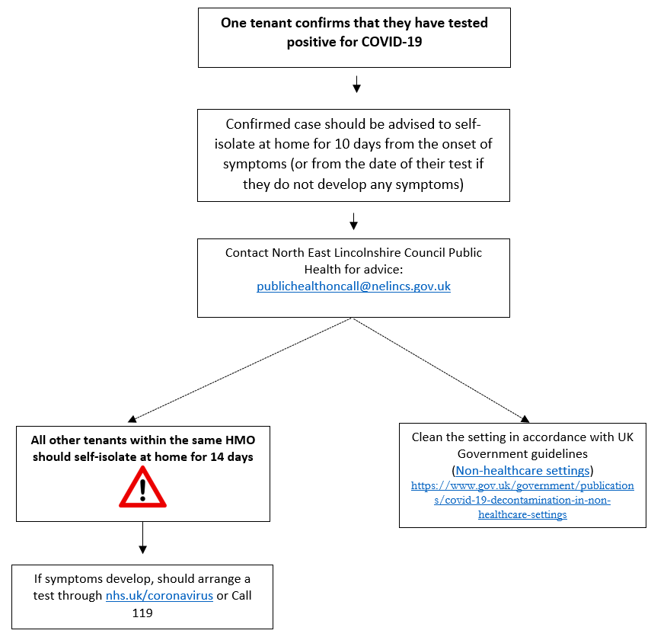

If one tenant confirms that they have tested positive for COVID-19, they should be advised to self-isolate at home for 10 days from the onset of symptoms (or from the date of their test if they do not develop any symptoms).
The Landlord/Agent should contact North East Lincolnshire Council Public Health for advice: publichealthoncall@nelincs.gov.uk.
All other tenants within the same HMO should self-isolate at home for 14 days. If symptoms develop, should arrange a test through nhs.uk/coronavirus or call 119.
The setting should then be cleaned in accordance with UK Government guidelines (Non-healthcare settings).
Further advice is available at: https://www.gov.uk/government/publications/covid-19-decontamination-in-non-healthcare-settings

Flow chart 2
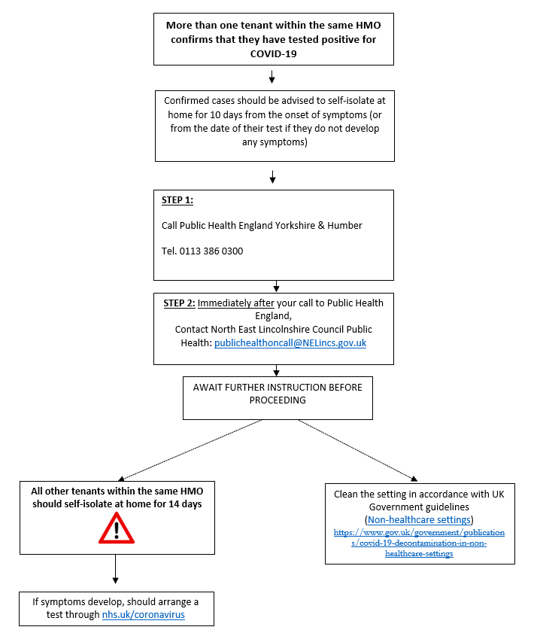
If more than one tenant within the same HMO confirms that they have tested positive for COVID-19, the confirmed cases should be advised to self-isolate for 10 days from the onset of symptoms (or from the date of their test if they do not develop any symptoms).
All other tenants within the same HMO should self-isolate at home for 14 days. If symptoms develop, should arrange a test through nhs.uk/coronavirus.
STEP 1: Call Public Health England Yorkshire & Humber on 0113 386 0300
STEP 2: Immediately after your call to Public Health England, contact North East Lincolnshire Council Public Health on publichealthoncall@NELincs.gov.uk
Then await further instructions before proceeding.
The setting should be deep cleaned in accordance with UK Government guidance (Non-healthcare settings).
Further advice is available at: https://www.gov.uk/government/publications/covid-19-decontamination-in-non-healthcare-settings

Flow chart 3
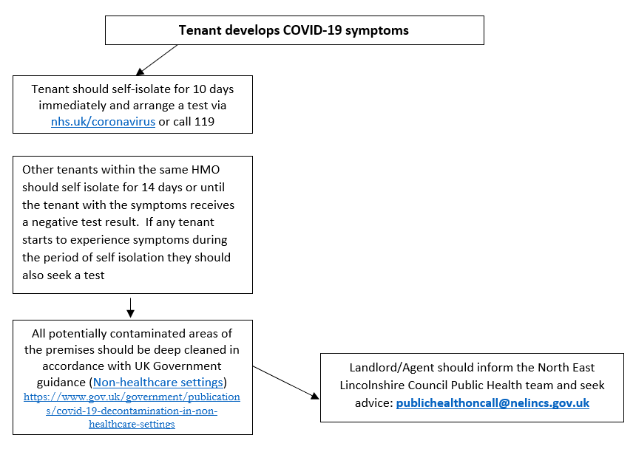
If a tenant develops COVID-19 symptoms, they should self-isolate for 10 days immediately and arrange a test via nhs.uk/coronavirus or call 119.
Other tenants within the same HMO should self isolate for 14 days or until the tenant with the symptoms receives a negative test result. If any tenant starts to experience symptoms during the period of self isolation they should also seek a test.
All potentially contaminated areas of the premises should be deep cleaned in accordance with UK Government guidance (Non-healthcare settings).
Further advice is available at: https://www.gov.uk/government/publications/covid-19-decontamination-in-non-healthcare-settings

The Landlord/Agent should inform the North East Lincolnshire Council Public Health team and seek advice: publichealthoncall@nelincs.gov.uk

Flow chart 4
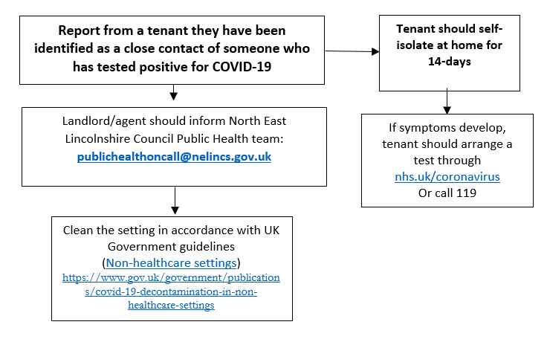

If a tenant reports that they have been identified as a close contact of someone who has tested positive for COVID-19, they must self-isolate at home for 14-days.
If they develop symptoms, the tenant should arrange a test via http://www.nhs.uk/coronavirus or call 119.
The landlords or agent should inform North East Lincolnshire Council Public Health team by emailing publichealthoncall@nelincs.gov.uk.
They should then Clean the setting in accordance with UK Government guidelines (Non-healthcare settings).
Further advice is available at: https://www.gov.uk/government/publications/covid-19-decontamination-in-non-healthcare-settings

Appendix 2: COVID-19 KEY MESSAGES

The main symptoms of COVID-19 are:
- A new continuous cough and/or
- A fever (temperature of 37.8°C or higher)
- A loss of or change in, normal sense of taste or smell (anosmia)

What is the mode of transmission?
COVID-19 is passed from person to person mainly by large respiratory droplets and direct contact (close unprotected contact). These droplets can be directly inhaled by the person, or can land on surfaces which another person may touch which can lead to infection if they then touch their nose, mouth or eyes.

What is the incubation period?
The incubation period (i.e. time between exposure to the virus and developing symptoms) is between 1 and 14 days (median 5 days).

When is a person infectious?
A person is thought to be infectious 48 hours before symptoms appear, and up to seven days after they start displaying symptoms. If someone without symptoms tests positive then it is from 48 hours before the positive test till 10 days after the test result.

Contact definitions
A ‘contact’ is a person who has been close to someone who has tested positive for COVID-19 anytime from 2 days before the person was symptomatic (or 2 days before a test if no symptoms) up to 10 days from onset of symptoms (this is when they are infectious to others). For example, a contact can be:
- People who spend significant time in the same household as a person who has tested positive for COVID-19.
- Sexual partners.
- A person who has had face-to-face contact (within one metre), with someone who has tested positive for COVID-19, including:
- being coughed on
- having a face-to-face conversation within one metre
- having skin-to-skin physical contact, or
- contact within one metre for one minute or longer without face-to-face contact
- A person who has been within 2 metres of someone who has tested positive for COVID-19 for more than 15 minutes.
- A person who has travelled in a small vehicle with someone who has tested positive for COVID-19 or in a large vehicle or plane near someone who has tested positive for COVID-19.

GETTING TESTED
Anyone who has symptoms of coronavirus (COVID-19) can get a free test to check if they have the virus. You can get a test:
- For yourself, if you have coronavirus symptoms now (a high temperature, a new, continuous cough, or a loss or change to your sense of smell or taste).
- For someone you live with if they have coronavirus symptoms.
- For yourself, if you have been told to have a test before you go into hospital, for example, for surgery.

The test usually involves taking a swab of the inside of your nose and the back of your throat, using a long cotton bud. You need to get the test done in the first 5 days of having symptoms. If you do not have symptoms, you can only get a test if your hospital has told you to.

People can apply for a test online via here or call 119.

INFECTION PREVENTION AND CONTROL

All of the following measures will prevent the spread of infection and therefore protect tenants:
- Clean your hands often and wash hands for 20 seconds as a minimum
- Minimise contact and mixing
- Avoid unnecessary mixing
- Reduce sharing of equipment
- Remove the unnecessary equipment / items
- Minimise contact with individuals who are unwell
- Catch it, bin it, kill it for respiratory hygiene
- Clean surfaces that are touched frequently

APPENDIX 3: – FREQUENTLY ASKED QUESTIONS

If I am notified by a tenant that they are ill with COVID-19 symptoms do I need to advise other tenants to self-isolate?
If there are shared facilities in use within the property such as a kitchen or bathroom then yes. If not then seek further advice. The person who is ill should stay at home for at least 10 days (Stay-at-home-guidance) and be advised to get tested. If the person tests positive for COVID-19, you should call the Health Protection Team for support with identifying contacts and for further advice. Other tenants in the house should self-isolate at home for 14 days. If they become ill they should also obtain a test.

A tenant is a contact of someone who tested positive for COVID-19, what should we do?
If a HMO tenant is known to be a contact of a confirmed case they will be advised to self-isolate at home and follow the guidance for contacts. Their own contacts do not need to self-isolate as long as no one in the HMO has symptoms or has tested positive. If someone in the HMO develops symptoms or tests positive, all residents should follow the guidance to stay at home and self-isolate.

Testing
How can a tenant arrange testing?
A tenant with COVID-19 symptoms can arrange to be tested via nhs.uk or by contacting NHS 119 via telephone.

Can people be tested if they do not have symptoms?
No. People should only be tested if they have symptoms.

We have tenants who are asymptomatic but wish to be tested is this possible?
Currently, only people who are symptomatic are advised to access a test via nhs.uk or calling 119.

What additional cleaning is necessary following a symptomatic or confirmed case?
It is important to concentrate on regular cleaning of frequently touched items / surfaces. This is likely to be highly effective as high contact surfaces will present the main risk in terms of indirect transmission. Regular cleaning should be thorough and maintained at all times.

The infection risk from Covid-19 following contamination of the environment decreases over time and is likely to be reduced significantly after 72 hours.
- The minimum PPE to be worn for cleaning an area where a person with possible or confirmed Covid-19 is disposable gloves and an apron. Hands should be washed with soap and water for 20 seconds after all PPE has been removed.
- Cleaning an area with normal household disinfectant after someone with suspected coronavirus (COVID-19) has left will reduce the risk of passing the infection on to other people.
- Wear disposable or washing-up gloves and aprons for cleaning. These should be double-bagged, then stored securely for 72 hours then thrown away in the regular rubbish after cleaning is finished.
- Using a disposable cloth, first clean hard surfaces with warm soapy water. Then disinfect these surfaces with the cleaning products you normally use. Pay particular attention to frequently touched areas and surfaces, such as bathrooms, grab-rails in corridors and stairwells and door handles.
- If an area has been heavily contaminated, such as with visible bodily fluids, from a person with coronavirus (COVID-19), use protection for the eyes, mouth and nose, as well as wearing gloves and an apron.
- Wash hands regularly with soap and water for 20 seconds, and after removing gloves, aprons and other protection used while cleaning.

Please refer to government guidance for updates on cleaning non-healthcare settings available here.

Do toilets need to be cleaned after every use?
Toilets are frequently touched surfaces, so they should be cleaned regularly throughout the day, but not after every use (except if used by a symptomatic person). Apart from gloves and apron, there is no need for additional PPE.

Appendix 4: Additional guidance information sources for Houses of Multiple Occupation

Additional guidance on coronavirus (COVID-19):
- Coronavirus outbreak FAQs: what you can and can't do
- Staying alert and safe (social distancing)

For information

Houses in multiple occupation
A property is considered to be in multiple occupation (HMO) if both of the following apply:
- at least 3 tenants live there, forming more than 1 household
- tenants share toilet, bathroom or kitchen facilities
A property is considered to be a large HMO if both of the following apply:
- at least 5 tenants live there, forming more than 1 household
- tenants share toilet, bathroom or kitchen facilities with other tenants

A property is considered to be in multiple occupation (HMO) if both of the following apply: - at least 3 tenants live there, forming more than one household - tenants share toilet, bathroom or kitchen facilities
https://www.nhs.uk/conditions/coronavirus-covid-19/testing-and-tracing/get-an-antigen-test-to-check-if-you-have-coronavirus/
https://www.gov.uk/government/publications/guidance-for-contacts-of-people-with-possible-or-confirmed-coronavirus-covid-19-infection-who-do-not-live-with-the-person/guidance-for-contacts-of-people-with-possible-or-confirmed-coronavirus-covid-19-infection-who-do-not-live-with-the-person
https://www.gov.uk/government/publications/covid-19-decontamination-in-non-healthcare-settings/covid-19-decontamination-in-non-healthcare-settings

