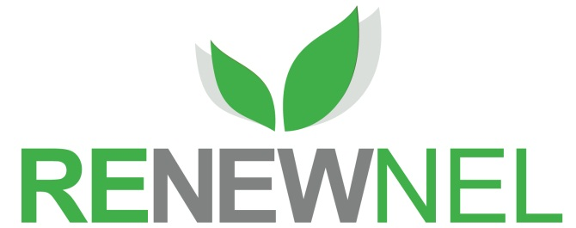

NORTH EAST LINCOLNSHIRE COUNCIL

**ENVIRONMENTAL POLICY**

**STATEMENT**

**2016**

**Our Vision**

North East Lincolnshire Council’s priorities are clear:-

**‘Stronger economy and stronger communities’**

To achieve this vision we need to work in new ways with partners in the public and private sectors, the voluntary and community sector, and with individuals, families and communities. We must address the issues we face with creativity and innovation if we are to secure the outcomes we desire. The protection and enhancement of the environment is key to achieving this vision and improving the quality of life in North East Lincolnshire.

We recognise that the Council’s activities have an impact on the environment, that we have a responsibility to ensure that this is positive, and that our use of limited natural resources is minimised. We aim to stabilise and progressively reduce North East Lincolnshire Council’s environmental footprint and make sure we adapt our activity to accommodate the effects of climate change. We will also contribute to improving North East Lincolnshire’s character, local environmental quality and natural environment.

This policy supports our priorities:

* By leading North East Lincolnshire towards consuming resources more efficiently, eliminating waste and supporting & developing the green economy & infrastructure.
* By recognising and realising the economic and social benefits of a high quality environment
* By working towards a low carbon North East Lincolnshire that is prepared for, and resilient to, the impacts of climate change,

We are committed to considering the environment in all our activities and decisions and we will develop an environmental framework which better coordinates and supports what we do. We will set a good example to other organisations and work with our partners, suppliers and contractors to improve environmental standards. We will continue to support action in the wider community and to support the most vulnerable so that they benefit from environmental improvements.

We recognise that, with limited resources, we must prioritise our actions and activity. We will therefore focus our initial effort towards establishing a more coherent and considered approach to energy conservation, generation and supply in North East Lincolnshire. In collaboration with partners we will become more resilient and less reliable on traditional sources of energy, use energy more efficiently, source cheaper alternatives and shift toward lower-carbon fuels. This will provide a springboard from which we can deliver wider environmental benefits for the communities of North East Lincolnshire.

**Our Commitment:**

**Leadership**

**We will :**

* Set a good example and adopt good practice
* Support communities in North East Lincolnshire to find local solutions that benefit themselves and the environment
* Consider the environmental impact of key decisions and policies
* Fully comply with environmental legislation and statutory duties and prevent environmental pollution
* Set environmental targets and regularly publish information about our performance.

**Response to Climate Change**

**We will:**

* Take action to reduce our impact on climate change and make sure that the causes and effects of climate change and severe weather events are considered in decisions and policies
* Assess the risks from climate change to our services and seek to recognise and address them
* Support environmentally responsive local economic growth recognising the increased stress on habitats.

**Transport & Travel**

**We will:**

* Reduce the overall need to travel and actively encourage sustainable options such as walking, cycling, public transport, car sharing, and the use of new technology
* Minimise the environmental impact of our fleet vehicles
* Improve access to and promote the use of sustainable transport solutions to enable communities to contribute positively to reducing carbon emissions
* Adopt a collaborative approach, working across sectors to achieve better outcomes for communities

**Workforce**

**We will:**

* Raise awareness & understanding to instil and encourage good environmental behaviour
* Provide information and deliver support to elected members and employees so that they understand and comply with relevant environmental legislation and regulations.

**Built & Natural Environment**

**We will:**

* Take action to reduce carbon emissions from council activities, including meeting more of our energy needs from renewable sources
* Minimise pollution created by our estate and take action to reduce, reuse and recycle waste and water wherever possible
* Aim to incorporate sustainable construction practices and design in new developments
* Use our land efficiently, and reuse previously developed land and buildings before green field sites, wherever practical;
* Proactively manage land and developments to safeguard and enhance the quality of the natural environment and deliver gains in biodiversity. .

**Procurement**

**We will:**

* Seek ways to reduce the environmental impact of the purchase of goods and services
* Work with our suppliers to help them reduce the environmental impacts of providing goods and services
* Ensure timber and paper products are obtained from certified sustainable sources and aim to procure products with a recycled content.

This policy statement and progress against our commitments will be reviewed annually by Cabinet.

Leader - signature 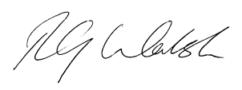

**The Leader Chief Executive**

**North East Lincolnshire Council North East Lincolnshire Council**