Summary of Current COVID-19 Epidemiology in NE Lincolnshire

October 19th 2020

Key Points

A total of 1,037 residents of North East Lincolnshire have had a confirmed diagnosis of COVID-19 (based on Pillar 1 and Pillar 2 Testing) which is an increase of 419 cases over the last week (by far the biggest week on week increase in confirmed cases that has been reported). The last three weeks have seen a doubling in new cases every six days and a forty-fold increase in the seven day rate of infection since the start of September.

Nationally there has been a significant increase in the number of positive COVID-19 tests in recent weeks. We are now seeing clear signs of an increase in hospital inpatients and deaths. Nationally a far greater proportion of cases are occurring amongst younger people who are less likely to suffer serious illness. In North East Lincolnshire analysis of cases confirmed since 1st October suggests an even spread across the working age population, with a steadily increasing number of cases now occurring in the young adult population. Since the beginning of October we have begun to see a growing number of cases in older people which is a worrying trend. Geographically cases are occurring in all parts of the borough but far more are now occurring in the Grimsby residential suburbs of Humberston & New Waltham, Freshney, Yarborough and Park wards.

NLaG report that there are 20 patients with confirmed COVID-19 in Grimsby Hospital (as of 19th October). This is the most since April and represents a substantial increase since the beginning of October.

Care homes have been one of the major sources of new COVID-19 cases nationally since the beginning of the pandemic. There are a small number of cases in care homes currently. Many care homes are situated in the parts of the borough currently experiencing the highest number of cases.

We are now experiencing regular, small outbreaks in a range of settings including social clubs, spas and gyms. However the largest number of outbreaks are occurring in workplaces and schools.

Public Health Update
There has been a substantial increase in the rate of new COVID-19 infections since the beginning of September in most parts of the country but particularly in the North East of England, the North West of England and the Yorkshire & Humber. North East Lincolnshire has also seen a forty- fold increase in the rate of new infections during this period although our rate remains lower than the Yorkshire & Humber rate. North East Lincolnshire has been placed into the Medium Risk (Tier 1) category that the Government has introduced to determine restrictions associated with COVID-19 infection rates. People in North East Lincolnshire will face the basic national rules currently in force:
- Leisure time: Pubs, bars and restaurants will have to close at 22:00 BST. They are restricted to table service only. Face coverings must be worn, except when seated to eat or drink. Face coverings must be worn on public transport and indoor areas such as museums and cinemas. You can be fined £200 for breaking the rules. Shops can open with social distancing measures in place. Face coverings must be worn by customers and staff. Gyms open as normal.
- Meeting up: The rule of six (number of people who can meet up) applies both indoors and outdoors in all settings. You can meet in a group of up to six people from multiple households. This includes children and applies indoors and outdoors, including private homes. There are exceptions, for example if your household or support bubble is larger than six. You could be fined for breaking these rules.
- Going to work: You should work at home if possible. If you have to return to your workplace your employer must make arrangements for you to work safely.
- Schools and nurseries: Schools, colleges and universities remain open, and youth club activities are permitted. Registered and wraparound childcare, supervised activities permitted in private homes and children’s groups are permitted.
- Places of worship remain open (subject to the rule of 6)
We have analysed the 644 new cases that have been confirmed in North East Lincolnshire since the 1st October. During October the majority of our cases have been in the working age population between 21 and 60 with a fairly even spread between male and female (Figure 1). However there has been a substantial increase across all age-bands compared with the previous month, see Figure 2. Cases in the 65 and overs have increased significantly over the last two weeks from a seven-day infection rate of 6 per 100,000 to an infection rate of 82 per 100,000.
Figure 1: Cases of Confirmed COVID-19 in North East Lincolnshire since 1st OCTOBER, analysed by age and gender

*2 cases have been excluded as their date of birth was missing
Figure 2: Heat maps of age specific incidence per 100,000 people Rates are calculated excluding data from the last four days due to reporting delays
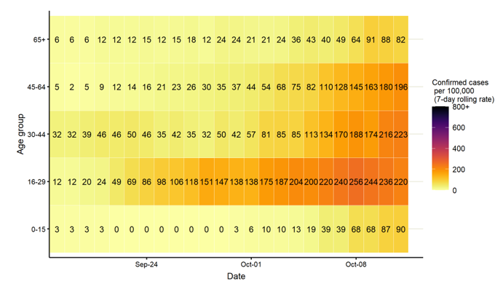
We are continuing to see cases spread across the borough but there are increasing indications of clustering and hot spots. Since the beginning of October we have seen the largest number of cases in Humberston & New Waltham, Freshney, Park and Yarborough (Figure 3). Freshney ward in particular has seen massive growth in cases as only six were confirmed there for the whole of September compared with 67 for the first 19 days of October.

Figure 3: COVID Cases Confirmed since 1st OCTOBER 2020 in NEL by Ward of Residence

National Epidemiology

As of 19th October 2020, there are 722,409 cases in the UK, of which 612,846 are in England, and 87,316 in the Yorkshire and the Humber region. 43,646 people have died from their infection in the UK (within 28 days of a positive test). Figure 4 shows the average daily number of confirmed COVID-19 cases in the UK per week. As can be seen, the average daily number of confirmed cases almost doubled this week rising by 97% to 11,994 cases per day on average. This is the thirteenth consecutive increase in the average number of daily confirmed COVID-19 cases per week for the UK. Average daily cases are now at their highest level ever, and are 2.5 times higher than at the first peak in late April (though it should be recognised that in the period between March and May testing was only usually available to people who became very ill or who worked in healthcare settings, the true number of cases during this period was therefore far higher than officially recorded). With schools largely fully reopen and most university terms started, as well as the colder autumn weather meaning people are likely to spend a greater part of their time indoors, further increases in the numbers of new cases are likely over the coming weeks.

Figure 4:
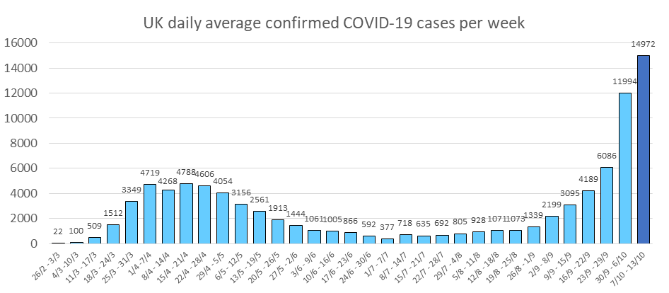

Regional and Local Epidemiology

As of the 19th October 2020, 1,037 North East Lincolnshire residents have tested positive for COVID-19 based on pillar 1 tests and pillar 2 tests, an increase of 419 cases over the previous week. The cumulative rate of COVID-19 infection in North East Lincolnshire is therefore 596.6 per 100,000, this is a significant increase from the previous week (w/c 5th October the rate was 382.3 per 100,000 population). Figure 5 displays the cumulative rates of COVID-19 cases for all upper tier local authorities in the Yorkshire and the Humber.

Figure 5: Laboratory confirmed COVID-19 cases (Pillar 1 & Pillar 2) by upper tier local authority in the Yorkshire and the Humber, total cases (up to 19th October 2020)

Data Source: https://coronavirus-staging.data.gov.uk/cases

Recent COVID-19 Data for North East Lincolnshire

Figure 6 shows the 7-day rate per 100,000 population of new COVID-19 cases from 11th October to 17th October 2020 that have been confirmed for each upper tier local authority in the Yorkshire and Humber (blue bar), and the overall cumulative positive test rate per 100,000 population since the start of the pandemic to 10th October 2020 (red line), both rates including both pillar 1 and pillar 2 tests. With a 7-day infection rate of 188.3 cases per 100,000 population, North East Lincolnshire had the fifth lowest rate of new infections out of the 15 local authorities in the Yorkshire and the Humber region, however it has seen by far the largest increase in new infection rate on the previous week in the Yorkshire and Humber and for the first time has the highest rate of cases within the Humber area. Sheffield continues to have the highest rate of new infections followed by Leeds.

Figure 6: Laboratory confirmed daily cases of COVID-19 by sample date and local authority for prior week and cumulative total to date (Pillar 1 and Pillar 2)

Diana Princess of Wales Hospital

Numbers of positive COVID-19 cases being treated in Diana Princess of Wales Hospital have increased significantly in recent days and are now at their highest since the end of April with 20 inpatients currently having confirmed COVID-19 (as of 12th October).

Care Homes

The North East Lincolnshire CCG care home tracker currently reports that three care homes have a single active case of COVID-19 among its residents. Four care homes are currently closed to admissions, all other homes are currently open to admissions. A large proportion of North East Lincolnshire care homes are situated within parts of the borough that are currently seeing the highest number of cases such as Yarborough, Waltham and Croft Baker wards which is a concern and supports the need for regular testing of care home staff. There are a small number of care home staff who have tested positive for COVID through the whole care home testing programme in recent weeks. These have been asymptomatic.

Deaths

The average daily numbers of COVID-19 deaths in the UK peaked during 08/04-14/04 at 938 deaths per day on average, and thence decreased each week until the end of August. This week deaths from COVID-19 increased by just over half (54%) to 82 deaths per day on average, the fifth increase seen since the peak in early April, and the fourth consecutive increase. The average daily deaths from COVID-19 this week are higher than at any point since the first half of June. Despite this increase, the average daily number of COVID-19 related deaths remains 91% lower than at the peak, as shown in Figure 7.

Figure 7:
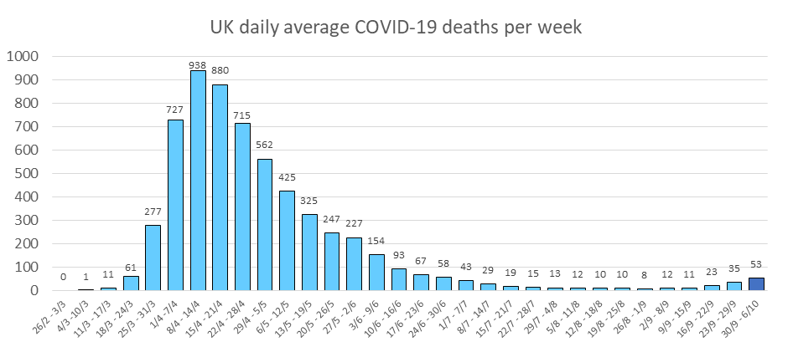

There have been five deaths associated with COVID-19 in North East Lincolnshire since the end of May, the three most recent occurred in October. A total of 49 deaths have now been registered in North East Lincolnshire with COVID-19 identified as a cause of death, with 36 being North East Lincolnshire residents and 13 being residents of other local authorities. It is believed that a further three deaths of North East Lincolnshire residents have been registered elsewhere.

In North East Lincolnshire there have been no deaths registered in children. Five deaths were of people aged under 60 years, and 59% of deaths occurred in people aged over 80 years.

