**Summary of Current COVID-19 Epidemiology in NE Lincolnshire**

**October 26th 2020**

**Key Points**

A total of 1,553 residents of North East Lincolnshire have had a confirmed diagnosis of COVID-19 (based on Pillar 1 and Pillar 2 Testing) which is an increase of 516 cases over the last week (the biggest week on week increase in confirmed cases that has been reported). The seven rate of new cases now stands at 306 per 100,000 which represents a doubling in new cases every seven days on average during the last four weeks. However there are signs that the rate of growth is now slowing.

Nationally there has been a significant increase in the number of positive COVID-19 tests in recent weeks. We are now seeing clear signs of an increase in hospital inpatients and deaths. In North East Lincolnshire analysis of cases confirmed since 1st October suggests an even spread across the working age population, with a steadily increasing number of cases now occurring in the young adult population. Since the beginning of October we have begun to see a rapidly increasing number of cases in older people which is a worrying trend. Geographically cases are occurring in all parts of the borough but far more are now occurring in central Grimsby areas such as Park, Heneage, Yarborough and Freshney wards. For the first time we are also seeing significant numbers of cases emerging in some of the most deprived parts of the borough.

NLaG report that there are 38 patients with confirmed COVID-19 in Grimsby Hospital (as of 26th October). This is the most at any point during the pandemic and represents a substantial increase since the beginning of October.

The number of cases in our care homes has grown significantly in the last week with nine care homes currently treating a total of 19 residents for COVID-19. This is the highest number of cases within our care homes since the spring. There have not however been any deaths associated with COVID-19 in care homes in the last three months

We are now experiencing regular, small outbreaks in a range of settings including social clubs, spas and gyms. However the largest number of outbreaks are occurring in workplaces and schools.

**Public Health Update**

There has been a substantial increase in the rate of new COVID-19 infections since the beginning of September in most parts of the country but particularly in the North East of England, the North West of England and the Yorkshire & Humber. North East Lincolnshire has also seen a sixty-fold increase in the rate of new infections during this period although our rate remains lower than the Yorkshire & Humber rate. North East Lincolnshire is currently in the Medium Risk (Tier 1) category that the Government has introduced to determine restrictions associated with COVID-19 infection rates. People in North East Lincolnshire will face the basic national rules currently in force:

* **Leisure time**: Pubs, bars and restaurants will have to close at 22:00 BST. They are restricted to table service only. Face coverings must be worn, except when seated to eat or drink. Face coverings must be worn on public transport and indoor areas such as museums and cinemas. You can be fined £200 for breaking the rules. Shops can open with social distancing measures in place. Face coverings must be worn by customers and staff. Gyms open as normal.
* **Meeting up**: The rule of six (number of people who can meet up) applies both indoors and outdoors in all settings. You can meet in a group of up to six people from multiple households. This includes children and applies indoors and outdoors, including private homes. There are exceptions, for example if your household or support bubble is larger than six. You could be fined for breaking these rules.
* **Going to work**: You should work at home if possible. If you have to return to your workplace your employer must make arrangements for you to work safely.
* **Schools and nurseries**: Schools, colleges and universities remain open, and youth club activities are permitted. Registered and wraparound childcare, supervised activities permitted in private homes and children’s groups are permitted.
* **Places of worship** remain open (subject to the rule of 6).

We have analysed the 1,298 new cases that have been confirmed in North East Lincolnshire since the 1st October. During October the majority of our cases have been in the working age population between 21 and 60 with a fairly even spread between male and female (Figure 1). However there has been a substantial increase across all age-bands during the month (Figure 2). Cases in the 65 and overs have increased significantly since early October.

**Figure 1: Cases of Confirmed COVID-19 in North East Lincolnshire since 1st OCTOBER, analysed by age and gender**

**Figure 2: Heat maps of age specific incidence per 100,000 people** *Rates are calculated excluding data from the last four days due to reporting delays*

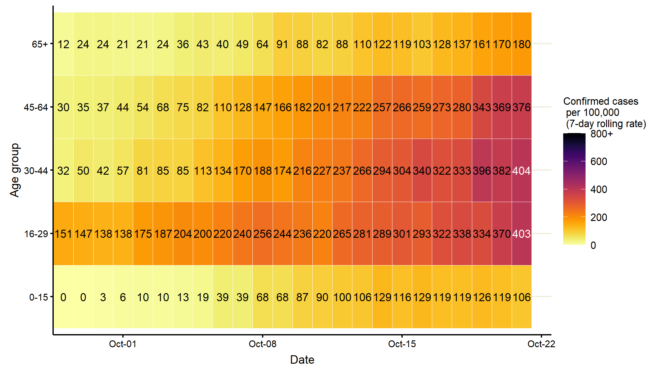

We are continuing to see cases spread across the borough but there are increasing indications of clustering and hot spots. Since the beginning of October we have seen the largest number of cases in Park, Humberston & New Waltham, Heneage, Yarborough and Freshney wards (Figure 3).

**Figure 3: COVID Cases Confirmed since 1st OCTOBER 2020 in NEL by Ward of Residence**

Table 1 displays changes in the number of cases in the last two weeks that we have complete data for. Heneage, South, East Marsh, Wolds and Sidney Sussex wards have seen the most significant increase in new infections compared to other North East Lincolnshire wards. This is the strongest indication so far that the virus is now circulating in the more deprived central parts of Grimsby.

**Table 1: Rate of COVID-19 per 100,000 per week in most recent 7 day period with complete data (October 15 2020 to October 21 2020) and prior 7 day period (October 8 2020 to October 14 2020), for wards in North East Lincolnshire** *4 most recent days excluded due to reporting delays. Relative change based on incidence rate ratio p value <0.05 - please interpret carefully as increases or decreases to rates in some areas may be deemed insignificant (represented by “=”) at ward level but may still represent increases due to local outbreaks. Table ordered by ward with highest to lowest rate.*

| Rank (Most recent rate) | Ward | Total | | Prior week (2020-10-08 to  2020-10-14) | | Most recent week (2020-10-15 to 2020-10-21) | | Change in rate between two weeks | |
| --- | --- | --- | --- | --- | --- | --- | --- | --- | --- |
|  |  | Cases | Rate | Cases | Rate | Cases | Rate | Absolute difference | Relative |
| 1 | Heneage | 125 | 1049.8 | 24 | 201.6 | 56 | 470.3 | 268.7 | Increase |
| 2 | South | 111 | 868.7 | 21 | 164.3 | 46 | 360.0 | 195.7 | Increase |
| 3 | Humberston and New Waltham | 145 | 1294.1 | 49 | 437.3 | 37 | 330.2 | -107.1 | = |
| 4 | Park | 155 | 1303.5 | 39 | 328.0 | 38 | 319.6 | -8.4 | = |
| 5 | East Marsh | 85 | 734.0 | 13 | 112.3 | 36 | 310.9 | 198.6 | Increase |
| 6 | Freshney | 106 | 1121.5 | 45 | 476.1 | 29 | 306.8 | -169.3 | = |
| 7 | Yarborough | 129 | 1101.6 | 29 | 247.7 | 35 | 298.9 | 51.2 | = |
| 8 | Scartho | 127 | 1122.4 | 22 | 194.4 | 33 | 291.6 | 97.2 | = |
| 9 | Wolds | 68 | 888.2 | 9 | 117.6 | 22 | 287.4 | 169.8 | Increase |
| 10 | Sidney Sussex | 82 | 653.7 | 12 | 95.7 | 36 | 287.0 | 191.3 | Increase |
| 11 | Haverstoe | 100 | 1025.5 | 14 | 143.6 | 26 | 266.6 | 123.0 | = |
| 12 | West Marsh | 62 | 806.2 | 15 | 195.1 | 20 | 260.1 | 65.0 | = |
| 13 | Croft Baker | 110 | 955.9 | 19 | 165.1 | 26 | 225.9 | 60.8 | = |
| 14 | Waltham | 82 | 1216.3 | 21 | 311.5 | 12 | 178.0 | -133.5 | = |
| 15 | Immingham | 65 | 549.3 | 12 | 101.4 | 15 | 126.8 | 25.4 | = |
| 16 | Unknown ward | 1 | NA | NA | NA | NA | NA | NA | = |

**National Epidemiology**

As of 26th October 2020, there are 894,690 cases in the UK, of which 758,148 are in England, and 111,580 in the Yorkshire and the Humber region. 44,980 people have died from their infection in the UK (within 28 days of a positive test). Figure 4 shows the average daily number of confirmed COVID-19 cases in the UK per week. As can be seen, the average daily number of confirmed cases increased by more than one fifth this week, rising by 22% to 18,232 cases per day on average. This is the fifteenth consecutive increase in the average number of daily confirmed COVID-19 cases per week for the UK. Average daily cases are now at their highest level ever, and are 3 times higher than the level at the end of September, and are 3.8 times higher than at the first peak in late April (though it should be recognised that in the period between March and May testing was only usually available to people who became very ill or who worked in healthcare settings, the true number of cases during this period was therefore far higher than officially recorded). With rapidly rising rates in many parts of the country, despite various levels of restrictions, and the colder autumn weather meaning people are likely to spend a greater part of their time indoors, further increases in the numbers of new cases are likely over the coming weeks.

**Figure 4:**

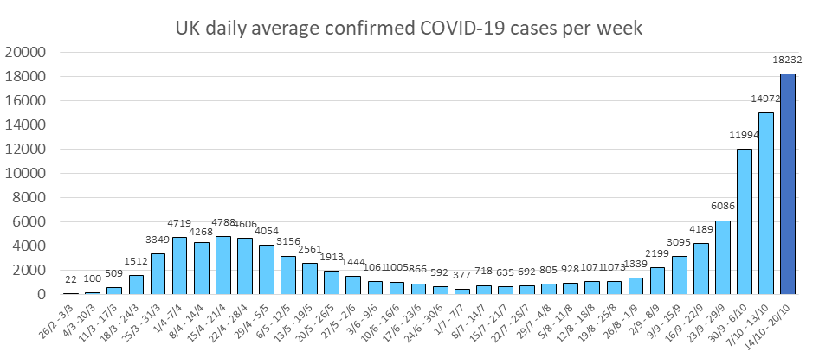

**Regional and Local Epidemiology**

As of the 26th October 2020, 1,553 North East Lincolnshire residents have tested positive for COVID-19 based on pillar 1 tests and pillar 2 tests, an increase of 516 cases over the previous week. The cumulative rate of COVID-19 infection in North East Lincolnshire is therefore 973.3 per 100,000, which represents a near trebling of cumulative cases during the last three weeks (w/c 5th October the rate was 382.3 per 100,000 population). Figure 5 displays the cumulative rates of COVID-19 cases for all upper tier local authorities in the Yorkshire and the Humber.

**Figure 5: Laboratory confirmed COVID-19 cases (Pillar 1 & Pillar 2) by upper tier local authority in the Yorkshire and the Humber, total cases (up to 26th October 2020)**

**Data Source:** <https://coronavirus-staging.data.gov.uk/cases>

**Recent COVID-19 Data for North East Lincolnshire**

Figure 6 shows the 7-day rate per 100,000 population of new COVID-19 cases from 16th October to 22nd October 2020 that have been confirmed for each upper tier local authority in the Yorkshire and Humber (blue bar), and the overall cumulative positive test rate per 100,000 population since the start of the pandemic to 22nd October 2020 (red line), both rates including both pillar 1 and pillar 2 tests. With a 7-day infection rate of 305.8 cases per 100,000 population, North East Lincolnshire had the sixth lowest rate of new infections out of the 15 local authorities in the Yorkshire and the Humber region, but has the highest 7 -day rate of cases of the 4 Humber local authority areas. Barnsley and Doncaster have the highest rate of new infections.

**Figure 6: Laboratory confirmed daily cases of COVID-19 by sample date and local authority for prior week and cumulative total to date (Pillar 1 and Pillar 2)**

**Diana Princess of Wales Hospital**

Numbers of positive COVID-19 cases being treated in Diana Princess of Wales Hospital have increased significantly in recent weeks and are now at their highest since the end of April with 38 inpatients currently having confirmed COVID-19 (as of 26th October).

**Care Homes**

The North East Lincolnshire CCG care home tracker currently reports that 9 care homes have a total of 19 cases of COVID-19 among its residents with a range of 1 to 7 residents affected. This represents a big increase on last week when just 3 homes were reporting one or more cases. Six care homes are currently closed to admissions, all other homes are currently open to admissions. A large proportion of North East Lincolnshire care homes are situated within parts of the borough that are currently seeing the highest number of cases which is a concern and supports the need for regular testing of care home staff. There are a small number of care home staff who have tested positive for COVID through the whole care home testing programme in recent weeks. These have been asymptomatic.

**Deaths**

The average daily numbers of COVID-19 deaths in the UK peaked during 08/04-14/04 at 938 deaths per day on average, and then decreased each week until the end of August. This week deaths from COVID-19 increased by two thirds (66%) to 136 deaths per day on average, the sixth increase seen since the peak in early April, and the fifth consecutive increase. The average daily deaths from COVID-19 this week are higher than at any point since the beginning of June. Despite this increase, the average daily number of COVID-19 related deaths remains 86% lower than at the peak, as shown in Figure 7.

**Figure 7:**

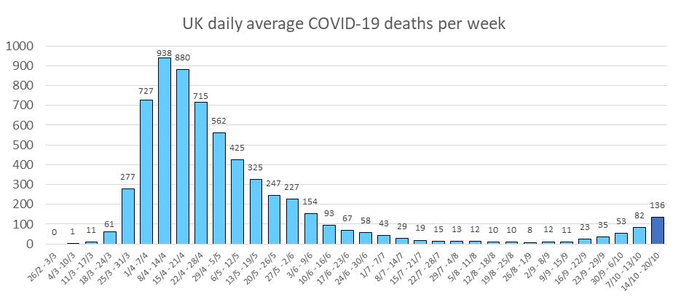

There have been 8 deaths associated with COVID-19 in North East Lincolnshire since the end of May, the 6 most recent occurred in October. A total of 52 deaths have now been registered in North East Lincolnshire with COVID-19 identified as a cause of death, with 39 being North East Lincolnshire residents and 13 being residents of other local authorities. It is believed that a further three deaths of North East Lincolnshire residents have been registered elsewhere.

In North East Lincolnshire there have been no deaths registered in children. Five deaths were of people aged under 60 years, and 60% of deaths occurred in people aged over 80 years.