North East Lincolnshire Council
Education, Health and Care Hub
User Guide for the Hub – Professionals
Rebecca Taylor (NELC)
10-7-2020

Introduction
An electronic Education, Health and Care (EHC) Hub has been purchased, which is an online case management system. The software will be used to manage two key processes involving Education, Health and Care Plans (EHCP):
- The initial request for and Education Health and Care Plan and subsequent 20-week assessment process (from 7th October)
- The annual review process (TBC-further information available Autumn 2020)

The purpose of the hub is to draw together a number of processes, that previously been done in paper or e-mail format, so that they are all kept together and makes it simpler to track progress for an individual child or young person.

Website and log-in Screen
To access the hub, please visit https://ehchub.nelincs.gov.uk/
Once you receive your log-in details for the EHC Hub, this is the first screen that you will see.

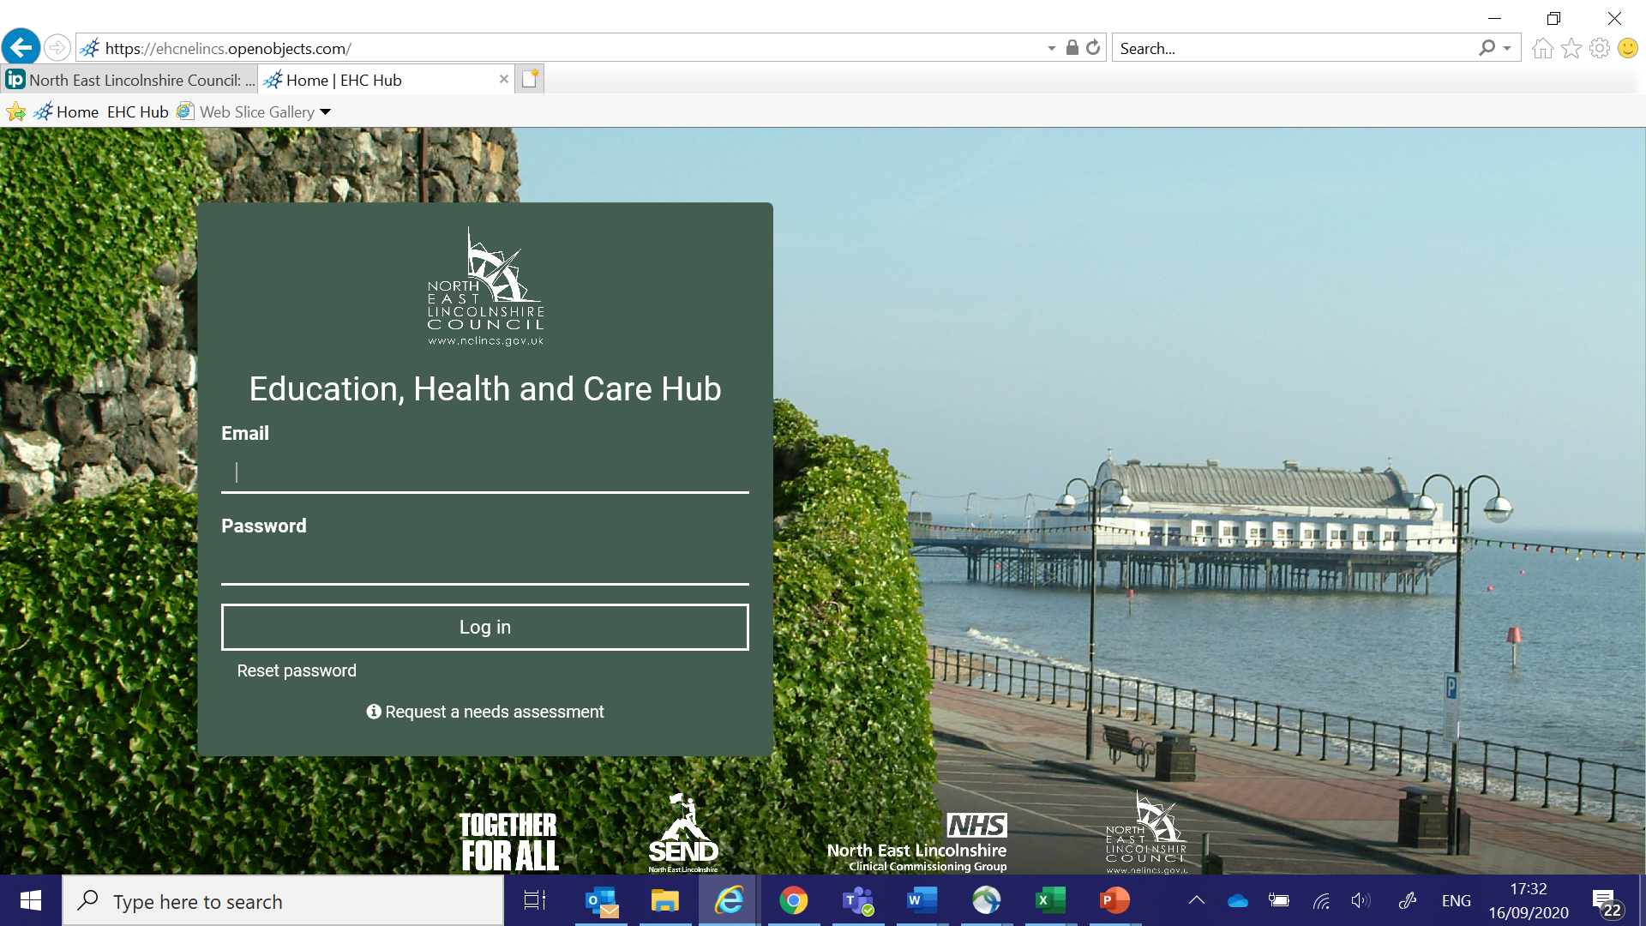
E-mail Address
An e-mail is needed to use the Hub and for professionals, it will be mandatory to run cases through the Hub. If you need to register for the Hub please email sen@nelincs.gov.uk or if you are a health professional please email designatedclinicalofficer@nelincs.gov.uk for further advice and support.

Access Privileges
There will be different levels of access for different users, depending on your role and involvement with individual cases. You will only have access to the areas of the Hub that are appropriate for you. If a manager needs a caseload to be accessed by a whole team, it will be possible to allow as many as is needed to access the required records. An EHCP Co-Ordinator will send alerts to all professionals involved in a case to request information. You will be sent a notification to your e-mail when something is being requested of you or involves you. Many of these are automated notifications, prompting you to log in to the hub. Please only use your own log-in and password and do not share these with anyone else.

Information in Other Languages
The information on the Hub will be in English, but Google Translate could be used, as long as the content is in plain English, which might be enough to help families navigate the Hub. The Hub also could integrate with web accessibilities, such as Browsealoud.

Resetting Password
In order to reset your password, there is a link at the bottom of the log-in screen and you must enter your e-mail address and press submit. The password reset instructions will be sent to your registered e-mail address.

Technical Help
If technical help is required, please email openobjects.servicedesk@idoxgroup.com and someone will be in touch shortly afterwards. Calls are usually responded to on the same day. If the issue is urgent you can call 03330 111 668.

First screen
Once you have successfully entered your e-mail address and password, this is the next screen that you will see. As mentioned previously, you will only have access to the areas of the Hub that are appropriate for you.
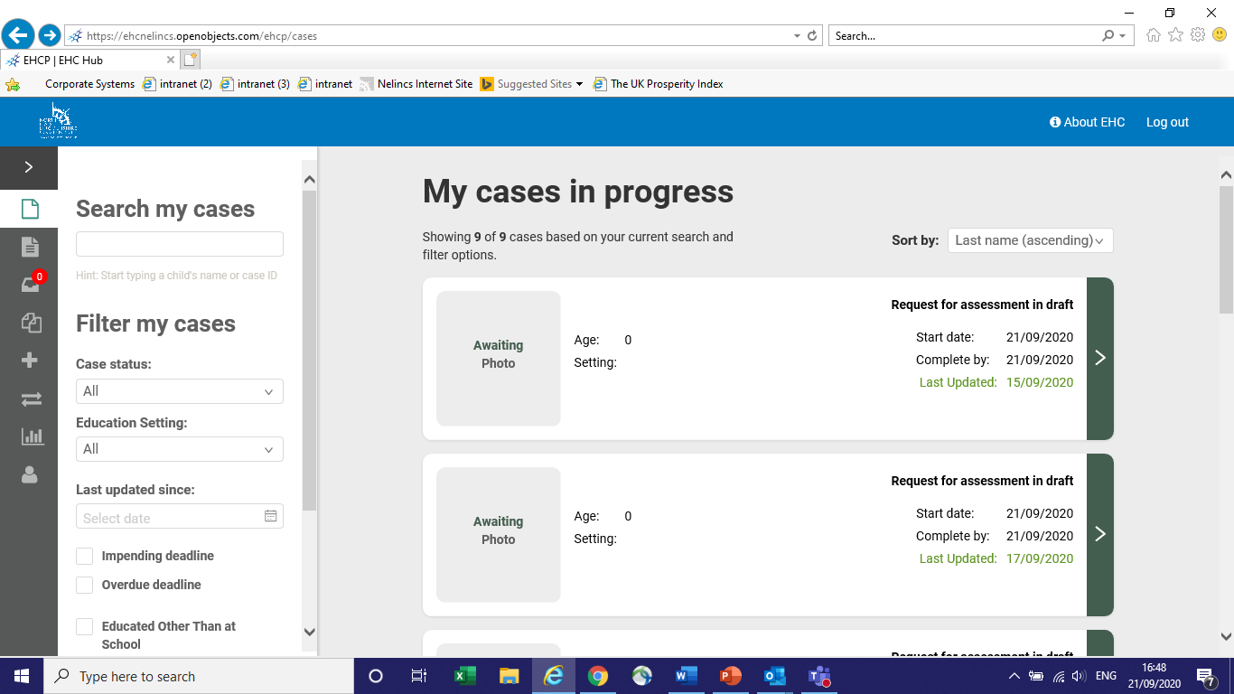
Education, Health and Care Plan
If you click on the About EHC tab on the top right hand corner, this will take you to information on what an Education, Health & Care Plan (EHCP) is, who needs an EHCP and how to get an EHCP. There is then a link at the bottom to click on, in order to request an Education, Health and Care (EHC) Needs Assessment.
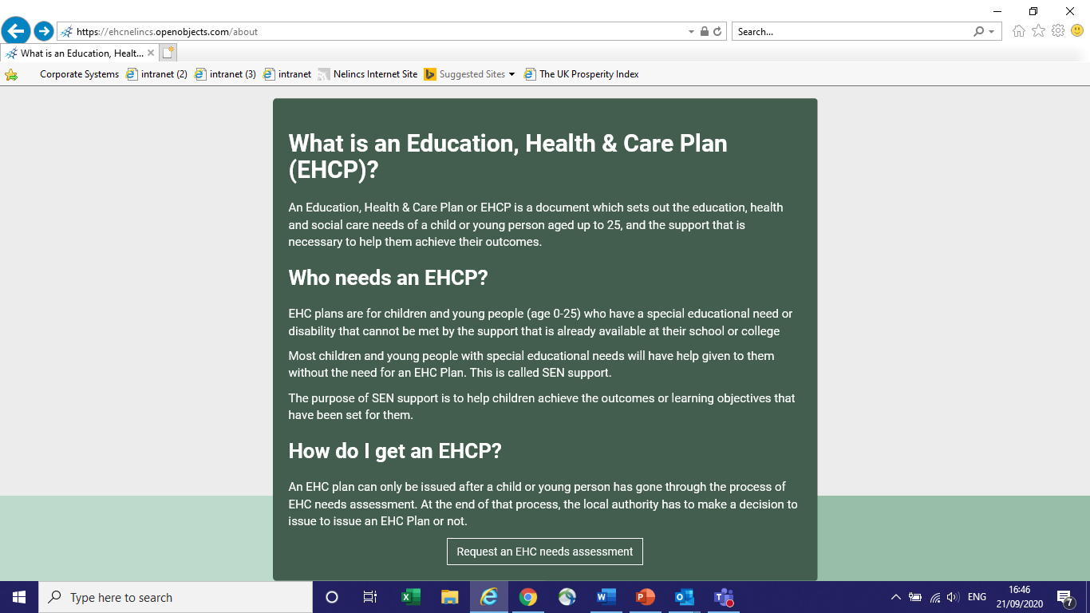

EHC Needs Assessment
The LA (Local Authority) must reply within 6 weeks.
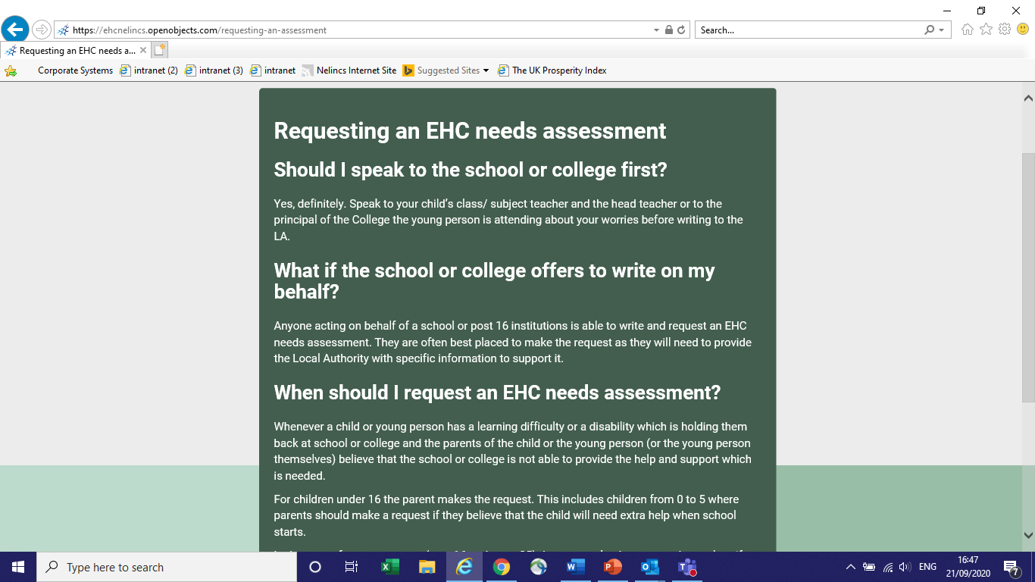

EHC Needs Assessment Form
The assessment form will be completed by the Local Authority, although the parent, or the young person, can be asked to provide information. The form consists of 8 sections.

The form can be completed in stages, as you have the option to save and return at a later time/date if needed.

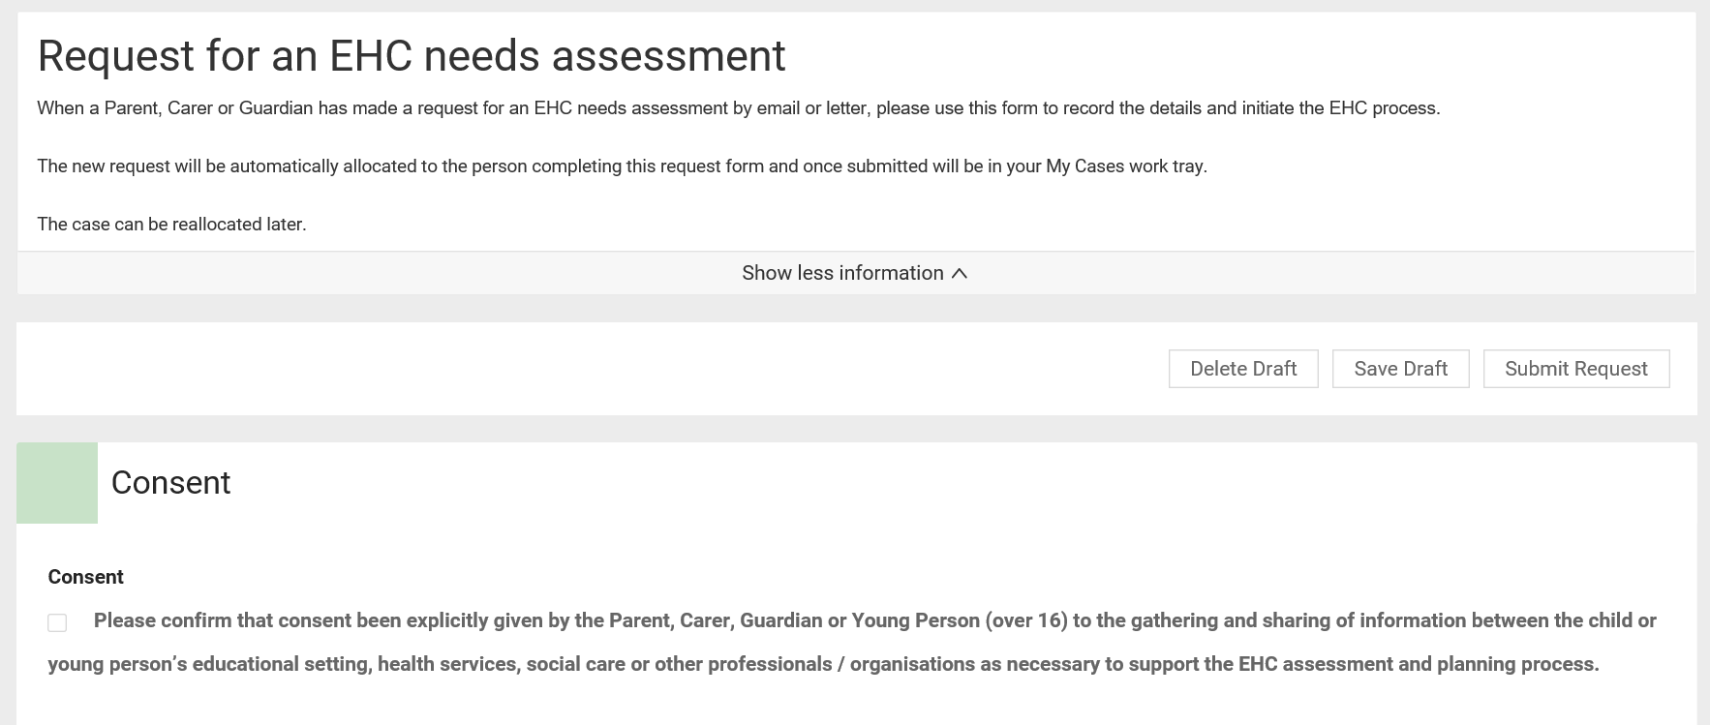

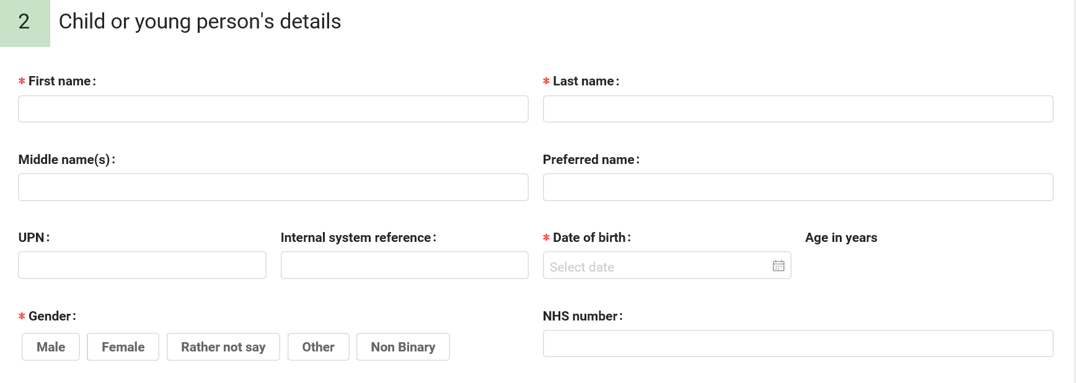

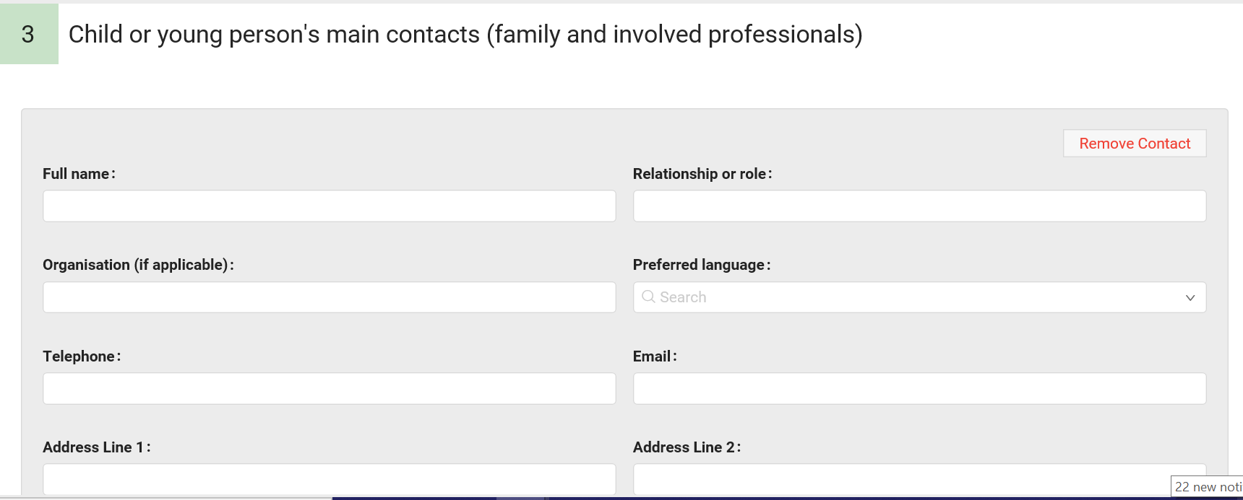

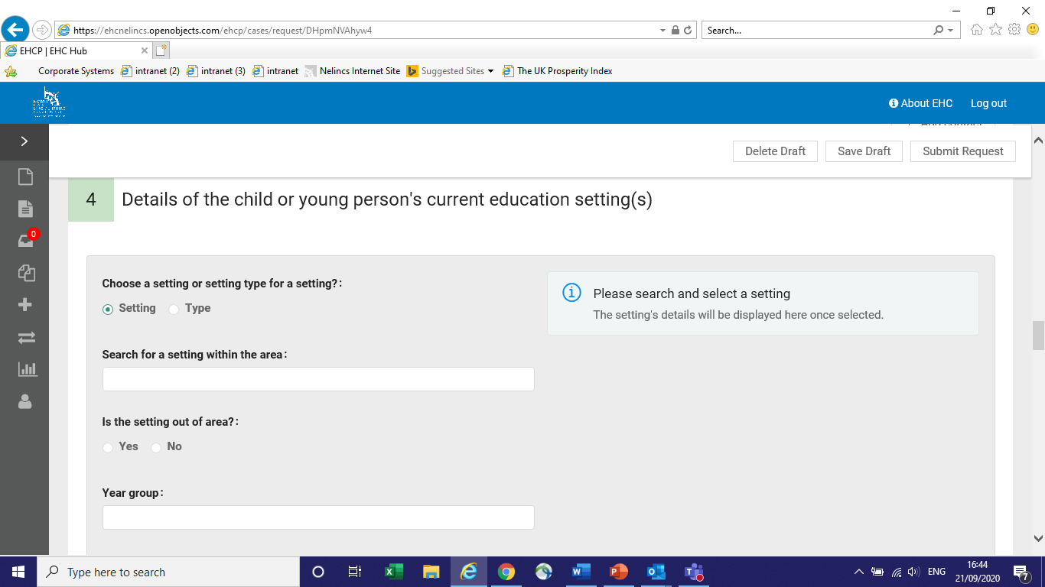

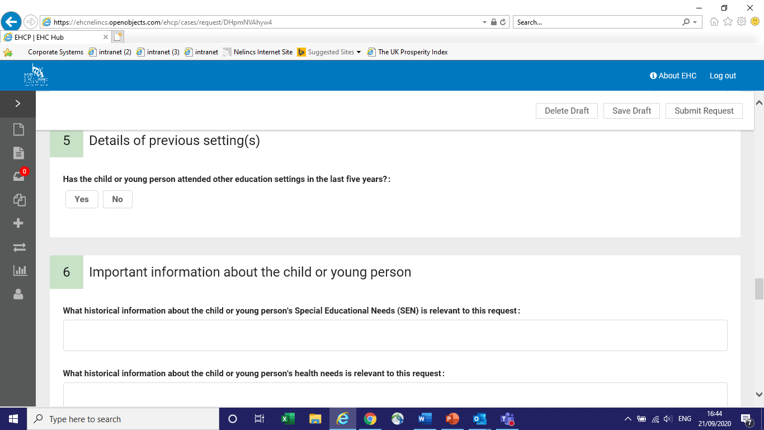

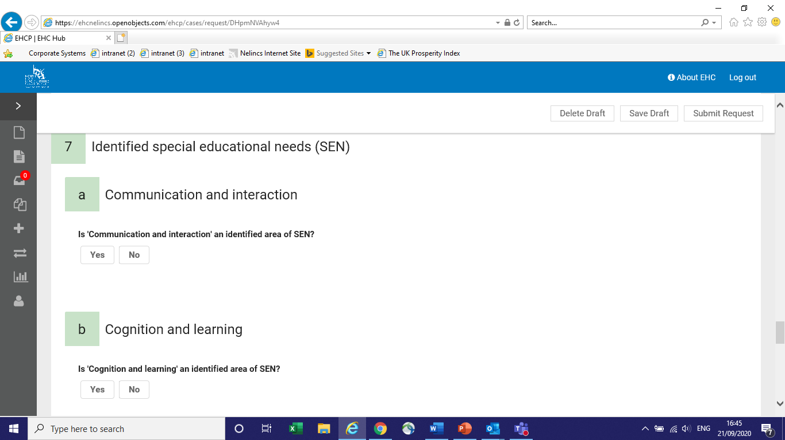

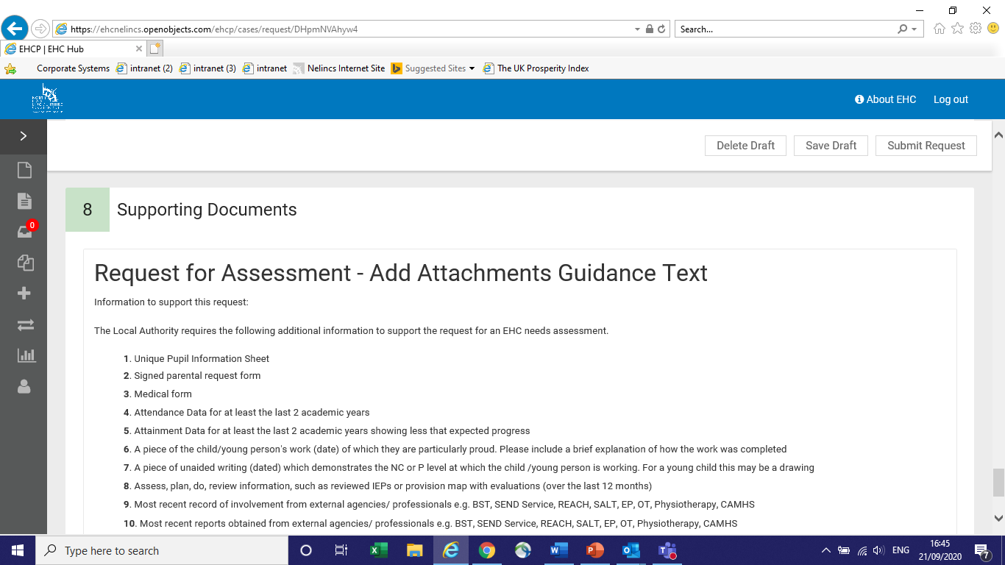

Next Steps
Once the EHC Needs Assessment has been completed, the Local Authority has six weeks to gather further information from any relevant professionals including school staff, to decide whether or not it is appropriate to continue with a full needs assessment which would result in an Education, Health and Care Plan being issued. Please see the timeline below summarising the process as outlined in the SEND Code of Practice (2014):

- Weeks 1-6: Decision to assess - Initial information gathered from education, health and social care professionals
- Weeks 7 – 16: Assessment and evidence gathering - More detailed information gathered, from professionals already involved or further input and assessment completed where required
- Weeks 17-20: Draft plan

If the application does not result in an assessment, parents and carers will have to wait 6 months before re-applying in line with the SEND (Special Educational Needs and Disabilities) Code of Practice (2014).

Further Information
Further information can be found on North East Lincolnshire Council’s website under Special Educational Needs and Disabilities (SEND) and Local Offer: https://www.nelincs.gov.uk/children-and-families/send-and-local-offer/

