North East Lincolnshire Council
Education, Health and Care Hub
User Guide for the Hub – Parents and Carers
Rebecca Taylor (NELC)
10-7-2020

Introduction
An electronic Education, Health and Care (EHC) Hub has been purchased, which is an online case management system. The software will be used to manage two key processes involving Education, Health and Care Plans (EHCP):
- The initial request for and Education Health and Care Plan and subsequent 20-week assessment process (from 7th October)
- The annual review process (TBC-further information available Autumn 2020)

The purpose of the hub is to draw together a number of processes, that previously been done in paper or e-mail format, so that they are all kept together and makes it simpler to track progress for an individual child or young person.

Website and log-in Screen
To access the hub, please visit https://ehchub.nelincs.gov.uk/
Once you receive your log-in details for the EHC Hub, this is the first screen that you will see.

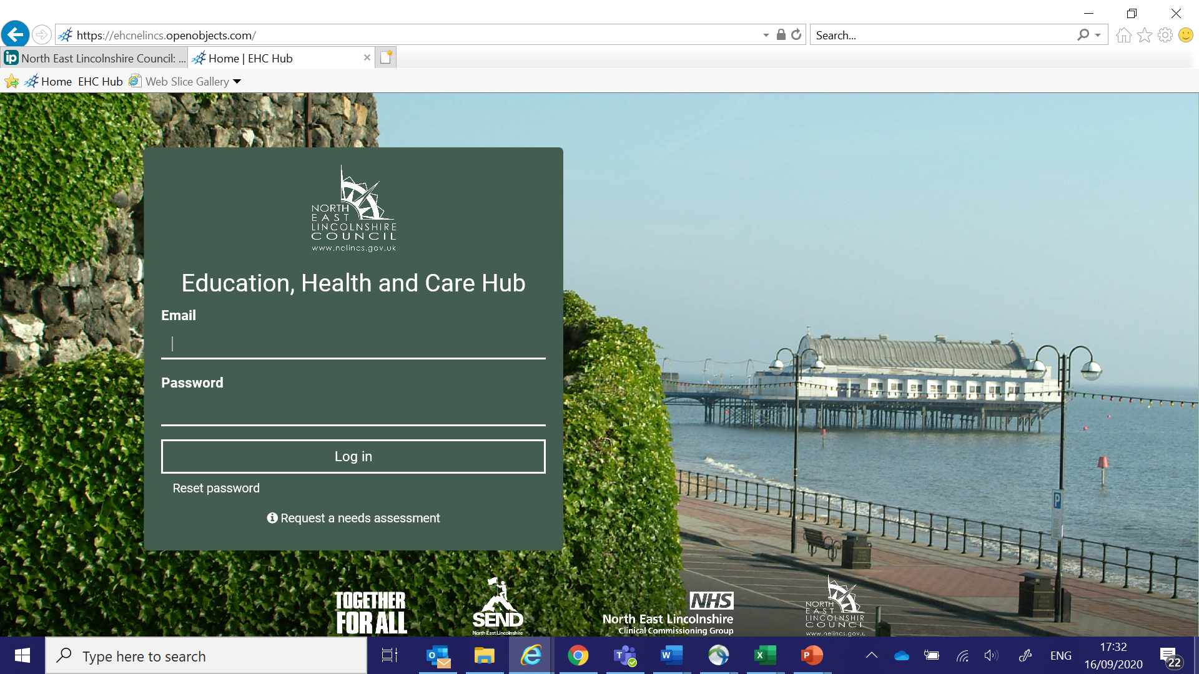
Using the Hub
An e-mail is needed to use the Hub. However, it is recognised that using the Hub may not be for every family, either because they do not have internet access, or that they do not want to have access to the Hub. It will not be mandatory for parents/foster parents/carers to use the Hub, as the information can be printed out and sent in hard copy format. Alternatively, access to the Hub can be granted to an advocate, or the parent can sit with the setting SENCo or Co-Ordinator and look at the information on the screen. For professionals, it will be mandatory to run cases through the Hub.

Access Privileges
There will be different privileges for different users, rather than generic access e.g. read-only, or access to a part of a form that needs to be completed. You will only have access to the areas of the Hub that are appropriate for you. Please only use your own log-in and password and do not share these with anyone else.

Information in Other Languages
The information on the Hub will be in English, but Google Translate could be used, as long as the content is in plain English, which might be enough to help the family navigate the Hub. The Hub also could integrate with web accessibilities, such as Browsealoud.

Resetting Password
In order to reset your password, there is a link at the bottom of the log-in screen and you must enter your e-mail address and press submit. The password reset instructions will be sent to your registered e-mail address.

Technical Help
If technical help is required, please email openobjects.servicedesk@idoxgroup.com and someone will be in touch shortly afterwards. Calls are usually responded to on the same day. If the issue is urgent you can call 03330 111 668.

Requesting a needs assessment
Anyone (parent/carer, SENCo, health professional, social worker etc) can make a request for a child or young person to be considered for a needs assessment. Whilst the preference would be to make it through the EHCP Hub, there are a number of ways that you can still place a request.
- Through the EHCP Hub
- Contacting the Special Educational Needs Annual Review Team (SENART) on 01472 323166
- Via e-mail sen@nelincs.gov.uk

Parents and carers do not need a username or password to make a request for a needs assessment through the EHCP Hub.
Step 1
On the homepage of the website click here.

This will take you to a short form to complete as shown on the next few pages.

Step 2
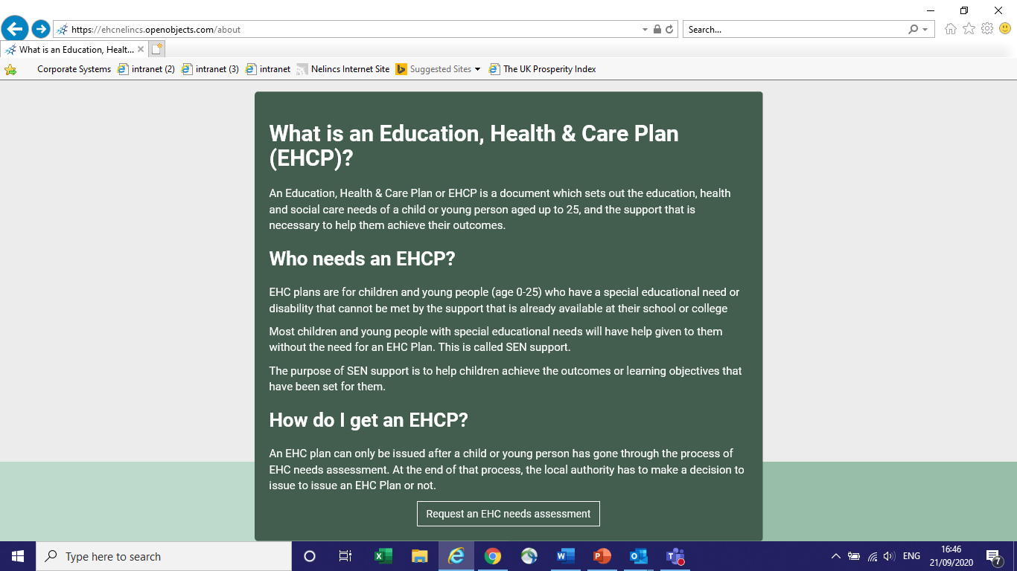
Click here to continue

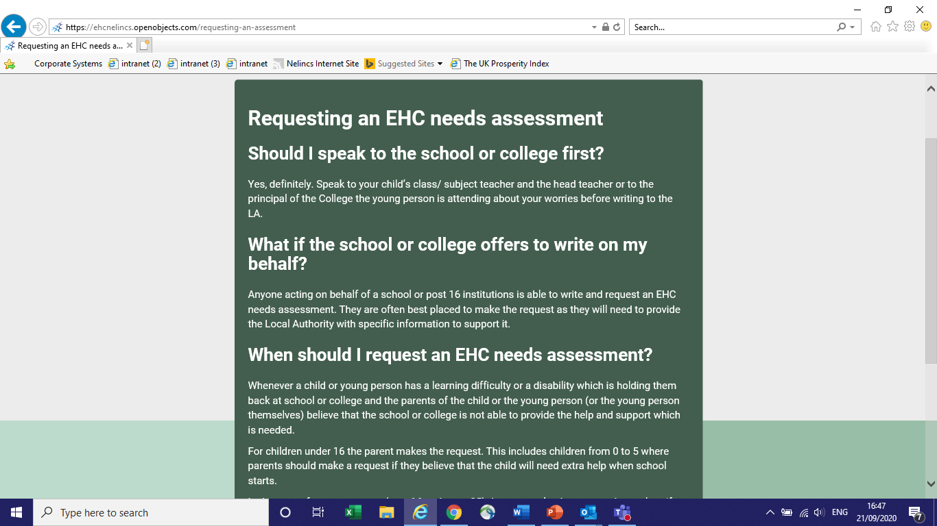
EHC Needs Assessment
The LA (Local Authority) must reply to all requests within 6 weeks.
They will always reply to you as a parent (or young person), even where the request was made by the school or college.

Step 3
EHC Needs Assessment Form
The assessment form will be completed by the Local Authority, although you, or the young person, will be asked to provide information. The form consists of 8 sections and the screenshots on the next few pages, will give you an idea of the information that will be collected.

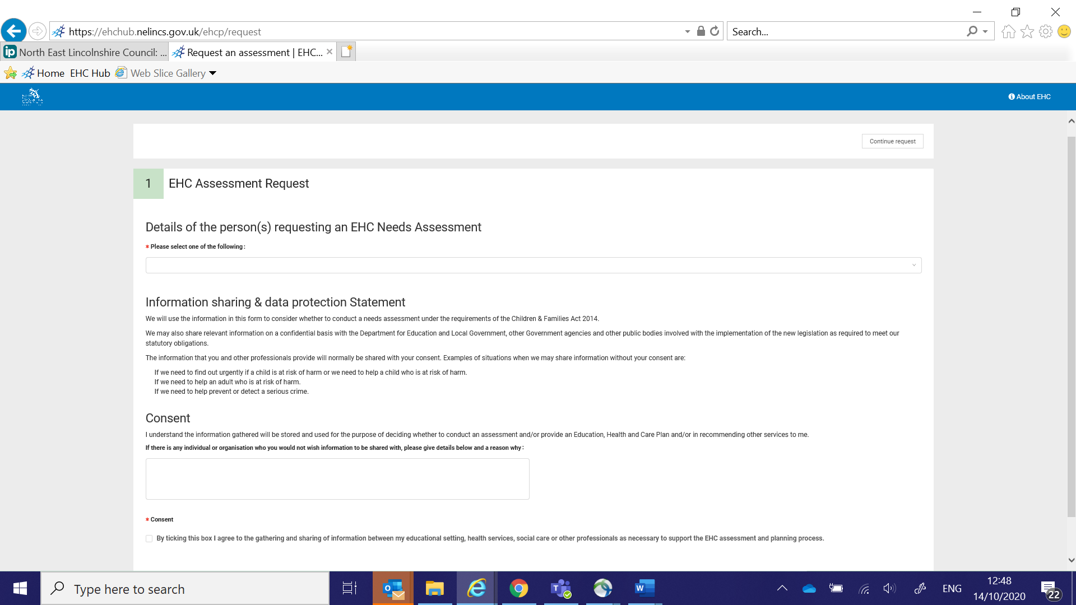
Anything with a red star, you MUST complete.
If you have any professionals or SENDIASS working with you, please put their details in here.
Click here once you have completed your name and given your consent.

Step 4

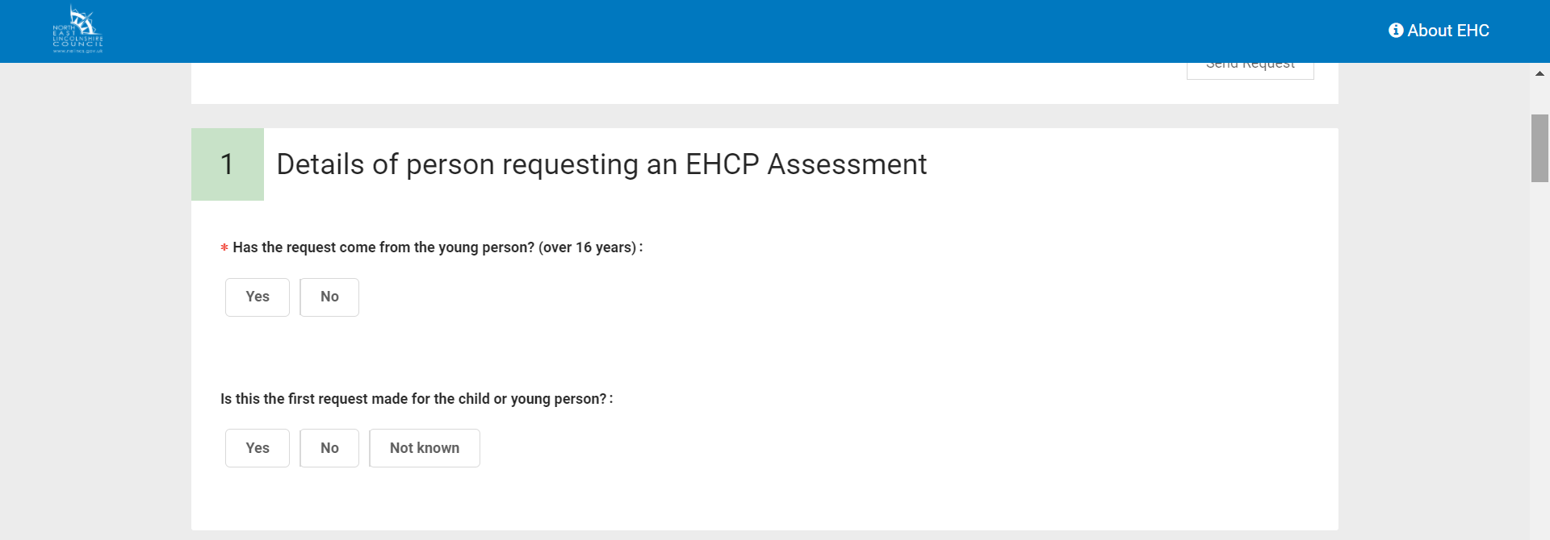
The next few pages, show you the five sections where you can provide information to the local authority about your request.

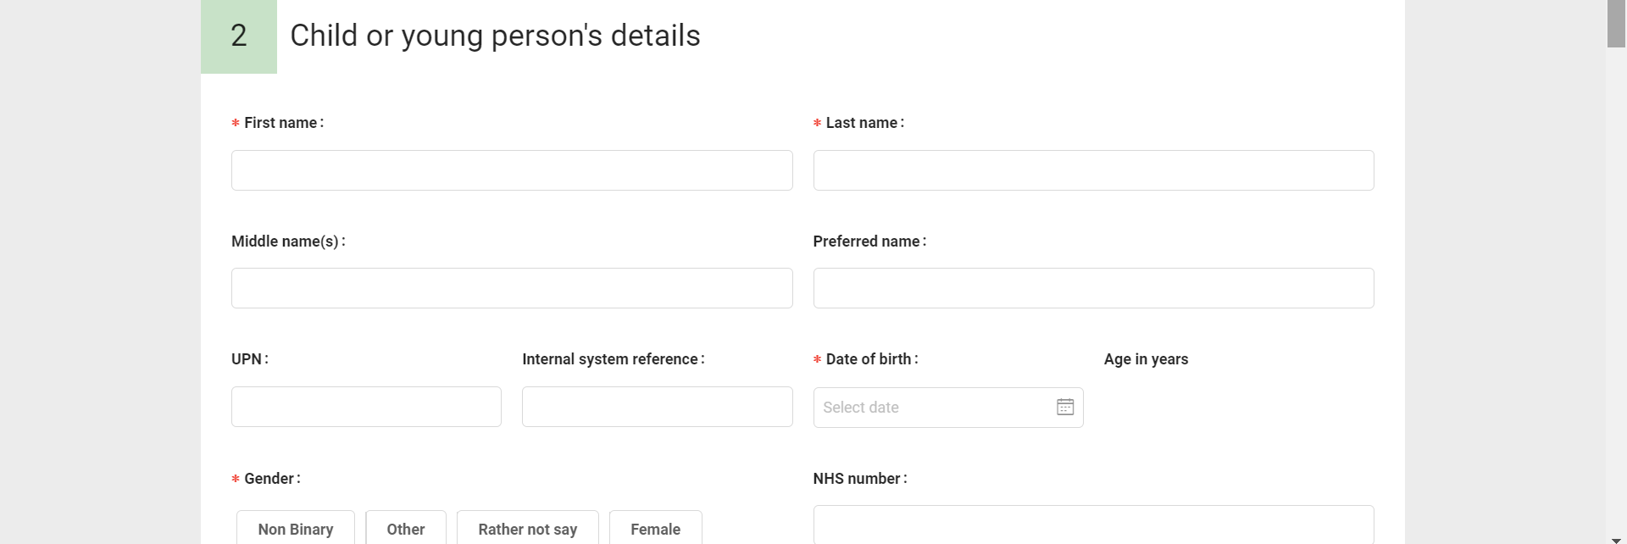
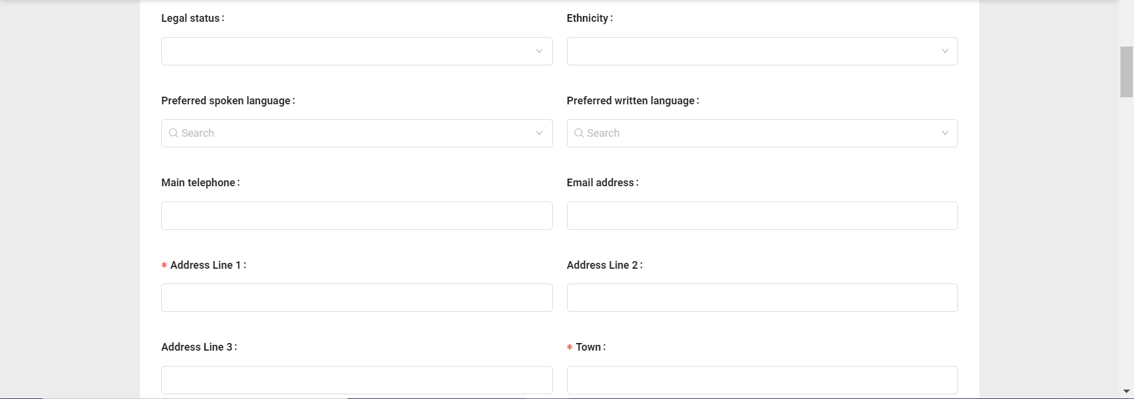
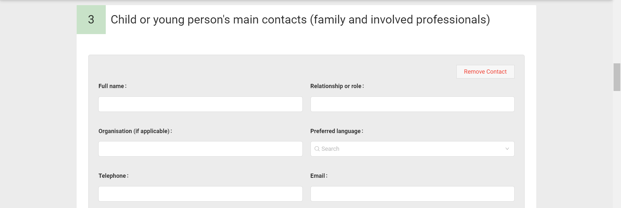
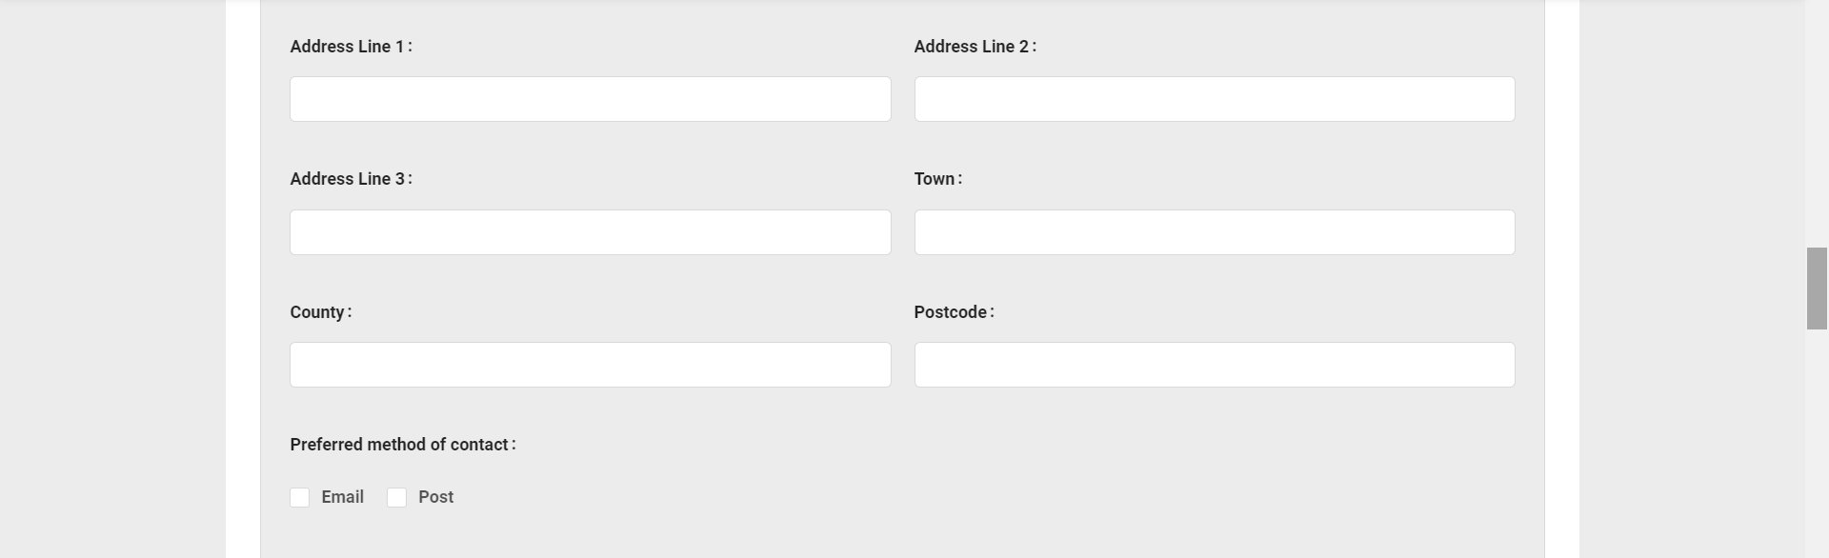
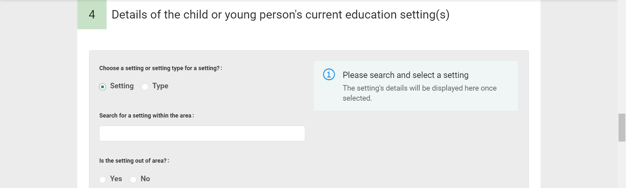

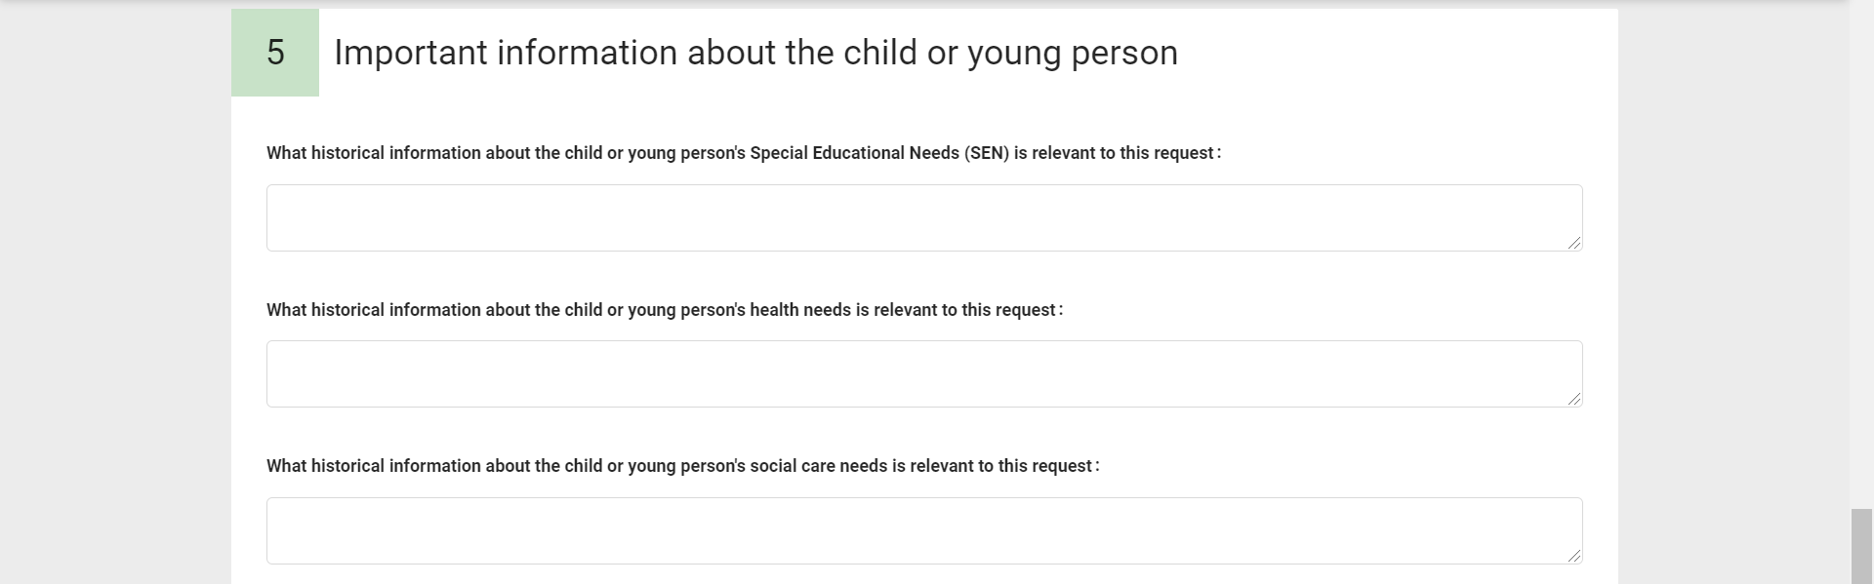

Step 4
Submit your request.
Click here once you have completed all of the information.

Next Steps
Once the EHC Needs Assessment has been completed, the Local Authority has six weeks to gather further information from any relevant professionals including school staff, to decide whether or not it is appropriate to continue with a full needs assessment which would result in an Education, Health and Care Plan being issued. Please see the timeline below summarising the process as outlined in the SEND Code of Practice (2014):

- Weeks 1-6: Decision to assess - Initial information gathered from education, health and social care professionals
- Weeks 7 – 16: Assessment and evidence gathering - More detailed information gathered, from professionals already involved or further input and assessment completed where required
- Weeks 17-20: Draft plan

If the application does not result in an assessment, parents and carers will have to wait 6 months before re-applying in line with the SEND (Special Educational Needs and Disabilities) Code of Practice (2014).

Further Information
Further information can be found on North East Lincolnshire Council’s website under Special Educational Needs and Disabilities (SEND) and Local Offer: https://www.nelincs.gov.uk/children-and-families/send-and-local-offer/

