Summary of Current COVID-19 Epidemiology in NE Lincolnshire November 2nd 2020

Key Points

A total of 2,405 residents of North East Lincolnshire have had a confirmed diagnosis of COVID-19 (based on Pillar 1 and Pillar 2 Testing) which is an increase of 852 cases over the last week (the biggest week on week increase in confirmed cases that has been reported). The seven day rate of new cases now stands at 377 per 100,000. This has increased from 306 per 100,000 one week ago and has doubled in 14 days compared to a doubling rate of seven days the previous week. Therefore although it is the highest figure that we have seen it represents a significant slow down in the overall rate of growth suggesting that we are close to a peak in the infection rate in North East Lincolnshire.

Nationally there has been a significant increase in the number of positive COVID-19 tests in recent weeks. We are now seeing clear signs of an increase in hospital inpatients and deaths. In North East Lincolnshire analysis of cases confirmed since 1st October suggests an even spread across the working age population, but evidence that the rate of growth may now have stopped in that population. By contrast we are continuing to see a rapid increase in the number of cases in people over the age of 65. This is likely to put a significant burden on our hospital services over the coming weeks. Geographically cases are occurring in all parts of the borough with the highest numbers over the last two weeks reported in Haverstoe, South, Heneage and Scartho wards.

NLaG report that there are 48 patients with confirmed COVID-19 in Grimsby Hospital (as of 2nd November), an increase of ten from the previous week. This is the most at any point during the pandemic and represents a substantial increase since the beginning of October.

The number of cases in our care homes has grown significantly in the last week with eight care homes currently treating a total of 60 residents for COVID-19. This is the highest number of cases within our care homes since the spring.

We are now experiencing regular, small outbreaks in a range of settings including social clubs, spas and gyms. However the largest number of outbreaks are occurring in workplaces and schools. The disease is now largely endemic across the North East Lincolnshire population.

Public Health Update
There has been a substantial increase in the rate of new COVID-19 infections since the beginning of September in most parts of the country but particularly in the North East of England, the North West of England and the Yorkshire & Humber. North East Lincolnshire has also seen a ninety-fold increase in the rate of new infections during this period although our rate remains lower than the Yorkshire & Humber rate. North East Lincolnshire was moved into the high risk (Tier 2) category that the Government has introduced to determine restrictions associated with COVID-19 infection rates on 31st October. However shortly after this it was announced that the whole of England would move into a partial lockdown from Thursday November 5th. Key restrictions and measures in this lockdown include the following:
- People will be told to stay at home except for education, work (if it can't be done from home), exercise and recreation, medical reasons, shopping for food and other essentials, or to care for others
- All pubs and restaurants will have to close (takeaways and deliveries can continue)
- All non-essential shops will have to close (supermarkets can sell non-essential goods)
- Households will not be allowed to mix with others indoors, or in private gardens
- Individuals can meet one person from outside their household in an outside public space
- Support bubbles for people who live alone and households made up of single parents and children can continue and children will be able to move between homes if their parents are separated
- Schools, nurseries, colleges and universities will remain open
- Hotels will only open for people who have to travel for work plus a number of other limited reasons
- Weddings and civil partnership ceremonies will not be allowed, apart from exceptional circumstances
- Places of worship will generally close but funerals, with a maximum of 30 people attending, individual prayer, and a few other activities will be allowed
- Workplaces will be asked to stay open if people cannot work from home - including construction and manufacturing
- Outdoor exercise and recreation will be allowed, but gyms will have to close
- Clinically vulnerable advised not to go to work if they are unable to work from home.
From 2nd December the current plan is that different regions will return to the tiers system, depending upon the rates of infection.
During the month of October, 2,010 new cases of COVID-19 were confirmed in North East Lincolnshire, representing more than 80% of all cases confirmed in the borough since the start of the pandemic. During October the majority of our cases have been in the working age population between 21 and 60 with a fairly even spread between male and female (Figure 1).
Figure 1: Cases of Confirmed COVID-19 in North East Lincolnshire since 1st OCTOBER, analysed by age and gender

Does not include cases where DOB or sex was missing.
Figure 2 displays the growth in cases in the various age categories. It shows that cases have grown in all age groups during the course of the month but, more positively, there is evidence that this growth stopped in the under 15 age category from the middle of the month and appears to have stopped in the working age population one week later. Unfortunately, however the rate of growth in the over 65 population has continued to increase which is likely to have a major impact on health services over the coming weeks.

Figure 2: Trends in age specific incidence per 100,000 people from 27th September to 27th October

Cases of COVID-19 are now occurring at high numbers in all parts of the borough. South ward now had the highest number of new infections during October and the number in this ward almost doubled in the last week; Park, Heneage, Humberston and New Waltham and Yarborough wards also recorded very high numbers of cases for October (Figure 3).

Figure 3: COVID Cases Confirmed since 1st OCTOBER 2020 in NEL by Ward of Residence

Table 1 displays changes in the number of cases in the last two weeks that we have complete data for. Haverstoe, South, Scartho and Croft Baker wards have seen the most significant increase in new infections compared to other North East Lincolnshire wards. By contrast Freshney which was identified as one of our hot spots two weeks ago has seen a big fall in cases.

Table 1: Rate of COVID-19 per 100,000 per week in most recent 7 day period with complete data (October 21 2020 to October 27 2020) and prior 7 day period (October 14 2020 to October 20 2020), for wards in North East Lincolnshire 4 most recent days excluded due to reporting delays. Relative change based on incidence rate ratio p value <0.05 - please interpret carefully as increases or decreases to rates in some areas may be deemed insignificant (represented by “=”) at ward level but may still represent increases due to local outbreaks. Table ordered by ward with highest to lowest rate.
Rank (Most recent rate) | Ward | Total cases | Total rate | Cases – (Prior week 2020-10-14 to 2020-10-20) | Rate –(Prior week 2020-10-14 to 2020-10-20) | Cases – (Most recent week 2020-10-21 to 2020-10-27) | Rate – (Most recent week 2020-10-21 to 2020-10-27) | Change in rate between two weeks - Absolute difference | Change in rate between two weeks - Relative
1 | Haverstoe | 152 | 1558.8 | 19 | 194.9 | 55 | 564.0 | 369.1 | Increase
2 | South | 190 | 1486.9 | 41 | 320.9 | 68 | 532.2 | 211.3 | Increase
3 | Heneage | 183 | 1536.9 | 51 | 428.3 | 61 | 512.3 | 84.0 | =
4 | Scartho | 175 | 1546.6 | 30 | 265.1 | 52 | 459.6 | 194.5 | Increase
5 | Croft Baker | 164 | 1425.1 | 23 | 199.9 | 47 | 408.4 | 208.5 | Increase
6 | Park | 200 | 1681.9 | 45 | 378.4 | 47 | 395.3 | 16.9 | =
7 | Sidney Sussex | 138 | 1100.1 | 35 | 279.0 | 46 | 366.7 | 87.7 | =
8 | Yarborough | 173 | 1477.4 | 40 | 341.6 | 41 | 350.1 | 8.5 | =
9 | East Marsh | 127 | 1096.7 | 37 | 319.5 | 40 | 345.4 | 25.9 | =
10 | Waltham | 107 | 1587.1 | 13 | 192.8 | 23 | 341.1 | 148.3 | =
11 | Wolds | 89 | 1162.5 | 21 | 274.3 | 26 | 339.6 | 65.3 | =
12 | Humberston and New Waltham | 194 | 1731.4 | 34 | 303.4 | 37 | 330.2 | 26.8 | =
13 | West Marsh | 79 | 1027.3 | 17 | 221.1 | 18 | 234.1 | 13.0 | =
14 | Freshney | 151 | 1597.5 | 30 | 317.4 | 22 | 232.8 | -84.6 | =
15 | Immingham | 91 | 769.0 | 16 | 135.2 | 19 | 160.6 | 25.4 | =
16 | Unknown ward | 2 | NA | NA | NA | NA | NA | NA | =

National Epidemiology

As of 2nd November 2020, there are 1,034,914 cases in the UK, of which 879,046 are in England, and 133,160 in the Yorkshire and the Humber region. 46,717 people have died from their infection in the UK (within 28 days of a positive test). Figure 4 shows the average daily number of confirmed COVID-19 cases in the UK per week. As can be seen, the average daily number of confirmed cases increased by more than one fifth this week, rising by 21% to 22,148 cases per day on average. This is the sixteenth consecutive increase in the average number of daily confirmed COVID-19 cases per week for the UK, with the average number of new cases having previously decreased in each of the first ten weeks since the first peak in confirmed cases of 4,788 cases per day on average was reached during 15/04-21/04. Average daily cases are now at their highest level ever, and are more than three times higher than the level at the end of September.

Figure 4:
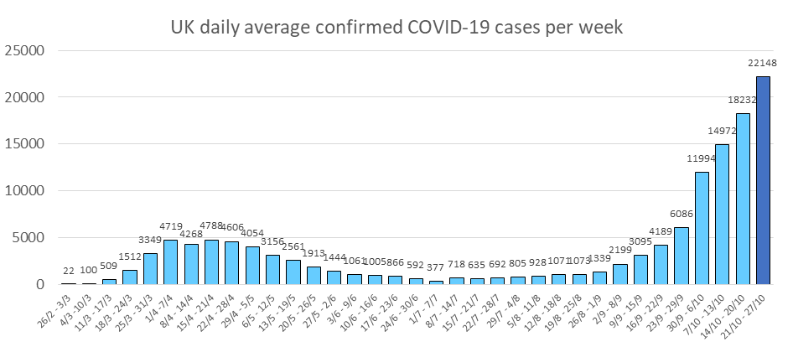

Regional and Local Epidemiology

As of the 2nd November 2020, 2,405 North East Lincolnshire residents have tested positive for COVID-19 based on pillar 1 tests and pillar 2 tests, an increase of 852 cases over the previous week. The cumulative rate of COVID-19 infection in North East Lincolnshire is therefore 1,388.2 per 100,000, the rate has more than trebled during the last four weeks (w/c 5th October the rate was 382.3 per 100,000 population). Figure 5 displays the cumulative rates of COVID-19 cases for all upper tier local authorities in the Yorkshire and the Humber, for the first time since the start of the pandemic, North East Lincolnshire no longer has the region’s lowest cumulative rate.

Figure 5: Laboratory confirmed COVID-19 cases (Pillar 1 & Pillar 2) by upper tier local authority in the Yorkshire and the Humber, total cases (up to 2nd November 2020)

Data Source: https://coronavirus-staging.data.gov.uk/cases

Recent COVID-19 Data for North East Lincolnshire

Figure 6 shows the 7-day rate per 100,000 population of new COVID-19 cases from 25th October to 31st October 2020 that have been confirmed for each upper tier local authority in the Yorkshire and Humber (blue bar), and the overall cumulative positive test rate per 100,000 population since the start of the pandemic to 31st October 2020 (red line), both rates including both pillar 1 and pillar 2 tests. With a 7-day infection rate of 377.3 cases per 100,000 population, North East Lincolnshire had the sixth lowest rate of new infections out of the 15 local authorities in the Yorkshire and the Humber region, but has the highest 7 -day rate of cases of the 4 Humber local authority areas. Doncaster, Rotherham and Barnsley have the highest rate of new infections in the region.

Figure 6: Laboratory confirmed daily cases of COVID-19 by sample date and local authority for prior week and cumulative total to date (Pillar 1 and Pillar 2)

Diana Princess of Wales Hospital

Numbers of positive COVID-19 cases being treated in Diana Princess of Wales Hospital (DPoW) increased substantially during October. As of 2nd November 2020, there are 48 positive inpatients in DPoW, 8 of which are in critical care. This is a large increase compared to previous weeks and the highest number at any point during the pandemic.

Care Homes

The North East Lincolnshire CCG care home tracker currently reports that 8 care homes have a total of 60 cases of COVID-19 among its residents with a range of 1 to 22 residents affected. This represents a big increase on last week when 19 cases were reported. This pattern is unfortunately being repeated in many parts of the country where infection rates have dramatically increased in recent week. Six care homes are currently closed to admissions and one is partially closed, all other homes are currently open to admissions.

Deaths

The average daily numbers of COVID-19 deaths in the UK peaked during 08/04-14/04 at 938 deaths per day on average, and thence decreased each week until the end of August. This week deaths from COVID-19 increased by almost half (47%) to 200 deaths per day on average, the sixth consecutive increase. The average daily deaths from COVID-19 this week are higher than at any point since the beginning of June. Despite this increase, the average daily number of COVID-19 related deaths remains 79% lower than at the peak, as shown in Figure 9.

Figure 9:
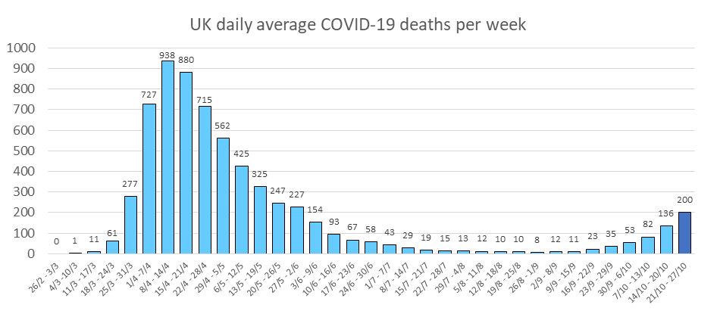
There have been 17 deaths associated with COVID-19 in North East Lincolnshire in October, 11 were registered in the last week. A total of 63 deaths have now been registered in North East Lincolnshire with COVID-19 identified as a cause of death, with 47 being North East Lincolnshire residents and 16 being residents of other local authorities. It is believed that a further three deaths of North East Lincolnshire residents have been registered elsewhere.

In North East Lincolnshire there have been no deaths registered in children. Five deaths were of people aged under 60 years, a third of deaths have been in people in their seventies and 54% have occurred in people aged over 80 years.

