Garth Lane Waterfront Improvement Scheme
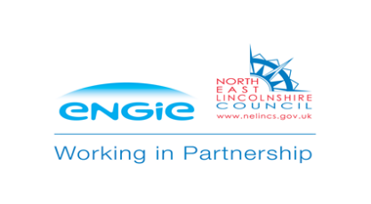

Public Engagement - Evaluation

- Scheme Description
‘Unlocking the Potential’ is a capital programme that will accelerate the development of three key sites in Grimsby Town Centre. This programme will make a significant contribution to the Council’s strategic objective of a ‘Stronger Economy’ by delivering key infrastructure and public realm works that will unlock and accelerate private sector investment in the town centre. The programme, part funded through Humber Local Growth Fund, Town Deal and the Council’s Capital Programme, will create an environment which will help secure business investment on the Garth Lane sites, redevelopment of St James House, further investment in the Cartergate site and Town Hall Square. The projects will support the creation of new businesses and new jobs in the town centre.

An important part of this programme is the improvement to the public realm and highway around Garth Lane, which aims to create an enhanced environment for members of the public to connect with the waterfront and improve the link between the town centre and key development sites to the north of Frederick Ward Way.
In June 2019, representatives from adjacent organisations including ABP, Grimsby Canoe Club and Onside (Youth Zone) as well as relevant Council and Engie personnel were consulted and the following interventions were agreed as the main priorities:
- Improved access to the water for recreation, maintenance and emergency services
- Protect and enhance the natural environment to encourage biodiversity
- Enhance the heritage setting
- Promote positive social behaviour and feeling safe within the area
- Enhancements through new planting and management of existing stock
- Improve the pedestrian experience linking the town centre to the waterfront
- Improve the appearance of the ABP pump station and compound
- Create a new 5m wide footbridge to create a statement linking the Riverhead to the Garth Lane site.

Following a number of meetings, an outline proposal was taken forward to public engagement.

- Public Engagement

The engagement process started on Monday 18th November and ended on Wednesday 4th February 2019. Two engagement events were held during the consultation period, plus an online engagement and questionnaire.
Engagement events were held in Heritage Centre on:
- Friday 29th of November 2019 (4.30pm to 7:00pm)
- Saturday 30th (10.00am to 1:00pm)

The engagement events were publicised through the following methods:
- A Press Release was issued by ENGIE and NELC
- Public Notice appeared in the Grimsby Evening Telegraph giving details of the consultation taking place and where the documents could be viewed.
- The event was publicised through social media.
- Email invitations were sent to Ward Councillors, Councillors, the Portfolio Holder and interested parties including neighbouring businesses, ABP, Neighbourhood Services and Humberside Police.
- Proposals were available to view on www.investnel.co.uk with a facility to complete an online questionnaire based on the physical consultation.
- Email notifications were sent to our consultation mailing list subscribers.

The events were well attended and all comments were captured, between 20-30 people visited the Fishing Heritage Centre events. Another 588 people viewed the engagement online and 330 people completed the survey.

- Public Engagement Response

The overall response to the public engagement on the Garth Lane Waterfront improvement was generally positive. People were asked a number of questions to ascertain how they would want the space to look and feel. The questions and responses are shown graphically below;

The Feature Bridge
The new feature bridge, which will be flat, will be extended to a larger width of five metres. Do you think the feature bridge should focus on...

Do you think the feature bridge should focus on...

The public art will reflect the chosen theme asked in the previous question.
Please rank (1-3) the types of artwork in order of preference:

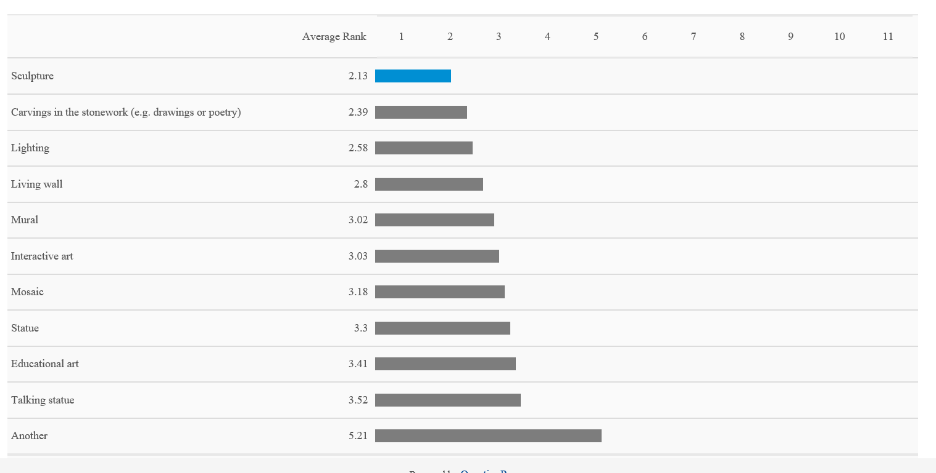

The priorities of the public space design will be influenced by what the public think.
What do you think the most important features of the scheme are:

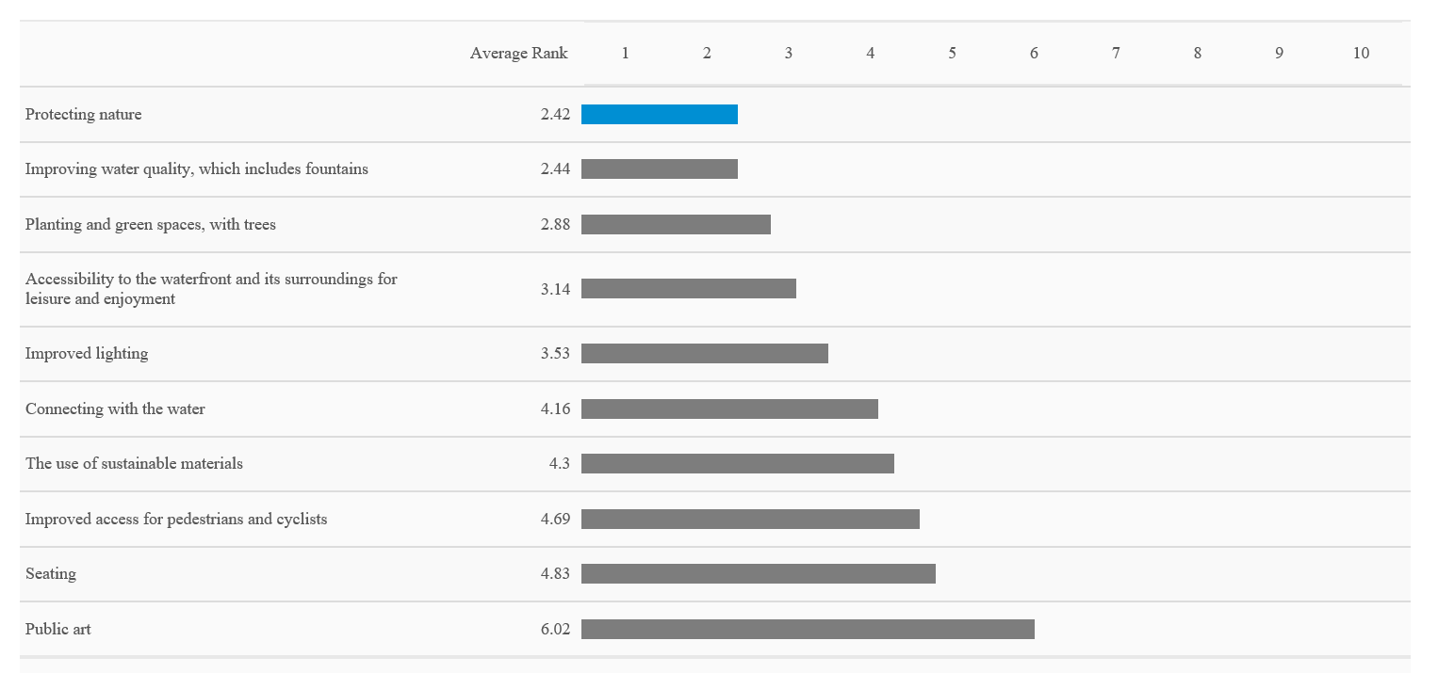

People were asked how they would like to see the space used and the responses can be seen below in a word cloud.

In response to the feedback and subject to available funds the following actions are under consideration;

- An area of riverbank is to be set aside for a habitat for wildlife.
- Additional aquatic planting to enhance biodiversity to create a margin along the east wall of the river basin.
- Dredging, leaving a margin of reed bed to allow kayaking and other water activities while maintaining areas of natural reed beds for birds and animals to nest and feed.
- Interpretation boards for wildlife and heritage.
- Lighting onto Alexandra Dock.
- A seating area adjacent to ABP pump station.
- Re-use of the felled willow tree as a habitat, sculpture or seating.
- Otter camera under the new footbridge.
- Inclusion into the Heritage Trail, including artwork inset to paving and online content.

Additional comments around safety and antisocial behaviour have been considered and incorporated into the scheme by improved levels of lighting and a 2m high boundary fence is to be included behind a 5m wide margin of low planting.
Other comments around maintenance of the completed scheme and the water have been considered during the design and selection of materials. A 3m wide slipway is included to allow easier access to the water for cleansing and ‘off the shelf’ materials have been used where possible to facilitate cost effective and timely turn around in the event of any maintenance requirements.

