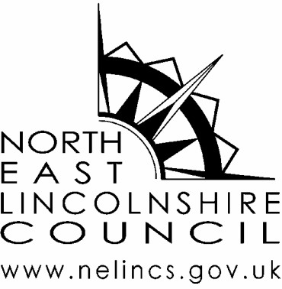

Preventing COVID-19 in Your Business

Social distancing and lockdown measures have been enormously effective in reducing the transmission of COVID-19 throughout the country. In North East Lincolnshire we have had amongst the lowest rates of confirmed cases of COVID-19 anywhere in England and our ambition is to keep it that way. If we can do this we will prevent any future lockdowns that could be imposed in our area following a spike in cases. This requires cooperation between public health authorities and many sectors of the economy who will be expected to play their part in keeping COVID-19 at bay. As event organisers you can assist this by ensuring you, your staff and your customers adhere to the three principles below:
- Social distancing- we strongly advise that wherever possible people should maintain a 2 metre social distance from other people outside their usual household. If this is not possible then 1 metre social distancing plus some other form of protection such as a face mask or screen is advised. NB. Ensuring that your staff maintain social distancing will also make it less likely that staff members have to self isolate due to being a ‘contact’ of someone who develops COVID-19.
- Hand Washing- regular hand washing for 20 seconds with soap and water will reduce transmission of the virus. Ensuring the easy availability of handwashing facilities along with public information proposing regular handwashing will help to prevent spread of the virus.
- Cleaning- ensuring work surfaces, including communal spaces are regularly cleaned will help to ensure that the virus does not linger. Typically this means doubling of the usual cleaning regime. In the event of someone displaying symptoms in the event area then much more rigorous cleaning will need to be undertaken to substantially reduce the risk of others becoming infected. Advice is available here: https://www.gov.uk/government/publications/covid-19-decontamination-in-non-healthcare-settings

