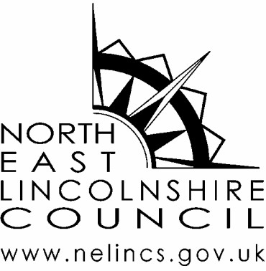

Internal reference: | NELC ESAGdrones
Review date: | February 2021
Version | V3

Guidance on use of drones in North East Lincolnshire

Contents

Aims of this guidance

Objectives

Guidelines
- What is a drone?
- Drone flying rules UK
- Drone regulations UK explained
- Drone registration UK
- New drone laws UK from Dec 2020

Drones and Wildlife

Frequently Asked Questions

Further Information

Aims of this Guidance
North East Lincolnshire Council's (NELC) guidance on local drone usage sets out the organisations stance on the use of drones generally, as well as for specific events as part of the advice given by the Event Safety Advisory Group (ESAG).

- To ensure that if the use of drones is agreed the operator complies with all current legislation
- That any use of drones is undertaken away from groups of people in line with current guidance to minimise the risk to the general public
- To clarify that the position of the Council is only to agree the use of drones on Council land where there is a clear case for the use of the drone and we will only allow qualified drone pilots to operate drones from council owned land (including Public highways, public rights of way & the coastline)
- If drones are to be used, that they will be used only after consultation with ESAG and will comply with all reasonable requests from ESAG member organisations, and drones will only be operated by a qualified and experienced operator, within the guidelines detailed below.

Important note: Any government and national policy and statute pertaining to the operation of drones that is published after the date of this document, but prior to its inclusion here, will take precedence

Objectives
- Establish local guidance on the use of drones in the area
- Offer guidance to operators to support use
- Enhance the health and safety of the public nearby drone usage
- Ensuring adherence to important drone safety rules designed to protect the public from harm

Guidelines
Post 31st Dec 2020 UK drone laws and regulations, so users can continue to enjoy drones safely and responsibly.

Drone meaning – What is a ‘drone’?
For our purpose we are talking about any aerial vehicle where person responsible for piloting the aircraft is not on-board, that is affordable, that is available to purchase commercially, and that weighs no more than 25kg.

Drone Flying Rules UK

What is the purpose of the flight? (No longer applicable from 31st Dec 2020)
Due to slight variations in the regulations for different flight purposes, it used to be important to first consider the type of drone flight that you intended to carry out. Generally speaking, your flights would tend to fall under one of the following categories:
- Recreational – where the flight is being conducted purely as an ‘enjoyment’ or sporting activity
- Commercial – where the flight is being conducted for business purposes in return for specific remuneration or other form of valuable consideration
- Private/Non-Commercial – flights that are either:
  - not considered to be recreational
or
  - flown for business purposes, but without any remuneration or other valuable consideration being involved

Drone Regulations UK Explained – How to fly a drone?
In simple terms, the regulations state that you must:
- always keep your drone in sight so you can see and avoid other objects – you may hear this referred to as VLOS (Visual Line Of Sight);
- fly below 400ft to reduce the likelihood of conflict with manned aircraft. If you are flying over hilly/undulating terrain, you should consider how the 400ft rule applies to your flight
- stay well away from airports and airfields – often referred to as the “Flight Restriction Zone” – see image below;

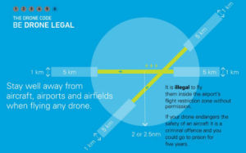

- follow the drone manufacturer’s instructions on every flight;
- only fly if you are satisfied that the flight can be made safely;
- not cause or permit any object to be dropped from the aircraft;
- remember that legal responsibility lies with you. Failure to fly responsibly could lead to criminal prosecution; and
- not fly the for the purposes of commercial operations, unless the relevant permission has been granted by the Civil Aviation Authority (No longer applicable from 31st Dec 2020)
It used to be the case that if your drone was fitted with some form of on-board camera, you needed to familiarise yourself with further regulations in addition to those listed above. In simple terms, the regulations stated that you must not:
- fly over or within 150 metres of any congested area;
- fly over or within 150 metres of an organised open-air assembly of more than 1000 people;
- fly within 50 metres of people and/or property that are not under the direct control of the drone user; and
- ensure any images you obtain using the drone do not break privacy laws.

The new regulations no longer contain different separation distances for drones without a camera. Separation distances are now dictated by the aircraft’s flying weight and pilots’ certification level. Of course, adherence to privacy laws must still be observed.

Drone Registration UK
- In 2018 the UK Government mandated a drone registration and education scheme, and has been a legal requirement under the Air Navigation Order from 30th November 2019
- Anyone operating a drone up to 25 kilograms in the UK must be registered to the scheme
- As part of the scheme, all drone operators are required to take an online foundation test
- Applicable to both recreational and commercial users
- Prerequisite of the A2 C of C and GVC qualifications
- Scheme developed and operated by the Civil Aviation Authority
- Users who fail to register or sit the competency tests could face fines of up to £1,000

New Drone Laws UK (in force from 31st Dec 2020)
The new legislation originates from Europe and was originally expected to come into force on July 1st but was delayed until 31st December 2020 as a result of the global COVID-19 pandemic.
The aim of the new drone laws is to standardise the process for drone operations across Europe and avoid differing rules across countries.

The new regulations are intended to remove limitations and ambiguity around commercial and non-commercial drone operations and instead follow guidelines based on:
- the weight of drone being used
- The type of operation being carried out
- The level of risk
- The level of pilot competence

The table below shows the type of operation that you’re now able to conduct under the new ‘Open Category’ based on the Maximum Take-Off Mass (MTOM) of your drone(s) and the formal qualification(s) (if any) you’ll need.

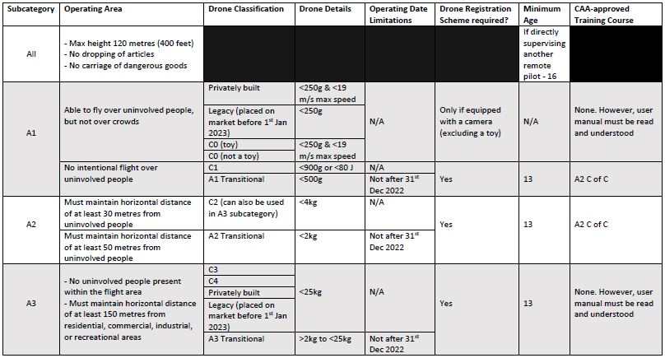A breakdown of the new ‘Open Category’

Any drone operation that does not meet the criteria detailed in the above table will be classified as being in the ‘Specific Category’ and will require an Operational Authorisation from the CAA.

Drones and Wildlife
The Potential Impact of Drones on Sensitive Habitats and Species

Specific and unique to the area, drone pilots need to take account of the highly sensitive habitats and protected species that occur around the Humber Estuary. Much of the estuary, the mudflats, saltmarshes, reed beds and sand-dunes are protected by international legislation, which applies equally to drone users. The most important issues relate to the potential disturbance of internationally important bird and seal populations.

There are four key considerations
- The potential to disturb legally protected breeding birds, primarily from May to September. Scaring birds from their nests can lead to birds abandoning their eggs or young and can lead to increased predation of nests. Legally protected species that are most at risk include
- Little Terns
- Avocets
- Bitterns
- Marsh Harriers
- Peregrine Falcons

It is a criminal offence to intentionally or recklessly disturb these specifies on or near their nest sites. If found guilty you could be subject to an unlimited fine or up to 6 months in prison.

- The disturbance of feeding or roosting migratory birds in autumn and winter can also have a deleterious effect. Up to 120,000 water birds (waders, ducks and geese) visit and live on the estuary in winter. Forcing birds to fly from roost sites where they are resting, or disrupting the normal feeding patterns of birds, both affect the bird’s ability to build up excess fat to fuel their next vital long migration flight. It may affect the birds’ ability to obtain sufficient fitness to breed in the following season. In particularly cold or wet winter weather, excessive disturbance can lead to exhaustion and death.

- Disturbance of seals during their breeding season from October to December can lead to panic and accidental death of pups, crushed by fleeing adults.

- Many people come to the Humber to enjoy its wildlife and tranquillity. Drone use can prevent other estuary users from achieving their enjoyment.

Further recommendations to help drone users protect wildlife;

Avoid flying near important bird breeding locations between May and September.
These include:
- Spurn, Kilnsea Wetlands and Beacon Ponds
- North Cave Wetlands
- Blacktoft Sands
- Alkborough
- Far Ings
- Tetney
- Donna Nook
- Saltfleetby-Theddlethorpe Dunes
(This is not an exhaustive list)

- Avoid flying your drone towards flocks of roosting or feeding birds between September and March. There are many important locations around the estuary at these times of year.
- Avoid flying near the breeding seal populations around Donna Nook between October and January. In any event, Donna Nook is an active RAF training ground so drone flying here at any time risks interference with flying aircraft and breaking the law.

- If you are planning a commercial flight, in the vicinity of land designated as a Special Protection Area, Special Area of Conservation or Ramsar Site, you will require, (in addition to the landowners permission), a consent to operate at that location, at that time, from Natural England.

- If in doubt, contact Natural England or Humber Nature Partnership for advice

Frequently Asked Questions

Q: How old do you have to be to fly a drone?
A: There is currently no age restrictions to fly small drones (<250g) in the A1 subcategory of the new “Open Category”. However, the CAA does have a minimum age requirement of 13 years to fly in subcategories A2 and A3 of the Open Category and 14 years to fly in the Specific Category.

Q: Is it legal to fly a drone over private property in the UK?
A: According to UK laws regulated by the Civil Aviation Authority, consumer drones (classed as those that weigh under 25kg) must be flown no higher than 400 feet (120 metres). Whilst new laws now allow sub 25kg drones to be flown close to isolated property, the pilot should always observe privacy laws and seek the permission of the land or property owner before flying. Pilots must also remember that there are formal certification requirements to permit flight of any +250g drone within a built-up area.

Further Information
- https://rawview.co.uk/blog/drone-laws-uk-drone-laws-and-regulations-in-2019/

webpage updated January 4th 2021
- Dronesafe UK
- Crowd Management Academy - information on the use of drones at events
- Civil Aviation Authority – Information for the public about drones
- Civil Aviation Authority – Drone and model aircraft registration

