Date  Version No. | March 2021  V2.0 | 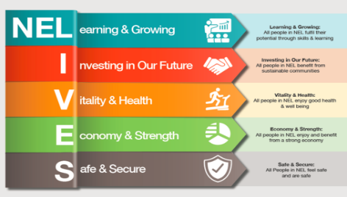 | 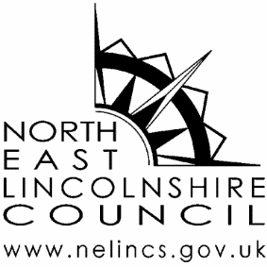

North East Lincolnshire Local Authority Terms of Reference for
Joint AIM Information Exchange Pathway Panel Meeting for cases where there is Problematic and Harmful Sexualised Behaviour in children and young people aged 5-18 years

Membership:

- Specialist Locality Lead - Chair
- Advanced practitioner social work, CASS children’s safeguarding service – Co-chair
- Business support - NELC
- Youth Offending Service – NELC
- Supervisor - Prevention and early help NELC
- Clinical Psychologist - Young minds matter
- Police officer - Vulnerable Persons Unit
- Specialist Safeguarding children’s nurse - Health
- Representation - Alternative education
- Group manager - Access and inclusion, education services NELC
- Service manager – SEN NELC

Meeting Arrangements:

- The AIM Information Exchange panel meeting will be chaired by the NELC specialist locality lead and co-chaired by the advanced practitioner within CASS.
- All members are expected to attend and provide a deputy in absence (only to use the deputy in emergencies). Membership of the panel assumes a commitment to fully participate in information sharing, decisions and actions to support good outcomes for children and young people.
- Meeting frequency is on the first Monday afternoon 1-5pm each month. The venue is predominantly at Riverside Family Hub, Sorrell Road, Grimsby however this is based on availability and all panel members will be notified through their invites.

Key Areas of Responsibility:
Problematic of harmful sexualised behaviour (aged 5-18 years)
- The NELC is the conduit for all HSB referrals. The NELC will take the referral information and book a time slot on panel for discussion.
- All referrals for discussion at panel will be sent to panel members by the NELC business support, seven working days prior to the panel. There is an expectation that all panel members will research new referral details and share information on previous contacts and involvement.
- There is an expectation that each referrer into the AIM panel will attend to present the case.
- Panel will make a decision on the agreed intervention route and the risk rag-rating based upon information known at that time.
- Business support for the panel will be undertaken by NELC who will minute key actions and distribute to all participants within 7 working days.
- On Liquid Logic the decision will be recorded on the child’s file as a management decision/discussion case note with a heading of: HSB AIM. The formal minutes of the meeting will be recorded in the documents section of Liquidlogic and categorised as: P25 YYYY/MM/DD LEGAL MEETINGS (HSB AIM).
- Membership from the key agencies above will have a named representative that attends the panel on a regular basis.
- All agencies will take responsibility in sending a deputy to panel in their absence.

- Individual panel members representing their agency will take agreed actions from the panel and send in updates within the timescales agreed at the time of panel.
- Children’s social care will co-chair the panel

Key Aims:

- To provide an integrated operational framework for managing the outcomes for children and young people who display harmful sexualised behaviour.
- To manage risk collectively as a multi-agency duty/ responsibility
- To prevent prosecution of Young people displaying HSB where the behaviours can be managed safely within the community on a voluntary basis.
- To protect the public from harm
- To have a single point of access to manage all referrals in NEL where problematic and harmful sexualised behaviours are identified.
- To manage these consistently using the traffic light tool to identify the level of assessment and intervention required
- To provide a continuum of responses to children and young people ranging from early community based assessment and intervention with low risk cases to intensive work with the highest risk.
- To review escalation or de-escalation of risk for all cases and ensure that appropriate strategies are in place to manage this.
- To gather key data on the scale and type of problematic and harmful sexualised behaviour that children and young people in North East Lincolnshire exhibit.
- To use up-to-date and relevant research to inform best practice and including exposure to online abuse
- To continually develop practitioners and supervisors in this subject area
- To test a model of inter-agency collaboration that supports best practice in the area of managing harmful sexualised behaviour.

Key Outcomes:

- To reduce the impact and prevalence of harmful sexualised behaviours through timely assessment and interventions including a Treatment Programme for high risk behaviours.
- To manage risk at the lowest threshold with the right intervention at the right time.
- To reduce risk classification of young people displaying HSB.
- To decrease recidivism
- To understand the pathways that lead to harmful sexualised behaviours to enable preventative measure to be developed.
- To seek to prevent custodial sentence and criminalising children.
- To use the data and evaluation outcomes to support further development of the services being offered

Governance and Accountability:

- The chair of the Aim Information Exchange panel meeting will attend and report to the LSCB ‘Keeping Children Safe’ sub group each quarter to report on the outcome based accountability performance score card.
- The score card data and narrative will be presented to the Operational and Leadership Board of the LSCB to ensure that safeguarding processes are robust and effective.
- Each red and amber intervention is reviewed every 12 weeks or sooner if required, to monitor impact and outcomes.
- A safeguarding Team manager from the Local Authority sits on panel to address any newly identified outstanding child protection or wider safeguarding concerns.
- Clear referral pathways are established for this service with Practice Guidance and Procedures in place to underpin all of this work.

