Date  Version No. | September 2020  V2.0 | 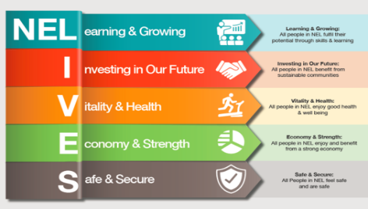
MACE
Terms of Reference
Aims and Objectives

- This strategic group will undertake six weekly multi-agency discussions on young people identified as being at significant risk or complexity in respect of any of the three vulnerabilities: Child Sexual Exploitation (CSE), Child Criminal Exploitation (CCE) and Missing.
- The MACE group will review the plans in place for those children currently identified as in the ‘top 10’ children that agencies are most concerned about in relation to concerns around exploitation. These children will have been identified via OVM
- Agree by consensus multi-agency actions to address and reduce the identified risk and deploy additional resources in respect of young people at significant or complex risk of one or any of the vulnerabilities.
- Escalate issues that raise significant cause for concern to the Safeguarding Childrens Partnership. (NB Agencies to follow own internal escalation to avoid delay for immediate decision making).
- Identify system-wide themes and issues in respect of the vulnerabilities that will contribute to multi-agency awareness, effectiveness of partnership and response and response which informs strategic planning and workforce development and problem profile.
- Provide a quarterly report to the Safeguarding Children’s Partnership to provide a clear and comprehensive account of the prevalence of vulnerabilities across the partnership and how agencies are working together to provide a timely, robust service for children, young people and their families.

Membership

- Members are expected to attend all meetings or provide a deputy in their absence.
- Membership assumes your commitment to participate and support the successful achievement of this group’s objective.

The formal membership of the group will comprise the following roles as a minimum:

Role | Organisation/Service | Named Officer
Chair  Head of Safeguarding | NELC/Children’s Social Care | Dawn Alaszewski
Chair  DCI | Humberside Police | Doug Blackwood  Kate Chalmers
Interim Head of Early Help and Prevention | NELC/ Childrens Social Care | Matt Clayton
Lead for Exploitation | NELC/Children’s Social Care | Emily Scott
Service Manager | NELC/ Childrens social care | Kerrie Scraton
GRAFT Team Manager | GRAFT | Emma Young
Detective Sergeant Intel | Humberside Police | Neil Mcrae
 | NELC/Children’s Public Health | Sharon Humberstone
CCE Police Sergeant | Humberside Police | Simon Appleby
CSE Police detective Sergeant | Humberside Police | John Shepherd
Missing Police team Detective Sergeant | Humberside Police | Amanda Walker
Missing Police Co-ordinator | Humberside Police | Aimee Scott
Service Manager | Addaction | Beth Mottram
Housing | YMCA | Sam England
Housing | YMCA | Debbie Cook
 | Minute Taker | Alice Tilling

Meeting Frequency

MACE will be held every 6 weeks on a Friday morning.

Reporting and Action Tracking

- Cases to be heard at MACE will be escalated from the Operational Vulnerabilities Meeting (OVM). The exploitation tool and child exploitation vulnerability tracker should be submitted to the Panel Administrator 3 days in advance of the meting for papers to be circulated.

- Minutes for the meeting will be recorded and distributed to all MACE members and the relevant parts to the keyworkers of the cases discussed.

- All case information and decisions made at the meeting will be recorded by the individual agencies represented on their respective systems on the child’s file. On Liquid Logic the decision will be recorded on the child’s file as a management decision/discussion case note with a heading of: MACE. The formal minutes of the meeting will be recorded in the documents section of Liquidlogic and categorised as: P25 YYYY/MM/DD LEGAL MEETINGS (MACE).

- Any key worker (from any agency) that is not present at the meeting for a child or family will be notified directly of any actions recommended.

- An action log will be maintained, and actions will be reviewed at the subsequent MACE

- A tracker will also be maintained to ensure themes are being appropriately captured within MACE meetings, such as age groups and risk factors, to understand whether a more strategic response is required

- Group members will update the actions and bring updates to the next meeting.

