Date  Version No. | March 2021  V2.0 | 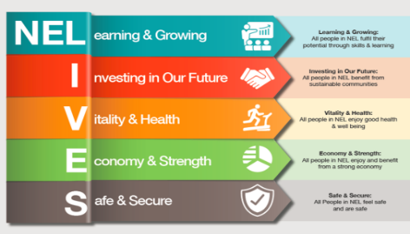

NELC Childrens Resources Panel
Terms of Reference
Principles
- Provide the right level of care and support where all children feel and are safe and have the opportunity to reach their full potential
- Capture the voice of the child and family, and ensure they have consistency of service and are involved in all the decisions that will affect them
- Ensure the workforce is well resourced, trained and supported to follow identified processes, in order to build positive relationships with families for sustainable change and decision making is informed by good evidence and data
- Work together alongside our statutory, voluntary and community sector partners to achieve success for our families.
- All Education, Health and Care Plan requests for assessment and awarding of plans for children and young people should be proportionate and focused on developing a child’s strengths and meeting and reducing their needs. Agreed resources will be ratified and discussed at EHCP assessment and Complex Case Panels
Objectives
- The panel will consider the eligibility criteria and any information that they currently hold within their service area on an individual in order to focus on the needs of Children and Young People and that their health, education, and social needs are being addressed at the most appropriate level.
- The Panel will ensure that actions are being taken to ensure that where possible, the needs of children and young people are met through universal services available for children and young people with Children with Disabilities, and the most appropriate way of discharging their duties e.g. Direct Payments, the use of Cromwell House and or St. Andrews Hospice
- The panel will be responsible for making recommendations about what further assessment may need to take place, or the resource and services that can support children and young people with their identified needs.
- The panel does not make casework decisions and does not perform a supervisory function although both excellent and poor practice will be brought to the attention of the relevant Head of Service.
Criteria for Presenting to Panel
- All requests for Education, Health and Care Plans will need to be presented to this panel to consider the social care element of the plan before going to the SEND assessment and complex case panel
- All requests for services and support as per the child/young persons assessment.

Membership and Meeting Details
Chair: Service Manager/Head of Service: Children Social Care

Panel Members: Team Manager – Children with Disabilities / Children in Care
Early Help Manager/Deputy Manager
Representative from St Andrews Hospice
Homes Manager (Cromwell House / Cambridge Bungalow)
Fostering representative (with CWD experience)
Parents/Carer
IRO/CP representative (with CWD experience)
Voluntary Sector, e.g., Gravity Red; Flag; Sendisas; Cloverfield
Panel Administrator
Designated Social Care Officer (when in post)
Any observers/New Starters (confirmed by chair)

Venue: Remotely via Microsoft Teams

Frequency: Fortnightly for 1.5 hours

When: The panel is held on a Tuesday morning 9 – 10.30 and slots are allocated each week with the agenda setting.

Process: All paperwork to be presented must be sent to the Administrator on the Wednesday at 3pm before Tuesday panel every week so it can be sent electronically to panel members.

Who comes to panel?
- The Social Worker who has been allocated the case will provide an overview of the request to present to panel.
Paperwork required
- EHCP if one in place
- “All about me”
- Social Work Assessment and Draft support plan
- Chronology

What to do before panel
- Before cases are presented to panel there is a clear expectation that the assessment has been agreed by their line manager and the support plan is detailed.
- Evidence of this work will be required for the panel to reach a decision.

Decision Making
Where possible, decisions to proceed with a support plan will be achieved via consensus of the panel. If a consensus cannot be reached, the decision of the Chair should be deemed as final.
The decision will be recorded on the child’s file case within Liquid Logic/staff reminded to make their own notes

