Date  Version No. | March 2021  V2.0 | 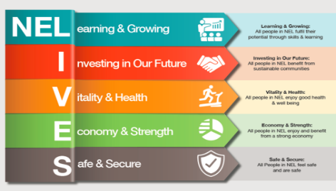

NELC SEND Assessment Panel

Principles
High quality teaching, differentiated for individual pupils, is the first step in responding to pupils who have or may have SEN. Additional intervention and support cannot compensate for a lack of good quality teaching. SEND Code of Practice (2015)

All Education, Health and Care Plan requests for assessment and awarding of plans for children and young people should be proportionate and focused on developing a child’s strengths and meeting and reducing their needs.

Objectives
- The panel will agree whether to proceed to a full assessment for an Education health and Care Plan within the six-week timescale identified within the SEND Code of Practice (2015).
- The panel will agree whether the evidence provided on completion of multi-agency assessments, require a child to be awarded an Education health and Care Plan within the statutory 20 week timescale as set out in the SEND Code of Practice (2015).
- In doing so the panel will consider any information that they currently hold within their service area on an individual in order to focus on the needs of Children and Young People and that their Health, Education, and social needs are being addressed at the most appropriate level.
- The Panel will ensure that actions are being taken to ensure that where possible, the needs of children and young people are met through universal services available for children and young people with SEND first, before considering the requirement of an Education, Health and Care Plan.
- The panel will be responsible for making recommendations about what further assessment may need to take place, or the resource and services that can support children and young people with their identified needs.
- The panel will consider requests made be parents, carers, young people over 16 or professionals working within education, health or social care fields.
- The panel does not make casework decisions and does not perform a supervisory function although both excellent and poor practice will be brought to the attention of the relevant Head of Service.

Criteria for Presenting to Panel
- All requests for Education, Health and Care Plans will need to be presented to this panel.
- Requests are made through the Education Health and Care Plan Hub by parents, carers and professionals. Requests can also be made by parents and carers via a letter, or e-mail to the SEND team.
- All requests should be presented to the panel as soon as is practicable after the request has been received. This will ensure a swift response from all agencies.
Membership and Meeting Details
Who are the panel?
The panel consists of:
- SEN services manager – Chair
- Panel Administrator
- EHCP Co-ordinator(s)
- Team Manager or Assistant Team Manager Children’s Disability Service
- Designated Clinical Officer
- SEND Statutory Process Manager
- Compass Go
- Access Pathway Co-Ordinator
- Educational Psychology
- Specialist Advisory Service
- Some partners will be virtual- Adult services where a request is for a post 18 learner and Early Years where a request is for a 0-5 learner.
- Any observers/ New starters (please book for observations through the chair) and all are welcome

The panel is held on a Monday between 1-5pm and slots are allocated each week with agenda setting.
All paperwork to be presented must be sent to the Administrator on the Wed at 3pm before Monday panel every week so it can be sent electronically to panel members.

Who comes to panel?
The EHCP Co-Ordinator who has been allocated the case will provide an overview of the request to present to panel.

Paperwork requested
- EHCP request for assessment (electronic through the EHCP Hub)
- Valuing SEND tool – where a professional is making a request

What to do before panel?
Before cases are presented to panel there is a clear expectation that the panel members have gathered any intelligence held by the team/wider service. This would include whether the child or young person is already known to their service and what the current or previous involvements are/were.
Evidence of this work will be required for the panel to reach a decision.

Decision Making
Where possible, decisions to proceed with a full assessment, or award a plan will be achieved via consensus of the panel. If a consensus cannot be reached, the decision of the Chair should be deemed as final.
The decision will be recorded on the child’s file case within the Education health and care plan hub.
Staff are reminded to make their own notes on actions and recommendations on next steps.

requests to chair in advance of the meeting

