# **The North East Lincolnshire Strategic Plan For Wellbeing**

Final draft

# Foreword

[To be completed for the final version]

# Introduction

‘Wellbeing is about people and creating the conditions for us all to thrive. Its quality of life and prosperity, positive physical and mental health, sustainable thriving communities. Wellbeing is a measure of social progress and, arguably, the goal of good government and charitable activity.’

Wellbeing is not just focusing on health and social care but includes all the aspects of life that impact on people’s sense of themselves and their families as well as their sense and experience of the place where they live.

Our approach to “Stronger Economy, Stronger Communities” has been captured within an Outcomes framework that originated in the Council but has increasingly been adopted as the outcomes for Place.

The Outcomes Framework illustrates the way in which the importance and emphasis of each of the outcomes can vary at each stage in life, with certain systems, organisations and services having a more prominent role in contributing to the issues at different stages. It also illustrates the interdependency between the life stages and how intergenerational inequalities persist requiring ownership by all partner organisations to achieving all the outcomes not just the ones more relevant to their services.

This Wellbeing strategic framework also serves to show the complexity of how all the systems, organisations and partnerships, contribute to shaping North East Lincolnshire and people’s lives. Elements of the outcome framework shape the economy, the environment and the culture in which people strive to improve their own and their families’ wellbeing. This collectively is reflected in **place shaping**- creating the **opportunities** for people to thrive through jobs, education, and leisure, and enabling **people to be safe from harm** particularly those most vulnerable from harm at home or at work and creating infrastructure that keeps people **connected** and able to access opportunities and services. Provides a sustainable supply of varying types of **accommodation** to meet population needs, stewardship of our **natural environment** and builds an economy that tackles the impact of climate change, technological advancement and changing workforce need.

**Skills**, capability and the **confidence** that accompanies a sense of **being in control** of one’s circumstances, have a different focus throughout the life course. This can be reflected through a sense of vulnerability or being resilient in adverse situations. Skills as a parent, skills applied within the education system, job related skills, feeling confident managing a long term condition, confidence as a carer, feeling valued when volunteering. Being able to take advantage of opportunities such as those in the employment field or education system as well as being able to cope with more adverse circumstances are key to people’s wellbeing.

The services that our organisations provide also play a key role in supporting people through life as well as providing a safety net for the most vulnerable. Whilst many of the services have historically been developed as universal provision, increasingly we have to look more closely at providing **services proportionate to need** (equitably) retaining a level of **quality**, whilst supporting and encouraging people wherever appropriate to do more for themselves. This applies whether services are preventing through early help, supporting people in crisis or helping people to get on with their lives. This is also reflected in the approach adopted by the services own workforce and the way they relate to their clients. This shift is key to the future of sustainable service provision.

An essential component of our overall approach is people having access to trusted **information** enabling them to take action, take advantage of opportunities and pursue self-directed solutions. As with the other examples above information needs vary across the life course and the ability to navigate ones way through this information rich era, is a fundamental basis for empowerment.

Common to all organisations and systems that operate to address the needs and ambitions of people in North East Lincolnshire, are a number of **common functions** that underpin and support the approaches adopted.

* **Intelligence** – not merely data or the sharing of data but appraisal and insight into need and evidence of what works including input from local people in particular the intended recipients of the interventions
* **Workforce and organisational development** – skills and ethos within all providers of service including voluntary sector organisations that enables delivery of services and interventions reflecting a shared set of values and principles
* **Community capacity building and engagement** – skills, confidence, structures for involvement within communities and with the decision making planning processes. How we collectively support and enable people to take action on the issues that matter to them
* **Policy, protocols and procedures** – developing the environment and culture that shapes Place and promotes quality and protects the vulnerable from harm
* **Governance and partnership** – system management, quality assurance and accountability to all stakeholders including local people and advocacy for under represented
* **Information Advice and Guidance** - A key principle there should be ‘No Wrong Front Door’ (i.e. wherever people seek support, they access it, or are promptly redirected to where they can access it).

(See appendices for more information on these common functions).

This strategic framework shows the contribution of the systems underpinning the Outcomes Framework, their key strategies and their current priorities. However there are issues facing North East Lincolnshire that require a whole Place system approach with all organisations contributing to add value and ensure impact. These issues will be few in number and identified in the coming months.

A Place based approach is not just about what we do but the way in which we work and collaborate as part of our core business. This strategic document sets out a number of values and principles that shape our relationships with people and with the Place.

# A shared Vision for the people of North East Lincolnshire

Our vision for a stronger economy and stronger communities is described through the outcomes framework underpinned by a set of values and principles shaping the culture and way it which we go about things. Predominantly this is about the people of North East Lincolnshire

# The values that underpin our approach

We can identify a set of values and principles that are aspirational and recognise that there is still much to do

* We try to be Inclusive wanting to ensure everyone can be involved. We try to focus on people of all ages, listening to “what matters to you, who matters to you”. In all that we do we endeavour to treat all people humanely, with kindness, compassion and dignity.
* Whether as individuals or as organisations, we will be open, honest and transparent in our work, and expect to be held accountable by the people we serve, whether citizens, clients or customers.
* We will work collaboratively with other organisations in pursuing the outcomes for the people of North East Lincolnshire and where ever possible working with local people in identifying the problems they face and in the design of any solutions.
* We seek to support all people in the borough to realise their ambition in life and recognise that some people have less resources and opportunities to live a life they value.

# The principles shaping our system wide approach

1. **Outcomes focused**

Many organisations are evaluated on the services they provide and their quality whilst over the last few years, greater emphasis has been put on how to measure the impact made on people, the outcomes that demonstrate an intervention’s success. . Each of the five outcomes could be pursued independently and demonstrate success but the ethos behind inclusive growth and an inclusive economy illustrated in this wellbeing framework, show the interdependency between each of the outcomes in striving for a stronger economy and stronger communities.

An outcomes focus equally applies to how we consider success at the individual personal level and how we commission and deliver services that impact on people’s wellbeing throughout life. We will be working to develop our approach to outcomes based commissioning in securing the right balance of efforts and resources to support people achieve improvement to their health and wellbeing.

“If you believe that you are bad and unacceptable, you are unable to look back at your past with pleasure or your future with hope. Only bad things happened to you in the past, and only bad things will happen to you in the future.”

1. **Inequalities and inequity focused**

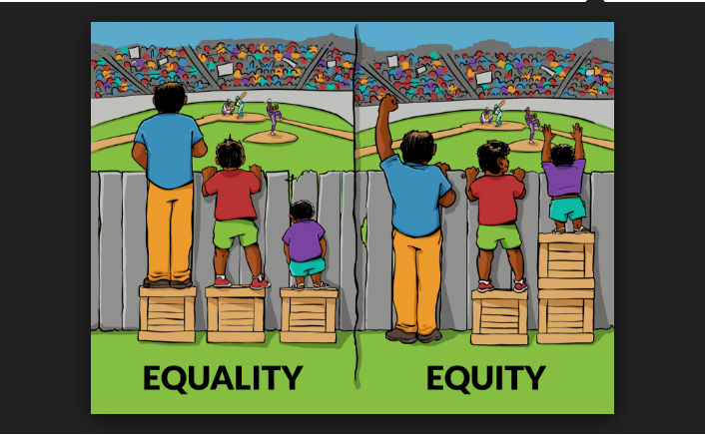

This recognises that not all people start from the same point and do not get access to the same opportunities. Resources and effort need to be directed to those with the greatest need and organisations also need to constantly keep under review how accessible their services are to all communities

1. **Vulnerability/resilience focus**

Vulnerability is where an individual or group is less able to anticipate, cope with, resist and recover from the impact of a natural or man-made hazard. Vulnerability is most often associated with poverty, but it can also arise when people are isolated, insecure and defenceless in the face of risk, shock or stress. People differ in their exposure to risk as a result of their social group, gender, ethnic or other identity, age and other factors. The impact can be accumulative.

The reverse side of the coin is capacity and resilience, which can be described as the resources available to individuals, households and communities to cope with a threat or to resist the impact of a threat and the ability to “bounce back”. Such resources can be physical or material, but they can also be found in the way a community is organised or in the skills or attributes of individuals and/or organisations in the community.

1. **Valuing relationships –**

Working ‘with’ people, rather than doing ‘to’ or ‘for’ others. When we work with and alongside people, rather than make decisions about them in isolation, outcomes and impact are so much greater. It proactively builds connection, belonging and a sense of community.

Many agencies are revisiting their own ethos towards their service users, customers etc, reframing the everyday interactions with a “What matters to me, Who matters to me” perspective endeavouring to put the person centre stage.

1. **Co-designed, produced and delivered**

We are already starting to work differently and recognise that simply putting services in place does not mean that people use or value them. Our approach to inclusive growth means that we take a starting point that has the community as part of the solution, able and willing to use their knowledge and skills to bring about positive change to their lives and that of the wider community.

1. **Prevention and early help**

Prevention and early help is defined as responding as soon as possible to the needs of people and families who are ‘vulnerable’ to poor life outcomes. It aims to put services in place and offer support before things get worse, to help people move on from their difficulties and get back on course. Prevention and early help therefore aims to promote better long term life outcomes for people and families and in doing so, also prevent them needing more intensive and higher cost provision in the future. This links closely with resilience and avoiding a culture of blame, taking account of the underlying determinants of wellbeing.

1. **A commitment to quality of place, quality of services**

The quality and accessibility of public services provided to the citizens of North East Lincolnshire is enshrined in the constitution driving the NHS, and a key focus of all organisations providing public service including the community and voluntary sector. The commitment to fundamental and safe levels of quality within the services remains core alongside maintaining dignity and humanity in the way in which people are treated by those services that in turn shape the reputation of public service in the borough.

The quality of the environment in which people live work and play also has a profound impact on people’s wellbeing and reflects a shared responsibility of agencies and citizens alike. Whether this refers to the air we breathe, our access to green space, our working environment, our own home and neighbourhood or access to cultural and leisure opportunities in the borough. This shapes our perception, our civic pride and how we feel about ourselves. This principle recognises there may be environmental impact in many of the decisions each of us makes

1. **Sustainability**

This term is widely applied to a range of issues. Primarily it asks us to consider our legacy to future generations, and whether our actions now will have an adverse impact on the future. This represents a commitment to always have consideration to climate change and all its causes, including transport choices, consumer patterns and recycling, energy production and use.

The term is also used in relation to services available to citizens in the borough. As financial resources diminish, new models of delivery evolve to ensure outcomes continue to be delivered. Changes in technology, demography and consumer patterns require flexibility and adaptation that may not result in organisations being sustained but wider systems operating to ensure continuity of service. In many circumstances an enabling role, giving more control to local people may lead to a more sustainable outcome.

Sustainability also applies to the communities within the borough and ensuring we collectively support the building of capacity and capability within communities to take action and deliver solutions.

1. **Social Value -**

Social Value is about more than driving a hard bargain when commissioning services – itis a statement of principles. These principles underpin the Council’svision and priorities. From committing to paying as a minimum the Discretionary Living Wage, to partnershipworking that enables the Council, and its partners, to create opportunities that enhance our communities and improve the lives of our residents.

Social value requires commissioners to think about how they achieve outcomes in a more integrated way. Rather than thinking about services in isolation or in the short term, this approach requires commissioners to consider long term costs, sustainability and how the inclusion of Social Value outcomes can potentially reduce pressures and realise opportunities in other areas.

# Contributing relationships to a Place based approach to wellbeing

To achieve both stronger economy and stronger communities there need to be a connection between the two to ensure benefit and impact on all citizens in NEL.

Most recently, the concept of inclusive growth has emerged in response to widening inequalities and the disconnect between the “grow now, distribute later” trickle down model and its benefit to society and impact on the most vulnerable.

Much of the recent commission’s report[1] resonates with our Place based approach and is reflected in the focus of this proposed approach, emphasising a focus on prevention early help and building capability within communities.

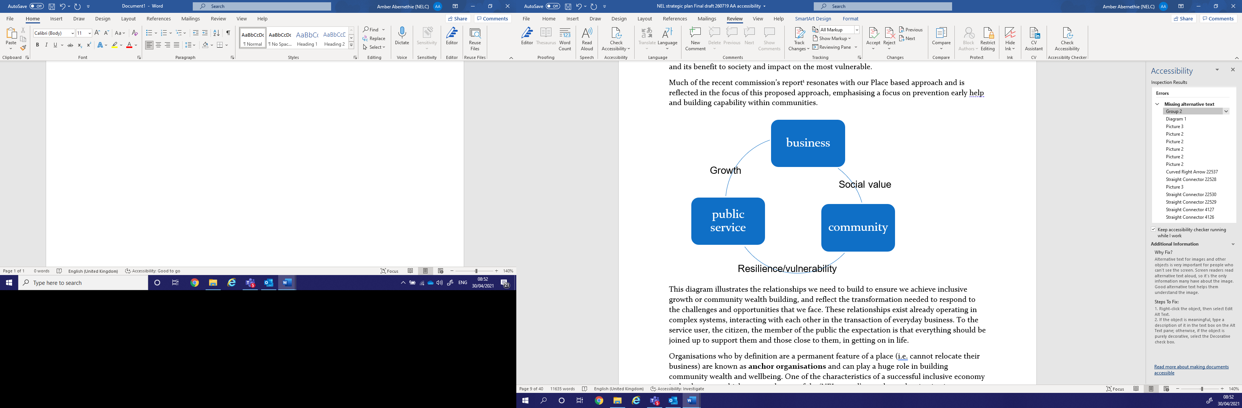

This diagram illustrates the relationships we need to build to ensure we achieve inclusive growth or community wealth building, and reflect the transformation needed to respond to the challenges and opportunities that we face. These relationships exist already operating in complex systems, interacting with each other in the transaction of everyday business. To the service user, the citizen, the member of the public the expectation is that everything should be joined up to support them and those close to them, in getting on in life.

Organisations who by definition are a permanent feature of a place (i.e. cannot relocate their business) are known as **anchor organisations** and can play a huge role in building community wealth and wellbeing. One of the characteristics of a successful inclusive economy is the degree to which more and more of the ‘NEL pound’ spent by anchor institutions goes directly into our local economy and growing the social economy.

This set of relationships has shaped the evolving approach to partnership in the Borough. It recognises historic imbalance between the three domains and aspires through adoption of the values and principles within this framework to change how we operate in North East Lincolnshire.

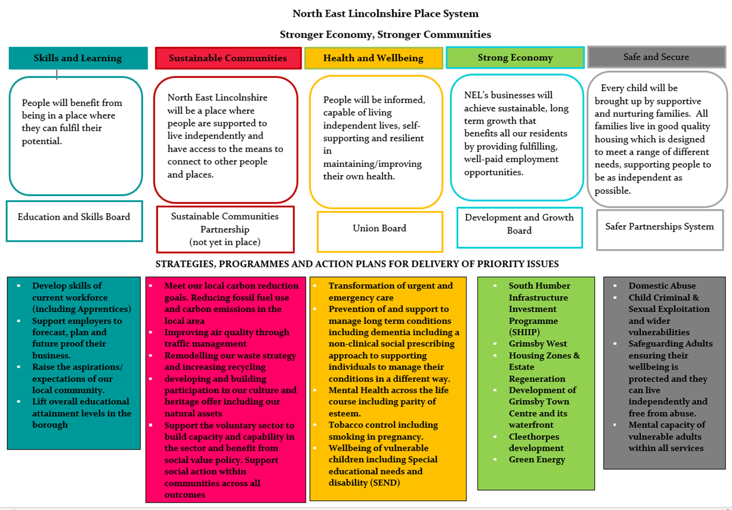

* Domestic Abuse
* Child Criminal & Sexual Exploitation and wider vulnerabilities
* Safeguarding Adults ensuring their wellbeing is protected and they can live independently and free from abuse
* Mental capacity of vulnerable adults within all services
* Domestic Abuse
* Child Criminal & Sexual Exploitation and wider vulnerabilities
* Safeguarding Adults ensuring their wellbeing is protected and they can live independently and free from abuse
* Mental capacity of vulnerable adults within all services
* Domestic Abuse
* Child Criminal & Sexual Exploitation and wider vulnerabilities
* Safeguarding Adults ensuring their wellbeing is protected and they can live independently and free from abuse
* Mental capacity of vulnerable adults within all services

**The outcomes framework**

This focus on outcomes to deliver our shared focus on stronger economy stronger communities has been captured under 5 broad ambitions that reflect the components needed to pursue wellbeing for Place and People.

Simple outcome statements have been expanded to better explain what actually lies behind the outcome in terms of component factors and that give an indication of the systems that contribute to the pursuit of that outcome. Evidently these incomes are not discreet and nor are the contributory systems: Each interacting with each other and impacting on more than one outcome

This image demonstrates the outcomes framework and lays out the five broad ambitions which together spell LIVES: Learning and growing, Investing in our future, Vitality and health, Economy and strength, and Safe and secure.

**OUTCOME – learning and growing**

**All people in North east Lincolnshire fulfil their potential through skills and learning**

All people in NEL fulfil their potential through skills and learning we want all people in NEL to benefit from being in a place where they can fulfil their potential. We recognise the importance of enabling children to start and develop well and how important it is to have the best possible start. All communities will have access to good or outstanding nurseries, schools and further/ higher education establishments. All children and young people attend and achieve at these establishments.

NEL must be a place where we enable children to have excellent school readiness and where they can reap the benefits from high levels of attendance, in schools where they can excel. A place where young people can meet aspirations, develop skills and where all young people who are able actively participate in earning and learning. This contributes to low unemployment rates and high aspirations and matching expectations as individuals have good career opportunities (including volunteering) and employees are supported to work and develop within a thriving local economy.

This should be a place where all people benefit from life-long learning and where regardless of age, people are fulfilling their potential in NEL. People and their carers are supported to develop skills and confidence in living with long term conditions. NEL is a place where young people’s aspirations are high and where no child and family are left behind.

**STRENGTHS AND CHALLENGES**

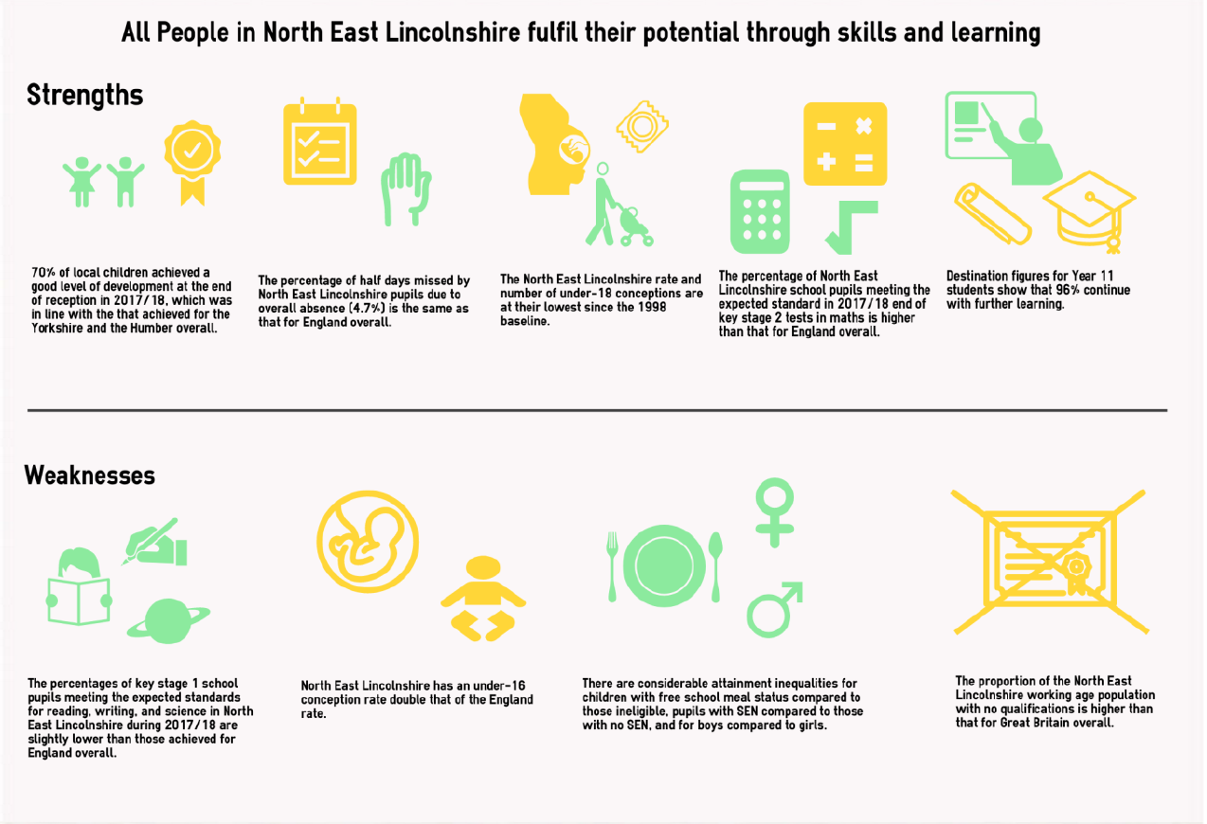

Achieving full potential starts from an early age and starts with achieving a good level of development by the age of five years. Overall, the majority of children living in North East Lincolnshire are school ready by the age of five years; however, more girls than boys are school ready at this age. Levels of secondary school attainment are also currently similar in North East Lincolnshire to other parts of the country although children in receipt of free school meals and boys perform less well. There are wide socioeconomic inequalities across North East Lincolnshire in school attainment. Similarly fewer of our 18 and 19 year olds proceed into higher education than other areas and far fewer young people from poorer backgrounds do.

With fewer of our young people going into higher education, a key focus for the Town Deal, it is especially important that young people living in North East Lincolnshire remain in some form of education, employment or training. When young people are engaged in education or training their self-esteem and confidence are increased. Conversely, when young people are not engaged in education, employment or training, they are at greater risk of a range of negative outcomes, including poor health, depression or early parenthood. Despite the socio-economic challenges of North East Lincolnshire, we have seen considerable improvement (i.e. reduction) in the number of 16 to 18 year olds that are not engaged in education, employment or training. In September 2018 96% of Year 11 pupils continued into further learning. The number participating in work-based learning and training apprenticeships in the area has also increased. This should create a better trajectory for the future.

Historically, North East Lincolnshire has had a high rate of under-18 conceptions which is linked to the high level of deprivation and poverty in the area. The rate of under-18 conceptions in North East Lincolnshire has reduced considerably in the last decade and is now less than half what it was in the 1990’s when teenage pregnancy measures were first widely adopted, however, it still remains significantly higher than the national average. Becoming a parent at a very young age often results in the mother leaving education early and reducing future opportunities. This potentially leads to children of these teenage mothers, being at increased risk of poverty; living in poor housing, having poor health, low educational attainment, and also lower rates of economic activity in adult life.

Long-standing issues around low secondary school attainment has resulted in North East Lincolnshire having a much higher working age population with no qualifications than other parts of the country. This has resulted in skills gaps and a tendency for people to migrate from elsewhere to fill better paid opportunities in North East Lincolnshire. With the growth associated with the renewables industry and the requirement for a skilled labour force there is new focus on ensuring that local people can access the training and education they require to fill these posts.

**The learning and skills system**

The key partnership is the Education and Skills Board, supported by a number of forums reflecting the range of organisations central to shaping the learning experience. They strive to support greater integration along the learning pathway, working closely with schools, colleges and local employers to raise awareness of local opportunities that people may want to access and to be clear on what qualifications and skills are valued and needed locally should people’s choice be to develop a career locally.

**Priorities:**

* Develop skills of current workforce (including Apprentices)
* Support employers to forecast, plan and future proof their business
* Raise the aspirations/expectations of our local community
* Lift overall educational attainment levels in the borough

**Key outcome indicators:**

Educational attainment rates (key stages, GCSE and further education)

**OUTCOME – Investing in our future**

**All people in NEL benefit from sustainable communities**

**We want North East Lincolnshire to be a place where people are supported to live independently and have access to the means to connect to other people and places**

**A place where all its’ citizens, partner organisations and visitors have access to a high quality, well maintained natural and built environment.**

**A place where we can celebrate our natural heritage and cultural offer.**

**A place where residents and partner agencies are encouraged and empowered both individually and in partnership to help shape support and contribute to the communities in which they live, work and play.**

**A place where communities support each other and engender a sense of community cohesion and civic pride.**

**STRENGTHS AND CHALLENGES**

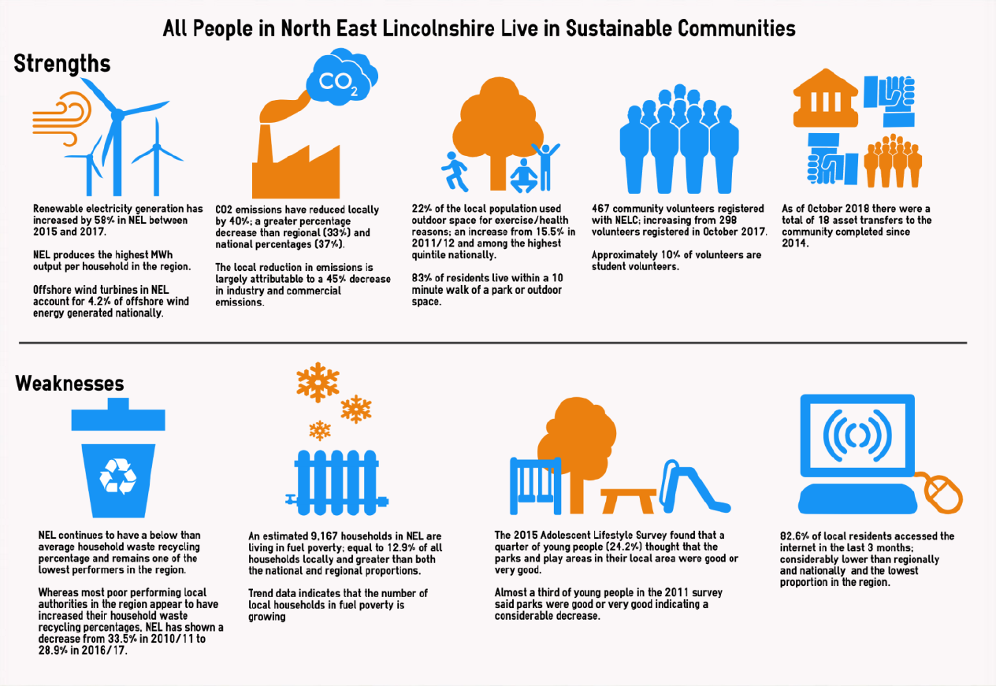

North East Lincolnshire is a predominantly urban authority that is fortunate to have coastal and countryside amenities within and adjacent to it. This means that we have a wonderful green and blue infrastructure which if managed well, will help to make the area an attractive place to live and help to generate inward investment. The economic challenges of the last half century have had a negative impact on urban infrastructure with a lot of under-utilised land and buildings that were once associated with industry, fishing and ports.

In addition much of the urban housing stock is relatively low quality early 20th century terraced housing that now sits in the private rented sector. The general availability of low cost private rental housing has though contributed to a low rate of homelessness and households in temporary accommodation although there is an ongoing need to improve standards in the management of the private rented housing stock and encourage best practice. . There is also evidence that the number of people sleeping rough is increasing.

Demographically North East Lincolnshire has a higher proportion of older people and a smaller amount of working age population than the England average. This reflects the fact that parts of the borough are popular retirement destinations but also that young adults who move away for higher education tend not to return to the area later and the borough does not have a significant post 18 student population of its own. With recent developments and commitments to the economic future of North East Lincolnshire, there is significant opportunity to upskill the local population as well as attract skills and aptitude from outside of the local area.

Although its relative geographical isolation can mean getting to North East Lincolnshire from regional and national centres is time consuming, the relatively small size of the borough means moving around within the borough by private or public transport is quite easy. The large majority of the NEL population live within 10 minutes’ walk of a park or accessible green space and rates of cycling in the population are higher than average. The borough also contains eight railway stations, though all but three are lowly utilised.

North East Lincolnshire has had some of the highest amounts of waste and lowest rates of recycling in the country in recent years but a number of initiatives have been introduced in the last year which are expected to change that ( recent figures indicate an increase to 36.2%). Participation in local and national elections is also low especially in the most deprived wards of the borough. More affluent parts of the borough have a much greater level of public participation and volunteers, probably associated with a greater volume of retired people.

**The sustainable communities system**

There is currently no lead partnership driving this outcome and this is an area for exploration and development. The purpose of such a partnership would be to provide a focus for the various elements that shape the local community in which people live. What contributes to making a community an attractive and welcoming place to live is a strong determinant of people’s wellbeing. It is recommended that the voluntary and community sector are invited and supported to initiate the process of exploring and developing such a partnership with relevant partner organisations.

In reviewing the elements of this important outcome, we can also determine those aspects that are better driven forward under another of the outcomes, for example the economy outcome for those elements inferring impact of climate change and green energy.

Other partnerships are also planned, such as a new Culture and heritage board linked to our successful securing of external funding that will contribute to this outcome.

**Priorities:**

* Reducing fossil fuel use and carbon emissions in the local area
* Improving air quality through transport and traffic management
* Remodelling our waste strategy and increasing recycling
* developing and building participation in our culture and heritage offer including our natural assets through public engagement and enjoyment
* Support the voluntary sector to build capacity and capability in the sector
* Support social action within communities (cultural, environmental, health, housing, economic and social)
* Support the further development of volunteering in the borough.

**Key indicators:**

Air quality

Local environmental quality

Number of people who are proud to live and work in NEL

**OUTCOME – Vitality and health**

**All people in NEL enjoy good health & wellbeing**

**We want people to be informed, capable of living independent lives, self-supporting and resilient in maintaining/improving their own health. By feeling valued throughout their lives feel, people will be in control of their own wellbeing, have opportunities to be fulfilled and are able to actively engage in life in an environment that promotes health and protects people from avoidable harm.**

**Access will be made available to safe quality services that prevent ill health, support, maintain and restore people back to optimal health or support them with dignity at end of life as close to home as safety allows: Services that are part of an affordable innovative and quality health and social care system which directs resources according to need.**

**STRENGTHS AND CHALLENGES**

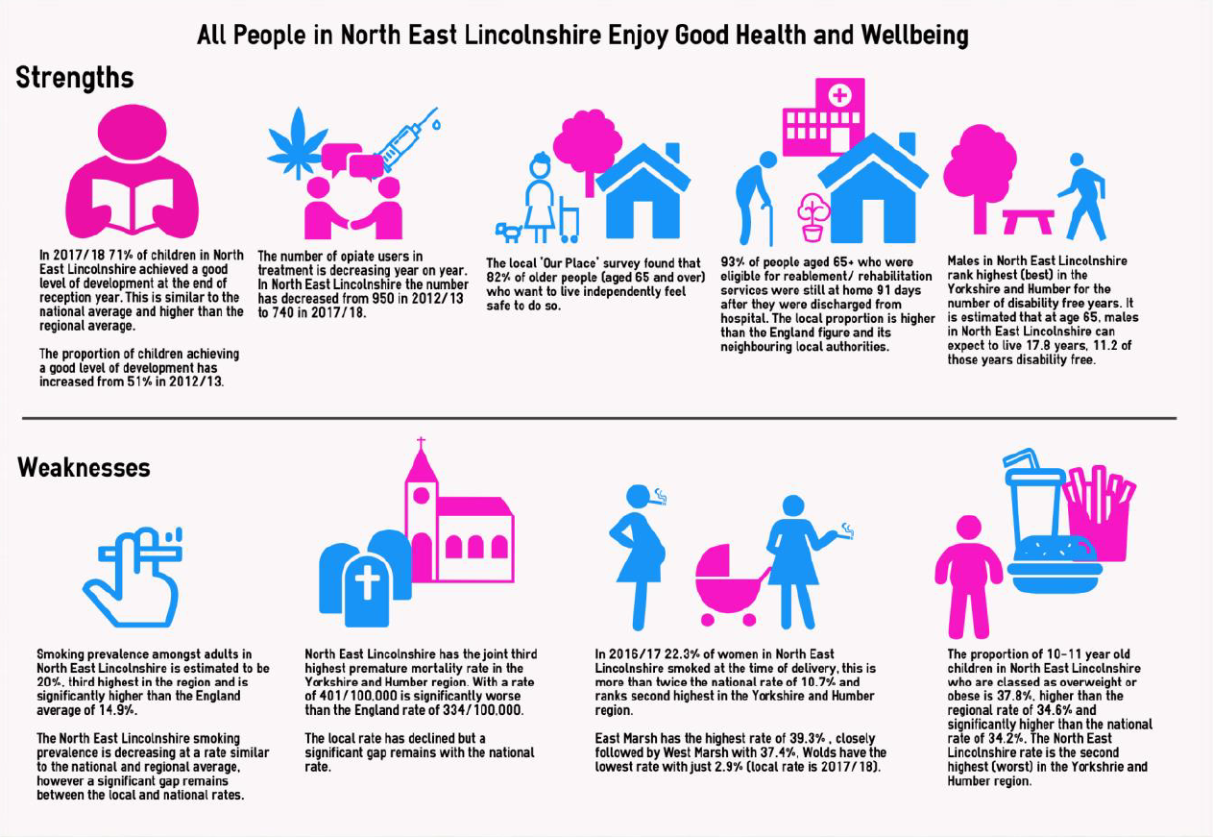

Smoking continues to be the major cause of early death and disease in North East Lincolnshire and it is therefore disappointing that rates of smoking in some of our deprived wards remain over 30%.  Similarly the high number of women smoking in pregnancy has implications both for the future health of the child but also the costs to an increasingly under strain NHS.  Better news is that our adolescent lifestyle survey is pointing to a rapid downturn in the number of our teenagers taking up smoking and our overall smoking prevalence rate is heading steadily downwards.

Health and wellbeing in early years will impact dramatically on a child’s future life chances.  The good news is that we have some of the best childhood immunisation rates in the country contrasted with continued low rates of breastfeeding and high rates of child obesity.

As we get older our lifestyle choices have an ever greater impact on our health.  Unfortunately we are seeing a substantial burden of disease amongst people in middle age in North East Lincolnshire in our more deprived communities arising from the early appearance of long term conditions associated with smoking, alcohol & drug use, poor diets.  Common mental health problems such as anxiety and depression are also widespread.  Underlying these health problems are **a range of social and economic factors such as poverty, long term unemployment, low paid insecure work** and family breakdown.

Better news is that people in North East Lincolnshire living in more affluent communities have seen substantial increases in life expectancy in the last 20 years and those who reach retirement age in good health can expect a longer retirement than ever before.  This is though bringing challenges to our health and social care system with ever increasing numbers of dependent older people in the population and numbers will continue to grow for at least the next 20 years.  However large numbers of healthy older people have significantly increased the number of volunteers assisting in health and social care delivery both in the public and private domain.

**The health & care system**

North east Lincolnshire are at the forefront of integrating the health and care agenda, symbolised by the development of the Union between the local authority and the Clinical Commissioning Group(CCG). The Union Board will be the key partnership driving this outcome forward supported by a range of partnership systems at different geographies from sub regional through to the newly emerging primary care networks all focused on delivering the health & wellbeing outcome incorporating the requirements set out in the new NHS long term plan.

**Priorities**:

* Transformation of urgent and emergency care
* Prevention of and support to management long term conditions including dementia including a non-clinical social prescribing approach to supporting individuals to manage their conditions in a different way.
* Mental Health across the life course including parity of esteem
* Tobacco control including smoking in pregnancy
* Wellbeing of vulnerable children including Special educational needs and disability (SEND)

**Key Indicators:**

Smoking prevalence

Under 75 all-cause mortality

**OUTCOME – Economy and strength**

**All people in NEL enjoy and benefit from a strong economy**

* NEL’s businesses will achieve sustainable, long-term growth that benefits all of our residents by providing fulfilling, well-paid employment opportunities. We will create the ‘right’ environment to attract and sustain private investment, by providing high quality business infrastructure- including road and rail connectivity, superfast broadband, high quality employment sites and premises
* Equip NEL residents – particularly young people, and those living in our most deprived communities – with the skills and confidence to secure and sustain well paid employment in all sectors of our economy.
* NEL will drive the growth of the ‘Energy Estuary’ as an international centre for offshore renewable energy. The Port of Immingham and Grimsby has cemented its role as the largest port in the UK, diversifying successfully into new markets. The growth of NEL’s food sector has been driven by new export opportunities. Our visitor economy, services and retail sector will continue to grow through efforts to change internal and external perceptions of NEL as an attractive place to live, work, visit and invest.
* We want North East Lincolnshire to be a place where the local existing and emerging workforce actively participate in learning and employment levels are high.

**STRENGTHS AND CHALLENGES**

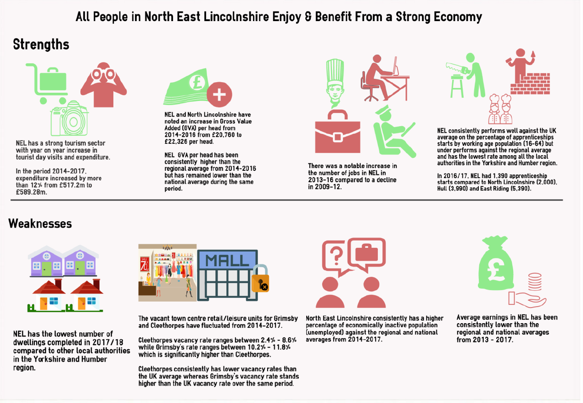

North East Lincolnshire has struggled economically for several decades. The decline in the fishing industry and the growing tendency for people to holiday away from English coastal resorts in the late 20th century hit our area hard as these sectors had contributed enormously to the growth of the borough in the previous century. With declining employment opportunities we have seen a legacy of inter-generational unemployment and poor housing in our most deprived areas. In addition the employment sectors that expanded in the late 20th century such as food processing were often low skilled and low paying jobs. Therefore the rate of children in low income families has long been well above regional and national averages.

Recent years have produced new challenges but also new opportunities and a real sense of optimism that better times lie ahead. Since the end of the 2008 financial crash and subsequent recession, we have seen average incomes slip further behind regional and national comparators but a steadily falling rate in the number of people claiming out of work benefits.

The growth in the off shore wind industry and related sectors in the Humber estuary has seen an increase in the volume of inward investment to the area with the expectation of more to follow. We have also seen growth in the tourism industry locally and the development of new hotels and leisure facilities in the area, in part to meet demand generated by business visitors. The resort of Cleethorpes continues to meet the needs of existing visitors whilst diversifying to attract new visitor markets.

Whilst the Borough currently provides a limited choice of housing and there are some challenges with the existing pre-1919 housing stock, there are plans to substantially develop the housing offer going forward with a number of strategic, greenfield housing sites allocated in the Local Plan. These will be complemented by ongoing plans to deliver housing development on urban brownfield sites, working in partnership with Homes England, the Lincolnshire Housing Partnership and other key stakeholders.

The South Humber Industrial Investment Programme offers the potential to unlock up to 195 hectares of land between the Ports of Grimsby and Immingham for new industrial development. With support from the Humber and Greater Lincolnshire Local Enterprise Partnerships, the Council is investing on an unprecedented scale to enable these opportunities and attract investment and jobs to the Borough.

Perhaps most exciting of all, the unique Greater Grimsby Town Deal offers place changing opportunities for the area, developing our higher education offer, reconnecting the town centre with its underutilised waterfront and creating new opportunities for tourism, leisure and housing in the town centre.

**The economic system**

The key partnership leading on the delivery of the economy outcome is the Development and Growth Board which is currently undergoing a review of membership and remit. This is supported by a number of issue specific partnerships both place based and sub regional reflecting the influences on prosperous growth and a sustainable economy. In our efforts to develop an inclusive economy, the relationship with community wealth and the role of the community and voluntary sector is an important dimension currently being explored.

A key driver for North East Lincolnshire is the unique Town Deal with central government. The Greater Grimsby Partnership Board therefore remains an important part of our Place based governance system.

**Priorities:**

The Town Deal incorporates some of the existing programmes and initiatives which, cumulatively, contribute to the realisation of the ambitions of the Local Plan, Economic Strategy and Town Deal:

* South Humber Infrastructure Investment Programme (SHIIP)
* Grimsby West
* Housing Zones & Estate Regeneration
* Development of Grimsby Town Centre and its waterfront
* Cleethorpes development
* Green Energy

**Key Indicators:**

Number of visitors to NEL

Gross Value added

Number of jobs

**OUTCOME – Safe and secure**

**All people in NEL feel safe and are safe**

* **Every child will be brought up by supportive and nurturing families. All families live in good quality housing which is designed to meet a range of different needs, supporting people to be as independent as possible. Living within low crime communities, people will feel safe in their home and are able to access opportunities for work, socialising and leisure. Communities where there is zero tolerance of violence. Communities are supportive to and value children, vulnerable people and the elderly. Where possible people are encouraged to make a contribution to the communities in which they live or work.**
* **People can access services, when needed, that are safe and individuals and their families are confident in the quality and safety of care provided.**

**STRENGTHS AND CHALLENGES**

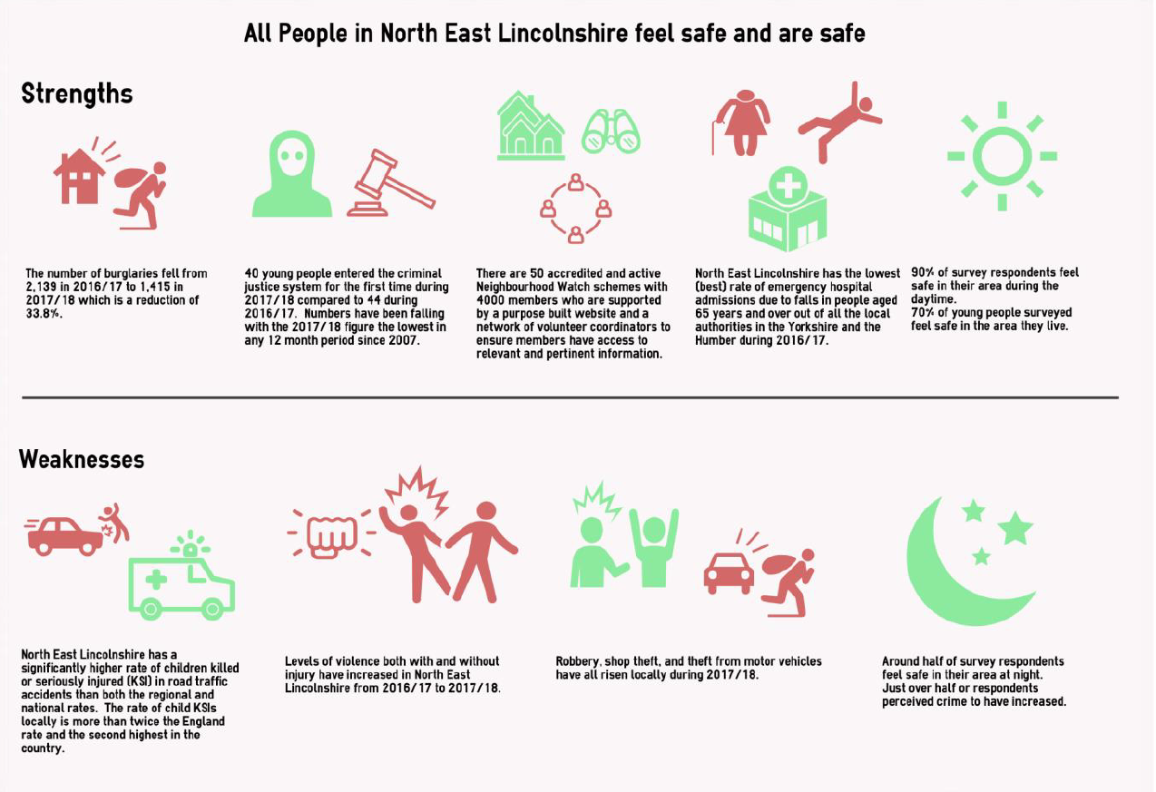

Living and growing up in a community that has high levels of crime or antisocial behaviour inevitably leads to feelings of insecurity and anxiety. The fear of crime may lead an individual to avoid going out alone, or stay in at home more, or have a detrimental effect upon their mental health, thus having a significant impact upon their quality of life. It can also lead to or exacerbate drug and alcohol problems. This can in turn lead to financial problems and a risk that people may slip into a criminal lifestyle to fund that habit. A considerable proportion of acquisitive crime is associated with drug misuse, and antisocial behaviour, violent crime, and criminal damage are strongly associated with alcohol misuse. Many of our more deprived communities are blighted by high crime rates and it is particularly concerning that violent crime and hate crime has increased significantly in recent years. The toxic trio of substance misuse, domestic violence and mental health issues is impacting on too many children, especially in our more deprived communities.

Providing a child with a safe and secure start to their lives, ideally in a stable family situation, can make a substantial difference to that child’s overall life chances. It is therefore a major concern that so many children in North East Lincolnshire are defined as being in need of social care and/ or subject to a child protection plan. Being safe also relates to the environment around us including the ability to move around safely. It is concerning that North East Lincolnshire currently has one of the highest rates of children killed and seriously injured in road collisions. Many of these incidents occur on crowded roads in urban residential areas. If children cannot walk and cycle safely it is likely that they will have their freedom to move about curtailed, impacting negatively on their health and wellbeing. North East Lincolnshire is also not immune from a wider national issue which is seeing growing levels of self-harm in teenagers and young adults which appears to be associated with a range of factors in modern living. More positively our most recent adolescent lifestyle survey told us that most young people feel happy about their life, have never tried drugs, and feel safe in the area in which they live.

**The safe and secure system**

The partnership system driving this outcome forward is currently undergoing a major transformation reflecting changes in national legislation. As such the leadership is shared across the Community Safety partnership and the safeguarding system. The Children’s partnership is currently transitioning into the Safeguarding Children Partnership, and the Adult Safeguarding Board is also being reviewed with the aspiration of bringing the system together.

**Priorities:**

Domestic Abuse

Child Criminal & Sexual Exploitation and wider vulnerabilities

Safeguarding Adults ensuring their wellbeing is protected and they can live independently and free from abuse

Mental capacity of vulnerable adults within all services.

**Key indicators**

* domestic abuse rates
* Incidences of abuse
* crime rates
* % of residents who feel safe

# Inequalities across the life course

The approach to stronger economy through inclusive growth and stronger communities addressing vulnerability needs to acknowledge and take account of the varying ways in which inequalities manifest themselves at different stages in life. Establishing what success looks like for the population at each stage and the emphasis of each of the five outcomes will vary.

**Give every child the best start in life**

Unhealthy behaviours before and during pregnancy, and after childbirth, are more prevalent in more deprived communities, and are both a cause and consequence of inequalities. Matters are further compounded by the clustering of such behaviours, so babies and children are exposed to multiple risks arising from parental smoking, harmful drinking, unhealthy weight, poor nutrition etc.

As babies come into the world, some of the inequalities they will experience during their life will have already been pre-determined by their parents’ socio-economic circumstances. Too many children unacceptably grow up in poverty and there is a correlation between levels of child poverty and numbers of children reaching a good level of development at 5 years of age[2]. The largest proportion of that poverty occurs in working, not workless, households, reflecting wider societal issues of income inequality and affordability, including housing. We can already see the odds stacking up for some of our children, setting them off on a trajectory likely to lead to poor outcomes.

Positive, secure relationships surrounding babies and children are key to good outcomes and can act as a blueprint for the child’s future relationships as they go through various life stages, and in particular as they move into parenthood themselves later on in life. A baby’s first interactions are generally with mum and the importance of maternal attachment and attunement in the early years is well documented. For some mums and babies, however, that attachment can be significantly compromised by mum’s poor mental health in the perinatal phase, and can continue throughout a child’s early life without timely identification and effective support.

There is now compelling evidence around the extent and nature of a range of adverse childhood experiences (ACEs) and the impact these can have on children, their development and life chances. ACEs tend to fall into two main categories: child maltreatment and household or family adversity, such as, domestic abuse, substance abuse and mental illness. Around half of all adults have experienced one or more form of adversity as a child or young person. These are highly stressful and potentially traumatic events, which lead to neurobiological and neurocognitive changes in early years brain development which is at its peak, particularly up to 2 years of age. The resultant impact of such changes is a much greater risk of a range of poor health and wellbeing outcomes later on in the life course.

**Enable all children and young people to optimise their capabilities and resilience and have control over their lives**.

As children reach school-age, and continue to grow, gaining increased independence and a greater sense of self, they will need to develop a series of life skills to confidently navigate towards young adulthood and a series of transition points and relationships along the way. This ability will be determined to some extent by their earlier experiences and inequalities will open up further. Chronic exposure to poor social circumstances or harmful experiences means any negative impacts will become more entrenched and likely more complex. Left unresolved, these may manifest in a number of ways, such as, problematic behaviour at home and school, offending behaviour or mental health problems increasing risks variously of school exclusion, contact with the criminal justice system, or social isolation.

Children from more deprived backgrounds will be more likely to engage in risky health behaviours and commence these at an earlier age than their more affluent counterparts. Although not the only factors in this, for some this will represent a combination of modelling the social norms set by their parents and an absence of parental guidance. Thus, harmful issues and behaviours become generational and stubbornly persistent, including teenage pregnancy, smoking, obesity, poor sexual health and substance misuse.

The above combine to generate a greater likelihood of poor educational outcomes and life skills, for those experiencing greatest disadvantage and adversity. Despite many of our children setting out with future ambitions and hope for their future, these are revised at some point in this life stage, likely influenced by the employment and further education experiences of family and friends. Thus, those from our most deprived and disadvantaged communities have a lower starting point as they transition into adulthood and enter the labour market.

**Enable all adults to have control over their lives, and contribute to life through employment or other purposeful activity**

As children and young people move into adulthood their identity and life chances will to a great extent be determined by their ability to obtain and sustain employment. Those who have a reasonable quality of education or skills will likely be able to obtain secure employment that will enable them to live independently in an area of their choosing, engage in family life in they wish to do so, have reasonable leisure time and as a result be more likely to maintain a good quality of health and wellbeing.

By contrast those who have not achieved in education in training, perhaps because they have come from a background where expectations were low will have far fewer choices and are more likely to be unemployed or only able to obtain jobs that are low paid, casual, lacking autonomy, insecure or even outside the formal economy. This will almost certainly impact on their wider lives with limited choices in terms of where they can live, usually in low quality housing with insecure tenure, a greater exposure to crime and antisocial behaviour, more likely to be tempted by risky behaviours or become dependent on unhealthy substances such as tobacco, drugs and alcohol, more likely to slip into financial difficulties and ultimately mental health and physical health problems way before their time. There is also a greater risk of exposure to particularly harmful social situations such as themselves becoming involved in the criminal justice system or becoming involved in a violent or chaotic home life.

Adults of working age with lower educational attainment and from disadvantaged communities, are more likely to be living with a long term condition or disability, be workless and experience up to 10 years less of health life. Whether in work, in more unskilled roles or workless may experience a loss of control and low self-value and poor mental wellbeing

**Enable people to maintain their wellbeing and independence into older age**

**Indicator: people living independently in their own home**

Inequalities in later life predominantly reflect the accumulation of poverty and disadvantage across the life course, rather than age itself. The pattern of health inequalities in chronic diseases continues and multi-morbidity is strongly associated with age and deprivation, often linked with lifestyle risk factors. So, those who are more deprived will have a greater number of health problems and at an earlier age, than those who are more affluent. Thus, the burden of disease falls greatest on the poorest, fastest, who then spend a longer time in ill-health, living with a disability and dying earlier than those from more affluent backgrounds. These inequalities can be compounded further in later life by the ability to access quality health and social care, which varies across the social gradient.

Levels of vulnerability resulting from the ageing process and social and environmental factors also vary by socio-economic status. The physiological changes associated with the ageing process signal various forms of function decline but this is more likely to occur much earlier in life for those who have experienced the greatest disadvantage throughout life. Frailty – a term used to describe cumulative vulnerability – can manifest much earlier in those who are most deprived, and in the oldest old (85+) we see some of the sharpest inequalities by deprivation.

The poorest are likely to be living in some of the worst housing conditions and have least social connections. Worries about safety, securing and getting around the local neighborhood are greater in more deprived, older age groups. This can have devastating consequences for mental health and emotional wellbeing. And whilst financial hardship is an inequalities issue in itself, it can be more acute in older age for the most disadvantaged. Earlier ill-health means those who are most deprived will be least likely to be in employment in later life and will have limited retirement income to sufficiently maintain a basic standard of living. This stimulates further vulnerability and sharpens inequalities further. The resultant lack of reserve and resilience, means those who are more deprived will have a worse quality of life and life expectancy than those who are least deprived, with a much reduced capacity to bounce back from ill-health, associated with later life, such as malnutrition and bereavement.

**People experience a dignified end of life**

As people approach the end of their life, inequalities persist and those whose lives have been blighted by poverty and deprivation can expect inequality in dying too. Dying with dignity is really important for us all, and involves making choices about where you die and how you want your care to be delivered and co-ordinated. Whilst the majority of people express a preference to die at home few do so, but those from more deprived backgrounds are much more likely to die in hospital than those who are least deprived. Planning how you want to be cared for, expressing choices to maximise comfort and wellbeing, and having your holistic needs met, are all important factors in individualised care in the last stages of life and co-ordination is key. However, there is unequal access to quality, co-ordinated care, across the social gradient, and this can be compounded by lack of awareness of various possibilities.

There is a degree of uncertainty in the outlook for those experiencing life-limiting illnesses which can make advanced planning difficult, but the most deprived are least likely to have done so. Whilst the poorest will have experience various manifestations of poverty, they are now likely to be faced with funeral poverty. Those with the least financial resources are less likely to have been able to make planned financial provision for funeral arrangements, or indeed legal matters. In the absence of any other financial support, families left behind can be spring-boarded into debt, at a highly emotive time, in order to meet funeral costs. The poverty, into which a person is born into and, dies in, leaves its legacy for others.

# North East Lincolnshire’s strategic approach to wellbeing

Each of these outcomes, the positive and more challenging aspects facing North East Lincolnshire reflect the focus of a number of organisations or systems that shape North East Lincolnshire as a place as well as how people experience living working or visiting the borough

Each of these systems are often governed by one or more partnerships, having their own priorities of focus and the impact on people and their experience of these systems can be both positive or negative at different stages of their life, depending on their circumstances, and the resources they have to call on. The organisations within these complex systems will deliver a range of services, programmes and projects that will have a direct influence on people and place at different stages of life. Each of these systems and the organisations within them, interact and contribute to more than one outcome. Whilst the desire to “keep it simple” is often expressed, it is important in consideration of any design, to acknowledge the complexity of these systems and how they often interact to influence **people** and shape the **place** in which they live.

What follows is a brief description of the systems that are driving each of the outcome areas in the Outcomes Framework, the key strategies and programmes of delivery and the priorities currently within those systems

# Summary diagram of current existing priorities

**Learning and skills system**

* Develop skills of current workforce (including Apprentices)
* Support employers to forecast, plan and future proof their business.
* Raise the aspirations/expectations of our local community.
* Lift overall educational attainment levels in the borough

**Sustainable communities’ system**

* Meet our local carbon reduction goals? Reducing fossil fuel use and carbon emissions in the local area
* Improving air quality through transport and traffic management
* Remodelling our waste strategy and increasing recycling
* developing and building participation in our culture and heritage offer including our natural assets
* Support the voluntary sector to build capacity and capability in the sector and benefit from social value policy. Support social action within communities across all outcomes.
* Work with the sector to further develop volunteering in the borough.

**Health and care system**

* Transformation of urgent and emergency care
* Prevention of and support to manage long term conditions including dementia including a non-clinical social prescribing approach to supporting individuals to manage their conditions in a different way.
* Mental Health across the life course including parity of esteem.
* Tobacco control including smoking in pregnancy.
* Wellbeing of vulnerable children including Special educational needs and disability (SEND)

**Economic system**

* South Humber Infrastructure Investment Programme (SHIIP)
* Grimsby West
* Housing Zones & Estate Regeneration
* Development of Grimsby Town Centre and its waterfront
* Cleethorpes development
* Green Energy

**Safer communities’ system**

* Domestic Abuse
* Child Criminal & Sexual Exploitation and wider vulnerabilities
* Safeguarding Adults ensuring their wellbeing is protected and they can live independently and free from abuse
* Mental capacity of vulnerable adults within all services

# A life course strategic approach to wellbeing

The Outcomes framework and the associated programmes and interventions when applied across the life course vary in their importance and application for different stages. Whilst the economy frames everything and determines the prosperity for the borough, people’s relationship to the economy will vary depending on the stage in life. For those agencies delivering services specific to key life stages it helps to agree what the optimal focus is for that stage in life, irrespective of the agency one works for. These life stages compliment the overall framework approach.

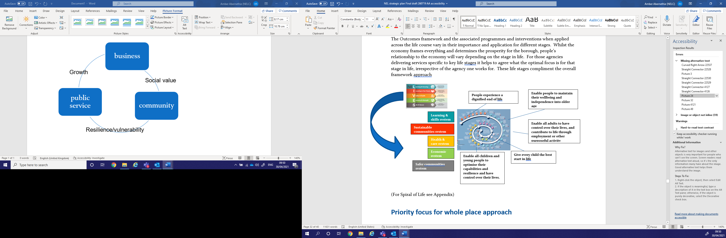

(For Spiral of Life see Appendix)

# Priority focus for whole place approach

Each of these systems and the organisations are working as part of core business and in partnership to impact on the outcomes and ambitions captured within the Outcomes Framework. They have established priorities for action based on the needs of the population, the pressures of demand made on services or responding to national policy. Whilst many of the existing priorities may seek adoption at Place Board and across the Place system, the principle is to devolve leadership to the relevant system partnership. However as well as laying out how all of these systems are delivering the framework, there are issues that would benefit from a **whole Place-based approach** with all of the systems/organisations adding value through their contribution.

The first of these issues identified by the Place Board is **employability and skills**. A collective approach to addressing current vacancy, recruitment and retention pressures and perhaps more importantly, how to support local young people over the next ten years to secure the jobs that will result from the expected growth in the North East Lincolnshire economy.

**Indicative Actions Identified for place forums**

|  |  |  |  |
| --- | --- | --- | --- |
|  | **Public Sector** | **Voluntary Sector** | **Private Sector** |
| Action 1 | Workforce planning and develop a collective approach to work experience, entry points into work and career development within the public sector | Identify existing service provision that could be adapted to include career /employment / skills advice and signposting | Identify and share current and future skills and employment needs (workforce planning) in each of the sectors |
| Action 2 | Consider sector wide opportunities rather than organisational – recruitment and retention across place organisations | Explore models of potential peer support for parents to enable networking and improved understanding of local career / work opportunities | Identify people employed locally to act as work role models / mentors who can promote employment opportunities in schools, colleges and the wider community |
| Action 3 | Review our multi-agency wellbeing approach to young people in partnership with schools | Workforce planning – is there any potential to recruit in to the sector rather than individual organisations | Promote jobs available in the area – clarify the types of jobs available in local businesses to dispel some of the myths about certain industries |
| Action 4 | Consider how we identify families of children who would benefit from a whole family approach and how to develop multi-agency intervention | Explore a co-ordinated approach to Volunteering as a route to employment within NEL | Develop age appropriate opportunities for young people to experience the world of work in each of the sectors |

Other issues that may benefit from a whole Place system approach have yet to be agreed. As part of the process of each partnership reviewing the priorities for each outcome, the lead partnership will be asked to identify those issues they feel require a whole place based system approach cross all outcomes.

# Appendix 1

**Functions in common, underpinning a place based approach to wellbeing**

**Intelligence and insight**

Excellent systems of intelligence collection, management and interpretation that extend ideally across a range of partner organisations are vital components for the successful delivery of wellbeing and place strategies. This must go far beyond performance and outcome indicator reporting and should also include appraisal and insight into need and evidence of what works including input from local people, in particular the intended recipients of the interventions.

The council currently produces the Outcomes Framework (which is the main part of the overall Joint Strategic Needs Assessment (JSNA)). The outcomes framework is the most comprehensive assimilation of intelligence on North East Lincolnshire that is produced anywhere, with a wealth of intelligence on economy, safer communities, health and wellbeing, sustainable communities and skills and learning. We have also now integrated the Joint Strategic Intelligence Assessment within the outcomes framework.

The Outcomes Framework includes a number of different products that are intended to provide different levels of depth and is constantly under development. Currently the products include the following:

* Detailed reports on each of the council’s 5 outcomes which are updated every 3 years (N.B. from this year the Feel Safe and Are Safe outcome report will be refreshed annually as this now incorporates the requirements of the JSIA)
* A State of the Borough Executive Summary of the outcomes framework which will be updated annually
* Statistical analysis of all indicators in the outcomes framework which are updated at least annually.
* New infographic summaries of the main outcome indicators to be updated at least annually.
* Strategic assessments of issues of major importance to place, e.g. economic and housing condition assessments.

In addition strategic assessments and individual topic based needs assessments that provide detailed intelligence and survey based reports are incorporated within the outcomes framework. Recent examples completed in the last 2 years include pharmaceutical, financial resilience, drugs and alcohol, sexual health and mental health and wellbeing.

However whilst the outcomes framework provides an excellent source of high quality intelligence for North East Lincolnshire, it is clear that many other organisations in North East Lincolnshire collect and manage intelligence that is not always featuring in the Outcomes Framework. All too often obstacles are put in the way of sharing good intelligence across and sometimes even within organisations. Whilst some of this is legitimate data protection, all too often it results from a misunderstanding of data protection laws or an over cautious approach that limits the usefulness of the intelligence and impacts on service delivery.

**Workforce & Organisational Development**

By creating the right environment and equipping employees with the skills and behaviours to be courageous, it will bring about positive and ongoing changes.

Much of what organisations do is determined by the people within it, the values and principles they follow and the relationships they develop. As organisations we can reflect whether we have got the emphasis right in achieving our purpose. This is equally applicable to working in partnership.

How and where we deliver services, how organisations work with communities and how they are perceived by users all shape an organisations approach.

The skills, competencies and attitudes of our workforce, the skill mix necessary to meet the demands of the future, the flexibility in the ways in which we encourage staff to work are part of workforce development and its contribution to delivering the outcomes. We also have to future proof our ability to attract retain and develop our workforce of the future, ensuring the right skills and aptitudes providing the greatest opportunity to local people of all backgrounds wherever we can.

**Community capacity building and Community Engagement**

There are a number of current ‘mechanisms’ used to engage community groups / individuals on different issues / services within NEL. Some of these target specific geographies, others specific groups such as children and young people, older people, people with a particular health issue. A single engagement strategy is being developed by the union which will be supported by a forward engagement plan.

There is occasionally an issue with some groups being ‘engaged’ several times on different issues, being asked the same / similar questions in a slightly different way. This has led to individuals / groups feeling that they are not listened to, that the Council will ‘do what they want to anyway’ and has led to a mistrust by some of the council from many members of our community. The JSNA and JSIA now form a combined survey and engagement officers from across the Council CCG and police meet to reduce the potential for duplication.

Community engagement and capacity building go together as an essential element of enabling people to have the confidence and skills to engage. This approach draws on the Scottish community development approach which recognises the need for a parallel programme of work within public sector organisations seeking to engage communities. A key element for the delivery of health and wellbeing outcomes and a key component of stronger communities is community capacity building.

As commissioners seeking to impact on an issue through the VCS sector, we should ensure that there is capacity/capability added to in communities most affected by the issue – doing “with” rather than to. This “legacy” may be skills and confidence for individuals to thrive but also community organisations specific to that issue to enable them to be more effective.

As a voluntary sector voice this may involve identifying communities/areas where support/infrastructure is absent and/or needs development: skills and confidence within communities to organise and act.

A range of funding and other resources assist activity/capacity building in local communities and increasingly the voluntary and community sector are commissioned to provide services themselves. Place based activity needs to accelerate commissioning to outcomes, embedding social value and alternative means to secure a resilient and sustainable sector.

**Policy, protocols and pathways**

There are many different ways in which we shape the way in which people behave, whether as members of the public or as employees within an organisation. Some are designed to promote positive behaviours others to restrict certain activities.

Policies are an important tool to protect and enhance the sustainability of the environment in which we live. They can also serve by creating a culture and environment of inclusion cohesion and tolerance of diversity.

Protocols and pathways also play an important role in ensuring consistency in the way people are treated and to protect people from harm. This is particularly important in the public services where the public have to interact with a wide range of organisations and staff.

In November 2018 the Council approved a social value policy, a key underpinning to the approach to inclusive growth.

**Partnership & governance**

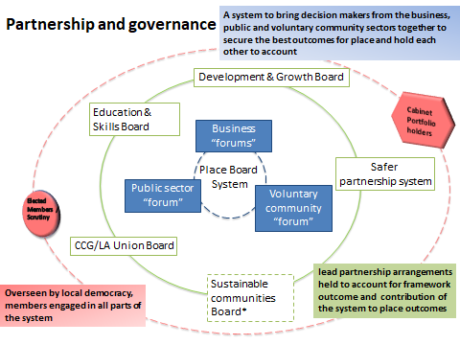

The ‘Place Based System’ is a system not built on hierarchy but one of distributed and devolved decision making. In order to effect change it is recognised that there needs to be contributions from the Public, Voluntary/Community and Business sectors and the organisations that sit within these. The Outcomes Framework is a collective narrative that articulates the vision for the 5 key outcome areas in North East Lincolnshire. The devolved model of governance suggests that there needs to be a lead partnership for each outcome responsible for driving the agenda forward and providing assurance to the system of progress towards the outcome.

The diagram above depicts how such a system could work to ensure that key issues for North East Lincolnshire are presented and debated thereby allowing collective discussions and solutions to be developed. The sustainable communities’ partnership is an area for exploration and development.

Elected members and democratic accountability will continue to play a key role within the system both through specific portfolio and scrutiny arrangements and their community involvement through wards.

The three forum groups explore the contributions of the sector to each outcome and the framework overall, looking at collaboration for issues as well as in the underpinning functions across the system.

**Information advice and guidance**

Information and advice is crucial if we are to empower people to live the lives that they want to lead, take charge of their health and wellbeing, and make the best decisions for themselves.

Through discussion with and feedback from communities and providers of information and advice, two main barriers to accessing information and advice were identified:

1. Lack of knowledge (people don’t know where to go or what to ask)
2. Lack of coordination resulting in both confusion (largely due to conflicting information and advice) and inefficiency (with people being passed from pillar to post).

Digital access to information has also been identified as problematic. Information about topics/services is often duplicated over many websites/directories, adding to the difficulty of keeping digital information up-to-date and trustworthy. It is envisioned that as digital access expands, more people will choose self-help options, freeing resources to ensure that those in need of more support can receive it.

To support citizen wellbeing from the beginning to the end of life, the **No Wrong Front Door** initiative is looking to establish a place-based approach for information and advice in North East Lincolnshire. A key principle of our approach is that there should be ‘No Wrong Front Door’ (i.e. wherever people seek support, they access it, or are promptly redirected to where they can access it).

Various collaborations are underway in health & social care, children’s services and in relation to employment opportunities in the borough. The challenge will be to encourage a place based approach

**Appendix 2**

**Measuring progress as a Place based system**

Currently we produce an annual report on the progress and direction of travel for this initial indicator set to illustrate progress of the overall outcomes.

**Outcomes Framework indicators**

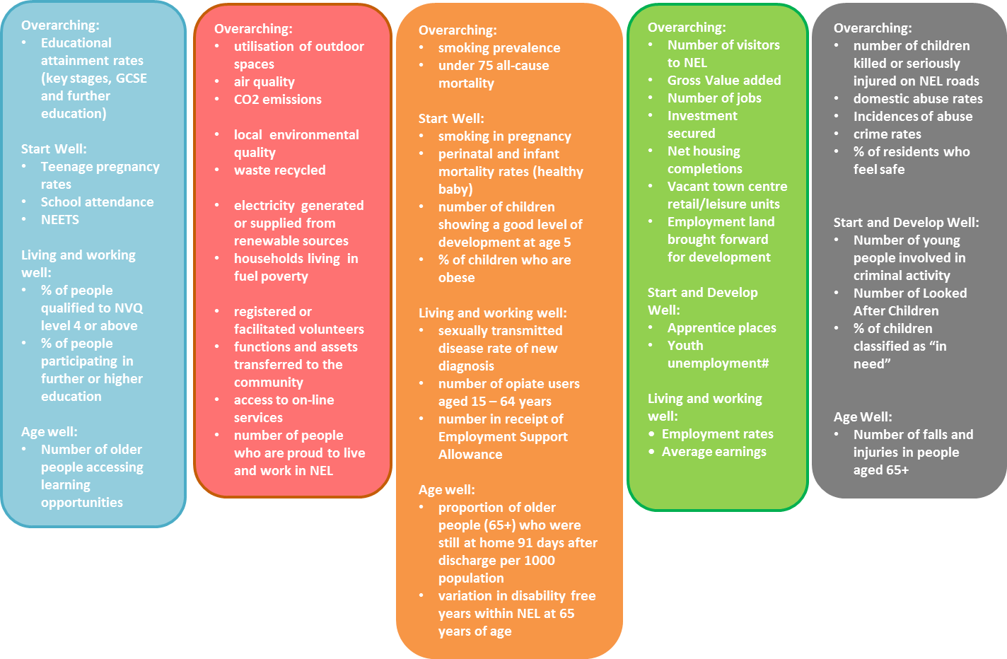

**Appendix 3: Spiral of life**

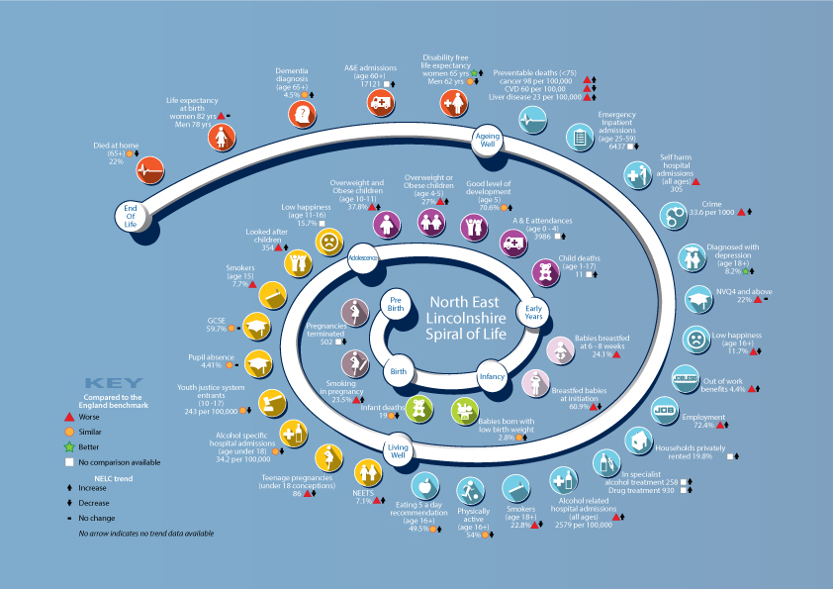

1. https://www.thersa.org/globalassets/pdfs/reports/rsa_inclusive-growth-commission-final-report-march-2017.pdf
2. David Taylor-Robinson et al. BMJ 2015;351:bmj.h5330