GRIMSBY TOWN CENTRE
ACTIVATION & COMMUNITY ENGAGEMENT (ACE) FUND
GUIDANCE & APPLICATION FORM

Contents
Background 2
Priorities 2
Anticipated outcomes/benefits of the funding 3
Who can apply? 3
Funding available 4
How to apply 5
Submission/next steps 5
Need help? 6
Additional Information 6
Undertakings in Difficulty 6
Tax 6
Data Protection 6
Subsidy Allowance 6
Activation and Community Engagement Fund - APPLICATION FORM 8
Activation and Community Engagement Fund - APPLICATION PROCESS 13

Background

The Activation and Community Engagement (ACE) Fund is one of six Grimsby Town Centre projects which form Grimsby’s Town Fund programme.

Grimsby’s Town Centre Vision
The vision for Grimsby’s town centre over the next 10 years is for it to have a vibrant and attractive town centre which is home to growing businesses and a residential community. It will have enlivened public areas and waterfront, where culture and heritage is embraced, and a broad range of activities and pastime can be enjoyed by all.

The town centre has already undergone a programme of substantial regeneration in the last three years. Several large capital projects have recently been completed including the refurbishment of St James Square, a new footbridge across to Alexandra Dock and heritage improvements to Corporation Bridge. Detailed plans are now progressing for a new cinema, market, and food hall at the western end of Victoria Street which will re-purpose empty retail units and offer new facilities to visitors.

The Towns Fund programme now offers the Council and its partners the opportunity to continue to deliver these large infrastructure improvements for example the refurbishment of Riverhead Square and its waterfront, which is being designed now. Other key projects for the next 3-5 years include refurbishing the Central Library and finding new uses for its vacant floors, and a new housing development which is on the horizon for the Garth Lane area.

The purpose of this funded programme is to enable grass roots projects to come forward and ‘activate’ spaces in the town centre. Offering funds for community engagement and business ventures that will add local interest and value to the larger Council led capital projects taking place. The grants being offered will support activity which is aligned to the core objectives of Grimsby’s Town Investment Plan and Masterplan (2020). It aims to unlock smaller bespoke town centre activity led by the community and its businesses. It aims to promote ‘ownership’ and participation in Grimsby’s Towns Fund programme, offering organisations the opportunity to directly contribute to activity which takes place in the town centre over the next few years.

Priorities

In meeting the eligibility criteria applicants will need to consider if their project proposal fits with at least one of the following six key town centre priorities.

- Introduce more diverse uses to the town centre - e.g., Initiatives which bring new uses to spaces and properties in the town centre, enhancing the town centre offer.

- Reconnect the town centre and the community with the waterfront - e.g., Capital investment which activates the water and waterfront drawing visitors to the area and introduces new purpose to the town centre.

- Promote and support community ownership and participation - e.g., Community-driven initiatives which help drive activity and footfall and restore a sense of pride and positivity.

- Introduce development opportunities to the town centre - e.g., Supporting businesses to recover from Covid-19, improve the townscape through shopfront enhancements. Activation of vacant buildings or shops to provide pop-up space for new independent business ventures. ‘Green’ low-carbon initiatives that will promote environment sustainability.

- Prioritise health and wellbeing activity in the town centre - e.g., Arts and culture investment and new health and wellbeing initiatives for all ages to activate the town and drive footfall. Other ‘meanwhile’ pastimes which offer health and wellbeing benefits to the community.

- Enhance employment, skills and entrepreneurial opportunities - e.g., Initiatives which offer new opportunities for employment and learning (experience and training).

Anticipated outcomes/benefits of the funding

Successful applications will clearly demonstrate how their project will attract more residents and visitors to Grimsby town centre. It will find new purpose for unused properties, activate town centre space, the water and the waterfront and invigorate the town centre.

As we expect a diverse range of projects to apply, we also expect the resultant benefits to the town centre to be varied. We will therefore ask applicants to describe the benefits their projects will bring to the town centre when they make their application.

The types of results we expect to see from applications are.

- Vacant town centre units refurbished to attract alternative uses
- Increased arts and cultural activity within the town centre
- Increased town centre sports and recreational activities
- New jobs created or learning and skills opportunities
- Improved environmental, low-carbon or eco-friendly initiatives
- Activity which fosters investment and entrepreneurship
- Leisure activities within the town centre

Please note this is not a complete list, we expect applicants to contribute some of their own.

Who can apply?

It is envisaged that the funds will be used by local organisations and small businesses to facilitate the delivery of schemes which will strengthen local cultural and community assets, promoting social equity and inclusion in the community.
Applications will be accepted from eligible organisations who wish to deliver a capital project in Grimsby town centre. It is expected that this will be open to the following organisations.
- Businesses with social, charitable, or community-based objectives
- Small, medium or micro businesses
The programme is open to business and community (capital based) projects that will help to reinvigorate the town centre and increase the number of visitors. SME’s and other legally constituted organisations like CIC’s can apply.

Only Small or Medium sized businesses (no more than 250 employees and a turnover of £25m or Balance sheet of £50m) who are registered and trading in North East Lincolnshire are eligible to apply for this grant. Large businesses will only be considered in exceptional circumstances.
The project activity must be based in Grimsby town centre within the eligible area as outlined in the map below.
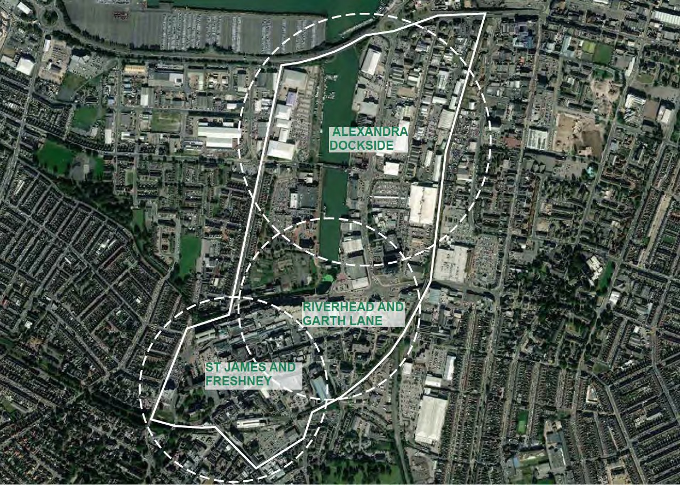

Grants can only be offered for projects with eligible capital expenditure and projects will need to result in positive outcomes for the town centre.

If there is more than one organisation applying to deliver a project, a lead organisation must be selected to become the lead applicant (and grant recipient) with the remaining organisation(s) acting as a delivery partner(s). In this situation, the applicant would be responsible and liable for the delivery partner(s) and ensuring the project is operating as planned.

Funding available

It is anticipated that the grant will be released in phases across a 3-year period to allow time for businesses and community groups to create a sustainable business case and generate match funding, either through sponsorship, crowd funding, own funds, or alternative fund-raising activities.

Grants are available between £500 and £25,000, awards outside these thresholds will only be considered in exceptional circumstances. High value grant applications will require more robust appraisal checks during the application process and will be expected to offer sustainable and measurable benefits to the town centre.

There is an expectation that grant applicants will be able to contribute some match funding so that we can support as many businesses as possible with the grant funding available. However, in very exceptional circumstances this may be waived if applicants can evidence a need for 100% funding and are meeting a minimum of 3 of the 7 anticipated outcomes listed above.

The grant can only support capital expenditure, for example (but not limited to).
- Refurbishment of a premises (if an application is made by a landlord, we would expect a tenant/s to have been identified and a joint application submitted)
- Investment in new fixtures and fittings

How to apply

You will need to complete, sign (electronic signature is acceptable) and submit the application form below. The application form and associated documentation will be treated with the strictest of confidence.

Part A of the application form checks your eligibility for the grant. If you answer yes to all the questions in Part A, you can continue to complete Part B.

Once you have completed the application form in full, please submit your application (in a PDF and/or Word format) to community.investment@nelincs.gov.uk.

You will also need to attach the following documentation with your application.

- Latest 2 years accounts or HMRC tax returns (businesses trading for less than two years will need to provide a cash flow forecast and business plan)
- A recent bank statement (business account)
- 2 quotes (for schemes of £5,000 and below) or 3 quotes (for schemes over £5,000)

Submission/next steps

Applications will be reviewed by the Programme Delivery Team at NELC. If the grant applied for is £5,000 or less, the Programme Delivery Team will make the decision whether to support. For grants £5,000 and above, a recommendation will be made to our grant panel who will make the decision whether to approve or decline the application.

If the funding is not recommended for approval, the applicant will receive feedback concerning why they were not successful. An unsuccessful decision does not exclude you from re-applying, but applicants must take into consideration the feedback they receive and address this in any future applications.

Please ensure that you do not commit to incurring any expenditure in advance of receiving confirmation that an award has been made. Any expenditure incurred prior to an award being made will not be eligible for financial support.

Please note that the decision is final and there is no right of appeal.

A step-by-step flowchart has been developed to show the process from application stage through to grant award can be found at the end of this document.

Need help?

We want to see a diverse mix of projects coming forward which will bring alternative, sustainable business and community activities to the town centre.

If you need assistance finding a suitable property, are a landlord who wishes to get involved and would like help putting in touch with suitable tenants, or you are looking to join up with other organisations to share the responsibility of a property, contact Linda Bulbeck at North East Lincolnshire Council – Linda.bulbeck@nelincs.gov.uk

We recommend contacting one of the following free advisor services for assistance with your application:
Email: BusinessSupport@e-factor.co.uk
Contact Becky Darnell

email: info@investmenthubnel.org.uk
Mob: 07921 562500

Additional Information

Undertakings in Difficulty
NELC are entitled to suspend or terminate a grant and/or require successful applicants to repay all or any of the grant if they enter into (or in our view are likely to enter into), administration, liquidation, receivership, or dissolution.

Tax
Please note, grant income received by a business is taxable, therefore funding paid under the scheme will be subject to tax.

Data Protection
We are collecting your personal details to allow us to provide this service effectively and to allow us to contact you if we require further information. This information may be shared with a third party to assess the eligibility of your application, and other Government departments. The information you provide will be processed and stored in accordance with the principles of Data Protection legislation.

Subsidy Allowance
If your application is successful, the acceptance of this grant must not result in your business breaching Subsidy Control Law, meaning all legally enforceable requirements in relation to subsidy control as defined within Part 2, Title XI, Article 3 of the UK-EU Trade and Cooperation Agreement (TCA), the World Trade Organisation’s Agreement on Subsidies and Countervailing Measures and the subsidy control provisions in the UK’s Free Trade Agreements or any other applicable law in force from time to time.

For further information and updates relating to subsidy control please see link below.
Guidance on the UK’s international subsidy control commitments - GOV.UK (www.gov.uk)

Activation and Community Engagement Fund - APPLICATION FORM

This application form will be treated in strictest confidence. The information provided in this form will help the Programme Delivery Team determine the eligibility of your project and will be key to the appraisal of your application.

Please read the grant application guidance above prior to completing this form. If you have any queries or require further information, please contact the Economy and Growth Team at North East Lincolnshire Council on (01472) 326142 or community.investment@nelincs.gov.uk

Please complete Part A to check your eligibility for the grant.
Part A - Gateway Criteria
Are you an SME or a business with social, charitable or community-based objectives? (See definition in the application guidance above) | Yes ☐ No ☐
Is your organisation registered and physically trading? | Yes ☐ No ☐
Will the project be delivered within 1 year? | Yes ☐ No ☐
Does the project fit with at least 1 anticipated outcome identified in the guidance? | Yes ☐ No ☐
Will the project costs be capital expenditure? | Yes ☐ No ☐
Will the project activity be based in Grimsby town centre within the eligible area outlined in the map above | Yes ☐ No ☐

If you have selected ‘No’ to any of the above, unfortunately your project does not meet our eligibility criteria. If you have answered ‘Yes’ to all the questions above, please proceed with the rest of the form.
Part B - Application
1. Organisation Details
1.1 | Name of Organisation:
1.2 | Address (including postcode):
1.3 | Contact name(s):
1.4 | Contact number(s):
1.5 | Email address(es):
1.6 | Type of Organisation: | Sole trader, Limited company, charity etc.
1.7 | Company identifier (e.g. Company Registration Number, Registered Charity, Partnership number or Sole Trader Unique Tax Reference)
1.8 | Number of employees (full time equivalents)
1.9 | Date business was formed
1.10 | Sector/type of business
1.11 | Business Rates (If applicable) | Account number (Begins with 44 on your statement) | Rateable Value (not the amount you pay)

2. Project Details
2.1 | Tell us a little bit about your business and your aspirations (max 100 words)
2.2 | Tell us about your project and what you are planning to do (max. 100 words).
2.3 | Why is grant funding required (max.100 words)?
2.4 | Is this a joint project with another organisation? if so, please give details.
2.5 | Where will the project take place (including postcode)?
2.6 | If you secure the required funding, when do you anticipate the project starting?
2.7 | What is the anticipated completion date of the project? If the project is reliant on conditions such as obtaining planning permission, please give details and anticipated timescales.
2.8 | What % of match funding are you anticipating to be able to provide towards your project and how are you intending to raise this?

3. Project Cost
3.1 | Please detail the funding you are intending to use for your project.
Funding Source | Amount | Secured
Activation Fund | £ | Yes ☐ No ☐
Own Funds | £ | Yes ☐ No ☐
Fundraising | £ | Yes ☐ No ☐
Crowdfunding | £ | Yes ☐ No ☐
Other (Please specify in the box below)
If you are not able to provide any match funding at all, please tell us why in the box below. We may come back to you for further information.
Total | £

3.2 | Please detail your project activity
Please add more lines if required.

Breakdown of costs (preferred supplier)
Item | Preferred supplier Cost (£) excluding VAT
 | £
 | £
 | £
 | £
 | £
Total cost excluding VAT | £

Please detail in the boxes below the alternative quotes received and state why you have chosen your preferred supplier.

Quotation 2
Supplier name | Total cost excluding VAT
 | £
Quotation 3 (if project is above £5,000)
Supplier name | Total cost excluding VAT
 | £
Reason for choosing preferred supplier

4. Project Outcomes
4.1 | What will this project achieve for your business, Grimsby Town Centre, and the wider North East Lincolnshire area?
4.2 | How will you know if your project has been a success?
4.3 | What measurable outcomes will you be able to report?
Example outcomes;
- Providing job and training/volunteering opportunities for local people, in turn provide people with skills and experience which could help them in their career.
- Supporting healthier lifestyles.
- Improving the look and feel of a town centre supporting pride of place, increasing footfall, which in turn can create a greater sense of safety, especially for vulnerable people.
- Helping to showcase the culture and heritage of our town centre, again strengthening pride, and supporting community cohesion.
- Supporting enterprises and attracting new businesses improving access to job opportunities.
- Empty town centre property brought back into use

4.3 | How will the above be measured?

5. Additional Information
5.1 | Have you accessed the free support of a local business advisor to assist with this application?
Yes ☐ No ☐
If yes, name of advisor

Declaration
- I have the authority to represent the organisation/s detailed in this application form and to the best of my knowledge I have provided accurate and up to date information regarding these organisations.
- I agree that NELC reserve the right to undertake further checks to confirm eligibility for the grant and will contact me directly should this be required or if there are any matters that need to be discussed regarding this application.
- I consent to NELC processing, within its own organisation and the department for Levelling Up, Housing and Communities in accordance with the Data Protection Legislation any information that I have provided to them in order to process my claim successfully.
- I declare that my company is not in (or likely to enter into) administration, liquidation, receivership, or dissolution.
- I agree and accept that NELC does not guarantee any funding in respect of this application and that there is no right to appeal.
- This grant is Government funded. If successful, the acceptance of this grant will not result in my business breaching Subsidy Control Law, meaning all legally enforceable requirements in relation to subsidy control as defined within Part 2, Title XI, Article 3 of the UK-EU Trade and Cooperation Agreement (TCA), the World Trade Organisation’s Agreement on Subsidies and Countervailing Measures and the subsidy control provisions in the UK’s Free Trade Agreements or any other applicable law in force from time to time. It is the Lead Applicant’s responsibility to ensure it does not exceed these limits, and if the limit is exceeded the grant may be required to be repaid.
- I understand that this grant is taxable and receipt of it must be declared in my annual tax return.

Name:
Signature:
Position:
Date:

Please submit the application by email in either Word or PDF format, to community.investment@nelincs.gov.uk with the following documents
Application checklist | Please tick
Completed application form | Yes ☐ No ☐
Accounts from last 2 financial years and/or | Yes ☐ No ☐
Copies of submitted 19/20 and 20/21 HMRC Tax returns | Yes ☐ No ☐
Copy of Business plan and cashflow forecast (if neither of the above available) | Yes ☐ No ☐
Copy of a recent bank statement (business account) | Yes ☐ No ☐
2 written quotes (for applications of £5,000 or less) or 3 written quotes (for applications over £5,000) | Yes ☐ No ☐

Activation and Community Engagement Fund - APPLICATION PROCESS

Applicant
Completes the application and returns it to the Programme Delivery Team (Preferably having engaged the support of a free local Business Advisor)

Programme Delivery Team
Acknowledges by email application is received (*within 2 working days of submission)
Appraises application – if further information is required, applicant will be contacted, either by the Programme Delivery Team or a Business Advisor

Grants £5,000 and under - Programme Delivery Team
decides to approve or reject the proposal (*We will aim to complete this within 2 weeks of receiving all the required information).

Grants above £5,000 - Grant Panel decides to approve or reject the proposal. (*We will aim to complete this within 3 weeks of receiving all the required information).

Programme Delivery Team
Notifies applicant of decision.

Application APPROVED
Application REJECTED

Programme Delivery Team offers a contract with terms and conditions at the time of approval.

Programme Delivery Team Informs applicant why application has been rejected.

Applicant returns signed acceptance of contract (within 2 weeks) and commences project.

Applicant submits a completed project evaluation report (template provided).

Programme Delivery Team pays applicant Grant (*within 5 working days) once evaluation report is approved
* please note these are the timescales we will aim towards
but in the instance of a HIGH VOLUME of applications it
may take longer.

