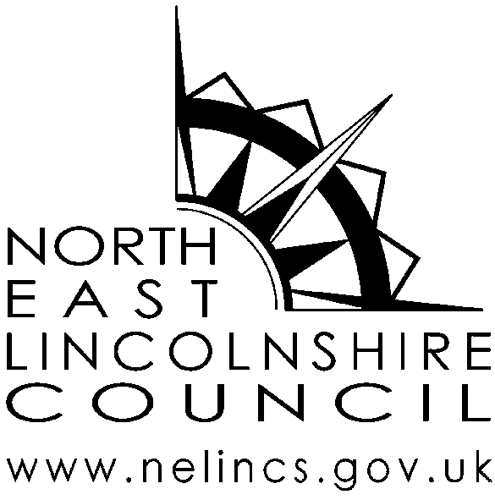 | Internal Ref: | JF1
 | Review date | 01 July 2017
 | Version No. | 01
Bus Pass photograph request form (For self)
You can request a copy of your Bus Pass photograph, for which there will be a charge of £5 per photograph.
Before issuing you with the photograph, we will need to confirm your identity.
Please use BLOCK CAPITALS and BLACK INK when completing this form
Your Details
Surname / Family Name
First name (s)
Title (Mr, Mrs, Ms, Dr etc)
Contact Address

Contact Address | Post Code:
* Contact telephone No
* Contact e-mail address
* These fields are not mandatory, but will assist us to contact you if we need to discuss your request

Declaration
- I wish to request a copy of the Bus Pass photograph held by North East Lincolnshire Council for the administration of my Buss Pass.

- I understand that a person who impersonates another or attempts to impersonate another may be guilty of committing a criminal offence and subject to prosecution
Signature |  | Date
Completed forms should be submitted at; Centre4, Wootton Road, Grimsby DN33 1HE (open 9am to 5pm Monday to Friday) along with the £5 administration charge.

 | Internal Ref: | JF2
 | Review date | 01 July 2017
 | Version No. | 01
Bus Pass photograph request form (For another person)

As part of the bus pass application process a photograph is taken. There are circumstances, such as following the death of a relative, when the next of kin may wish or need to request a copy of the photograph.

To help us find the photograph, and consider whether the photograph can be provided to you, we would ask that you please supply the following details. All requests will be considered on their own merits and in confidence. A charge of £5 per photograph is made to cover administration costs.
Please use BLOCK CAPITALS and BLACK INK when completing this form
Section 1: Your Details
Surname / Family Name
First name (s)
Title (Mr, Mrs, Ms, Dr etc)
Contact Address

(this will be the address all correspondence is sent to)

Post Code:
* Contact telephone No
* Contact e-mail address
* These fields are not mandatory, but will assist us to contact you

Section 2: Details of the person, who you would like the photograph of
Surname / Family Name
First name (s)
Title (Mr, Mrs, Ms, Dr etc)
Date of Birth
Address used for Bus Pass application

Address used for Bus Pass application | Post Code:
Their relationship to you
Section 3: Please provide details, of why you are requesting the photograph

Please note: Before providing you with the photograph you have requested, we will need to confirm your identity and that you have a justified right to request and receive the photograph.

Section 4: Declaration
- I wish to confirm that the information I have provided on this form is accurate to the best of knowledge; and

- I understand that a person who impersonates another or attempts to impersonate another may be guilty of committing a criminal offence and subject to prosecution.
Signature |  | Date
Please print name

Completed forms should be submitted at; Centre4, Wootton Road, Grimsby DN33 1HE (open 9am to 5pm Monday to Friday) along with the £5 administration charge.

