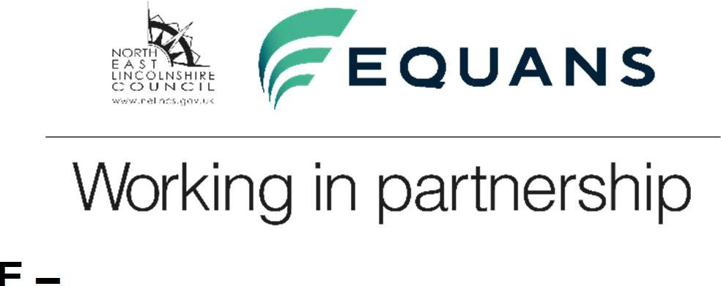
North East Lincolnshire Planning Service

OBTAINING PRE-APPLICATION ADVIC NON-DOMESTIC DEVELOPMENT
E –
GUIDANCE NOTES TO POTENTIAL PLANNING APPLICANTS.
- Informal Advice (Free)

We provide general advice either on the phone or face to face, about the planning process. Beyond this, in order to obtain site specific advice, you must first pay a fee. The schedule of fees is detailed separately.

Payment can be made by cheque, payable to Equans Services Ltd, or by debit card by contacting 01472 326289 – Option 1. If paying by card, please quote the development address or enquiry number if you have this.

Pre-Application Service

Upon payment of the correct fee, and receipt of a completed pre-application form with the required supporting documentation, we will provide comprehensive and timely pre-application advice.

As explained below, there are 3 levels of service according to the type of development planned.

Minor & Other Development:
For dwellings, minor development is one where the number of dwellings to be constructed is between 1 and 9 inclusive. Where the number of dwellings to be constructed is not decided, a site area of less than 0.5 hectares will be used as the definition of a minor development. For all other uses, a minor development is one where the floor space to be built is less than 1,000 square meters or where the site area is less than 1 hectare. Also included in this category are ‘Changes of Use’ and ‘Advertisement’ proposals.

This service includes a written response from the case officer following receipt of a valid enquiry, subject to sufficient information.

Depending on the nature of the enquiry the response will include some or all the following information:
  - Clarification about whether you need planning permission or advertisement consent if that is your request.
  - A professional opinion on whether your proposal is likely to obtain permission and if not, what changes are recommended to make it acceptable.
  - Reference to any previous applications at the site where relevant.
  - Details of the planning policies relevant to the council’s consideration of your plans.
  - Advice on whether a meeting with a case officer would be helpful

Small Scale Major Development:
For dwellings, a small-scale major development is one where the number of residential units to be constructed is between 10 and 199 (inclusive). Where the number of dwellings to be constructed is not given in the application a site area of
  - hectare and less than 4 hectares will be used as the definition of a small-scale major development. For all other uses, a small-scale major development is one where the floor space to be built is 1,000 square meters and up to 9,999 square meters or where the site area is more than1 hectare but less than 2 hectares.

This service includes:
    - Up to two pre-application meetings, the first of which will normally be scheduled within 10 working days of receiving a valid pre-application enquiry. Officers from other parts of the council and outside organizations (such as the Environment Agency and Natural England) will also be invited, and actively encouraged to participate, in at least one of these meetings.
    - A written opinion, after the final pre-application meeting, on whether your proposal is likely to obtain permission and if not, what changes are recommended to make it acceptable.
    - As part of the above, a clear scoping of the planning issues relevant to the consideration of your future application, identifying those that are of the greatest threat to the success of your application or where significant additional work is recommended. In identifying this, we will use a simple ‘traffic light’ approach so that it is clear which issues are of greatest importance.
    - Agreement of an achievable program with you and the process to be followed to achieve a planning permission, including the completion of legal agreements. If required, this can be in the form of a Planning Performance Agreement (PPA).
    - Advice on the minimum scope of information and evidence necessary so that your subsequent application will be validated upon receipt and upon any additional information or evidence that would recommend.
    - Advice on pre-application engagement with the local community, interest groups and consultees on your application so that the views of these parties are fully understood, considered and reflected within the details subsequently submitted with an application.
    - Where considered appropriate by North East Lincolnshire Council, the opportunity to present your development to elected councilors following the closure of one of the scheduled monthly Planning Committee meetings.
- Advice on opportunities to enhance your proposal.
- Intelligence on the local social and economic context for your development.
- Identification of any parallel application processes that will be needed, such as building regulations or drainage consents.
- Advice on planning conditions which are likely to be imposed so that their implications are clear and, where possible, in order that information and evidence can be submitted with the application to lessen the number of conditions and accelerate a development’s delivery.

Large Scale Major Development:
For dwellings, a large-scale major development is one where the number of residential units to be constructed is 200 or more. Where the number of residential units to be constructed is not known, a site area of 4 hectares or more will be used as the definition of a large-scale major development. For all other uses a large-scale major development is one where the floor space to be built is 10,000 square meters or more, or where the site area is 2 hectares or more.

This service includes:
- Up to three pre-application meetings, the first of which will normally be scheduled within 10 working days of receiving a valid pre-application enquiry. Officers from other parts of the council and outside organizations (such as the Environment Agency and Natural England) will also be invited, and actively encouraged to participate, in at least one of these meetings.
- A written opinion, following the final pre-application meeting, on whether your proposal is likely to obtain permission and if not, what changes are recommended to make it acceptable.
- As part of the above, a clear scoping of the planning issues relevant to the consideration of your future application, identifying those that are of the greatest threat to the success of your application or where significant additional work is recommended. In identifying this, we will use a simple ‘traffic light’ approach so that it is clear which issues are of greatest importance.
- Agreement of an achievable program with you and the process to be followed to achieve a planning permission, including the completion of legal agreements. If required, this can be in the form of a Planning Performance Agreement (PPA).
- Advice on the minimum scope of information and evidence necessary so that your subsequent application will be validated upon receipt and upon any additional information or evidence that would recommend.
- Advice on pre-application engagement with the local community, interest groups and consultees on your application so that the views of these parties are fully understood, considered and reflected within the details subsequently submitted with an application.
- Where considered appropriate by North East Lincolnshire Council, the opportunity to present your development to elected councilors following the closure of one of the scheduled monthly Planning Committee meetings.
- Advice on opportunities to enhance your proposal.
- Intelligence on the local social and economic context for your development.
- Identification of any parallel application processes that will be needed, such as building regulations or drainage consents.
- Advice on planning conditions which are likely to be imposed so that their implications are clear and, where possible, in order that information and evidence can be submitted with the application to lessen the number of conditions and accelerate a development’s delivery.

Exemptions
Exemptions to paying for pre-application advice will be applied consistent with those exemptions for planning applications (except for the last item), namely:
  - People with disabilities - The fee would be exempt if the proposed works are to create access for, or to provide for or improve the safety, health or comfort of a disabled person.
  - Registered charities - exempt if the development was in association with the charity.
  - Town and Parish Councils.
  - Listed Building applications (any works which would only require listed building consent and not a full application).
  - Applications made by North East Lincolnshire Council or upon its behalf.

