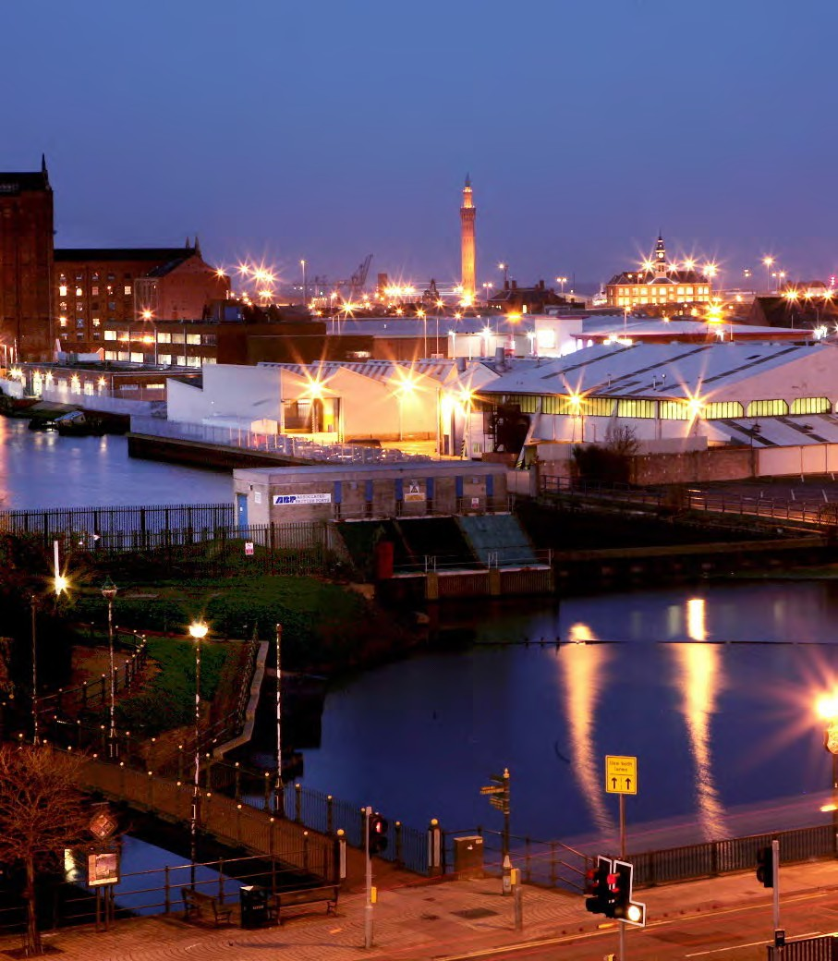

Grimsby Town Investment Plan
Submission to MHCLG

October 2020

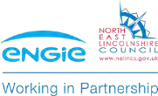

Forward

Cllr Philip Jackson
Leader, North East Lincolnshire Council

“There’s real optimism for Grimsby’s future, with many opportunities ahead for us, not least the prominence of our role to the UK’s green agenda. Therefore having a vibrant and enriched town centre that can serve the whole community is significantly important. I am pleased to support the projects identified in the Town Investment Plan and believe they will make a step change to how we build our local economy.
Change is not just desirable, but critical in recreating our town centre, this plan along with funding from the Towns Fund will be a vital tool in making the vision for our town a reality, helping to make the ‘heart of the town’ somewhere we’re all proud of.”

“’I’m proud to have led the Greater Grimsby Town Board over the past few years, working with local stakeholders and other representatives with links to Grimsby. The Board secured the first Town Deal in the country in 2018, and has been working hard to convert our ambitions for our town into reality. This next phase is our chance to look at what’s really required to create a new future and I fully endorse this Town Investment Plan. There’s now a real momentum to be harnessed around our community’s desire for change and a determination to see projects completed to enhance the lives of everyone that visits, works or lives in our great town.”

David Ross
Chair, Greater Grimsby Board

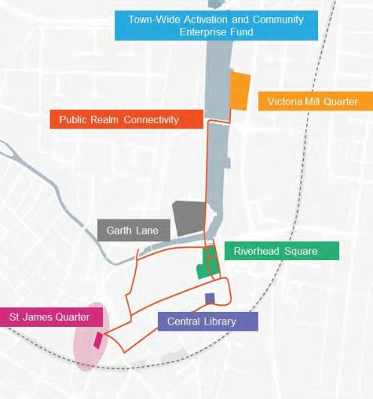
Executive summary

Grimsby was the first town to secure a Town Deal in 2018 and this support has helped unlock existing projects and leverage private sector investment into the wider region.
This includes growth in Grimsby’s offshore renewable sector and the introduction of new growth sectors into the region focused on the low carbon economy.
There is an urgent need for Grimsby town centre to retain pace with what is happening across the wider region by improving the quality of the local environment and creating a more positive environment for the private sector to invest.
A strong and successful town centre will help support even further growth across the region and ensure parts of Grimsby do not get left behind.
This is why this Town Investment Plan (TIP) is focused on delivering transformational change in the town centre. The TIP has been informed by a new masterplan for the town centre which provides the strategic context to change over the next 10 years and has been produced with extensive input from businesses, stakeholders and the public.
This TIP seeks £25m for seven projects which together, help deliver transformational change in the town centre. These projects will address the main weaknesses and challenges the town centre faces and will help deliver the ambitions of residents, businesses and other partners in Grimsby to ensure it has a bright future.

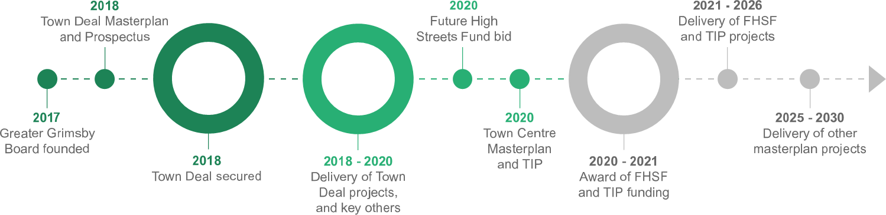
October 2020
3

Contents

Context 5

Our Strengths 6

Our Opportunities 12

Our Challenges 18

Context Summary 28

Spatial Strategy 31

Engagement 37

Vision & Strategy 42

Town Investment Plan 53

Selecting projects for the TIP 54

Project Locations for the TIP 55

Area of Focus for the TIP 57

Implementation & Delivery 81

Appendices

Appendix 1: Town Centre Masterplan 2020

Appendix 2: Local Economic Assessment 2019

Appendix 3: Stakeholder Engagement Plan 2020 Appendix 4: Theory of Change and Project Sifting

Grimsby Town Investment Plan

Context

October 2020 5

Introduction
Grimsby is a port town in North East Lincolnshire (NEL) located on the east coast of England at the mouth of the Humber Estuary. The town is the second largest conurbation in Greater Lincolnshire with a catchment of 90,000 people within a 15-minute drive, and 350,000 within a
45-minute drive. Grimsby is well connected to other towns and cities in the region by road and has good connectivity to Doncaster, Sheffield and Manchester and Manchester airport by rail.
Humberside International Airport is a 20-minute drive away. North East Lincolnshire has three towns: Grimsby and Immingham, with their ports, maritime industries and services; and Cleethorpes, a seaside resort attracting millions of visitors per year. The Lincolnshire Wolds, an Area of Outstanding Natural Beauty, lies a few miles to the south of Grimsby, offering a unique rural landscape and picturesque villages.

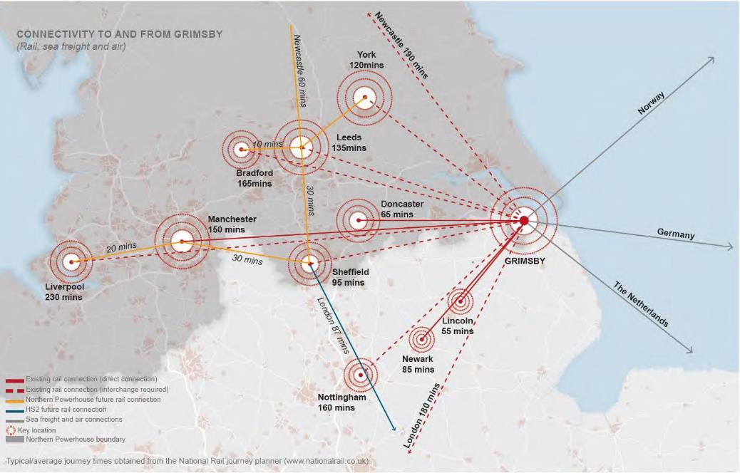
Grimsby’s strategic position in relation to the Midlands Engine and Northern Powerhouse © Arup

The Port of Grimsby and Immingham is the UK’s largest port by tonnage handling around 12% of the UK’s cargo. It serves a diverse range of industries and is an international gateway.
The Humber is also the UK’s Energy Estuary and the Port of Grimsby, located on the south bank, is recognised as the centre for operations and maintenance (O&M) services to the offshore wind farms. Now a major base for businesses such as Ørsted, E.ON, Innogy and GLID/Siemens, these global leaders in offshore renewable energy offer many high skilled jobs for the area. The rapid growth of the renewable energy industry in the UK has presented new economic opportunities for Grimsby in the last decade.
Recent announcements by Government to support the growth of the UK’s offshore renewable sector highlights the important role Grimsby will play in its future development.
‘The energy sector in North East Lincolnshire is not only important to both the UK and local economy, but also play a significant role in ensuring the UK’s fuel security.’
NELC Local Plan 2013 – 2032 [1]

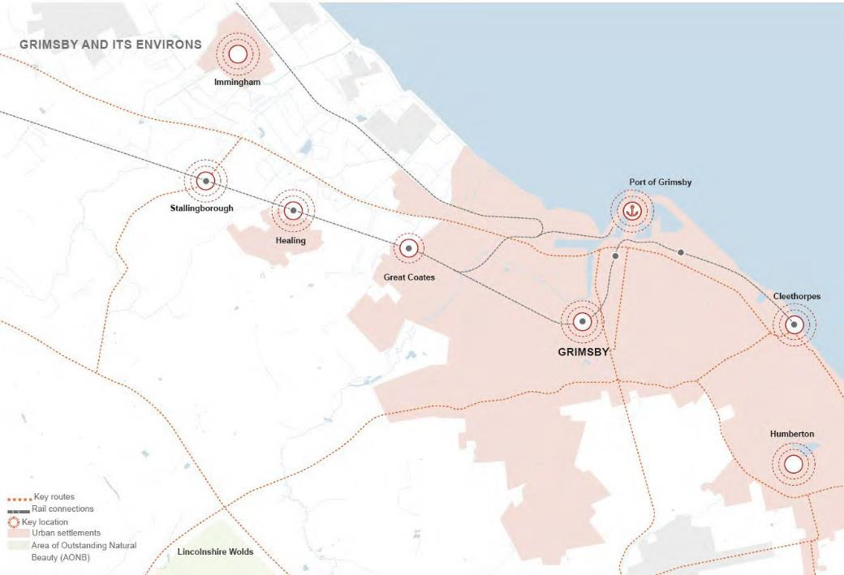
Grimsby town centre in relation to the wider North East Lincolnshire region © Arup

New era of economic growth
The creation of the Council’s flagship South Humber Industrial Investment Programme (SHIIP), a long term multi-million-pound economic growth programme founded to develop up to 195 hectares of employment land across six Enterprise Zone sites has helped to unlock major new business investment for the area.
- The Velocys (Altalto) project, a Europe-led green jet fuel plant planned for Stallingborough, will convert over half a million tons of waste per year into clean burning aviation fuel, representing a significant step change for aviation and an important step in the reduction of our carbon emissions.
- The Stallingborough Interchange has its first ‘anchor’ industrial unit in construction, with an advanced mechanical engineering company ready to take up occupancy in February 2021. Industrial sites on the south bank of the Humber are seeing new clusters of investment forming in waste to energy schemes as the pressure for sustainable models of waste recycling intensifies.
- An innovative Ecological Mitigation Scheme, a European first, has enabled the Council to turn unused land into environmental mitigation sites, protecting the natural environment whilst encouraging economic growth.
- Better connectivity and access between Grimsby and Immingham’s key employment sites and industrial development land will soon be realised, with the completion of the ‘port connector’ Humber Bank Link Road.
Strength: Emerging green sector will attract new investment and residents to the town (S6) Strength: Proven private sector interest in the future success of the town centre (S7)

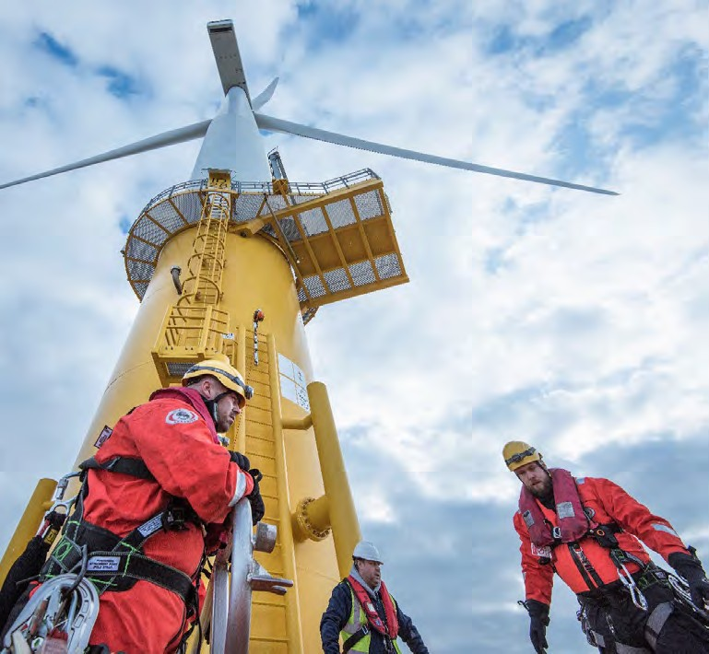
Grimsby is fast becoming the global centre of gravity for the operation and maintenance (O&M) function of the offshore wind industry © NELC

Grimsby continues to be the UK’s leading seafood cluster, home to 500+ food-related companies. Food production remains as one of Grimsby’s key employment sectors with 10% of its workforce employed in the manufacturing of food products [2], which is worth more than £2.5bn to NEL’s economy.
High on North East Lincolnshire Council’s (NELC) agenda is the move to a low carbon economy. NELC has bold ambitions to be nationally and internationally recognised as the UK’s leading region for low-carbon energy by 2032 and is pursuing new energy solutions including district heat networks and battery storage of power. The Council’s ‘Low Carbon Future’ routemap guides these ambitions. NELC supports the delivery of the Humber’s plans to decarbonise the Estuary’s energy intensive industries in a move towards clean growth, one of the four Grand Challenges of the UK Industrial Strategy.
Some exciting and innovative developments taking place include:
- Emerging UK Freeport opportunities that could open up foreign investment and high value jobs for the wider area, with the ports of Grimsby and Immingham playing a key part of a Humber bid for Freeport status;
- A direct rail connection from Grimsby and Cleethorpes to London is being actively considered;
- The Offshore Renewable Energy (ORE) Catapult project, now based in Grimsby’s Port Offices, plan to create a Centre of Excellence. This will serve as a leading testing facility for the development of next generation technologies benefiting the whole of the UK. Direct industry input into projects at the OMCE is expected to be £90m over the next 10 years[3];
- Grimsby’s Heritage Action Zone (HAZ) status has brought with it a wealth of resource and expertise from Historic England;
- The Kasbah, the local name for a collection of historic buildings on the Port of Grimsby is experiencing a renaissance, finding new purpose through a range of strategic investments;
- Grimsby Creates, one of five nationally funded cultural development programmes will place cultural activities at the heart of the town centre offer; and
- Grimsby Youth Zone, a new town centre facility, by the national charity OnSide, will renovate heritage buildings at West Haven Maltings (Garth Lane) and provide activity and leisure space for children and teenagers.
Looking to the future, Grimsby has an important role in the future economic growth of the country, in close proximity to both the Northern Powerhouse and the Midlands Engine for Growth. These attributes make Grimsby an appealing location, with process plant and manufacturing, transport and storage and a technically skilled workforce, relocating companies have a lot on offer to them.
“Improving urban quality of place is central to our plans for inclusive economic growth”
Grimsby Town Deal Prospectus (2018)

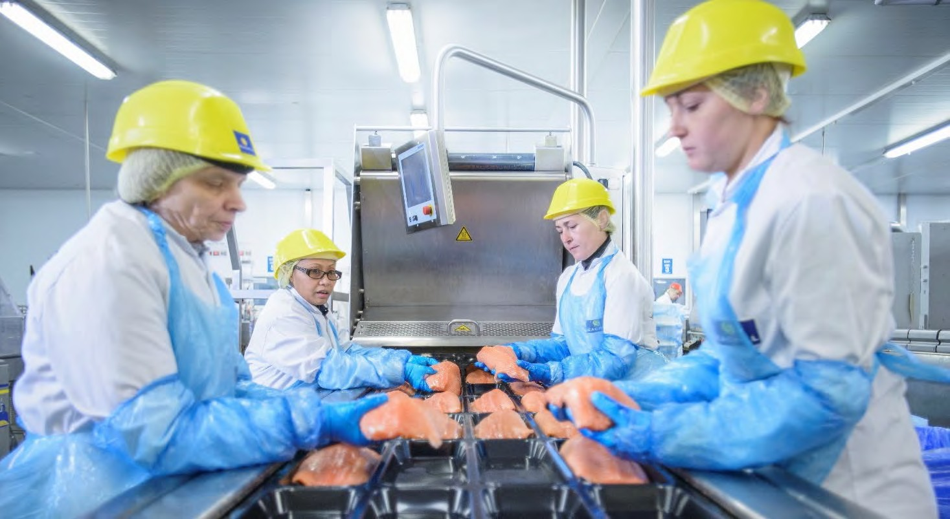
Grimsby is home to the food processing giants of Youngs, Islandic Seachill, Two Sisters, Country Style Foods and Morrisons and food processing makes up 10% of the workforce in Grimsby © NELC

Our Strengths

Grimsby – where it is and what it has to offer

A strong sense of community
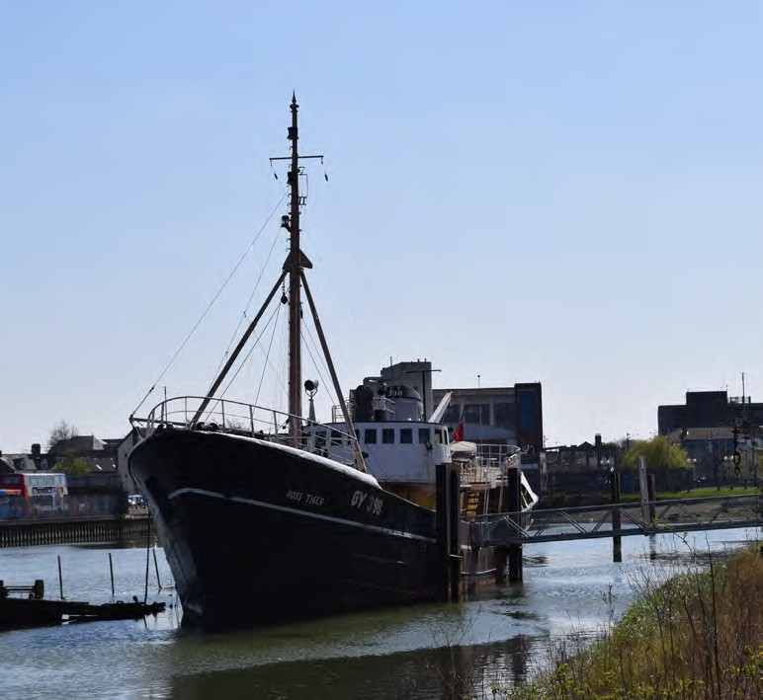
A strong history of partnership working and a commitment to public engagement are already well established in Grimsby.
Based on our stakeholder engagement (Appendix 3), we know that whilst the residents of Grimsby see lots of potential for improvement in the town centre, they are excited for the future. Similarly, the heritage and the history of the town is a huge source of pride, and residents want to make the most of their heritage assets. Stakeholders and partners are passionate about working together with NELC to create a successful Grimsby and recognise the town’s huge potential.
The voluntary and community sector is very active in Grimsby, covering skills and education, employability, heritage, arts and culture, social care, youth services, environmental sustainability and strategic input in to place initiatives through the VCSE Forum. The groups are all supported by Sector Support NEL which coordinates activity across the voluntary, community and wider third sector to enable them to meet the needs and aspirations of communities within North East Lincolnshire working as part of the Place Partnership system.

Strength: Strong community and voluntary sector (S4)
Weakness: Fragmented community ownership of the town centre despite high levels of civic pride (W2)
The Ross Tiger boat, moored on Alexandra Dock outside the Fishing Heritage Centre © NELC

Our Opportunities

The town centre today

Strong building blocks for growth
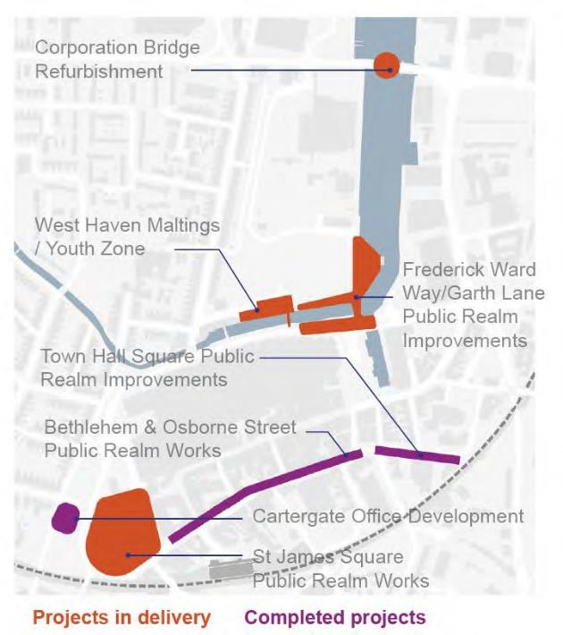
Grimsby has pipeline of available land and opportunities for development across the town centre.
Freshney Place Shopping Centre, which is in private ownership, is at the heart of the town centre and its retail catchment stretches beyond the borough boundary, reflecting the strength of Grimsby as a regional centre. Like other places, it has felt the impact from the shift in consumer habits to online retailing and is looking to adapt to the future needs of the community. A bold Future High Streets Fund scheme, seeks to create a new leisure hub by reconfiguring the retail space in Freshney Place.
The Council itself owns land in and around the town centre, including the recently acquired Garth Lane development site. In the future, as some of the larger retail sites around Alexandra Dock come forward for redevelopment, acquisitions could serve to simplify and consolidate ownership and help accelerate redevelopment opportunities.
The construction of the Cartergate offices shows there is demand for high quality office space, though fast changing work patterns are likely to lead to multi-use functionality in future such developments.
Enhancements to public realm such as St James Square and areas around the waterfront will help to add interest in the development of vacant sites.

Strength: Supply of vacant or underused buildings, some in Council ownership (S5)

Completed projects and projects in delivery around Grimsby town centre

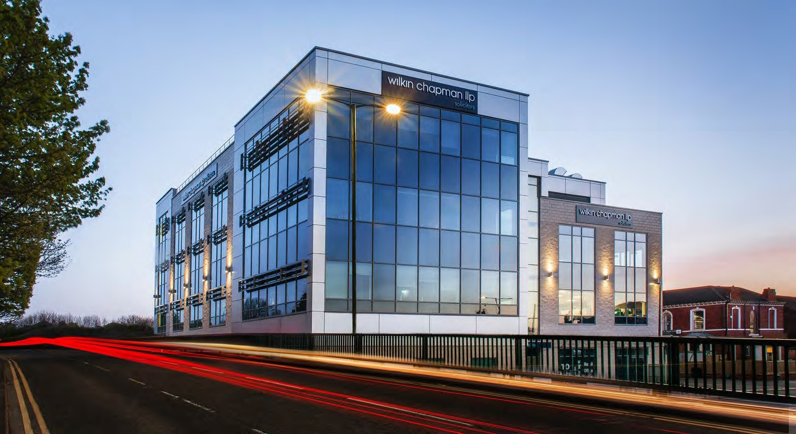

The latest addition to Grimsby’s commercial stock, Cartergate House, keeping 300 jobs in the town centre © NELC

Our Opportunities

The town centre today

Fostering innovation and entrepreneurial spirit
Innovation is an important contributor to economic growth giving businesses a competitive edge and improving productivity.
Grimsby’s high number of start-up companies ranks it in the top ten towns and cities in the UK [4] and there is well established business support provision delivered by organisations like E-Factor. Business support services in the town centre have been highly successful in recent years, providing start-up and scale up space to local businesses, as well as networking and coaching opportunities.
A cluster of flexible work spaces is emerging in the Kasbah (at the Port) focussed on the creative industries and food sectors, helping to bring back into use unused heritage buildings. Water’s Edge Creative Studios provides office space for small businesses working within the creative sector.
Facilities like these support this entrepreneurial spirit in Grimsby, but there are few based in the town centre itself.
Several new businesses and leisure ideas have emerged in recent years including the independent brewery - Docks Beer, craft markets, the ‘Great Grimsby Food Fight’ street food event at Freeman Street Market, the Labyrinth Escape Rooms, and a drive-in cinema as a result of Covid-19. These initiatives have already proved successful amongst families and young professionals, demonstrating demand and potential for new leisure offers.

Strength: Growing demand for more activities and leisure uses and an afternoon to evening economy (S8)
Strength: Emerging culture of entrepreneurship and creative sectors (S9)

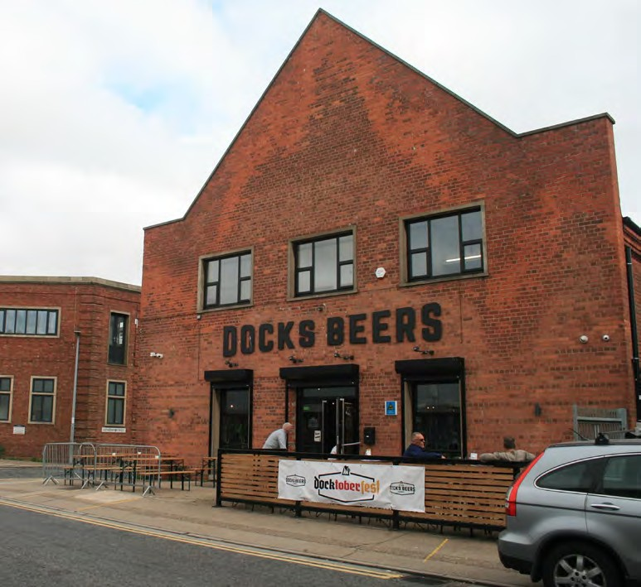
Docks Bears, a brewery and food an drink venue providing a new offering to Grimsby

Our Opportunities
The town centre today

Movement and connectivity in Grimsby
The town centre is easy to access by private car with plenty of options for town centre parking. However, there are some pinch points on the roads at peak times due to the dominance of car travel in Grimsby.
Bus connections are relatively frequent, although public transport usage is low, with just over 10% using public transport to commute to Grimsby [5].
There is a need to provide more local level connections into and within the town centre, making it easier to move around on foot and by bike and reducing the severance effect caused by the road network in key places.
Around 85% of Grimsby postcodes are served by superfast broadband, but greater digital connectivity across the town centre would help people and businesses access online services [6]. Digital skills can help people feel part of a community and can help individuals manage their physical and mental health and wellbeing.
Grimsby town centre has strong physical assets; it is a town of walkable scale, has landmark heritage buildings, a waterfront location and a good transport network. What Grimsby town centre needs now is to better connect and purpose these assets such that they draw in and contribute to Grimsby’s wider economic opportunity.

Skilled Grimsby
Significant employment growth is planned over the next decade across North East Lincolnshire, and a skilled workforce is required to support this growth. Grimsby must ensure it’s current residents are given the opportunities to train and take on this work, as well as welcoming new people to the town.
NEL is served by an estimated 300 private training providers [7] and many larger employers also have significant in-house training provision and programmes in place. Specialist industry-based training is delivered by CATCH, an industry-led partnership supporting the process, energy, engineering and renewable industries in Yorkshire and Humber.
Grimsby Institute has over 13,000 students and is one of the UK’s leading colleges for digital learning and using virtual reality and cutting-edge training it was recently awarded the status of EdTech Demonstrator College by the Department for Education, as well as Microsoft Showcase College status.

Strength: Opportunity to exploit town centre geography to improve spatial cohesion between different areas (S3)
Weakness: Poor pedestrian and cycling connectivity throughout the town centre (W1)

Our Opportunities

The town centre today

Embracing Grimsby’s rich culture
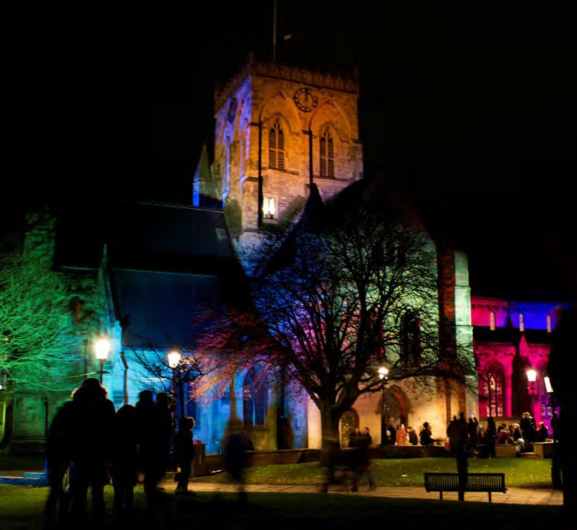
Grimsby has a strong history and a close relationship with the sea. Its waterfront and its historic assets gives Grimsby fantastic scope to differentiate itself from other towns and cities and generate a positive interest in the town.
The Fishing Heritage Centre at Alexandra Dockside is a museum depicting the heyday of Grimsby’s world famous fishing fleet. It celebrates Grimsby’s heritage in a unique way and holds a number of awards including Trip Advisor Hall of Fame.
As well as iconic heritage buildings there are other heritage assets like the local history library, archives and museum collection and the historic fishing vessels, the Ross Tiger and Esther located at Alexandra Dock and Corporation Bridge. Restoration, protection and better promotion of all these assets including better connectivity between their locations and the town centre, would benefit the look and feel of the town, help to draw more visitors and help boost civic pride. Recent investment into Grimsby Creates, a Cultural Development Fund grant programme, has offered Grimsby the opportunity to focus on growing its cultural and creative sector.
Grimsby’s waterfront location is another key asset, both commercially and physically, with many people associating Grimsby with its rich maritime past. Whilst the town centre sits between the River Freshney and Alexandra Dock, the proximity of the town centre to the waterfront is not being maximised.
Strength: Distinctive and plentiful heritage assets from Grimsby’s industrial past (S1)
Strength: Unique water spaces with huge potential but currently underutilised and inaccessible (S2)

The Minster lit up for Grimsby’s Christmas Lights © NELC

Our Opportunities

The town centre today

Green Grimsby
The low carbon economy is a national priority for growth, with ‘clean growth’ identified as one of the grand challenges which will transform our future.
Adopting a zero-carbon agenda must be at the forefront of any transformation taking place in the town centre. Where existing buildings are renovated, energy efficiency and energy saving technologies must be integrated.
Improving the quality of the natural environment, for example enhancing the waterfront and natural biodiversity of the River Freshney, will help create attractive areas of interest and help the community to reconnect with the town’s natural assets.
St James Square, a key heritage quarter of the town, offers an area of open space for people to enjoy and is benefiting from recent investment to further enhance it. The River Freshney and Alexandra Dock can be seen from key points around the town, but these strong and unique natural assets need to become focal points with improved accessibility.

Weakness: Lack of good quality, inviting and safe public realm (W7)

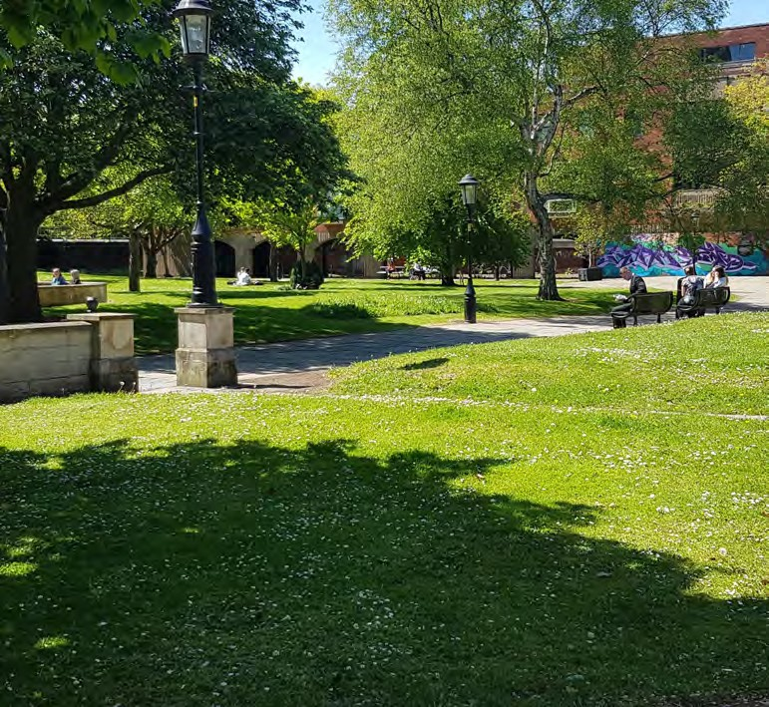
St James Square, currently under redevelopment, is one of the only public squares in the town today © NELC

Our Challenges

The town centre today

Despite its size and catchment area, the town is under-performing.

88.6k
population
(up just 1% since 2001)

68% rise in age 65+ by 2040
(18% fall in 0-24 population)
53% of employment
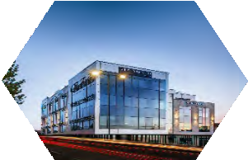
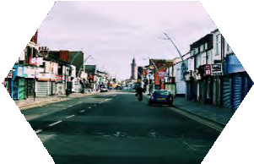
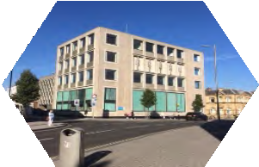
at risk from Covid-
19 restrictions 20% of workforce
are process, plant or machine

-5.2%
employment growth
(2015-2018)

£23,526
average household income
(25% lower than England & Wales)

1 in 3 LSOAs
in NEL are among England’s 10% most deprived
operators 12%
of Grimsby pop. have no qualifications
(8% in the UK)

October 2020 18

Our Challenges
The town centre today

Mismatch between district-wide growth and the capacity of the local labour market
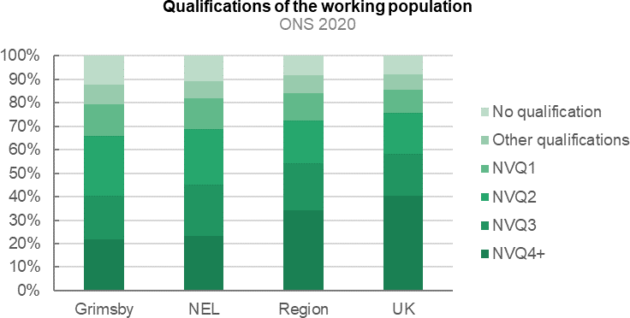
There is increasing investment in the wider Grimsby region with continued growth expected in Grimsby’s key industries. Velocys, a joint venture between British Airways and Shell to produce the UK’s first waste to jet fuel project in Stallingborough, is envisaged to bring ‘hundreds of millions of pounds of investment’ [8]. The Offshore Wind and Renewable Energy (ORE) catapult has a base in Grimsby and the town is already servicing Rounds 1 and 2 offshore wind farms through EON, Ørsted and Siemens who have chosen to locate in the area.
These examples indicate the appeal of the Greater Grimsby area to companies who will need to attract a skilled workforce of local and external labour. Whilst investment in these industries presents huge opportunities and illustrates responsiveness to new global trends such as digitalisation, automation and climate change, there is also a risk that the town centre and Grimsby’s residents are ‘left behind’.

The town’s employment profile shows that the local labour force is not equipped to adapt to working in sectors that contribute most to enhanced productivity and economic growth and there is a mismatch between the district wide growth and the capacity of the local labour market to participate in the emerging and growing markets.
NE Lincolnshire is ranked one of the most deprived council areas in terms of skills and education [9]. Accounting for over 60% of the population, Grimsby has an even higher proportion of the population with no qualifications or low-level qualifications than the NEL, Yorkshire and Humber or UK average [10].

NEL is one of the most deprived council areas in terms of skills and education in the UK

Our Challenges

The town centre today

Mismatch between district-wide growth and the capacity of the local labour market

NEL also has higher levels of economic inactivity amongst women, people aged 25-49 and the BME population when compared to the national picture [11]. This challenge needs addressing to ensure growth is inclusive.
Projected change in Grimsby’s demographics could also present a challenge. With a working age population (people aged between 16 and 64 years) of approximately 96,500, the economic activity rate was 75% in both Grimsby and NEL, which is lower than the economic activity rates observed in the region (77%), the Greater Lincolnshire and the Humber Local Economic Partnerships (78%), and the UK average (79%) [12].
The size of the economically active population in NEL has also been decreasing slower than the working age population [13], suggesting that factors other than the ageing population are contributing to the smaller than average labour force. Poor perception of the living environment and low retention of graduates within the region are two possible causes.

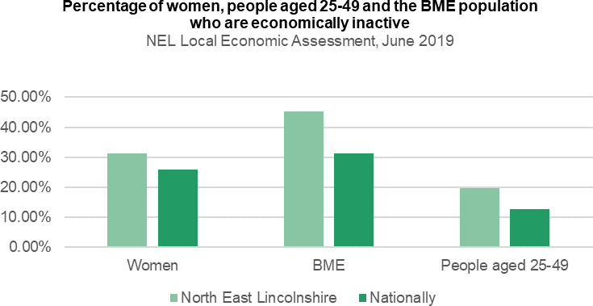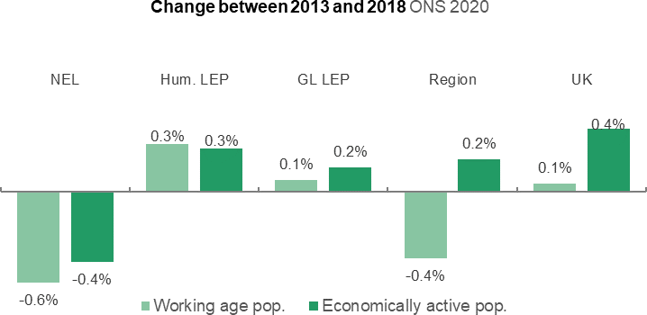

NEL has high levels of economic inactivity amongst women, people aged 25 to 49 and the BME population
The proportion of the economically active population in NEL has been falling more slowly than the working age population

Our Challenges

The town centre today

Vulnerability to automation
In comparison to the regional and national occupational structures, Grimsby’s current structure is heavily focussed on manual occupations as opposed to a knowledge-based economy.
According to the ONS, process, plant or machine operators and elementary occupations are amongst the most exposed to automation [14] . This presents a challenge for the town, as both of these occupations make up a high proportion of Grimsby’s workforce. For example, process, plant or machine operators represent the largest proportion of the town’s labour force (19.8%), compared to the UK (6.2%) and North East Lincolnshire (15.4%) [15] (see following page). As automation becomes more prevalent, and cheaper to invest in, industries which have traditionally been reliant on

people, such as food processing, may require fewer employees, or employees with different skills.
The town’s residents must be able to adapt by bridging the skills gap and sparking entrepreneurship, supply chain and related services growth to better connect with higher value employment opportunities.

Weakness: Low skill levels amongst Grimsby residents and high risk of automation (W3)

Sectoral employment in Grimsby ONS 2019
1% 1% 2%
 | 17% | 3% |  | 4% | 11% | 5% | 4%

20%

10%

5%

9%

2%

5%
2%
0% 1%
Agriculture, forestry & fishing Mining, quarrying & utilities Manufacturing Construction
Motor trades Wholesale Retail Transport & storage Accommodation & food services Information & communication Financial & insurance Property Professional, scientific & technical Business administration & support services Public administration & defence Education
Health Arts, entertainment, recreation & other services

Share of professional occupations by area in 2019 ONS 2020

100%

90%

80%

70%

60%

50%

40%

30%

20%

10%

0%
England

Yorkshire and the Humber North East Lincolnshire

Grimsby

Corporate Managers and Directors Other Managers and Proprietors
Science, Research, Engineering and Technology Professionals Business, Media and Public Service Professionals
Science, Engineering and Technology Associate Professionals Health and Social Care Associate Professionals
Culture, Media and Sports Occupations Business and Public Service Associate Professionals
Administrative Occupations Secretarial and Related Occupations
Textiles, Printing and Other Skilled Trades Leisure, Travel and Related Personal Service Occupations
Sales Occupations Customer Service Occupations
Elementary Administration and Service Occupations

In comparison to the regional and national occupational structures, Grimsby’s current structure is heavily focussed on manual occupations as opposed to a knowledge-based economy.

Our Challenges

The town centre today

A town centre focused on retail and lacking a sense of place
Grimsby town centre is dominated by retail uses and the poor perception of the local environment and personal safety within the town centre contributes to lower footfall and limited dwell time within Grimsby, particularly in the evening.
Of 492 registered commercial properties in Grimsby, 29 are currently vacant, representing around 6% [16]. Footfall data collected by North East Lincolnshire Council between 2014 to present, shows a decline in footfall within Grimsby town centre each year since 2014, with the month with the highest monthly footfall [17] in 2019 reaching only 58% of the highest monthly footfall in 2014.
These issues are exacerbated by the few leisure activities within the town, the town’s declining quality of ageing assets and the large supply of retail space, as evidenced in the chart opposite. For example, the Freshney Place shopping centre has seen falling rents, with some tenants leaving altogether. The current mix of uses within the town centre fails to draw on Grimsby’s identity as a port town and contributes to the town lacking a sense of ‘place’.

Number of registered commercial properties within Grimsby categorised by land use

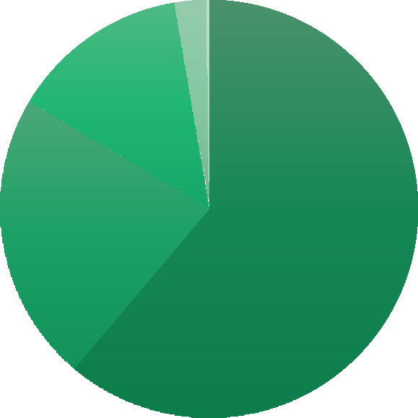
CoStar 2020
3% 0%
14%
22%
61%

Retail Office
Industrial / Light Industrial
Land Health Care

Our Challenges

The town centre today

Need for high quality housing in the town centre
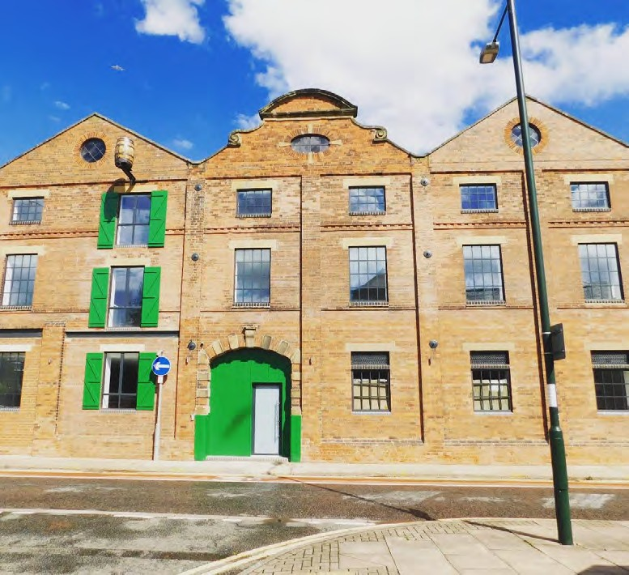
There is currently little residential use in the town centre and a more varied residential offer is required to attract a range of economic groups including professionals from emerging and growth industrial sectors.
North East Lincolnshire’s housing stock contains a higher proportion of terraced properties (33%) compared to the national average (25%), but a lower proportion of detached and flatted properties [18].
Recent analysis [19] found that ‘the performance of the housing stock in North East Lincolnshire compared to the EHS (English Housing Survey) England average is mixed, with North East Lincolnshire performing slightly better for excess cold, disrepair and low income households but worse for all hazards, fall hazards and fuel poverty’, with the private rented sector generally performing worse than the social and owner-occupier sectors.

Weakness: Dominance of retail space in the town centre and lack of residential (W6)
The Cooperage is one of only a few recent residential developments in the town centre © NELC

Our Challenges

The town centre today

Improving wellbeing in the town centre
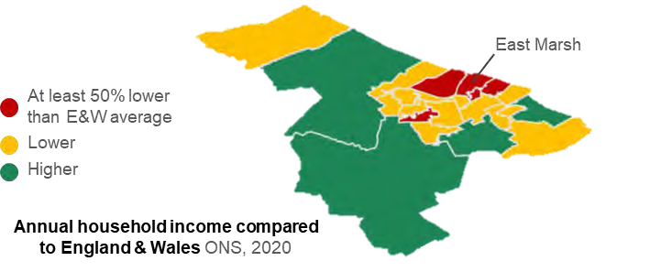
As measured by the 2015 Index of Multiple Deprivation, North East Lincolnshire was the 31st most deprived of the 326 local authorities in England, a worsening relative position compared with 2010’s rank of 46th. Certain wards, such as East Marsh, face higher concentrations of deprivation with seven out of the eight neighbourhoods in the area amongst the 10% of the most deprived in the country [20] Low income and deprivation are also wider determinants of health.
The health of people in NEL is lower than the average for England, and the life expectancy for both men and women is shorter than nationally. For example, the adult population in NEL are less physically active and more likely to be classified as overweight than the England Average [21] .

North East Lincolnshire was the 31st most deprived of the 326 local authorities in England

Weakness: Perception of the town centre as an attractor of ASB and unwanted behaviours (W4)
Weakness: High levels of deprivation and poor health outcomes (W5)

Our Challenges

The town centre today

Need for ongoing Investment in business facilities and skills
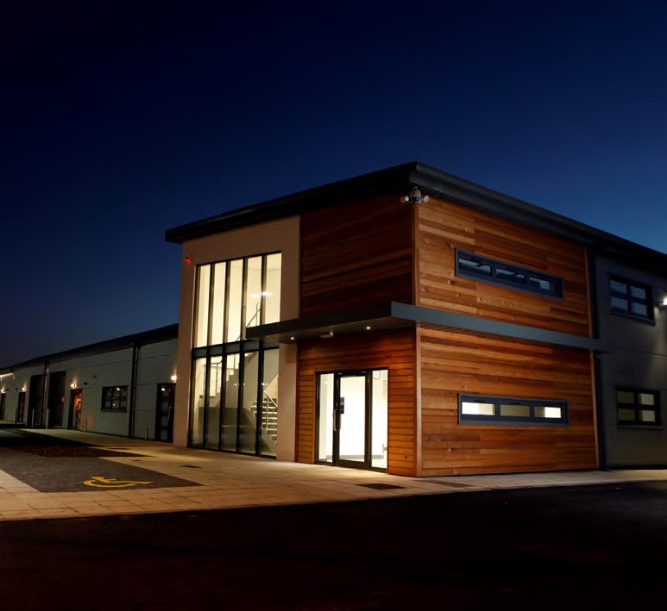
The area surrounding the town centre offers various commercial space for local business, such as E-Factor’s Business Hive, providing incubation space and industrial units and offices at their Enterprise Village which due to high demand, is currently undergoing a 7 unit expansion. Freeman St Market Hub and Water’s Edge Creative also offer office rental space.
Demand remains high for small business premises as well as the need to collaborate, innovate and scale-up.
Developing digital skills is important for existing and emerging businesses, aided by proximity to educational establishments such as the University of Lincoln and the Grimsby Institute. This will be a hugely important sector to support and grow as we learn and adapt from the Covid-19 pandemic.

Weakness: Limited availability of start-up and scale-up space (W8)

E-Factor, a shared workspace and business support offer in Grimsby, is at capacity © E-Factor

Our Challenges

Impact of Covid-19

How the pandemic has exacerbated challenges
With a negative employment growth rate of -5.2% between 2015 to 2018, Grimsby’s growth was already lower than the national and regional average (3.7% and 2.9% respectively) prior to the pandemic [23]. Unemployment was also higher, with a claimant count of 4.1%, compared to national and regional averages (1.6% and 1.9%) [23]. Whilst some issues have evidently been long-standing, Covid-19 has exacerbated existing challenges.
Only 5% of businesses were back fully operational
in comparison to partially back or temporarily closed
53% of respondents were currently less busy than expected
28% of businesses would find advice on funding and finance, tailored 1:1 online / telephone business advice and support useful if available.
Accessibility of a correctly skilled workforce was deemed the most important factor to the future growth of businesses beyond the pandemic.
(highest % of respondents selected this)
70% reported a turnover lower than previous years
In light of the pandemic, 52.8% of employment within Grimsby is classified within ‘at risk’ categories [24], higher than both the national (48.9%) and regional (51.4%) average. Given the low skill levels within Grimsby, it may also be more difficult for those impacted to adapt. In September 2020 NELC conducted a Business Recovery survey of businesses, the results of which are presented opposite [25].
The impact of the pandemic has not been felt equally across all sectors, with pubs and restaurants, accommodation, non-food retail and arts & leisure all disproportionately affected [26]. This is a concern for Grimsby town centre, given its retail dominance, and only emphasises the importance of moving away from its reliance on retail and towards new uses
The pandemic has also highlighted the need for safe and welcoming spaces indoors and outdoors in the town centre.

Context Summary

Town centre strengths, opportunities and challenges

Grimsby faces some challenges, but has strong assets to build from
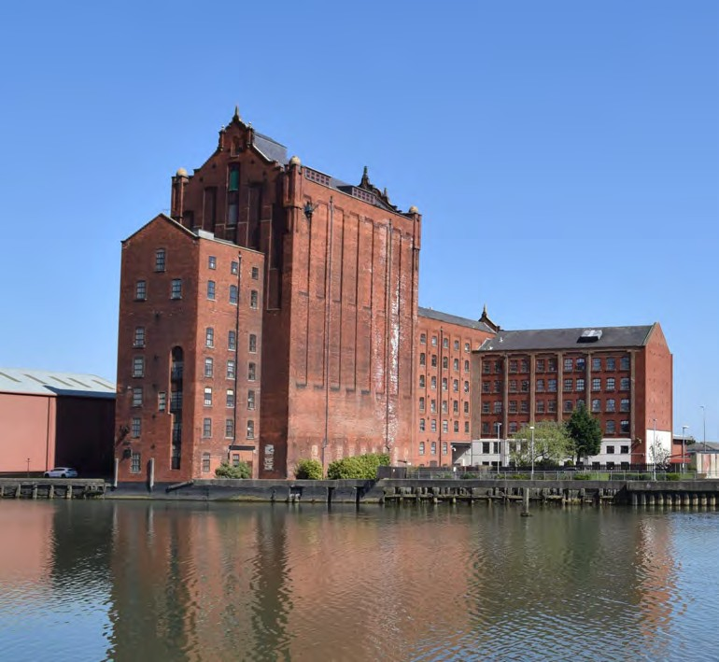
Grimsby has a host of assets including strong and varied industrial sectors, a pipeline of investment, investment in the public realm, and unique heritage and culture. However, skill levels are low, and many jobs in the town’s traditional industries are likely to be at risk of automation in the future. Supporting an environment for innovation and enterprise and raising the aspirations and wellbeing of local people is key to unlocking future economic growth.
Whilst investment is taking place in the wider region, the town centre is not receiving the same amount of investment from the private sector and there is a danger it gets “left behind” and continues to deteriorate. Creating a stronger and more attractive town centre for the private sector to invest in will add further strength to the region as a whole and be catalytic in helping to make Grimsby an even more attractive place to invest.
The following is a summary of the strengths Grimsby should build upon, and the weaknesses that it should address to become an attractive and vibrant place. These principles have been key in determining the vision for the TIP.

Alexandra Dockside and the buildings around it represent a significant development opportunity in Grimsby

Context Summary

Town centre strengths

S1: Distinctive and plentiful heritage assets from Grimsby’s industrial past | Grimsby’s rich history has resulted in landmark heritage assets across the town: Grimsby Minster, Corporation  Bridge, and Victoria Mill.
S2: Unique water spaces with huge potential but currently underutilised and inaccessible | The water is both a commercial and physical asset for Grimsby, with the town centre sitting between the River  Freshney and Alexandra Dock.
S3: Opportunity to exploit town centre geography to improve spatial cohesion between different areas | Grimsby town centre is flat and of walkable scale, but would benefit from better connectivity around the dock,  across the town centre and beyond.
S4: Strong community and voluntary sector | Wide range of voluntary and community organisations who have a strong voice in the town and decision-  making.
S5: Healthy supply of vacant or underused buildings, some in Council ownership | Approximately 6% of Grimsby’s registered commercial properties are vacant. Historic vacant buildings will provide key opportunities to build on  the town’s identity and sense of place.

S6: Emerging green sector will attract new investment and residents to the town | Grimsby’s competitive position in the offshore wind industry presents a key opportunity for the town to be at the centre of the renewables sector and support the Government’s clean growth  agenda.
S7: Proven private sector interest in the future success of the town centre | Grimsby town centre must meet the aspirations of the businesses investing in the region if it is to capture the opportunities presented by such  investments.
S8: Growing demand for more activities and leisure uses and an afternoon to evening economy | New businesses and leisure offers have emerged in recent years, attracting people into the town centre and proving successful particularly  amongst young professionals.
S9: Emerging culture of entrepreneurship and creative sectors | Recent success stories in terms of new leisure offers, business growth services and evidence of an emerging creative  sector.

Context Summary Town centre challenges

W1: Poor pedestrian and cycling connectivity throughout the town centre | The town centre has poor quality pedestrian routes, exacerbated by the dominance of main roads, and the  severance caused by the railway.
W2: Fragmented community ownership of the town centre despite high levels of civic pride | Disassociation of residents from the town centre as it is now, but strong sense of civic pride and hope for the future.
W3: Low skill levels amongst Grimsby residents and high risk of automation | The skills and qualifications of residents in Grimsby lag behind regional and national levels and the occupations that are most exposed to automation make up a high proportion  of Grimsby’s workforce.
W4: Perception of the town centre as an attractor of ASB and unwanted behaviours | There is a poor perception of the living environment and safety within the town centre, contributing to low footfall and dwell time.
W5: High levels of deprivation and poor health outcomes | The old industrial areas surrounding the port in Grimsby are one of the most  deprived areas within the region.

W6: Dominance of retail space in the town centre and lack of residential | The current mix of uses within the town centre fails to draw on Grimsby’s identity as a port town and contributes  to the town lacking a sense of ‘place’.
W7: Lack of good quality, inviting and safe public realm | Many of the high-quality open spaces are beyond the town centre itself, and current public realm offer is of low- quality and are not suited to hosting activities/events; Alexandra Dock is not  accessible.
W8: Limited availability of start-up and scale-up space | Current flexible workspaces are at capacity and are looking for places to  expand.

Grimsby Town Investment Plan

Spatial Strategy

October 2020 31

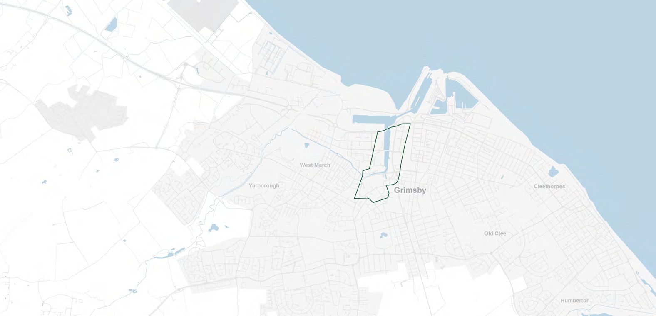

1st tenant, Myenergi, secured for 2021

South Humber Industrial
Stallingborough Interchange EZ business park
Investment Programme
£42m
Ecological Mitigation Scheme
172 acres

Grimsby West Housing Development 3,335 homes
Humber Bank Link Road connecting Grimsby and Immingham ports

Velocy’s (Altalto) green aviation jet fuel investment
£300m+

King’s Park Scartho
Recent investments Planned investments Housing delivery
Town centre investments
76 homes

Grimsby to Immingham Cycle Superhighway Project
c.£2.6m

Europarc Business Park expansion; Phases III and IV

St James Square and Garth Lane
£5.3m

Energy centre heat network at Grimsby Hospital

Emerging UK Freeport opportunities

Grimsby Institute of Further & Higher Education redevelopment

Port of Grimsby ORE Catapult Centre of Excellence c.£35m

Enrolled Freemen of Grimsby masterplan for Freeman St.

Clee Meadows 250 homes

Further offshore wind
farm investment planned for the Port of Grimsby

6 operational wind farms serviced from Port of Grimsby incl. Hornsea 1 (largest in the world)

Cleethorpes Public Realm investment
£7.2m

There is increasing investment in the ‘locality’ of Grimsby and growth is expected within Grimsby’s key industries. There is no doubt that the investment these industries bring presents huge opportunities and illustrates responsiveness to new global trends such as digitalisation, automation and climate change. The South Humber Industrial Investment Programme, Associated British Ports masterplan for the Port of Grimsby, and the Enrolled Freemen of Grimsby’s health campus plans on Freeman Street are all helping to bring forward new districts in the area, driven by the private sector, and supported by NELC.
However this growth, investment, and arrival of emerging sectors are, for the most part, taking place outside the core town centre and there is a risk that the town centre and Grimsby’s residents are ‘left behind’; indeed stakeholders told us that the town centre is at risk of ‘hollowing out’ if some scale of redevelopment does not take place. Analysis suggests that it is the core town centre which is facing the toughest challenges, rather than areas on the edges of the town, many of which are residential. A vibrant, enriched and welcoming town centre is required to grow, attract and retain a skilled workforce; if current trends continue, the town centre will serve neither existing residents and businesses, or attract new ones.
The map on the previous page demonstrates just how much investment is being driven into North East Lincolnshire and Great Grimsby overall. The town centre has seen relatively little investment itself. Therefore, the boundary for the TIP (see next page) is more focussed than the boundary set by MHCLG, but still covers a significant proportion of the town including Alexandra Dock.

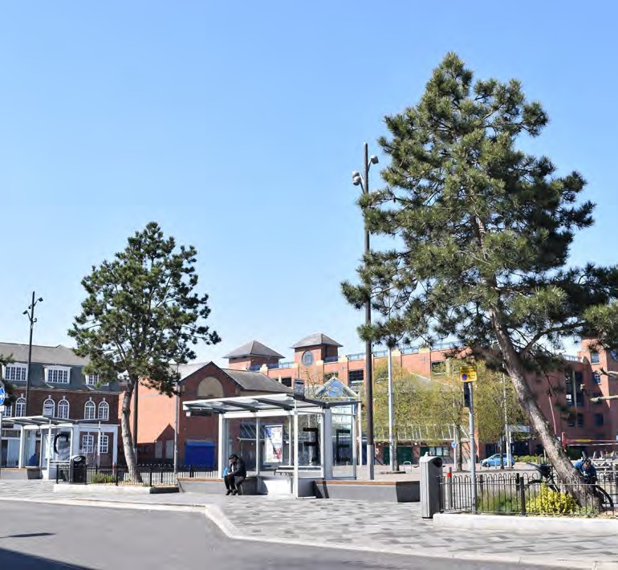
Riverhead Square sits at the heart of Grimsby town centre © NELC

Grimsby’s 2018 Pilot Town Deal - Strategic Towns Fund boundary
MHCLG 2019 Towns Fund boundary
Grimsby’s Town Investment Plan boundary

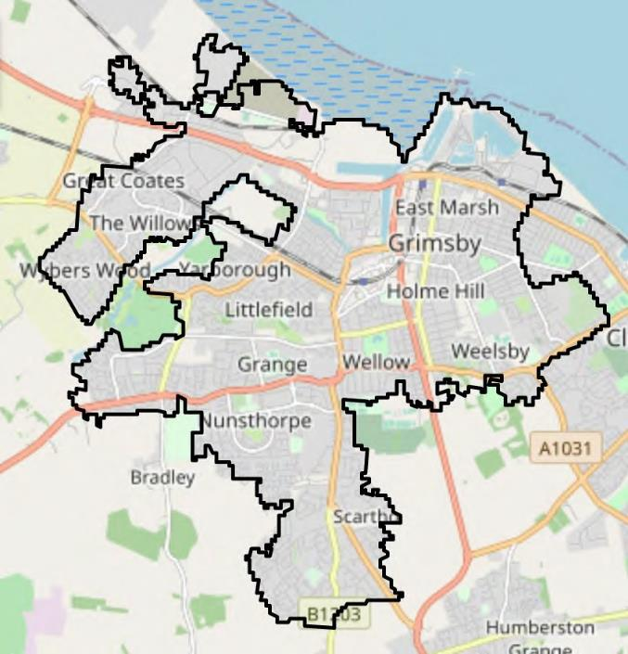
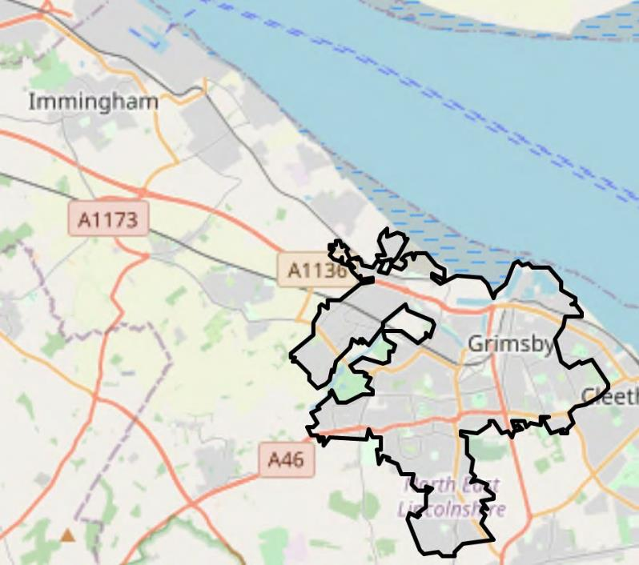
Maps showing the Grimsby’s Pilot Town Deal - Strategic Towns Fund boundary in grey, MHCLG Towns Fund boundary for Grimsby in black, and the selected boundary for the TIP and masterplan in green
© OpenStreetMap contributors, CC-BY-SA, Nomis, Arup

The programme of projects included in the Towns Fund has been developed in conjunction with a broader masterplanning exercise undertaken for the town centre. This town centre masterplan has been developed over Summer 2020, with extensive input from partners, stakeholders and the community.
The masterplan sets out a strategic vision for the town centre for the next 10 years. Each project identified in the masterplan will help achieve the long term vision for Grimsby, but those that have been selected for the Town Investment Plan are catalytic in nature; they will bring market confidence and help attract private sector investment to propel the town forward along its well-established trajectory of growth.

Town Centre Masterplan (2009)

Grimsby Town Centre 2030
Masterplan
TIP Projects
(Funded partially through Towns Fund)
Local Plan (2013 – 2032)
Economic Strategy (2016)

Projects identified in the masterplan
Town Centre Masterplan (2017)
Town Deal Prospectus (2018) MyTown public engagement (2019-2020) Local Economic Assessment (2020) Future High Street Fund (2020)
Other Masterplan Projects
(Funded through private sector Investment, Cultural Development Fund, National Lottery Heritage Fund, Homes England etc.)

Public consultation and stakeholder engagement

For both the TIP and the masterplan, it was important to ensure that the boundary would serve the needs of the town centre until 2030, and beyond. The boundary was drawn to reflect the area of highest need, and biggest opportunity in the wider Great Grimsby area. By targeting investment, from the Towns Fund as well as other funding streams, into the core, it is hoped that not only will it continue to attract private investment, but it will also create multiplier effects which over time will ripple out to the rest of the town, and it’s residents.

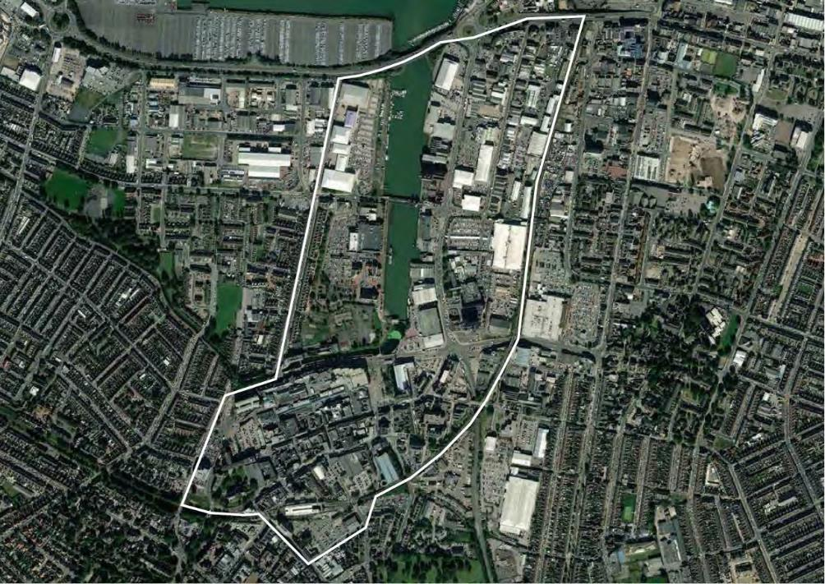
TIP and Masterplan 2020 boundary

Grimsby Town Investment Plan

Engagement

October 2020 37

How we engaged
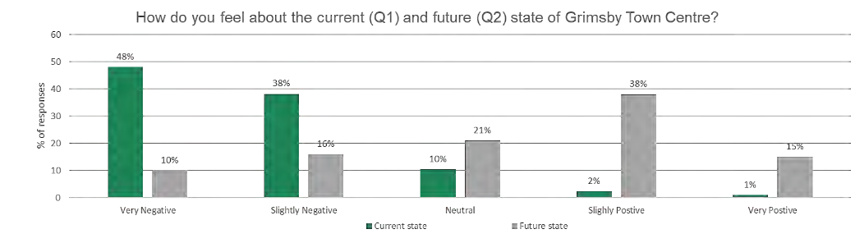
This Town Investment Plan was informed by stakeholder and public engagement during summer 2020.
A range of consultation methods were used:
- Virtual Engage, a web-based public engagement platform;
- Dedicated stakeholder meetings; and
- Stakeholder focus groups.
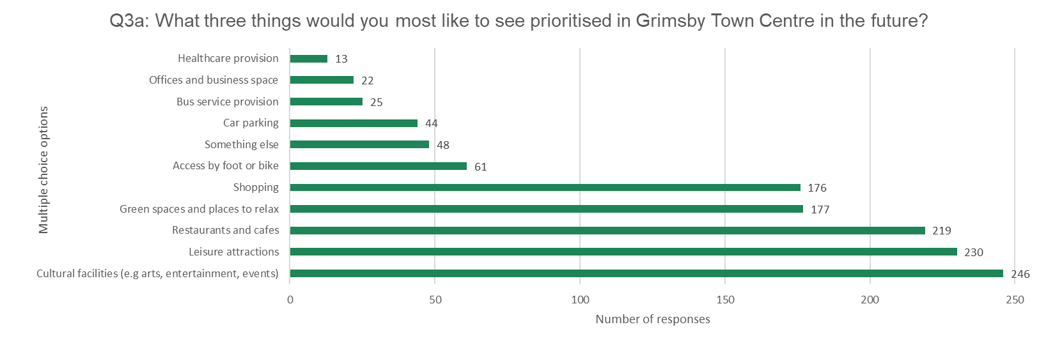
Public engagement took place, between Wednesday 15 July 2020 and Sunday 26 July 2020. An online engagement tool was used - a ‘virtual room’ giving the impression of visiting a real venue to navigate between information boards and a survey [27].
Respondents were negative about the current state of Grimsby town centre but are positive about its future.
Respondents want to see cultural facilities, leisure attractions, and restaurants and cafes as the future priorities for Grimsby town centre.
Quotes from the public consultation can be found in the following sections.

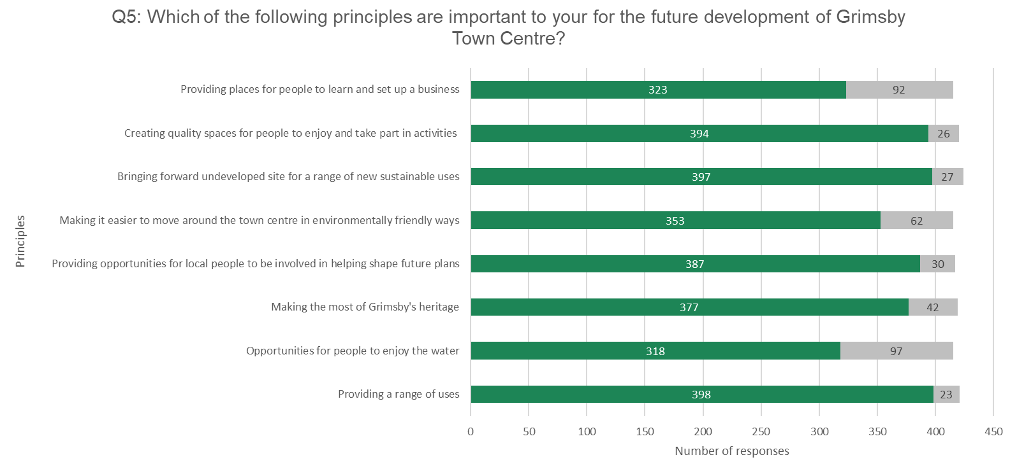
Respondents gave strong support for providing a range of uses and creating quality spaces for activities in the town centre.

Business and commercial sector views

A representative from Freshney Place Shopping Centre described how there are not currently the facilities for office workers within the town centre.
The Commercial Property Group, Development and Growth Board and existing businesses shared their views though meetings with their groups, focus groups and via the public engagement.

‘It is great to see the focus on connecting communities back to the water. We are a new industry in the town that benefits greatly from the maritime heritage of Grimsby and our connection’

‘If you look at other cities and towns they are successful because they have a strong educational offering in there town and city centre - but Grimsby doesn’t have this.’
A local property investor described how new residential development in Grimsby needs to be about communal living, access to the waterfront and greenspace

‘83% of our workforce are local to this region - so regeneration is a direct benefit to our workforce and their families.’

A representative from E Factor described how recent investment in a street food event has revitalised the leisure offer within the town centre, and similar initiatives should be employed across the town centre.

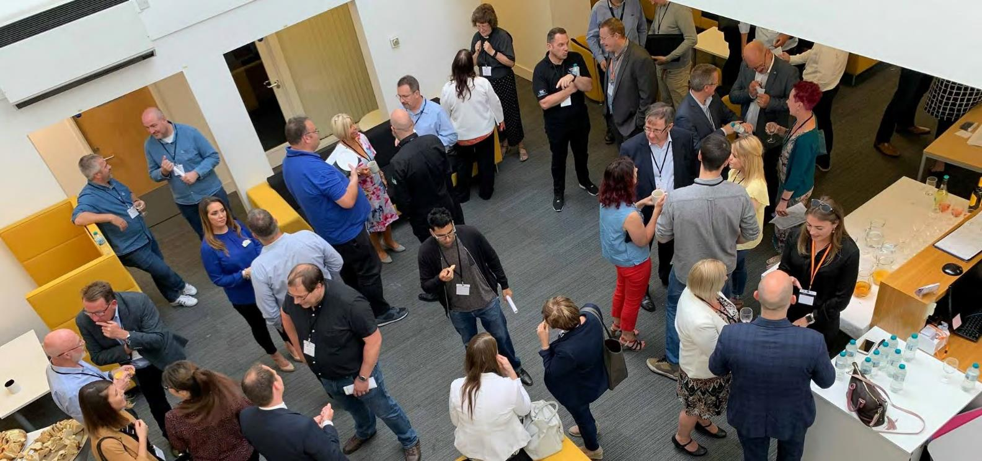

Networking events hosted by E-Factor © E-Factor

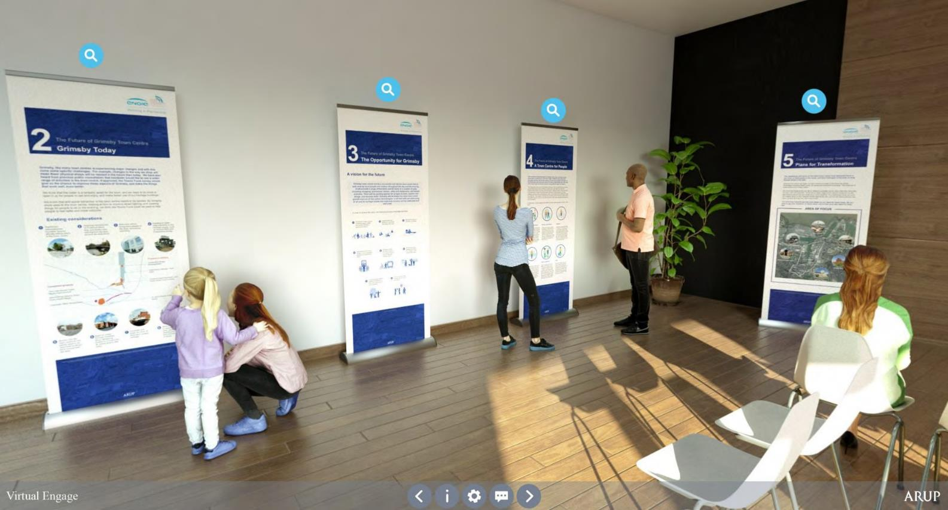

The ‘Virtual Engage’ website where the public engagement was hosted © Arup

Grimsby Town Investment Plan

Vision and Strategy

October 2020 42

This vision for Grimsby town centre, delivered through these eight principles, will be underpinned with a commitment towards promoting high levels of environmental sustainability in everything that is delivered in the town centre. This will ensure the change that is planned for the town centre makes a major contribution towards delivery of a low carbon future.
By 2030 Grimsby will be recognised globally for its contribution to the UK’s green agenda, acting as a magnet for the growth of low carbon industries, its vibrant and attractive town centre will be home to a growing business and residential community. It will have enlivened public areas and waterfront, where culture and heritage is embraced, and a broad range of activities and pastimes can be enjoyed by all.

1. Introduce more diverse uses into the town centre
2. Reconnect the town centre with the waterfront
3. Celebrate and enhance our heritage assets
4. Promote and support community ownership and participation

5. Improve permeability of the town centre
6. Identify development opportunities
7. Prioritise health and wellbeing
8. Enhance opportunities for employment, skills and enterprise

Maximising momentum
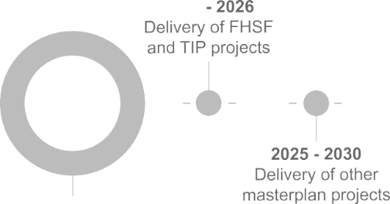
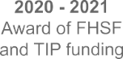
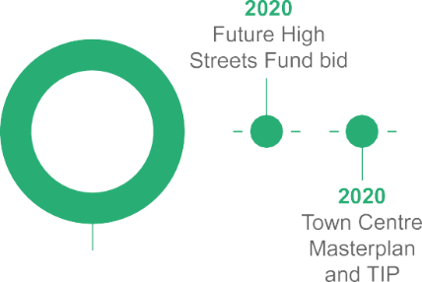
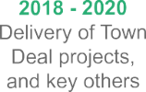
Grimsby, as the first and only town to secure a Town Deal in 2018, has the momentum, governance and partnerships in place to ensure success. The 2018 Town Deal provided a catalytic spark and there is already a strong track record of effective delivery in the town, evidenced through recently completed projects described above. This culture of delivery is based on strong partnerships, with the council taking the lead, supported by delivery partners across the town. The partnerships between the public and private sector is strong, creating a positive climate of delivery for the Town

Investment Plan. Delivering the vision requires substantial investment from a range of parties and organisations.
The Towns Fund and Future High Streets Fund would ignite a further set of projects that extend the benefits of the 2018 Town Deal and help achieve the TIP vision for real change in the prospects of those living and working in the town. The timeline below indicates how proven success in the past will help Grimsby to delivery meaningful change in the future.

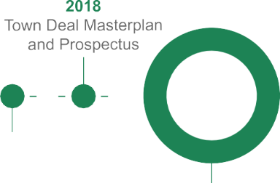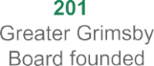
7
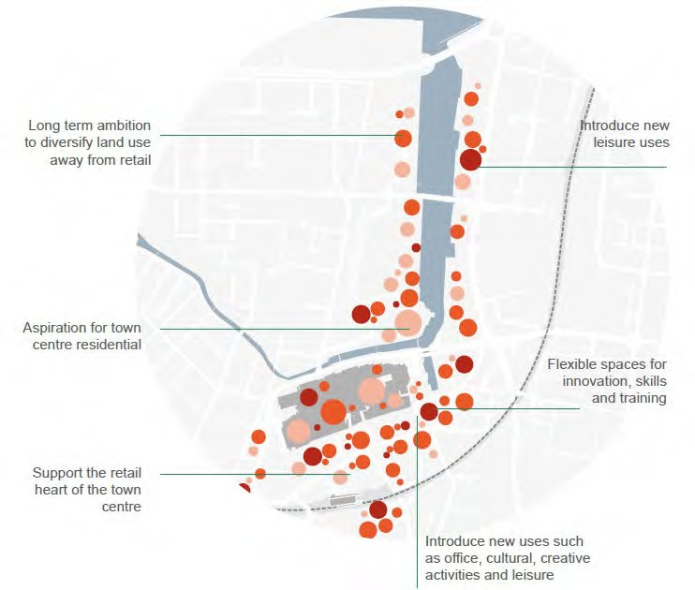

Introduce more diverse uses into the town centre
Encourages a greater mix of land uses in and around the town centre, including
- New, flexible commercial space for future businesses including those in the digital and green economy;
- New public spaces and opportunities for events and community activities;
- New residential uses, supporting a thriving and vibrant new town centre community;
- Flexible space for educational, skills and training uses; and
- A stronger mix of leisure uses that serve the needs of existing and future residents, and visitors to the town.
‘I would like to see a variety of cafes and coffee shops and local independent shops, places for meeting friends and socialising.’

‘I feel that the focus should be on leisure and recreation rather than shops.’

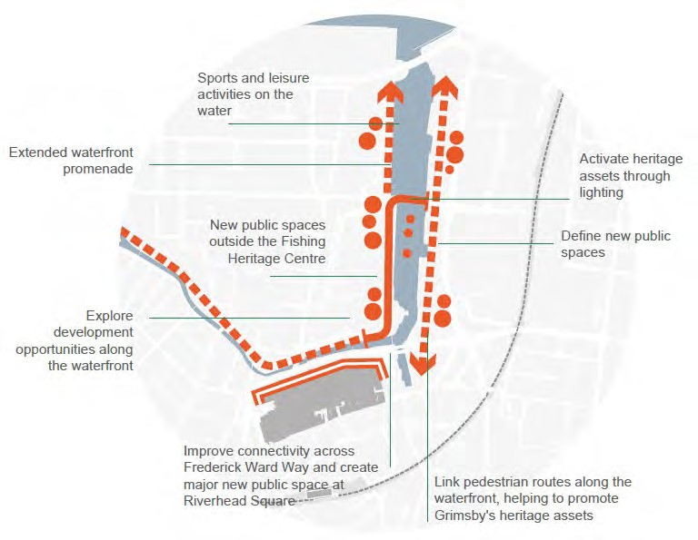
Reconnect the town centre with the waterfront
The water is a huge natural asset and improving access to it and making more of the water as a space for leisure, recreation and new uses will help bring new life into the town centre.

‘Develop an attractive waterside with footpaths connecting to other areas’
‘I would like a green space by the side of the river and a walking trail’

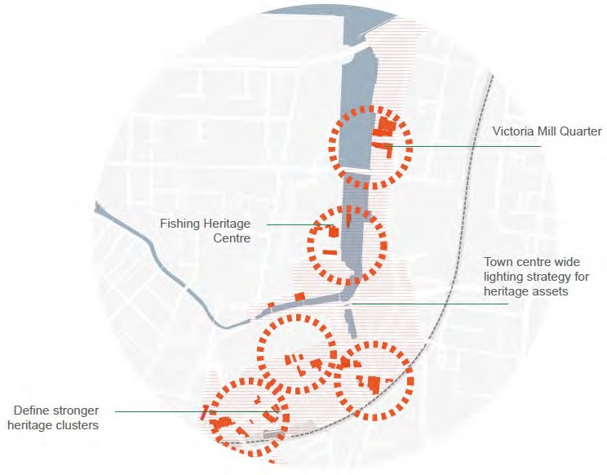
Celebrate and enhance heritage assets
The heritage of Grimsby can be found across the town in iconic buildings such as the Minster, the Victoria Mill Silo building and the Corporation Bridge.
Making these assets more connected and visible and bringing new life into these buildings will help strengthen the unique identity of Grimsby, attracting new visitors and instilling a stronger sense of pride in the town for local people.

‘Would be nice to include cycle lanes that connect all the heritage sites and key zones together.’

‘I want to see historical information hotspots such as plaques, and foot stones to narrate our past’.

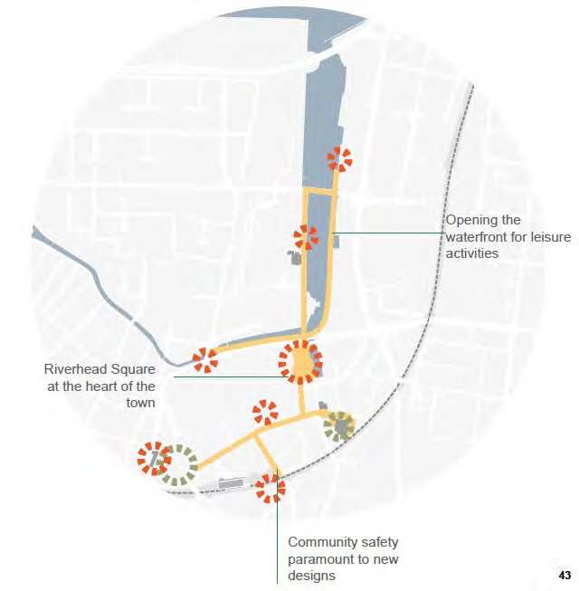

‘It should be an area that the public are welcomed into and something which we can be proud of ’.
‘I want to see the town owning our heritage’

Promote and support community ownership and participation
The pride and passion that local people have for the town is indisputable. This must be harnessed and used to create a positive wave of community- driven change and ownership of the town centre, led by the strong voluntary and community sector.

‘As well as celebrating the heritage, I also think we should celebrate the people of the town
– past and present – and create a sense of community’.

‘I want Grimsby to have communal and community space to bring people together and enable pop-up shops for temporary exhibitions’.

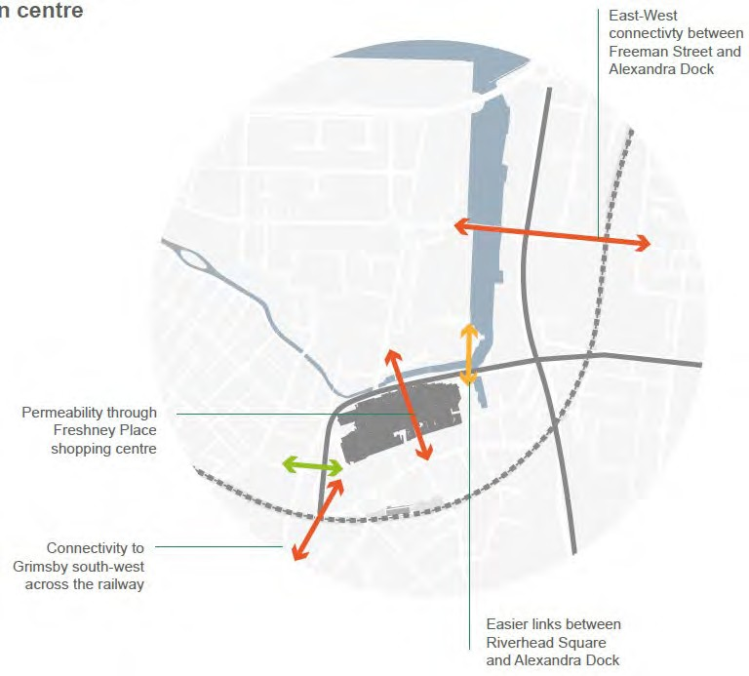

Improve permeability of the town centre
A more permeable town centre will support more active travel, contributing to health and wellbeing outcomes. Specific priorities include:
- Improving the connections between Riverhead Square and Alexandra Dock, building on work already underway at Frederick Ward Way;
- Creating new connections between St James Square and the River Freshney, including better links through the Freshney Place shopping centre;
- Enhancing east-west connectivity between Freeman Street and Victoria Street/Alexandra Dock including crossing of the railway;
- Strengthening connections south of the town centre including improvements to existing crossings of the railway; and
- Opportunities for improved north-south connectivity between Freeman Street, Alexandra Dock and the heritage assets in the Kasbah area.

‘Provide connections by better signage and wayfinding linking all the town’.

‘Movement between shopping areas should be easier… attractive routes should be in place and lined with shops to encourage use particularly for pedestrians’.
49

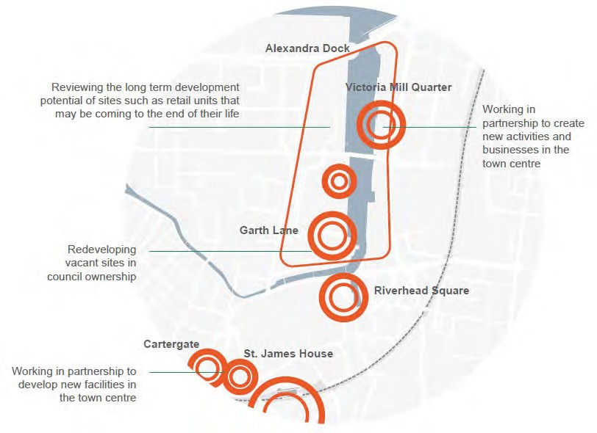

Identify development opportunities
The redevelopment of vacant sites provides opportunities for introducing new land uses and activities in the town centre which will have a wider catalytic effect on the regeneration of the town centre.

‘I want Grimsby to have more town centre homes to attract people back into the town centre after the shops close.’

‘I would like to see homes built near the water as Hull have done successfully’.

‘I think you should purchase empty shops and turn them back into houses which will bring in more footfall to the town centre.’

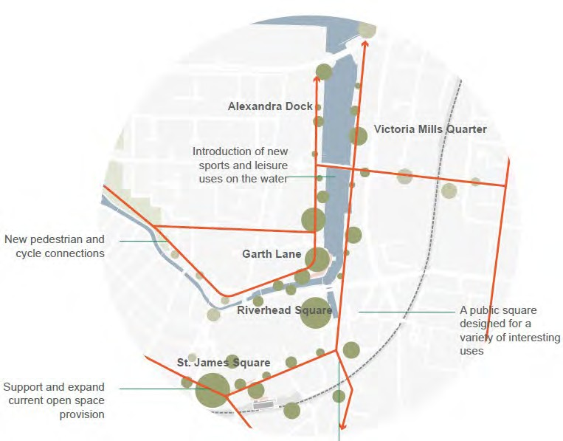
Prioritise health and wellbeing
Creating a more accessible, safer and attractive town centre, which helps improve quality of life and enhance the experience of people living, working and spending time in the town centre by:
- Improving access to the waterfront and opening up areas of new open space for leisure and recreational activities.
- Providing new places to relax and enjoy the natural environment.
- Provide well connected, accessible walking and cycling routes.
- Enhancing in lighting, wayfinding and security to ensure the town centre feels safe and welcoming to all, throughout the day and into the evening.
‘I want a town that is walkable and people friendly’.
‘Open up a community garden, we need more green spaces in this town. Greenery improves mental health and is great for ecosystems’.
‘A space to enjoy the water and the heritage as you gaze around’.

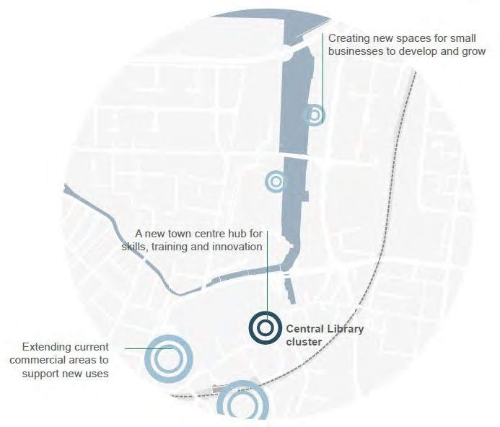
Enhance opportunities for employment, skills and enterprise
As the economy of Grimsby continues to diversify and new sectors are attracted to the town sector, skills and training facilities need to adapt in a highly flexible way. Providing spaces for learning, training and innovation in the town centre, with flexibility to grow and adapt over time, accommodating new partners and training providers, particularly those with a digital focus, will help ensure a stronger enterprise culture is developed in Grimsby. This will support greater collaboration, networking and innovation across sectors.

‘We should have a place to showcase skills, where people can drop in and try things out, with low barrier to entry building to more advanced or involved projects.’
‘Space for activities that build skills for adults as well as a young audience, build confidence with tools and engineering concepts and link with computer-aided design and robotics.’

Grimsby Town Investment Plan

Town Investment Plan

October 2020 53

TIP Project Prioritisation
The Greater Grimsby Board (Grimsby’s Town Board) have led on the selection process in developing the TIP projects. The process took three stages;
- Longlist of projects
- Initial Sifting Exercise
- Final Sifting Exercise
The first exercise created a long list of projects located within the Towns Fund boundary - 22 projects were identified in total. These projects were derived from a range of sources, for example engagement with stakeholders like local business groups as well as Board members and feedback from MyTown public engagement (2019-20). Relevant projects were also taken from key strategic documents like; the Economic Strategy (2016) Local Plan (2018), the Town Deal Prospectus (2018) and Local Economic Assessment (2020). The second stage was an initial sifting exercise that looked at how these 22 projects fit with a set of more detailed criteria, which is listed below.
- Public engagement responses and
- Alignment with:-
  - Grimsby town objectives
  - Towns Fund Intervention Themes
  - Regional and national policy
  - HM Treasury Green Book criteria
  - Stakeholder ‘buy-in’

A scoring matrix was applied to prioritise the projects which resulted in 17 projects moving on to the next stage.
The final sifting exercise which shortlisted the final projects for the TIP, involved an outcomes-led approach, for example how well the projects could demonstrate the Theory of Change, as a result of Towns Fund intervention. The cost appraisal of each project also formed part of the final decision in developing a programme of Towns Fund projects.
This final exercise identified 7 projects for inclusion in the TIP. At the Board meeting on 29th September 2020 Board members agreed the project proposals for the TIP.
The selected projects work in a highly integrated way, delivering benefits in their own right, but also contributing to a much larger step change across the town as a package of highly complementary proposals.
In order to ensure that the key issues and opportunities outlined in the Context section are addressed directly – or as a consequence of – the Towns Fund projects, a logic model was developed to identify key linkages between the needs, vision and objectives, projects and outcomes. There is a Theory of Change logic model for each of the projects proposed in this TIP.
A summary of the prioritisation process is overleaf, and a sift, with longlisted projects and full scale programme-level Theory of Change can be found in Appendix 4.

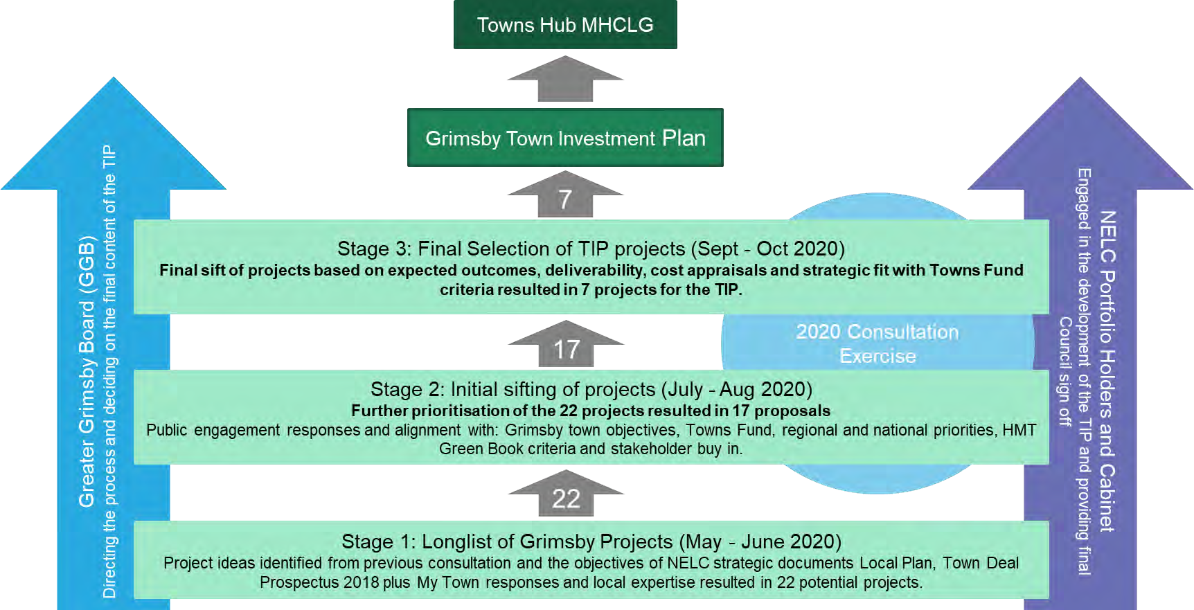

Project Selection Process

Public Realm Connectivity
Victoria Mill Quarter

Town-Wide Activation and Community Enterprise Fund
Garth Lane
Riverhead Square

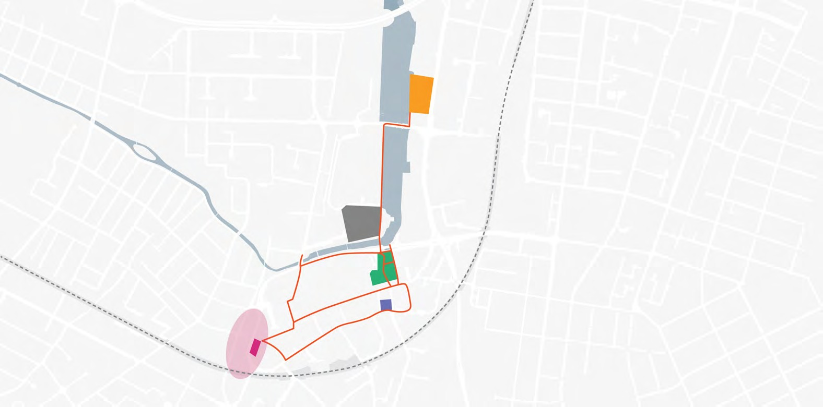
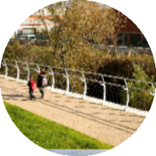
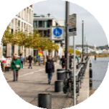
St James Quarter
Central Library

Grimsby’s Town Investment Plan Area of Focus for the TIP

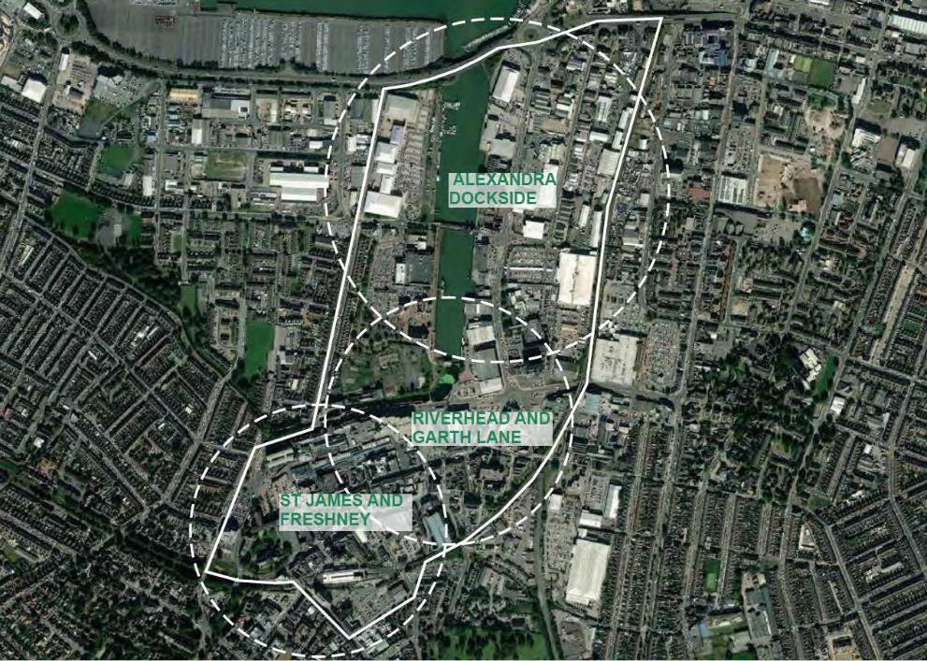
As previously described, the aim of the TIP projects, and the masterplan overall, is to strengthen the town centre, so it can better support existing and new investment in the wider Great Grimsby area.
The TIP boundary focusses therefore on the traditional town centre around Victoria Street, Freshney Place shopping centre and the Minster, but it also includes the around Alexandra Dock which is strategic development area.
Within this boundary, three key ‘character areas’ emerge:
- Riverhead and Garth Lane;
- St James and Freshney; and
- Alexandra Dockside.
Connectivity between these areas, and linkages with adjoining neighbourhoods and important areas of activity like Freeman Street the Kasbah and Port, are also recognised. Town centre-wide projects and programmes can be implemented to support this cohesion.
The following pages describe each of these areas, and outline the TIP projects within each.

Grimsby’s Town Investment Plan

Riverhead and Garth Lane

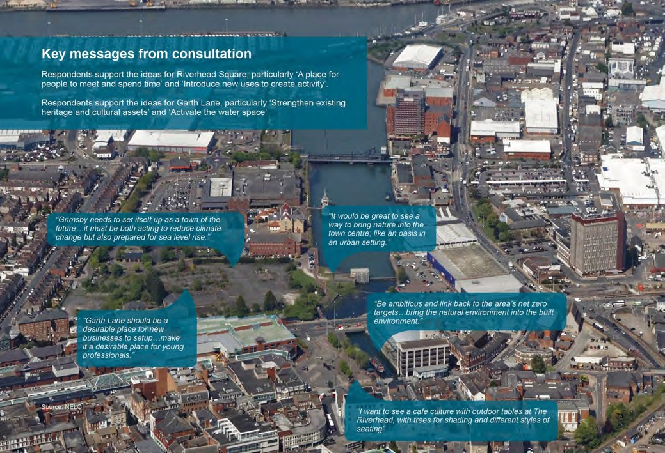
The Riverhead is where Grimsby town centre comes together with the water. The area has a mixture of uses including retail, offices, restaurants and bus stops and contains the largest public space in the town centre, Riverhead Square.
This area also includes Garth Lane, a significant opportunity site on the edge of the current town centre; the Fishing Heritage Centre, one of Grimsby’s key heritage assets with a direct relation to the water, and the Central Library, a building with architectural value and well located in the heart of the town centre.
The masterplan identifies four projects for this Character Area, three of which have been selected for the TIP; Riverhead Square, Garth Lane and Central Library.

Riverhead and Garth Lane; key messages and quotes from the consultation © NELC

Riverhead Square

PROJECT DESCRIPTION ALIGNMENT WITH LOCAL/REGIONAL/NATIONAL POLICY
This project will deliver the redesign of the public realm in Riverhead square to create a high quality new public space in the heart of the town centre. The aim of this project is to bring the square to life as it is currently a large open space with no identity and this redesign will transform it into an attractive, safe and inclusive place for people to meet and spend time. There will be facilities for flexible business activity to activate the space and attract footfall as well as offering social, community and leisure uses such as “pop ups” and meanwhile uses. The square will also form a public space that can be used throughout the year for a wide range of events and activities, such as Christmas Markets, festivals or concerts, helping to drive additional activity and footfall in the town centre. The proposals will also improve facilities for bus passengers by integrating enhancements to waiting
- This project is in a key position to be fast-tracked and therefore aid economic
recovery from Covid-19
- Connecting people with the environment to improve health and wellbeing is identified as a key action area within the Government’s 25-year environment
plan and improved active travel options will support the Clean Growth Strategy
- North East Lincolnshire Local Plan: SO5* Social and health inequality, SO8 Town centres and local facilities, SO9 Design
- Improving the perceptions of the area has been identified as a key opportunity within NEL’s Local Economic Assessment.
*strategic objective

facilities and public transport information and include a dedicated cycle parking hub, something that was highlighted in the recent consultation as a priority for the town centre.
T O W N S F U N D A S K | C O - F U N D I N G
- £3.3 million | - £1.0 million secured through TF  Accelerated Funding
P R O J E C T D E T A I L S | B E N E F I T S
- 3931 sq. m of high quality public realm space | - £59,250 public realm benefits per annum from 2024 (price value in  2024)
- £2,148,400 construction expenditure that will bring full time equivalent employment (FTEs) and positive supply chain effects. | - 3 net additional local job construction/supply chain jobs  - £60,312 associated additional local  GVA

INDICATIVE PROJECT ILLUSTRATION
INPUT AND OUTCOME INDICATORS

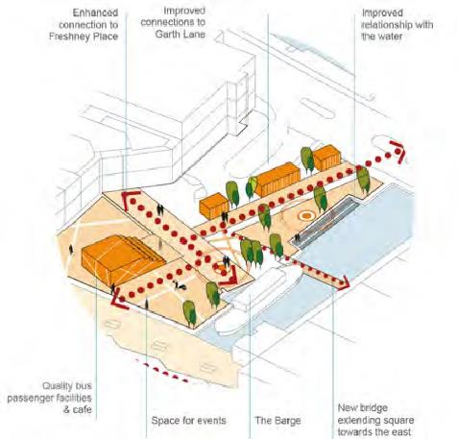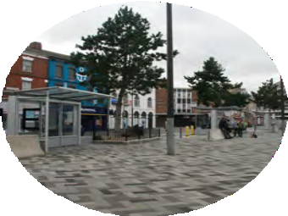

Riverhead Square

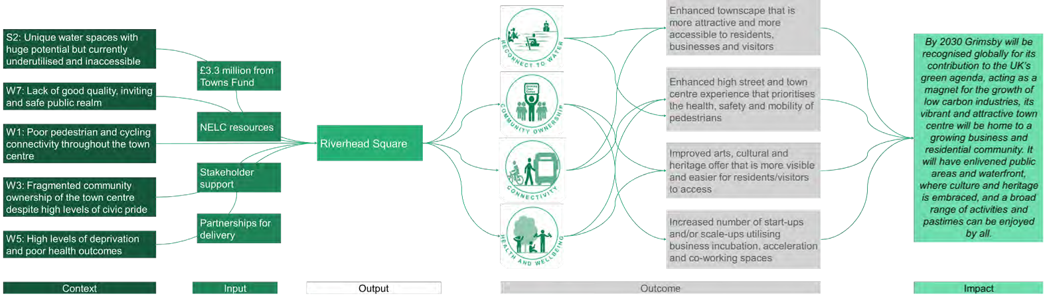
ALIGNMENT TO THE THEORY OF CHANGE
SHORT AND MEDIUM TERM OUTCOMES (TO 2026) LONGER TERM IMPACTS (TO 2030 AND BEYOND)
- Riverhead Square will be major new public and civic space (W7) that residents of Grimsby can be proud of, creating a new landmark in the town centre (W3). The square could host a variety of inclusive uses including seating, event space, heritage information boards, planting and the
introduction of meanwhile uses.
- The new square will also be a multi-modal transport hub, making the most of its pivotal location, offering bus facilities and cycle infrastructure, and acting as
a key pedestrian zone with related wayfinding (W1).
- These improvements will result in an improved townscape, enhancing Grimsby’s connection to its water space (S2), boosting people’s perception of the town when they arrive, as well as the image of Grimsby for potential
investors.
- Meanwhile uses could help support new businesses, providing them with a platform to test their offer. Other events, such as Christmas markets, concerts and performances and will not only support culture, craft and creative sector start-ups, but will drive up footfall and dwell time in the town centre, in turn
helping to reduce unwanted behaviours.

- Improved bus facilities, cycle parking and wayfinding will all help to encourage mode shift away from private cars and towards more sustainable public and
active transport, supporting health and wellbeing outcomes (W5).
- As other projects such as Garth Lane and the Public Realm Connectivity come forward, Riverhead Square will act as the new heart of the town centre, linking the traditional town centre, with the emerging Alexandra Dockside
district.

Riverhead Square

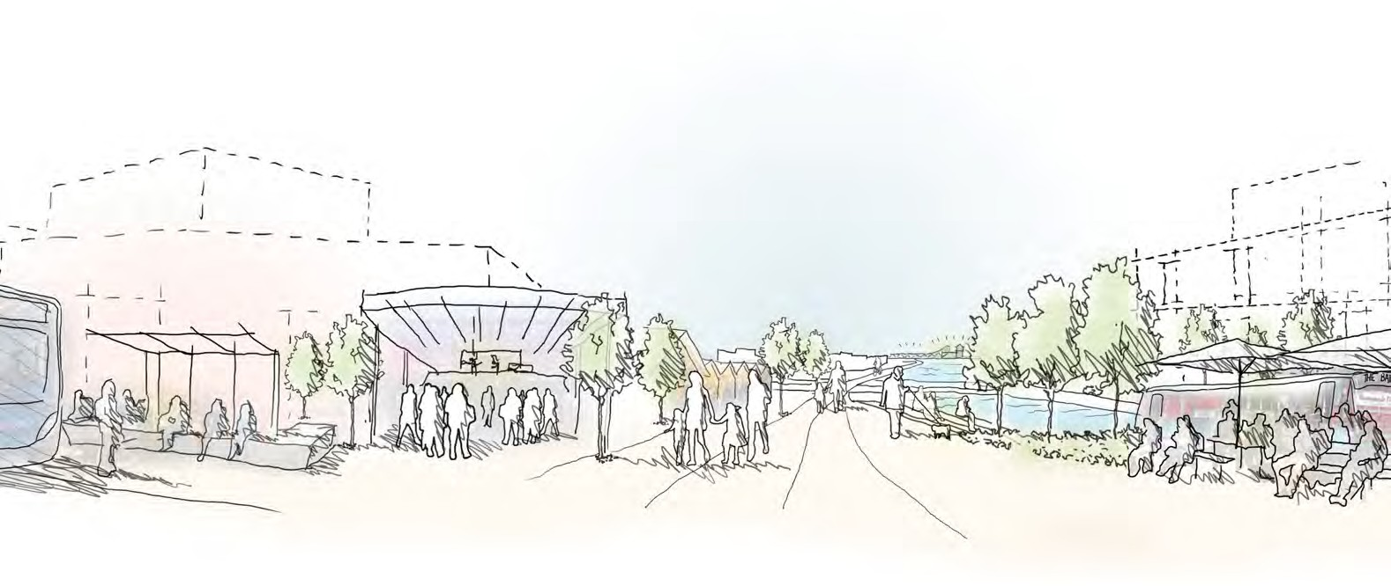

Artist’s impression of the future Riverhead Square © Arup

Garth Lane

PROJECT DESCRIPTION ALIGNMENT WITH LOCAL/REGIONAL/NATIONAL POLICY
This project is the development of a council-owned vacant waterfront site called Garth Lane into a new residential district, supported by other leisure and community uses, that would provide a new type of town centre living in Grimsby whilst connecting the town centre more coherently with Alexandra Dock.
- Building new homes has been identified as a key driver in helping Britain to
build back better, greener and faster [28] in the wake of the Covid-19 pandemic.
- Alignment with strategic objective 4 (Housing) in the NEL Local Plan
- Improving the perceptions of the area to attract skilled workers, visitors and inward investment has been identified as a key opportunity within NEL’s Local
Economic Assessment.
- The provision of safe walking and cycling routes for residents will help accelerate the shift to low carbon transport- a key policy within the
Government’s Clean Growth Strategy

The offer of aspirational housing, an enhanced pedestrian and cycling experience and more leisure activities would help to attract talent and contribute to a town centre commensurate to the private investment in wider Grimsby. Development of Garth Lane also supports and maximises recent investments including the refurbishment of the West Haven Maltings buildings into the OnSide Youth Zone, pedestrian crossing improvements on Frederick Ward Way and the creation of a new footbridge over the River Freshney and enhancements to the public spaces

around the waterfront.

INDICATIVE PROJECT ILLUSTRATION
INPUT AND OUTCOME INDICATORS

T O W N S F U N D A S K | C O - F U N D I N G
- £8.8 million | - Homes England
P R O J E C T D E T A I L S | B E N E F I T S
- 200,00 sq. ft of residential use (240 units)  - 25,762 sq. ft of retail floorspace | - £41 net additional local jobs  - £2,307,898 associated additional local GVA (2023)
- £27,249,910 construction expenditure that will bring full time equivalent employment (FTEs) and positive  supply chain effects. | - 36 net additional local construction/ supply chain jobs  - £2,092,735 associated additional  local GVA.

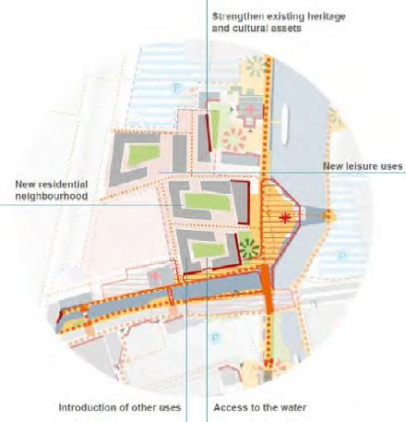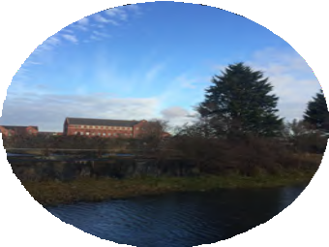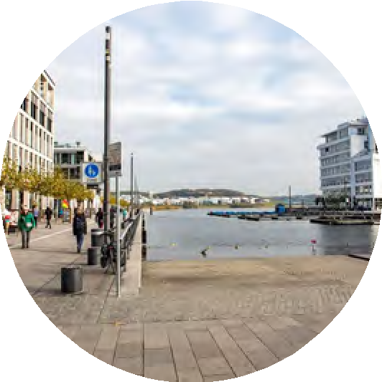

Garth Lane

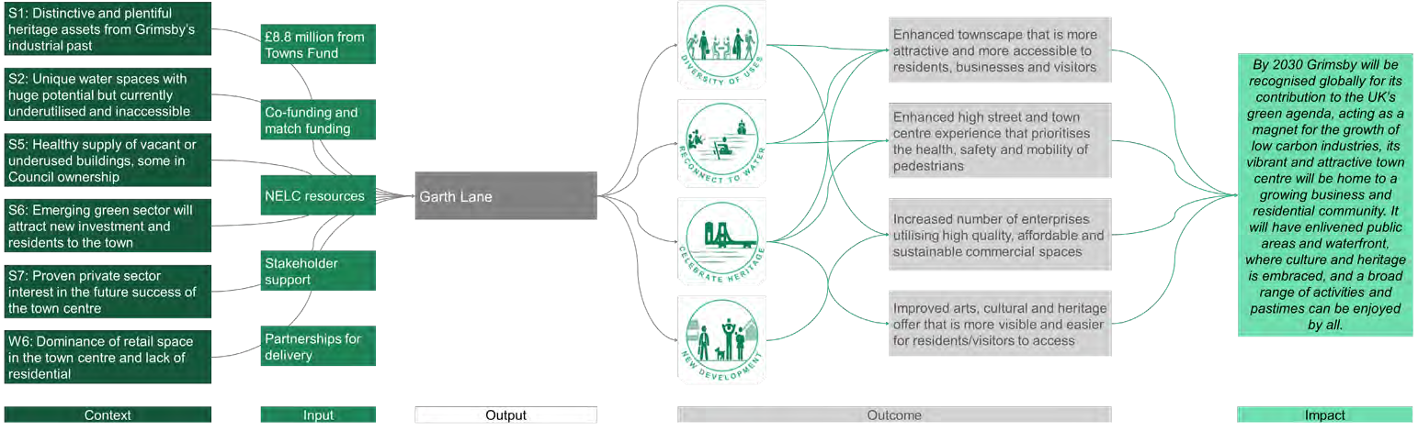
ALIGNMENT TO THE THEORY OF CHANGE
SHORT AND MEDIUM TERM OUTCOMES (TO 2026) LONGER TERM IMPACTS (TO 2030 AND BEYOND)
- Garth Lane represents one of the most important catalytic sites for the future redevelopment of the Alexandra Dock area, and Grimsby town centre (S5). A new residential-led mixed-use development, with active ground floors featuring space for retail and leisure uses would help create a vibrant new district in
Grimsby.
- Creating attractive, waterside homes will help to draw new families and workers to Grimsby town centre, such as those working in the emerging green industries (S6). It also helps to rebalance the retail dominance of the town
centre (W6).
- The creation of leisure, offices and flexible workspaces, and F&B uses at ground floor will support new employment in the town centre, and drive
footfall.
- By embedding high quality public realm and placemaking in the design of the new development, this long-blighted site will help improve the town environment and contribute to greater pedestrian and cycling accessibility around the southern end of Alexandra Dock, reconnecting residents to the
water (S2).

- A third phase of the Garth Lane residential development will come forward, when the market would have been proven and the viability gap reduced for private sector investors to come forward to deliver this final phase (S7). The phased redevelopment of Garth Lane is essential to the regeneration of the whole Alexandra Dock area, acting as the main gateway site between the dock and the town centre.
- Setting a new standard and demonstrating a market for residential and leisure uses will help to ensure this waterside district develops gradually, as and when other significant sites around the dock become available for development.
- As planned development of the Fishing Heritage Centre comes forward, the northern edge of the Garth Lane site would seamlessly integrate with this
important town asset, increasing permeability and access to the museum (S1).

Garth Lane

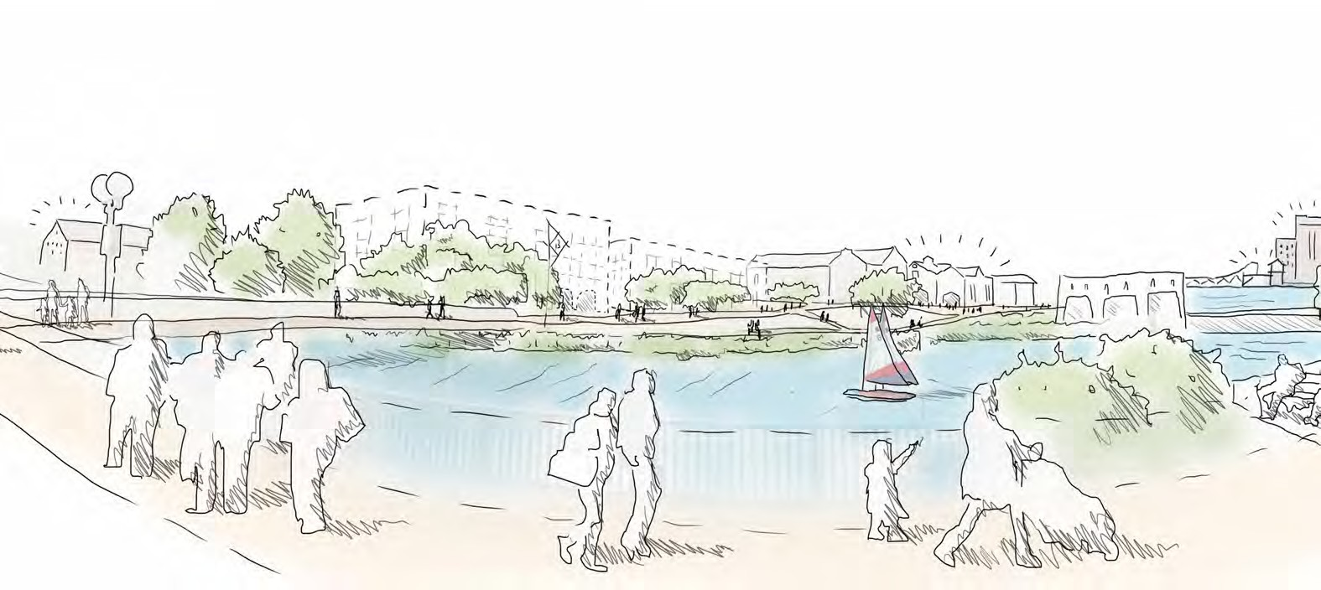
Artist’s impression of the future Garth Lane © Arup

Central Library

PROJECT DESCRIPTION ALIGNMENT WITH LOCAL/REGIONAL/NATIONAL POLICY
Grimsby’s Central Library opened in 1968 and is a substantial civic building in the heart of the town centre and currently underused. The preferred future use for the full library building is to retain but improve the feel and layout of the library function on the ground floor and use the upper floors as an innovation and enterprise hub. Currently, only some of the floors can be used by the public as the upper floor require upgrade to the mechanical and electrical systems and the current layout does not provide adequate provision for meetings, training, research or include modern staff facilities. The creation of an innovation and enterprise hub will provide a space for more investment in skills and training, including digital skills and fostering an enterprise culture. Embedding digital and renewable energy generating services within the refurbished building would also future proof the facility and
- By placing a key focus on green technologies and renewables, the hub will support business investments within sectors such as offshore wind- identified
as a key opportunity within the Government’s Clean Growth Strategy.
- Initiatives which promote a ‘clean green recovery’ align with the Government’s commitments to build back better, greener and faster following the Covid-19
pandemic.
- The hub will enable the people of Grimsby to develop their skills and receive training, helping to address the mismatch between the district-wide growth and capacity of the local labour market and the growth within the wider district
(aligns with strategic objective 3 within the NEL Local Plan).

contribute towards carbon reduction. The future use of this building would make a significant contribution to supporting growth and diversification of the town centre and be a catalyst for the redevelopment of adjoining sites.
T O W N S F U N D A S K | C O - F U N D I N G
- £4.2 million
P R O J E C T D E T A I L S | B E N E F I T S
- 3,710m2 of innovation space | - 28 net additional local jobs  - £1,529,695 associated additional local GVA (2023)
- £3,110,700 construction expenditure that will bring full time equivalent employment (FTEs) and positive supply chain effects. | - 4 net additional local construction/ supply chain jobs  - £221,831 associated additional local GVA.

INDICATIVE PROJECT ILLUSTRATION
INPUT AND OUTCOME INDICATORS

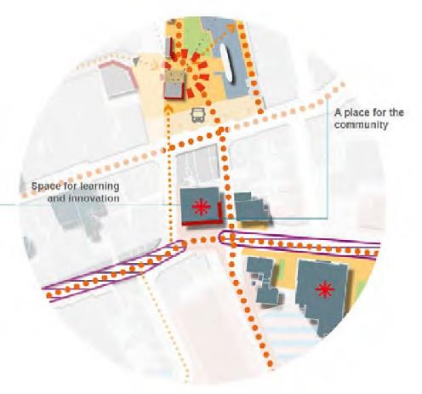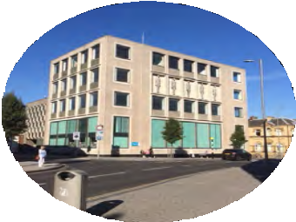

Central Library

ALIGNMENT TO THE THEORY OF CHANGE
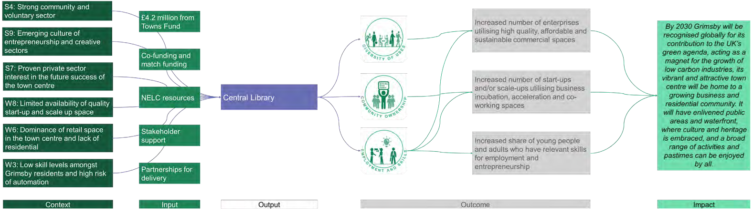
SHORT AND MEDIUM TERM OUTCOMES (TO 2026) LONGER TERM IMPACTS (TO 2030 AND BEYOND)
- A revitalised Central Library will contribute significantly to the skills, enterprise and innovation infrastructure in Grimsby. Centrally located in the town centre, it will help to boost footfall during the day, and into the evening (W6).
- The hub would help to address the need for continual investment in skills and training (W3), including and expertise in emerging business sectors such as education-technology and low carbon energy (S9). The hub presents an opportunity to develop stronger digital capabilities with partners in Grimsby.
- The hub would also have flexible co-workspaces, meeting rooms, and an event space to support greater collaboration between the public and private sector in Grimsby and foster a culture of knowledge sharing and innovation (W8).
- Located within the library building, the skills hub would be highly visible and accessible to local people – increasing outreach and providing services access to a wide range of communities (S4).

- Over time, the Central Library could act as the central hub in a wider offer of shared flexible workspaces located throughout the town centre.
- If a suitable new location for the library function is found, this space could be used to host new partners, such as a digital health hub (an operator of which has already shown interest in setting up a test bed in Grimsby; W7).

Grimsby’s Town Investment Plan

St James and Freshney

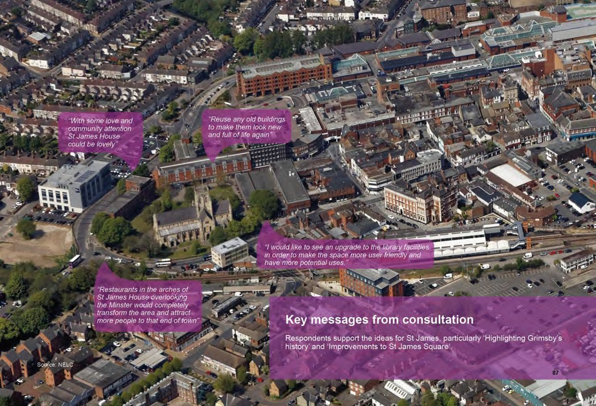The Minster, St James House, St James Square, Cartergate, the train station and Freshney Place form the traditional heart of the town centre.
There is a need to diversify the range of land uses in this part of the town centre including the introduction of leisure uses; additional commercial space and residential. The enhancement of St James Square is currently underway. This creates a catalyst for the redevelopment of St James House, bringing an important building back into use. The successful Cartergate office development has highlighted the potential for new town centre commercial development with the potential for additional commercial space to be added.
The masterplan identifies four projects in this Character Area, one of which has been selected for the TIP; St James Quarter. The other projects identified in the masterplan are likely to manifest in the medium to long term and could be brought forward by the private sector. As a key connector between residential neighbourhoods and the town centre, supporting the redevelopment of the ground floor of St James House maximises the recent investment in St James Square public realm and provides a catalyst for the
redevelopment of sites at Cartergate. St James and Freshney; key messages and quotes from the consultation © NELC

St James Quarter

PROJECT DESCRIPTION ALIGNMENT WITH LOCAL/REGIONAL/NATIONAL POLICY
This project seeks to kick start the active reuse of vacant sites and buildings within the St James Quarter though two initiatives targeting specifically i) St James House and ii) support to a potential development site at Cartergate. St James Quarter is already subject to considerable change with enhancements to the square outside the Minster underway and proposals for a new a mixture of food/leisure and entertainment uses in Freshney Place shopping centre (hopefully funded through FHSF). Overlooking St James Square and the Minster, St James House sits in a prominent position currently unoccupied. The redevelopment of the upper floors of St James House could accommodate either residential or commercial uses, but the ground floor of the building is currently an open space of archways, that could be converted for retail / commercial/ food and drink / leisure or a major community/civic
- The proposed active ground floor use of St James House seeks to enhance the leisure offer within the town, supporting industries that have been disproportionately impacted by the Covid-19 pandemic and helping to attract skilled labour into Grimsby, identified as a key opportunity within NEL’s Local
Economic Assessment.
- The proposals support NEL’s vision to strengthen the vitality and viability of town centres and meet the communities’ needs for retail, commercial and leisure – strategic objective 8 within NEL’s Local Plan.
- The retrofitting of existing buildings, such as bringing St James House back
into use, is in alignment with the Government’s Clean Growth agenda.

function. The Cartergate area comprises a mixture of surface car parks and buildings including the recently completed office space (300 jobs) with some sites in council ownership. Supporting one of these sites coming forward for potentially a residential based scheme (assisted living) would help to drive activity and footfall.
T O W N S F U N D A S K | C O - F U N D I N G
- £1.65 million | - Private Sector
P R O J E C T D E T A I L S | B E N E F I T S
- 6,089 sq. ft of retail floorspace | - 10 net additional local jobs  - £546,319 associated additional local GVA (2023)
- £1,977,541 construction expenditure that will bring full time equivalent employment (FTEs) and positive supply chain effects. | - 2 net additional local construction/ supply chain jobs  - £141,023 associated additional local GVA.

INDICATIVE PROJECT ILLUSTRATION
INPUT AND OUTCOME INDICATORS

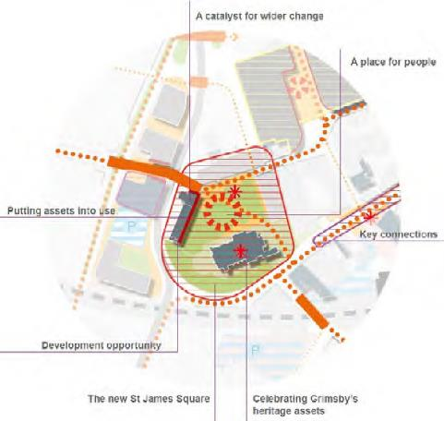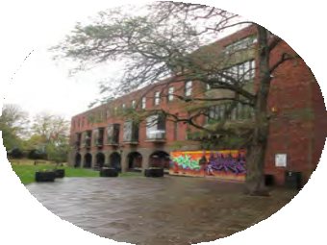

St James Quarter

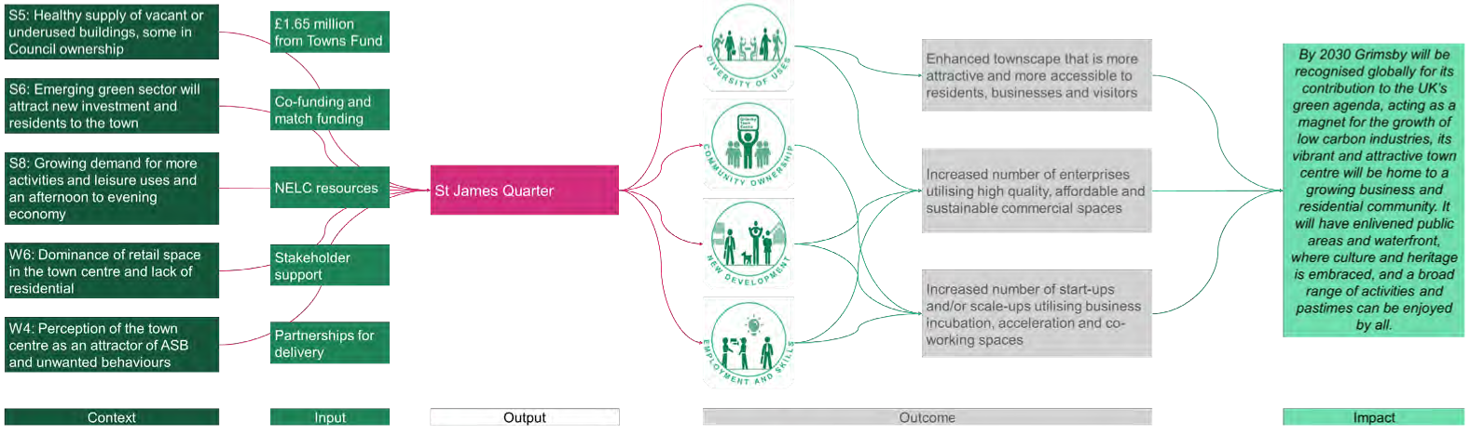
ALIGNMENT TO THE THEORY OF CHANGE
SHORT AND MEDIUM TERM OUTCOMES (TO 2026) LONGER TERM IMPACTS (TO 2030 AND BEYOND)
- Activating the ground floor of St James House (S5) and enabling the creation of residential uses above would help drive activity and footfall in the area (S6), complementing the major investment that is being made in the restoration of
the square.
- Supporting the creation of an extra-care housing development would not only meet these social needs of the residents, providing them a well-located place to live, but would diversify the town centre offer (W6) and draw new activity to this area of the town. It would also provide new employment in the town
centre.
- Activation of St James House will contribute to making the square an attractive and safe place for people to meet and spend time, where everyone feels welcome. The retail, community and F&B offer is St James House will generate footfall and activity(S8); it will also reduce the risk of anti-social
behaviour in the square (W4).
- It will also help showcase and celebrate the new St James Square, which is currently being restored, and make everyone feel welcome in it, as well as improving access to the Minster, one of Grimsby’s key heritage assets (S1).

- Redevelopment of St James House would be a catalyst for the next phase of redevelopment of the Cartergate sites, identified in the Local Plan as opportunity sites (S5).
- Ensuring key developments such as St James House, Cartergate House and the potential Future High Streets Fund project to the western end of Freshney Place Shopping Centre work together and complement each other will strengthen this end of the core town centre, and encourage further development opportunities towards the station and along Cartergate to come
forward.

St James Quarter

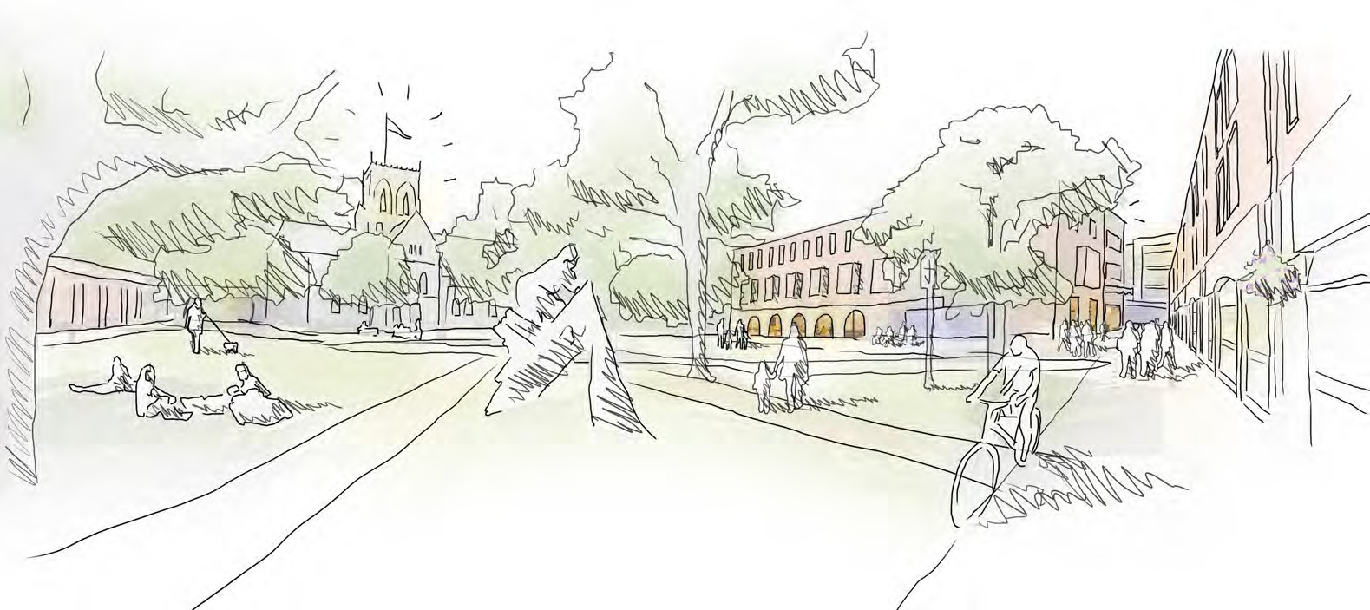
Artist’s impression of the future St James Quarter © Arup

Grimsby’s Town Investment Plan

Alexandra Dockside

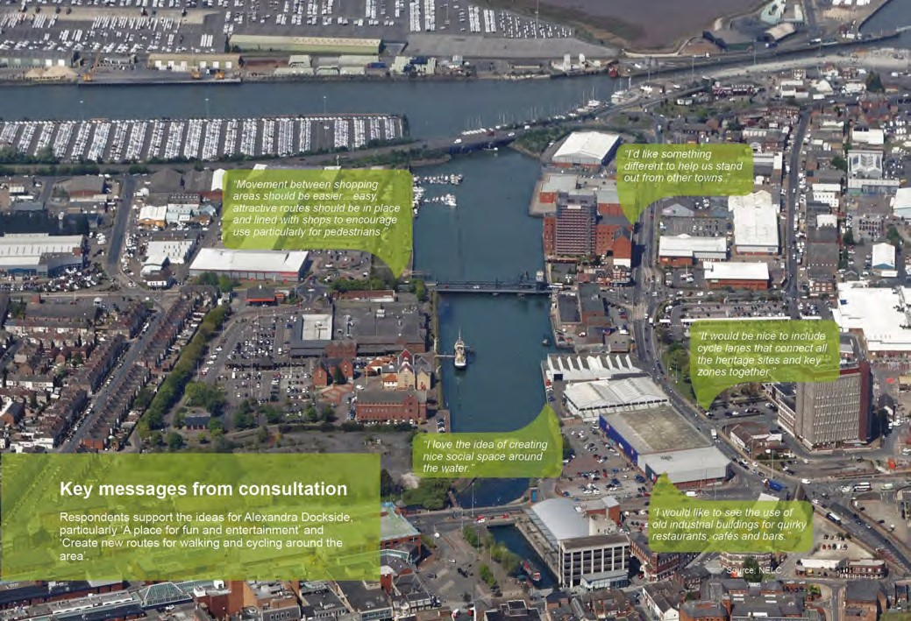Alexandra Dock presents significant opportunities for Grimsby town centre including the potential to reconnect the water space with the town centre, making it more accessible to people and improving connections to/from and around the water. Many of the retail uses that are clustered around the dock will be subject to change in the future, given the wider changes happening in the retail sector. This will create opportunities for development coming forward, taking advantage of the waterfront setting. Existing buildings such as the Victoria Mill building have potential to be bought back into use, accommodating a range of possible land uses. The water itself offers enormous opportunity for sports, leisure and recreational use, creating a new space that local residents and visitors can enjoy.
The masterplan identifies four projects for this Character Area, one of which has been selected for the TIP; Victoria Mill Quarter. This project will provide new leisure and innovation activity in the short term and act as a catalyst for the wider regeneration of the surrounding area over time.

Alexandra Dockside; key messages and quotes from the consultation © NELC

Victoria Mill Quarter

PROJECT DESCRIPTION ALIGNMENT WITH LOCAL/REGIONAL/NATIONAL POLICY
The cluster of buildings forming the Victoria Mill Quarter (including the Victoria Mill Silo building and Castle Press) are an important part of the Alexandra Dock and present the opportunity to re-use existing heritage buildings to create and grow a unique mixed residential, commercial and leisure district on the waterfront. The refurbishment of the Castle Press print works would provide a water front venue to support local festivals, an artisan street food quarter and flexible workspaces, all anchored by a large brewery and distillery. By establishing the Castle Press development and introducing new uses and activity in this area, it will improve the underlying market conditions to secure a sustainable long term use for the Victoria Mill Silo building. This historic landmark, in council ownership, has the potential for a range of possible uses including residential, leisure and cultural uses. This project
- In support of the Government’s Clean Growth ambition, the regeneration of this area is connected to the proposals for investment in new pedestrian and
cycling connections around the dock.
- The refurbishment of the Castle Press print works building will improve the leisure offer within the town centre, helping to improve the image and perceptions of the area and stimulate the visitor economy (identified as
opportunities within NEL’s Local Economic Assessment).
- The opportunity for residential use aligns with proposals for a ‘New Deal for Britain’, whereby building new homes has been identified as a key driver in
rebuilding the economy following the Covid-19 pandemic.

will fund further work on the assessment of viability and cost of securing a long term partner for the development and use of this building. These proposals will help kick start the wider regeneration of the eastern side of the Alexandra Dock area and provide a new destination for residents and visitors.
T O W N S F U N D A S K | C O - F U N D I N G
- £1.65 million | - £2.65 Private sector
P R O J E C T D E T A I L S | B E N E F I T S
- 4,200 sq. ft of flexible workspace  - 6,160 sq. ft of floorspace for a food court  - 13,670 sq. ft of floorspace for a brewery | - 57 net additional local jobs  - £3,099,364 associated additional local GVA (2023)
- £2,180,227 construction expenditure that will bring full time equivalent employment (FTEs) and positive supply chain effects. | - 3 net additional local construction/ supply chain jobs  - £155,477 associated additional  local GVA

INDICATIVE PROJECT ILLUSTRATION
INPUT AND OUTCOME INDICATORS

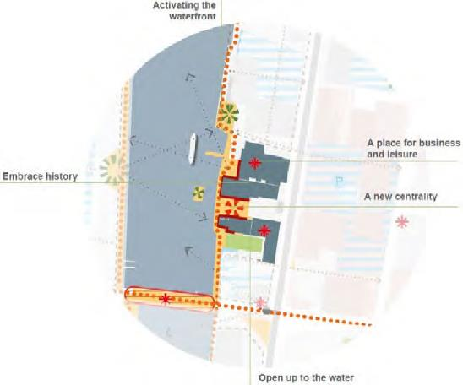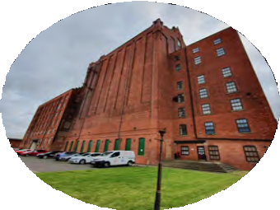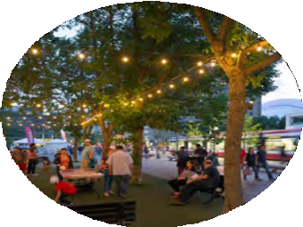

Victoria Mill Quarter

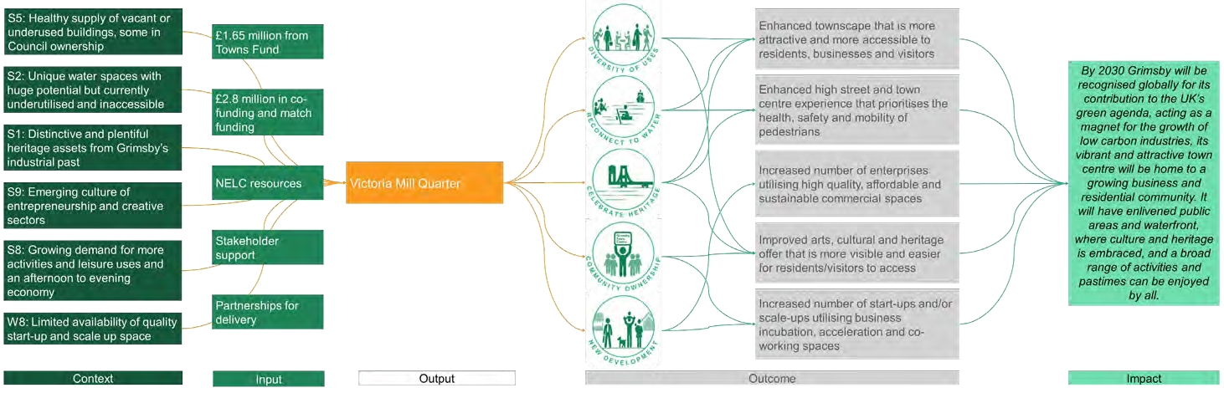
ALIGNMENT TO THE THEORY OF CHANGE
SHORT AND MEDIUM TERM OUTCOMES (TO 2026) LONGER TERM IMPACTS (TO 2030 AND BEYOND)
- Providing a new mixed-use offer to this part of the Alexandra Dock waterfront would bring this part of the town centre to life.
- Currently under-used, the regeneration of this quarter would enhance heritage assets (S1), activate them and bring them back into use (S5). The project would enhance their setting, providing improved lighting, interpretation and public access.
- Provision of flexible, co-workspaces (W8), meetings and events space, and the creation of a brewery would all help to deliver employment and enterprise in the town (S9).
- Linked with the Public Realm Connectivity project, this project will help improve pedestrian access to the waterfront and create new places for people to relax and socialise (S8). Furthermore, this access would allow greater utilisation of the water itself, including new leisure uses and water-based activities (S2).

- Having developed the Castle Press site and drawn activity towards this part of the dockside through the Public Realm Connectivity project, the viability and feasibility of large-scale development within the Victoria Mill Silo will improve. Options include a new leisure use, offices and workspaces, cultural or
performance space, residential, or a combination of all these.
- The Victoria Mill Quarter sits at the heart of the Alexandra Dock area and will act as a catalyst for wider regeneration. It will form a new gateway, linking to two other major development locations: the Kasbah heritage district in the Port of Grimsby, and the secondary shopping district, Freeman Street to the east. Both these areas have significant planned development in the pipeline, and an
active Victoria Mill Quarter would support these.

Victoria Mill Quarter

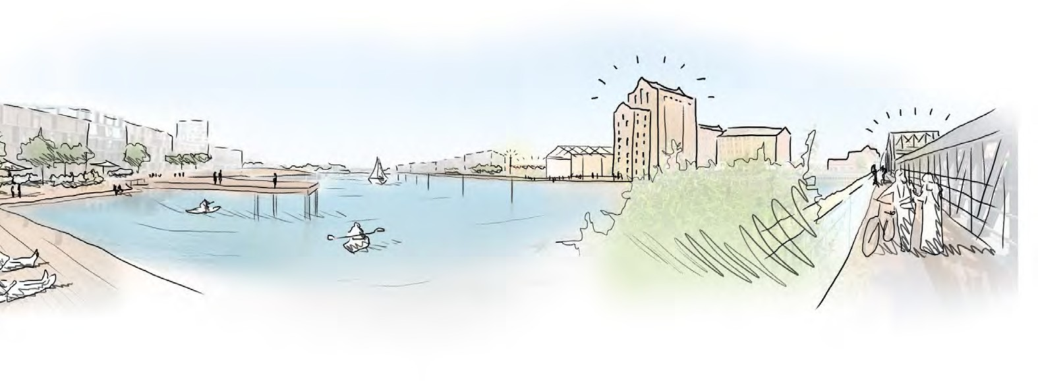
Artist’s impression of the future Victoria Mill Quarter © Arup

Grimsby’s Town Investment Plan

Town centre-wide supporting projects

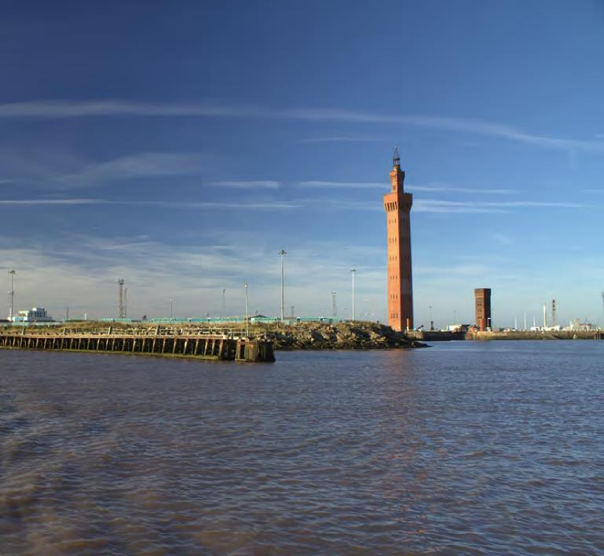
There are four town centre-wide supporting projects included in the masterplan, the role of which is to link areas of the town centre together to make it easier to navigate through the centre of Grimsby, and to activate spaces in the town.
Two of these supporting projects have been selected for the TIP: Public Realm Connectivity and the Activation and Community Enterprise Fund. Both projects provide an added boost to the other five projects selected for the TIP, and will act as a catalyst for investment in the medium and longer term projects in the masterplan.

The Dock Tower in the Port of Grimsby © NELC

Public Realm Connectivity

PROJECT DESCRIPTION ALIGNMENT WITH LOCAL/REGIONAL/NATIONAL POLICY
The public realm connectivity project will create high quality, quick and safe movement corridors for pedestrians and cyclists through the town centre and the waterfront. The project’s main objective is to improve connectivity and permeability within the town centre, making it easier for people to move to/from and within by foot and by cycle, addressing some of the severance issues that exist today. Three priority routes have been identified including: St James to Riverhead Square, St James to Garth Lane and Riverhead Square to Victoria Mill Quarter. Tying together Grimsby’s Town centre, Riverhead Square and Alexandra Dock through a series of active travel loops will better connect the town as 'one', enhance the walking and cycling experience of residents and visitors and encourage people to be more active and spend more time within the town. The loops have also been designed to
- Creating these movement corridors provides outdoor space for socially- distanced interactions and active travel, and aligns with proposals for a ‘clean,
green recovery’ following the Covid-19 pandemic.
- Promoting sustainable transport aligns with the Government’s Clean Growth agenda, in addition to the NEL Local Plan.
- The project seeks to promote healthier lifestyles and connect people with the environment to improve health and wellbeing, which are objectives within the
NEL Local Plan and the Government’s 25-year environment plan respectively.
- Connecting Grimsby’s historic assets will enhance the quality of the built, historic and natural environment (SO6 in NEL’s Local Plan).

connect with Grimsby’s key historic assets and recent projects being delivered.
T O W N S F U N D A S K | C O - F U N D I N G
- £3.9 million
P R O J E C T D E T A I L S | B E N E F I T S
- 4,350 sq. m of public realm space | - £65,565 public realm benefits per annum from 2024 (price value in 2024)
- £2,478,068 construction expenditure that will bring full time equivalent employment (FTEs) and positive supply chain effects. | - 3 net additional local job construction/supply chain jobs  - £69,567 associated additional local  GVA

INDICATIVE PROJECT ILLUSTRATION
INPUT AND OUTCOME INDICATORS

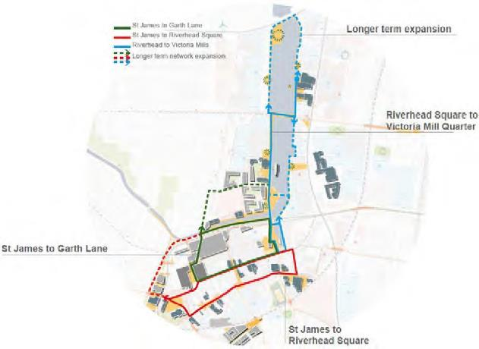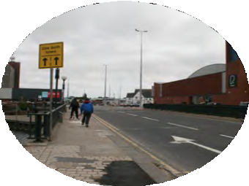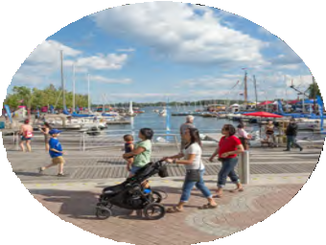

Public Realm Connectivity

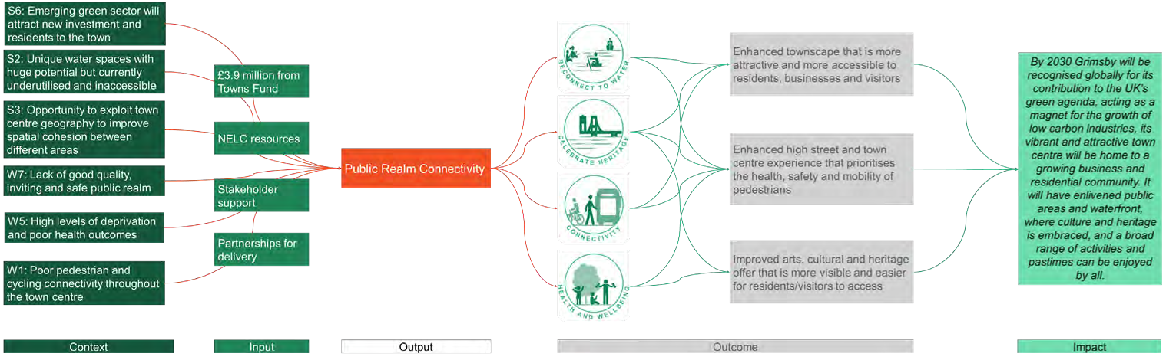
ALIGNMENT TO THE THEORY OF CHANGE
SHORT AND MEDIUM TERM OUTCOMES (TO 2026) LONGER TERM IMPACTS (TO 2030 AND BEYOND)
- Grimsby town centre covers a large area and is dominated by private cars. By knitting the distinct areas of Grimsby together through a series of pedestrian and cycle routes, and at the same time creating a loop between the other TIP projects presented here, a more harmonious and pedestrian-friendly town can evolve (S3).
- Improved wayfinding, lighting, information and crossing improvements will all help to improve the safety of the pedestrian environment (W1). Safer and more enjoyable opportunities to walk or cycle will encourage more active travel, improve health outcomes for users (W5), and provide sustainable and affordable travel options for residents, workers and visitors.
- The routes have been designed to link many of the key heritage assets together, such as the Minster, Corporation Bridge and the Victoria Mill Quarter, helping people to access these unique assets (S1); information boards and viewing points will further support this outcome. Larger areas along the route, with benches and lookout points will provide more public realm and places to enjoy the waterfront (S2; W7).

- Over time, and as the Alexandra Dockside district begins to develop, these walkways and cycle routes can also extend to reach new residential and commercial areas.
- The new linkages around the town will help drive footfall and creating activity across the whole of the town centre, helping to support the introduction of new land uses over time (S5).

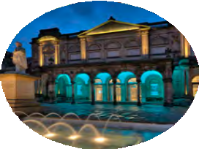
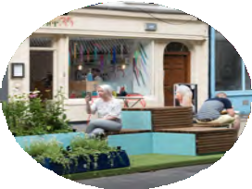
Activation and Community Enterprise Fund

PROJECT DESCRIPTION ALIGNMENT WITH LOCAL/REGIONAL/NATIONAL POLICY
This project will be a local capital grant programme open to community organisations and small businesses to enable grass-roots, community focused projects to come forward and ‘activate’ spaces in the town centre. It will help unlock smaller bespoke town centre investment opportunities which are aligned to community based objectives of Grimsby’s Town Investment Plan. It is envisaged that the funds will be used by local organisations and small businesses to facilitate the delivery of schemes which will strengthen local cultural and community assets, and their provision and access promoting social equity and inclusion in the community. Applications will be invited for grants of up to £25,000 subject to meeting defined eligibility and scoring criteria.
- This fund will be critical in supporting community organisations and small businesses, particularly as they recover from the Covid-19 pandemic.
- Whilst it is anticipated that all projects will help Grimsby to build back better, greener and faster following Covid-19, projects will be categorised under 5 key themes, each of which will align with different policies. For example, Environmental projects will be focused on alignment with the Government’s
25-year environment plan and Clean Growth Strategy, whilst projects supported under the Social Equity and Inclusion theme will place greater focus
on aligning with the Government’s levelling-up agenda.

INPUT AND OUTCOME INDICATORS
T O W N S F U N D A S K | C O - F U N D I N G
- £1.5 million | - Applicants for larger grants (over  £10,000) may be asked to provide some match funding

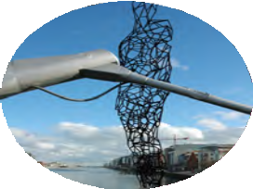
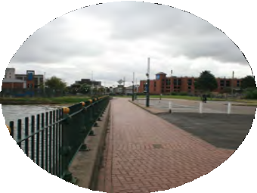
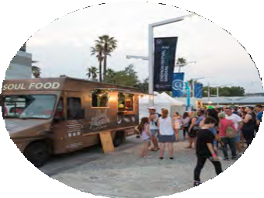
INDICATIVE PROJECT ILLUSTRATION

Activation and Community Enterprise Fund
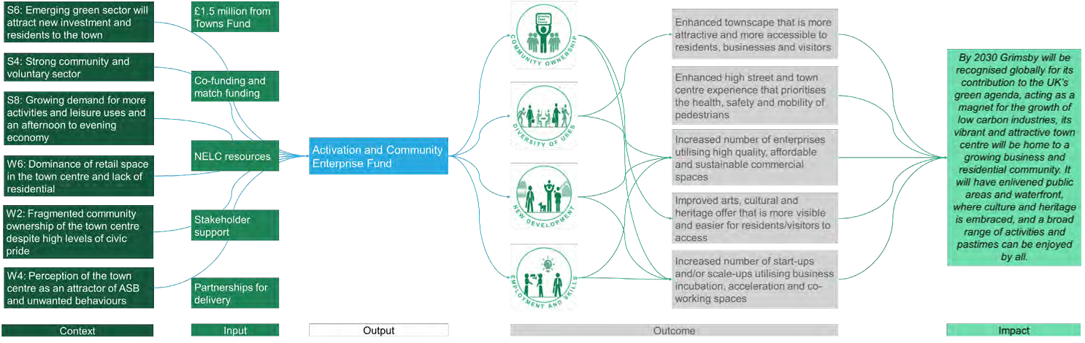
ALIGNMENT TO THE THEORY OF CHANGE
SHORT AND MEDIUM TERM OUTCOMES (TO 2026)

- A town-wide effort to support the introduction of new uses, activate spaces, bring buildings back into use and support small enterprises will help deliver some immediate benefits whilst engaging local people and businesses in the regeneration process. Complementing major investment in physical spaces with smaller initiatives will ensure lasting value is generated from investment taking place.
- Community-driven initiatives, with the right support in place, can make a significant impact on the vitality of a town centre, helping to drive activity and footfall and restore a sense of pride and positivity (W2). By encouraging the community to come forward with initiatives and ideas (S4), this has the potential to “lock in” a sense of support and commitment to improving in the town centre; in turn this helps ensure the changes are welcomed by the public, and sustainable in the longer term.
- Potential outcomes include: Supporting businesses recover from Covid-19; Improved townscape through shopfront enhancements; Activation of vacant buildings or shops to provide pop-up space for new independent retailers, or co-working space for start-ups (S6); Arts and culture programmes taking place in the town centre, such as performances, exhibitions or events will activate the town, drive footfall and help reduce ASB (S8; W4); New businesses coming to Grimsby to establish offers for children and families, such as a theatre or water sports (W6).

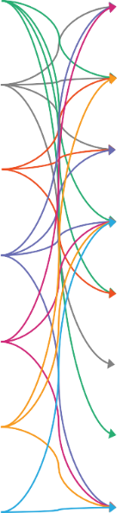
Context Input Outcome Impact

Increased share of young people and adults who have relevant skills for employment and entrepreneurship
Increased number of start-ups and/or scale-ups utilising business incubation, acceleration and co-working spaces
Improved arts, cultural and heritage offer that is more visible and easier for residents/visitors to access
Increased number of enterprises utilising high quality, affordable and sustainable commercial spaces
Enhanced high street and town centre experience that prioritises the health, safety and mobility of pedestrians
Enhanced townscape that is more attractive and more accessible to residents, businesses and visitors
Output
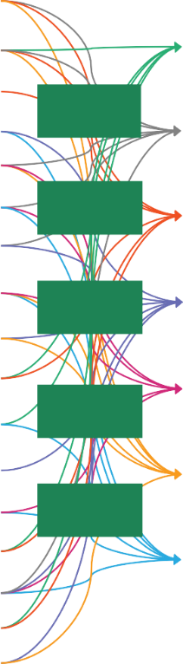
£25 million from Towns Fund
Co-funding and match funding
NELC
resources
Stakeholder support
Partnerships for delivery
Activation and Community Enterprise Fund
Victoria Mill Quarter
St James Quarter
Central Library
Public Realm Connectivity
Garth Lane
Riverhead Square
S1: Distinctive and plentiful heritage assets from Grimsby’s industrial past
S2: Unique water spaces with huge potential but currently underutilised and inaccessible
S3: Opportunity to exploit town centre geography to improve spatial cohesion between different areas
S4: Strong community and voluntary sector
S5: Healthy supply of vacant or underused buildings, some in Council ownership
S6: Emerging green sector will attract new investment and residents to the town
S7: Proven private sector interest in the future success of the town centre
S8: Growing demand for more activities and leisure uses and an afternoon to evening economy
S9: Emerging culture of entrepreneurship and creative sectors
W1: Poor pedestrian and cycling connectivity throughout the town centre
W2: Fragmented community ownership of the town centre despite high levels of civic pride
W3: Low skill levels amongst Grimsby residents and high risk of automation
W4: Perception of the town centre as an attractor of ASB and unwanted behaviours
W5: High levels of deprivation and poor health outcomes
W6: Dominance of retail space in the town centre and lack of residential
W7: Lack of good quality, inviting and safe public realm
W8: Limited availability of quality start-up and scale up space

By 2030 Grimsby will be recognised globally for its contribution to the UK’s green agenda, acting as a magnet for the growth of low carbon industries, its vibrant and attractive town centre will be home to a growing business and residential community. It will have enlivened public areas and waterfront, where culture and heritage is embraced, and a broad range of activities and pastimes can be enjoyed by all.

The overarching Theory of Change for Grimsby town centre, for illustrative purposes only – please see project-specific ToCs for more information

Grimsby Town Investment Plan

Implementation and Delivery

October 2020 81

Grimsby’s plans for delivery of transformational change across the town centre are already underway. With a track record of effective delivery evidenced through completed projects, this culture of delivery is based on strong partnerships. Grimsby was the first town to have secured its Town Deal and its Town Board (the Greater Grimsby Board (GGB)) has been working effectively for a number of years. The partnership between the public and private sector is strong, creating a positive climate of delivery for the Town Investment Plan.

Project Profile
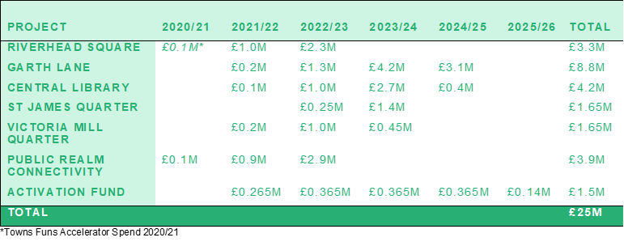A high level breakdown of Towns Fund project expenditure is profiled in the table below:

This investment of £25m will be matched, where possible with funding from other sources including contributions from the private sector for some projects (such as Victoria Mill Quarter, St James House and Garth Lane) and existing skills and training providers (Central Library).
Discussions are also underway with Government agencies about funding support from other programmes including the Heritage Lottery Fund, Homes England, BEIS funding related to decarbonisation, and DfT funding related to low emission transport and active travel.
Grimsby has already secured funding from the Town Deal Accelerator Funding (in response to Covid-19) to be used in 20/21 and this funding is being used to accelerate work on plans for Riverhead Square. This will ensure the project can quickly progress through the stages of planning and design once Towns Funding has been secured.

Implementation and Delivery
Business case, engagement and assessment

Projects for inclusion in the TIP have been through a considered three stage selection process which began in May 2020 (See Appendix 4). Following the final selection and approval of the seven TIP projects by the GGB the project team prepared outline business case information for all the projects. This covered project rationale, proposed delivery models, indicative project costs and timeline, project dependencies, strategic alignment and estimated outputs and outcomes.
As the projects are developed further, they will each have assigned project managers and a specific project delivery group which will include delivery partners. This group will develop the full business case focusing on the following areas:
- Detailed project design, cost and benefits, including detailed assessment of risks to inform project budgets and contingencies;
- Further market viability assessments, as required;
- Delivery and procured models agreed
- Match funding plans and funding agreements draw up
- Further technical assessments including detail, surveying, data collection, consideration of ground conditions etc;
- Consenting and delivery routes including consideration of planning processes, environmental and highway consents etc
- State Aid considerations
- Detailed programme planning including key milestones; and
- Monitoring and evaluation plans
A programme of continuous engagement and sharing via web-based tools will be developed as projects are developed, to ensure community groups and stakeholders are actively shaping proposals and bought into the success of projects from the outset. Details of stakeholder engagement to date and a plan for taking this forward is included at Appendix 3.
In developing the business cases we will draw on the resources available via the Towns Hub to provide assistance where relevant. This will also address any specific issues raised through the Heads of Terms.
We will also undertake an independent appraisal of the business case for the projects (and the programme) to provide the necessary assurance for the GGB.
At the end of this process, we will have detailed business cases for the projects in the programme, delivery programmes and structures, funding plans and proposals for monitoring and reporting.
This will be combined into a Towns Fund Delivery Plan for Grimsby. This Delivery Plan will include all project commitments, milestones and budget allocations.

Implementation and Delivery

Governance

Our approach to governance is informed by the success of the GGB as a highly effective and established partnership board that already brings together different interests across the town centre including public/private sector and community representatives. The GGB Assurance Framework outlines the governance for Grimsby Towns Fund and describes how the GGB will be responsible for overseeing the programme implementation, ensuring overall strategic direction. The Board will give NELC delegated authority for managing the programme and funds, and will receive regular reporting on performance to ensure compliance with appropriate governance and assurance processes.
The GGB will be supported by an NELC Delivery Team headed up by a Programme Manager working with project managers and technical specialists responsible for day to day operations. This work will be overseen by senior managers and a Senior Responsible Officer (SRO) who make up the Grimsby Town Centre Programme Improvement Board. The SRO is a new role with operational responsibility for the overall delivery of the programme. The GGB will adopt a programme wide approach to consultation and engagement that will be supported through a dedicated website and regular newsletters on the progress of the programme.

Towns Fund Delivery

Reporting and decision-making process

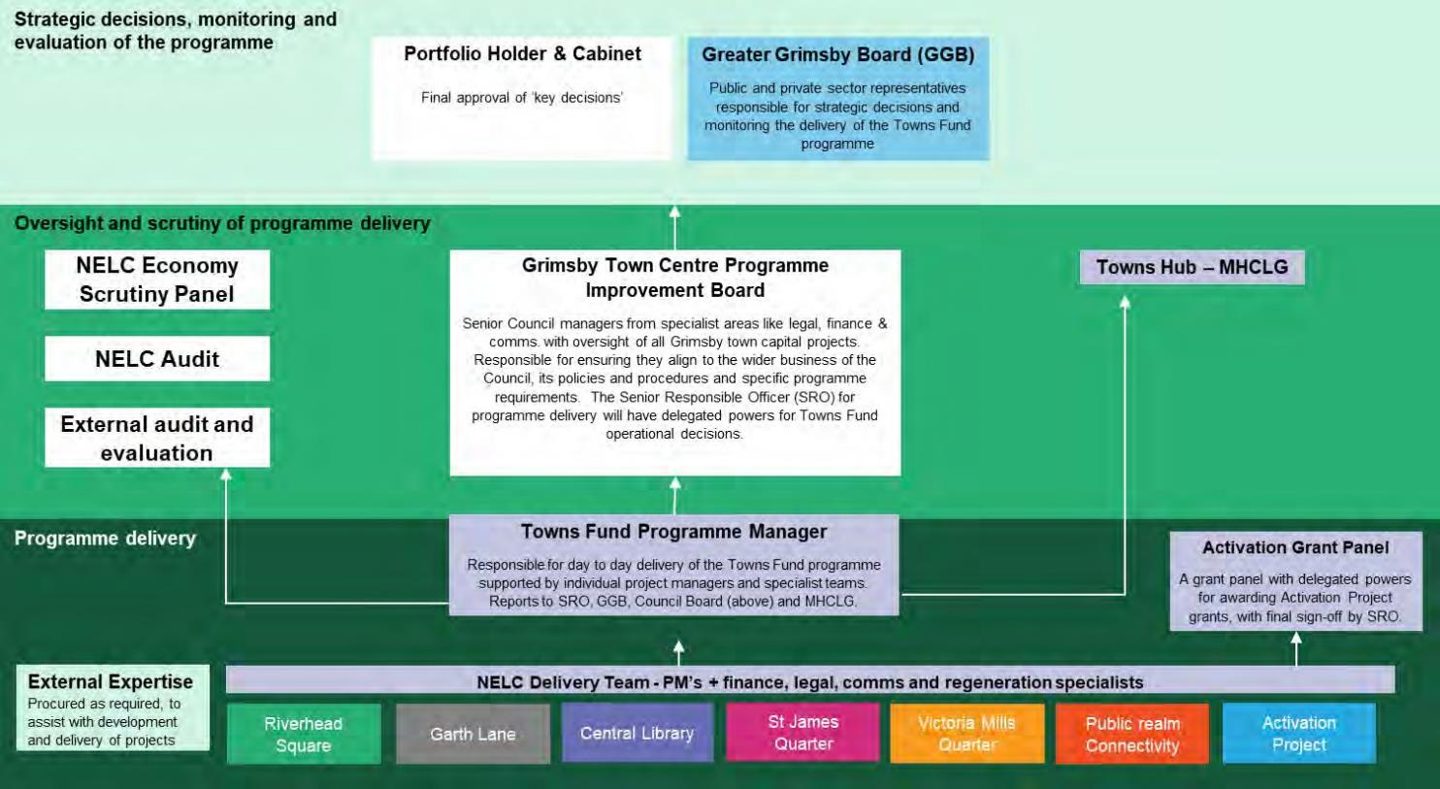

Implementation and Delivery Milestones and assurance

Proposed project delivery milestones
Date | Stage
November/December 2020 | Heads of Terms agreement
November – March 2021 | Development of business cases and preparation of the Towns Fund Delivery Plan
April 2021 | Complete Accelerator Project – 1st phase of Riverhead Sq scheme
April 2021 | Approve Delivery Plan
April 2021 onwards | Begin phased delivery of TIP projects beginning with Phase 2 of Riverhead Sq scheme and the launch of the Activation and Community Enterprise Fund.

Scrutiny and assurance
The Grimsby Town Centre Programme Improvement Board is made up of Senior managers with oversight of all Grimsby town capital projects, responsible for ensuring they align to the wider business of the Council and its policies and procedures. There is representation from specialist areas like legal, finance and communications, they act on behalf of the accountable body and will regularly scrutinise the performance of the Towns Fund programme to ensure appropriate compliance to Council, MHCLG and Towns Fund policies and processes. Additional scrutiny of the programme will be carried out through programme reviews by NELC’s Scrutiny Panel, internal Audit reviews and where appropriate external auditing and evaluation of the programme which would be a procured service. Monitoring and reporting will be the responsibility of the Programme Manager and SRO who will regularly present information to the Grimsby Town Centre Programme Improvement Board, the GGB and MHCLG.

Footnotes & References

1 | North East Lincolnshire Council Local Plan 2013 – 2032
2 | ONS – Business Register and Employment Survey (2019)
3 | Interview with representative from ORE Catapult
4 | Centre for Cities – Cities Outlook (2014) https://www.centreforcities.org/wp- content/uploads/2014/09/Grimsby.pdf
5 | Travel to Work Mode; Census 2011
6 | Centre for Cities – Cities Outlook (2014) https://www.centreforcities.org/wp- content/uploads/2014/09/Grimsby.pdf
7 | Humber LEP Skills Advisory Panel Report Data Analysis Final Report (Hatch Regeneris)
8 | https://www.velocys.com/2019/08/20/plans-submitted-for-the-first-waste-to-jet-fuel-plant-in-the-uk-and- europe/
9 | Index of Deprivation and Social Mobility Commission cited in Go Big Go Local: The UK2070 Report on a new deal for levelling up the United Kingdom
10 | ONS – Annual Population Survey (2020).
11 | North East Lincolnshire Local Economic Assessment. June 2019
12 | ONS – Annual Population Survey (2020).
13 | ONS – Annual Population Survey (2020).
14 | ONS – The probability of automation in England: 2011 and 2017 (2019).
15 | Professional Occupations in 2019. ONS – Annual Population Survey (2020).
16 | CoStar (2020)
17 | Month with the highest footfall across the year
18 | Census 2011, cited in North East Lincolnshire Strategic Housing Market Assessment May 2013
19 | BRE Integrated Dwelling Level Housing Stock Modelling and Database for North East Lincolnshire Council. UNPUBLISHED. 7 February 2020

20 | NEL Local Economic Assessment 2019
21 | Public Health England, North East Lincolnshire Health Profile (2019).
22 | Statistics from the Towns Fund Dashboard. Business Register and Employment Survey (2018)
23 | Statistics from the Towns Fund Dashboard. Claimant Count (May 2018)
24 | Statistics from the Towns Fund Dashboard using 2018 data. Sectors at risk were identified using the Office for Budget Responsibility output loses by sector in the second quarter of 2020 taken from their published commentary ‘OBR coronavirus reference scenario’ (14 April 2020). Any sector that had over a 50% reduction in GDP was classified as ‘at risk’.
25 | Response rates differed between questions
26 | BRES data, cited in: Centre for Towns. The effect of the COVID-19 pandemic on our towns and cities
27 | Full Stakeholder Engagement Plan at Appendix 3
28 | https://www.gov.uk/government/news/pm-a-new-deal-for-britain
 | The statistics on slide 17 have been taken from the Towns Fund Dashboard, ONS and IMD (Index of Multiple Deprivation Data)

Grimsby Town Investment Plan

October 2020 88

