# **Cost of Care Report - Residential Annex B**

1. **Introduction**

North East Lincolnshire (NEL) is a small unitary authority area with most residents living in the towns of Grimsby, Cleethorpes, and Immingham. It is somewhat geographically remote from larger centres of population, and the local authority needs to retain and grow our local workforce capacity and capability across a range of sectors including health and care. Figures (mid-2020) from the Office of National Statistics (ONS), estimate the North East Lincolnshire resident population at 159,364 persons. This shows that the local population has changed very little over the past decade, with the 2011 Census recording the local resident population at 159,616 people. The latest ONS population projections estimate that the local population will continue to change very little over the coming decade and will remain at around 159,000 in 2030. Despite the estimation that the overall population will remain static, there are clear differences in the projections across the life course, with the 0-19 resident population projected to decrease by 5.4 per cent between 2020 and 2030, and the 80+ resident population (frail elderly) projected to increase by 30.6 per cent within the same time-period. This is likely to create significant growth in demand to be met from the resources available to the health and care economy within the borough.

Estimates from the annual population survey show that approximately five per cent of the North East Lincolnshire population overall is non-white British, which is much lower than that for England overall. Again, there are differences across the life course, with increasing ethnic diversity among the younger age groups, as the local school census shows that around ten per cent of primary school pupils are recorded as non-white British.

The approach taken to supporting citizens is that where possible support in a person’s home is explored first and residential or nursing care are for where this is not possible. Traditionally North East Lincolnshire has had residential occupancy levels of 75-81%.

As well as applying Home First principles, North East Lincolnshire believes that a care home is a resident’s home, and the approach is that people should be supported to remain in their residential placements where possible and not moved from one placement to the next because of changing needs except in very specific circumstances and taking into account the persons wishes or best interests.

1. **Overview of the current care home market in North East Lincolnshire:**
   * + There are 1305 Care Quality Commission (CQC) registered number of beds with an 78% per cent occupancy rate as of September 2022.
     + CQC inspections demonstrate the following ratings across the homes in scope of this exercise:
       - 1 home is rated outstanding (3 per cent),
       - 28 homes are rated good (85 per cent),
       - 3 homes are rated ‘requires improvement’ (9 per cent),
       - 1 home rated inadequate(3 per cent).
     + 33 local CQC registered homes within the scope of the exercise; a split of 27 residential homes and 6 nursing homes.
     + 931 staff across the in-scope homes.

The self-funder market is 34% across all residential and nursing care home. The self-funder market currently breaks down as follows:

* + - 6 care homes (representing 18% of the market) have over 50% self-funders making up their total occupancy
    - 16 care homes (representing 49% of the market) have between 25-49.9% self-funders making up their total occupancy
    - 10 care homes (representing 30% of the market) have less than 25% self-funders making up their total occupancy
    - Only 1 provider (shuttered care home) has 0 self-funders

We currently have 12 homes charging top ups (36%)

1. **Choice of data collection tool**

To ensure consistency of approach to data collection, tools meeting the Department of Health and Social Care’s (DHSC) suggested functionality have been published by the Local Government Association / Association of Directors of Adult Social Services (LGA/ADASS). As part of the very early engagement, providers were consulted over the choice of tools to be used, those that expressed a preference wished to use the iESE tool as suggested in the guidance as against a locally developed model. In completing the tool, most providers provided an inflationary uplift percentage to reflect the cost change from 21-22 to 22-23. Where providers had not indicated a percentage, the median percentage per cost line was applied to the data.

1. **Provider engagement**

As part of the engagement in the late spring, summer and autumn of 2022 the local authority worked with the local market with initial contact made via the Support to Care Home network and by use of newsletters, supported by email communications.

Providers also had access to drop-in sessions with local authority staff to assist in any questions regarding accessing, registering, or completing the iESE data collection tool. This included key timelines to meet the national deadline. A provider event was held jointly with North Lincolnshire Council on 5th May 2022 and included the iESE tool developers to ensure consistency of approach. This is because several providers work across both authority areas.

Provider support sessions with the iESE development team were signposted, to help providers complete their returns, as well as one to one sessions held with the North East Lincolnshire project team to aid the completion of the returns, and discuss any queries with data submitted. Individual 1:1 was available via telephone support and Microsoft Teams. This was assisted by the continued engagement with providers because of supporting the COVID -19 pandemic and through the regular and frequent support network meetings.

Queries about individual components on returns were raised with providers within the iESE tool and followed up by emails where appropriate. Responses were then considered, and amendments agreed. In some cases, this included a request for evidence to support the values submitted. It should be noted that not all queries were resolved by the close of the exercise.

Further engagement has taken place in early 2023 to inform fee rate setting for the 2023/ 2024 year.

1. **Response rate**

North East Lincolnshire appreciates the support from care providers who have submitted their responses to the fair cost of care exercise, as this has provided insight and understanding into the local cost of providing care for care homes (65+). The exercise has identified the lower quartile, median and upper quartile costs as required.

In North East Lincolnshire there are 28 residential care homes and 6 nursing care homes who were in scope of the exercise.

The 13 care homes who completed the return equated to a 38% response rate for those within the scope of the exercise. Some providers declined to participate as they saw this as an additional burden that they didn’t have the time or capacity to complete; especially as this was towards the end of the most recent pandemic wave. A standard support payment was offered to care homes to complete the tool to try to mitigate this, however this did not have a significant impact on completion of returns.

Whilst the percentage of returns is thought to be in line with national average, the small number of providers overall meant that there were limitations to the extent the data helps to inform the use of the Fair Cost of Care Fund and future fee setting strategy. There is therefore a need to take into account additional factors to arrive at the intended fee rate that North East Lincolnshire will move towards. This will be supported by further engagement in early 2023.

1. **Data tables**

**Table 1**

65+ care home without nursing

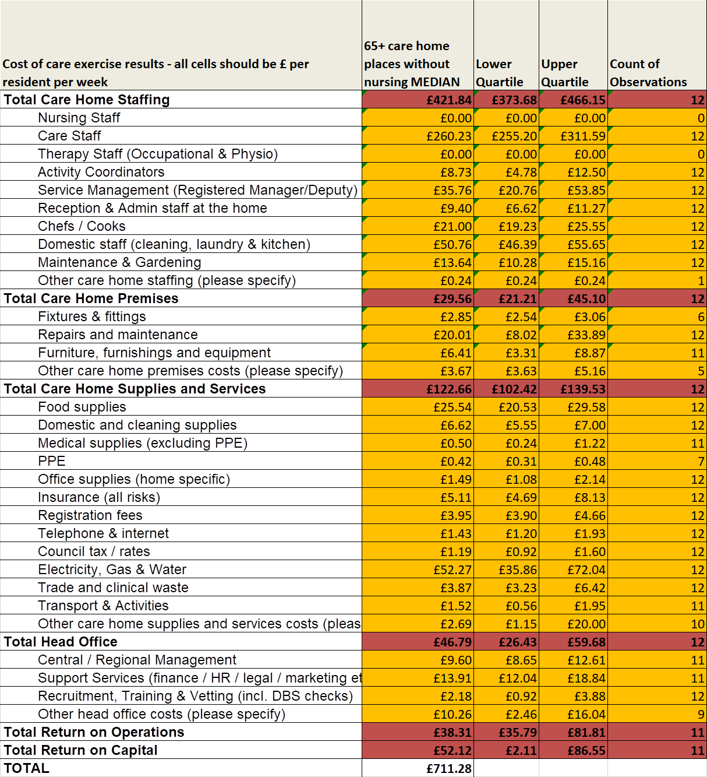

**Table 2**

65+ care home without nursing – enhanced needs

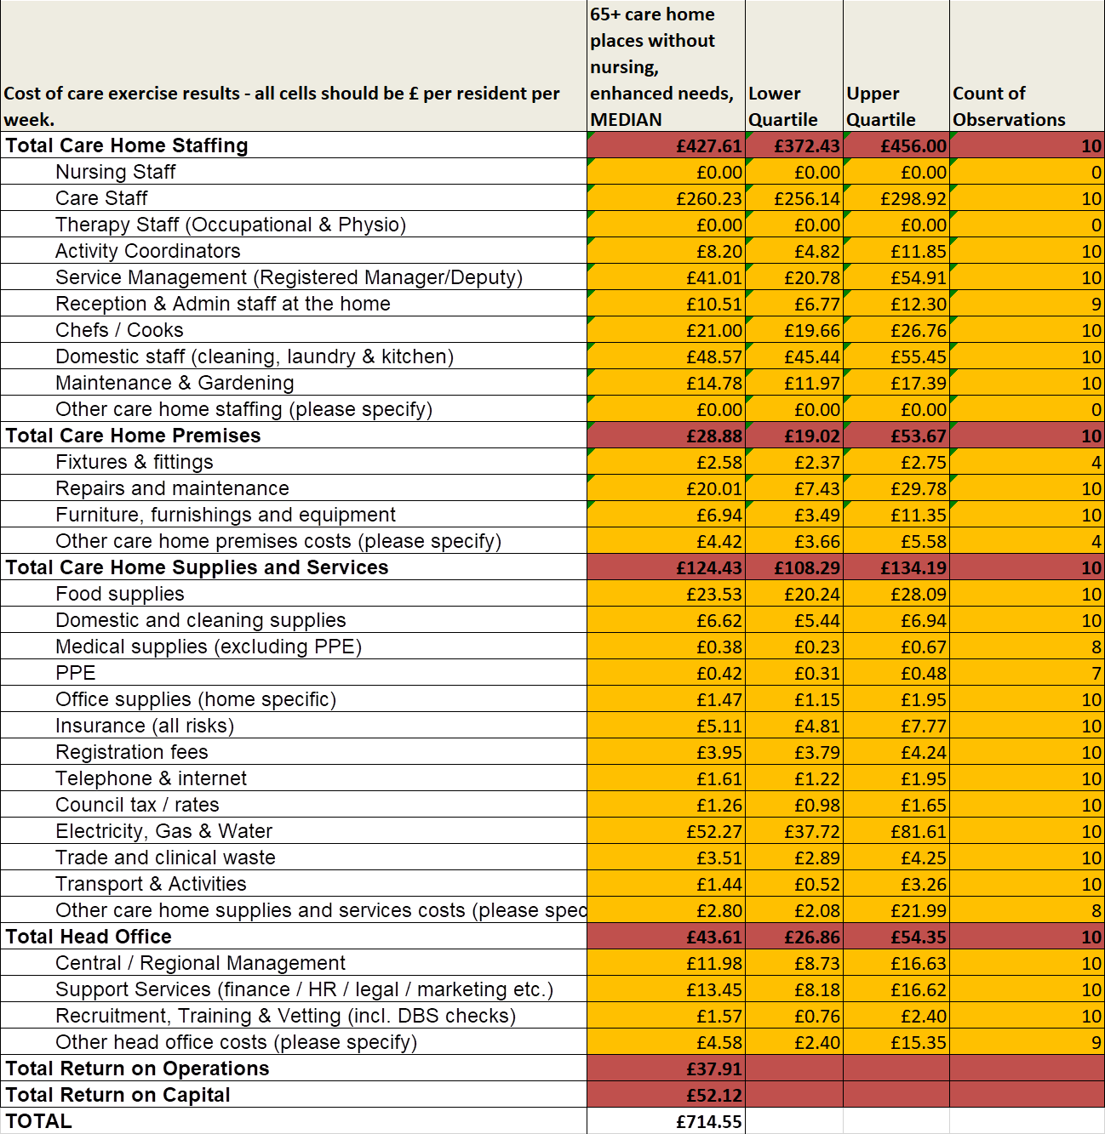

**Table 3**

65+ Care home placements with nursing

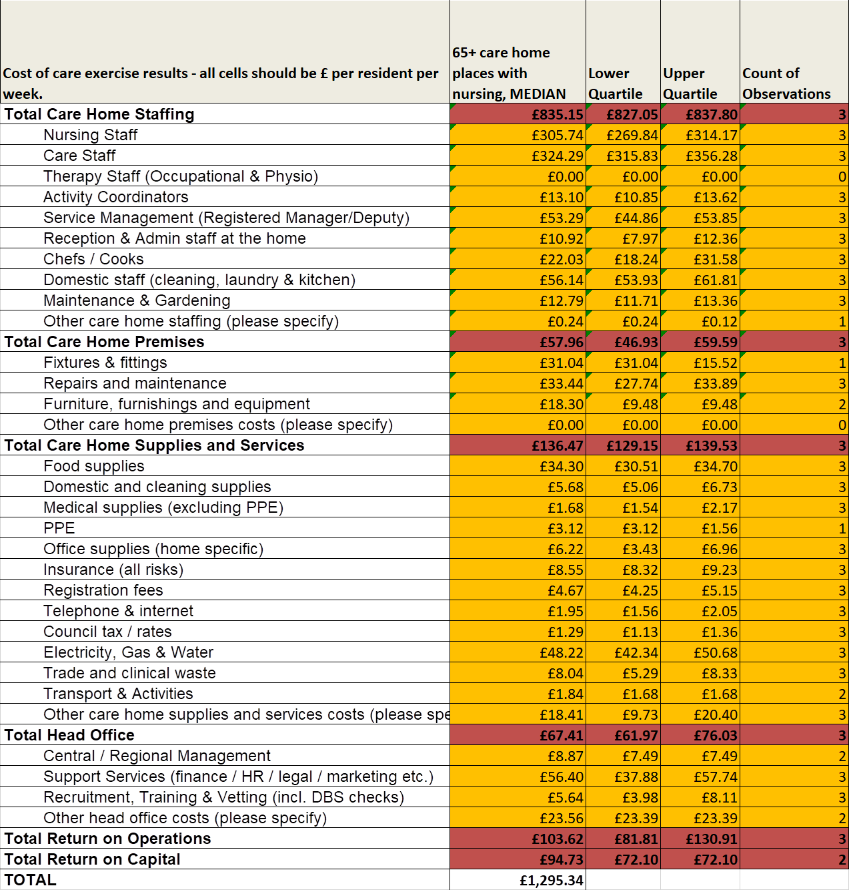

**Table 4**

65+ Care homes with nursing & enhanced needs. The Nursing values without enhanced needs have been used as no responses for this category were received.

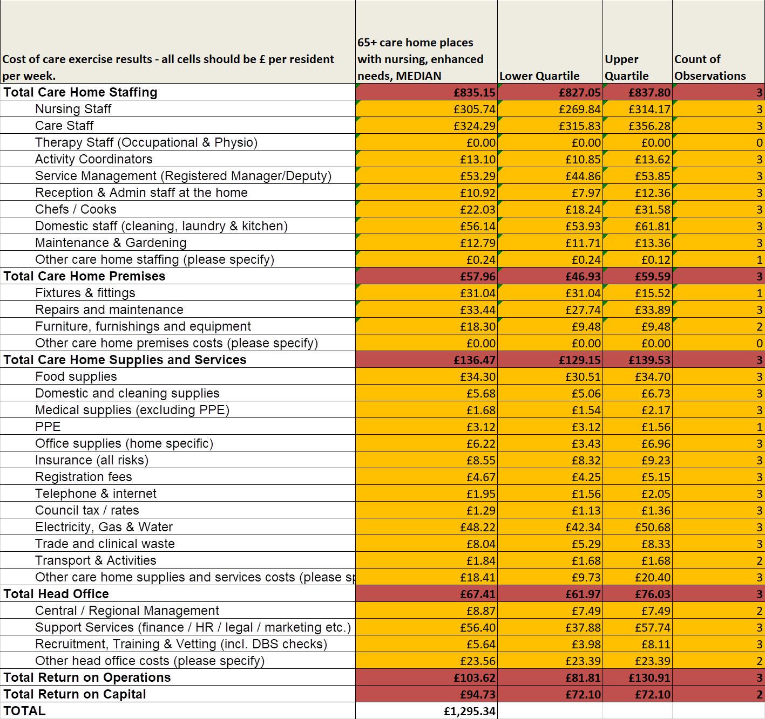

**Table 5**

The full table in Annex A, Section 3 with one column of median values for each care type

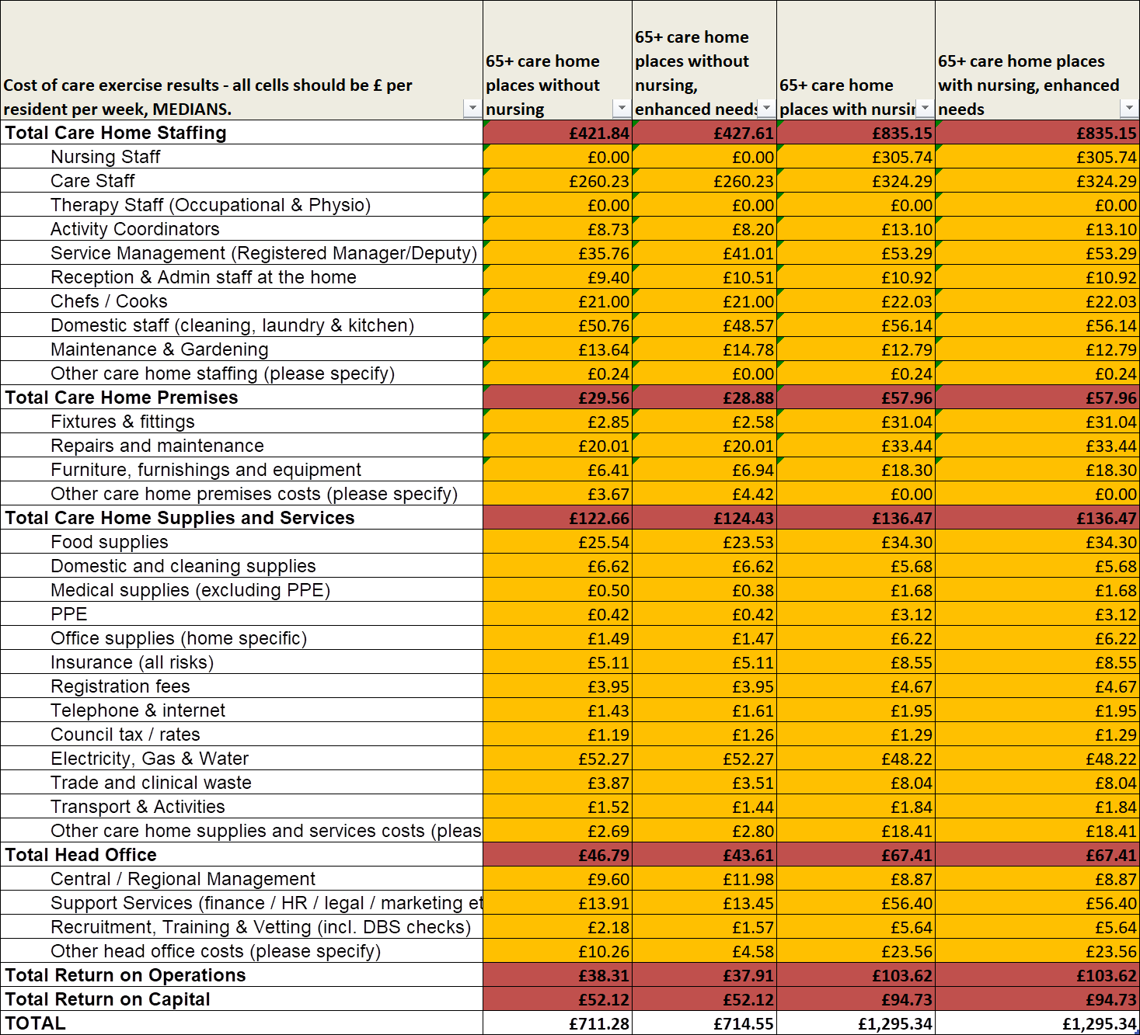

|  |  |  |  |  |
| --- | --- | --- | --- | --- |
| Supporting information on important cost drivers used in the calculations: | 65+ care home places without nursing | 65+ care home places without nursing, enhanced needs | 65+ care home places with nursing | 65+ care home places with nursing, enhanced needs |
| Number of location level survey responses received | 12 | 10 | 3 | 3 |
| Number of locations eligible to fill in the survey (excluding those found to be ineligible) | 28 | 28 | 6 | 6 |
| Number of residents covered by the responses | 234 | 165 | 45 | 45 |
| Number of carer hours per resident per week | 22 | 22 | 23 | 23 |
| Number of nursing hours per resident per week | 0 | 0 | 10 | 10 |
| Average carer basic pay per hour | £9.79 | £9.76 | £9.86 | £9.86 |
| Average nurse basic pay per hour | £0.00 | £0.00 | £18.31 | £18.31 |
| Average occupancy as a percentage of active beds | 79% | 80% | 63% | 63% |
| Freehold valuation per bed | £23,187.62 | £23,187.62 | £20,000.00 | £20,000.00 |

1. **Considerations of the data Outputs**

The local authority does not consider the cost information from providers to be wholly reflective of the state of the market and needs to be reviewed in light of other information especially for nursing provision as the reported costs point to significantly higher rates than the council has been paying, whilst at the same time there has been over-supply across the market

In considering the approach to the information provided by the returns there is a need to consider some limitations in the information and our local commissioning context are as follows:

Key considerations:

* Consideration of occupancy rates, which have historically been low across residential/nursing homes in North East Lincolnshire. The previous model used suggests 90% for efficiency.
* Gaps in specific lines in the return that were not completed by the care homes.
* No returns received for 65+ nursing with dementia.
* Significant differences in the approaches to return on capital and return on operations.
* Relatively low value land and property prices in comparison to the region.
* A home first model of care delivery.
* Small numbers of nursing homes.
* Different business models.
* Consistency in the methodology providers have used to apportion costs.
* Variation in who completed the forms - e.g. in some cases corporate leads, in other cases individual home managers.
* General issues about the consistency and accuracy of some of the data.
* Data used as of April 2022.
* Staffing levels for nursing may be less flexible than for carers.
* The data and intelligence gathered by further engagement with providers in early 2023.

1. **Choice of model for calculating median**

The local authority considered four options to model the median cost, these were:

* Each line with zeros.
* Each without zeros.
* Each section with zeros.
* Each section without zeros.

Because of the variance in the interpretation of each line and our discussions with providers, and given the inconsistencies in the data representation, the local authority decided to use the median from each section without zeros as it was believed this offered a fairer representation of the data received.

1. **Queries, adjustments and data validation**

Manual adjustment to the data that was received in the IESE tool, additional amends with made for inflation uplifts for 22/23 for two providers that did not state an uplift we used the median from the other providers to uplift the values for those two providers.

We have made five amendments to specific values within 4 care home returns. Where queries have been raised and either the provider has not done the amendment in the tool or where they have given sufficient information to make a reasonable amendment. Amendments included adjustments to PPE, and other care home supplies. One entry that we amended was effectively a duplication of staffing costs, one was a value in place of % uplift and one where costs were included that should not have been (Rent Capex)

For the two providers that did not indicate an inflationary value between 21/22 and April 22 we have manually adjusted for this based on the median inflation rate taken from the other provider responses – to ensure all responses were presented at April 22 values

1. **Considerations on returns on operation and capital**

The local authority is considering the approach to be taken when manging return on operation (ROO) and return on capital (ROC) and our consideration will take into account some of the areas described below. There was significant variance in this area by each provider.

The local authority will consider national and regional benchmarking information and has engaged specialist support to establish a reasonable value. This will include further engagement with providers and will inform the market sustainability plan due for publication in late March 2023.

In order to develop the local authorities Market Sustainability Plan (MSP) it is necessary to understand this information to ensure it becomes a foundation of a sustainable market and to arrive at the fair local fee rate.

1. **Our plan for uplift**

North East Lincolnshire uses a process of engagement with providers, which considers the existing fee rate in light of proposed national changes such as the National living wage, general inflation levels and changes impacting on businesses. In addition, consideration of individual aspects of service delivery where cost changes are identified during engagement with providers including consideration of capacity and quality. Adjustments to the fee level is considered as part of the Council budget process and resource allocation. The local authority has a programme of annual engagement with providers.

Uplifts will, in the future, also be based on the level and type of provision, and this is reflected in our local needs assessments and continued development of commissioning intentions and strategy.

The Market Position Statement for 2022 – 2025 outlines strategic commissioning intentions in North East Lincolnshire.

More detail on our commissioning intentions in coming years will be published at the end of March 2023 in the Market Sustainability Plan.

1. **Other Cost of Care Data Requirements**

Section 4 within Annex A requirement, to state the IBCF fee rates for 21-22 and 22-23 as a comparator to the FCOC rates presented in section 3. This highlights a difference in methodology basis and is not considered a wholly relevant comparison. In addition, the percentage calculation used to present the distance from the cost of care exercise result does not reflect the change from current IBCF rate to reach the cost of care. The current calculation appears to understate the gap.