Event Toilet Provision Guidance – Taken from the Purple Guide for Outdoor Events

Table 1 below provides guidance on sanitation provision at a variety of event types when facilities provided are either toilet blocks or self-contained toilets where basins are NOT internal. Please refer to 18.23 below for appropriate ratios of external basins.
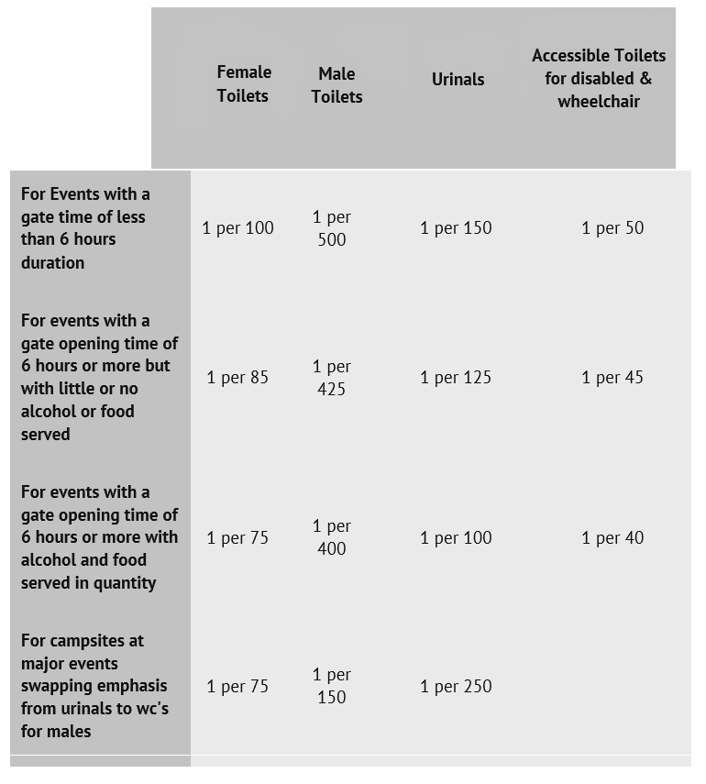
18.23 Hand wash basins can cause similar or even greater queuing than for WCs, especially for female toilets.
Where possible, provide hand-washing facilities in the ratio of one hand wash basin per two toilets for females, one hand wash per four toilets for males, applicable in installations of mains connected toilet facilities. However, for single plastic toilet installations then hand-washing facilities should be provided normally in the ratio of one hand wash basin per five facilities (WCs & Urinals) with not less than one hand-washing facility per ten toilets provided. Consideration should be given to providing lower height wash basins where wheelchair users and/or a significant number of children are expected to attend the event and also to hand operated rather than foot operated pumps for wheelchair users.

Table 2 below refers to self-contained toilets with internal basins ONLY. Please note that ratios of accessible toilets are not affected by this recommendation since their internal basin needs to be a specialist unit with a hand pump and external units typically with a foot pump are unsuitable.

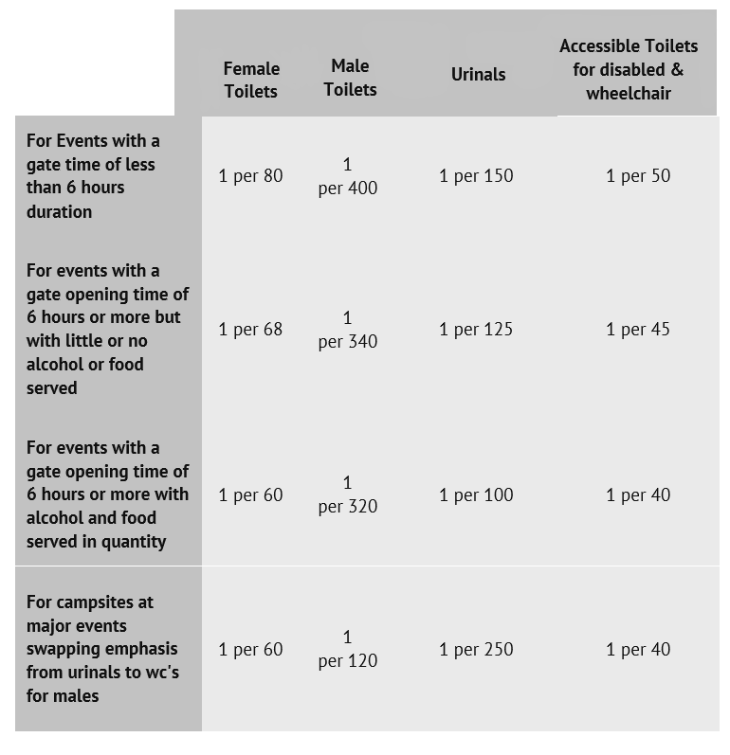
Version 1 - 13-10-2023

