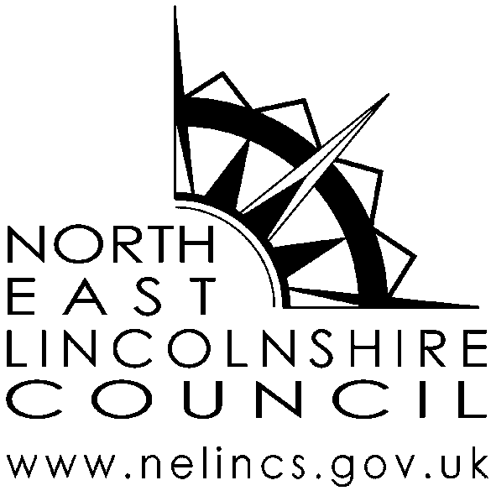

Bus Pass photograph request form

(For self)
You can request a copy of your Bus Pass photograph, for which there will be a charge of £11 per photograph.
Before issuing you with the photograph, we will need to confirm your identity.
Please use BLOCK CAPITALS and BLACK INK when completing this form

Your details
Last name
First name(s)
Title (Mr, Mrs, Ms, Dr etc)
Address
Postcode
Contact number *
Email address *
Bus Pass number *
These fields are not mandatory but will assist us to contact you if we need to discuss your request.

Declaration
- I wish to request a copy of the Bus Pass photograph held by North East Lincolnshire Council for the administration of my Buss Pass.
- I understand that a person who impersonates another or attempts to impersonate another may be guilty of committing a criminal offence and subject to prosecution.
Signature
Date
Completed forms should be submitted at; AGE UK Grimsby or Cleethorpes along with the £11 administration charge.

