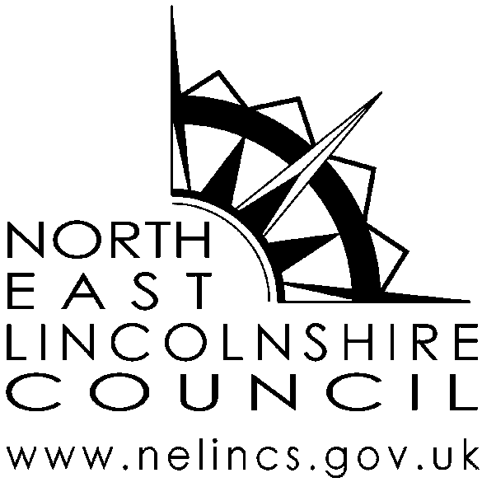

Bus Pass photograph request form

(For another person)
As part of the bus pass application process a photograph is taken. There are circumstances, such as following the death of a relative, when the next of kin may wish or need to request a copy of the photograph.

To help us find the photograph, and consider whether the photograph can be provided to you, we would ask that you please supply the following details. All requests will be considered on their own merits and in confidence. A charge of £11 per photograph is made to cover administration costs.
Please use BLOCK CAPITALS and BLACK INK when completing this form.

Section 1: Your details
Last name
First name(s)
Title (Mr, Mrs, Ms, Dr etc)
Address (this will be the address all correspondence is sent to)
Postcode
Contact number *
Email address *
These fields are not mandatory but will assist us to contact you if we need to discuss your request.

Section 2: Details of the person you would like the photograph of
Last name
First name(s)
Title (Mr, Mrs, Ms, Dr etc)
Address used for the Buss Pass application
Postcode
Contact number
Email address
Their relationship to you

Section 3: Details of why you are requesting the photograph
Please provide details
Please note: Before providing you with the photograph you have requested, we will need to confirm your identity and that you have a justified right to request and receive the photograph.

Section 4: Declaration
- I wish to confirm that the information I have provided on this form is accurate to the best of knowledge; and
- I understand that a person who impersonates another or attempts to impersonate another may be guilty of committing a criminal offence and subject to prosecution.
Signature
Date
Please print name
Completed forms should be submitted at; AGE UK Grimsby or Cleethorpes along with the £11 administration charge.

