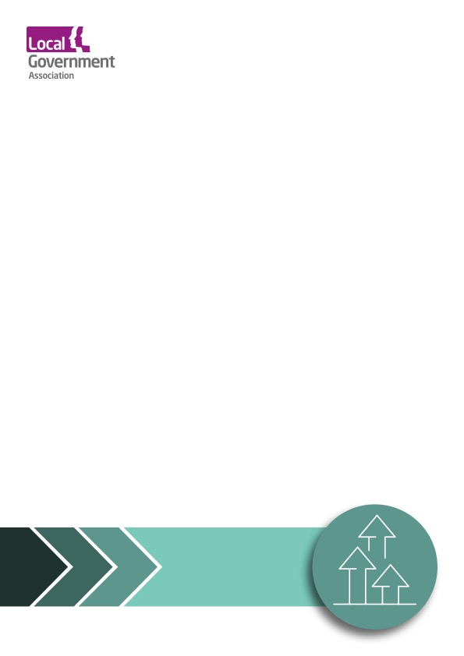

LGA Corporate Peer Challenge – Progress Review

North East Lincolnshire Council
30th November 2023

Feedback

Contents
1. Introduction 3
2. Summary of the approach 3
3. Progress Review – Feedback 4
4. Final thoughts and next steps 8

Introduction
The council undertook an LGA Corporate Peer Challenge (CPC) during March 2023 and promptly published the full report with an action plan.
The Progress Review is an integral part of the Corporate Peer Challenge process. Taking place approximately ten months after the CPC, it is designed to provide space for the council’s senior leadership to:
- Update peers on the early progress made and to receive feedback on this including how the action plan aligns to the CPC’s recommendations
- Consider peer’s reflections on any new opportunities or challenges that may have arisen since the peer team were ‘on-site’ including any further support needs
- Discuss any early impact or learning from the progress made to date
The LGA would like to thank North East Lincolnshire Council for their commitment to sector led improvement. This Progress Review was the next step in an ongoing, open and close relationship that the council has with LGA sector support.

Summary of the approach
The Progress Review at North East Lincolnshire Council took place on 30th November 2023.
The progress review focussed on each of the recommendations from the Corporate Peer Challenge, under the following theme headings:
- Local priorities and outcomes
- Organisational and place leadership
- Governance and culture
- Financial planning and management
For this progress review, the following members of the original CPC team were involved:

- Member peer – Cllr Abi Brown, Stoke-on-Trent City Council
- Chief Executive Peer – Becky Shaw, East Sussex and West Sussex County Councils
- Officer Peer – Alan Denby, Director of Pride and Place, Torbay Council
- Judith Hurcombe - LGA Peer Challenge Manager
The peer team met face to face in North East Lincolnshire Council over the course of 1 day with the following representatives from the council:
- Cllr Philip Jackson, Leader of the Council
- Cabinet Members
- Leaders of Opposition Groups
- Rob Walsh, Chief Executive
- Directors
- Senior and middle managers

Progress Review – Feedback
Local priorities and outcomes
North East Lincolnshire Council has made significant progress and can evidence progress on the range of recommendations made in the Corporate Peer Challenge of March 2023. Over the last 8 months members and officers appear to have grown in confidence and focus and are increasingly optimistic about the future and the council’s role in delivering improvement for communities.
Organisational and place leadership
At the end of November 2023, the council ratified a new devolution deal for Greater Lincolnshire with North Lincolnshire and Lincolnshire County Councils, and government. The council leader has played a significant role in bringing this about and his leadership in doing so deserves recognition. A separate devolution deal has developed between Hull and East Riding Councils and government.
The ambition for the NEL area is clear, as well as the ambition to maximise the benefits for the borough. Now that the deal has been signed it will be important for the council to ensure it is ready on two fronts: with projects which will bring the most impact and can be rolled out quickly, and secondly continuing to engage, across complex landscape of two Devolution Deals, with partners, particularly businesses, who can support and influence discussions and shape delivery. The council has a significant and important ongoing role to play in asserting its demands and aspirations through the new structures and arrangements.
The council has revisited its approach to senior leadership development and engagement and a new Leadership Forum will be launched in early 2024. This aims to develop a problem-solving response across the organisation, to make better use of existing skills and to share experiences.
In March 2023 the peer team found that equality, diversity and inclusion (EDI) had a very low profile across the council and its communities. A good start has been made in addressing this, with effort going into understanding the evidence base within the council and of the broader population. An internal EDI champions group has been created which brings together staff from across the organisation, which is supported by a director at corporate level and champions have received external training. Exploring and understanding what partners do in this area has also helped shape thinking, including approaches which have been adopted by health partners. However, there is more to do on EDI across the organisation: the council is aware of this and is becoming more confident in its approach.
A staff survey was undertaken in May 2023, followed by a shorter pulse survey in October. Workshops with staff explored some of the issues arising from the full survey. The overall approach this year has provided some good feedback which is informing the development of action plans.
Earlier in 2023 there was uncertainty and concern from the council and its partners about how the new Integrated Care Board arrangements would impact the adult social care arrangements across North East Lincolnshire. In particular there were concerns about how the low cost and high impact model would be affected locally given the large footprint of the ICB over the Humber and North Yorkshire. Since then, progress has been made and the council and ICB have agreed, in principle, new arrangements on pooling budgets (commonly known as S.75 agreements). The new arrangements will operate in shadow form from January to March 2024.
The momentum on the council’s regeneration plans continues at pace and new projects have started. The Humber Freeport is a notable milestone especially with NEL as the accountable body. Work has started at a number of urban locations including Town Deal projects at Riverhead Square, St James House, the Onside Youth Zone and Freshney Place in Grimsby and major public realm projects in Cleethorpes.

Governance and culture

Children’s Services improvement is clear. In March 2023 there were signs that the council was on the cusp of progress, and over the past 8 months improvement has been delivered. The DfE external commissioner’s public statements recognise NEL’s rapid improvement, as reflected in the 5th monitoring report published on 15th November 2023. This service has been in the spotlight over the last couple of years due to poor performance and the inadequate Ofsted rating and has been subject to a great deal of effort across the council, supported by Lincolnshire County Council as its improvement partner. In addition, children’s health services have received a Good rating from CQC. As the performance of Children’s Services has begun to improve, so has the confidence of the council. The peer team also heard of wider ownership across the council of the issues facing Children’s Services.
Confidence at corporate level is growing with a stronger sense of team working, and new appointments, including joint DPH, are bringing new ideas and perspectives to the council. An important milestone takes place in December 2023 when all of the members of the senior management team will be permanent appointees. Related to these changes at the most senior levels, in Children’s Services the council will shortly have a new leadership team. In light of these changes and permanent appointments it will be important to integrate the new corporate and Children’s Services teams quickly so that corporate focus and ownership can be consolidated, supporting ongoing service improvement.
The strong commitment to good and effective partnerships was clear, especially with VCS as well as other statutory and business partners. There is clear evidence of strong joint work on EDI, supporting migrants, armed forces and households.
Expectations on the council’s members and where they need to visibly step up continues to grow and their roles will be even more important in the new devolution environment. This growing expectation needs to be matched to a broader member development offer which maximises opportunities for all councillors to get up to speed with ongoing changes in local government. Some members consistently engage with development opportunities but there is still room for others to improve their uptake, and knowledge and understanding.
Development in its widest sense for councillors includes exploring what other councils and places are doing, and using those opportunities to promote what North East Lincolnshire is doing well. For example, good practice on Adult Social Care, on skills development and offshore energy. NELC was the first council to receive a Town Deal and has an emerging story to share on the delivery of levelling up.
Financial planning and management
A CPC recommendation was to make closer linkages between the council’s priorities and its performance, and the council has introduced joint finance and performance quarterly reporting to Cabinet and Scrutiny. The reports are open and clear. This is a positive and transparent step which will help to improve members’ understanding of the budget.
As in many other councils, significant budget pressures remain. The medium-term financial plan includes savings of £6.1m for 2023/24 and £7.9m in 2024/25 and £6.2m in 2025/26: the peer team heard differing views about how these gaps will be addressed, suggesting there is more to do on identifying savings, as well as needing a broader understanding of the budget and its pressures.
In addition, and in common with other councils, there are growing demand-led pressures on services. In NEL Children’s Services have been overspending for some time particularly on Looked After Children and this is not uncommon in councils with external intervention in the service. The numbers of Looked After Children is beginning to fall and this will help to reduce some, but not all, of the budget pressure.
The council has been using its reserves and taking mitigating measures to address overspending, but a key issue remains that reserves can only be spent once, and the overall levels of reserves is reducing.
During November 2023 the council had secured a land agreement which will result in a capital receipt of £20.5m. Whilst this is a positive result, the peer team heard differing views on how this receipt will be spent. Windfalls such as this are good news, but they are not enough singularly or collectively to stem the holes in the budget.
Despite windfalls and external funding successes, the easier options facing the council to balance its budget each year have already been used, and there are some tough decisions to be made. Making those tough decisions will require members to have a really thorough understanding of the whole budget, as well as to be clear about priorities, and what the council will need to stop doing. They will also test members’ resolve. As awareness of the budget and financial planning improves and the budget tightens further an important aspect will be members expectations and what can realistically be delivered. They will need to be more disciplined about sticking to agreed policies and not expecting officers to provide work arounds or make exceptions for special cases, however small, even when the implementation of some policies will be unpopular and difficult.
Different ways of working bring the potential of more efficient service delivery and better outcomes for local people. The council should explore further what it means by transformation, digital, customer service and its future operating model, and how these can effectively contribute towards members’ aspirations for North East Lincolnshire, as well as to save money.

Final thoughts and next steps
The LGA would like to thank North East Lincolnshire Council for undertaking an LGA CPC progress review.
We appreciate that senior managerial and political leadership will want to reflect on these findings and suggestions in order to determine how the organisation wishes to take things forward.
Under the umbrella of LGA sector-led improvement, there is an on-going offer of support to councils. The LGA is well placed to provide additional support, advice and guidance on a number of the areas identified for development and improvement and we would be happy to discuss this.
Mark Edgell (Principal Adviser) is the main point of contact between the authority and the Local Government Association (LGA) and their e-mail address is mark.edgell@local.gov.uk

