Householder Pre-Application
Form

Do I Need Planning Permission – Householder Developments
Please complete all sections relevant to your enquiry and return to either:
Planning@nelincs.gov.uk
or
North East Lincolnshire Planning, Municipal Offices, Town Hall Square, Grimsby, North East Lincolnshire, DN31 1HU

The fee of £42 (inc VAT) can be made by debit or credit card by calling 01472 326289 Option 1 for Planning, by cheque payable to Equans Services Ltd, or by bank transfer (details on request).
We endeavour to respond to enquiries within 10 working days, however, it is possible that more information will be required before a response can be issued.
Please ensure that all measurements are provided in metres. Where possible, please provide site photographs and rough sketches.
Your information
Applicants Details

Name: Click or tap here to enter text.
Address: Click or tap here to enter text.
Postcode: Click or tap here to enter text.
Telephone Number: Click or tap here to enter text.
Email Address: Click or tap here to enter text.
Agents Details (if applicable)

Name: Click or tap here to enter text.
Company: Click or tap here to enter text.
Address: Click or tap here to enter text.
Postcode: Click or tap here to enter text.
Telephone Number: Click or tap here to enter text.
Email Address: Click or tap here to enter text.
Site Details
Site Address (If different from above): Click or tap here to enter text.
Postcode: Click or tap here to enter text.
Brief description of proposed works: Click or tap here to enter text.
Is your property: Choose an item.
Is the site in a conservation area? Yes ☐ No ☐
Is the building where the works are being carried out listed? Yes ☐ No ☐

Extensions and Alterations (inc porches)
Where will the extension/alterations be (select all that apply): Front ☐Side ☐ Rear☐
Will the proposal be within 2m of any boundary? Yes ☐ No ☐
Are there any new windows proposed to the upper floor of any side wall or roof slope? Yes ☐ No ☐
If yes, how many? Click or tap here to enter text.
Please specify how high would this/they would be above the floor of the room in which it is to be installed: Click or tap here to enter text.
And would it/they be obscurely glazed? Yes ☐ No ☐ Some but not all ☐
Would any part of the proposal include a: veranda ☐ balcony ☐ raised platform ☐ none of these ☐
Will the proposed materials match the existing house? Yes ☐ No ☐
If No, what will they be:
External Walls: Click or tap here to enter text.
Roof: Click or tap here to enter text.
Doors and Windows: Click or tap here to enter text.
Extensions & Porches Only

Will the extension be: Single Storey ☐ Two Storey ☐ Both ☐
How far does the proposal project off the original wall? Click or tap here to enter text.
Please provide height of the proposal in metres below:
Height to the eaves: Click or tap here to enter text.
Height to the highest point: Click or tap here to enter text.
Will the proposal, when combined with existing structures cover more than 50% of the curtilage/plot? (ie, the total area of the whole property excluding the ground area of the original dwelling house): Yes ☐ No ☐
Will the proposal be higher than the highest part of the roof of the existing dwelling? Yes ☐ No ☐
Will the eaves of the proposal be higher than the eaves of the existing dwelling? Yes ☐ No ☐

Would the proposal exceed the highest part of the existing dwelling roof by more than 1m? Yes ☐ No ☐
Installation or Replacement Chimney, Flue or Soil and vent pipe
If the site is within a conservation area, would the proposal be inserted onto a wall or roof slope which fronts a highway and forms either the principle (main) elevation or side elevation of the existing dwelling? Yes ☐ No ☐
Alteration or Enlargement of a Dwelling Roof

Will the proposal be higher than the highest part of the existing roof? Yes ☐ No ☐
Will the proposal extend beyond an existing roof slope which forms the principal elevation of the dwelling or fronts a highway? Yes ☐ No ☐
What would the cubic volume of the extension/alteration be (height x width x depth)? Click or tap here to enter text.
What would the proposed external materials be?
Click or tap here to enter text.
Would any part of the proposal include: a veranda ☐ a balcony ☐ raised platform none of these ☐
Are there any new windows proposed to any side wall or rood slope? Yes ☐ No ☐
If yes, please specify how high this would be above the floor of the room in which it is to be installed: Click or tap here to enter text.
And would it be obscurely glazed? Yes ☐ No ☐
If the proposal is for rooflights or solar panels, how far would it/they project beyond the plane of the roof slope? Click or tap here to enter text.

Outbuildings within the Curtilage of the Dwelling
Please provide the external measurements of the proposal below:
Length: Click or tap here to enter text.
Width: Click or tap here to enter text.
Height to the eaves: Click or tap here to enter text.
Height to the highest roof point: Click or tap here to enter text.
Would any part of the proposal be within 2m of any boundary? Yes ☐ No ☐
Would the building be: Choose an item.
Where would the buildings be positioned: To the front ☐ At the side ☐ At the rear ☐
What is the intended use of the proposal? (I.e, domestic/business) Click or tap here to enter text.
Would the proposal, when combined with existing structures (excluding the ground area of the original dwelling house), exceed 50% of the curtilage of the dwelling? Yes ☐ No ☐
Fences, Walls or Other Means of Enclosure

What would the total height be from ground level? Click or tap here to enter text.
If this is a repair, would the proposal exceed its former height? Yes ☐ No ☐
Would it be adjacent to a highway used by vehicular traffic or to the front of the property? Yes ☐ No ☐
Hard Surfacing

What is the size of the area to be hard surfaced or replaced? Click or tap here to enter text.
Please identify where in the curtilage (plot) this would be? (A plan showing this area would be useful) Click or tap here to enter text.
What materials would be used? Click or tap here to enter text.
How would surface water run-off be disposed of? Click or tap here to enter text.
Where would surface water run off drain to? Click or tap here to enter text.

Satellite Dishes
Do you have any existing satellite dishes? Yes ☐ No ☐
If yes, how many? Click or tap here to enter text.
How many are proposed? Click or tap here to enter text.
Where would it/they be located? Click or tap here to enter text.
What are the dimensions?
Length:Click or tap here to enter text.
Height: Click or tap here to enter text.
Width: Click or tap here to enter text.
Does the property have a chimney? Yes ☐ No ☐
When installed, would it be higher than the ridge of the existing dwelling? Yes ☐ No ☐
Domestic Solar Energy
Solar Panels

Where would the panels be on the dwelling? Click or tap here to enter text.
Would it result in the highest part being higher than the highest part of the existing dwelling roof (excluding the chimney)? Yes ☐ No ☐
How far would it/they project beyond the wall or plane of the roof slope?
Click or tap here to enter text.
If the solar panel is to be stand alone in the curtilage of the dwelling, how high would it/they be? Click or tap here to enter text.
Would it/they be within 5m of any boundary? Yes ☐ No ☐
How many would there be? Click or tap here to enter text.
Would the surface area of the panels forming part of a stand-alone solar exceed nine square metres or any dimensions of its array exceed 3 square metres? Yes ☐ No ☐
All Renewable Energy Proposals

Does the proposal include the installation, alteration or replacement of a: ground source ☐ water source ☐ air source heat pump ☐ none of these ☐
Does the proposal include the installation, alteration or replacement of a flue, forming part of a biomass heating system? Yes ☐ No ☐
If yes, would this exceed the highest part of the roof of the dwelling? Yes ☐ No ☐
If yes, by how much? Click or tap here to enter text.
Wind Turbines

Is the proposal to erect a wind turbine? Yes ☐ No ☐
If yes, where would it be located? Click or tap here to enter text.
How high would it be? Click or tap here to enter text.
Would it be attached to the dwelling? Yes ☐ No ☐

Sketches and Supporting Information
It is useful if you can provide an aerial plan roughly marking the location of your works. Photos of the area in which the works would be taking place should be included. You can also provide rough sketches in the space provided below.
Example Sketch
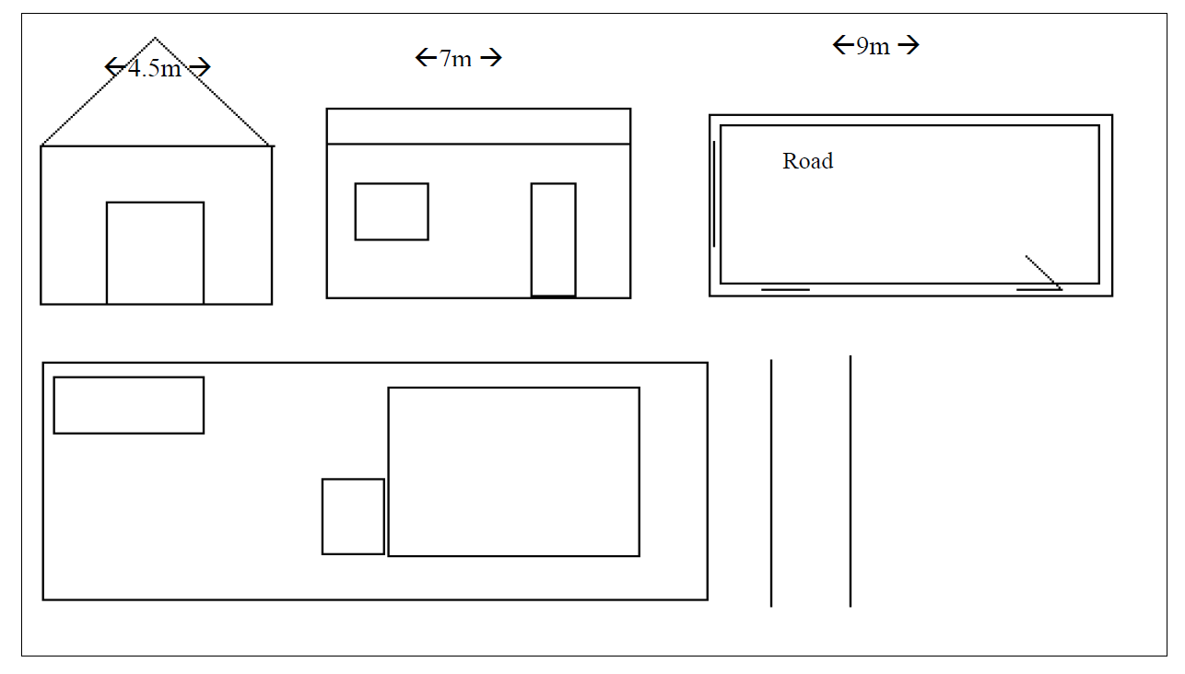
Sketch Area

Click or tap here to enter text.

Other Information

You may also need Building Regulation Approval. Please call 01472 326289 Option 2 for more information on this.
The pre application service provides you with an informal opinion about your proposal. The formal way to determine if a proposal is authorised or not is to apply for a Certificate of Lawful Use. More information on this can be found on the planning portal.

