**NELC logo
**

**Permit with introductory note**

**NORTH EAST LINCOLNSHIRE COUNCIL**

**POLLUTION PREVENTION AND CONTROL ACT 1999**

**Environmental Permitting Regulations 2016 (as amended)**

**Installation address**

**Ashcourt (Lincolnshire) Limited**

**South Humberside Industrial Estate**

**Estate Road 2**

**Grimsby**

**DN31 2TG**

**Permit Ref. no:** **EP/202400001**

**Introductory note**

*This introductory note does not form a part of the Permit*

The following Permit is issued under Regulation 13 of the Environmental Permitting (England and Wales) Regulations 2016 (S.I.2016 No. 1154) (“the EP Regulations”) to operate an installation carrying out one or more of the activities listed in Part 2 to Schedule 1 of those Regulations, to the extent authorised by the Permit.

The permit includes conditions that have to be complied with. It should be noted that aspects of the operation of the installation which are not regulated by those conditions shall be subject to best available techniques, used to prevent or, where that is not practicable, reduce emissions from the installation in relation to any aspect of the operation of the installation which is not regulated by any condition within the permit.

Techniques include both the technology used and the way in which the installation is designed, built, maintained, operated and decommissioned.

**Confidentiality**

The Permit requires the Operator to provide information to North East Lincolnshire Council. The Council will place the information onto the public registers in accordance with the requirements of the EP Regulations. If the operator considers that any information provided is commercially confidential, it may apply to North East Lincolnshire Council to have such information withheld from the register as provided in the EP Regulations. To enable North East Lincolnshire Council to determine whether the information is commercially confidential, the Operator should clearly identify the information in question and should specify clear and precise reasons.

**Variations to the permit**

Your Attention is drawn to the Variation Notification Procedure condition in the permit. This Permit may be varied in the future. If at any time the activity or any aspect of the activity regulated by the following conditions changes such that the conditions no longer reflect the activity and require alteration, the Regulator should be contacted.

**Surrender of the permit**

Where an Operator intends to cease the operation of an installation (in whole or in part) the regulator should be informed in writing, such notification must be made as specified in regulation 24(3) of the EP regulations.

**Transfer of the permit or part of the permit**

Before the Permit can be wholly or partially transferred to another person, a joint application to transfer the Permit has to be made by both the existing and proposed holders, in accordance with Regulation 21 of the EP Regulations. A transfer will be allowed unless the Authority considers that the proposed holder will not be the person who will have control over the operation of the installation or will not ensure compliance with the conditions of the transferred Permit.

**Responsibility under workplace health and safety legislation**

This Permit is given in relation to the requirements of the EP regulations. It must not be taken to replace any responsibilities you may have under Workplace Health and Safety legislation.

**Appeal against permit conditions**

Right to Appeal

You have the right of appeal against this permit within 6 months of the date of the decision. The Council can tell you how to appeal. You will normally be expected to pay your own expenses during an appeal.

You will be liable for prosecution if you fail to comply with the conditions of this permit. If found guilty, the maximum penalty for each offence if prosecuted in a Magistrates Court is £50,000 and/or 6 months imprisonment. In a Crown Court it is an unlimited fine and/or 5 years imprisonment.

Our enforcement of your permit will be in accordance with the Regulators ‟Compliance Code.”

Anyone who is aggrieved by the conditions attached to a Permit can appeal to the Secretary of State for the Environment, Food and Rural Affairs. Appeals must be made in accordance with the requirements of Regulation 31 and Schedule 6 of the EP Regulations.

Appeals should be received by the Secretary of State for Environment, Food and Rural Affairs. The address is as follows:

The Planning Inspectorate

Environmental Team, Major & Specialist Casework

Room 4/04 – Kite Wing

Temple Quay House

2 The Square, Temple Quay

BRISTOL

BS1 6PN

Tel: 0117 372 8726

Fax: 0117 372 8139

**Please Note**

An appeal brought under Regulation 31 (1) (b) and Schedule 6, in relation to the conditions in a permit will not suspend the effect of the conditions appealed against; the conditions must still be complied with.

In determining an appeal against one or more conditions, the Act allows the Secretary of State in addition to quash any of the conditions not subject to the appeal and to direct the local authority either to vary any of these other conditions.

**End of introductory note**

**Permit issued under the Environmental Permitting Regulations (England and Wales) 2016 (as amended)**

**Permit**

**Permit Ref. No:** EP/202400001

North East Lincolnshire Council (the Regulator) in exercise of its powers under Regulation 13(1) of the Environmental Permitting Regulations 2016 (S.I.2016 No. 1154) hereby permits.

**Ashcourt (Lincolnshire) Limited** (“the operator”),

Whose registered office is:

**Ashcourt Group,**

**Foster Street,**

**Hull,**

**HU8 8BT**

Company Registration. no: 01844065

To operate an installation at:

**Ashcourt (Lincolnshire) Limited**

**South Humberside Industrial Estate**

**Estate Road 2**

**Grimsby**

**North East Lincolsnhire**

**DN31 2TG**

to the extent authorised by and subject to the conditions of this Permit and within the boundary identified in Appendix 1, installation boundary.

**Signed**

|  |
| --- |
| Official signature |

Shaun Poole

Senior Environmental Protection Officer

Authorised to sign on behalf of

North East Lincolnshire Council

**Dated**

|  |
| --- |
| 2nd July 2024 |

**Activity description**

Process using bulk cement as prescribed by Section 3.1 of Schedule I to the Environmental Permitting (England and Wales) Regulations 2016 (as amended).

Cement and other powdered cement materials are delivered by road. The powdered materials are transferred through a closed system of heavy-duty hoses to storage silos, using compressed air as a carrier medium. Silos are vented to allow air to escape through filters, so controlling dust emission.

Concrete is manufactured by mixing, in carefully controlled proportions, Portland cement or a mixture of cement materials in powder form, together with coarse and fine aggregates (gravel, crushed stone or sand), and water. The proportions chosen are determined by the performance or composition necessary to meet the specification or performance requirements. Small amounts of admixtures may be included to modify the properties of the mix.

The installation boundary and key items of equipment mentioned in permit conditions are shown in the plan attached to this permit.

**Conditions**

Emissions and monitoring

1. No visible particulate matter shall be emitted beyond the installation boundary.
2. The emission requirements and methods and frequency of monitoring set out in Table 1 shall be complied with. Sampling shall be representative.

Any monitoring display required for compliance with the permit shall be visible to operating staff at all times. Corrective action shall be taken immediately if any periodic monitoring result exceeds a limit in Table 1, or if there is a malfunction or breakdown of any equipment which might increase emissions. Monitoring shall be undertaken or repeated as soon as possible thereafter, and a brief record shall be kept of the main actions taken.

1. All plant and equipment capable of causing, or preventing, emissions and all monitoring devices shall be calibrated and maintained in accordance with the manufacturer’s instructions. Records shall be kept of such maintenance.

Silos

1. Bulk cement shall only be stored within the bulk cement silos.
2. Dust emissions from loading or unloading road tankers shall be minimised by back-venting to a delivery tanker fitted with an on-board, truck-mounted relief valve and filtration system and by connecting transfer lines first to the delivery inlet point and then to the tanker discharge point, and by ensuring delivery is at a rate which does not pressurise the silo.
3. Silos and bulk containers of dusty materials shall not be overfilled and there shall be an overfilling alarm.
4. When loading silos which were new after June 2004, deliveries must automatically stop where overfilling or over-pressurisation is identified.
5. Displaced air from pneumatic transfer shall pass through abatement prior to emission to air.

Aggregates delivery and storage

1. Dusty materials (including dusty wastes) shall only be stored in the storage bays on the plan attached to this permit (Appendix 2) and shall be subject to suppression and management techniques to minimise dust emissions. Stockpiles shall be kept lower than the retaining walls.

Belt Conveying

1. All dusty materials, including wastes, shall be conveyed using a fully-enclosed conveyor. All transfer points shall be fitted with a chute or wind protection barrier.

Loading, unloading and transport

1. No potentially dusty materials (including wastes) or finished products shall arrive on or leave the site other than by use of fully-enclosed or sheeted vehicles.

Roadways and transportation

1. All areas where there is regular movement of vehicles shall have a consolidated surface capable of being cleaned, and these surfaces shall be kept clean and in good repair.
2. Vehicles shall not track material from the site onto the highway.

Techniques to control fugitive emissions

1. The fabric of process buildings shall be maintained so as to minimise visible dust emissions.

Records and training

1. Written or computer records of all tests and monitoring shall be kept by the operator for at least 24 months. They shall be made available for examination by the Council. Records shall be kept of operator inspections, including those for visible emissions.
2. Staff at all levels shall receive the necessary training and instruction to enable them to comply with the conditions of this permit. Records shall be kept of relevant training undertaken.

Best available techniques

1. The best available techniques shall be used to prevent or, where that is not practicable, reduce emissions from the installation in relation to any aspect of the operation of the installation which is not regulated by any other condition of this permit.
2. If the operator proposes to make a change in operation of the installation, he must, at least 14 days before making the change, notify the regulator in writing. The notification must contain a description of the proposed change in operation. It is not necessary to make such a notification if an application to vary this permit has been made and the application contains a description of the proposed change. In this condition „change in operation‟ means a change in the nature or functioning, or an extension, of the installation, which may have consequences for the environment.

**End of Permit**

**Table 1 – Emission limits, monitoring and other provisions**

|  |  |  |  |  |
| --- | --- | --- | --- | --- |
| **Substance** | **Source** | **Emission limits / provisions** | **Type of monitoring** | **Monitoring frequency** |
| Particulate matter | Whole Process | No visible airborne emission to cross the site boundary where harm or nuisance may be caused | Operator observations | At least daily |
|  | Silo inlets and outlets (for silos new since 1st July 2004) | Designed to emit less than 10mg/m3 | Operator observations | At time of delivery |
|  | Silo inlets and outlets | No visible emission |  |  |
|  | Arrestment equipment, or any point where dust contaminated air is extracted from the process to atmosphere, with exhaust flow >300m3/min. (other than silo arrestment plant) | 50mg/m3 | Recorded indicative monitoring | Continuous |
|  |  |  | *Isokinetic sampling | At least once to demonstrate  compliance, then as necessary to provide a reference for the  continuous indicative monitor. |
|  | Arrestment equipment, or any point where dust contaminated air is extracted from the process to atmosphere, with exhaust flow >100m3/min. (other than silo arrestment plant) | No visible emission  Arrestment equipment should be provided with a design guarantee that the equipment can meet 50mg/m3 | Indicative monitoring to  demonstrate that the arrestment equipment is  functioning correctly | Continuous |
|  | Arrestment equipment, or any point where dust contaminated air is extracted from the process to atmosphere, with exhaust flow <100m3/min. (other than silo arrestment plant) | No visible emission | Operator observation  Or  Indicative monitoring | At least daily  Or  Continuous |
| Droplets, persistent mist and fume | All emissions to air (except steam and condensed water vapour) | No droplets, no persistent mist, no persistent fume | Visual observations | *On start-up and at least two more occasions during the working day* |

Only emissions to atmosphere are required to comply with the emission limits within this table.

Notes:

* All periodic monitoring results shall be checked by the operator on receipt and sent to the Council within 8 weeks of the monitoring being undertaken.*

1. The reference conditions for limits in Table 1 are: 273.1K, 101.3kPa, without correction for water vapour content, unless stated otherwise.
2. All periodic monitoring shall be representative, and shall use standard methods.
3. The emission limits do not apply during start-up and shut down. All emissions shall be kept to a minimum during these periods.

**Appendix 1**- Site boundary

The operator is authorised to carry out the activities and/or associated as specified and within the boundary shown in red on the plan below.

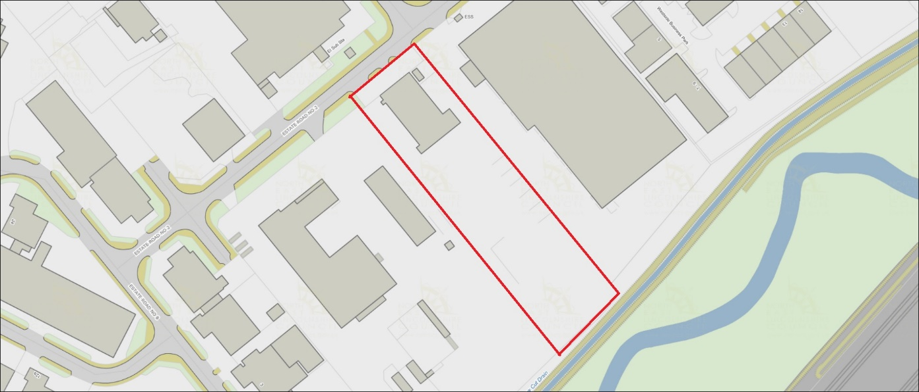



**Appendix 2** – Designated Storage Areas

