# þÿþÿInstruction to your

bank or building society to pay by Direct Debit

## Please fill in the whole form including official use box using a ball

**point pen and send it to: Service user number**

FOR NORTH EAST LINCOLNSHIRE COUNCIL OFFICIAL USE ONLY

This is not part of the instruction to your bank or building society.

Please specify your preferred payment date:

(If a date is not indicated the direct debit will be deducted on the 1st of the month)

1st

15th

**NORTH EAST LINCOLNSHIRE COUNCIL LOCAL TAXATION & BENEFITS SERVICE BUSINESS RATES SECTION**

**MUNICIPAL OFFICES TOWN HALL SQUARE GRIMSBY, DN31 1HU**

**3**

**7**

**5**

**1**

**7**

**9**

## Name(s) of account holder(s)

**Bank/building society account number**

|  |  |  |  |  |  |  |  |
| --- | --- | --- | --- | --- | --- | --- | --- |
|  |  |  |  |  |  |  |  |

**Branch sort code Instruction to your bank or building society**

Please pay North East Lincolnshire Council Direct Debits from the account detailed in this Instruction subject to the safeguards assured by the Direct Debit Guarantee. I understand that this Instruction may remain with North East Lincolnshire Council and, if

**Name and full postal address of your bank or building society** so, details will be passed electronically to my bank/building society.

To: The Manager

Bank/building society

Postcode

Address

## Local Authority Account Number

Date

Signature(s)

Banks and building societies may not accept Direct Debit Instructions for some types of account

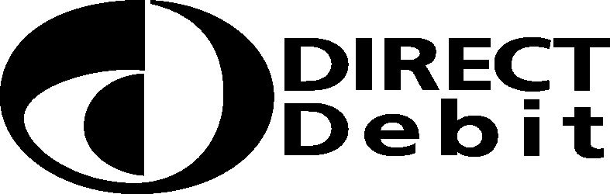This guarantee should be detached and retained by the payer.

|  |
| --- |
| The Direct Debit Guarantee |
| * This Guarantee is offered by all banks and building societies that accept instructions to pay Direct Debits |
| * If there are any changes to the amount, date or frequency of your Direct Debit North East Lincolnshire Council will notify you 10 working days in advance of your account being debited or as otherwise agreed. If you request North East Lincolnshire Council to collect a payment, confirmation of the amount and date will be given to you at the time of the request. |
| * If an error is made in the payment of your Direct Debit, by North East Lincolnshire Council or your bank or building society you are entitled to a full and immediate refund of the amount paid from your bank or building society   – If you receive a refund you are not entitled to, you must pay it back when North East Lincolnshire Council asks you to |
| * You can cancel a Direct Debit at any time by simply contacting your bank or building society. Written confirmation may be required. Please also notify us. |