 | 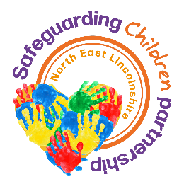 | Internal Ref: | NELC.02.01.24.00.00.07
 |  | Review date | October 2019
 |  | Version No. | V01.00

NORTH EAST LINCOLNSHIRE PRIMARY CARE TRUST

GP’S REPORT TO CHILD PROTECTION CONFERENCE

Note to support on-screen completion: This form is LOCKED. Use TAB or MOUSE to move between required boxes. Type directly into grey box. The field should grow to accommodate your text. Press SPACEBAR or left-mouse to type an ‘x’ in a box when required to make a choice. To complete by hand, unlock the form first. Alter the boxes to the size you will need before printing.

Name of Child/ren |  | D.O.B
Date of Conference:

Frequency of Contact
Nature of Contact
General Observations
Any Concerns
I am able to attend the child protection conference
I am unable to attend the child protection conference
Signature |  | Date
Name (printed) |  | Base
The contents of this report been shared with the family? |  |  |  | Yes |  | No

