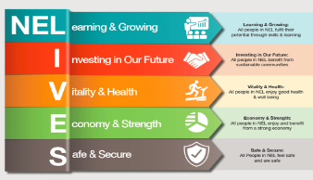

|  |  |
| --- | --- |
| Review date | March 24 |
| Version No. | final |

North East Lincolnshire Council

Lifelong Links Service

Policy and Standards

Updated by: FGC Manager

Date 2024

LIFELONG LINKS SERVICE

North East Lincolnshire

CONTENT

Scope of the policy p1

Related Policies p1

Relevant Guidance p1

Introduction p1

What is a Lifelong Links p1-2

Criteria p2

Role of the Referrer p2-3

Stages of the Lifelong Links FGC p3-5

Lifelong Links Timescales p6

Recording and information sharing p6

**Appendices**

**1.Lifelong Links Standards p6-9**

**2.Lifelong Links flowchart p9**

**3.Guiding Principles of the Lifelong Links Process p9-10**

**SCOPE OF THIS POLICY**

This policy sets out the role of the Lifelong Links Service, its criteria and referral process.

**RELATED POLICIES**

Family Group Conference Policy and Standards 2024

Conflict Resolution Policy 2024

**RELEVANT GUIDANCE**

Family Rights Group Quality Standards

Family Rights Group Service Accreditation

**1. Introduction**

The policy reflects current good practice within the Lifelong Links Process and evidence-based research for national and internationally recognised bodies such as the UK’s Family Rights group. It will be regularly evaluated and updated to ensure best practice is integral to everything we do. This is a document which will ensure that no matter to whom the service is provided, they will experience all elements of the Lifelong Links process positively.

All our Coordinators are fully trained in Family Group Conferencing, Lifelong Links and have received additional training in mediation skills, they are independent and impartial. To ensure the Lifelong Links coordinators are fully supported they receive regular supervision sessions with the Team Manager and complete self-assessments, are observed in practice and are encouraged to attend development/ practice learning sets through the National Family Rights Group. All FGC staff are supervised by an experienced Team Manager. The Coordinators and Team Manager do not have any direct, previous, or current involvement in any case decision making for any young person or child.

**2. What is a Lifelong Links?**

Lifelong Links is a service for young people in care. It helps bring together the people who care about the young person. This might be people they know well, people they have not seen for a while, (like a former teacher or carer) and even a relative they have not yet met. These people can be brought together in a meeting called a Family Group Conference(FGC), or in another way to be able to make a plan for the young person. At a Lifelong Links FGC meeting they can talk with the young person about what support they can offer, both now and in the future. This is written down into a plan so that everybody knows exactly what they are doing. The plan should be agreed by the young person’s social worker providing it is safe.

The Lifelong Links process is consent based and the young person and professionals surrounding them must be in agreement that this is safe to progress.

The Lifelong Links process and conference will only happen with the young person’s consent and if they change their mind at any point they can pause or end their Lifelong Links journey.

**2.1 Objectives**

The primary objective of Lifelong Links is to create a positive lasting support network for looked after children resulting in:

* Stronger relationships in care and when they leave care.
* Greater placement stability.
* A stronger sense of identity.
* Improved mental health and emotional wellbeing.
* Reduced likelihood of going missing.
* Reduced harmful and risky behaviours including substance misuse, self-harm and criminal activity.
* Improved long term outcomes including an increase in training and employment opportunities and a reduced likelihood of their own children being removed.

**2.2 What are the benefits of being connected to supportive adults.**

* Positive long-term effects on their social, psychological, financial outcomes, improvement of self-esteem, educational achievement, and social skills.
* Supportive relationships increase placement stability and a better transition from care.
* Reduced incidents of young people running away from care.
* Positive relationships supporting the young person’s sense of self and identity.

**3. Criteria**

The Lifelong Links service is available to, and this policy applies to children and young people who are looked after in the care system. This can be by a foster career or in a residential home placed by the local authority.

**4.Role of the referrer**

It is important for the success of Lifelong Links that all key participants have a clear understanding of their roles and responsibilities and a shared understanding of the principles and values of the work. People need to work collaboratively and openly and the following sets out some of the core roles and responsibilities required of key participants:

* Social worker to discuss the possibility of a referral for Lifelong Links with the young person and their carer(s). Where appropriate, parents should also be involved at the referral stage.
* Gain initial agreement for the referral from the young person and consent from the person with parental responsibility.
* Complete the Lifelong Links written referral form and discuss this with the Lifelong Links coordinator or their manager.
* Provide additional information needed for the referral including placement timeline and chronology.
* To attend the planning meeting to discuss the referral and plan for the Lifelong Links journey.
* Continue to maintain casework responsibility and working with the family and inform the Lifelong Links co-ordinator of any changes.
* Provide the co-ordinator with information such as risks identified and provide risk assessments or police checks if needed to aid the young person’s relationships and family time.
* Work with Lifelong Links coordinator to plan for Lifelong Links FGC.
* Continue to support the young person throughout the process and beyond.

**5. Stages of the Lifelong Links FGC**

**Stage One**

**Referral**

* Initial discussion between Team Manager and referrer (child’s Social Worker).
* Agreement from child and consent obtained from the young person and those with parental responsibility.
* Lifelong Links Referral form completed and sent to dedicated FGC Team inbox for consideration.
* Referral assessed against our access criteria and if accepted, the young person is matched with an FGC Lifelong Links Co-ordinator.

**Stage Two**

**Planning Stage**

FGC Lifelong Links Co-ordinator contacts FGC Manager, Social Worker, Team Manager (and carer where appropriate) and Independent Reviewing Officer to schedule a planning meeting.

The following must be considered:

* Planning Meeting takes place involving the Lifelong Links coordinator, their manager, the referrer, the independent reviewing officer and any other relevant individuals.
* Key objectives/information that the referrer will need to provide to the family
* Any constraints/ risk elements
* Participation and support needs of young person and how they will be assisted to prepare for the Lifelong Links work including an offer of an advocate and/or translator.
* Support needs of the young person’s carer, support needs of the carer and support network.
* Any ongoing consent issues.
* Timescales and agreement of next steps with a clear plan for continuing with Lifelong Links agreed by all agencies.
* **Chronology needs to be provided**

**Stage Three**

**The Child or young person’s network is thoroughly explored**

**Preparation**

* The coordinator gathers relevant details from the social worker and the network and who is known.
* The coordinator meets the young person.
* The coordinator engages with the young person and uses a variety of tools to map their experiences, history, and network. The coordinator ensures that all essential processes are offered including timelines, chronology, genogram, online searches, mobility mapping and social connections tool is explored and completed.
* The coordinator discusses the results of this discovery stage with the young person and agrees the next steps.
* The coordinator discusses the results of this discovery stage with the social worker and carer and agrees the next steps.

**Stage Four**

**The young person’s identified network is engaged with and supported to participate**

* The coordinator visits the young person’s identified family and wider network and ensures that they are given clear, appropriate information about Lifelong Links.
* The coordinator shares agreed information about the young person’s circumstances with their network and explores their commitment to engage with the process and what support they may be willing to offer.
* The coordinator explores the support networks needs and ways to facilitate their participation and continues to explore and expand on the support network.

**Stage Five**

**Lifelong Links FGCs are thoroughly planned for and take place in a timely way**

* The coordinator together with the young person’s input, plans for the Lifelong Links FGC.
* The coordinator considers the support needs of the young person.
* The coordinator considers the support and safety needs of the network and prepares the network members to participate in the Lifelong Links FGC.
* A neutral venue is agreed, food and invitations are agreed in consultation with the young person whilst taking account of the needs of the network (which includes cultural, dietary and accessibility).
* Information Sharing by professionals. The coordinator ensures that professionals are prepared for the Lifelong Links FGC and that they understand what information is required by the network, and that it is clear, accessible, and shared in writing with the network prior to Lifelong Links FGC.
* Private Family Time – voice of child/young person and family members, discussion and agreement made, actions and contingency plan developed by family.
* Lifelong Links FGC held. Plan formulated with young person, network, and referrer to seek agreement; this is incorporated into the Care Plan.
* If an FGC is not appropriate or the young person does not want to hold a formal meeting, alternative ways of deciding are explored.

**Stage Six**

**The Lifelong Links process (FGC has taken place or it has not) is facilitated effectively so that the family and wider network can plan with and for the child or young person.**

* The family and wider network are offered the opportunity to have a Lifelong Links FGC review.
* When a Lifelong Links does not lead to a family group conference, any plan that is made is shared appropriately.
* Feedback is routinely sought from the family and wider network concerning the Lifelong Links Process.
* The coordinator distributes the plan to appropriate participants within 5 working days.

**Stage Seven**

**The Lifelong Links Plan is implemented and embedded into the young person’s care plan.**

* The child’s Independent Reviewing Officer (IRO) has a copy of the Lifelong Links Plan, and it is integrated into the child’s care or pathway plan.
* Where the initial Lifelong Links FGC Plan proposed holding a review FGC then this is offered to the young person, and with appropriate agreements and consent the meeting is convened.
* The Lifelong Links plan and members of the identified support network are considered routinely as part of the child’s looked after children review. Members of the network are invited to contribute to the review meeting, as agreed by the child / young person.
* The Lifelong Links plan is part of the young person’s pathway plan. Members of the network are invited to or contribute to the pathway plan review meetings, as agreed with the young person.

**Stage Eight**

**The service will support stakeholder involvement and promote the ongoing sustainability of Lifelong Links.**

* Families will be offered the opportunity to be involved in the strategic development of the Lifelong Links service.
* Stakeholders are given the opportunity to provide feedback about their involvement in Lifelong Links and the views of all stakeholders are considered in the ongoing development of the Lifelong Links service.
* There are regular training sessions offered for potential referrers to Lifelong Links and regular awareness raising sessions for all stakeholders.

**6. Lifelong Links timescales**

The work that takes place with the young person for Lifelong Links is at their pace and will depend on what they would like from their Lifelong Links journey. This may take 2/3 months or as long as a year.

By offering Lifelong Links soon after a young person enters care, Lifelong Links aims to ensure those social networks can be available for them in care, providing stability during their childhood and support them as they become adults.

**7. Recording and information sharing**

The FGC service's primary function is to facilitate the Family Group Conference, and any recording will relate solely to the conference. A record is maintained on Liquid Logic, however, this is held separately on the system from the main case record. If information is given which relates to concerns for a child's or other person's safety this information will be sent to the social worker for them to record.

The referrer will be responsible for recording their involvement with the FGC and the outcome of the conference. Coordinator’s will be expected to record information on Liquid Logic, including a copy of the family's plan. It is the referrer's responsibility to share all key documentation including relevant sections of the plan with Legal Guardians and the court.

**Appendix 1 Lifelong Links Family Group Conference Standards**

**Standard One**

|  |
| --- |
| *The FGC Service will provide a high-quality service which works within the North East Lincolnshire Council FGC Standards and reflects national and international guidance and good practice in its delivery of Lifelong Links.* |

1.1 The FGC service will be delivered by an Independent Co-ordinator trained in Lifelong Links who will have no other professional role with the family and who will not be involved in any professional decision making for the child/young person or family.

1.2 The FGC Service will ensure that the Independent Co-ordinator will be trained in the FGC model and in the skills necessary to undertake the role.

1.3 The FGC manager will provide supervision to the Co-ordinator.

1.4 FGC managers will oversee and ensure a responsive and accountable delivery of the service.

**Standard Two**

|  |
| --- |
| *The voice of the child/young person will be central to the Lifelong Links FGC process and must be sought and heard at all stage of the process.* |

2.1 The Independent Co-ordinator will ensure that the wishes and feelings of the child/young person/vulnerable adult will be sought and represented in the conferencing process.

2.2 The Co-ordinator will ensure that advocacy / Interpreter is available for those who require it.

2.3 The Co-ordinator will ensure that the views of those unable to attend are shared at the meeting.

**Standard** **Three**

|  |
| --- |
| *Everyone participating in the FGC will be prepared and supported throughout the process* |

3.1 The Co-ordinator will outline the reasons for the referral identifying the young person as being central to the process and with their agreement, share the information with the wider family network and professionals.

3.2 The Co-ordinator, with the child/young person will explore those they wish to invite to the conference.

3.3 The Co-ordinator will use a range of creative methods to ensure that all contributions are sought and shared and will ensure that the views of those unable to attend are shared at the meeting or they have been offered the alternative of joining via media such as TEAMS/ZOOM or WhatsApp if they wish.

3.4 The Lifelong Links FGC will be held in the first language of the child/young person/vulnerable adult, and attention will be given to any significant cultural issues.

3.5 The Co-ordinator will ensure that all children/young people and families will be prepared and supported to participate fully in the Lifelong Links FGC process.

3.6 The Co-ordinator will assist the professionals in preparation for their role in the Lifelong links FGC process and will ensure regular planning meetings with key workers to discuss any risks / issues that may have arisen during the process.

3.7 The Co-ordinator, at the end of the process, will ensure that all participants have understood what has been planned.

**Standard Four**

|  |
| --- |
| *Families have a right to private family time within a safe and supportive environment to enable them to make decisions and plans.* |

4.1 The Lifelong Links Family Group Conference will be agreed at a date, time and venue that suits the young person, their family and identified support network.

4.2 The Co-ordinator will ensure that there is a neutral venue which is suitable for the young person and family to plan in private. Here there can be discussions around areas important for the young person for example contact arrangements with family members, friends, siblings, how this contact will take place: in person, letter, telephone etc, relocation and permanency planning and any other important discussion points raised by the young person which will impact on their future care planning. There is sufficient time made available for the young person and family to do so

.

4.3 The Co-ordinator has the responsibility to outline the expectations of behaviour in the meeting. The Co-ordinator will ensure that “ground rules” are established and adhered to so that all participants can feel safe and respected, and their views heard.

4.4 The Co-ordinator and other relevant professionals will be available to the family for clarification or to answer any questions the young person and / or family / network wish to ask.

4.5 Only exceptionally, if requested by the young person or a family member ,will a Co-ordinator and /or another professional be present during private family time.

4.6 It is important to include all those identified by the young person; however, the Co-ordinator will assess any safety issues before the meeting and plan how these can be managed. In exceptional cases this may result in a family member not being invited to attend the meeting and their views represented in other ways at the meeting.

**Standard Five**

|  |
| --- |
| *Families have the right to have safe plans agreed and resourced.* |

5.1 The child’s FGC Lifelong Links Plan is the only written document to be produced by the Lifelong Links FGC. The Co-ordinator will ensure that all participants receive a copy of the plan as soon as possible after the meeting.

5.2 The referrer will agree the plan only if it does not place the child/young person/vulnerable adult at risk of harm and will consider any resources identified by the family.

5.3 If there is to be a delay in agreeing the plan the child / young person, family need to be informed of the reasons and a timescale agreed.

5.4 The referrer will support the child / young person, family to carry out their plan and ensure that any resources agreed are provided to the young person and the family in a timely way.

5.5 The child / young person may choose a monitor/link-person who, along with the referrer, ensures that the child’s plan is being followed.

**Standard** **Six**

|  |
| --- |
| *Families have the right to be involved in the evaluation and development of Lifelong Links FGC services*. |

6.1 Services will routinely seek feedback from all participants and these views will be used to inform and develop practice.

6.2 The FGC Service will use creative methods to ensure the views of the child/young person are sought and heard.

6.3 Participants can raise concerns or provide feedback about their involvement with the FGC and Lifelong Links process, and this will be dealt with in a constructive way. Participants will be fully informed of the complaints process.

**Appendix 2 Lifelong Links Flowchart**

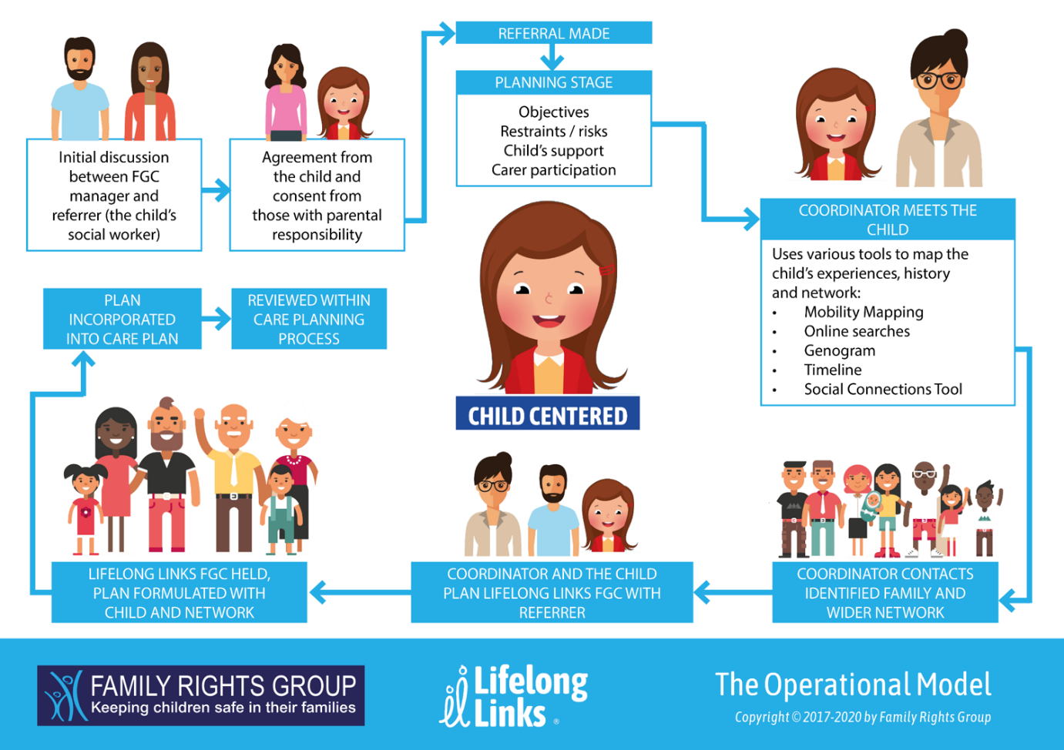

**Appendix 3 Guiding Principles of the Lifelong Links Family Group Conference Process**

The Family Group Conference process is a strength based, solution focused way of working, which acknowledges the positives as well as addressing the needs and challenges in a family.

Children and young people are at the centre of the decision-making process and have the right for their voices to be heard. The Lifelong Links process is clearly explained to young people ensuring that agreement has been given at the beginning and regularly reconfirmed throughout the Lifelong Links process. Agreement must be obtained by the young person to share their information with their network.

The FGC Lifelong Links Co-ordinator is always independent of any professional involvement with the family. The independence of the Co-ordinator is a crucial factor in the process, and this must be preserved. The team are managed by a member of staff who is independent to the service and who is not involved in any case management.

Children and young people have the right to have their families and other significant people fully involved in planning their future ensuring that they do not compromise the safety of the child/ren. Lifelong Links is clearly explained to parents and their agreement is sought wherever possible.

Families have the right and responsibility to be active decision makers about their family members. Given the relevant information, families can make informed, safe decisions about how the needs of a child/young person can be met.

Participation in a Lifelong Links Family Group Conference is a voluntary process for the child/young person and family members involved. Coordinators ensure that there is informed consent obtained and given by an appropriate person with the legal authority to agree to Lifelong Links with the understanding that this consent can be withdrawn at any time. As part of this process Lifelong Links is clearly explained and discussed with those caring for the young person which includes foster carers, residential workers and their support for the process is established.

Each family is unique. Its culture and communication style are respected and embedded in the FGC process. Therefore, each Lifelong Links FGC is unique.

The process of the Lifelong Links FGC should be informed by the child / young person at the centre and proceed at their pace which will depend on their specific needs and the circumstances of the family.

Private time for the family is an essential component of the FGC process.

The Lifelong Links Family Group Conference plan should be accepted, embedded in the Care Plan and resourced by the referring agency unless it places a child, young person, or vulnerable adult at risk of significant harm.