**Targeted Family Help**

**Working in partnership with families across North East Lincolnshire**

**Guidance**

**November 2024**

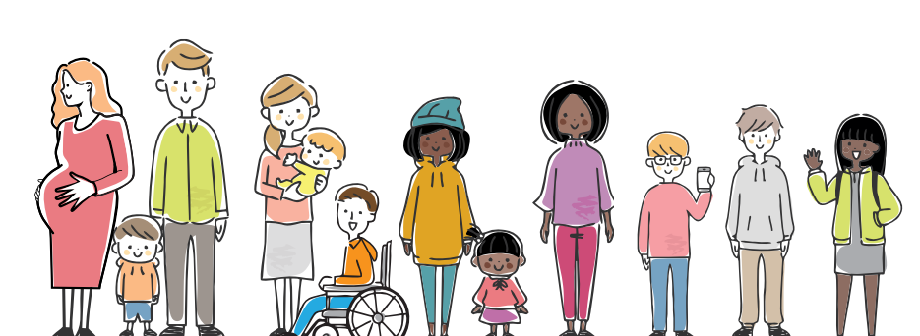

**Our Vision**

In North East Lincolnshire, we want all children to be safe from harm and enjoy growing up in loving homes, have the best start in life and a happy, healthy, fun childhood. Our aim is that all children start school ready to learn, do well at all levels of learning and have the skills and opportunities they need to enjoy a bright future. It is our ambition that all children and families are part of an inclusive, compassionate, and thriving community.

In the context of the Children’s Social Care National Framework 2023, we are also committed to ensuring that:

* Children, young people and families stay together and get the help they need
* Children and young people are supported by their family network
* Children and young people are safe in and outside of their homes
* Children in care and care leavers have stable, loving homes

The strength of our Family Help offer is our partnership approach, working with families to meet the diverse needs of children and young people. Having a shared vision for our children and families, we can use the knowledge, skills, and expertise of all our partners to ensure the right help is available at the right time.

This document provides guidance for professionals working with children and families making a request for this service.

**Levels of Need**

**Helping, Supporting and Protecting Children and Families in** **North East Lincolnshire 2024/28** sets out the support children, young people, and families can expect to participate, find help online and in their networks and communities, to be resilient, stay safe and independent.

It is overseen by our North East Lincolnshire Safeguarding Children Partnership that includes the three statutory safeguarding partner organisations – Humberside Police, Health through the Integrated Care Board and North East Lincolnshire Council - and other relevant partners.

In line with **Working Together to Safeguard Children 2023** our level of needs threshold is set out as below

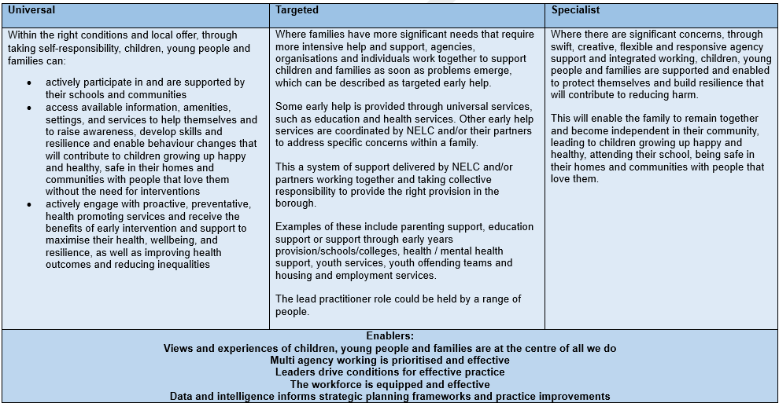

**Early Help**

*‘Early help is support for children of all ages that improves a family’s resilience and outcomes or reduces the chance of a problem getting worse. It is not an individual service, but a system of support delivered by local authorities and their partners working together and taking collective responsibility to provide the right provision in their area. Some early help is provided through universal services, such as education and health services. They are universal services because they are available to all families, regardless of their needs.’* Working Together 2023

**The Early Help System**

A strong Early Help System is made up of many different types of practitioners and services who operate as one to meet the needs of the family. The Early Help System available to children and their families in North East Lincolnshire is made up of three types of services that combine in different ways to form the local area’s Early Help offer to its residents.

1. **Community support** includes Family and friends, local places and environments, online support services, voluntary, faith and community services, local members of the community and local businesses
2. **Universal services** includes Post-16 education, schools, early years settings, family hubs, and youth centres, GP surgeries, libraries, maternity services, specialist public health or community nurses and community co-ordinators
3. **Acute and targeted services** includes Family support, social care, accident and emergency departments, allied health professionals, mental health services, special education needs support services, jobcentre plus, school attendance and exclusion support, domestic abuse services, alternative provision, housing services, police, probation and prison services, family court and family court advisory services, substance misuse services, fire and rescue, youth offending and targeted youth services.

The role of the Lead Professional is to coordinate provision and act as a single point of contact for a child or young person and their family when a range of services are involved, and an integrated response is required. The Lead Professional will be a professional who is supporting the child, young person or family and should always be the right person for the family at the right time, with the family having a say in who they are. In some circumstances specific professional groups or VCS organisations may have greater involvement as lead practitioner or as part of the team around the family following needs or risk assessment or because of specific contracting arrangements.

Within North East Lincolnshire, using the Whole Family Approach, all practitioners, across all services should know how to respond to family’s needs at the earliest opportunity, to prevent any harm, and offer support in the least intrusive way. By using the Early Help Assessment tool and plan, professionals are able to highlight the concerns for the full family and help the family come up with their own solutions, and when this is not possible, use the tools identify the needs that may be met by other services.

Where children, young people and families require more than one agency to support them with their needs, the Early Help Assessment should be used to identify the needs, plan the support required and identify other services

**Targeted Family Help**

*‘Other early help services are coordinated by a local authority and/or their partners to address specific concerns within a family and can be described as targeted early help. Examples of these**include parenting support, mental health support, youth services, youth offending teams and housing and employment services. Early help may be appropriate for children and families who have several needs, or whose circumstances might make them more vulnerable. It is a voluntary approach, requiring the family’s consent to receive support and services offered. These may be provided before and/or after statutory.’* Working Together 2023

North East Lincolnshire Councils Targeted Family Help offers different ways of helping on an individual, family and group work basis to improve outcomes for children and families. Help is offered in partnership with families, using their expert knowledge of their lives and the existing networks they have. The wishes and feelings of children and young people are the starting place for engaging with them in achieving positive outcomes.

Support is offered to the whole family to help:

* Parents and carers to successfully meet the needs of their children.
* Children and families to achieve positive outcomes.
* Children and families to access their universal entitlements.
* Families to remain together where there is a risk of family breakdown.
* Children who are in the care of the local authority to be returned to the care of their family.

The following services sit within North East Lincolnshire Councils Targeted Family Help Offer and can be accessed via completing an Early Help Assessment with the family or from a referral from a Social Worker.

* Targeted Family Help
* Young Carers
* Children’s Disability
* Targeted Group/Parenting Programmes
* Intensive Family Help (Edge of Care)
* Graft (Child Exploitation and Missing)
* Youth Justice Prevention

**How to access Targeted Family Help**

**Partner request**

Any professional can support a family to access Targeted Family Help by completing and submitting an Early Help Assessment to the [FamilyHelpRequest@nelincs.gov.uk](mailto:FamilyHelpRequest@nelincs.gov.uk) email address.

Before completing an Early Help Assessment with the family, professionals should first check with the family to see if they already have a Family Help Worker. If they do the professional can contact the current Family Help Worker to discuss any concerns or issues with the family and become part of the Team Around the Family which is already in place.

If the family are not open to Targeted Family Help, and the professional supporting the family feels that this would be beneficial, an Early Help Assessment must be completed, consent must be gained from the family for a referral to be made, clearly outlining the support to be provided by Targeted Family Help and the rationale for this.

Once an Early Help Assessment has been submitted the referrer will receive an outcome from the referral, either by email or letter. If a worker is allocated to support the referrer will be informed who this will be and timescales for the work to be started, the family will receive a telephone call from the allocated worker introducing themselves and arranging a mutual time for them to meet and discuss the work requested. The Family Help Worker will become the Lead Professional for the case.

**Family request**

If a family would like support from the Targeted Family Help team, but they do not have any professionals currently supporting them, they can request support by contacting any Professional who they have a relationship with and ask them to complete an Early Help Assessment, or they can make contact with any of the Family Hubs within North East Lincolnshire.

The Family Help worker will be the lead professional for the family until the work identified has been completed, during this time the family and all professionals involved will hold regular reviews of the families plan. If at the end of the Targeted Family Help involvement there are outstanding areas of concern, which the family can be supported with by other professionals, the family will continue to receive these services, and work towards completion of their plan, with the other professionals remaining involved and meeting regularly.