 

**GRIMSBY TOWN CENTRE**

**ACTIVATION & COMMUNITY ENGAGEMENT FUND**

**GUIDANCE & APPLICATION FORM**

Contents

Background 3

Priorities 3

Anticipated outcomes/benefits of the funding 4

Who can apply? 4

Funding available 5

How to apply 6

Submission/next steps 6

Need help? 6

Additional Information 7

Undertakings in Difficulty 7

Tax 7

Data Protection 8

Subsidy Allowance 8

Activation and Community Engagement Fund 8

Application Form 8

Application process 15

# Background

The Activation and Community Engagement Fund is one of six Grimsby Town Centre projects which form Grimsby’s Town Fund programme.

*Grimsby’s Town Centre Vision*

*The vision for Grimsby’s town centre over the next 10 years is for it to have a vibrant and attractive town centre which is home to growing businesses and a residential community. It will have enlivened public areas and waterfront, where culture and heritage is embraced, and a broad range of activities and pastime can be enjoyed by all.*

The town centre has already undergone a programme of substantial regeneration since 2019, including the refurbishment of St James Square, a new footbridge and improvements to Alexandra Dock, and a newly repurposed Riverhead Square. In addition, works have commenced to bring St James House back into use as a business hub, construction of a Horizon Youth Zone on the waterfront, and the construction of a large community diagnostics hub in the heart of the town. Plans are progressing for a new cinema, market, and food hall at the western end of Victoria Street which will re-purpose empty retail units and offer new facilities to visitors.

The Towns Fund programme offers the Council and its partners the opportunity to continue to deliver these large infrastructure improvements for example the refurbishment of the Central Library and finding new uses for its vacant floors, and a new housing development for the Alexandra Dock area.

The purpose of this funded programme is to enable grass roots projects to come forward and ‘activate’ spaces in the town centre, offering funds for community engagement and business ventures that will add local interest and value to the larger Council led capital projects taking place. The capital grants being offered will support activity which is aligned to the core objectives of Grimsby’s Town Investment Plan and Masterplan (2020).

It aims to unlock smaller bespoke town centre activity led by the community and its businesses, bringing vacant buildings back into use. It aims to promote ‘ownership’ and participation in Grimsby’s Towns Fund programme, offering organisations the opportunity to directly contribute to activity which takes place in the town centre over the next few years.

# Priorities

In meeting the eligibility criteria applicants will need to consider if their project proposal fits with at least one of the following six key town centre priorities.

1. Introduce more diverse uses to the town centre - e.g., Initiatives which bring new uses to spaces and properties in the town centre, enhancing the town centre offer.
2. Reconnect the town centre and the community with the waterfront - e.g., Capital investment which activates the water and waterfront drawing visitors to the area and introduces a new purpose to the town centre.
3. Promote and support community ownership and participation - e.g., Community-driven initiatives which help drive activity and footfall and restore a sense of pride and positivity.
4. Introduce development opportunities to the town centre - e.g., , Improving the townscape through shopfront enhancements. Activation of vacant buildings or shops to provide pop-up space for new independent business ventures. ‘Green’ low-carbon initiatives that will promote environment sustainability.
5. Prioritise health and wellbeing activity in the town centre - e.g., Arts and culture investment and new health and wellbeing initiatives for all ages to activate the town and drive footfall. Other ‘meanwhile’ pastimes which offer health and wellbeing benefits to the community.
6. Enhance employment, skills and entrepreneurial opportunities - e.g., Initiatives which offer new opportunities for learning, bring more workers into the town centre, or support new business opportunities which enhance the town centre offer.

# Anticipated outcomes/benefits of the funding

Successful applications will clearly demonstrate how their project will attract more visitors to Grimsby town centre. It will find new purpose for unused properties, activate town centre space, the water and the waterfront and invigorate the town centre.

As we expect a diverse range of applicants, we also expect the resultant benefits to the town centre to be varied. We will therefore ask applicants to describe the benefits their projects will bring to the town centre when they make their application.

The types of results we expect to see from applications are.

* Vacant town centre units refurbished to attract alternative uses (with a focus on arts, culture, sports and recreation).
* An increase in the number of people working or learning in the town centre.
* Improved environmental, low-carbon or eco-friendly initiatives.
* New and existing organisations relocating or expanding within the town centre which increases town centre footfall and spending.

Please note this is not a complete list, we expect applicants to contribute some of their own.

# Who can apply?

It is envisaged that the funds will be used by local organisations and small businesses to facilitate the delivery of schemes which will strengthen local cultural and community assets, promoting social equity and inclusion in the community.

Applications will be accepted from eligible organisations who wish to deliver a capital project in Grimsby town centre. It is expected that this will be open to the following organisations.

* Businesses with social, charitable, or community-based objectives
* Small, medium or micro businesses

The programme is open to business and community (capital) projects that will help to reinvigorate the town centre and increase the number of visitors. SME’s and other legally constituted organisations like CIC’s can apply.

Only Small or Medium sized businesses (no more than 250 employees and a turnover of £25m or Balance sheet of £50m) who are registered and trading in North East Lincolnshire are eligible to apply for this grant. Large businesses will only be considered in exceptional circumstances.

The project activity must be based in Grimsby town centre within the eligible area as outlined in the map below (within the solid border).

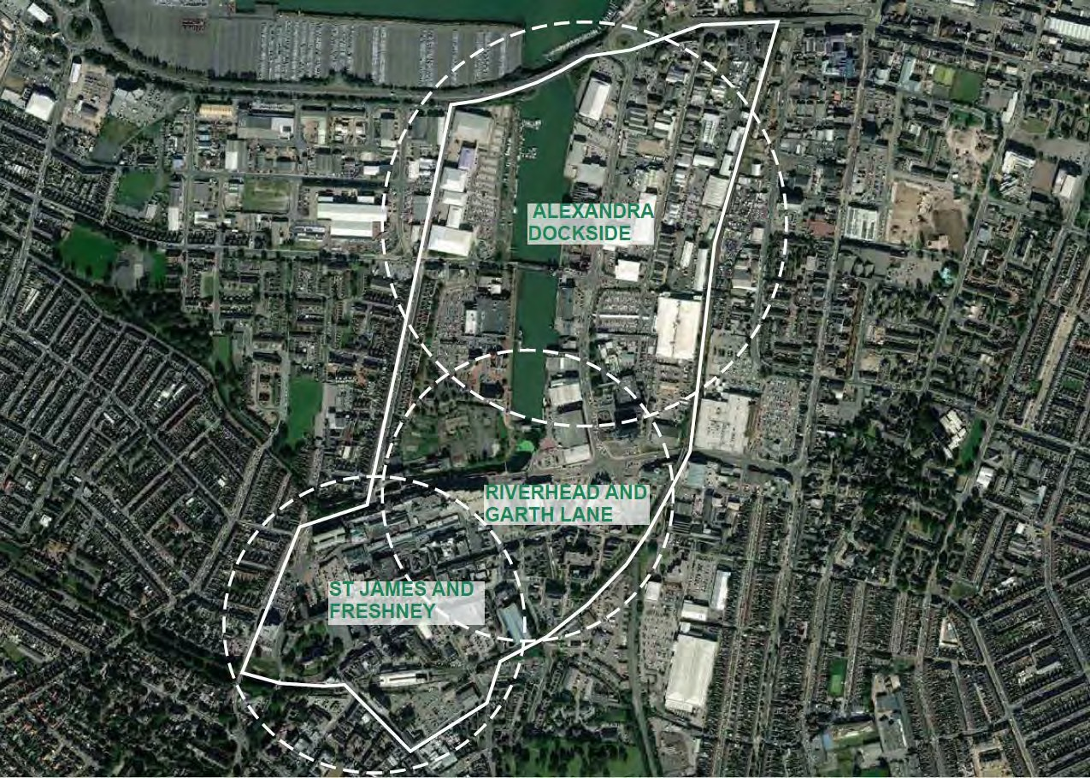

Grants can only be offered for projects with eligible capital expenditure and projects will need to result in positive outcomes for the town centre.

If there is more than one organisation applying to deliver a project, a lead organisation must be selected to become the lead applicant (and grant recipient) with the remaining organisation(s) acting as a delivery partner(s). In this situation, the applicant would be responsible and liable for the delivery partner(s) and ensuring the project is operating as planned.

# Funding available

It is anticipated that applicants can provide a sustainable business case and generate match funding, either through sponsorship, crowd funding, own funds, or alternative fund-raising activities.

Grants are available between £500 and £25,000, awards outside these thresholds will only be considered in exceptional circumstances. High value grant applications will require more robust appraisal checks during the application process and will be expected to offer sustainable and measurable benefits to the town centre. The amount of grant available is dependent on the overall impact the project will have on the town centre.

There is an expectation that grant applicants will be able to contribute some match funding so that we can support as many businesses as possible with the grant funding available. However, in very exceptional circumstances this may be waived if applicants can evidence a need for 100% funding and are meeting a minimum of 3 of the 7 anticipated outcomes listed above.

The grant can only support capital expenditure, for example (but not limited to).

* Refurbishment of a premises (if an application is made by a landlord, we would expect a tenant/s to have been identified and a joint application submitted)
* Investment in new fixtures and fittings

# How to apply

You will need to complete, sign (electronic signature is acceptable) and submit the application form below. The application form and associated documentation will be treated in the strictest of confidence.

Part A of the application form checks your eligibility for the grant. If you answer yes to all the questions in Part A, you can continue to complete Part B.

Once you have completed the application form in full, please submit your application (in a PDF and/or Word format) to community.investment@nelincs.gov.uk.

You will also need to attach the following documentation with your application.

* Latest 2 years accounts or HMRC tax returns (businesses trading for less than two years will need to provide a cash flow forecast and business plan)
* A recent bank statement (business account)
* 2 quotes (for expenditure of £5,000 and below) or 3 quotes (for expenditure over £5,000)

# Submission/next steps

Applications will be reviewed by the Programme Delivery Team (PDT) at NELC. If the grant applied for is £5,000 or less, the Programme Delivery Team will make the decision whether to support. For grants £5,000 and above, the PDT will assess and present the application to an independent grant panel who will make the decision whether to approve or decline the application.

If the funding is not recommended for approval, the applicant will receive feedback detailing the reasons why they were not successful. An unsuccessful decision does not exclude you from re-applying, but applicants must take into consideration the feedback they receive and address this in any future applications.

Please ensure that you do not commit to incurring any expenditure in advance of receiving confirmation that an award has been made. Any expenditure incurred prior to an award being made will not be eligible for financial support.

Please note that the decision is final and there is no right of appeal.

A step-by-step flowchart has been developed to show the process from application stage through to grant award and can be found at the end of this document.

# Need help?

We want to see a diverse mix of projects coming forward which will bring alternative, sustainable business and community activities to the town centre.

If you need assistance finding a suitable property, are a landlord who wishes to get involved and would like help putting in touch with suitable tenants, or you are looking to join up with other organisations to share the responsibility of a property, contact Maggie Johnson at North East Lincolnshire Council – [maggie.johnson@nelincs.gov.uk](mailto:maggie.johnson@nelincs.gov.uk?subject=Activation%20funding%20assistance)

We recommend contacting one of the following free advisor services for assistance with your application:

**e-Factor**

e-Factor logo

Free business support for existing enterprises and new starts email: [BusinessSupport@e-factor.co.uk](mailto:BusinessSupport@e-factor.co.uk)

**North East Lincolnshire Investment Hub**



Free financial advice and support for businesses email: [info@investmenthubnel.org.uk](mailto:info@investmenthubnel.org.uk)

**Create North East Lincolnshire**



Support for creative individuals is offered by the Create North East Lincolnshire Team, and there are also drop-ins the first Tuesday morning of each month at venues across the borough.

Information can be found at [www.createnortheastlincolnshire.gov.uk](http://www.createnortheastlincolnshire.gov.uk) or email: [createnortheastlincolnshire@nelincs.gov.uk](mailto:createnortheastlincolnshire@nelincs.gov.uk)

**Sector Support North East Lincolnshire**



Free support for anyone working in the voluntary and community sector, including social enterprises, from start-ups and small groups to large charities.

Email: [Hannah@nbforum.org.uk](mailto:Hannah@nbforum.org.uk) or telephone: 07791 041459

# Additional Information

## Undertakings in Difficulty

NELC are entitled to suspend or terminate a grant and/or require successful applicants to repay all or any of the grant if they enter into (or in our view are likely to enter into), administration, liquidation, receivership, or dissolution.

## Tax

Please note, grant income received by a business is taxable, therefore funding paid under the scheme will be subject to tax.

## Data Protection

We are collecting your personal details to allow us to provide this service effectively and to allow us to contact you if we require further information. This information may be shared with a third party to assess the eligibility of your application, and other Government departments. The information you provide will be processed and stored in accordance with the principles of Data Protection legislation.

## Subsidy Allowance

If your application is successful, the acceptance of this grant must not result in your business breaching Subsidy Control Law, meaning all legally enforceable requirements in relation to subsidy control as defined within Part 2, Title XI, Article 3 of the UK-EU Trade and Cooperation Agreement (TCA), the World Trade Organisation’s Agreement on Subsidies and Countervailing Measures and the subsidy control provisions in the UK’s Free Trade Agreements or any other applicable law in force from time to time.

For further information and updates relating to subsidy control please see link below.

[Guidance on the UK’s international subsidy control commitments](https://www.gov.uk/government/publications/complying-with-the-uks-international-obligations-on-subsidy-control-guidance-for-public-authorities/technical-guidance-on-the-uks-international-subsidy-control-commitments) - GOV.UK

# Activation and Community Engagement Fund

## Application Form

This application form will be treated in strictest confidence. The information provided in this form will help the Programme Delivery Team determine the eligibility of your project and will be key to the appraisal of your application.

Please read the grant application guidance above prior to completing this form. If you have any queries or require further information, please contact the Economy and Growth Team at North East Lincolnshire Council on (01472) 326142 or community.investment@nelincs.gov.uk

Please complete Part A to check your eligibility for the grant.

**Part A – Gateway Criteria**

Are you an SME or a business with social, charitable or community-based objectives? (See definition in the application guidance above)

**Yes  No**

Is your organisation registered and physically trading?

**Yes  No**

Will the project be delivered within 1 year?

**Yes  No**

Does the project fit with at least 1 anticipated outcome identified in the guidance?

**Yes  No**

Will the project costs be capital expenditure?

**Yes  No**

Will the project activity be based in Grimsby town centre within the eligible area outlined in the map above

**Yes  No**

**If you have selected ‘No’ to any of the above, unfortunately your project does not meet our eligibility criteria. If you have answered ‘Yes’ to all the questions above, please proceed with the rest of the form.**

**Part B – Application**

1. **Organisations details**
   1. Name of organisation:
   2. Address (including postcode):
   3. Contact name(s):
   4. Contact number(s):
   5. Email address(es):
   6. Type of organisation (sole trader, limited company, charity etc):
   7. Company identifier (e.g. Company Registration Number, Registered Charity, Partnership number or Sole Trader Unique Tax Reference):
   8. Number of employees (full time equivalents):
   9. Date business was formed:
   10. Sector / type of business:
   11. Is your organisation VAT registered:
2. **Project details**
   1. Tell us a little bit about your business and your aspirations (max 100 words):
   2. Tell us about your project and what you are planning to do (max. 100 words):
   3. Why is grant funding required (max.100 words)?
   4. Is this a joint project with another organisation? if so, please give details:
   5. Where will the project take place (including postcode)?
   6. If you secure the required funding, when do you anticipate the project starting?
   7. What is the anticipated completion date of the project? If the project is reliant on conditions such as obtaining planning permission, please give details and anticipated timescales:
   8. What % of match funding are you anticipating to be able to provide towards your project and how are you intending to raise this?
3. **Project cost**
   1. Please detail the funding you are intending to use for your project

| **Funding Source** | **Amount** | **Secured** |
| --- | --- | --- |
| Activation Fund Grant | £ | Yes  No |
| Own Funds | £ | Yes  No |
| Fundraising | £ | Yes  No |
| Crowdfunding | £ | Yes  No |
| Other |  |  |
| Total | £ | - |

If you are not able to provide any match funding at all, please tell us why:

* 1. Please detail a breakdown of costs below (preferred supplier). If you confirmed your organisation was not VAT registered in section 1.11 (therefore unable to claim VAT) please include gross costs below.

| **Item** | **Preferred supplier Cost (£) excluding VAT** |
| --- | --- |
|  | £ |
|  | £ |
|  | £ |
|  | £ |
|  | £ |
| **Total cost excluding VAT** | **£** |

Please detail in the boxes below the alternative quotes received and state why you have chosen your preferred supplier.

**Quotation 2**

Supplier name:

Total cost (excluding VAT):

£

**Quotation 3** (if project is above £5,000)

Supplier name:

Total cost (excluding VAT):

£

Reason for choosing preferred supplier:

1. **Project outcomes**
   1. What will this project achieve for your business, Grimsby Town Centre, and the wider North East Lincolnshire area?
   2. How will you know if your project has been a success?
   3. How will the above be measured?

Please use the tables below to indicate the number of outputs the project will achieve.

* + 1. **Introduce more diverse uses to the town centre**

| **Output** | **Number anticipated** |
| --- | --- |
| Number of derelict buildings refurbished |  |
| Number of new cultural facilities |  |

* + 1. **Reconnect the town centre and the community with the waterfront**

| **Output** | **Number anticipated** |
| --- | --- |
| Number of schemes associated with the waterfront |  |

* + 1. **Promote and support community ownership and participation**

| **Output** | **Number anticipated** |
| --- | --- |
| Number of schemes led by multiple partners |  |
| £ achieved through crowdfunding/fundraising |  |

* + 1. **Introduce development opportunities**

| **Output** | **Number anticipated** |
| --- | --- |
| Number of shop-fronts refurbished |  |
| Number of vacant town centre units refurbished |  |
| Number of environmental or low-carbon initiatives supported |  |

* + 1. **Prioritise health and wellbeing activity in the town centre**

| **Output** | **Number anticipated** |
| --- | --- |
| Number of community engagement events |  |
| Number of health and wellbeing activities supported |  |
| Number of individuals taking part in health and wellbeing activities |  |

* + 1. **Enhance employment, skills and entreprenuerial opportunities**

| **Output** | **Number anticipated** |
| --- | --- |
| Number of temporary FT jobs supported during project implementation |  |
| Number of full-time equivalent (FTE) permanent jobs created through the projects (please only count jobs that will be based within the town centre) |  |
| Number of volunteering opportunities provided |  |
| Number of paid work experience provided |  |

* 1. Are there any additional outputs you would like to report?

1. **Additional information**
   1. Have you accessed the free support of a local business advisor to assist with this application?

Yes  No

If yes, name of advisor:

**Declaration**

1. I have the authority to represent the organisation/s detailed in this application form and to the best of my knowledge I have provided accurate and up to date information regarding these organisations.
2. I agree that NELC reserve the right to undertake further checks to confirm eligibility for the grant and will contact me directly should this be required or if there are any matters that need to be discussed regarding this application.
3. I consent to NELC processing, within its own organisation and the department for Levelling Up, Housing and Communities in accordance with the Data Protection Legislation any information that I have provided to them in order to process my claim successfully.
4. I declare that my company is not in (or likely to enter into) administration, liquidation, receivership, or dissolution.
5. I agree and accept that NELC does not guarantee any funding in respect of this application and that there is no right to appeal.
6. This grant is Government funded. If successful, the acceptance of this grant will not result in my business breaching Subsidy Control Law, meaning all legally enforceable requirements in relation to subsidy control as defined within Part 2, Title XI, Article 3 of the UK-EU Trade and Cooperation Agreement (TCA), the World Trade Organisation’s Agreement on Subsidies and Countervailing Measures and the subsidy control provisions in the UK’s Free Trade Agreements or any other applicable law in force from time to time. It is the Lead Applicant’s responsibility to ensure it does not exceed these limits, and if the limit is exceeded the grant may be required to be repaid.
7. I understand that this grant is taxable and receipt of it must be declared in my annual tax return.

Name:

Signature:

Position:

Date:

**Please submit the application by email in either Word or PDF format, to community.investment@nelincs.gov.uk with the following documents:**

Yes No Completed application form

Yes No  Accounts from the last 2 financial years **and/or**

Yes No  Copies of submitted 22/23 and 23/24 HMRC Tax returns

Yes No  Copy of business plan and cashflow forecast (if neither of the above available)

Yes No Copy of a recent bank statement (business account)

Yes  No  2 written quotes (for applications of £5,000 or less) or 3 written quotes (for application over £5,000).

## Application process

Please note these are the timescales we will aim towards. But in the instance of a high volume of applications it may take longer.