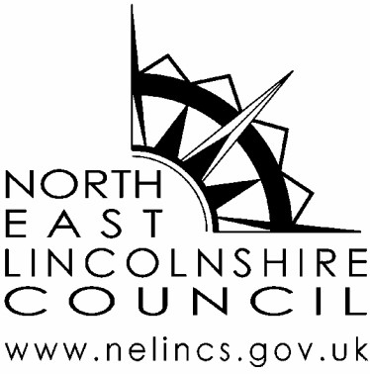**Annual Equality Report**

**Updated: June 2025**

**Contents**

1. Our Equality Policy Statement 2

2. Leadership Statement 3

3. Elected Members 4

4. Our Workforce 4

5. Our Community 6

6. Service Delivery 19

7. Partnerships 19

8. Social Value and Procurement 20

9. Updates on Actions and Monitoring 21

This document can be made available in a range of languages, large print, on tape, electronic and other accessible formats from the Strategy, Policy, and Performance Team.

Tel: 01472 323512 or e-mail: [**strategypolicyandperformanceteam@nelincs.gov.uk**](mailto:strategypolicyandperformanceteam@nelincs.gov.uk).

# Our Equality Policy Statement

1.1 North East Lincolnshire Council:

* is committed to ensuring equality of treatment for everyone in connection with service delivery, recruitment, and employment.
* is committed to the broad principles of social justice; is opposed to any form of discrimination, victimisation, and harassment; and accepts all its legal responsibilities in these respects.
* is committed to treating equally everyone with whom its representatives come into contact including current and potential service users, its employees, Elected Members and visitors.
* is committed to ensuring that no-one is treated in any way less favourably on the grounds of age, disability, gender reassignment, marriage and / or civil partnership, pregnancy and maternity, race, religion or belief, sex, sexual orientation.
* will implement all necessary actions and training to ensure its commitments with regard to equality of treatment are fulfilled and will monitor and review progress on a six-monthly basis.

1.2 North East Lincolnshire Council is committed to fulfilling its duties as a public authority under the Public Sector Equality Duty.  As part of this general duty, we are required to publish a set of equality objectives every four years. These objectives will be reviewed in 2026.

1.3 Our current equality objectives are based around the themes of the Local Government Equality Framework:

1. **Access to services** – collect and share information about our communities; effective community engagement; and fostering good community relations.
2. **Building cohesion and integration** – focus on health and wellbeing; creating effective pathways in education, training and employment; and partnership working to tackle domestic and sexual abuse.
3. **Understanding and working with our communities** – work with partners to celebrate our place; tackle poverty and inequality; ensure our borough is an inclusive and accessible place to live and visit; and work with partners to raise awareness of hate crimes and how it can be reported.
4. **Diverse and engaged workforce** – workforce diversity and inclusion; inclusive strategies and policies; collecting, analysing and publishing workforce data; learning, development and progression; and health and wellbeing.

1.4 These equality objectives help us to:

* work with communities to ensure they are involved in decision-making;
* oppose all forms of prejudice and discrimination;
* promote diversity and tolerance;
* prevent harassment and victimisation of residents, service users and employees;
* provide equal access to jobs at all levels of the council; and,
* make sure our employment policies and practices are inclusive.

**Report Details**

1.5 The Council has a statutory requirement to publish an Annual Equality Report and this report includes key information about our community and organisation. Further equality data is held on the North East Lincolnshire Data Observatory (NELDO) and is available here: [Equalities - UTLA | North East Lincolnshire | InstantAtlas Reports (nelincsdata.net)](https://www.nelincsdata.net/).

1.6 This resource provides key headline data about our residents and service-users with a particular focus on those with protected characteristics under the Equality Act 2010. A brief commentary is included on some of the key data, particularly where there has been a notable change over time, or where the local population's need is different to that of the general population. Where available, the information is presented at a local level including by ward, alongside comparative data at either a regional or national level.

1.7 The Local Government Association self-assessment framework for Equality, Diversity, and Inclusion (EDI) is being used to identify where we can improve our approach to EDI for our residents and employees. This will be used to guide our development and progression moving forward. The current actions related to this framework are detailed within the updates in section 9.

1.8 This report helps us to better allocate resources to assist those communities identified as needing additional support. We will seek to redesign public services and reshape teams around the needs of service-users, creating more joined up and accessible services which are in tune with the changing needs and behaviours of those we serve.

1.9 A review of our Equality Policy Statement and our Equality Objectives will be undertaken and set for the next four years in the next Annual Report.

# Leadership Statement

2.1 This year the Council published its new Council Plan focused on the next three years (2025 to 2028) to build a stronger economy and stronger communities. The world is rapidly changing, and this plan emphasises the importance of ensuring the Council is ready to take advantage of developments whilst being robust and prepared for any challenges that may arise. The commitment to ensuring we attract the right people and ensure that our area is inclusive and welcoming is critical to this future success.

2.2 The phrase ‘Team NEL’ captures our pride in North East Lincolnshire and our ambition for the future. We are ambitious for our place and people, and we want to celebrate our collective successes and share in the benefits from our opportunities for growth. This can only happen if we recognise and build on the strengths that the diversity of our community and workforce gives us. We aim to recognise, value, and promote the diversity of all people and ensure equal opportunities to access and receive services.

2.3 In addition to the nine protected characteristics within NEL we recognise that there are many other inequalities that need to be considered to ensure our service design and delivery is inclusive. Therefore, the Council will continue to review which groups should be considered in addition to the nine protected characteristics. At present, this includes care experienced, care leavers and children in care as well as the armed forces community.

2.4 This Annual Report is an important part of our commitment to building our approach to Equality, Diversity, and Inclusion in North East Lincolnshire. As part of our ongoing development of service delivery, we will continue to strengthen our approach to inclusive service design for our customers and service users as well as ensuring our recruitment and retention of staff recognises and values the importance of inclusivity.

2.5 The Inclusivity and Belonging (EDI) Champions staff group is focussed on promoting equality, diversity, and inclusion within the Council and has continued to develop over the last year. The focus of this group includes raising awareness, providing challenge, and leading on equality priorities across the Council. The Champions have contributed to a number of projects and developments providing an opportunity for challenge and engagement whilst developing the approach to equality, diversity and inclusivity.

# Elected Members

3.1 Elected Members play a key role in ensuring we engage with our community and listen to their needs. This includes a lead for Equalities, Diversity and Inclusion appointed by Cabinet.

3.2 We are committed to treating all Elected Members fairly and equitably, irrespective of their political group membership, circumstances, or affiliations, and recognise the right of Elected Members to promote the interests or concerns of any political group of which they are a member.

3.3 We recognise that our processes may need to be adjusted to accommodate the access needs of some Elected Members, in particular those with a disability or particular requirement. The Council is committed to providing reasonable adjustments in such circumstances.

3.4 The Council expects that Elected Members conduct themselves with integrity and in a manner that is consistent with the various policies, procedures, protocols and Codes of Conduct that apply to the roles they undertake as Elected Members of the Council.

3.5 The Council will support Elected Members through its Member development programme to understand our statutory duties, raise awareness of importance of understanding EDI, actively support communities to reduce inequalities, value and celebrate diversity and promote inclusion.

# Our Workforce

4.1 North East Lincolnshire Council is one of the largest employers in the area and recognises the importance of a diverse workforce. The Council has a firm commitment to equality of opportunity and has a duty to be a champion of equal opportunity principles and practice as an employer.

4.2 A refresh of the People Strategy sets out the Council’s vision and ambition for its workforce, both now and in the future. The Strategy recognises the importance of our people in delivering the Council plan and our aspirations for our Place.

4.3 The Council is committed to ensuring that all policies and procedures in relation to employment practices are reviewed through a lens of equality, diversity, and inclusivity, this is achieved through the Stakeholder group and the Inclusivity and Belonging champions group.

4.4 Our recruitment policy and practices continue to be reviewed and strengthened to ensure that all candidates have the same opportunities, and no-one receives less favourable treatment. A recent change has been the introduction of advancing interview questions to all interview candidates 24 hours before an interview. All staff who are involved in recruitment are trained in effective recruitment practices.

4.5 The Employee Voice, our annual employee engagement survey provides our staff with an opportunity to provide feedback on working within the Council. This enables the Council to listen and respond to feedback through the development of action plans.

4.6 The Council provides an extensive wellbeing offer to all staff, with a dedicated wellbeing section on our intranet to support our staff and promote our offer. Our wellbeing officers provide immediate one to one support as well as signposting to specialist advice, support, and counselling. The Council also offers extensive learning and development opportunities around wellbeing, resilience, and coaching/mentoring opportunities.

4.7 The Council has developed an extensive learning and development offer to support our commitment to equality, diversity, and inclusivity. The offer ranges from mandatory EDI training for all new starters, to face to face workshops and webinars on a range of subjects available to all employees which is monitored to encourage participation.

4.8 Our Ways of Working Policy recognises the positive impact that agile working can have on employee wellbeing. The policy ensures that the customer is central to all our activities and service delivery, whilst providing a greater level of flexibility for employees, as deemed appropriate for each service area.

4.9 The Council will work with its partners and other local organisations to promote best practice and encourage them to adopt policies which support the specific needs and requirements of their service-users, individuals and groups within North East Lincolnshire.

4.10 The monitoring of our employment practices is an important part of the Council’s Equalities commitment. This will include monitoring all stages of the recruitment and selection process to identify equalities representation within the workforce by department, pay, training, promotion, redeployment, redundancy, complaints, investigations, grievances, and disciplinary proceedings.

4.11 You can find further information in relation to our workforce on our website: <https://www.nelincs.gov.uk/your-council/council-workforce/>

# Our Community

5.1 The Office for National Statistics (ONS) published data from The Census 2021 in 2022 and 2023. This information is available here: [How life has changed in North East Lincolnshire: Census 2021 (ons.gov.uk)](https://www.ons.gov.uk/visualisations/censusareachanges/E06000012/). This provides an insight into how the population of North East Lincolnshire has changed – it shows that our area is becoming more diverse. It is important that this is recognised and celebrated.

5.2 The latest census data also shows that North East Lincolnshire's population decreased by 1.7%, relative to the last census in 2011, falling from just over 159,600 residents in 2011 to just under 157,000 in 2021. However, according to the ONS mid-year population estimates for 2023, there were 80,643 females and 77,692 males in NEL in June 2023, totalling 158,335 people. This represents a 0.9% increase between March 2021 (the time of The Census 2021) and June 2023.

5.3 In 2021, North East Lincolnshire was home to 815 people per square kilometre – a 1.7% decrease on 2011. The 2021 figure was higher than the English average of 434 people. Other local authorities ranged from 15,695 to 26 people per square kilometre. But just as there was a rise in the overall population when the aforementioned, latest population estimates are factored in, both NEL’s and England’s population density rose from the census to that point, from 815 to 824.7, and from 434 to 442.7, respectively.

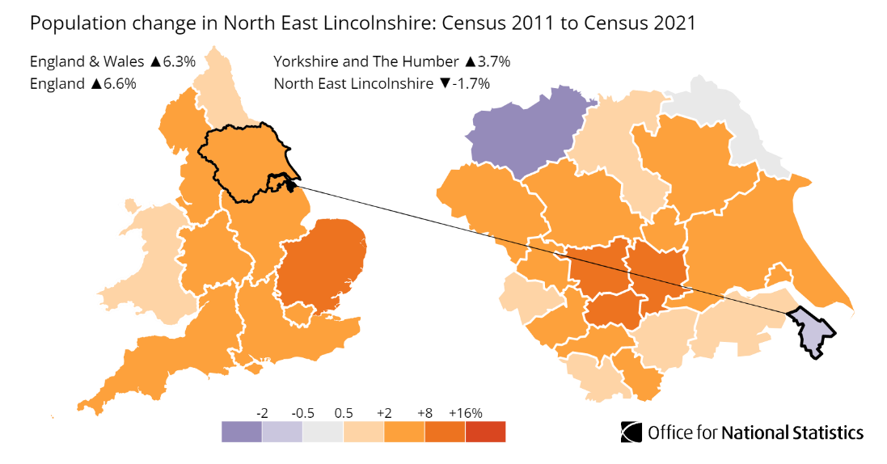

*Source: Office for National Statistics – 2011 Census and Census 2021*

**Adolescent Lifestyle Survey (ALS)**

The ALS is a questionnaire completed by secondary school age children in NEL carried out by the Council’s Public Health Intelligence Team on a three-to-four-yearly basis. In the 2024 ALS, a small number of pupils attending a school outside of NEL - whom are residents of NEL - were surveyed for the first time also. The survey is anonymous and is carried out online - usually this is done during an ICT lesson at school. It is designed to capture information on pupils' health and wellbeing and asks questions such as whether they smoke cigarettes, drink alcohol, have exercised for one hour or more in the previous week, and feel safe in the area they live. The information is important in understanding the lives of children in our area.

The most recent ALS, done in the Autumn term of 2024, achieved 6,169 responses. This is likely to represent just over half of all potential respondents in mainstream secondary schools and alternative provision in the area, though we cannot be certain due to gaps in the way the number of enrolled pupils are reported. It was also offered to Electively Home Educated pupils, but take up was extremely low.

The survey revealed that, of those taking part:

* 15.2% provided care for someone at home with a serious illness or health condition who could not manage without their support (almost one-in-five of that figure provided over two hours per day);
* 10.4% had a Special Educational Need;
* 5.1% had a Long-Term Illness;
* 6.7% had a Disability;
* 17.7% were an ethnic minority (the most populous ethnicity within this being white - other);
* 9.5% had a first language that wasn't English (the most populous language that wasn't English being Polish).

Sexuality was the topic of a question asked of the years 9-11 *only*; 81.3% indicated they were straight - a 6.5% rise on the figure from 2021. With reference to sex assigned at birth, 51.6% were female and 48.4% were male. On which of the options presented best represented respondents gender identity, 'female' was selected by 48.2% of respondents, and 'male' by 45.8%, while 3.1% had an identity that did not match their sex assigned at birth (non-binary was the most populous group within this). This survey was the first where 'non-binary' was presented as a standalone option. The team designing the survey made the choice to do this after the 2021 survey saw it written 80 times in the free text option for this question. Moreover, the language options were brought in line with the School Census and an increased focus on Domestic Violence (DV) saw a set of questions added to gauge what pupils perceive to be DV.

This survey gives crucial information to be considered as part of service design and service delivery, with full results available on the North East Lincolnshire Data Observatory here: [InstantAtlas NE Lincolnshire – Children’s JSNA](https://www.nelincsdata.net/childrens-jsna/). Additional focus reports will also be published through the year.

**Age**

5.4 Relative to 2021, the ONS estimates that the median age did not change from 43.1 in 2022; the median age was 42.9 in the 2019 edition of the ONS’ mid-year population estimates and 41.1 in Mid-2011, suggesting the upward trend has slowed. However, North East Lincolnshire remains older – on average – relative to Yorkshire and the Humber and England, which had a median age of 40.6 and 40.5 in 2022, respectively. NEL’s median age in The Census 2021 saw it place 127th out of 331 local authorities, with 1st being the oldest.

5.6 At ward-level, the ONS' mid-2022 population estimates reflect large differences in the distribution of people by age in NEL’s wards (see the figure below), with South and East Marsh having the highest percentage of under 18s (27.7% in both), while Haverstoe and Waltham wards have the lowest, with 15.9% and 16.3%, respectively.

5.7 West Marsh and Heneage have the highest proportion of those classed as working age (18-64), with 63.1% and 60.8%, respectively, while Haverstoe and Waltham have the lowest, with 48.4% and 51.4%, respectively.

5.8 The largest disparities lie in the proportion of those aged 65 and over – the lowest is in East Marsh and West Marsh (12.4% for both), rising to 35.7% in Haverstoe. These trends generally follow deprivation, with more deprived areas having a higher proportion of their residents aged under 18 and a lower proportion at an older age; poorer areas generally have a higher birth-rate, while many older people move to less deprived wards in retirement, both altering the average for an area.

5.9 At an NEL footprint, the average proportion aged under 18 is 21.9%; the average aged over 64 is 21.2%, and the average aged within a working age bracket is 56.9%.

Distribution of the population in Lincolnshire



**Disability**

5.10 Per age-standardised data from the 2021 Census, 9.0% of North East Lincolnshire residents identified themselves as disabled in line with The Equality Act, indicating their day-to-day activities were “limited a lot”. This figure decreased by 0.7% from 9.7% in 2011. Around one in nine people (11.1%) were disabled and limited a little, relative to 10.7% in 2011. Collectively the most recent data suggests one-in-five were disabled either identifying as “limited a lot” or “limited a little” in their day-to-day activities.

5.11 Below is a summary plot to show the proportion that were disabled in NEL in 2021.

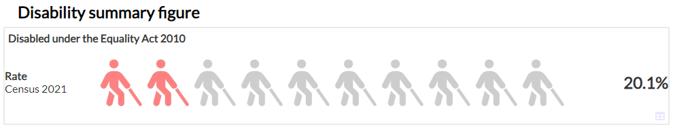

5.12 The census-based ward picture shows clear differences between areas of North East Lincolnshire, with an 8.8% difference between the Wolds and East Marsh wards, the latter of which was a quarter with a disability. This trend likely reflects the reduced standard of health that goes with a more deprived population. These are not age standardised, but this would not change the trend.

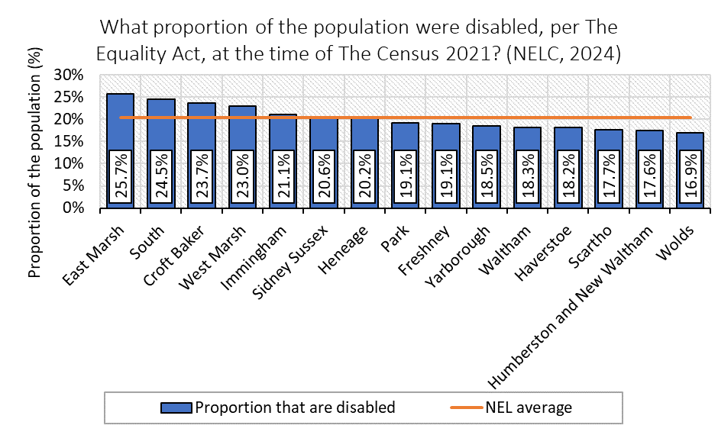

5.13 The ward picture is similar when we consider the proportion of the population whose day-to-day activities are limited by a health condition.

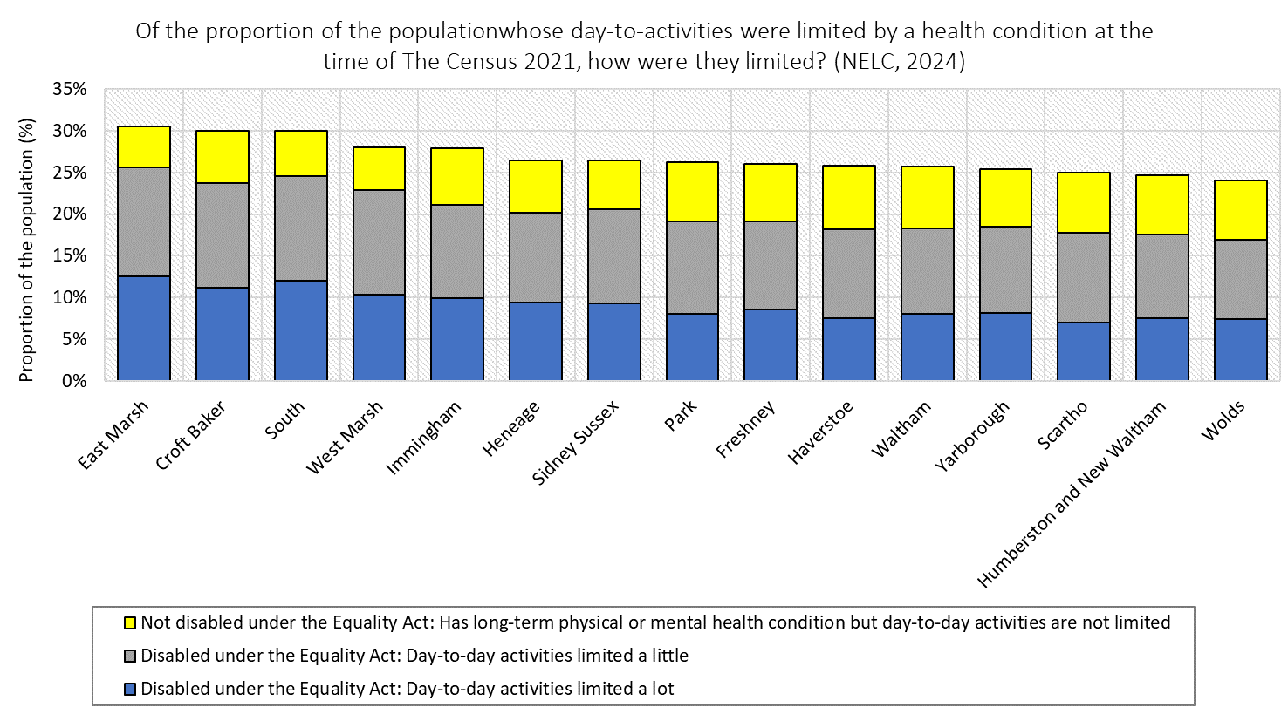

**CASE STUDY: Advancing Interview Questions**

In August 2024, North East Lincolnshire Council (NELC) initiated a trial to advance interview questions as part of their recruitment process. This initiative aimed to address the challenge of attracting top talent in a competitive job market.

 The primary goal of this trial was to enhance the Employee Value Proposition of NELC by creating a more inclusive and supportive recruitment experience. The trial involved providing interview questions to candidates 24 hours before their interview. This approach was designed to help candidates prepare more thoroughly, reduce their anxiety, and enable them to present their experiences and skills more effectively.

Throughout the six-month trial, feedback was collected from both candidates and hiring managers. Candidates overwhelmingly reported that receiving the questions in advance allowed them to consider their answers more carefully, which helped them feel more prepared and less nervous during the interview. This preparation enabled candidates to showcase their best examples and experiences, making NELC stand out in the job market.

Hiring managers also provided positive feedback, noting that candidates appeared more at ease and relaxed, which allowed for better interaction and a clearer demonstration of their knowledge and experiences. Managers observed that candidates who prepared in advance were able to offer more insightful responses and required fewer follow-up clarifications. This enabled managers to focus more on delving deeper into responses to get a better insight into candidate experiences within their examples.

"*Candidates seemed more at ease and relaxed, and I feel we got a better sense of their experiences and knowledge through them using real case examples."*

*“It took a lot of the anxiety and nerves away from the situation which in turn can only have a positive impact towards a smoother running interview.  Helps to focus the process.”*

*“I felt less nervous during my interview as I knew what I was going to speak about beforehand, and it felt more like having a conversation with colleagues rather than a test.”*

**Sex and Gender**

5.14 The population of North East Lincolnshire (156,966) was recorded as 51.1% (80,154) females and 48.9% (76,812) males in The Census 2021. *Source: nelincsdata.net*

5.15 The ward profile below is based on the ONS' Mid-Year Population Estimates from June 2022, at which point there was a negligible difference between these, the ONS’ most recent publications on the split in population by sex in each of NEL’s 15 wards. There is only one ward where there are [slightly] more males than females (Freshney), although Wolds has a perfectly even split. All the remaining wards have more female than male residents; Waltham has the largest gap, as it is 52.7% female, having 378 more females in what is the smallest ward. The average for NEL is 51.0% female and 49.0% male.

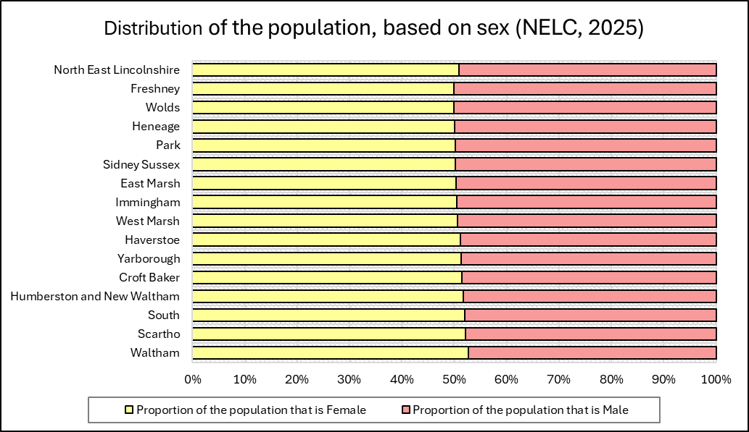

5.16 On gender, the question on people’s gender identity in The Census 2021 was voluntary and was only asked of those aged 16 years and over. The question asked, “Is the gender you identify with the same as your sex registered at birth?”. In North East Lincolnshire, 94.3% answered “Yes” and 0.45% answered “No”. The remaining 5.31% did not answer. A slightly higher proportion answered yes at a regional and national level.

Below is a summary plot showing this proportion in NEL in 2021.

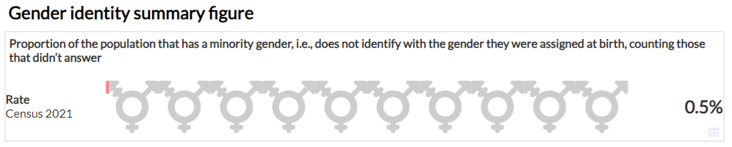

5.17 The question on gender identity was new for Census 2021 and was added to provide the first official data on the size of the transgender population in England and Wales.

This data will help to:

* provide better quality information for monitoring purposes.
* support anti-discrimination duties under the Equality Act 2010
* aid allocation for resources and policy development.

**Marriage and Civil Partnerships**

5.18 Of North East Lincolnshire residents aged 16 years and over, 33.1% said they had never been married or in a registered civil partnership in the census 2021, down from 36.2% in 2011. The proportion that are married or in registered civil partnership was most recently 42.4%, down from 45.2% in 2011.

5.19 Same-sex marriage was legalised in 2014 and opposite-sex civil partnerships in 2019. At 0.2% and 0.1% of the total population in NEL, these did not make up substantial proportions of the population in 2021.

Below is a summary plot to show this proportion for NEL.

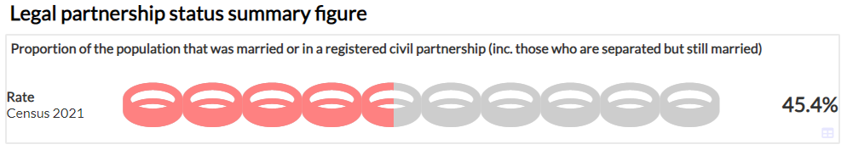

5.20 When considered by ward, again there are clear differences. The proportion of the population married or in civil partnership is over half in six wards, and below 1-in-3 in two, ranging from 58.3% in Haverstoe to 28.4% in East Marsh. This is likely correlated with the age breakdown, with East Marsh having the lowest proportion of people aged 65 and over, and Haverstoe having the highest.

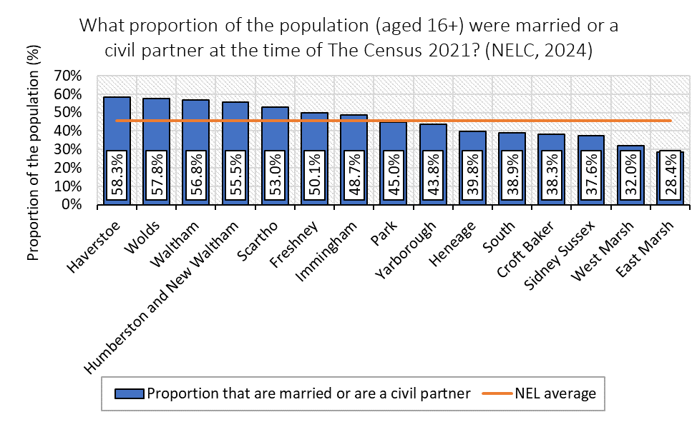

**Pregnancy and Maternity**

5.21 In 2021, 1,501 babies were (live) born to mothers’ resident in North East Lincolnshire, with a general fertility rate (GFR) of 54.6/1,000 live births. This was similar to the England rate of 54.3/1,000. The number of births has decreased over the last 10 years. In 2011, there were 2,032 live births to mothers’ resident in North East Lincolnshire (GFR was 61.4/1000 for NEL and 64.2/1000 for England).

5.22 In 2022/23, the number of babies born live in NEL fell to 1,404 for the financial year, Sidney Sussex and South accounted for 21% of these; Haverstoe and Waltham accounted for 6.6%.

Below is a summary plot to show the proportion of NEL’s females that gave birth in 2021.

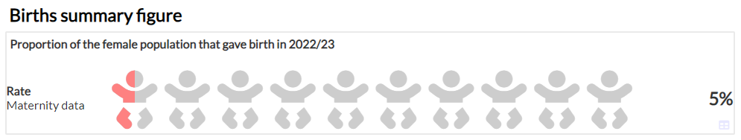

5.23 In terms of the proportion of the female population giving birth at a ward level, different wards’ figures ranged from 6.3% in South ward to 3.5% in Humberston and New Waltham. Like the number of rate of births by ward in general, this is almost certainly linked to the age split, with the five wards with the highest proportion of females giving birth also being the five with the highest proportion of females of reproductive age (15-45) (this is 43.8% in East marsh and 23.9% in Haverstoe).

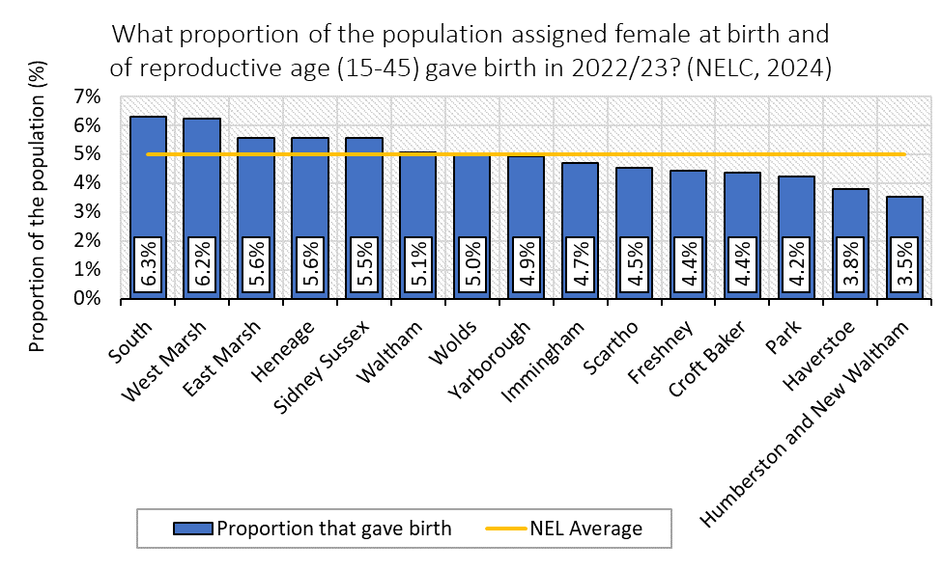

5.24 At 109.8 premature live births and stillbirths per 1,000 live births and stillbirths, North East Lincolnshire has the highest premature birth rate in England and the trend increased from 2015-17 to 2018-20, only falling again in the most recent datapoint (2019-21). Premature births are the leading cause of infant mortality and the fastest increasing cohort of children with special educational needs. Children born prematurely are also more likely to have a range of health problems, affecting areas from dental health to hearing and sight. Mothers living in the most deprived areas of North East Lincolnshire are more likely to give birth prematurely than those in the least deprived areas.

5.25 Rates of obesity in pregnancy, smoking at the time of delivery, and teenage pregnancy are all high in North East Lincolnshire and are significantly higher than the England rates, with smoking at the time of delivery in NEL in 2022/23 being the 2nd worst of all LAs in England, just as NEL’s figure for under 18s conceptions places it fourth worst. Obesity and smoking are both risk factors for premature birth and rates of teenage pregnancy are higher in our most deprived areas.

**CASE STUDY: Women in Manufacturing and Engineering Event**

The event included Manufacturing, Engineering, Digital, Construction and Renewables and more with the ambition of promoting Women in Manufacturing and Engineering (WIME).

 In total 43 locally based companies set out their stalls for over 100 members of the public and 445 students from primary schools all the way up to University.  Despite there being a range of opportunities across manufacturing, engineering, digital, construction and renewables in North East Lincolnshire, figures show how these sectors remain male-dominated with only 9% of the workforce being female.

The Women into Manufacturing and Engineering (WiME) initiative was developed to balance the scales and encourage more women to consider a STEM (science, technology, engineering and maths) based career. In the next two years alone, it’s believed an estimated 186,000 new jobs will be needed across these sectors. With regular events taking place across the Humber region, attendees had the chance to chat with local organisations and find out what it’s like to be a woman working in these industries.

The event has welcomed 1000s of budding learners over the years with many impressed by what was on offer. One year 6 said: “Success depends on if you believe in yourself and, after speaking to the women today, I do now.”

**Sexual Orientation**

5.26 The census question on sexual orientation was also a voluntary question asked of those aged 16 years and over *only*. In North East Lincolnshire, 93.3% of the population aged 16 years and over answered the question. Of those who answered, 90.8% identified as straight or heterosexual and 2.6% identified with an LGB+ orientation (“Gay or Lesbian”, “Bisexual” or “Other sexual orientation”). The remaining 6.7% did not answer.

5.27 Below is a summary plot showing the proportion of NEL that was aged 16 and over and identified as a sexual minority in 2021.

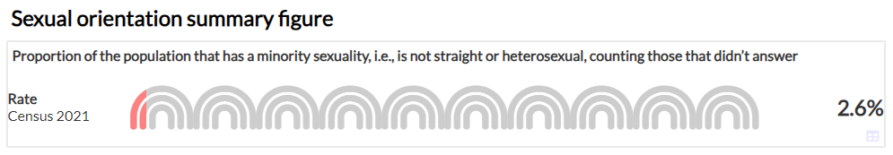

**Race**

5.28 The proportion of the population that consider themselves White British fell from 2011 to 2021, from 95.4% to 92.6%; the percentage considering themselves white fell from 97.4% to 96.2%. These changes reflect the trend seen in England and Wales, where the proportion that was White British fell from 80.5% to 75.4% and the proportion that were white fell from 86% to 81.7%. “White: Other” was the second largest ethnic group in NEL, which made up 3.3% of residents, 44.7% of whom were Polish or Romanian. The third largest was ‘Other: Asian’ (0.5%), most of whom were Filipino or Afghan (33.7%). The ethnic groups changing the most in NEL in this 10-year period were the ‘Any Other Ethnic Group’, ‘Black: Other’, and ‘Gypsy or Irish Traveller,’ with the former being the largest at 671 individuals in 2021. Only 3 in 18 minority ethnic groups shrank, with the Chinese group shrinking the most, from 605 to 438 individuals.

Below is a summary plot showing the proportion of NEL that was not White British: English, Welsh, Scottish, or N. Irish, per The Census 2021.

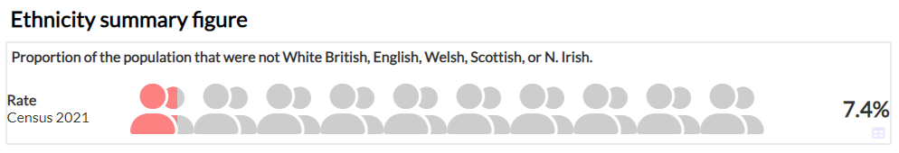

5.29 When considered on a ward-by-ward basis there are huge differences between areas regarding the proportion of people who have a minority ethnic background. The West Marsh and East Marsh have figures of 16.3% and 13.0%, respectively, whereas Haverstoe – which has the lowest proportion – has a figure of only 2.6%.

5.30 Generally, deprivation is higher among minority ethnic populations, and as poorer residents live in areas with more affordable housing, i.e., East Marsh and West Marsh, the proportion of people with a minority ethnic background is likely to be much higher in wards such as these.

Population by Ward in NEL

**Religion**

5.31 In The Census 2021, 46.5% of North East Lincolnshire residents reported having "no religion", making it the most common response (up from 30.4% in 2011). Across Yorkshire and The Humber and England, the percentage of residents who described themselves as having "No religion" also increased but the proportion identifying as Christian was still the largest category in both areas. In 2021, 45.3% of people in North East Lincolnshire described themselves as Christian (down from 60.7%), while 5.9% did not state their religion (down from 7.2% the decade before).

5.32 Below is a summary plot showing the proportion of NEL with an “Other” religion in 2021.

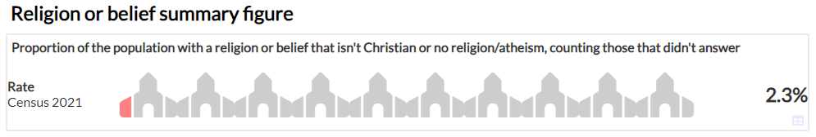

5.33 The ward profile illustrates that there are relatively small differences between wards in their proportions identifying with a minority religion or belief. Park has the highest proportion with 3.9%, while Haverstoe has the lowest (1.1%), indicating that factors like age and deprivation are not as strongly linked to religious belief as others.

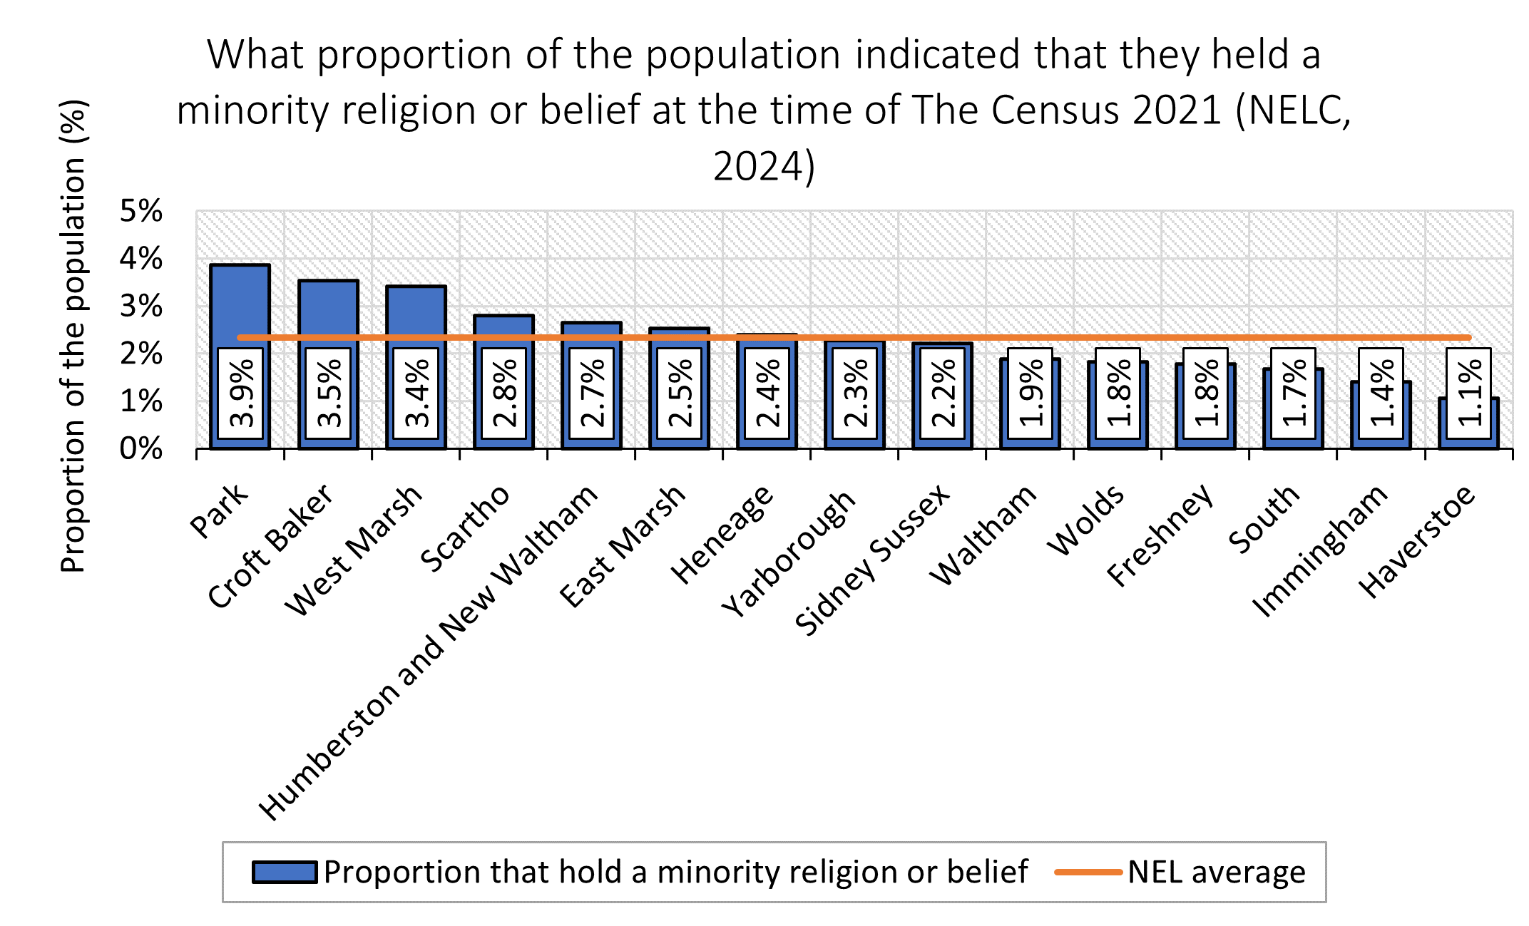

**Carers**

5.34 Carers are defined as anyone, including children and adults, who look after a family member, partner or friend who needs help because of their illness, frailty, disability, mental health problem, or addiction, and who cannot cope without their support. The care that they give is unpaid.

Below is a summary plot showing the proportion of NEL providing unpaid care in 2021.

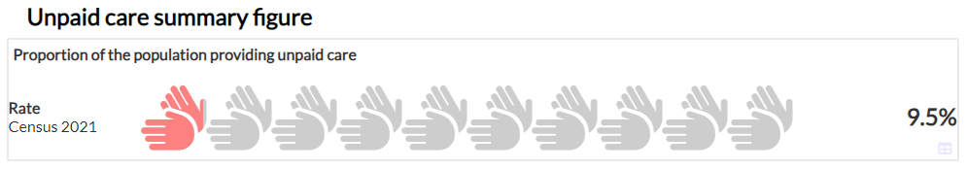

5.35 According to the Census 2021, which counted carers as those aged 5 and above, there were 14,053 people providing another person with unpaid care – just over 9% of NEL. 34.5% of these provide 50+ hours of care per week. North East Lincolnshire has the second highest percentage increase in the number of people providing 20-49 hours of care per week in England and Wales.

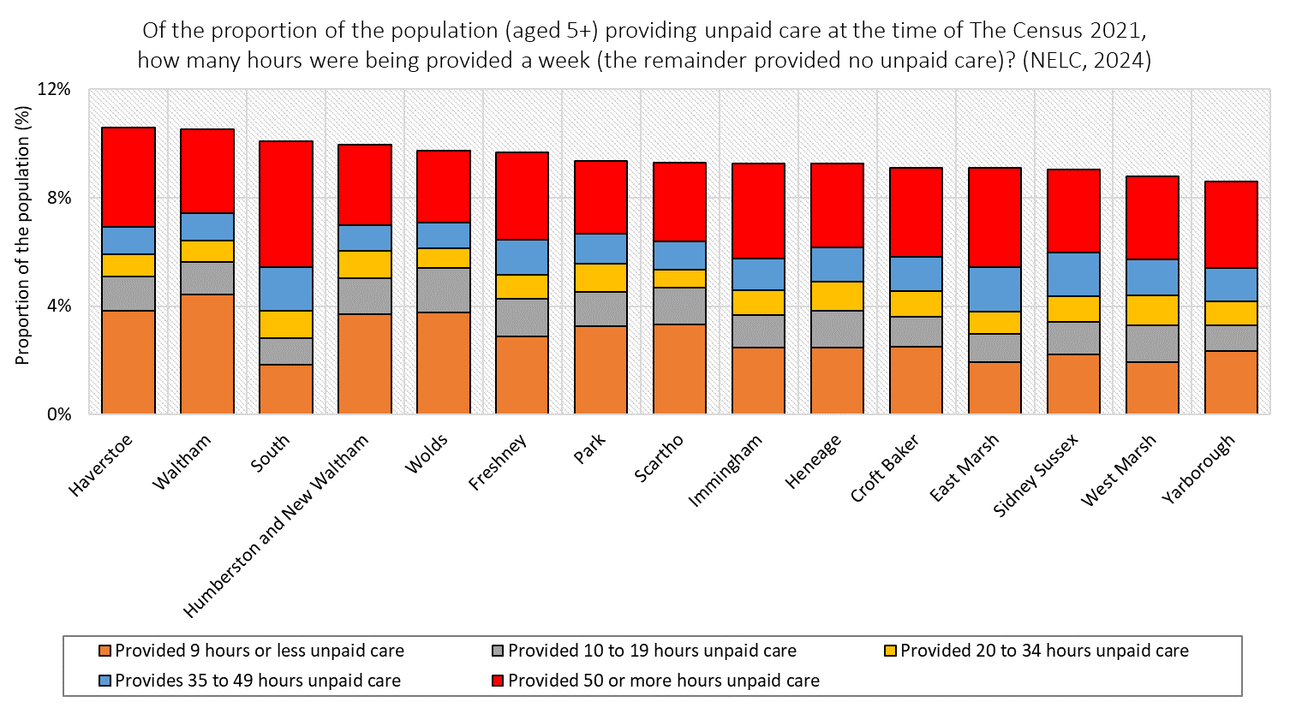

5.36 A census-based view of hours of unpaid care provided with a split by ward shows the opposite picture to that illustrated by the corresponding breakdown of disability – the least deprived wards are shown to have a higher proportion providing unpaid care, though there is a weak link between the ward and the split in hours provided, especially in the three categories in between the highest and the lowest provision. South is the exception, as its population is highly deprived, and almost half its unpaid carers provide 50 or more hours.

5.37 The table below shows the proportion of carers in relation to people living in each Ward in North East Lincolnshire, with a split by age. It shows there is a great deal of variation between wards, and that, while proportions are low, almost 1 in 50 under 18s in Humberston and New Waltham provide unpaid care.

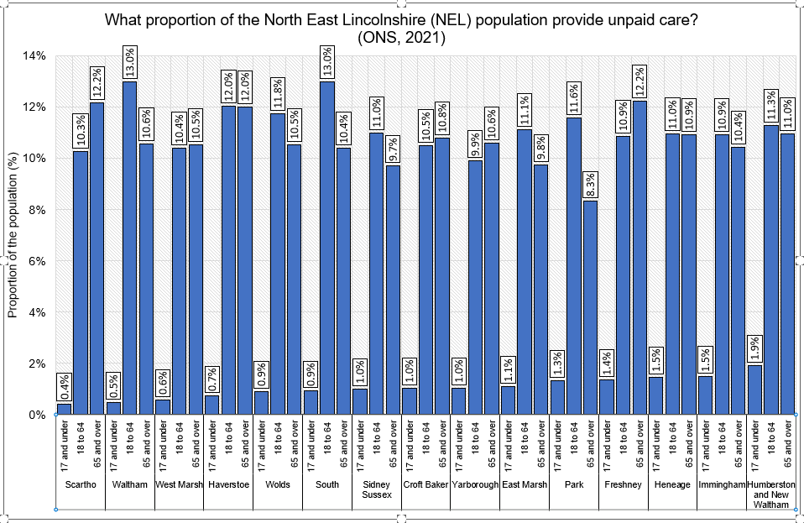

**Looked After Children, Care Experienced and Care Leavers**

Population by Ward in NEL

5.38   North East Lincolnshire Council is currently supporting 438 looked after children (April 2025).  Their age range is as follows:

5.39   Care Leavers in England are over ten times more likely than their peers not to be in education, employment or training by the age of 21.  In North East Lincolnshire, the percentage of 19 to 21-year-old care leavers not in education, employment or training (NEET) was 50.6% at the time of their birthday during 2024-25.  The last published national average for 2023-24 was 54%.

5.40   Despite care experienced people making up around 1.4% of the UK population, they account for 25% of homeless people in England and a quarter of the prison population.  Nearly half of all under 21-year-olds in contact with the criminal justice system have been in care.

**Armed Forces Community**

5.41 Information regarding Veteran Status was new for the Census 2021. The ONS defined a veteran as someone who had served at least one day in the UK armed forces, either as a regular, reserve, or merchant mariner who had seen duty on legally defined military operations. Overall, 7,034 people, or 5.5% of NEL’s population aged 16+ were veterans in the 2021 census, which was higher than the England and Wales and regional figures. Only East Riding of Yorkshire had a higher proportion than NEL in the region. Those 7,034 veterans were made up of 5,812 who served in the regular UK armed forces; 953 who served in the reserves; and 269 who served in both.

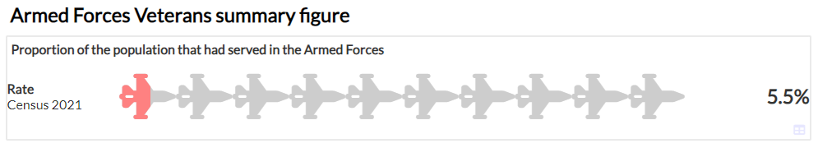

5.42 The ward picture ranges from 6.6% in the Immingham ward to 4.1% in the East Marsh. Broadly, veterans are older than the average for the population and the overwhelming majority are male. This likely links to the fact that three of the six wards with the highest proportion of veterans also have the highest proportion of residents aged over 65.

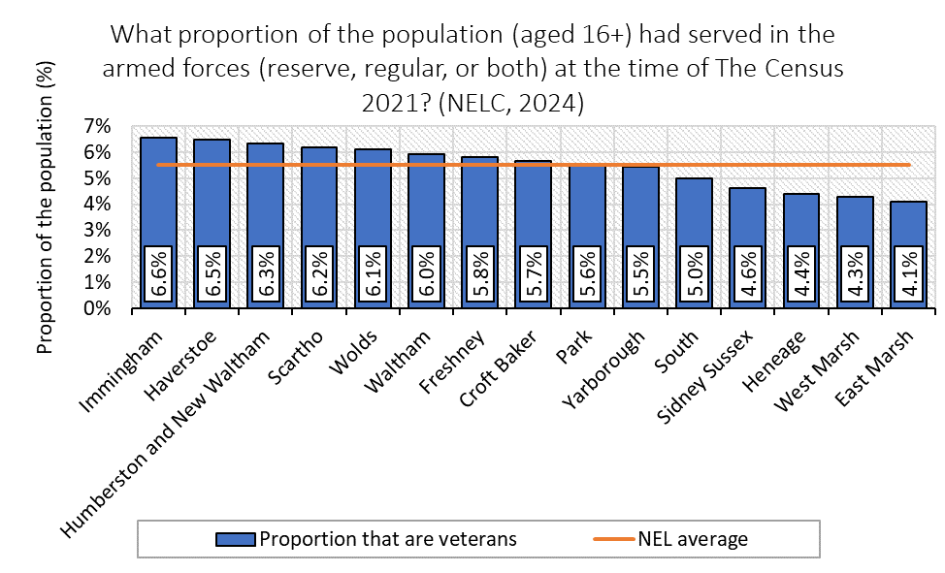

5.43 For further information about the Council’s commitment to the armed forces, please see [www.nelincs.gov.uk/your-council/armed-forces/](http://www.nelincs.gov.uk/your-council/armed-forces/).

# 6. Service Delivery

6.1 North East Lincolnshire Council is committed to ensuring that its services are accessible to all its residents and service users. It is important to us to ensure that no one experiences barriers when trying to access services. The Council will ensure that the range and quality of services provided are appropriate and sensitive to the needs of the people of North East Lincolnshire.

6.2 The Council will ensure that no service user is subjected to unjustifiable discrimination or harassment in the delivery of any of the Council’s services and will seek to promote equality, diversity and social inclusion amongst our partners in the services they provide.

6.3 In order to achieve this, the Council will consider equality issues at the outset of commissioning and service delivery decisions. These considerations will form part of the service planning process and will be an integral part of the way that all services are managed and delivered. Regular review and monitoring will be used to ensure that the services do not have an unjustifiable adverse impact on residents or any population group. It is the responsibility of each Assistant Director and service managers to ensure that these services meet the needs of the specific key groups.

6.4 All service areas of the Council will ensure that they are responsive to the changing and diverse needs within the community of North East Lincolnshire and that service users receive equitable treatment when accessing services. Equality Impact Assessments (EIAs) will be carried out across service areas.

6.5 This means that the services we deliver, or contract out do not discriminate against someone because of perceived difference. It also means that we take an active role as a leader in the community and remove barriers to participation and access for all members of the community.

# 7. Partnerships

7.1 The Council will ensure that all work undertaken by partners on our behalf is carried out in accordance with our Equality Policy Statement. These services will be appropriate and sensitive to the needs of the people of North East Lincolnshire.

7.2 The Council will ensure that all terms of reference and other relevant partnership documentation complies with the Council’s Equality Policy Statement and all relevant legislation. It is the responsibility of each Assistant Director to ensure that actions to meet the needs of the specific key groups are included in partnership plans and strategies, and that appropriate monitoring mechanisms are in place to ensure these are met.

7.3. The Council will ensure that all commissioned partners adhere to our Equality Policy Statement by the inclusion of equality as a criterion by which contracts are awarded and the inclusion of equality objectives in contract specifications.

7.4 The use of Equality Impact Assessments will extend to services delivered in partnership, where appropriate, and action plans monitored to ensure there are no significant differences in satisfaction for all groups.

7.5 The Council will encourage organisations which represent a range of community interests to become involved in partnership working, and will seek, wherever justifiable, to ensure that the interests of the specific key groups are explicitly represented on each partnership.

7.6 The Council will encourage partners to undertake equality awareness training.

7.7 It is recognised that there are other third parties who have a relationship with the Council, either working on behalf of or with the Council, who are not partners or contractors. The Council will expect these third parties to adhere to the standards defined in our Equality Policy Statement.

7.8 The Council will seek to ensure that our approach to equalities is co-produced with a range of partners where possible. By taking this inclusive approach, we will be able to better identify areas of activity that need to be addressed to deliver good equality outcomes for employees and the community. This will help us to further embed equality into processes and practices and support organisations to become inclusive employers.

# 8. Social Value and Procurement

8.1 Social Value is defined as “outcomes and activities that will improve the quality of life and life chances of our residents and enhance the economic, social and environmental sustainability of the local area”.

8.2 The revised Social Value Policy was published in 2023 and provided a renewed focus on aligning the benefits that Social Value can offer aligned with the Council Plan and our Equalities Objectives.

8.3 Where possible, we have started to involve local citizens at the earliest opportunity in the commissioning process to identify solutions which offer social value outcomes. In 2022, we brought together our citizen engagement, commissioning, solution design, procurement, and other strategic functions into one centralised service to ensure more consistent and collaborative approach that promotes wider involvement in decisions and solutions.

8.4 Our approach to social value and procurement seeks to ensure that suppliers and partners adopt sound and legal employment terms, including high quality health and safety standards, ensuring fair and equal treatment in the workplace and evidence of working to employment and equality legislation. This includes practises which ensure modern slavery and child labour issues are positively addressed.

8.5 Our Social Value policy sets out commitments we would like to see from those bidding for contracts with the Council to adopt as part of their contribution to the North East Lincolnshire Outcome Framework. These commitments include using social value as a platform to provide:

* equal access to high-quality education, employment and career progression through schemes such as apprenticeships, work placements, and encouragement of lifelong learning.
* working with partners to tackle disadvantage and address inequalities of health, wealth, and opportunity by targeting activity towards those most in need, prioritising our most vulnerable.
* helping our people feel valued and able to contribute to our society, by promoting diversity, encouraging volunteering, and involving the community in change.

8.6 Through clearly setting out the Council’s expectations in this way we will be able to evidence and demonstrate the impact that procurement and social value is having on North East Lincolnshire and our communities.

# 9. Updates on Actions and Monitoring

9.1 The Council is using the Local Government Association’s Equality Framework, which sets out four modules for improvement. These are underpinned by a range of criteria and practical guidance that can help the council to plan, implement and deliver real equality outcomes for employees and the community.

9.2 The four modules are:

1. Understanding and working with your communities
2. Leadership and Organisational Commitment
3. Responsive Services and Customer Care
4. Diverse and Engaged Workforce.

9.3 As a large public sector organisation, our Equality Objectives cover a broad range of areas. We will continue to deliver them through projects, policies and strategies that shape how we deliver services; and will work with others on areas including supporting children, young people and families and improving health and wellbeing.

9.4 Each year, through this Annual Equality Report, we will provide an update on each of the Objectives, including how we are delivering and the impact we are achieving. These actions are set out below which align to the agreed work against the Local Government Equality Framework. The next update to this plan will be published in June 2026.

9.5 As well as demonstrating our legal compliance with the Public Sector Equality Duty, which this report forms part of the Council is also committed to broader objectives aimed at achieving equality for all residents, not solely those with protected characteristics. This is through the delivery of accessible, fair services, as an employer, contractor of services and a community leader. The Council celebrates diversity, and the positive contribution of all different groups.

**Progress against our objectives**

* **Access to services**

The Council has an updated approach to carrying out impact assessments for all projects, policy and service decisions. This is integrated into the Tools for Change Toolkit and the approach encourages initial assessments to be carried out as part of any decision making or service design to support comprehensive final assessments. Services are expected to ensure all data has been considered and where proportionate all those affected are consulted and engaged. Any final assessment should articulate all the findings and information captured throughout the initial assessment.

* **Building Cohesion and Integration**

The Community Safety Partnership Plan includes a section on Neighbourhood Networking. This sets out the CSP’s approach to supporting community-based problem solving and increasing community resilience within local neighbourhoods. Neighbourhood Networking is the golden thread that runs throughout our placed based approach. The CSP runs proactive communications and awareness raising campaigns on its social media accounts, scheduled throughout the year which cover a broad range of activity targeting key priorities with the intention of promoting positive relations.

* **Understanding and Working with Our Communities**

To support engagement the Talking Listening and Working Together strategy has been adopted by the Council and health and care partners. This is supported by a steering group, a partnership engagement officers’ network and the research and engagement team as part of the Council’s Insights function. The Council publishes past consultations and has a clear programme of activity including a shared engagement calendar. The Council website includes all current and past consultations with all new surveys and activity being shared with the Council, HCP, and VCSE.

The Council’s data observatory (NELDO) continues to be developed to ensure it captures all available local information. This includes reports and data from the most recent census. This information has been made available on various levels and continues to be promoted as the source of information to understand our communities when carrying out service design and delivery.

* **Diverse and Engaged Workforce**

There is a greater understanding of the local labour market provided through the census and through applicant data. An applicant survey has been implemented to gain feedback from candidates to help understand issues in the recruitment process. The application form has been updated to remove any potential barriers including a revised approach to ensure the language and questions used are inclusive throughout the recruitment process. Further local data supports understanding of candidate pools and the challenges.

When reviewing policies and procedures, we engage our workforce through focus groups, questionnaires and 1:1 feedback sessions to understand what works and what needs to be improved. We regularly engage with our Trade Unions to understand the concerns of their members and all new/updated policies are reviewed by our Stakeholder Group made up of representatives across the organisation.

An employee Inclusivity and Belonging Champions Group has been established and through that group we are exploring the make-up of the organisation and what further employee support groups may be developed. People and Culture have also been undertaking employee engagement surveys to provide insight into employee views.

There are various initiatives aimed at encouraging staff to provide equality information including as part of the recruitment process. Awareness around EDI is promoted through various routes including training activities such as the Induction/Welcome to New Colleagues, AcademyNEL and e-learning which all highlight the importance of staff providing this information. As part of the e-learning package offered to all employees EDI was identified as essential (mandatory) training.

To support health and wellbeing, targeted campaigns are derived from data which has led to a focus on stress and anxiety. In addition, there has been a development of a manager’s toolkit and a remodel of the Occupational Health and wellbeing provision. Reasonable adjustments are covered in the Health, Safety and Wellbeing policy along with a number of supporting procedures and guides with more specific information for employees, managers and supervisors. Those that are involved in making reasonable adjustments are supported throughout by People and Culture to ensure that each requirement is implemented and understood by those involved. Full wellbeing support, tools, training and support across the organisation is provided. This utilises many of the available tools, techniques, organisations and personnel available within the area to help manage the impact of detrimental mental health issues in the workplace.

* **Further actions**

The remaining actions below align to our priorities as set out against the Local Government Equality Framework.

| **Outcomes** | **Key actions to achieve this year** | **Timescale** |
| --- | --- | --- |
| 1. **Access to services** | Further promotion will be undertaken to ensure the organisation and partners are clear about what information is available to inform the development of services. This will promote the available information held by the Council and its partners including the creation of a central record and guide.  Further work with partners to promote information sharing and ensure that where possible information is being shared back with the Council.  The new customer management portal will be used to collect customer information consistently and support our understanding of the community and service-specific users.  Corporate Health information will be incorporated into the Council Plan dashboard reporting to give an overview of key metrics relating to our community. | **February 2026**  **February 2026**  **March 2026**  **April 2026** |
| 1. **Building Cohesion and Integration** | Develop the place-based EDI network and publish the NEL EDI Strategy. | **September 2025** |
| 1. **Understanding and Working with Our Communities** | The mechanism for engaging with our varied communities will continually be revised and revisited during engagement activities and/or consultations to ensure diverse communities can contribute to engagement.  There will be further development of our understanding of all groups within NEL with particular focus on understanding those who may not be engaging.  A Population Health approach is underway via the Health and Care Partnership. This has identified target health and wider determinants of public health in cohorts and localities. Work is being piloted through a) Integrated Neighbourhood Teams attached to primary care networks b) community led plans in the four wards with the highest health inequalities c) pilot activities by VCSE organisations. | **March 2026**  **March 2026**  **March 2026** |
| 1. **Diverse and Engaged Workforce** | A revised approach to Equality Impact Assessments within People and Culture will be adopted which will be used for all policy reviews and service changes.  The staff engagement - Employee Voice Survey – will continue to be undertaken with action being taken based on the results received. This survey is based on ensuring inclusivity across all areas of the Council and providing data to guide development.  To ensure that our recruitment and selection processes monitor all protected characteristics a quarterly equality assessment will be implemented. This will be supported by the creation of dashboards to provide details of applicants from application to selection.  The Council will seek to be recognised as a level 3 Disability Confident Employer. | **September 2025**  **March 2026**  **March 2026**  **March 2026** |