

|  |  |
| --- | --- |
| Internal reference: | NELC ESAGdrones |
| Review date: | August 2023 |
| Version | V4 |

**Guidance on use of drones in North East Lincolnshire**

**Contents**

1. Aims of this guidance
2. Guidelines
3. Drones and Wildlife

**Aims of this Guidance**

North East Lincolnshire Council's (NELC) guidance on local drone usage sets out the organisations stance on the use of drones generally, as well as for specific events as part of the advice given by the Event Safety Advisory Group (ESAG).

* To ensure that if the use of drones is agreed, the operator complies with all current legislation.
* That any use of drones is undertaken away from groups of people in line with current guidance to minimise the risk to the public
* To clarify that the position of the Council is only to agree the use of drones on Council land where there is a clear case for the use of the drone and we will only allow qualified drone pilots to operate drones from council owned land (including public highways, public rights of way & the coastline)
* If drones are to be used, that they will be used only after consultation with ESAG or an appropriate Officer and will comply with all reasonable requests from ESAG member organisations, and drones will only be operated by a qualified and experienced operator, within the guidelines detailed below.
* To ensure the avoidance of damage or disturbance to nationally protected sites, habitats and species, and wildlife in general

**Important note**: Any government and national policy and statute pertaining to the operation of drones that is published after the date of this document, but prior to its inclusion here, will take precedence.

**Guidelines**

**All** guidelines within the [CAA Drone Code](https://register-drones.caa.co.uk/drone-code/the_drone_code.pdf) must be adhered to. The Drone Code includes:

* ID and registration requirements
* Categories of drones
* Flying safely and responsibly
  + Always keep your drone in direct sight
* Where you can fly
  + Fly below 120m
  + Do not fly closer to people than 50m
  + Never fly over people who are crowded together
  + Keep at least 150m away from residential, recreational, commercial and industrial areas
  + Animals and wildlife
  + Sites of Special Scientific Interest (SSSI)
* Protecting people’s privacy
* Getting a flyer ID before you fly
* Getting an operator ID before you fly
* Drones in the law

**Drones and Wildlife**

The coastline of North East Lincolnshire is nationally and internationally important, designated and protected as part of the Humber Estuary Site of Special Scientific Interest (SSSI), Special Protection Area (SPA), Special Area of Conservation (SAC), Ramsar site, and European Marine Site (EMS), which protect the species and habitats within them because of their national and international importance. In our area, the main concern is wintering and breeding birds.

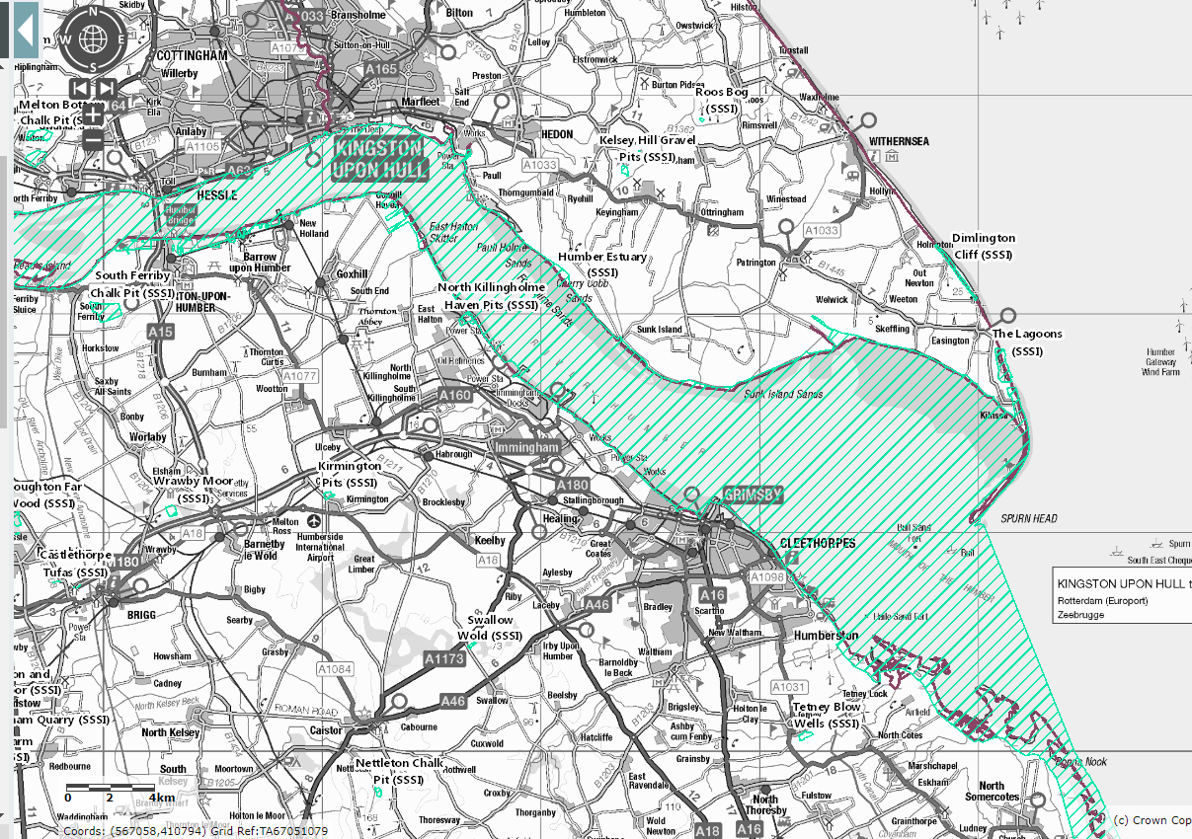

*Fig 1. Map showing the Humber Estuary area that is designated and protected, hatched in blue, taken from* [Magic Map Application (defra.gov.uk)](https://magic.defra.gov.uk/magicmap.aspx)

**Issues that drone operators need to know on the coast**

Relating to the potential disturbance of internationally important bird populations, the two key considerations are:

1. The potential to disturb breeding birds, primarily May to September. Scaring birds from their nests can lead to birds abandoning their eggs or young and increased predation of nests. Tetney Marshes is a significant breeding area.
   * Avoid drone use over Tetney Marsh and surrounding areas during May to September
2. The disturbance of feeding or roosting migratory birds in autumn and winter. Up to 120,000 water birds (waders, ducks and geese) live on the estuary in winter. Forcing birds to take flight from roost sites where they are resting, or disrupting the normal feeding patterns of birds, both affect the bird’s ability to build up excess fat to fuel their next vital long migration flight. It may affect the birds’ ability to obtain sufficient fitness to breed in the following season. In particularly cold or wet winter weather, excessive disturbance can lead to exhaustion and death. These birds are found along the whole estuary coastline, including Cleethorpes and Humberston.

* Do not fly your drone towards flocks of roosting or feeding birds

**Issues that drone operators need to know in general**

1. Disturbance or distress to any wild animal or livestock must be avoided by flying at a safe distance. If distress or disturbance of an animal due to the presence of the drone is witnessed, then move the drone away immediately.
2. Always be aware of where people and wildlife are and act accordingly and responsibly.