**North East Lincolnshire Borough Council**

**PUBLIC SPACES PROTECTION ORDER 2025**

**Dog Control**

This Order is made by North East Lincolnshire Council in exercise of its power under section 59 of the Anti-Social Behaviour, Crime and Policing Act 2014 (the “Act”).

1. The Order applies to the public areas described below or shown on the maps annexed to this Order (the “Restricted Area”).
2. The Council is satisfied that the following conditions have been met:
3. Activities have been carried out in the Restricted Area that have had a detrimental effect on the quality of life of those in the locality, or it is likely that activities will be carried out in the area and they will have such an effect; and
4. The effect, or likely effect of the activities is, or is likely to be, persistent or of a continuing nature, and is, or is likely to be, such that the activities are unreasonable and the effect justifies the restrictions imposed.
5. This Order shall have effect for a period of 3 years, commencing on 14th July 2025 and remaining in force until 13th July 2028.
6. The effect of this Order is to impose the following prohibitions:

4.1. **Borough-wide prohibitions**

The prohibitions in section 4.1 of the Order apply throughout the entire borough of North East Lincolnshire.

1. *Failure to remove dog faeces*

If a dog defecates at any time on land to which this Order applies, the person in charge of the dog at that time must remove the faeces from the land immediately.

1. *Dogs to be put on a lead when directed*

A person in charge of a dog on land to which this Order applies must put and keep the dog on a lead if directed to do so by an Authorised Officer.

An Authorised Officer may only give such a direction where it is reasonably necessary to prevent a nuisance, or behaviour by the dog that is likely to cause annoyance, disturbance, or harm to any other person or animal.

1. *Requirement to carry means to pick up dog faeces*

A person in charge of a dog on land to which this Order applies must have an appropriate means to pick up dog faeces in their possession and must produce it upon request by an Authorised Officer.

4.2. **Restrictions in specified areas**

1. Dogs to be kept on a lead in designated areas

A person in charge of a dog must keep the dog on a lead at all times in the following areas:

1. Grimsby Cemetery (*see Map 1*) and Cleethorpes Cemetery (*see* *Map 2*), including green and woodland burial areas, during opening hours.
2. All sports grounds, fields, parks, play areas and pitches maintained by North East Lincolnshire Council when in use for authorised events, including; fairs, sporting matches and charitable events.

This does not apply to the enclosed dog exercise area at Sussex Recreation Ground *(see Map 3).*

4.3. **Exclusion of dogs from certain areas**

1. *Enclosed children’s play areas*

A person in charge of a dog must not take it into or allow it to remain in any enclosed children’s play area where signage indicates that dogs are excluded (whether by words or symbols to that effect).

1. *Seasonal beach exclusion*

Dogs are not permitted on the beach between Wonderland Rock Groyne and Cleethorpes Leisure Centre *(see Map 4),* from Good Friday to 30 September each year.

1. *Sussex Recreation Ground Bowling Green*

Dogs are excluded at all times from the bowling green at Sussex Recreation Ground *(see Map 3).*

1. *Cemeteries outside of opening hours*

Dogs are excluded from Grimsby Cemetery (*see Map 1*) and Cleethorpes Cemetery (*see* *Map 2*), including green and woodland burial areas, outside of opening hours.

Clear signage will be erected in all specific restricted areas and dog exclusion areas.

1. Any person who, without reasonable excuse, fails to comply with any prohibition, exclusion or restriction set out within the Order commits an offence under section 67 of the Act, and is liable on summary conviction to a fine not exceeding level 3 on the standard scale (currently £1000).

A Police Constable or Authorised Officer may issue a fixed penalty notice to any person whom they reasonably believe has committed an offence under this Order. The recipient of such notice will have 14 days to pay the fixed penalty of £100. Failure to pay the fixed penalty within this period may result in prosecution.

1. Any challenge to this Order must be made at the High Court within 6 weeks of the date it is made by someone who lives in, regularly works in or visits the Restricted Area.

The validity of the Order may be challenged on the grounds that:

1. The Council acted beyond its powers in making the Order, or including certain provisions; or
2. The Council failed to comply with the procedural requirements prescribed by The Anti-social Behaviour, Crime and Policing Act 2014.

When an application is made, the High Court may decide to suspend the operation of the Order, in whole or in part, pending their decision. The High Court has the authority to uphold, quash or vary the Order.

1. This Order shall not apply to a person who has any of the following characteristics:
2. is registered as blind under section 29 National Assistance Act 1948;
3. is deaf and relies on a dog trained by Hearing Dogs for Deaf People (charity no. 293358), upon which they rely for assistance; or
4. has a physical or mental impairment which has a substantial and long-term adverse effect on their mobility, manual dexterity or physical coordination, and who relies on a dog trained by a recognised assistance dog organisation for support, including emotional support.
5. Additional notes and definitions for the purpose of this Order:
6. A person who habitually has a dog in their possession shall be deemed to be “in charge” of the dog, unless another person is in charge of the dog at that time.
7. Placing faeces in a receptacle on the land that is provided for the disposal of waste shall be considered sufficient removal from the land.
8. Being unaware of the defecation (whether due to not being in the vicinity or otherwise), or not having suitable means for removing the faeces, shall not constitute a reasonable excuse for failing to remove it.
9. An “Authorised Officer” means an employee, partnership agency representative or contractor of North East Lincolnshire Council who is authorised in writing by the Council for the purposes of enforcing this Order.

Dated:

The Common Seal of

North East Lincolnshire Borough Council

was hereunto affixed in the presence of:

Authorised Signatory

Map 1 – Cleethorpes Cemetery

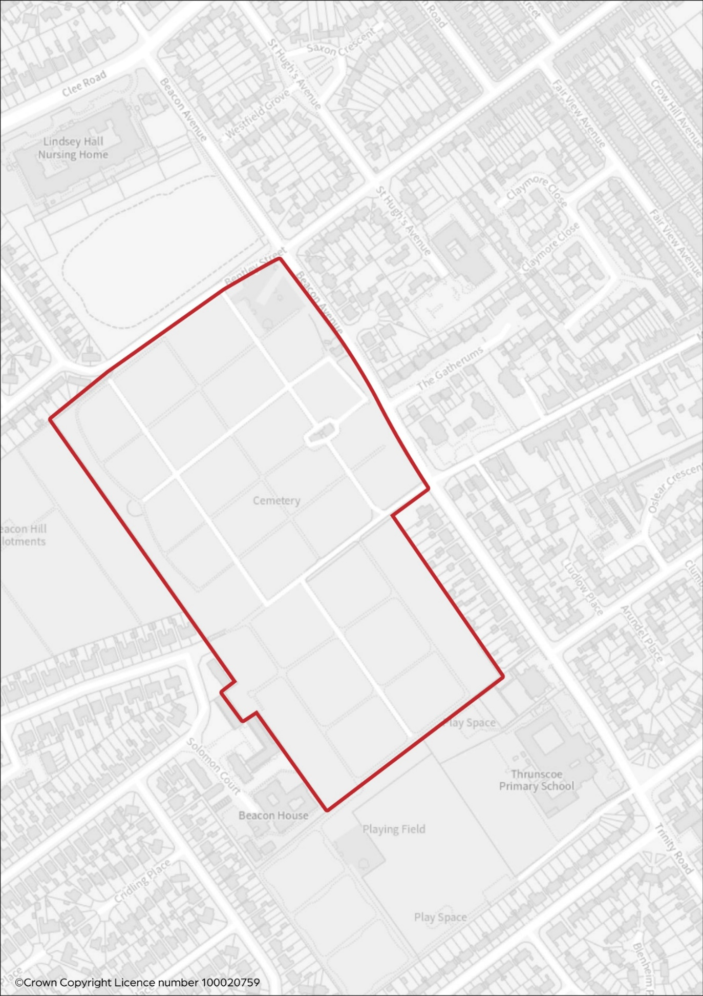

Map 2 – Grimsby Cemetery

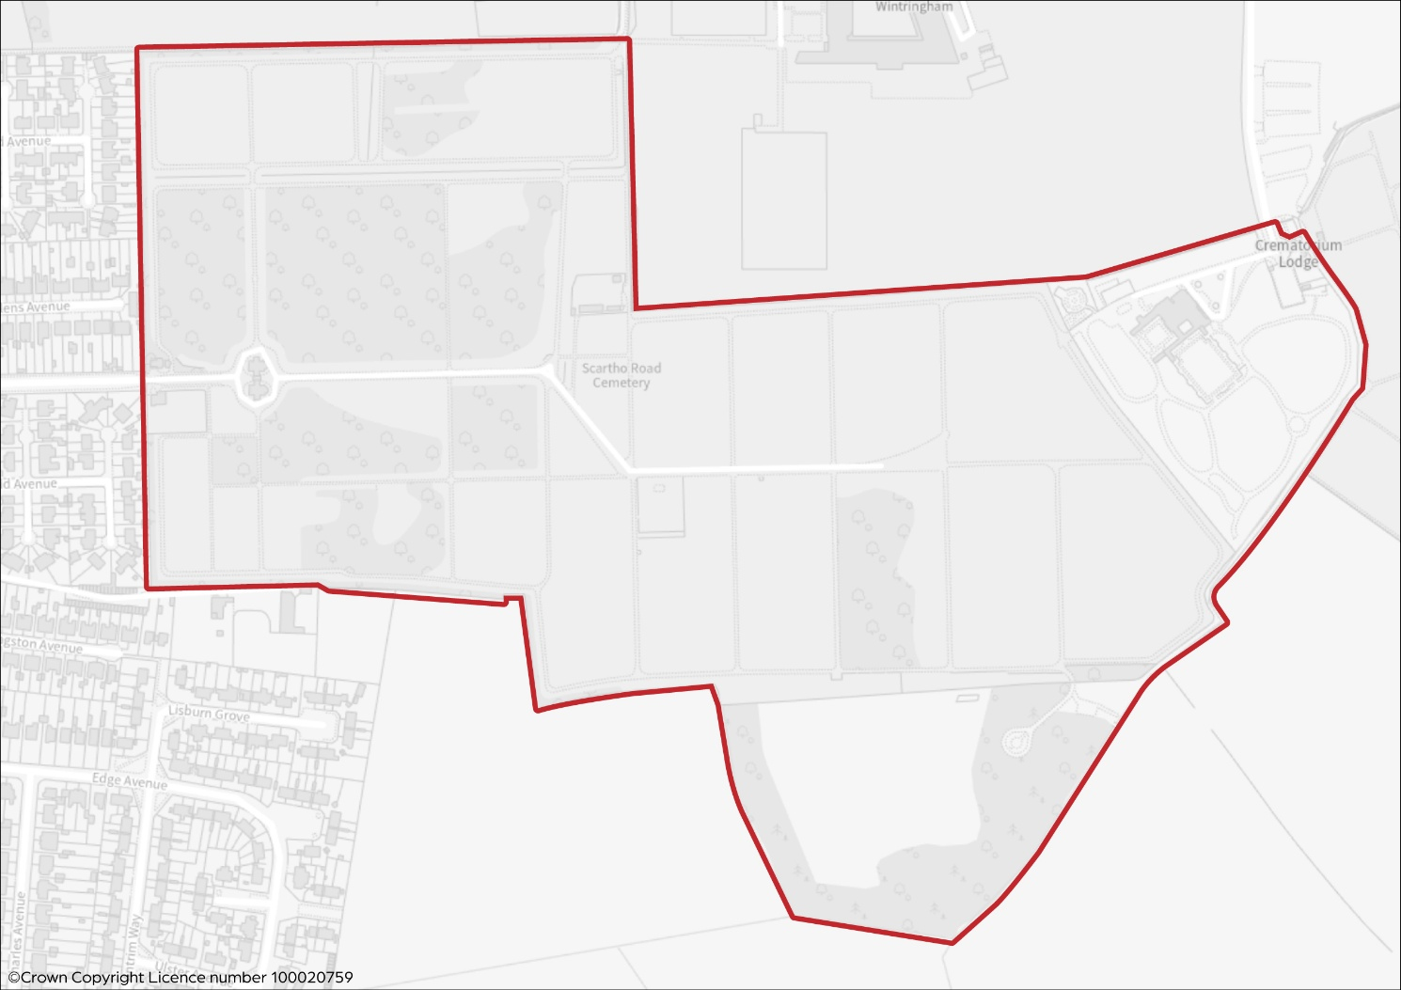

Map 3 – Sussex Recreation Ground

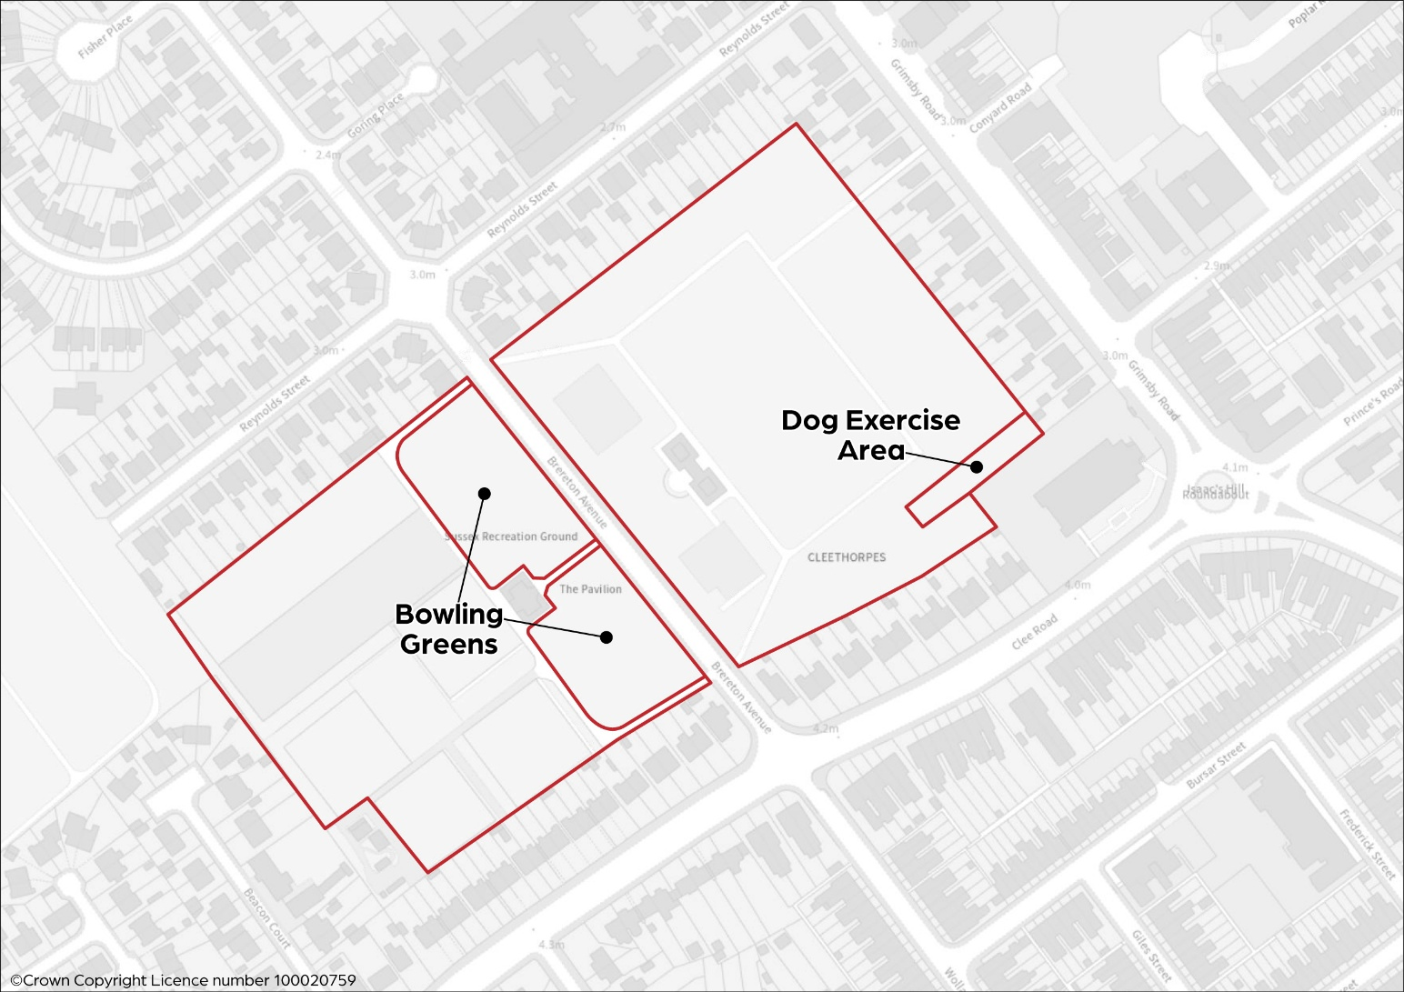

Map 4 – Cleethorpes Beach Dog Exclusion Zone

