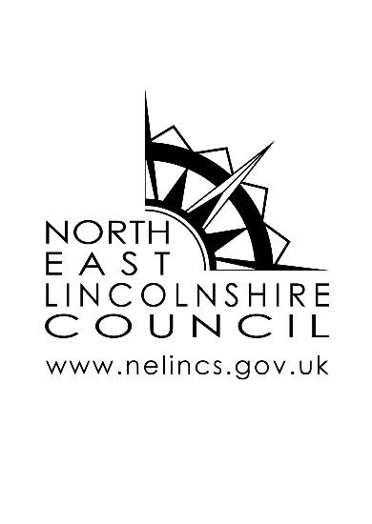

PROPOSED CERTIFICATE OF

LAWFULNESS PLANNING

APPLICATION CHECKLIST

**Application for a Lawful Development Certificate Proposed**

We encourage documents to be submitted electronically through the Planning Portal or via email to [planning@nelincs.gov.uk.](mailto:planning@nelincs.gov.uk) Plans should be submitted on plain paper with all drawing titles, drawing numbers and scales clearly labelled.



Fee

Submitted

For fee information, please call 01472 326289 selecting option 1 for planning. You can pay card via the link below and by selecting planning

[https://www.nelincs.gov.uk/pay-it](https://www.nelincs.gov.uk/pay-it/#1476968063425-68eb9ac9-953b)

Cheques are also accepted and must be made payable to North East Lincolnshire Council. Cash is NOT accepted

In exceptional circumstances, electronic payment details and instructions can be requested by calling 01472 326289 and selecting option 1

Please note all fees for applications submitted through the planning portal need to be paid directly through their website.



Application Form

One copy of the completed certificate of lawfulness proposed application form.



Site Plans

Base Ordnance Survey site plans can be obtained by calling 01472 326289 selecting option 1. You will then need to add the relevant information as detailed below.

Site Location Plan

A site plan to a scale of 1:1250 with the application site edged clearly with a

continuous red line. It must outline all land required for the works to be carried out. Any adjoining owned land must be outlined in blue. A north point must be clearly shown and sufficient road names and/or buildings on land adjoining the site must be shown in order to clearly identify the site.

Block Plan

A site plan to a scale of 1:500 or 1:200 clearly showing the proposed works to scale, a north point, all adjoining land and/or buildings and named roads. It must show an accurate representation of the proposed site including all trees (identifying any covered by a TPO), boundary treatments and outbuildings.

We require finished floor levels and existing and proposed ground levels for new dwellings.

Note: If your application is for or includes a new access, car park or dwelling, you

will require an existing block plan to the same specifications as above showing the site as existing.



Evidence

Supporting Planning Statement

Supporting planning statement must include grounds in which the certificate is sought. Along with a description of all uses of land within the site.



Drawings

All plans should be on a plain white background in black ink. The scale, drawing number and the title of the plan (ie, existing elevations) should be clearly stated on the plan.

Floor Plan

Existing and proposed floor plans must be at a scale of 1:100 or 1:50. All windows and doors must be shown, room uses labelled and all impacted floors must be supplied. Walls must be double lined to show thickness. They must correspond with the elevations.

Exceptions: Existing floor plans are not required for new structures. No floor plans are required for boundary treatments and new access or car park applications although these must be clearly identified on the block plan.

Elevations

Existing and proposed elevations should be at a scale of 1:100 or 1:50. All windows and doors should be shown which should correspond with the floor plan (if required) and should be supplied for all impacted elevations.

Existing elevations are required if alterations or extensions are being made to an existing building/structure or boundary treatment.

Proposed elevations are required when erecting a new building/structure, erecting extensions and new or replacement boundary treatments.

If you have a dropped kerb as part of your application, we require a section through to the above specifications.