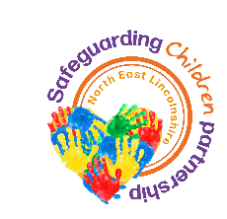

**NEL SCP**

# Bruising/injuries to Children including non-mobile Infants

**Contents**

Introduction

Definitions

Evidence base

Considerations

Bruising/injuries to all children

Actions to be taken

Recording

Suspected non-accidental bruising/injuries to children

Differences of opinion

Appendix 1: Types of injuries

Appendix 2: Body maps

Appendix 3a Process flowcharts

Appendix 4a & 4b: Process flowcharts for Northern Lincolnshire and Goole NHS Trust

Appendix 5: Paediatric initial review/ medical assessment

Appendix 6: Pathway for bruising in non-mobile babies’ children’s services flowchart

## Introduction

This guidance is relevant to practitioners who come into contact with infants and children. It provides advice on what to do following the identification of bruising/injuries to children including non-mobile infants.

A bruise or an injury must never be interpreted in isolation and must always be assessed in the context of medical and social history, developmental stage and explanation given. Any bruising, mark on the skin that might look like bruising or other injury in a child of any age that is observed by or brought to the attention of any practitioner must be considered as a matter of concern and thoroughly explored.

It should be noted that other unusual marks on the skin or unusual sites of bleeding (e.g., bleeding from the mouth in young children) without a clear explanation may also be a sign of non-accidental injury and should also be considered in line with this guidance.

It is recognised that a small percentage of bruising in non-mobile infants or non-independently mobile children will have an innocent explanation (including medical causes). However, practitioners should not make decisions in isolation due to the difficulty in excluding non-accidental injury.

Practitioners are reminded that all children are vulnerable to harm and as such they should remain alert to signs of abuse, unexplained or unusual injuries or injuries where the explanation provided is not congruent with the injury sustained.

This guidance takes into account the briefing from the [Child Safeguarding Practice Review Panel on Bruising in non-mobile infants, September 2022](https://www.gov.uk/government/publications/the-management-of-bruising-in-non-mobile-infants-paper).

## 

## Definitions

In order to ensure a consistent approach to consideration, the definition of a number of frequently used terms is provided:

**Non-mobile infant**

* Non-independently mobile infant or child. -  An infant or child who is unable to move independently through crawling, cruising or bottom shuffling. Particular attention should be given to the risks in those children who are unable to roll over.

**Non-independently mobile child**

* children who require assistance to move
* an older infant or child with a disability should also be carefully considered.

**Bruising**

Bruising is caused by leakage of blood into the surrounding soft tissues, producing a temporary discolouration of skin however faint or small with or without other skin abrasions or marks. Colouring may vary from yellow through green to brown or purple. This includes petechiae.

**Unexplained injury**

An injury, the cause of which, has not yet been determined or ascertained. It is anticipated that this term may be used in **early consideration** of injuries but could continue to be used where there is an unsuitable explanation.

**Unsuitable explanation**

An explanation for an injury or presentation that is implausible, inadequate or inconsistent:

* between parents or carers
* between accounts over time
* with the child’s
  + presentation
  + normal activities
  + existing medical condition
  + age or developmental stage
  + account compared to that given by parent and carers.

**Non-accidental injury**

Damage, e.g. bruise, burn, scald, fracture - deliberately inflicted.

Definitions of other types of injuries can be found in Appendix 1

## 

## Evidence base

The [Child Safeguarding Practice Review Panel briefing paper on bruising in non-mobile infants](https://www.gov.uk/government/publications/the-management-of-bruising-in-non-mobile-infants-paper) says that:

*The most comprehensive summary of the current evidence is contained within the Child Protection Evidence Systematic Review on Bruising (Royal College of Paediatrics and Child Health, 2020) 1 (RCPCH). This is based on an original systematic review completed in 2005 and regularly updated. It incorporates scientific literature on abusive and non-abusive bruising in children. The systematic review concludes that:*

*‘Bruising was the most common injury in children who have been abused. It is also a common injury in non-abused children, the exception to this being pre-mobile infants where accidental bruising is rare (0-1.3%). The number of bruises a child sustains through normal activity increases as they get older, and their level of independent mobility increases.’*

*A review of the studies included in this systematic review suggest that accidental bruising is uncommon in pre-mobile infants, particularly in those who are younger, unable to roll and unable to crawl. However, accidental bruising in pre-mobile infants is not unknown, with the numbers found to have a bruise on a single observation ranging from 0.6-5.3% in those who were not yet rolling or crawling. Accidental bruising is more common in more mobile children, in one study being found in up to 17.3% of those who were crawling but not yet cruising, and 17.8% in those who were crawling and cruising but not yet walking.*

## Considerations

### 

### Bruising/injuries to all children

You should consider:

* **Age of the child**

Non-independently mobile infants/children are at greater risk of non-accidental injury

* **Explanation of injury**

Is explanation / history provided by the parent/carer consistent with the presenting injury?

* **Child’s development**

Is the child’s development consistent with the presenting injury?

* **Severity of injury and any additional bruising/injuries**
* **Any unexplained delay in presentation or explanation for delay unsuitable**
* **Any additional safeguarding history**

The bruising/injury should be assessed in the context of personal, family and environmental history to ensure that it is consistent with an innocent explanation.

* **Child’s demeanour/presentation**

Voice of the child, verbal and non-verbal

Observations of parental interaction, attachment, reciprocal interactions

Practitioners must be professionally curious to determine further information in the interests of the child. A satisfactory explanation should be sought, and the characteristics of the bruising/injury should be assessed, and the distribution carefully recorded.

**Birth marks and blue grey spots.** Bruising to very young infants may be caused by medical issues e.g., birth trauma, however this is rare. Birthmarks may also be present at birth and can appear in the early weeks and months after birth. This should be documented in the child’s medical notes and parent held records.

In addition, some medical conditions can cause marks to the skin in very young infants that may resemble a bruise.

In all cases, unless the specific mark that has been identified has been confirmed as arising from birth trauma, birthmark or a medical condition, this guidance should be followed to enable multi-agency consideration of the suspected bruising/injury.

There may also be occasions where an explanation is given that another child has caused the injury. This should still be further explored taking into account this guidance.

## Congenital Dermal Melanocytosis (Blue grey spots): are flat, bluish to bluish grey, blue black or even deep brown skin markings that commonly appear at birth (or shortly thereafter). They appear commonly at the base of the spine, on the buttocks and back and can also appear on the shoulders and elsewhere. Congenital Dermal Melanocytosis (Blue grey spots) normally disappear 3 to 5 years after birth and almost always have disappeared by puberty.

Among those who are not aware of the background of Congenital Dermal Melanocytosis (Blue grey spots), it may sometimes be mistaken for a bruise, possibly resulting in unfounded concerns about abuse. For this reason it is important to have a diagnosis confirmed by a doctor and the diagnosis documented in the child's record. This is usually diagnosed at birth and therefore should be recorded in the hospital discharge information in PHCHR (red book), however Congenital Dermal Melanocytosis (Blue grey spots can develop at a later date and therefore it is important to seek a diagnosis by the GP within 24 hours of it being discovered. (The practitioner should follow this up ensuring that the child was taken to the GP). If Congenital Dermal Melanocytosis (Blue grey spots) is diagnosed then this should be recorded on the child's record and no further action is needed. If a diagnosis is not confirmed and the mark is still unexplained, then this guidance should be followed to enable multi-agency consideration of the suspected bruising/injury.

## 

## Actions To Be Taken

If the infant/ child appears ill or seriously injured the practitioner should seek or facilitate emergency treatment and notify Children’s Services and/or the police of their concerns.

If any practitioner believes that the infant/ child is at immediate risk of significant harm, they should contact the police as the only service who can immediately safeguard the infant/ child. They should also notify Children’s Services.

If a practitioner has concerns about an infant/ child welfare or that the infant/child has suffered or is likely to suffer significant harm, they should share the information with or make a referral to Children’s Services. If the practitioner works for Children’s Services, you should speak to your line manager immediately, they will either request a stratgey meeting or discuss with the Duty Team Manager in Cass for a step up to social care, who will consider the next steps. Appendix 6

Parents or carers should be included in the decision-making process, unless to do so would jeopardise information gathering (e.g., information or evidence could be destroyed) or if it would place the infant/ child at risk.

Whenever a practitioner identifies an infant/ child with a bruise/injury, they should seek an explanation from the parent/carer, and where possible, from the infant/ child themselves, if safe to do so. All people who live within the family home or participate in any aspect of the infant/ child’s care, should be considered.

Any practitioner who identifies a bruise/injury to an infant or child who is non-mobile, or suspects that an injury to a child is non-accidental as a result of abuse or neglect, needs to make a referral to Children’s Services Integrated Front Door. Reporting a concern can be done by calling North East Lincolnshire Children’s Services Integrated Front Door on **01472 326292 (option 2)** or [reporting a concern online](https://www.nelincs.gov.uk/health-wellbeing-and-social-care/childrens-social-care/report-a-concern-about-a-child/).

Parent/carer consent should be obtained by any practitioner making a referral unless it is identified this would jeopardise information gathering (e.g., information or evidence could be destroyed) or if it would place the child at risk.

Further detail in relation to making a contact/referral, information sharing and consent can be found in the NEL Information Sharing Guidance Information Sharing

### 

### Recording

In all cases, contemporary, comprehensive, accurate, dated, timed records should be kept and signed.

Mapping, description and recording of the size, colour, characteristics of bruising/injuries, including site, pattern and number should be made on a body map.

A careful record of parent/carers description of events and explanation for the bruising/injury should be made in the notes. If ascertained, this should include the description of events and explanation of all people who participate in any aspect of the child’s care. Template body maps can be found in Appendix 2.

### 

### Bruising/injuries to non-mobile infants and children

Where a practitioner identifies a bruise/injury to an infant or child who is **non-mobile**, in all cases they must make a contact/referral to Children’s Services.

The Child Safeguarding Practice Review Panel recommends that *in* ***all*** *cases of bruising in* ***children who are not independently mobile*** *there is:*

* *a review by a health professional who has the appropriate expertise to assess the nature and presentation of the bruise, any associated injuries, and to appraise the circumstances of the presentation including the developmental stage of the child, whether there is any evidence of a medical condition that could have caused or contributed to the bruising, or a plausible explanation for the bruising.*
* *A multi-agency discussion to consider any other information on the child and family and any known risks, and to jointly decide whether any further assessment, investigation or action is needed to support the family or protect the child. This multi-agency discussion should always include the health professional who reviewed the child.*

In all cases, Children’s Services will arrange a paediatric review, unless this has already taken place and a strategy discussion or multi-agency discussion will take place. See Appendix 5 for further information on paediatric initial reviews/medical assessments.

If a strategy discussion is held, it may or may not lead to a section 47 enquiry. Dependant on the circumstances of the case, it may be that a multi-agency discussion is held instead of a strategy discussion. The Paediatrician who will be completing the initial review/has completed the initial review will be included in the strategy discussion or multi-agency discussion.

See Appendix 3 for process flowcharts.

See Appendix 4a for infants and children presenting at Northern Lincolnshire and Goole NHS Trust – For Hospital Use Only

See Appendix 4b Suspected non accidental injury in children. – For Hospital Use Only

See Appendix 5 Guidance for the Paediatric assessment.

### Suspected non-accidental bruising/injuries in infants / children.

The practitioner who identifies a bruise/injury should discuss the bruise/injury and explanation provided, if this has been sought, with a supervisor, named or designated safeguarding lead. The practitioner should consider seeking advice from a qualified health professional if further support is required.

Practitioners should not make a decision in isolation, regarding the explanation offered by parents/carers or others, regarding the bruising/injuries sustained to the infant/ child. In the absence of not having another person to discuss the injury, the practitioner should not delay a discussion with, and any subsequent referral being made to Children’s Services, if based on their own professional judgement that this needs to be made immediately.

See Appendix 4b for infants and children presenting at Northern Lincolnshire and Goole NHS Trust

## Differences of opinion

Where there are professional differences of opinion about actions taken, or decisions made, in respect of arrangements for helping or protecting children the [NEL SCP Procedure for Resolution](http://www.northlincscmars.co.uk/policies-procedures-and-guidance/) and Escalation should be followed.

## Appendix 1: Types of injuries

|  |  |
| --- | --- |
| **Type of injury** | **Definition** |
| **Abrasion** | An area damaged by scraping or wearing away.  Synonyms includegraze, scrape, scratch, cut, gash, laceration, injury, contusion |
| **Bruise** | Bruising is caused by leakage of blood into the surrounding soft tissues, producing a temporary discolouration of skin however faint or small with or without other skin abrasions or marks. Colouring may vary from yellow through green to brown or purple. This includes petechiae.  Synonyms include contusion, lesion, mark, injury, skin discoloration |
| **Burn** | Damage to the skin or other body parts caused by extreme heat, flame, contact with heated objects, or chemicals. Burn depth is generally categorised as first, second, or third degree |
| **Petechiae** | Red or purple spots, less than two millimetres in diameter and often presenting in clusters |
| **Contusion** | A region of injured tissue or skin in which blood capillaries have been ruptured; a bruise.  Synonyms includebruise, lesion, mark, injury, skin discoloration |
| **Cut** | A long, narrow incision in the skin made by something sharp.  Synonyms includegash, slash, laceration, incision, wound, injury |
| **Fracture** | A medical condition in which there is a break in the continuity of the bone. This may be as a result of high impact force or stress or a minimal trauma injury as a result of certain medical conditions that weaken the bones |
| **Gash** | A long, deep cut or wound.  Synonyms includelaceration, cut, puncture, incision |
| **Graze** | A slight injury where the skin is scraped.  Synonyms include scratch, scrape, abrasion, cut, injury, sore |
| **Laceration** | A deep cut or tear in skin or flesh  Synonyms include gash, cut, wound, injury, tear, slash, mutilation, scratch, scrape, abrasion, graze, incision |
| **Lesion** | A region in an organ or tissue which has suffered damage through injury or disease, such as a wound, ulcer, abscess, or tumour.  Synonyms include wound, injury, bruise, abrasion, contusion, scratch, scrape, cut, gash, laceration |
| **Scald** | Tissue damage caused by applied wet heat such as hot water or steam |
| **Scratch** | A mark or wound made by scratching.  Synonyms include graze, scrape, abrasion, cut, laceration, wound |
| **Sore** | A raw or painful place on the body  Synonyms include inflammation, swelling, lesion |
| **Subconjunctival haemorrhage** | Bleeding within the whites of the eyes and should be considered as similar to bruising to the eye itself for the purposes of this protocol. |
| **Wound** | An injury to living tissue caused by a cut, blow, or other impact, typically one in which the skin is cut or broken.  Synonyms include injury, lesion, cut, gash, laceration, tear, rent, puncture, slash |

## 

## Appendix 2: Body mapsChild genitals body mapHands body map Baby left body map

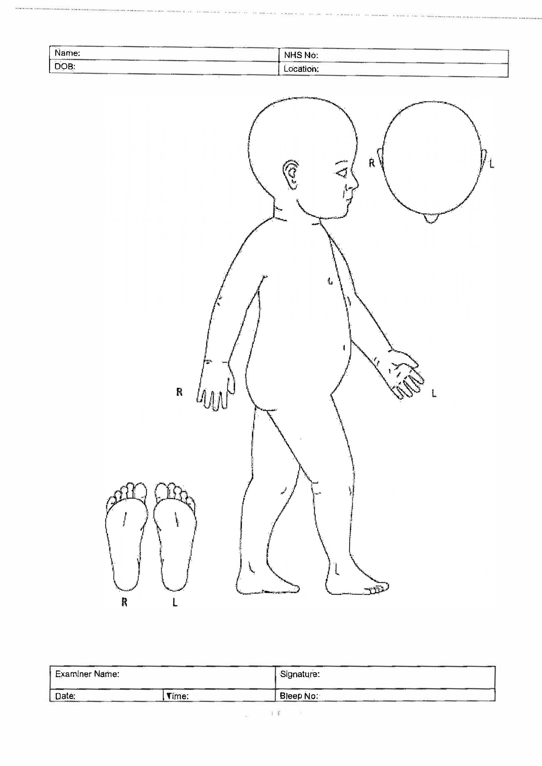 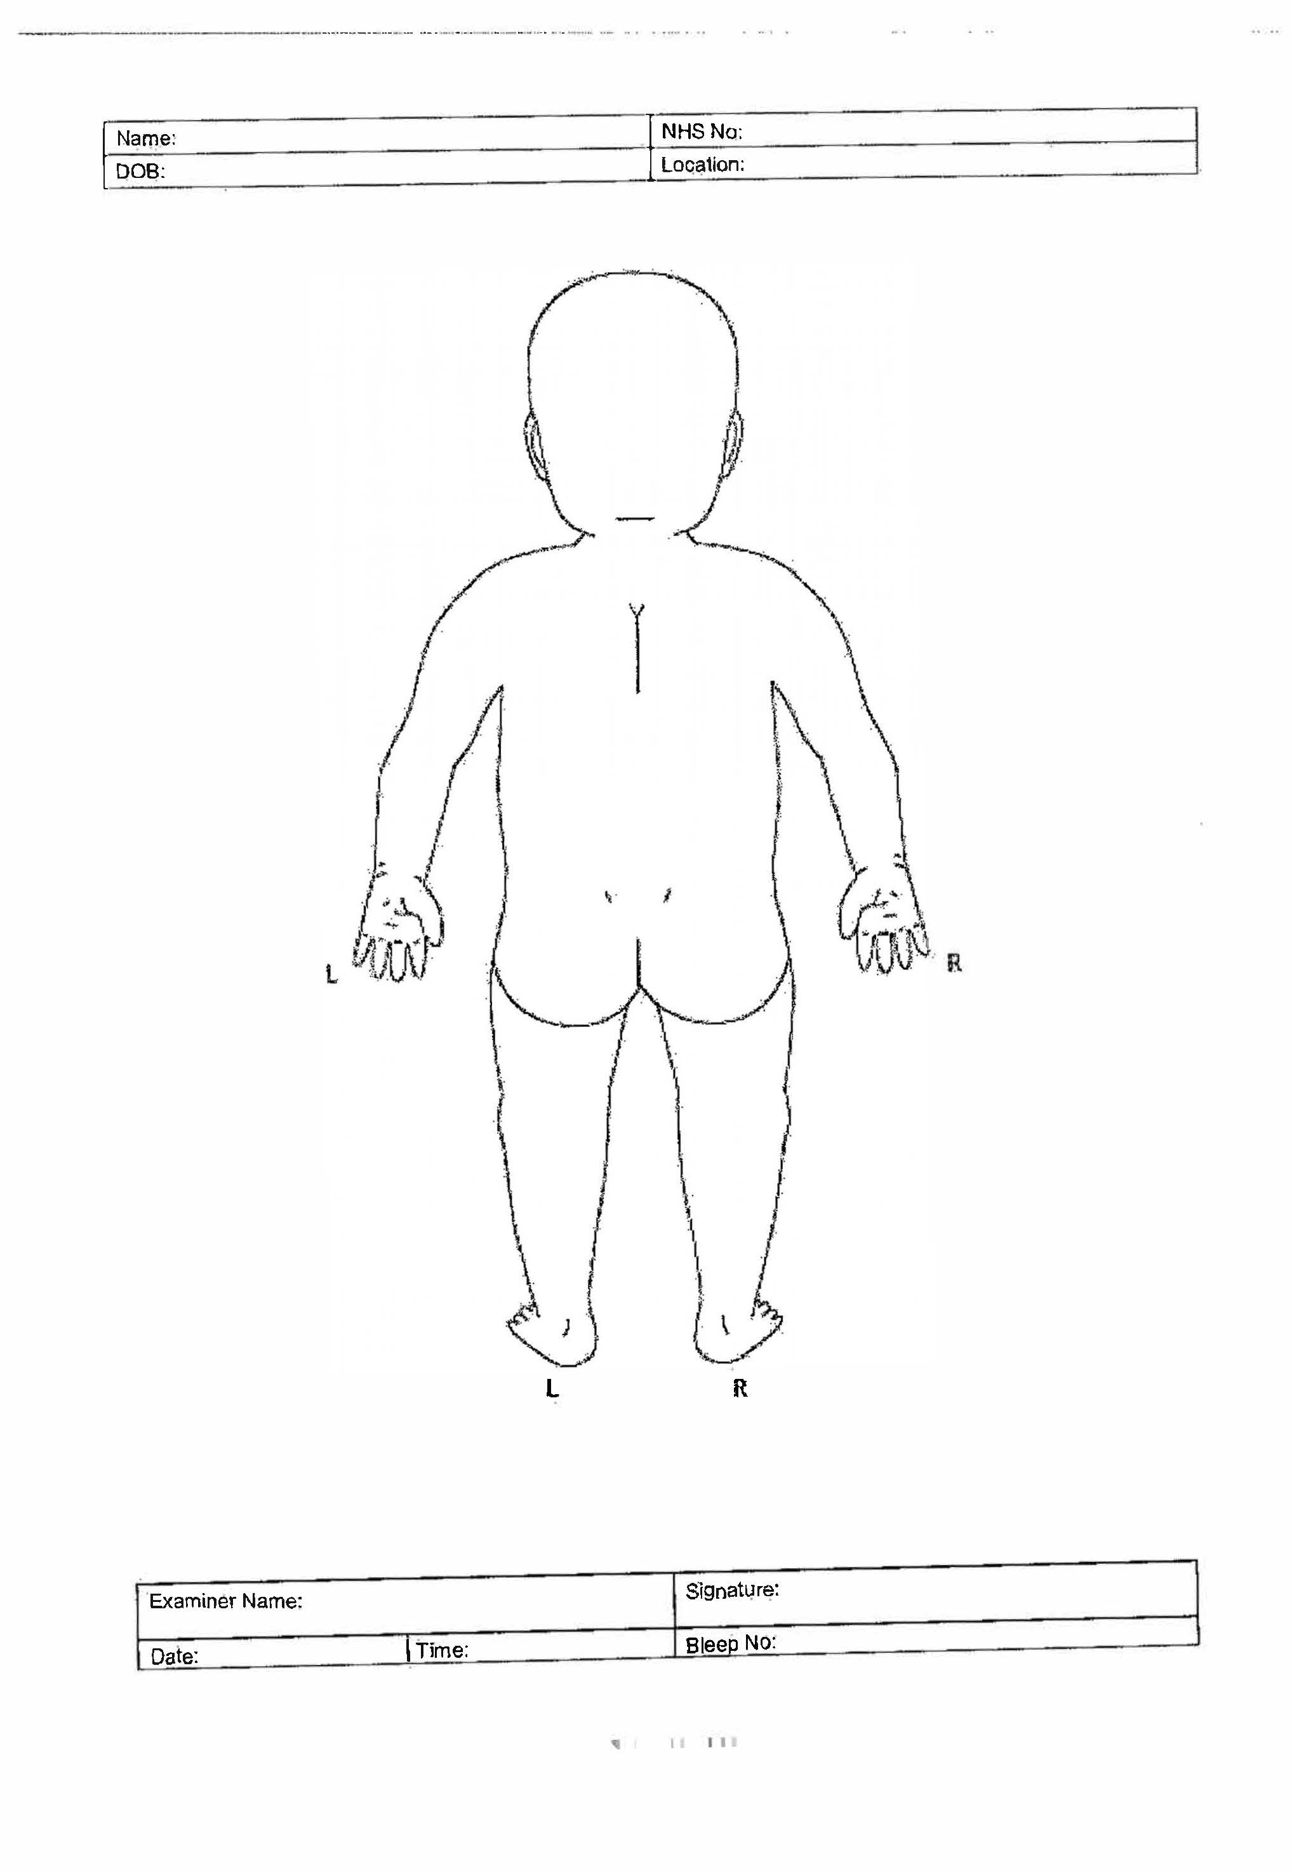 Baby front body map
Body map of a person's face


**Appendix 3:**

**Flowchart 2: Brusing/Injuries in infants who are not independently mobile**

Multi-agency strategy discussion / multi-agency meeting the case may or may not progress to a Section 47 investigation dependant on the information shared

Children’s Social Care to contact on call consultant paediatrician to Arrange Paediatric initial review with paediatrician – Children’s Social Care to share any historical information

Refer to Children’s Social Care – 01472 326292

Record all injuries / explanations (this should not delay referral to Children’s Social Care being made)

When safe to do so, seek explanation from parent / carer and advise of the local process and requirement to refer to Children’s Social Care

\***Non-Independent mobile infant (infant = 0 – 1 year)**

An infant who is unable to move independently through crawling, cruising or bottom shuffling.

Particular attention should be given to the risk in those children who are unable to roll over.

If infant presents as seriously ill / injuries, facilitate emergency medical treatment and notify Children’s Social Care and the Police

Bruising or injury is identified in a non-independently mobile infant*

## Appendix 4A: FOR HOSPITAL USE ONLY

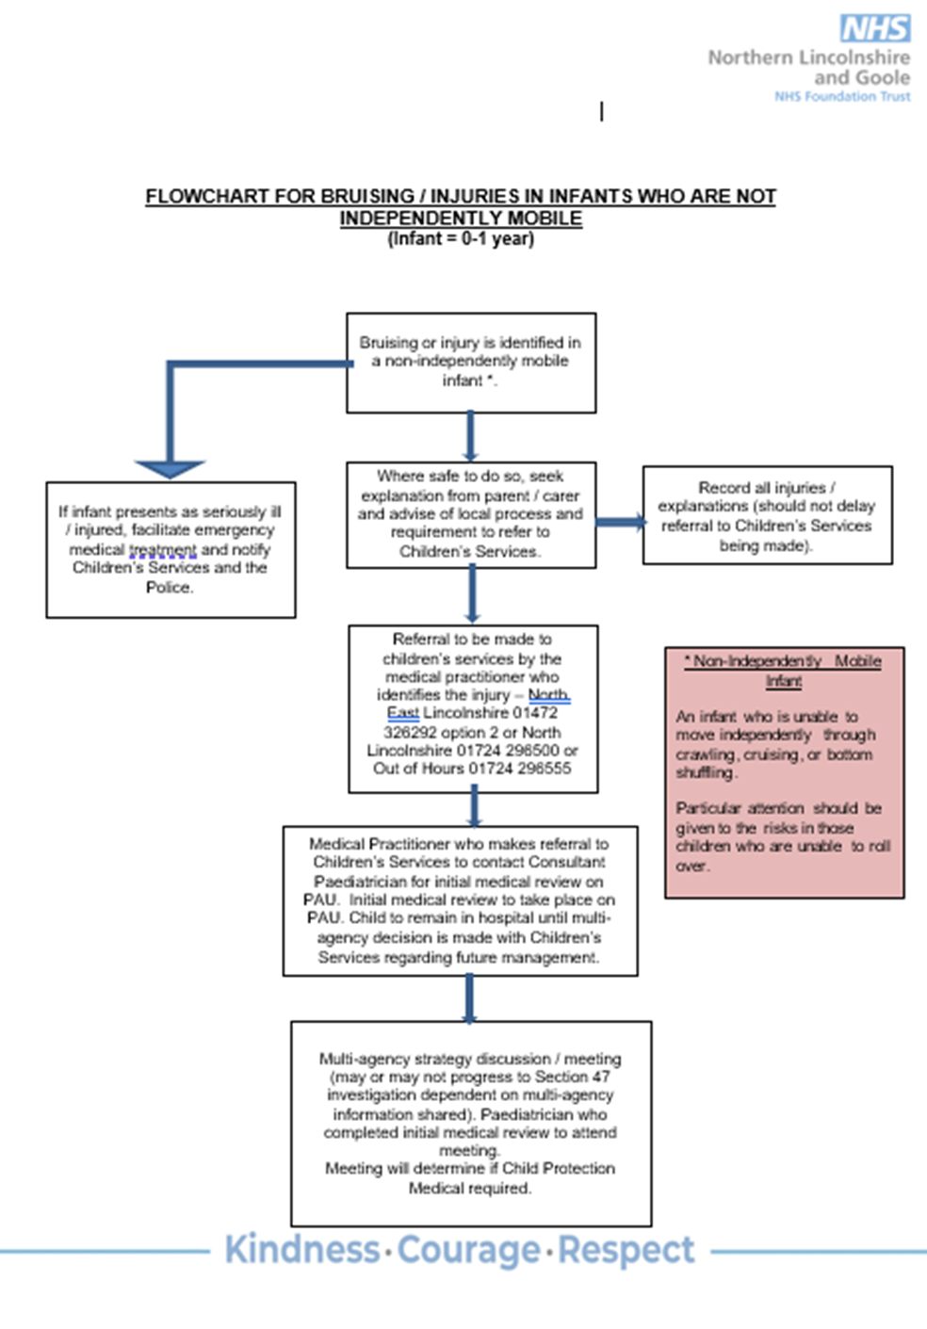

## Appendix 4B: FOR HOSPITAL USE ONLY

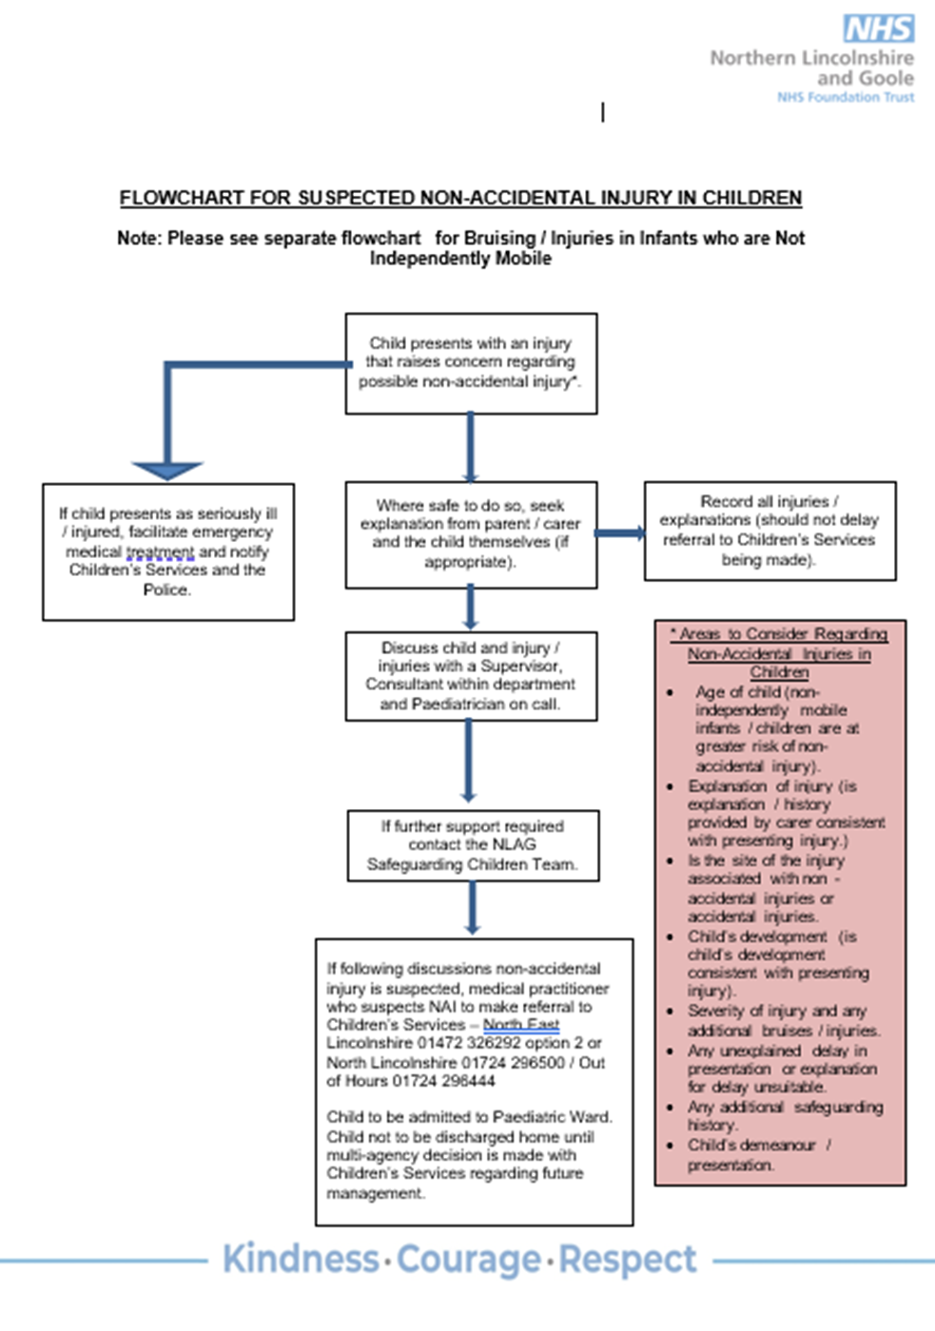

## Appendix 5 Paediatric initial review/ medical assessment

### Arrangements

In line with this guidance, a paediatric initial review/medical assessment will be completed by a Paediatrician as indicated.

Parents/carers **must not** be asked to take the infant/child to the hospital emergency department or to their GP as a substitute for assessment by a hospital Paediatrician.

The on call Paediatric Consultant will participate in all strategy discussions and/or multi-agency meetings where possible that are initiated in line with this guidance. The strategy discussion or multi-agency meeting will determine, in consultation with the Paediatrician, the need and timing for a medical assessment. The medical assessment physical examination will be completed as soon as possible or within 24 hours of the request from Children’s Services. Timing of the medical assessment will be on a case-by-case basis and based on clinical need. Children’s Services will liaise with the Paediatrician who has undertaken the medical assessment to arrange a date and time for subsequent strategy discussions and/or multi-agency meetings. Wherever possible, the examination should be attended by a member of Children’s Services staff who are familiar with the infant/ child. However, in cases where this is not possible e.g., with a family who are not previously known to Children’s Services, the worker(s) attending with the infant/ child should be fully familiar with the referral that has been made and the nature of the suspected bruise/injury. The Paediatrician requires a full picture of the concerns in order to complete their examination and may decline to undertake the medical examination, if no clear history is available. The worker attending should remain with the infant/ child or family until the medical has been completed and a joint plan made for the safety of the infant/ child which may be that the infant/ child remains in hospital.

It is imperative that the parent/carer who is providing consent is present at the medical examination. If this person is unavailable, the attending social worker or member of Children’s Services staff should have obtained written consent from the parent/carer before the medical examination. The Paediatrician should be satisfied that the infant/ child (if appropriate) and parent/carer has understood the purpose of the examination, what it will involve and how the results might be used. The infant/ child will not be examined, and the appointment cancelled if appropriate consent is unavailable.

In some cases, e.g., where the bruise/injury was identified within a hospital setting, the infant/ child may have already been seen by a Paediatrician prior to the referral. Where this is the case Children’s Services should decide whether a strategy discussion will be held and should include the Paediatrician, police and relevant others in order for the medical findings to be considered.

### The purpose of the medical assessment is to assess the health and wellbeing of the infant/ child, to establish whether there is any medical evidence of abuse or neglect and to initiate treatment as required.

### The expected outcomes of a medical assessment include:

* if developmental delay is noted during the medical assessment, a referral will be made by the consultant Paediatrician for a full development assessment.
* advice regarding treatment, investigation, or intervention
* reassurance to the infant/ child and parent/carer about any medical findings and any future implications
* a record of any physical findings, including written notes, drawings, photographs, video recordings or samples
* to establish whether the account given for any observed bruise/injury is consistent with the bruise/injury sustained.
* reports and statements as required by the investigation team.
* information sharing with the child’s GP and other relevant health professionals.
* providing continuing medical care or making referrals to relevant health service colleagues

The Paediatrician should arrange for additional medical investigations if the circumstances warrant this.

### Documentation and communication

The examining Paediatrician will provide the attending social worker or member of Children’s Services staff with an immediate handwritten copy of pages 13, 22 and 23 of the safeguarding children medical proforma. which provides a list and description of injuries, medical summary, and an initial view on causality / whether the bruising/injury may be non-accidental or unexplained.

The examining Paediatrician should provide a fully typed initial report within 10 working days from the examination or sooner if possible, depending on the specifics of the case. Following the initial report, if further tests are required, an addendum to this report will be provided as soon as possible. This is to provide the results of the medical investigations (for example skeletal survey and extended blood clotting screening) that will not be available at 10 days.

Where a report cannot be provided within timescales, the reason for this must be made clear to the referring agency.

The examining Paediatrician will be responsible for the distribution of the report to other appropriate agencies e.g., GP, Children’s Services, named professional for safeguarding at the hospital and the police.

Where there is a need for ongoing medical investigations, it is the responsibility of the Paediatric Consultant in charge of the case to ensure that multi-agency partners are kept informed of the results.

### Content of the report

The report should include:

* a verbatim record of the parent/carer's and infant/ child's accounts of the bruising/injuries and the concerns noting any discrepancies or changes of story.
* the documentary findings
* the site, size and shape of any marks or bruising/injuries, including those which may be considered accidental.
* the opinion of whether, and which, bruising/injuries are consistent with explanation(s), or perceived to be of concern.
* the date, time, and place of examination
* those present
* who gave consent and how (child / parent / carer, written / verbal)
* other findings relevant to the child (e.g. squint, learning or speech problems etc)
* confirmation of the infants/ child's developmental progress (especially important in cases of neglect)
* the time the examination ended.

All reports and body maps should be signed and dated by the Paediatrician undertaking the examination.

## Consent

Information about the medical assessment will be given to the parent/carers and child by the Paediatrician completing the medical assessment when the child and family attend the appointment.

The member of Children’s Services staff attending the appointment must obtain written consent for the medical assessment if the child is not being accompanied by a person who has parental responsibility. It is the responsibility of the examining Paediatrician to ensure that this written informed consent is obtained before proceeding with the examination. If consent to medical assessment is not available or cannot be obtained, then the examining Paediatrician may consider it appropriate to continue the assessment in order to facilitate the safeguarding of the infant/ child.

The following person(s) may give consent:

* A child of 16 years and over (unless lacking mental capacity)
* A child under 16 who is able to fully understand what is proposed and its implications (often referred to as Gillick/Fraser competence). The more serious the circumstances, the greater the need for the child to have a full understanding of the implications, otherwise the consent may be held to be invalid. However, the Paediatrician must always make a judgement and act in the best interests of the child. This may include going ahead with the medical assessment. If in doubt the examining Paediatrician should discuss with the consultant on call (if this is a different person to the one completing the medical)
* Any person with parental responsibility. When a child is subject to a Care Order, Interim Care Order or Emergency Protection Order parental responsibility is held by the local authority.
* A person with a residence or Special Guardianship Order from the court has parental responsibility.
* Adoptive parents have parental responsibility, and the birth parents cease to have such from the moment the adoption order is made.
* When a child is accommodated by agreement (section 20 Children Act 1989), the parents (and others with parental responsibility) retain parental responsibility and the local authority does not have parental responsibility.
* The court, when a child is subject to a Child Assessment Order. Note that consent for examination or assessment requires the court to make specific direction.

Police powers of protection do not give parental responsibility to the local authority (or the police), therefore if a person with parental responsibility or the child if judged as Gillick/Fraser competent, does not give medical consent then the medical assessment cannot proceed unless considered in the best interests of the child.

## Siblings

Consideration should be given as to whether siblings of the subject child also need a medical examination even though there are no obvious signs of injury/abuse in that infant/ child. The strategy discussion or multi-agency meeting must consider whether these examinations also need to occur within 24 hours. Should the decision be made to postpone or not to proceed with sibling medical assessments the decision and risk assessment should be clearly documented.

**Appendix 6: Pathway for bruising in non-mobile babies Childrens Services CHILDREN’S SERVICES USE ONLY**

Bruising or injury is identified in a non-independently mobile infant.

If the infant/ child appears ill or seriously injured the practitioner should seek or facilitate emergency treatment through calling emergency services 999 and notify your line manager.

**For babies open to a Social Worker**

Where safe to do so, seek explanation from parent/carer.

Immediately speak to your team manager (or equivalent) clearly explaining what has been observed/explained.

**Social Care Team Manager**

If following discussions non-accidental injury is suspected, complete a strategy meeting, ensure the Paediatrician completing the initial paediatric review is invited to the strategy meeting.

**For Children’s Services that are not Social Care (Early Help/GRAFT etc)**

Where safe to do so, seek explanation from parent/carer.

Immediately speak to your line manager (or equivalent) – If the baby has a social worker, contact the social work team manager clearly explaining what has been observed/explained.

If the child does not have a social worker, speak to the CASS Duty Team Manager explaining what has been observed.