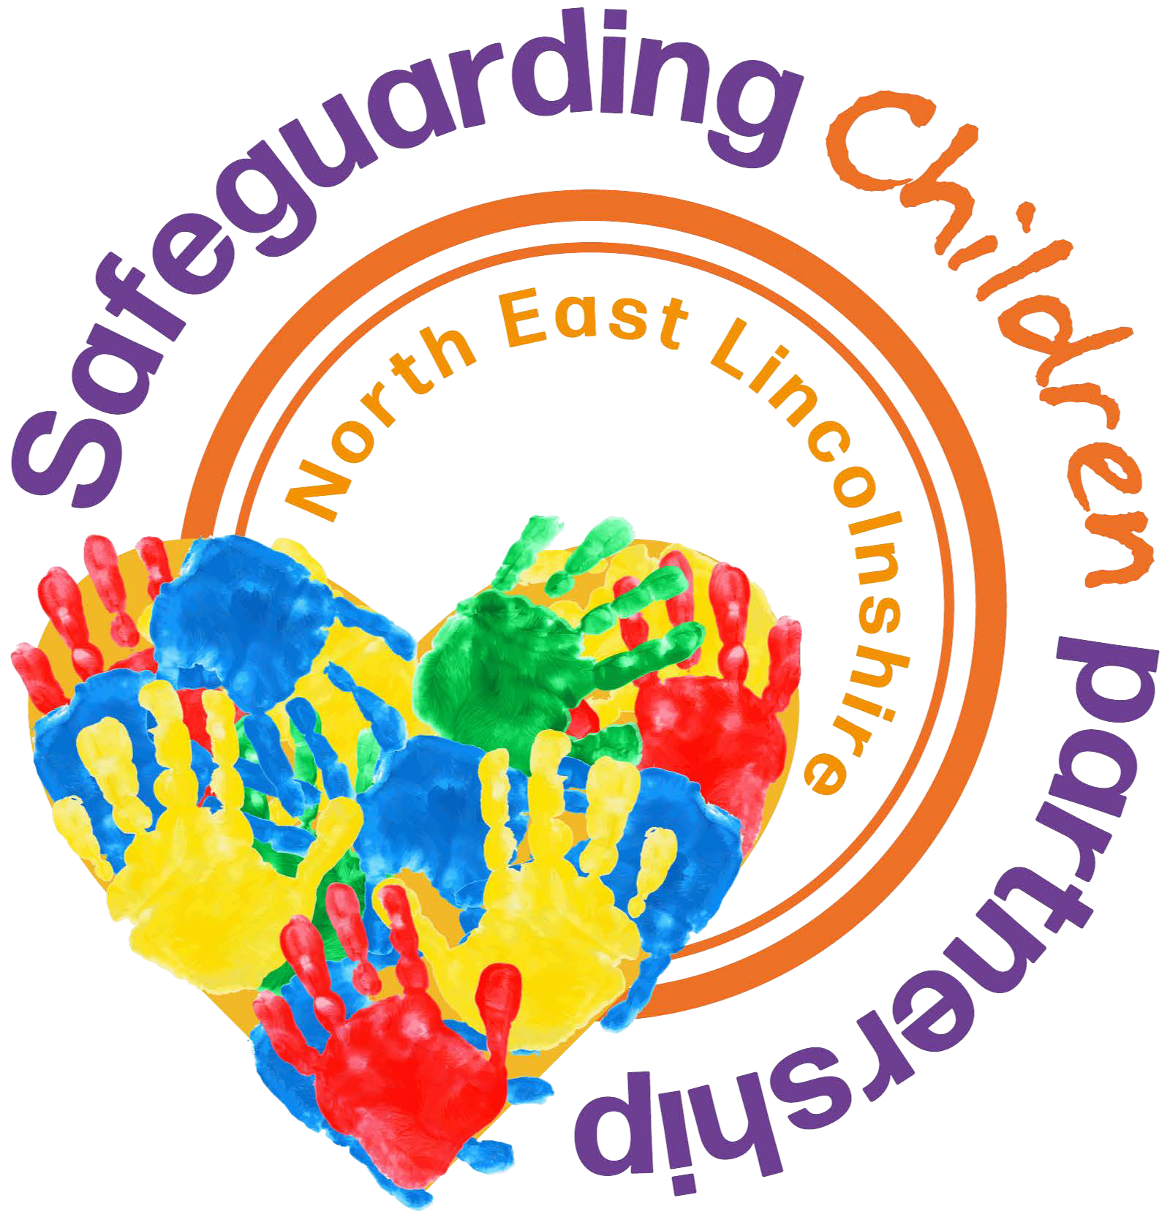

Local Protocol for Assessment and Support

# Introduction

This protocol responds to the requirements for local authorities, with their safeguarding partners and any relevant agencies, to develop, agree, and publish local protocols for assessments and support. This protocol reflects the local practice approach contained within our [Helping, Supporting and Protecting Children and Families in North East Lincolnshire Threshold](https://www.nelincs.gov.uk/assets/uploads/2025/07/NEL-Threshold-Document-2024-28-FINAL-refresh-May-2025.pdf)

[Document 2024/28,](https://www.nelincs.gov.uk/assets/uploads/2025/07/NEL-Threshold-Document-2024-28-FINAL-refresh-May-2025.pdf)

This Local Protocol for Assessment and Support sets out clear arrangements for how cases will be managed once a child is referred into North East Lincolnshire (NEL) Children’s Services. The protocol is an overarching document and is aligned to NEL Safeguarding Children Partnership (SCP) safeguarding policies, procedures and guidance including the [NEL Early Help Strategy](https://www.nelincs.gov.uk/assets/uploads/2025/05/Early-Intervention-strategy.pdf) and early help pathway.

This protocol also reflects the specific needs of certain groups, such as disabled children and their carers, young carers, children at risk of, or experiencing harm outside the home and others.

# Purpose of assessment

The purpose of Children’s Services assessments is to:

* + Gather important information about a child and family
  + Analyse their needs and/or the nature and level of any risk and harm being suffered by the child, including where harm or risk of harm is from outside the home
  + Decide whether the child is a child in need (section 17) or is suffering or likely to suffer significant harm (section 47)
  + Provide support to address those needs to improve the child’s outcomes and welfare and where necessary to make them safe
  + Identify support from within the family network

Action to meet a child's needs can begin even before assessment has concluded. Assessments should be:

# Assessment framework

The [NEL Practice Approach](https://www.nelincs.gov.uk/assets/uploads/2025/05/NEL-Practice-Approach-2025.pdf) sits alongside the Assessment Framework which enables a systematic approach to undertaking enquires and in achieving a comprehensive assessment for children. It investigates three domains

* + The child’s developmental needs
  + The capacity of parents or carers (resident and non-resident) and any other adults living in the household to respond to those needs
  + The impact and influence of the family network and any other adults living in the household as well as community and environmental circumstances

The Helping, Supporting and Protecting Children and Families in NEL threshold document clearly sets out the process for early help assessments, and the type and level of early help and targeted early help services to be provided under section 10 and 11 of the Children Act 2004.

(Requests for targeted Family Help will need to be directed to [Familyhelprequests@nelincs.gov.uk)](mailto:Familyhelprequests@nelincs.gov.uk)

It also sets out the criteria, including the level of need, for when a case should be referred to Children’s Services for assessment and for statutory services under the Children Act 1989.

The threshold document provides guidance and descriptors on the three levels of need,

Universal, Targeted and Specialist to support practitioners and supervisors in their decision making about the level of need.

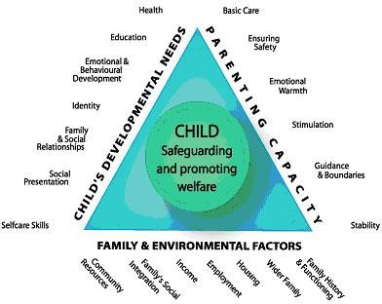

# Referral

The local referral process to Children’s Services is published on the [SCP website](https://www.nelincs.gov.uk/scp/). Anyone who has concerns about a child’s welfare should consider whether a referral needs to be made to Children’s Services and should do so immediately if there is a concern that the child is suffering significant harm or is likely to do so.

Where a child is admitted to a mental health facility, practitioners should make a referral to Children’s Services. The local threshold document should be referred to by practitioners in supporting their assessment of concern’s.

When practitioners refer a child, they should include any information they have on

* + The child’s developmental needs,
  + The capacity of the child’s parents, carers, or family network to meet those needs
  + And any external factors that may be undermining their capacity to parent

This information may be included in any assessment, including an early help assessment, which may have been carried out prior to a referral into Children’s Services. An early help assessment is not a prerequisite for a referral but where one has been undertaken, it should be used to support the referral.

Feedback will be given by Children’s Services to the referrer on the decisions taken. Where appropriate, this feedback will include the reasons why a case may not meet the statutory threshold and offer suggestions for other sources of more suitable support. Practitioners should always follow up their concerns if they are not satisfied with Children’s Services response and should escalate their concerns in line with local procedures if they remain

dissatisfied following the Professional Resolution and Escalation procedure

# Timeliness

The speed with which an assessment is carried out after a child’s case has been referred into Children’s Services should be determined by the needs of the individual child and the nature and level of any risk of harm they face. This will require judgments to be made by a social work qualified practice supervisor or manager on each individual case. Adult

assessments, for example, parent carer or non-parent carer assessments, should also be carried out in a timely manner.

Within one working day of a referral being received, Children’s Services will acknowledge

receipt to the referrer and a social work qualified practice supervisor or manager will decide next steps and the type of response required. This will include determining whether:

* + the child requires immediate protection and urgent action is required
  + the child is in need and should be assessed under section 17 of the Children Act 1989
  + there is reasonable cause to suspect that the child is suffering or likely to suffer significant harm, and whether enquiries must be made, and the child assessed under section 47 of the Children Act 1989
  + any immediate services are required urgently by the child and family and what type of services
  + further specialist assessments are required to help the local authority to decide what further action to take
  + to see the child as soon as possible if the decision is taken that the referral requires further assessment

For children in need of immediate protection, action will be taken by the local authority and/or the police if removal is required. This will happen as soon as possible after the referral has been made to Children’s Services.

The maximum timeframe for the assessment to conclude, such that it is possible to reach a decision on next steps, should be no longer than 45 working days from the point of referral. If, in discussion with a child and their family and other practitioners, an assessment exceeds 45 working days, the social worker should record the reasons for exceeding the time limit. In some cases, the needs of the child will mean that a quick assessment will be required. In all cases, as practitioners identify needs during the assessment, they do not need to wait until the assessment concludes before providing support or commissioning services to support the child and their family.

# Identification and analysis of risk

In NEL, the [Risk Analysis Framework (RAF)](https://www.nelincs.gov.uk/assets/uploads/2025/05/Risk-analysis-framework-updated-Sept.-2024-1-3.pdf) provides a consistent model for the assessment, analysis and management of risk. Any assessment and intervention by NEL Children’s Services due to concern about a child’s welfare, or that the child is suffering significant harm, or is likely to do so is underpinned by the NEL RAF.

It is acknowledged that it is impossible to remove all risk from a child’s life. The assessment, analysis and management of risk takes place within the three domains of the national Assessment Framework:

* + **The child’s developmental needs -** and the risks that they are experiencing
  + **Parenting capacity** - and ability and willingness to meet the child’s needs
  + **Family and environmental factors** - including extra-familial contexts and the family network

Assessing, analysing and managing risk within the RAF is therefore essential in balancing the needs/risks relating to a child considering the above. The RAF should be used for children across the following:

* + being assessed for, during or when reviewing an early help plan
  + completing a referral by the Children’s Services Integrated Front Door
  + being assessed by Children’s Services
  + children in Need including disabled children
  + child Protection
  + children in Care
  + care Leavers
  + children/young people involved with youth justice It focuses on two key aspects:
  + what factors are there in the child’s life that present a risk to their wellbeing (risk factors); and
  + what factors guard against risk (protective factors)

Having determined what risk and protective factors exist, the process is then to determine the balance of those factors, particularly whether there are sufficient protective factors in place to balance out the risk factors.

The next stage is to judge what meaning the level of risk has for the child and the impact on them. This will be on a continuum from no significant risk to severe risk.

The last stage is that the worker must determine what needs to change in order to reduce risk and devise a plan to deliver that change.

The RAF is repeated at key decision points or milestones such as reviews of the child’s plan, and at times when significant change occurs in the child’s circumstances, e.g.. a change in family circumstances, episodes of the child going missing, new and emerging evidence etc.

# Information Sharing

Practitioners should be proactive in sharing information as early as possible to help identify, assess, and respond to risks or concerns about the safety and welfare of children. This may be when problems are first emerging (for example, persistent school absences) or where a child is already known to Children’s Services. Sharing information about any adults with whom that child has contact, which may impact the child’s safety or welfare, is also critical. See NEL information sharing guidance.

# Provision of support and services for a child in need

Once the referral has been accepted by NEL Children’s Services, a social work qualified practice supervisor or manager will identify a social worker as the lead practitioner and allocate them in line with the local protocol.

In North East Lincolnshire, lead practitioners for assessing and supporting children and families under the auspices of Section 17 are qualified social workers, who have the skills, knowledge, competence, and experience to work effectively with the child and their family. The lead

practitioner for undertaking child protection enquires will also be a social worker.

Social workers have access to high quality supervision. Effective supervision can play a critical role in ensuring a clear focus on a child’s welfare and support practitioners to reflect critically on the impact of their decisions on the child and their family.

In response to the referral, the social worker should:

* + clarify with the referrer, when known, the nature of the concerns and how and why they have arisen
  + make clear to children and families how the assessment will be carried out and when they can expect a decision on next steps
  + inform the child and family of the action to be taken, unless a decision is taken on the basis that this may jeopardise a police investigation or place the child at risk of significant harm

# Focusing on the needs of the child and their family

Assessments should be child-centred and responsive to the voice of the child. This means decisions should be made in the child’s best interests, rooted in child development, age- appropriate, sensitive to the impact of adversity and trauma and informed by evidence.

Observation can be an important way to get the perspective of babies, infants, and non-verbal children. In the case of disabled children, practitioners should consider whether any specialist communication support is required and consider how advocacy services can support the child to communicate their views.

In addition, assessments should:

* + be focused on action and outcomes for children
  + be multi-agency and multi-disciplinary, based on information gathered from relevant practitioners and agencies, and drawing in the relevant expertise
  + be discussed with the child and their parents or carers, as appropriate
  + build a full picture of all aspects of a child’s and their family’s life, including their strengths and interests as well as any previous referrals and interventions
  + be holistic in approach and address presenting and underlying issues and each of the child’s needs, giving sufficient recognition and priority to the specific needs of disabled children and young carers and to any risks the child faces within or outside the home, including online
  + explore the needs of all members of the family as individuals and consider how their needs impact on one another as well as how the family network could support and help de-escalate issues
  + be a dynamic process, not an event, analysing and responding to the changing nature and level of need and/or risk faced by the child from within and outside their family
  + recognise and respect the individual and protected characteristics of families, including the ways in which these can overlap and intersect, ensuring support reflects their diversity of needs and experiences
  + lead to action, including the provision of services, the impact of which is reviewed on an ongoing basis
  + recognise a child’s entitlement to a full-time education and the positive impact attendance at school has on personal development and attainment

Where there are concerns that a child may be at risk of, or experiencing harm outside the home, assessments should include work with the child, parents, carers, family networks and partner to determine:

* the nature and duration of the harm
* where risk is located and understand the context in which harm is or may be happening, including online
* the level of risk associated with each concern and context identified

Assessments should consider how a child’s experience within their family and networks, including their friends and peer groups, and extra-familial contexts, such as the places and spaces where they spend their time, interplay with the risk of harm outside of the home.

Where the child has links to a foreign country, the lead practitioner may also need to work with embassies and colleagues abroad.

# Analysis and decision making

The analysis and decision-making should be a collaborative process between the social worker and the multi-agency team working with the family, including the social work qualified practice supervisor or manager.

No system can fully eliminate harm. Understanding harm involves judgement and balance. These are central to effective analysis of the relevant information gathered as part of the assessment. Analysis should build upon the history of every child, taking account of family

history and the child’s experience of cumulative abuse, neglect, and exploitation as well as the impact of any previous services. Where a child has been looked after and has returned home, information from previous assessments and case records should also be reviewed.

This information should be used by practitioners to get as comprehensive an understanding as possible of the level of need, and actual or likely significant harm being faced by a child, taking into account the child’s perspective of the protective and risk factors they are facing. This should include factors both inside and outside the home.

Practitioners’ analysis should be supplemented and challenged by others working in the multi- agency team, including the social work qualified practice supervisor or manager, with the family and/or in their teams and management chain. Critical reflection through supervision should further strengthen the analysis.

Practitioners should also be alert to a desire to think the best of adults and to hope they can overcome their difficulties. This should not subvert the need to protect children from chaotic, abusive, and neglectful homes. Practitioners should always reflect the latest research on the impact of abuse, neglect, and exploitation, and relevant findings from serious case and practice reviews when analysing the level of need and risk faced by the child. This should be reflected in the case recording.

Decisions on the nature and level of the child’s needs, and the level of actual or likely significant harm, if any, should be reviewed by a social work qualified practice supervisor or manager.

Decisions over what support to provide a child and family should be multi-agency, taken with the best interests of the child in mind, informed by the evidence available, and underpinned by knowledge of child development. Regular decision and review points should be held including through child in need meetings/reviews, involving the child and family and relevant practitioners to ensure that help is given in a timely and appropriate way, and that the impact of this help on the child’s outcomes and welfare is evaluated and changed as needed. Decisions should be agreed by the social worker and the multi-agency team working with the family, including the social work qualified practice supervisor or manager, as appropriate.

Judgements may need to be revised as a case progresses and further information comes to light. It is a characteristic of skilled practice that practitioners revisit their assumptions in the light of new evidence and take action to revise their decisions in the best interests of the individual child.

Decisions about whether looked after children can return home will rest on whether the needs that were previously identified have been addressed. This may include instances where harm from outside the home means the child has been placed out of area to ensure their immediate safety. The social worker should work with partners to take the decision about how to keep the child safe following the return to their family. The support and services that will be provided following reunification will be outlined in the child’s plan. It should be outlined to the child and parents who they can contact for support. A family solutions approach should be taken and family led-decision making should be included to support the child’s transition home from care, and the role the family network could play in supporting this.

# Focusing on outcomes

Where NEL Children’s Services involvement is continued, the social worker develops a plan of action with the child and family, and in partnership with the multi-agency team which includes the social work qualified practice supervisor or manager. The plan should set out which services are to be delivered, and what actions are to be undertaken, by whom and for what purpose. A child’s engagement with education should be reflected in the plan.

Many services provided will be for parents or carers (and may include services identified in a parent carer’s or non-parent carer’s needs assessment). Where this is the case, the plan should reflect this and set clear measurable outcomes for the child and expectations for the parents, with measurable, reviewable actions for them.

Under section 17 of the Children Act 1989, Children’s Services may provide financial support to family networks to support the plan. Any financial support provided will be subject to review in terms of supporting agreed improved outcomes for the child.

In cases where there are concerns of harm outside of the home, the plan should ensure the parents and carers are supported to understand what is happening to the child. This should take a strengths-based approach to support parents to meet the child’s needs. Practitioners should be aware that parents may feel blamed or criticised in these circumstances and will need to work thoughtfully with parents to build effective partnerships.

The plan should be reviewed regularly to analyse whether sufficient progress has been made to meet the child’s needs. This will be important for neglect cases where parents and carers can make small improvements. In such cases, the test should be whether any improvements in adult behaviour are sufficient and sustained. Practitioners should consider the need for further action and record their decisions. The review points should be agreed with other practitioners supporting the child, including the social work qualified practice supervisor or manager as appropriate, and focus on any change to their welfare. Child in need review meetings will be held within a minimum of 8-weekly timescales.

The social work qualified practice supervisor or manager should continue to meet families and go on joint home visits as needed to review the plan for the child. They should work in partnership to ensure help given is leading to a significant positive change for the child and consider whether the pace of that change is appropriate for the child. Practitioners working with children should always have access to appropriate colleagues to talk through their concerns and judgements

affecting the welfare of the child.

Practitioners should take a family solutions and family led decision making approach to determine the help and support the family network can provide for the child. NEL Children’s Services will undertake this approach if they believe there is a possibility the child may not be able to remain with their parents or carers, or in any event before a child becomes looked after, unless this would be a risk to the child. If family led decision making cannot be conducted at this point, Children’s Services should still consider this as an option later, including as a route to reunification with the birth parents or family network where appropriate.

Known transition points for the child should be planned for in advance. This includes where children are likely to transition between child and adult services, where they move from one local authority to another and where they move between schools.

Where a child in need has moved permanently to another local authority area, NEL Children’s Services should ensure that all relevant information (including the child in need plan) is shared with the receiving local authority as soon as possible. The receiving local authority should consider whether support services are still required and discuss with the child and family what might be needed, based on a timely re- assessment of the child’s needs. Support should continue to be provided by NEL Children’s Services in the intervening period. The receiving local authority should work with NEL Children’s Services to ensure that any changes to the services and support provided are managed carefully.

Where a child in need has moved permanently to live in NEL, Children’s Services will ensure they liaise with the previous local authority to receive all relevant information including the current child in need plan. NEL Children’s Services will consider whether support services are still required and discuss with the child and family what might be needed and consider a re- assessment of the child’s needs. NEL Children’s Services will work with the previous local authority to ensure that any changes to the services and support received by the family are managed carefully.

Children’s cases should be subject to regular supervision.as per the Policy and Quality Practice Standards which sets out the expectation of regular supervision for children’s cases. This is regularly monitored through performance management frameworks.

Cases also receive regular management oversight through activities such as audits and thematic dip sampling which are detailed with the [Children’s Services Assurance Framework](https://view.officeapps.live.com/op/view.aspx?src=https%3A%2F%2Fwww.nelincs.gov.uk%2Fassets%2Fuploads%2F2025%2F05%2FNEL-SCP-SAF-June-2024-Revised.docx&wdOrigin=BROWSELINK),

# Recording

Recording by all practitioners, practice supervisors and managers should include information on the child's development so that progress can be monitored to ensure their outcomes are improving. This is particularly significant in circumstances where neglect is an issue.

Records should be kept of the progress of the assessment on the individual child's record and in significant issues/events should be included in a chronology so that a summary of the child’s

history is available and any patterns of recurring concerns can be identified.

Child in need plans and child in need review meetings should be circulated to participants including the child, if appropriate, and the parents.

The recording should be such that a child, requesting to access their records, could understand the reasons for decisions and actions taken.

Supervision records should reflect the reasoning for decisions and actions taken.

# Specific need of certain groups

## Supporting disabled children and their carers

A crucial role of Children’s Services is to provide help and support to disabled children and their families. When undertaking an assessment of a disabled child, practitioners should recognise the additional pressures on the family, and the distinct challenges they may have had to negotiate as a result of their child’s disability.

The assessment process should focus on the needs of the child and family, be strengths-based, and gather information to inform decisions on the help needed to:

* + ensure the child achieves the best possible outcomes
  + enable the child’s family to continue in their caring role where that is right for the child
  + safeguard children in cases where there is abuse, neglect, and exploitation
  + ensure that appropriate practical support is in place to enable disabled children and their families to thrive

Children’s Services must also consider whether it is necessary to provide support under section 2 of the Chronically Sick and Disabled Persons Act 1970. Where it is satisfied that the identified services and assistance can be provided under section 2 of the Chronically Sick and Disabled Persons Act 1970, and it is necessary in order to meet a disabled child’s needs, it must arrange to provide that support. Where Children’s Services is assessing the needs of a disabled child, a carer of that child may also require the local authority to undertake an assessment of their ability to provide, or to continue to provide, care for the child, under section 1 of the Carers (Recognition and Services) Act 1995.

Children’s Services will take account of the results of any such assessment when deciding whether to provide services to the disabled child.

If Children’s Services considers that a parent carer of a disabled child may have support needs, it must carry out an assessment under section 17ZD of the Children Act 1989. It will also carry out such an assessment if a parent carer requests one. Such an assessment must consider whether it is appropriate for the parent carer to provide, or continue to provide, care for the disabled child. The assessment should also take account of parent carer’s needs and wishes, and the specific needs and circumstances of the child resulting from their disability. Parent carers have the right to request an assessment under section 17ZD of the Children Act 1989, including where a child is not otherwise known to Children’s Services. Children’s Services has a process to facilitate these assessments if requested. Locally this is reviewed under the current single assessment parent/carer section considering the impact of caring for the child/young person on their wellbeing, day to day tasks and if there is a need for a service.

In line with the commitments made in the Special Educational Needs (SEN) and Alternative Provision Improvement Plan, Children’s Services has implemented the role of Designated Social Care Officer (DSCO) who is the Service Lead for Children with a Disability. The DSCO provides the expertise to improve the links between social care services and the SEND system. Similar to the Designated Clinical Officer (DCO) or Designated Medical Officer (DMO) role in health, the DSCO role supports both operational input (such as the contributions from care to education, health and care assessments) and more strategic planning functions (such as the commissioning of care services such as short breaks) for disabled children and those with SEN. Locally an early help assessment would be carried out considering a whole family approach, we are currently updating the assessment to highlight the need to identify young carers within their own right.

## Supporting young carers–how does this work locally?

If Children’s Services considers that a young carer may have support needs, it must carry out an

assessment under section 17ZA of the Children Act 1989 to establish how best they can support the young carer and their family. Children’s Services must also carry out such an assessment if a

young carer, or the parent of a young carer, requests one. Such an assessment must consider whether it is appropriate or excessive for the young carer to provide care for the person in question, (which may be a sibling, parent, or other member of the family), in light of the young carer’s needs and wishes. The Young Carers (Needs Assessment) Regulations 2015 require local authorities to look at the needs of the whole family when carrying out a young carer’s needs assessment. NEL local authority must consider whether to combine a young carer’s needs assessment with any other assessment of the needs for support of the young carer, the person cared for, or a member of the young carer’s family.

## Supporting children at risk of or experiencing harm outside the home

Some children experience abuse and exploitation outside the home. This is often referred to as “extra-familial harm”. Harm can occur in a range of extra-familial contexts, including school and other educational settings, peer groups, or within community/public spaces, and/or online. Children may experience this type of harm from other children and/or from adults.

Forms of extra-familial harm include exploitation by criminal and organised crime groups and individuals (such as county lines and financial exploitation), serious violence, modern slavery and trafficking, online harm, sexual exploitation, teenage relationship abuse, and the influences of extremism which could lead to radicalisation. Children of all ages can experience extra-familial harm. See the local guidance.

Where there are concerns that a child is experiencing extra-familial harm, practitioners should consider all the needs and vulnerabilities of the child. Some children will have vulnerabilities that can be exploited by others and will require support appropriate to their needs to minimise the potential for exploitation. All children, including those who may be causing harm to others, should receive a safeguarding response first and practitioners should work with them to understand their experiences and what will reduce the likelihood of harm to themselves and others.

Where children may be experiencing extra-familial harm, Children’s Services assessments should determine whether a child is in need under section 17 of the Children Act 1989 or whether to make enquires under section 47 of the same Act, following concerns that the child is suffering or likely to suffer significant harm. A good assessment should:

* + build an understanding of the child’s strengths, interests, identity, and culture
  + respond to each of the vulnerabilities and/or challenges that the child may be facing, including any within the home
  + gather information on past experiences of trauma and how this may impact on the child’s current experience of harm and on how they interact with practitioners
  + explore how the child's experiences within their families and networks, including their friends and peer groups, interplay with the risk of harm outside of the home and identify what needs to change
  + support parents, carers, and family networks to understand what is happening to the child, working with them to ensure they can best meet the child’s needs and play an active part in the solutions and processes to help create safety for the child
  + understand the risk of extra-familial harm for siblings, for example, where older children are exploited, younger siblings may also be at risk of being targeted

Where there are concerns that more than one child may be experiencing harm in an extra- familial context, practitioners should consider the individual needs of each child as well as work with the group. The children in the group may or may not already be known to Children’s Services. Working with the whole group enables practitioners to build an understanding of the dynamics between those within the group and the extra-familial context.

Practitioners will need to build an understanding of the context in which the harm is occurring and draw on relevant knowledge and information from the children and wider partners in order to decide on the most appropriate interventions. Practitioners should consider the influence of groups or individuals perpetrating harm, including where this takes place online, and identify patterns of harm, risk and protective factors in these contexts. This may include working across the Safeguarding Children Partnership and Community Safety Partnership to agree a plan for keeping children safe.

Key decisions should be recorded and communicated to both the child and their parents or carers, so that everyone understands the action that has, or will be, taken to safeguard and promote their welfare. It is important that all partners are clear how actions contribute to safeguarding and promoting the welfare of the child.

## The National Referral Mechanism

The National Referral Mechanism (NRM) is the UK’s system for identifying victims of modern

slavery and human trafficking. If a first responder has concerns that a child may be a potential victim of modern slavery or human trafficking (including through county lines) then a

referral should be made to the NRM, as soon as possible. A child’s consent is not needed for a referral to be made. See local guidance.

## Supporting children in mother and baby units

When a woman applies for a place on a mother and baby unit (MBU), a referral for assessment must be requested by the prison from Children’s Services in the mother’s home authority. A Children’s Services assessment should set out the needs of the child in relation to the mother’s application to be placed on an MBU. The assessment should consider:

* + suitability of the placement in safeguarding and promoting the welfare of the child, including the needs of the child and any risk
  + impact of the placement on the child’s development, health, and wellbeing
  + contact arrangements with the family and family network
  + suitability and arrangements for the child’s care if the placement is not granted, including within the family network through a kinship care arrangement

The social worker responsible for the assessment should attend the MBU Admissions Board to represent the best interests of the child. When placed in an MBU, the mother retains full parental responsibility for the day-to-day care of the child and the local authority in which the prison is located is responsible for safeguarding and promoting the welfare of the child.

## Supporting children at risk from people in prison supervised by the probation service

The Prison Service undertakes a child safeguarding enquiry with Children’s Services for all newly sentenced prisoners and will identify prisoners who present an ongoing risk to children from within custody. Prisons will also decide on the level of contact, if any, they will allow between a prisoner and a child based on a child contact risk assessment and will prohibit or restrict a prisoner’s contact with a child where necessary.

In response to a child safeguarding enquiry, Children’s Services should:

* + review information provided by the Prison Service and record it as required
  + respond to a child safeguarding enquiry and share with the Prison Service any concerns about the prisoner and any contact with a child
  + contribute to the prisons’ child contact risk assessment where a child is known to Children’s Services, or has previously been known, by providing a report on the child's best interests and verifying the child's identity. Where the child is not known to Children’s Services, they should still provide a view on child contact and should advise the prison to complete a child safeguarding referral if one is required.

The Probation Service will share information with Children’s Services about supervised individuals who have contact with children or who pose a known risk and will also request information by making child safeguarding enquiries. Information exchange between probation and Children’s Services help both agencies develop a better understanding of the children and families they work with and ensures risk assessments are accurate and well informed.

Under the UKGDPR and Data Protection Act 2018 sharing of personal information of an offender must be lawful and fair and must comply with Part 3 of the Data Protection Act 2018 and in particular the data protection principles. Sharing of information for the purposes of law enforcement and keeping children and young people safe meets one of the requirements for lawful processing under the Data Protection Act 2018 as the data

sharing is authorised by law (under section 325(3) and (4) of the Criminal Justice Act 2003) (or section 14 of the Offender Management Act 2007). It is therefore not necessary for Prison and Probation Service staff to obtain consent from the offender under the Data Protection Act 2018.

For information exchange to be effective, Children’s Services should:

* + explore arrangements with North and North East Lincolnshire Probation Delivery Unit who have resources to support the timely provision of information in response to child safeguarding enquiries, including same day responses, where delay may negatively impact on a child. This may involve sharing information relating to a child, family, or offender who Children’s Services may currently or historically know
  + reflect the voice of the child in information shared with the Probation Service, where appropriate
  + be prepared to offer the Probation Service a view on decisions in the child’s best interest
  + this is achieved through the Integrated Front Door, the Probation Service will either request information or make a referral where there are concerns, procedures are then followed aligned to Working Together 2023

## Supporting children with apparent in custody

There is clear guidance in line with the document ‘Providing visits and services to visitors June 2014’ and best practice for managing risks and safeguarding the wellbeing, in line with the Children Act 1989, of children and young people, who may be visiting or having contact with adults or other young people, who are in a custodial setting. See local guidance.

## Supporting unborn children where there are concerns

The SCP guidance sets out how to respond to concerns for unborn babies, with an emphasis on clear and regular communication between practitioners working with the woman, the father/partner and the family. All professionals have a role in identifying and assessing families in need of additional support or where there are safeguarding concerns. See local guidance

## Supporting children at risk of female genital mutilation

Female Genital Mutilation is a procedure where the female genital organs are deliberately cut, injured or changed and there is no medical reason for this. It is a very traumatic and violent act and can cause harm in many ways. The practice can cause severe pain, and there may be

immediate and/or long-term health consequences, including pain and infection, mental health problems, difficulties in childbirth and/or death. See local guidance

## Supporting children in mental health impatient settings

Where a child or young person requires hospital treatment in relation to physical self-harm, practice should be as follows, in line with the National Institute of Health and Clinical Excellence (NICE) June 2013 and treatment should be undertaken by paediatric nurses and doctors trained to work with children and young people who self-harm in a separate area of the emergency department for children and young people. See guidance

## Supporting children returning home from care

Children’s Services has a duty to ensure that when children have been accommodated under Section 20 of the Children Act 1989 and are discharged from, or leave care, that the discharge is in their best interests and that they will be safeguarded and their welfare will be promoted.

Where a child has been accommodated for 20 days or more, the decision should be made by a

relevant Service Director, or the Director of Children's Services if the child/young person is 16/17 years and has been Accommodated under Section 20, before discharge.

Locally the decision to support a child to leave care is at Deputy Service Director level currently. The NEL Delegation of Responsibility covers change of care plan, of which supporting children to return home would be included. This is currently set at Service Lead Level. Locally the discharge of a care order will be through the care planning process and decision by Service Lead via Deputy Service Director oversight.

## Supporting children in hospital

Whether a child is in foster care, privately fostered, in a residential setting, hospital, custody or living in temporary accommodation with their family, the duty to protect is the same, and the local authority has a duty to undertake an assessment. The outcome of the assessment will reflect on the specific needs of the child and family and support offered at the right level including early help, child in need or child protection. Where there are concerns in relation to the risk of or the child experiencing significant harm, a section 47 enquiry will commence. See local guidance

## Supporting asylum seeking children

Unaccompanied asylum seeking and refugee children can be some of the most vulnerable children in our society. They are alone and in an unfamiliar country, at the end of what could have been a long, perilous and traumatic journey. Some of these children may have experienced exploitation or persecution in their home country or on their journey to the UK. Some may have been trafficked, and many more are at risk of being trafficked, being exploited in other ways, or going missing once they arrive in the UK.