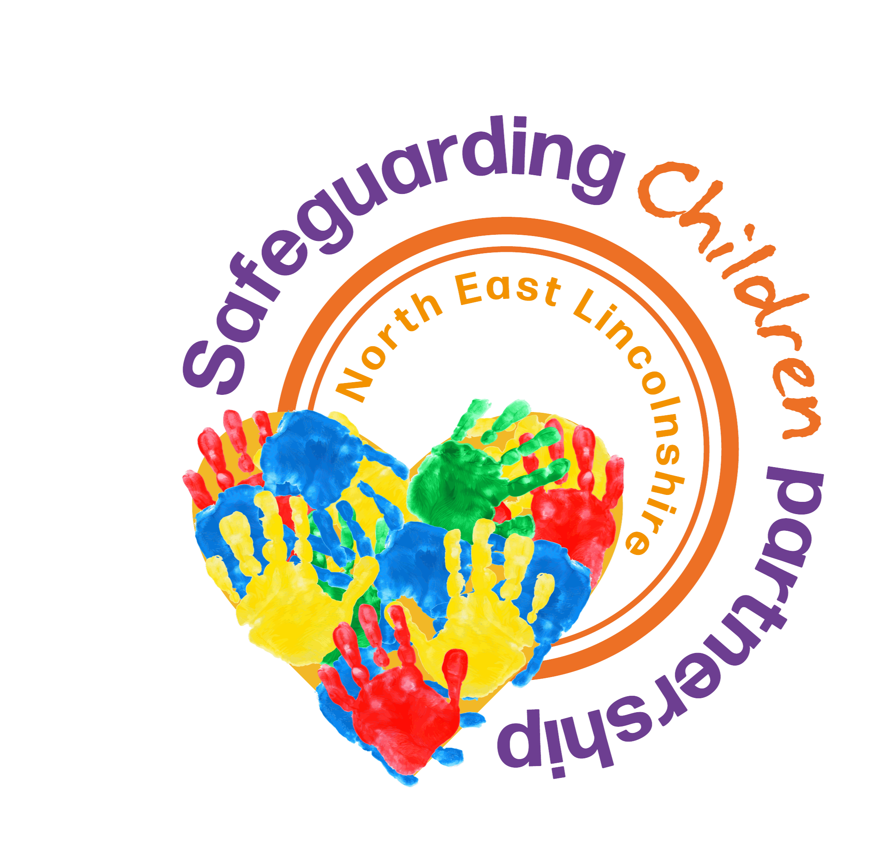

So-Called 'Honour' Based Abuse

1. Definition
So called ‘honour-based' abuse is a variety of offences (mainly but not exclusively against women and girls), including forced marriage, female genital mutilation (FGM), virginity testing, hymenoplasty, controlling and coercive behaviour, physical assault (which can cover practices such as breast ironing/breast flattening), imprisonment and murder where the victim is being punished by their family or community for undermining what they perceive to be the correct code of behaviour. Such behaviour is also likely to amount to domestic abuse.
For young victims it is a form of child abuse and a serious abuse of human rights. It can be distinguished from other forms of abuse, as it is often committed with some degree of approval and/or collusion from family and/or community members. Women, men and younger members of the family can all be involved in the abuse. The role of the family and community in perpetrating and condoning abuse means that victims are likely to be experiencing abuse from multiple perpetrators, often not only in the UK.
Despite the use of the term ‘honour’, there is no honour in abuse, and cultural sensitivities should not get in the way of tackling this issue. There are a number of practices associated with it that are illegal in the UK. Honour Based Abuse Definition – Karma Nirvana
‘Honour Based Abuse is a complex issue that can manifest itself in different ways; includes a range of harms and abuses; and can be perpetrated by a range of people.
While there is no statutory definition for Honour Based Abuse, it is defined as:
Any incident or pattern of controlling; coercive; manipulative; intimidating; or threatening behaviour, violence, or abuse perpetrated by one or more family, extended family, and/or community members and/or current/former intimate partners in response to perceived or alleged transgressions of accepted behaviours. While most often perpetrated against women and girls, anyone can experience honour based abuse regardless of age, ethnicity, sexuality, religion, or gender, including men and boys.
It can encompass but is not limited to:
Psychological, emotional, physical, sexual, spiritual and faith-related, economic, financial, and hate-aggravated abuse; forced marriage; female genital mutilation; abduction; isolation; threats; murder; and other acts of domestic abuse.
People living in the context of an honour dynamic face additional barriers to their ability to speak out against and report abuse for fear of repercussions including further and

2. Risks
Young victims may find themselves in an abusive and dangerous situation against their will with no power to seek help. The usual avenues for seeking help – through parents or other family members - may be unavailable.
So called ‘honour-based' abuse manifests itself in a diverse range of ways with children and young people, including forced marriage, domestic and/or sexual abuse, rape, virginity testing, hymenoplasty, controlling and coercive behaviour, physical assault (which can cover practices such as breast ironing/breast flattening), imprisonment, harassment, kidnap, threats of violence (including murder), witnessing abuse directed towards a sibling or indeed another family member, and female genital mutilation.
As with all forms of so called ‘honour-based' abuse, women and girls are the main victims of forced marriage, however men may also be at risk of forced marriage and so-called ‘honour-based' abuse especially if they identify as LGBTQI, and women may be perpetrators as well as victims in certain circumstances. There may also be multiple victims, such as siblings who are also at risk of so called ‘honour’-based abuse or forced marriage.
Where forced marriage is motivated by perceptions of ‘honour’, it is often part of a wider pattern of abuse, identifiable by efforts to control and monitor the victim, such as restrictions of movement, minimised contact with the opposite sex and emotional and physical abuse. Online targeting of victims is being used more frequently as a means of controlling and exploiting them.
The notion of shame and the associated risk to the victim may persist long after the incident that brought about so-called ‘dishonour’ occurred. This means any new partner of the victim, children, associates or their siblings may be at serious risk of significant harm.
Behaviours that could be seen to transgress concepts of ‘honour’ include:
- Inappropriate attitude, make-up or dress;
- The existence of a boyfriend or girlfriend or a perceived unsuitable relationship; e.g. a gay/lesbian relationship;
- Rejecting a forced marriage;
- Pregnancy outside of marriage;
- Being a victim of rape;
- Inter-faith relationships (or same faith, but different ethnicity);
- Leaving a spouse or seeking divorce;
- Reporting/fleeing domestic abuse, coercive control or forced marriage;
- Kissing or intimacy in a public place;
- Pre-marital sex or extra-marital affairs;
- Alcohol and drugs use;
- Defying parental authority or ideological differences;
- Running away from home.
It is important to be mindful that young people may be subject to so-called ‘honour-based' abuse for reasons which may seem improbable or relatively minor to others.
Victims can find it especially difficult to leave abusive relationships or ask for help if their immigration status is uncertain and those fears will be exploited by their abusers. They may face a number of issues such as a fear of deportation, bringing 'shame' on their families, financial difficulties and homelessness, or losing their children. Such concerns are compounded for migrant victims with no recourse to public funds who can face destitution if they leave an abusive relationship.
There are also a number of practices that are forms of so called honour based abuse and violence against women and girls and also a criminal offence.
These include Forced Marriage and Female Genital Mutilation.
See Forced Marriage procedure
See Female Genital Mutilation procedure
Virginity testing and hymenoplasty are forms of so called ‘honour-based’ abuse and violence against women and girls which can be precursors to child or forced marriage and other forms of family and/or community coercive behaviours, including physical and emotional control. The practices are degrading and intrusive. They can lead to extreme psychological trauma in the victim, and can provoke conditions including anxiety, depression and post-traumatic stress disorder. The practices have been linked to suicide. They can be physically harmful.
Women and girls may themselves present to agencies requesting the procedures in an attempt to protect themselves from further harm and abuse, including shaming, disownment, physical abuse and possible honour-killings. Family and/or community members who are unaware of the change in law may also try to contact agencies seeking the procedures for their daughters and female relatives.
SeeVirginity Testing and Hymenoplasty: Multi-agency Guidance (DHSC). Virginity testing and hymenoplasty: multi-agency guidance - GOV.UK
Breast flattening is the painful and harmful practice of bringing a girl's breasts into contact with hard or heated objects (which may vary in nature but may include stones, belts, pestles and heated implements) to suppress or reverse the growth of breasts by destroying the tissue. Breast flattening is often performed at first signs of puberty, usually by female family members professing to make a teenage girl look less womanly to avoid sexual interest, prevent pregnancy and rape, deter from sexual relationships outside marriage and dishonouring the family/community. Due to the type of instruments, force and lack of aftercare significant physical and psychological consequences and risks related to this practice.
Breast flattening is a form of child abuse. See theCPS legal guidance on So-Called Honour-Based Abuse.
CPS legal guidance on So-Called Honour-Based Abuse (So-Called Honour-Based Abuse | The Crown Prosecution Service

3. Indicators
It is likely that awareness that when a child is the victim of a so called ‘honour-based' crime will only come to light after an assault of some kind has taken place e.g. an allegation of domestic abuse or it may be that a child is reported as missing. There are inherent risks to the act of disclosure for the victim and possibly limited opportunities to ask for help for fear of retribution from their family or community.
There may be evidence of domestic abuse, including controlling, coercive and dominating behaviour towards the victim. Self-harming, family disputes, and unreasonable restrictions on the young person such as removal from education or virtual imprisonment within the home may occur. Victims are sometimes persuaded to return to their country of origin under false pretences, when in fact the intention could be to kill them or force them into an engagement or marriage.
A young person experiencing HBA may:
- Have bruising or other unexplained physical injuries;
- Appear withdrawn or exhibit signs of depression;
- Be self-harming or have attempted suicide;
- Have unexplained absences or poor performance at school;
- Have their movements at home strictly controlled;
- Talk of family rows or restrictions at home;
- Be constantly chaperoned;
- Be witnessing domestic abuse;
- Be going missing from home.
Other warning signs may be FGM, sexual abuse and forced marriage. See Female Genital Mutilation Procedure and Forced Marriage Procedure.
Continual assessment and review is paramount as circumstances can change very quickly, for example, following disclosure to the police the risks to the victim and others who are supporting the victim may increase.
Young people may face significant harm if their families/communities realise that they have asked for help. All aspects of their safety need to be carefully assessed at every stage. Initially this needs to address whether it is safe for them to return home following a disclosure. The young person will need practical help such as accommodation and financial support, as well as emotional support and information about their rights and choices.
Some families go to considerable lengths to find their children who run away, and young people who leave home are at risk of significant harm if they are returned to their family. They may be reported as missing by their families, but no mention is made of the reason. It is important that practitioners explore the underlying reasons for the child going missing before any decisions are made.

4. Protection and Action to be Taken
Any suspicion or disclosure of violence or abuse against a child in the name of ‘honour’ should be treated equally seriously as any other suspicion or disclosure or significant harm against a child. However, there are significant differences in the immediate response required. Bearing in mind the specific practice issues set out, where there are concerns about the welfare and safety of a child theSafeguarding Referrals Procedureshould be followed.
Safeguarding Referrals Procedure Concern about a child | NELC
Involving families in cases of so-called 'honour-based' abuse and forced marriage is dangerous:
- It may increase the risk of serious harm to the victim. as the family may punish them for seeking help;
- Discussion with the family, or any type of family involvement, will often place the child or young person at greater risk of harm. Family group conferences or other forms of mediation should not be used in cases where a young person is at risk because of the physical danger and potential emotional manipulation they may experience during this type of session with their parents and other members of their family or community.
- Under no circumstances is it sufficient to protect a child or young person by removing the alleged perpetrator from the household (as in the significant majority of cases the extended family and wider community are also involved); and placing the child or young person with a family member or member of the same community may place them at risk of significant harm from other family members or individuals acting on the family’s behalf.
- Any discussion and agreement reached between the family and the local authority children’s social care department should only be done where it will not place the child or young person at increased risk of significant harm.
- Interpreters should be on the approved list. Relatives, friends, community leaders and neighbours should not be used as interpreters in case they are linked to the group suspected of carrying out the crime - despite any reassurances from this known person.
In cases of abuse in the name of ‘honour’ and of forced marriage, it is essential to consider other siblings in the family that may be experiencing, or at risk of, the same abuse.
Accurate record keeping in all cases of violence/abuse in the name of ‘honour’ is important. Caution is required about how information is recorded, with whom it will be shared and how it will be shielded within the organisation to ensure the child’s safety Records should:
- Be accurate, detailed, clear and include the date;
- Use the person's own words in quotation marks;
- Document any injuries – include photographs, body maps or pictures of their injuries;
- Only be available to those directly involved in the person's case.
Practitioners must take care that information which increases the risk to the child is not inadvertently shared with family members.

5. Issues
Addressing the needs of the individual is key, as victims of so called ‘honour’-based abuse will require a tailored response dependent on a number of factors including e.g. language and cultural barriers, how long they have been in the country, their social and family networks and their economic circumstances.
The perception of so-called honour-based' abuse is often cultural, or traditional beliefs within certain communities, which may also include Forced Marriage and Female Genital Mutilation, but so-called ‘honour-based' abuse is typically carried out by a member or members of the family or extended family and is likely to involve behaviours specified in the statutory definition of domestic abuse in the Domestic Abuse Act 2021. Perpetrators may use a range of tactics against the victim, this can include restrictions to their freedom, isolation, physical abuse, and threats to kill.
Young people may be at an increased risk of abuse perpetrated by family members and may be inherently more vulnerable because it is harder for them to distinguish between normal and abusive behaviours. This may especially be the case where the perpetrator is a trusted family member.
A young person may find it more difficult to report or disclose abuse by an adult. There may be no safe channel for disclosure, young people may fear the repercussions of disclosure or may not want other family members to get into trouble.
In responding to abuse by family members, services should consider the ways in which the patterns of abuse may differ from, or in cases relate to, patterns of abuse found in cases of intimate partner abuse.
Services should ensure assessment procedures are used appropriately to identify risk. For example, professionals should be aware that family members are not always protective figures for those who experience intimate partner abuse, as in some circumstances family members may constitute a risk themselves and be complicit in abuse.
It is important that all agencies ensure their staff are aware of, can recognise and know how to respond to so-called ‘honour-based' abuse especially when domestic abuse is a presenting factor.
All practitioners working with victims of so called ‘honour’ based abuse need to be aware of the 'one chance' rule. That is, they may only have one chance to speak to a potential victim and thus they may only have one chance to save a life. This means that all practitioners working within statutory agencies need to be aware of their responsibilities and obligations when they come across these cases. If the victim is allowed to walk out of the door without support being offered, that one chance might be wasted.

6. Legal Position
Marriage and Civil Partnership (Minimum Age) Act 2022 expands the criminal offence of forced marriage in England and Wales to make it an offence in all circumstances to do anything intended to cause a child to marry before they turn 18. Marriage and Civil Partnership (Minimum Age) Act 2022
Female genital mutilation is an offence under the Female Genital Mutilation Act 2003, and can result in severe physical and psychological injuries and even death. It is almost always restricted to female children and young people i.e. those under 18 years old. See Female Genital Mutilation Procedure.
The Health and Care Act 2022 has made it illegal to carry out, offer or aid and abet virginity testing or hymenoplasty in any part of the UK. It is also illegal for UK nationals and residents to do these things outside the UK. Health and Care Act 2022
The Domestic Abuse Act 2021includes abuse by family members where they are personally connected and so encompasses a range of abusive behaviours including physical abuse, violent or threatening behaviour, sexual abuse, controlling or coercive behaviour, harassment or stalking, economic abuse, verbal abuse, technology-facilitated abuse, abuse relating to faith, and so called ‘honour’-based abuse. These will be prosecuted under the specific offence committed e.g. causing grievous bodily harm, stalking, and harassment, kidnap, rape, threats to kill and murder, etc. SeeDomestic Abuse Procedure. Domestic Abuse: statutory guidance (accessible version) - GOV.UK
See Domestic Abuse Procedure

7. Further Information
Karma Nirvana Helpline- specialist charity for victims and survivors of Honour Based Abuse in the UK. Karma Nirvana Helpline (https://karmanirvana.org.uk/get-help/helpline/)

So-Called Honour-Based Abuse (CPS)- legal guidance including an overview on so-called 'honour-based' abuse and other harmful practices and specific guidance on the offence of forced marriage. So-Called Honour-Based Abuse (CPS) (https://www.cps.gov.uk/legal-guidance/so-called-honour-based-abuse)
Forced Marriage Guidance, Home Office- Information and practice guidelines for professional protecting, advising and supporting victims. Forced Marriage Guidance, Home Office (https://www.gov.uk/guidance/forced-marriage)
The Multi-agency statutory guidance for dealing with forced marriage and multi-agency practice guidelines: Handling cases of forced marriagesets out the practice guidelines and provides advice and support to front line practitioners who have responsibilities to safeguard children and protect adults from the abuses associated with forced marriage. (https://www.gov.uk/government/publications/the-right-to-choose-government-guidance-on-forced-marriage/multi-agency-statutory-guidance-for-dealing-with-forced-marriage-and-multi-agency-practice-guidelines-handling-cases-of-forced-marriage-accessible#understanding-forced-marriage)
National Support Agencies (https://www.gov.uk/government/publications/the-right-to-choose-government-guidance-on-forced-marriage/multi-agency-statutory-guidance-for-dealing-with-forced-marriage-and-multi-agency-practice-guidelines-handling-cases-of-forced-marriage-accessible#national-support-agencies)
Safe Lives Resources for identifying the risk victims face- Dash stands for domestic abuse, stalking and ‘honour’-based violence. The questions are based on extensive research of domestic abuse seeSafe Lives Dash Risk Checklist Frequently Asked Questions. Safe Lives Resources for identifying the risk victims face (https://safelives.org.uk/practice-support/resources-identifying-risk-victims-face)
Safe Lives Dash Risk Checklist Frequently Asked Questions (https://safelives.org.uk/sites/default/files/resources/FAQs%20about%20Dash%20FINAL_0.pdf)
Protocol on the handling of 'so-called' Honour Based Violence/Abuse and Forced Marriage Offences between the National Police Chiefs' Council and the Crown Prosecution Service. (https://www.cps.gov.uk/publication/protocol-handling-so-called-honour-based-violenceabuse-and-forced-marriage-offences)

Forced marriage and honour based abuse Police APP (authorised professional practice)including Honour-based abuse advice for first responders. Forced marriage and honour based abuse Police APP (authorised professional practice) (https://www.college.police.uk/app/major-investigation-and-public-protection/forced-marriage-and-honour-based-abuse)
Virginity testing and hymenoplasty: multi-agency guidance (DHSC). Virginity testing and hymenoplasty: multi-agency guidance (DHSC) (https://www.gov.uk/government/publications/virginity-testing-and-hymenoplasty-multi-agency-guidance/virginity-testing-and-hymenoplasty-multi-agency-guidance)
Breast ironing: A brief overview of an underreported harmful practice (https://www.ncbi.nlm.nih.gov/pmc/articles/PMC8005301/)

