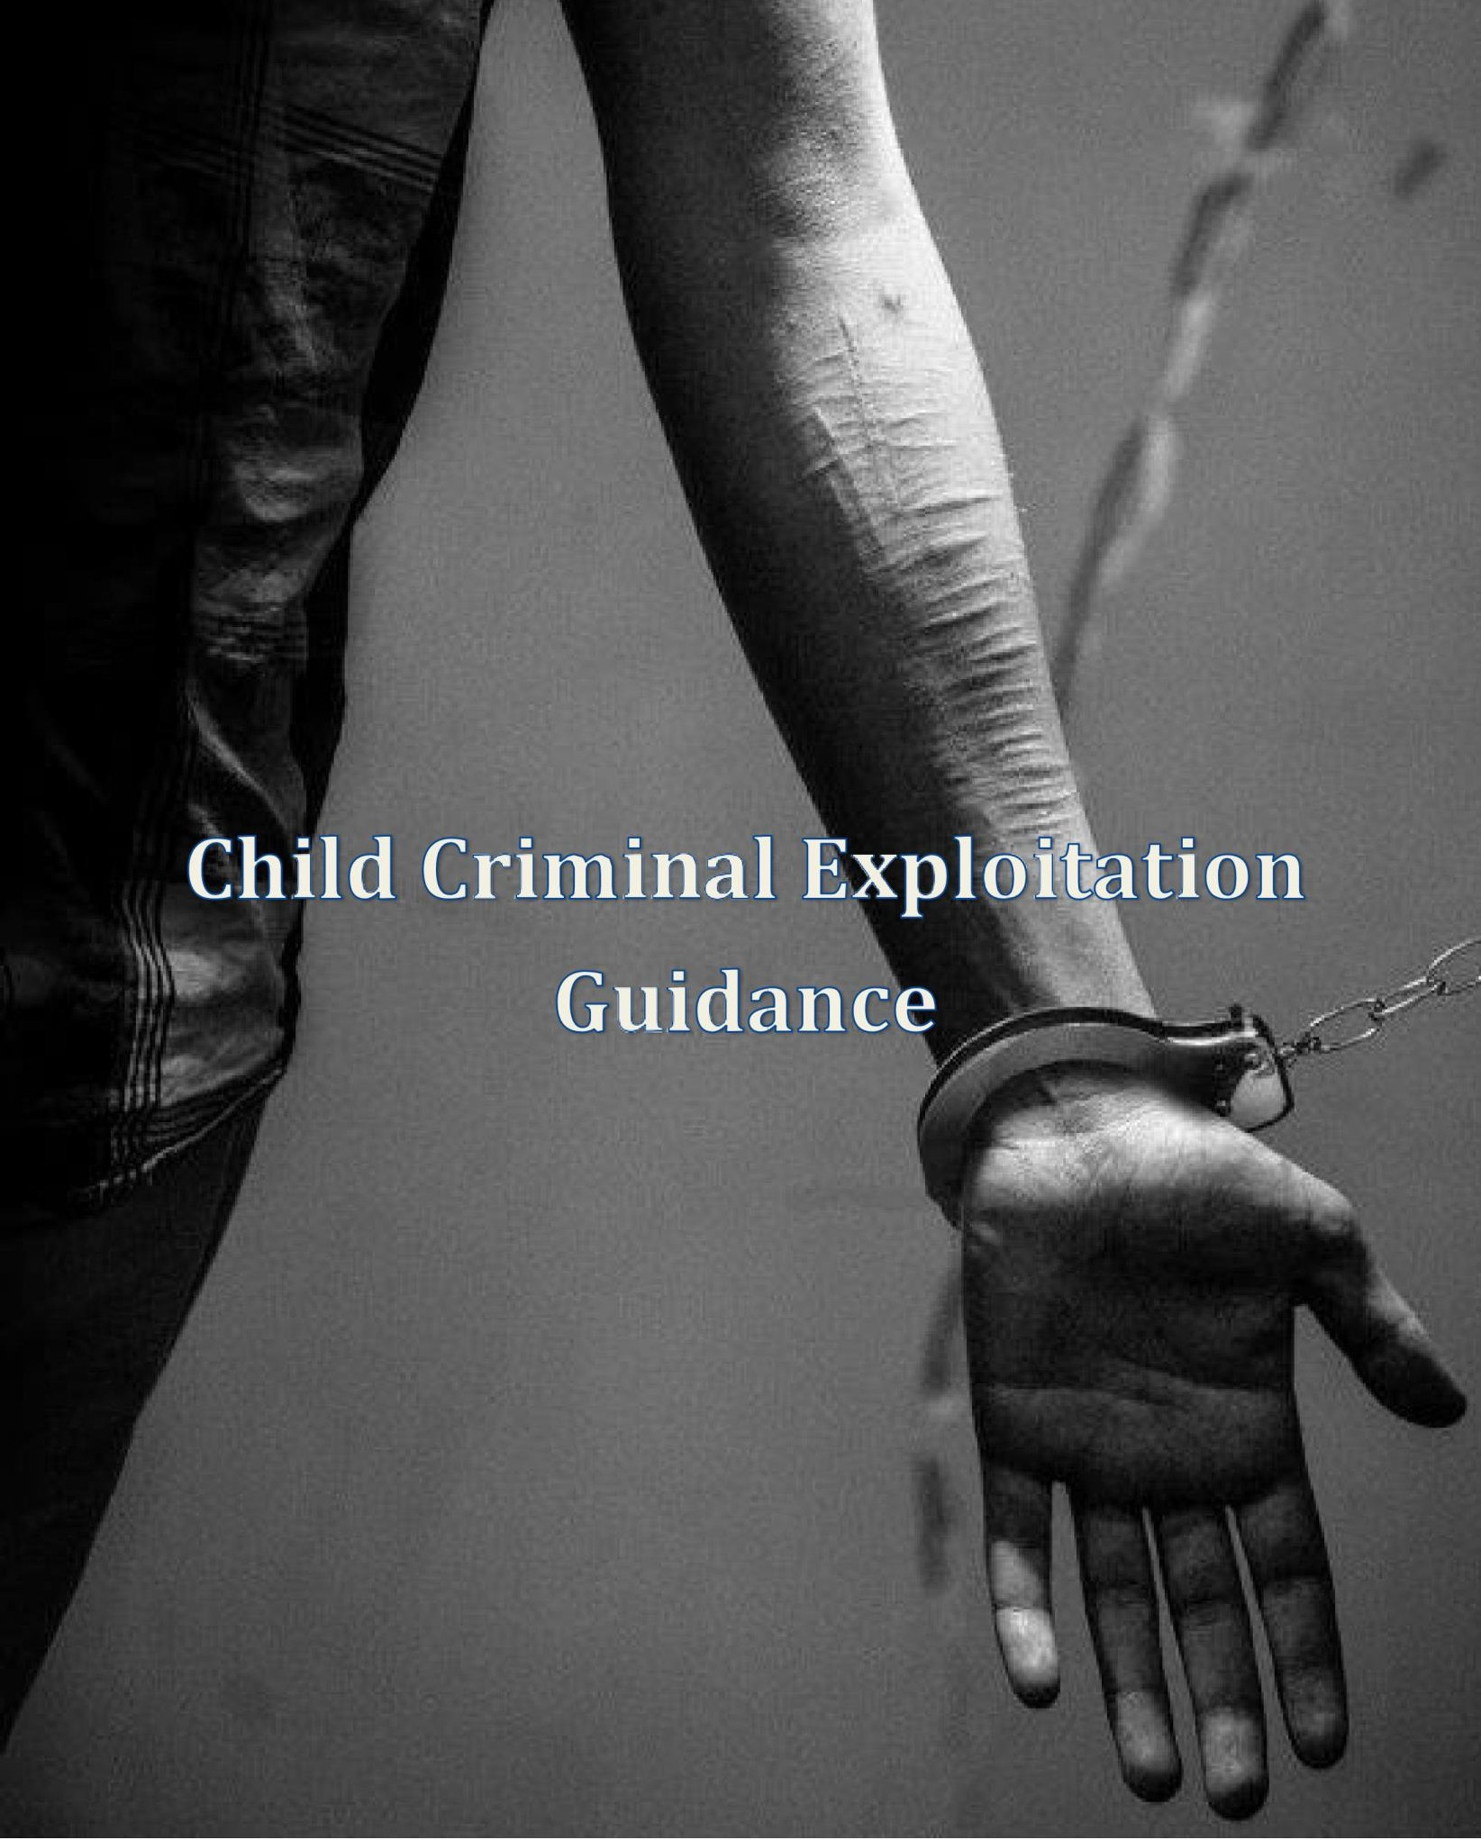

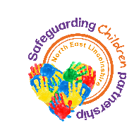

NORTH EAST LINCOLNSHIRE COUNCIL

**ww.wnelincs.gov.uk**

**Contents**

North East Lincolnshire Tackling and preventing Criminal Exploitation of Children Guidance 2

Purpose 2

Definition 3

Key principles 3

Factors and involved considerations 6

CCE and the law 6

Organised Crime Groups and Gangs 6

Who is vulnerable to child criminal exploitation? 6

Methods of exploiting children and young people? 7

Risks 9

Indicators 9

Modern Day Slavery and Trafficking in Procedure and National Referral Mechanism 10

Types of Human Trafficking 11

Report crimes of modern slavery 11

Stage one - Reasonable Grounds, Stage two - Conclusive decision 11

Stage three – Negative decision 12

Procedure: What to do if you are concerned a child is at risk of Criminal Exploitation 13

2

# North East Lincolnshire Tackling and Preventing Criminal Exploitation of Children Guidance

## Purpose

To provide all agencies with clear local practice guidance and process on how to recognise and respond appropriately to children who are at risk of Child Criminal Exploitation (CCE), or who are currently being exploited at all levels of the child concern model. A child is defined as anyone who has not yet reached their 18th birthday.

The practice guidance is aligned to the NEL Adolescent Risk Strategy which seeks to ensure there are effective local arrangements in place including information sharing across all agencies to manage and reduce the risk to children and young people at risk of and affected by CCE. It also ensures this response is tailored to their agreed level of risk and that roles and responsibilities of partner agencies are identified and clearly defined.

N.B.: *The procedure is not intended to replace individual agency procedures nor replace other actions that workers may take to safeguard children and young people*.

## Definition

North East Lincolnshire utilises the definition of child criminal exploitation provided by the Home Office:

*“Child Criminal Exploitation occurs where an individual or group takes advantage of an imbalance of power to coerce, control, manipulate or deceive a child or young person under the age of 18 into any criminal activity*

*(a) in exchange for something the victim needs or wants and/or (b) for the financial or other advantage of the perpetrator or facilitator and/or c) through violence or the threat of violence. The victim may have been criminally exploited even if the activity appears consensual. Child Criminal Exploitation does not always involve physical contact; it can also occur through the use of technology.”*

## Key principles

The principles underpinning a multi-agency response to child criminal exploitation include:

* Recognition - Criminal exploitation can include sexual, physical and emotional abuse, as well as, in some cases, neglect.
* Children do not make informed choices to enter or remain in exploitative relationships, but do so from coercion, intimidation, violence, enticement, manipulation or desperation.
* CCE covers a range of vulnerabilities which will need differing responses from a range of agencies; it is a multi-causal issue that needs to be addressed within a multi-agency approach.
* Locally it is recognised that CCE, county lines activity and Ending Youth Gang Violence issues and CSE are intrinsically linked and are therefore considered in tandem.
* Criminally exploited children and young people should be treated as victims of modern day slavery under the category of forced labour and potentially trafficking and this should be used in mitigation during any criminal proceedings.
* A multi-agency network or risk assessment and management meeting/discussion should take place for all children and young people considered at risk of child criminal exploitation.
* Child Protection Procedures should always be followed where:

The child or young person is at immediate risk of significant harm and/or has other

3

additional vulnerabilities. o There is concern that the criminal exploitation is being facilitated by the child/young person’s parent/carer.

* There is concern that a related or unrelated adult in a position of vulnerability may have their property taken over by organised criminal gangs, any child or young person may be exploited into criminal activity within this property which is commonly known as a trap house.
  + All concerns in relation to CCE should be considered in line with the NEL Thresholds of Harm 2024/28 document.

**Child Exploitation** as a form of abuse, is often characterised by power, exchange and (the restriction or absence of) consent, dynamics that are reflected in how the different categories of exploitation are defined in international and domestic legislation (see below Research in Practice Strategic Briefing 2020)

|  |  |  |  |  |
| --- | --- | --- | --- | --- |
| **Category of Exploitation** | **Power** | **Exchange** | **Consent** | **Definition** |
| **Child Sexual Exploitation** | Child sexual exploitation is a form of child sexual abuse. It occurs where an individual or group takes advantage of an imbalance of power to coerce, manipulate or deceive a child or young person under the age of 18 into sexual activity... | …. In exchange for something the victim needs or wants, and/or  (b) for the financial advantage or increased status of the perpetrator or facilitator. | The victim may have been sexually exploited even if the sexual activity appears consensual.  Child sexual exploitation does not always involve physical contact; it can also occur through the use of technology. | Working Together to Safeguard Children (HM Government, 2018a)  Child sexual exploitation: Definition and guide for practitioners (Department for Education, 2017) |
| **Child Criminal Exploitation** | Child criminal exploitation occurs where an individual or group takes advantage of an imbalance of power to coerce, control, manipulate or deceive a child or young person  under the age of | …. in exchange for something the victim needs or wants, and/ or  (b) for the financial or other advantage of the perpetrator or facilitator and/or  (c) through violence or the | The victim may have been criminally exploited even if the activity appears consensual.  Child criminal exploitation does not always involve physical contact; it can  also occur | Working Together to Safeguard Children (HM Government, 2018a)  Serious Violence Strategy (HM Government, 2018b) |

|  |  |  |  |  |
| --- | --- | --- | --- | --- |
|  | 18 into any criminal activity… | threat of violence. | through the use of technology. |  |
| **Human**  **Trafficking and Modern Slavery** | (a)“Trafficking of persons” shall mean the recruitment, transportation, transfer, harbouring or  receipt of  persons, by means of the threat or use of force or other forms of coercion, of abduction, of fraud, of  deception, of the abuse of power or of a position  of vulnerability or of the giving or receiving of payments or benefits to achieve the consent of a person having control over another person, for the purpose of exploitation. | Exploitation shall include, at a  minimum, the exploitation of the prostitution  of others or other forms of sexual exploitation, forced labour or services, slavery or practices similar to slavery, servitude or the removal of organs | The consent of a victim of  trafficking in persons to the intended exploitation set forth in subparagraph  (a) of this Article shall be irrelevant where any of the means set forth in subparagraph  (a) have been used  (c) The recruitment, transportation, transfer, harbouring or  receipt of a child for the purpose of exploitation shall be considered  “trafficking of persons” even if this does not involve any of the means set forth in subparagraph  (a) of this Article;  (d) “Child” shall mean any person under eighteen years of age. | Palermo Protocol (UN, 2000)  Modern Slavery Act 2015  Safeguarding children who may have been  trafficked (Department for Education and Home Office, 2011) |

## Factors and involved considerations.

* Pull factors: children performing tasks for others resulting in them gaining accommodation, food, gifts, status or a sense of safety, money or drugs; often the hook is through the perpetrator supplying Class B drugs such as cannabis to the child or young person;
* Push factors: children escaping from situations where their needs are neglected and there is exposure to unsafe individuals, where there is high family conflict or the absence of a primary attachment figure;
* Control: Brain washing, violence and threats of violence by those exploiting the child particularly then the child or young person is identified by the police, they are expected to take full responsibility for the offences for which they are charged – i.e. possession and supply of illegal substances.
* Many young people do not recognise that they are being exploited or that they are at risk.
* It is imperative that in recognising CCE as a priority, it is co-considered alongside children who go missing, Child Sexual Exploitation (CSE) and modern day slavery as all are intrinsically linked.

*N.B.: It is important to note that perpetrators of CCE may themselves be children who are criminally exploited and that the victims of CCE may also be at risk of becoming perpetrators.*

## CCE and the Law

The law states that consent is only valid where children and young people make a choice and have the freedom and capacity to make that choice. If a child feels they have no other meaningful choice, are under the influence of harmful substances or fearful of what might happen if they don’t comply (all of which are common features in cases of CCE) consent cannot legally be given whatever the age of the child.

## Organised Crime Groups and Gangs

Organised crime group means a group that-

1. Has as its purpose, or as one of its purposes, the carrying on of criminal activities, and
2. Consists of three or more persons who act, or agree to act, together to further that purpose Gang related violence and drug dealing activity is defined as gang related if it occurs in the course of, or is otherwise related to, the activities of a group that-
3. Consists of at least three people, and
4. Has one or more characteristics that enable its members to be identified by others as a group. (Serious Crime Act 2015)

## Who is vulnerable to child criminal exploitation?

The national and local picture on child criminal exploitation identifies the following vulnerability factors;

* Children of all ages including as young as seven are being exploited by gangs to courier drugs out of their local area; 11 – 16 years is the most common age range.
* Both males and females being exploited
* White British children generally being targeted because gangs perceive they are more likely to evade police detection.
* The use of social media to make initial contact with children and young people.
* The targeting of Alternative Education Provisions and Children’s Homes or anywhere vulnerable children are
* Dependent drug users or other vulnerable parents being targeted so that gangs can take over their homes (known as cuckooing).
* Gangs and groups are known to target vulnerable children and adults, some factors that heighten a person’s vulnerability include:
* Having prior experience of neglect, physical and/or sexual abuse
* Lack of a safe/stable home environment now or in the past (domestic abuse or parental substance misuse, mental health issues or criminality for example)
* Social isolation or social difficulties
* Economic vulnerability
* Homelessness or insecure accommodation status
* Connections with other people involved in gangs.
* Having a physical or learning disability
* Having mental health or substance misuse issues
* Being in care (particularly those in residential care and those with interrupted care histories).

## Methods of exploiting children and young people?

Like other forms of abuse and exploitation, child criminal exploitation:

* Can affect any child or young person (male or female) under the age of 18
* Can still be exploitation even if the activity appears consensual a child cannot consent to being exploited.
* Can involve force and/or enticement-based methods of compliance and is often accompanied by violence or threats of violence
* Can be perpetrated by individuals or groups, males or females, and young people or adults; and Is typified by some form of power imbalance in favour of those perpetrating the exploitation.
* Whilst age may be the most obvious, this power imbalance can also be due to a range of other factors including gender, cognitive ability, physical strength, status and access to economic or other resources
* One of the key factors found in most cases of child criminal exploitation is the presence of some form of exchange (e.g. carrying drugs in return for something). Where it is the victim who is offered, promised or given something they need or want, the exchange can include both tangible (such as money, drugs or clothes) and intangible rewards (such as status, protection or perceived friendship or affection known as a ‘Gang Family’).
* It is important to remember the unequal power dynamic within which this exchange occurs and to remember that the receipt of something by a young person does not make them any less of a victim.
* It is also important to note that the prevention of something negative can also fulfil the requirement for exchange, for example, a young person who engages with child criminal exploitation activity to stop someone carrying out a threat to harm his/her family.
* It is important to note that perpetrators are continually changing and developing techniques to exploit children and evade detection.

*N.B.: It is everybody’s responsibility to report intelligence on mechanisms used by completing the PIF in order to share intelligence on emerging trends.*

## Risks

* The risk or potential risk of harm to the child may be as a victim, a gang member or both - in relation to their peers or to a gang-involved adult in their household.
* Teenagers can be particularly vulnerable to recruitment into gangs and involvement in gang violence.
* This vulnerability may be exacerbated by risk factors in an individual's background, including violence in the family, involvement of siblings in gangs, poor educational attainment, or poverty or mental health problems. A child who is affected by gang activity, criminal exploitation or serious youth violence can be at risk of significant harm through physical, sexual and emotional abuse. Girls may be particularly at risk of sexual exploitation.
* Violence is a way for gang members to gain recognition and respect by asserting their power and authority in the street, with a large proportion of street crime perpetrated against members of other gangs or the relatives of gang members.
* The specific risks for males and females may be quite different. There is a higher risk of sexual abuse for females and they are more likely to have been coerced into involvement with a gang through peer pressure than their male counterparts.
* There is evidence of a high incidence of rape of girls who are involved with gangs. Some senior gang members pass their girlfriends around to lower ranking members and sometimes to the whole group at the same time. Very few rapes by gang members are reported.
* Gang members often groom girls at school using drugs and alcohol, which act as disinhibitors and also create dependency, and encourage / coerce them to recruit other girls through school / social networks.
* Children and Young People can also experience ongoing trauma as a result of CCE which can have a detrimental impact on all aspects of their future.

## Indicators

* The indicators for CCE can sometimes be mistaken for ‘normal adolescent behaviours’. It requires knowledge, skills, professional curiosity and an assessment which analyses the risk factors and personal circumstances of individual children to ensure that the signs and symptoms are interpreted correctly and appropriate support is given.
* Child withdrawn from family;
* Sudden loss of interest in school or change in behaviour. Decline in attendance or academic achievement (although it should be noted that some gang members will maintain a good attendance record to avoid coming to notice);
* Being emotionally 'switched off', but also containing frustration / rage.
* Starting to use new or unknown slang words and specific Gang language.
* Staying out unusually late without reason or breaking parental rules consistently.
* Sudden change in appearance - dressing in a particular style or 'uniform' similar to that of other young people they hang around with, including a particular colour;

Dropping out of positive activities.

* New nickname.
* Unexplained physical injuries, and/or refusal to seek / receive medical treatment for injuries;
* New/ unknown adults waiting to pick up children and young people.
* Unexplained acquisition of money, clothes, or multiple mobile phones (known as a graft phone).
* Constantly talking about another young person who seems to have a lot of influence over them.
* Breaking off with old friends and hanging around with one group of people.
* Associating with known or suspected gang members, closeness to siblings or adults in the family who are gang members.
* Going missing.
* Being found by Police in towns or cities many miles from their home.
* Concerning change in peer group
* Being scared when entering certain areas; and
* Concerned by the presence of unknown youths in their neighborhoods.
* Persistently going missing from school or home and/or being found out of area
* Excessive receipt of texts/phone calls
* Relationships with controlling/ older individuals or groups
* Leaving home/care without explanation
* Parental concerns • Carrying weapons
* Self-harm or significant changes in emotional wellbeing.

*N.B.: An important feature of gang involvement is that, the more heavily a child is involved with a gang, the less likely they are to talk about it.*

## Modern Day Slavery and Trafficking in Procedure and National Referral Mechanism

Modern Slavery is the term used within the UK and is defined within the Modern Slavery Act 2015. The Act categorises offences of Slavery, Servitude and Forced or Compulsory Labour and Human Trafficking.

These crimes include holding a person in a position of slavery, servitude forced or compulsory labour, or facilitating their travel with the intention of exploiting them soon after.

Although human trafficking often involves an international cross-border element, it is also possible to be a victim of modern slavery within your own country/ county or wherever there is the facilitation of a person from one place to another.

An example of this would be a victim moving drugs from one property to another with the intention to sell the drugs under forced/ compulsory labour often under the threat of violence.

It is possible to be a victim even if consent has been given to be moved.

Children cannot give consent to being exploited therefore the element of coercion or deception does not need to be present to prove an offence.

## Types of Human Trafficking

There are several broad categories of exploitation linked to human trafficking, including: Sexual exploitation

* Forced labour
* Domestic servitude
* Organ harvesting
* Child related crimes such as child criminal / sexual exploitation, forced begging, illegal drug cultivation, organised theft, related benefit frauds etc
* Forced marriage and illegal adoption (if other constituent elements are present)

## Report crimes of modern slavery

In the first instance the point of contact for all modern slavery crimes should be the local police force. If you have information about modern slavery crimes – those who are committing such crimes or where victims are at risk that requires an immediate response dial 999. Afterwards, all concerns must be reported through to the Integrated Front Door.

It is also the responsibility of professionals working with Young People they believe to be potential victims of Modern Day Slavery to complete an NRM. The National Referral Mechanism (NRM) is a framework for identifying victims of human trafficking or modern slavery and ensuring they receive the appropriate support. The NRM is also the mechanism through which the [Modern](http://www.nationalcrimeagency.gov.uk/about-us/what-we-do/specialist-capabilities/uk-human-trafficking-centre) [Slavery](http://www.nationalcrimeagency.gov.uk/about-us/what-we-do/specialist-capabilities/uk-human-trafficking-centre) [Human](http://www.nationalcrimeagency.gov.uk/about-us/what-we-do/specialist-capabilities/uk-human-trafficking-centre) [Trafficking](http://www.nationalcrimeagency.gov.uk/about-us/what-we-do/specialist-capabilities/uk-human-trafficking-centre) [Unit](http://www.nationalcrimeagency.gov.uk/about-us/what-we-do/specialist-capabilities/uk-human-trafficking-centre) [(MSHTU)](http://www.nationalcrimeagency.gov.uk/about-us/what-we-do/specialist-capabilities/uk-human-trafficking-centre) collect data about victims. This information contributes to building a clearer picture about the scope of human trafficking and modern slavery in the UK contributing to help change laws.

## Stage one - Reasonable Grounds/ Stage two - Conclusive decision

The reasonable grounds decision is made if there are reasonable grounds to believe the individual is a potential victim of human trafficking or modern slavery. The threshold at Reasonable Grounds stage for the trained decision makers is; “from the information available so far I believe but cannot prove” that the individual is a potential victim of trafficking or modern slavery.

The trained decision makers threshold for a Conclusive Decision is that on the balance of probability “it is more likely than not” that the individual is a victim of human trafficking or modern slavery.

Making decisions may involve seeking additional information from the first responder and other agencies such as police and/or social services.

If a reasonable decision or conclusive decision is reached the potential victim will be granted a 45 day reflection period in order for the victim to begin to recover from their ordeal and to reflect on what they want to do next, for example, co-operate with police as required, move out of area etc. During this time all professionals involved are able to make the necessary safety plans in order to adequately safeguard the young person.

The young person will automatically be allocated a PVP (protecting vulnerable people) Officer from Humberside Police.

Once either of the above decisions are made the first responder and Humberside Police will be notified by letter and email to confirm the decision.

## Stage three – Negative decision

If the threshold for a reasonable or conclusive decision isn’t reached there may be insufficient evidence. The decision maker would then contact the first responder to inform of the negative result. A negative decision can always be challenged by the first responder and further evidence and concerns may be emailed to support the challenge.

## What to do if you are concerned a child is at risk of Criminal Exploitation

If you have concerns regarding a child and feel that they could be at risk of exploitation/ currently being exploited, you do have a duty to ensure that the exploitation tool is completed. This needs to be done with as much relevant information as possible, utilising the partner agencies involved with the child to ensure the most holistic assessment as possible. This needs to be completed for children where the concerns are around Child Sexual Exploitation/ Child Criminal Exploitation/ Modern Day Slavery concerns or for children whose missing episodes are a cause of concern. Once completed you must consider if a safeguarding referral is required, if so a referral must be made to the Integrated Front Door [**NELCChildrensFrontDoor@nelincs.gov.uk**](mailto:NELCChildrensFrontDoor@nelincs.gov.uk)

## Further Information and Required Documents.

Threshold of Need Guidance 2024 – 2028 [NEL-Threshold-Document-2024-28-FINAL-refresh-May-2025.pdf](https://www.nelincs.gov.uk/assets/uploads/2025/07/NEL-Threshold-Document-2024-28-FINAL-refresh-May-2025.pdf)

North East Lincolnshire Exploitation Risk Assessment Tool [N-E-Lincs-Exploitation-Risk-Assessment-Tool.docx](https://view.officeapps.live.com/op/view.aspx?src=https%3A%2F%2Fwww.nelincs.gov.uk%2Fassets%2Fuploads%2F2025%2F05%2FN-E-Lincs-Exploitation-Risk-Assessment-Tool.docx&wdOrigin=BROWSELINK)