
DoL IN NON-STANDARD SETTING
NEW REQUEST

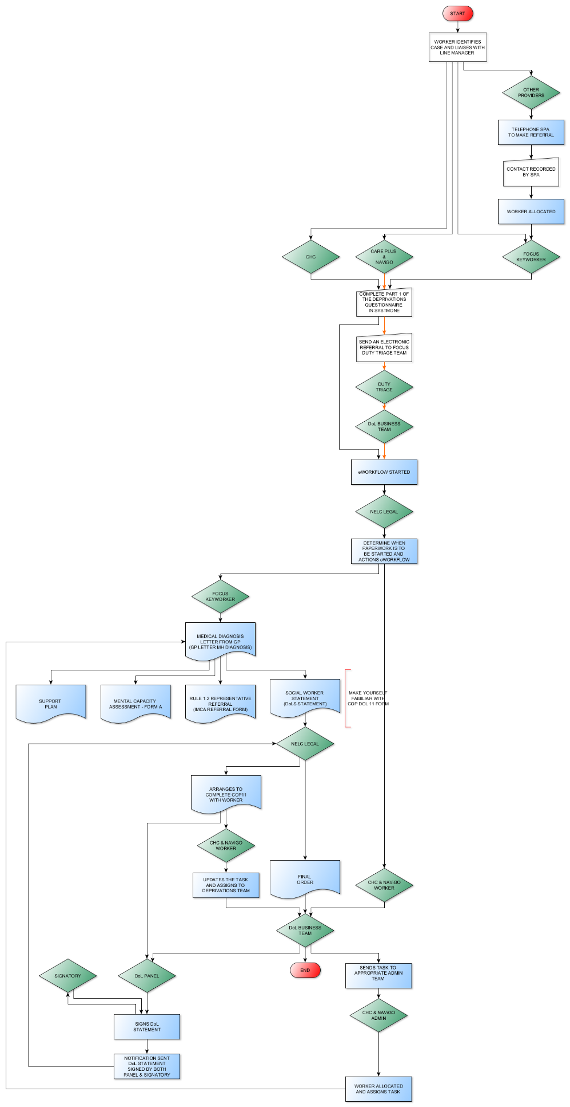

Initial considerations for making a DoL in Non-Standard Setting Request?

- Keyworker identifies a case where the care and treatment could amount to a deprivation at home or in Supported Living
  - See triggers/considerations practical guidance checklist at the end of this process for further information
- Worker then liaises with their Line Manager in the first instance
- If any query following discussion with Line Manager the keyworker/CPG/CHC/NAViGO are to initially email the Deprivations Team focus.mcadols@nhs.net and NELC Legal dols@nelincs.gov.uk with details of query (these queries will be discussed as part of the monthly meeting).

Keyworker (Focus & CHC)
- Completes a new Non-Standard Deprivations questionnaire (Part 1 only)
- Starts eWorkflow

Keyworkers (NAViGO & Care Plus)
- Completes a new Non-Standard Deprivations questionnaire (Part 1 only)
- Sends an electronic referral to Focus Duty Triage

Duty Triage
- Assign the electronic referral to DoL Business Team

DoL Business Team
- Starts eWorkflow

NELC Legal
- Determines when paperwork needs to be started by actioning the eWorkflow to start the process

Keyworker (Focus)
- Receives eWorkflow notification from NELC Legal that the process has been triggered and the following documents now need completing
  - GP Letter (completed by DoLS Business Team)
  - Support Plan
  - Mental Capacity Assessment
  - Worker Statement
  - Rule 1.2 Representative Referral (if required)
- Once paperwork completed Action the eWorkflow to notify Legal that the paperwork is completed

Keyworker (CHC & NAViGO)
- eWorkflow notification sent to DoL Business Team

DoL Business Team
- Send a Task to CHC and NAViGO Admin Teams to notifiy them that process can be started and the following documents now need to be completed
  - GP Letter (Deprivations complete)
  - Support Plan
  - Mental Capacity Assessment
  - Worker Statement
  - Rule 1.2 Representative Referral (if required)

CHC & NAViGO Admin
- Allocate a worker and assign the task from DoL Business Team to them to complete the relevant paperwork

Keyworker (CHC & NAViGO)

Update the task and reassign back to the DoL Business Team once all paperwork is completed and saved on SystmOne

DoL Business Team
- Action the eWorkflow to inform NELC Legal that the paperwork is ready for review

NELC Legal
- Receives eWorkflow notification from the Keyworker/DoL Business Team that the following documents in relation to the application have now been completed
  - GP Letter
  - Support Plan
  - Mental Capacity Assessment
  - Worker Statement
- Arranges to complete the COP11 in conjunction with the keyworker
- Receives notification that both Panel and Signatory have reviewed and signed the documents for issue to Court.
- Upon receipt of the Final Order from the Court sends the document via email to the Dols Team to upload to SystmOne

Panel
- Receives eWorkflow notification that the documents are ready to review.
- Reviews the documents using the criteria within the eWorkflow
- If satisfied the criteria is met signs the DoL Statement
- If queries sends a data quality workflow/task detailing the queries to the keyworker
  - When notification received that amendments have been made review documents again and then signs the DoL Statement

Signatory
- Receives eWorkflow notifying that Panel have reviewed the application and are satisfied that it meets the relevant criteria
- If queries sends a data quality workflow/task detailing the queries
- If satisfied signs the Dol Statement where indicated

IDENTIFYING A DEPRIVATION OF LIBERTY: A PRACTIAL GUIDE

The Home Setting - liberty restricting measures and questions for front line staff: | YES | NO
The prescription and administration of medication to control the individual’s behaviour, including on a PRN basis.
The provision of physical support with the majority of aspects of daily living, especially where that support is provided according to a timetable set not by the individual but by others.
The use of real-time monitoring within the home environment (for instance by use of CCTV or other assistive technology).
The regular use of restraint by family members or professional carers, which should always be recorded in the individual’s care plans.
The door being locked and where the individual does not have the key (or the number to a key pad) and is unable to come and go as they please, strongly suggests that they are not free to leave.
The individual regularly being locked in their room (or in an area of the house) or otherwise prevented from moving freely about the house.
Use of medication to sedate or manage behaviour, including PRN.

The following are examples of potentially liberty restricting measures that may apply in a supported living setting: | YES | NO
Decision on where to live being taken by others.
Decision on contact with others not being taken by the individual.
Doors of the property locked, and/or chained, and/or bolted for security reasons or to prevent resident leaving.
Access to the community being limited by staff availability
A member or members of staff accompanying a resident to access the community to support and meet their care needs.
Mechanical restraint, such as wheelchairs with a lapstrap or harness (e.g. Crelling), reinforced glass in mobility vehicles, protective helmets.
Varying levels of staffing and frequency of observation by staff.
Restricted access to finances, with money being controlled by staff or welfare benefits appointee.
Restricted access to personal items to prevent harm.
Restricted access to parts of the property, such as the kitchen or certain cupboards therein, to minimise health and safety risks.
Chemical restraint, such as medication with a sedative or tranquilising effect.
Physical restraint/intervention, such as with personal care tasks, breakaway or block techniques, distraction methods, staff withdrawing, physical touches or holds.
Restricted access to modes of social communication, such as internet, landline or mobile telephone, correspondence.
Positive behavioural reward systems, to reward “good” behaviour.
Restricted access to family, depending on level of risk and availability of staff and resources.
Lack of flexibility, in terms of having activities timetabled, set meal times, expected sleep times.

