
DoL IN NON-STANDARD SETTING
RENEWAL PROCESS

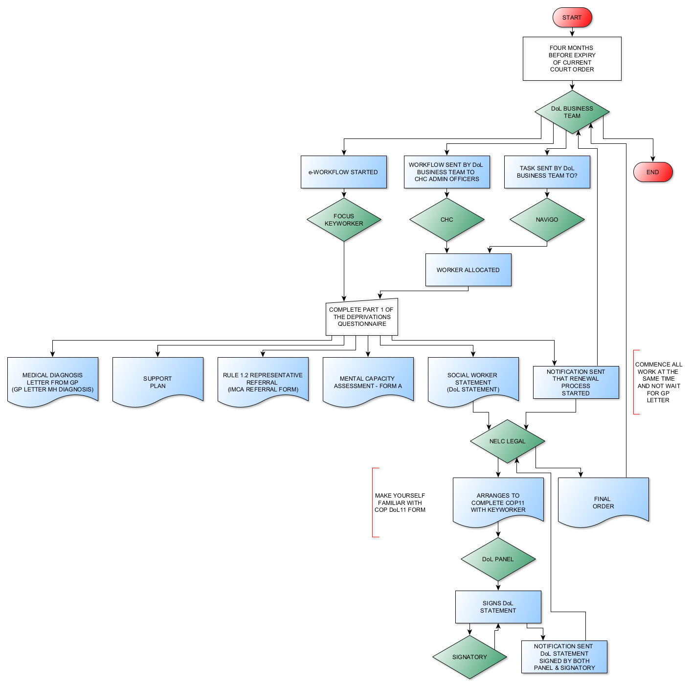

When does Renewal Process Commence?

- Four months prior to the expiry of current Court Order the DoL Business Team will commence COP Application Renewal Request eWorkflow.
- All stages of the renewal process are then completed by following the eWorkflow triggers

Keyworker
  - eWorkflow (FOCUS) Task (CHC & NAVIGO) received informing them that the current Court Order for the Non-Standard Deprivation is due to expire on (inserted date)
- Completes a new Non-Standard Deprivations questionnaire (Part 1 only)
- Keyworker completes the following actions
  - Request GP Letter
  - Update Support Plan (needs to be within in last 2 months)
  - Update MCA (needs to be within last 2 months)
  - Worker Statement (Word Document in Comms & Letters)
  - Complete Part 2 of Non-Standard Deprivation Questionnaire
- NELC Legal will arrange to complete the COP11 in conjunction with the keyworker

CHC Admin Officers & NAViGO Admin

- Workflow received from DoL Business Team requesting a keyworker is allocated to complete the DoL Renewal Process
- Keyworker allocated for completion of DoL Renewal Process

DoL Business Team
- Receives notification from Keyworker that questionnaire has been started and needs adding to the Deprivation Non-standard Renewal in Process Waiting List
- Receives notification from NELC Legal that a Draft Order has been issued
- Completes Part 3 of the non-standard
- Receives notification from NELC Legal that the final order has been received

NELC Legal
- Receives eWorkflow notification from Keyworker that the renewal process has commenced
- Receives eWorkflow notification from the Keyworker that the following documents in relation to renewal have now been completed
  - GP Letter
  - Support Plan
  - Mental Capacity Assessment
  - Worker Statement
- Arranges to complete the COP11 in conjunction with the keyworker
- Receives notification that both Panel and Signatory have reviewed and signed the documents for issue to Court.
- Upon receipt of the Final Order from the Court uploads the document to SystmOne

Panel
- Receives eWorkflow notification that the documents are ready to review.
- Reviews the documents using the criteria within the eWorkflow
- If satisfied the criteria is met signs the DoL Statement
- If queries sends a data quality workflow/task detailing the queries to the keyworker
  - When notification received that amendments have been made review documents again and then signs the DoL Statement

Signatory
- Receives eWorkflow notifying that Panel have reviewed the renewal application and are satisfied that it meets the relevant criteria
- If queries sends a data quality workflow/task detailing the queries
- If satisfied signs the Dol Statement where indicated

