


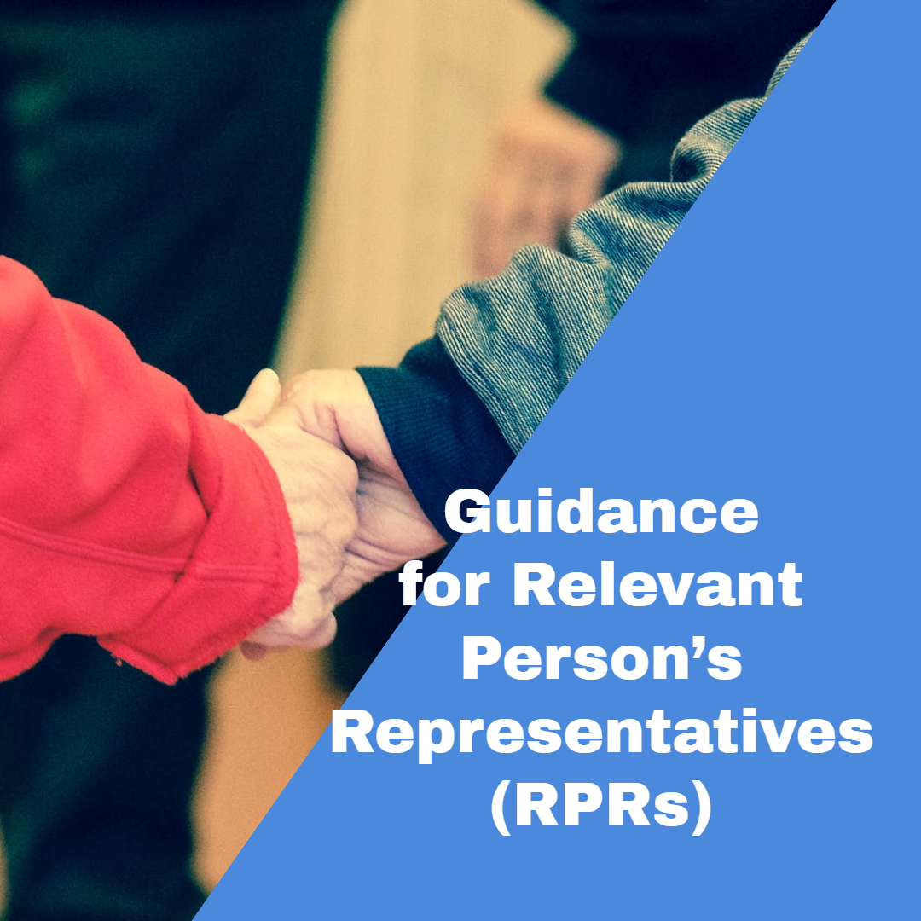

Guidance for Relevant Person’s Representatives (RPRs)

Why has this guidance been produced?
This guidance should be read with the booklet produced by the Department of Health, called “Deprivation of Liberty Safeguards A guide for relevant person’s representatives” in 2009. North East Lincolnshire Council and NHS Humber and North Yorkshire Integrated Care Board have produced this guidance to add to the information in the Department of Health’s booklet, and to share some local contact details. This guidance focuses on when to apply to the Court of Protection, because the Department of Health’s booklet does not give very much detail about the Court (on page 16) and we think more information on this would be helpful for RPRs. You can read the Department of Health’s booklet by selecting the following hyperlink Department of Health Booklet.

Background

What is a deprivation of liberty?
Some people are not able to consent (agree) to receiving health or social care because they have an impairment, illness, or injury that affects the way their mind or brain works and stops them being able to make decisions. Being unable to make a decision means that at the time the person needs to make a specific decision, they are not able to:
- Understand the information needed to make the decision; or
- Retain the information for long enough to make the decision; or
- Use and weigh the information to make the decision; or
- Communicate the decision (verbally or in any other way, such as by sign language).

Not being able to do any one of the above (understand, retain, use/ weigh or communicate) will mean that the person can’t make the decision at that time, and someone else will have to make it for them. Decisions must be made in the ‘best interests’ of the person who needs care, by following the legal rules in the Mental Capacity Act 2005 (‘the MCA’). The term ‘best interests’ has a special legal meaning when making decisions for a person who can’t make some or all of their own decisions. The MCA sets out a list of things that must be considered when anyone makes a best interests decision for another person. You can find the ‘best interests checklist’ in the MCA Code of Practice using this link Mental Capacity Act Code of Practice

Sometimes the care the person needs is so significant that their freedom is reduced a lot, or even completely taken away, in their best interests. Giving them the care they need to keep them safe could mean they are under ‘continuous supervision and control’ and ‘not free to leave’ the place where they are being cared for. Being under continuous supervision and control and not free to leave is known as a ‘deprivation of liberty’. No one should be deprived of their liberty without a good legal reason. Where someone is deprived of liberty, extra safeguards apply, to ensure that the care they receive is truly in their best interests, and made lawful by following a proper legal process.

What safeguards apply to a deprivation of liberty?
If a person aged 18 is being cared for in a hospital or a care home, their deprivation of liberty is made lawful using a process set out in the MCA, called the Deprivation of Liberty Safeguards (DoLS).

As part of the DoLS process, two specialist professionals, a Mental Health Assessor (MHA) and a Best Interests Assessor (BIA) meet with the person deprived of liberty. They work together to make important decisions about the person. The MHA decides whether the person has an impairment, illness, or injury to their mind or brain. The MHA also decides the best way of making sure that the person’s deprivation is made lawful; that means the MHA considers complicated legal rules to decide which piece of law (the MCA or the Mental Health Act 1983) should be used to approve the person’s deprivation of liberty. This guidance only considers people whose deprivation of liberty is approved using the MCA.

The BIA decides whether the impairment, illness or injury to the person’s mind or brain means that they cannot make decisions about whether to live where they are living to receive care and treatment. The BIA will also decide whether the way the person is being cared for is necessary to keep them safe, and is proportionate to the risks of not keeping them safe in this way. The BIA will consider if there are any less restrictive ways that the person could be cared for, and still be kept safe. The BIA will make their decisions using information from the person, their family or friends, the MHA, any professional who is caring for them, and an advocate or attorney if they have one. If the BIA decides that the arrangements for the person’s care are in their best interests, they will recommend that the local Council approves the deprivation of liberty. The Council’s approval is called an ‘authorisation’.

An authorisation can last anywhere from a few weeks to a maximum of 12 months. During the period of the authorisation, there are safeguards in place for the person. One of the safeguards is that someone is asked to support and represent the person (usually a family member or friend). The person and their representative must be given information about the deprivation of liberty, and help to understand the information as much as they can, with support from an advocate if needed. The safeguards also include being able to ask the Council to review the care which has resulted in the deprivation of liberty, or asking the Court of Protection to do so. The Court of Protection is specially designed to make decisions about people who are unable or who may be unable to make their own decisions. If there is an objection to, or a disagreement about, the care that has resulted in a deprivation of liberty and it can’t be sorted out informally, the Court of Protection can be asked to make a decision about it.

You can read more about the safeguards by using these links Deprivation of Liberty Safeguards Code of Practice or in this summary Deprivation of Liberty Safeguards Rights Leaflet. There are also videos available to watch or listen to that you can access by selecting this hyperlink Deprivation of Liberty - LiveWell (nelincs.gov.uk) and Deprivation of Liberty Safeguards training videos.

Acting as a Relevant Person’s Representative (RPR)

What is the role of a RPR?
The person who is deprived of liberty, who you have agreed to represent and support, is called the ‘Relevant Person’. The Relevant Person is being deprived of liberty in their best interests, so that they can be given the care they need to keep them safe and well.

As the Relevant Person’s Representative (RPR), you have a wide duty to help the Relevant Person with all things connected with their deprivation of liberty. You will need to visit the Relevant Person regularly (generally at least once each month) to keep up to date with the arrangements for their care and give them any support with the deprivation that they might need. For example, this might include checking that the organisation providing the Relevant Person’s care is regularly reviewing their care plan, to make sure that the Relevant Person’s needs will keep being met. It might also include making a complaint on behalf of the Relevant Person.

You will need to act independently of anyone arranging or giving care to the Relevant Person, and make sure that you put the Relevant Person’s interests first. This means that the Relevant Person’s wishes and feelings should always be at the heart of the way you help them, even if you disagree with the Relevant Person’s views. This includes taking into account things that the Relevant Person might have said in the past about their situation or similar situations, even if they are no longer able to tell you what they think.

Perhaps the most important part of your role is to challenge the Relevant Person’s care arrangements, if you (or the Relevant Person) have any concerns about them. A challenge could include a number of things, such as:

- Talking to the provider of care in the place where the Relevant Person lives (for example, the care home manager) to see whether they could be cared for in a way that is less restrictive. For instance, if the Relevant Person would be at risk if they left the care home on their own, instead of never letting them go out, care home staff could arrange for someone to go out with them and help them stay safe
- Asking the Council to review the care given to the Relevant Person. For instance, the Relevant Person’s needs might have changed, and the care they are receiving may have stopped being in their best interests
- Asking the Court of Protection to review the care given to the Relevant Person, which results in them being deprived of their liberty.

Deciding whether to apply to the Court of Protection
You will need to decide whether the Relevant Person wants to make an application to the Court of Protection to challenge their deprivation of liberty.

To help you decide whether to apply to the Court, think about the following:

Can the Relevant Person decide about making a Court application?
Is the Relevant Person able to make a decision about whether to apply to the Court? The Relevant Person doesn’t need to be able to make the Court application themselves; they just need to be able to understand that the Court has the power to stop or change their care arrangements if it is asked to. If the Relevant Person can make a decision about whether to apply to the Court, do they want to apply? If the Relevant Person can make a decision about whether to apply to the Court, and wants to apply, an application must be made.

If the Relevant Person can’t decide about making a Court application, what would they be likely to decide if they could?
If the Relevant Person is not able to make a decision about whether to apply to the Court, is the Relevant Person saying or doing anything that makes you think that they would want to apply to the Court if they were able to decide? You will need to think about the following:

What the person says
The Relevant Person may not be able to decide whether to apply to the Court, but they might still express feelings or wishes about making a Court application. Alternatively, the Relevant Person might tell you that they object to the arrangements for their care, or they might tell you generally how they feel about it (for example, upset or in low mood because of it). You will need to think about what the person is telling you, and judge if this means that they would want to make a Court application if they were able to decide. To help you judge, you should ask yourself these questions:
- How often does the Relevant Person object to living where they are being cared for? How often do they ask to leave? For example, is the person regularly asking to leave, or is their objection a one-off?
- How consistent is the Relevant Person when they tell you how they feel about their care arrangements, or about their feelings generally? For example, are they always low in mood (for instance they are withdrawn or are not eating or drinking), or do they just have the odd bad day?
- Are there other reasons for what the Relevant Person says or does, or for their emotional state? For example, they could be upset because someone close to them has died recently, rather than because they object to their care arrangements.

What the person does
The Relevant Person may not be able to tell you what they think, but they might be showing what they think by their behaviour. You will need to think about what the Relevant Person’s behaviour is showing you, and judge if this means that they would want to make a Court application if they were able to decide. To help you judge, you should think about:
- How the Relevant Person is behaving. For example, does the Relevant Person actively try to leave their care home? Do they take steps to prepare to leave, such as packing their bags? Are they refusing to take their medication, or rejecting other types of care? Do they seem to have a good relationship with staff or not?
- Why the Relevant Person might be behaving that way. For example, perhaps the person is trying to leave where they are living because they like going for a walk, rather than because they want to leave that place permanently. Perhaps they are taking medication that could change their behaviour (medication could make the Relevant Person more agitated, or it could make them quieter than usual)? Might the Relevant Person be unhappy with parts of their care or all of it?
- Whether there are any ‘triggers’ for the Relevant Person’s behaviour. For example, care home records might show that they are more challenging when they are woken up early, or that they are more unhappy with some staff members than others. Could small changes be made that might make the Relevant Person happier?

You will need to think about all of these things ‘in the round’ to help you judge what the Relevant Person is saying or doing. To do this, you will need to meet the Relevant Person more than once, and speak to their friends or family and staff members to get their views. If you think that the Relevant Person is doing or saying anything that shows that they want to apply to the Court, an application must be made.

What do you think about making a Court application?
If you think the Relevant Person is not asking or showing that they want to apply to the Court, you can still make an application for them if you think it is in their best interests. You might decide this if, for example:
- after discussing things with the Relevant Person’s care provider, you are still not happy that care is being given to the Relevant Person in their best interests, or in a way that is less restrictive (for example, you think that the arrangements for the Relevant Person are more restrictive than they need to be to keep them safe)
- after asking the local Council to review the Relevant Person’s care, you are still not happy that the arrangements for the Relevant Person are appropriate for them. You could ask the Court to look at the Relevant Person’s arrangements if you think that:

- they should not be deprived of their liberty because, for example, the Relevant Person is able to make decisions about their care arrangements, but they are not being allowed to. Or, if the Relevant Person can’t decide, the decisions that have been made by others are not in the Relevant Person’s best interests
- the period of the authorisation is not in the Relevant Person’s best interests. For example, the length of time that the Relevant Person’s deprivation of liberty is approved for is too long
- the arrangements for the Relevant Person could be less restrictive and still keep them safe. For example, if the Relevant Person was given a ground floor room, they may not need monitoring equipment such as door sensors to tell staff when they have left their room (and might fall down the stairs)
- any conditions that the authorisation is subject to are not in the Relevant Person’s best interests. For example, if a condition was included to arrange a home visit for the Relevant Person to look at the possibility of them returning home, and there was disagreement about whether this was in the Relevant Person’s best interests.

You should be aware that councils and the NHS have legal duties to meet the eligible needs of people they are responsible for, but they have choices about how to meet those needs. This means that the Council or NHS cannot be forced to provide or pay for care that they are not able or willing to, as long as the Relevant Person’s eligible needs are met. Even the Court cannot change this, if the Council or NHS have made their decisions about how to meet the Relevant Person’s eligible needs in a lawful way.

Help with making a decision
It might be difficult for you to decide whether to ask the local Council to review the Relevant Person’s care arrangements, or whether to make an application to the Court. The Council can put you in touch with a special advocate called an ‘IMCA’ (an Independent Mental Capacity Advocate) who will help you think about your rights, and those of the Relevant Person, and decide how to use them. For example, an IMCA could help you ask the Council to review the Relevant Person’s care arrangements, or apply to the Court. If you think that an IMCA could help you or the Relevant Person, contact the DoLS Team (0300 300 2860).

You might also want to get some legal advice to help you decide what (if any) action to take for the Relevant Person. Not all solicitors firms have the special knowledge needed to give this guidance on deprivation of liberty and your duties as an RPR. We cannot recommend any one solicitors’ firm, but we do know that the following regional firms can offer this advice (listed in alphabetical order):

Solicitors Firm | Contact Number
Cartwright King Solicitors | 03458 941 622
Irwin Mitchell Solicitors | 0370 1500 100
MJC Law | 0115 695 0084
Switalskis Solicitors | 0800 1380 458

For more information about deprivation of liberty go to https://livewell.nelincs.gov.uk/adult-social-care/deprivation-of-liberty/

Frequently Asked Questions
- Q. Does it matter that even if a Court application was made on behalf of the Relevant Person, it would be unlikely to result in a change to their circumstances (for example, they are not likely to be allowed to permanently leave the place they live)?
- No; the Relevant Person still has the right to ask that the Court looks at their situation
- Q. Does it matter that staff and professionals agree that the place where the Relevant Person lives best meets their needs?
- No; the Relevant Person still has the right to ask that the Court looks at their situation
- Q. Does it matter that you, as the RPR, think that the person should keep being cared for where they are (for example, you think they should stay in the care home they are in now)?
- No; it is your duty as RPR to make sure that an application is made to the Court if that is what the Relevant Person wants, even if you disagree with their views
- Q. Is making an application to the Court expensive?
It can be, but the Relevant Person is entitled to non-means-tested legal aid so that they can appeal against their deprivation. A solicitor will be able to give you advice on this
- Q. Does the care provider and/ or the Council have to be asked to consider the Relevant Person’s arrangements first before an application to the Court can be made?
- No, but working with the care provider and/ or Council to consider alternatives to the Relevant Person’s current arrangements could be more cost effective and quicker.

