


Mental Health Assessor Pack

Contents

For all Mental Health Assessors:
- Form 4 Guide (1-2)
- Form 4 Template (3-5)
- Form 4 – Full Example No.1 (6-9)
- Form 4 – Full Example No.2 (10-13)
- Invoice Template – Full Only (14)

Supplementary Pack only for Mental Health Assessors who have access to SystmOne through their substantive roles:
- Mental Health / Eligibility Lighter Touch (Form 4A) Criteria (16)
- Form 4A Template (17-18)
- Form 4A – Lighter Touch Example No.1 (19-21)
- Form 4A – Lighter Touch Example No.2 (22-24)
- Invoice Template – Lighter Touch Only (25)
- DoLS Module SystmOne Guide (completion of assessment and viewing/finding information) (26-37)

DoLS Team Contact Information: -
Telephone: - 0300 330 2860
Email: - focus.mcadols@nhs.net
(Staffed during office hours Monday – Friday 08:30-17:00)

Form 4 Guidance for Completion of Form 4

TWO assessments (Mental Health Assessment and Eligibility Assessment).
(Within North East Lincolnshire our Best Interests Assessors do the Mental Capacity Assessments).
Demographics of the person (Full name, Date of Birth, Placement Care Home or Hospital full address)
Name, Address and Profession of the Assessor (c/o Focus Independent Adult Social Work should be used for your address).
Name of Supervisory Body: - North East Lincolnshire Council, c/o Focus Independent Adult Social Work

Mental Health Assessment
Please detail the following (ensuring the IS / IS NOT boxes are completely accordingly): -
- Person’s full name
- Date and Purpose of visit
- Name of any worker who may have accompanied / supported with the assessment
- Time person has been in the placement (if known/established)
- Establish whether the person is suffering from a Mental Disorder within the meaning of the Mental Health Act (disregarding any exclusion for persons with Learning Disability) (NB. the noting any other conditions may also useful). Please ensure that Diagnoses are stated in full and not purely abbreviated.
- Date of Mental Disorder Diagnosis (if known)
- Symptoms of such Mental Disorder
- Any concerns about low mood, behaviour or agitation, particularly if the person appears to be objecting to their care and treatment along with brief day to day required care. If you identify a possible objection, please be sure to highlight it.
- Medications that the person is prescribed and why (ensuring correct spelling) and reference to whether they are daily / PRN / covertly administered. It is particularly important to note medication that may have a controlling and/or sedative effect and if they have recently been increased or decreased (if known and why).
- How the person presented on the day of the assessment and if this is representative of how they generally present. (It’s useful to provide a flavour of any questions asked / responses given to correlate the person’s cognition).
- Your impression / outcome of your assessment in terms of how the person’s presentation correlates to the person’s Mental Disorder Diagnosis
- If you have any recommendations to suggest – i.e. such as possibly requiring a review by say a local Mental Health Team and/or it could be your view as to when medications should need to be reviewed particularly if the medications may have a controlling and/or sedative effect – you can include reference to these and in bold would be useful
- In the follow-on question – identify how the person’s mental health and wellbeing is likely to be affected by being detained under a deprivation of liberty.

Eligibility Assessment
- Establish whether the person is eligible to be detained under the MCA – (i.e. complete accordingly the questions asked around whether the person is detained and/or subject to any Mental Health provisions listed (Yes / No)).
If Yes is answered then the person is ineligible for DoLS
- If the assessment is for a HOSPITAL placement – the additional questions listed require completing also.
- NB You are not required to decide (or even consider) whether an application under the MHA would be in the person’s best interests.

General
Please take all practicable steps to encourage P’s engagement in assessments, making reasonable adjustments if required.
Please list within your assessment what records you have examined and ensure that the Form 4 is spell checked accordingly and please sign, print name along with Date/Time.
Please note that family members can receive a copy of assessment paperwork so please be mindful of the terminology used to avoid any undue distress or upset.
Assessments to be undertaken face to face unless there are exceptional circumstances (such as the placement being closed due to say Covid). Virtual assessments can take place if there is no other alternative in those circumstances and to adhere to set deadlines (care homes should be able to facilitate MS Teams or Zoom). Please liaise with the DoLS Team (0300 330 2860 / focus.mcadols@nhs.net) if you have any queries / concerns.
The above Guidance relates to Form 4 (Full Mental Health and Eligibility Assessments). Mental Health Assessors with SystmOne Access may also be asked to undertake Light Touch Assessments (Form 4A). Separate Light Touch Guidance is available to Mental Health Assessors who would be asked to carry these out.

NHS Number: DoLS ID:
DEPRIVATION OF LIBERTY SAFEGUARDS FORM 4
MENTAL HEALTH and ELIGIBILITY ASSESSMENTS
Please indicate which assessments have been completed

Mental Health | Yes |  | Eligibility |  |  | Yes
This form is being completed in relation to a request for a standard authorisation.
This form is being completed in relation to a review of an existing Standard Authorisation under Part 8 of Schedule A1 to the Mental Capacity Act 2005.
Full name of the person being assessed
Date of birth |  |  |  | Est. Age
Name of the care home or hospital where the person is, or may become, deprived of liberty
Name and address of the Assessor |  | Dr ****  c/o focus independent adult social work  Heritage House  Fisherman’s Wharf  Grimsby  North East Lincolnshire  DN31 1SY
Profession of the Assessor
Name of the Supervisory Body |  | North East Lincolnshire Council  c/o focus independent adult social work
The present address of the person being assessed if different from the care home or hospital stated above.

MENTAL HEALTH ASSESSMENT
In carrying out this assessment, I have taken into account any information given to me, and any submissions made by any of the following:

- The DoLS Request (Form 1) / DoLS Renewal Request (Form 2 / Form 2A) as submitted by the Managing Authority
- The relevant person’s representative
- Any IMCA instructed for the person in relation to their deprivation of liberty
- I have consulted the Best Interests Assessor for any relevant information about possible objections to treatment, including whether any donee or Deputy has made a valid decision to consent to any mental health treatment.

Place a cross in EITHER box below
In my opinion the person IS NOT suffering from a mental disorder within the meaning of the Mental Health Act 1983 (disregarding any exclusion for persons with learning disability).
Provide a rationale for your opinion, including details of their symptoms, diagnosis and behaviour
In my opinion the person IS suffering from a mental disorder within the meaning of the Mental Health Act 1983 (disregarding any exclusion for persons with learning disability).
Provide a rationale for your opinion, including details of their symptoms, diagnosis and behaviour
In my opinion, the person’s mental health and wellbeing is likely to be affected by being deprived of liberty in the following ways:

ELIGIBILITY ASSESSMENT
Reference to Cases A to E refers to the cases of ineligibility for DoLS described in MCA Schedule 1A
Answer ALL of the following questions Yes or No, by placing a cross in the relevant box.
The person is detained under section 2, 3, 4, 35-38, 44, 45A, 47, 48 or 51 of the Mental Health Act 1983(Case A). |  |  |  |  | Yes
 |  |  |  |  | No
The person is subject to s17 leave or conditional discharge (Case B), or Community Treatment Order (Case C), or Guardianship (Case D), and a Standard Authorisation would be incompatible with a Mental Health Act requirement (e.g. as to residence) |  |  |  |  | Yes
 |  |  |  |  | No
If you have answered “Yes” to either of the above, the person is ineligible for DoLS.
Please give reasons/explanation for your answer:

Hospital Cases Only (Case E)
The purpose of detention is to receive medical treatment for mental disorder  Please explain further: |  |  |  |  | Yes
 |  |  |  |  | No
In my opinion this person could be detained under the Mental Health Act (on the assumption that the person cannot be assessed and treated under the Mental Capacity Act 2005  Please explain further: |  |  |  |  | Yes
 |  |  |  |  | No
If the answer to both of the above statements is YES please consider the next two statements
If either of the below are ticked the person is ineligible for DoLS
The person objects, or would object if able to do so, to some or all of the medical treatment for a mental disorder  Please explain further: |  |  |  |  | Yes
Are the deprivation of liberty safeguards the least restrictive way of best achieving the proposed care and treatment?  Describe the least restrictive way of best achieving the proposed care and treatment: |  |  |  |  | No
PLEASE NOW SIGN AND DATE THIS FORM
Signed |  | Date
Print Name |  | Time
In order to safeguard their rights please request that the person is assessed under the Mental Health Act and confirm this below:
CONFIRMATION OF REQUEST FOR MENTAL HEALTH ACT ASSESSMENT
Date and Time of request for Mental Health Act Assessment
Name of Person to which the request was made

NHS Number: (SystmOne generated) DoLS ID: (Provided by DoLS Team)
DEPRIVATION OF LIBERTY SAFEGUARDS FORM 4
MENTAL HEALTH and ELIGIBILITY ASSESSMENTS
Please indicate which assessments have been completed

Mental Health | Yes |  | Eligibility |  |  | Yes
This form is being completed in relation to a request for a standard authorisation. |  |  |  |  |  | X
This form is being completed in relation to a review of an existing Standard Authorisation under Part 8 of Schedule A1 to the Mental Capacity Act 2005.
Full name of the person being assessed |  | <Full Name>
Date of birth |  | <Date of Birth> |  | Est. Age | <Age>
Name of the care home or hospital where the person is, or may become, deprived of liberty |  | <Full Postal Address including Postcode of where the person is (Care Home or Hospital) who is being assessed>
Name and address of the Assessor |  | <Assessor Professional Name>  c/o focus independent adult social work  Heritage House  Fisherman’s Wharf  Grimsby  North East Lincolnshire  DN31 1SY
Profession of the Assessor |  | <Profession of Assessor>
Name of the Supervisory Body |  | North East Lincolnshire Council  c/o focus independent adult social work
The present address of the person being assessed if different from the care home or hospital stated above.
MENTAL HEALTH ASSESSMENT
In carrying out this assessment, I have taken into account any information given to me, and any submissions made by any of the following:

- The DoLS Request (Form 1) / DoLS Renewal Request (Form 2 / Form 2A) as submitted by the Managing Authority
- The relevant person’s representative
- Any IMCA instructed for the person in relation to their deprivation of liberty
- I have consulted the Best Interests Assessor for any relevant information about possible objections to treatment, including whether any donee or Deputy has made a valid decision to consent to any mental health treatment.

Place a cross in EITHER box below
In my opinion the person IS NOT suffering from a mental disorder within the meaning of the Mental Health Act 1983 (disregarding any exclusion for persons with learning disability).
Provide a rationale for your opinion, including details of their symptoms, diagnosis and behaviour
In my opinion the person IS suffering from a mental disorder within the meaning of the Mental Health Act 1983 (disregarding any exclusion for persons with learning disability).  Provide a rationale for your opinion, including details of their symptoms, diagnosis and behaviour |  |  |  |  |  | X
I visited <Name of Care Home / Hospital> on <Date> for <Name of Person’s> mental health and eligibility assessment for DoLS (Deprivation of Liberty Safeguards). At the care home, I met with their carer <Name of Carer> who provided me information about <Name of Person’s> progress and care needs. I have previously met <Name of Person> for a MHA assessment on <Date> and have also completed <Name of Person’s> DoLS assessments previously on <Date>.

<Name of Carer> reported that <Name of Person> had been a resident at <Name of Care Home / Hospital> since <Date> but went home some time last year. <Name of Carer> reported that <Name of Person> suffered from a relapse in their mental health and was admitted to an acute mental health setting in <Date> from where they were transferred to <Name of Care Home / Hospital> under section 17 leave on <Date>. According to the recent hospital discharge notification, <Name of Person> diagnoses include Delusional Disorder (F22.9) and Mild Cognitive issues of Dementia (F00.2). It was documented in the previous DoLS reports that <Name of Person> is also known to suffer from Seizures, Traits of Parkinsonism, and Hypertension.

<Name of Carer> reported that <Name of Person> is compliant with their prescribed medications that include (NB this is to include a full list of all prescribed medications, dose, frequency, route, as well as an indication of whether they are PRN and/or covertly administered, below is an example of such):
- Ramipril 5 mg oral 1 OD
- Betmiga (Mirabegron) 50 mg oral Nocte
- Paracetamol 500 mg oral 1 – 2 QDS PRN
- Procyclidine 5 mg oral 1 BD
- Sertraline 50 mg oral 2 OD
- Ibuprofen Gel topical TDS
- Lactulose 15 ml oral OD
- Diazepam 2 mg oral BD
- Fish Oil tablets oral 1 BD
- Lorazepam 0.5 mg oral QDS PRN
- Diazepam rectal PRN for Seizures

<Name of Carer> reported that <Name of Person’s> epilepsy is well controlled. <Name of Carer> said that <Name of Person> is “pretty settled here” and not presenting with aggressive, challenging or exit seeking behaviours.

In terms of <Name of Person’s> care needs, <Name of Carer> said that <Name of Person> is able to take themselves to the toilet when needed. There are no significant concerns reported currently regarding their sleep pattern at night although <Name of Carer> said that <Name of Person> is generally not the best sleeper.

<Name of Carer> reported that <Name of Person> has been managing normal diet and fluid intake. <Name of Person> is on normal diet and able to make their own choices about meals and fluids.
Regarding socialising and engagement in activities, <Name of Carer> said that <Name of Person> has regular visits from close family. <Name of Carer> said that <Name of Person> does not engage in activities with other residents in the communal areas and prefers to spend their time in their room.

Examination/Meeting:

I met with <Name of Person> in their room in the company of <Name of Carer>. <Name of Person> was watching television and presented as calm, normally dressed and kempt. <Name of Person> had visible tremors in hands. <Name of Person> spoke in a low volume and I explained the purpose of this assessment and DoLS.

<Name of Person> said that they vaguely remember our previous meetings. When I asked about how <Name of Person> was feeling, <Name of Person> said, “very well thank you”. When <Name of Person> was asked about the reasons for admission to the care home, <Name of Person> said “unsure”. <Name of Person> was aware that they were in <Name of Care Home> and came here last week from an acute mental health setting <Name of Person> said that they were feeling alright in mood and there was no mention of having any ideas or intentions of causing harm to self or others. Objectively, <Name of Person> appeared euthymic in mood with somewhat worried and anxious affect. <Name of Person> had insight into suffering from a mental disorder as when asked about it, said “I am not too bad and did lose some memory”.

<Name of Carer>. said that the way <Name of Person> presented in the assessment today, represents how they present on a day by day basis and that they are not likely to engage better than this in a similar assessment at some other time in the near future.

Impression:

Based on the information provided by <Name of Carer>, review of medical records and previous and today’s assessments, <Name of Person> meets the mental health criteria for DoLS of suffering from a disorder or disability of mind or brain as <Name of Person has a diagnosis of Delusional Disorder and Mild Cognitive issues of Dementia

In my opinion, the person’s mental health and wellbeing is likely to be affected by being deprived of liberty in the following ways:

In my opinion, <Name of Person is benefiting from the person centred care offered at the care home setting. Objective account of their carer suggests that <Name of Person> is content with most aspects of their care plan. On balance, I feel that <Name of Person’s> mental health and wellbeing is not getting adversely affected due to the deprivation of liberty currently because of living in the care home.

ELIGIBILITY ASSESSMENT
Reference to Cases A to E refers to the cases of ineligibility for DoLS described in MCA Schedule 1A
Answer ALL of the following questions Yes or No, by placing a cross in the relevant box.
The person is detained under section 2, 3, 4, 35-38, 44, 45A, 47, 48 or 51 of the Mental Health Act 1983(Case A). |  |  |  |  | Yes
 |  |  |  |  | No | X
The person is subject to s17 leave or conditional discharge (Case B), or Community Treatment Order (Case C), or Guardianship (Case D), and a Standard Authorisation would be incompatible with a Mental Health Act requirement (e.g. as to residence) |  |  |  |  | Yes
 |  |  |  |  | No | X
If you have answered “Yes” to either of the above, the person is ineligible for DoLS.
Please give reasons/explanation for your answer:

Hospital Cases Only (Case E)
The purpose of detention is to receive medical treatment for mental disorder  Please explain further: |  |  |  |  | Yes
 |  |  |  |  | No
In my opinion this person could be detained under the Mental Health Act (on the assumption that the person cannot be assessed and treated under the Mental Capacity Act 2005  Please explain further: |  |  |  |  | Yes
 |  |  |  |  | No
If the answer to both of the above statements is YES please consider the next two statements
If either of the below are ticked the person is ineligible for DoLS
The person objects, or would object if able to do so, to some or all of the medical treatment for a mental disorder  Please explain further: |  |  |  |  | Yes
Are the deprivation of liberty safeguards the least restrictive way of best achieving the proposed care and treatment?  Describe the least restrictive way of best achieving the proposed care and treatment: |  |  |  |  | No
PLEASE NOW SIGN AND DATE THIS FORM
Signed | <Signature of Assessor> | Date |  | <Date>
Print Name | <Type Full Name of Assessor> | Time |  | <Time>
In order to safeguard their rights please request that the person is assessed under the Mental Health Act and confirm this below:
CONFIRMATION OF REQUEST FOR MENTAL HEALTH ACT ASSESSMENT
Date and Time of request for Mental Health Act Assessment
Name of Person to which the request was made

NHS Number: (SystmOne generated) DoLS ID: (Provided by DoLS Team)
DEPRIVATION OF LIBERTY SAFEGUARDS FORM 4
MENTAL HEALTH and ELIGIBILITY ASSESSMENTS
Please indicate which assessments have been completed

Mental Health | Yes |  | Eligibility |  |  | Yes
This form is being completed in relation to a request for a standard authorisation. |  |  |  |  |  | X
This form is being completed in relation to a review of an existing Standard Authorisation under Part 8 of Schedule A1 to the Mental Capacity Act 2005.
Full name of the person being assessed |  | <Full Name>
Date of birth |  | <Date of Birth> |  | Est. Age | <Age>
Name of the care home or hospital where the person is, or may become, deprived of liberty |  | <Full Postal Address including Postcode of where the person is (Care Home or Hospital) who is being assessed>
Name and address of the Assessor |  | <Assessor Professional Name>  c/o focus independent adult social work  Heritage House  Fisherman’s Wharf  Grimsby  North East Lincolnshire  DN31 1SY
Profession of the Assessor |  | <Profession of Assessor>
Name of the Supervisory Body |  | North East Lincolnshire Council  c/o focus independent adult social work
The present address of the person being assessed if different from the care home or hospital stated above.
MENTAL HEALTH ASSESSMENT
In carrying out this assessment, I have taken into account any information given to me, and any submissions made by any of the following:

- The DoLS Request (Form 1) / DoLS Renewal Request (Form 2 / Form 2A) as submitted by the Managing Authority
- The relevant person’s representative
- Any IMCA instructed for the person in relation to their deprivation of liberty
- I have consulted the Best Interests Assessor for any relevant information about possible objections to treatment, including whether any donee or Deputy has made a valid decision to consent to any mental health treatment.

Place a cross in EITHER box below
In my opinion the person IS NOT suffering from a mental disorder within the meaning of the Mental Health Act 1983 (disregarding any exclusion for persons with learning disability).
Provide a rationale for your opinion, including details of their symptoms, diagnosis and behaviour
In my opinion the person IS suffering from a mental disorder within the meaning of the Mental Health Act 1983 (disregarding any exclusion for persons with learning disability).  Provide a rationale for your opinion, including details of their symptoms, diagnosis and behaviour | X
I visited <Name of Care Home / Hospital> on <Date> for <Name of Person’s> mental health and eligibility assessment for DoLS (Deprivation of Liberty Safeguards). At the care home, I met with <Name of Carer> who provided me relevant information regarding <Name of Person’s> care needs and accompanied me during my meeting with <Name of Person>.

<Name of Carer> said that <Name of Person> was admitted to <Name of Care Home / Hospital> on <Date> and that <Name of Person> is known to have a diagnosis of Alzheimer's dementia and has a history of left hip replacement.

<Name of Person> is reportedly compliant with their prescribed medications that include:
(NB this is to include a full list of all prescribed medications, dose, frequency, route, as well as an indication of whether they are PRN and/or covertly administered, below is an example of such):

- Paracetamol 1-2 QDS PRN
- Naproxen 500 mg oral 1 BD
- Dihydrocodeine 30 mg oral QDS
- Trazodone 50 mg oral 2 Nocte
- Donepezil 10 mg oral 1 Nocte
- Memantine 20 mg oral 1 OD

<Name of Carer> reported that <Name of Person> often screams and cries, and it was also reported that they regularly ask about going home. <Name of Carer> said that <Name of Person> tends to forget to have used the toilet and therefore ends up spending long periods of time in the toilet. <Name of Carer> also said that <Name of Person> prefers to stay in bed and requires prompting to join others in the communal areas.

In terms of their care needs, <Name of Person> reportedly requires one carer for all of their personal care needs. <Name of Carer> carer said that <Name of Person> is reluctant to receive help and without the support of carers, would be prone to self-neglect. <Name of Carer> also said that <Name of Person> tends to shout and scream when assisted with their personal care.

There were no concerns reported with regards to <Name of Person’s> pressure area skin. <Name of Carer> carer said that <Name of Person’s> sleep is variable due to attending the toilet several times a night.

<Name of Carer> said that <Name of Person> needs prompting of carers with their diet intake as they generally do not eat enough although there are no concerns with regards to their fluid intake. <Name of Person’s> most recent weight was checked at the time of admission to the care home when reportedly it was 46.3 kg. <Name of Carer> also said that <Name of Person> is now on weekly weight monitoring.

With regards to socialising and engagement in activities, <Name of Carer> reported that <Name of Person> likes reading the newspaper but does not engage in other activities. <Name of Person> has family visiting them a few times a week.

Examination/interview:

I met with <Name of Person> in the lounge area of the care home in the company of <Name of Carer>. <Name of Person> presented as underweight and was casually kempt and dressed. <Name of Person> had intermittent episodes of crying throughout the assessment but could not identify the reasons for that. I explained the purpose of this assessment and DoLS.

<Name of Person> said “I feel awful” when asked about how they were feeling today but could not explain the reason for this any further. <Name of Person> said that they want to go home and presented as lacking orientation in place and time as could not remember where they were currently living and also struggled to remember the time passed since they were admitted to this care home.

<Name of Person> was provided information with regards to the name of the care home and the time passed since they arrived but they were not able to retain and recall that a few minutes later. <Name of Person> said “I do not know” when asked questions regarding to the reasons for their admission to the care home, their care needs or if they were suffering from any memory related difficulties.

<Name of Carer> said that the way <Name of Person> presented during today's assessment, it represents how they normally present on a day to day basis and that they are not likely to engage better than this in a similar assessment at some other time in the near future.

Impression:

Based on the information provided by <Name of Carer> and today's assessment, <Name of Person> meets the mental health criteria for DoLS of suffering from a disorder or disability of mind or brain as they have a diagnosis of dementia. During today's assessment, <Name of Person> presented as lacking orientation in time and place. <Name of Person> was not able to retain and recall some of the information provided to during our meeting. <Name of Person> also appeared to lack insight into their care needs, reasons for admission to the care home and their cognitive difficulties.

Recommendations:

As <Name of Person> is currently prescribed two anti-dementia medications, it is suggested that their carer keep <Name of Person’s> kidney functions especially GFR (glomerular filtration rate) under review by requesting support from the GP regarding this.

<Name of Person> is not currently open to the local mental health team and if their low mood and/or anxiety worsens it might be advisable for a referral via the GP to the local mental health team to consider this further.

It was not clear during the meeting today whether there is a Dietician involved and due to <Name of Person’s> low weight it would be advisable that this is checked and if a Dietician is not currently involved then a referral potentially done if considered appropriate.

In my opinion, the person’s mental health and wellbeing is likely to be affected by being deprived of liberty in the following ways:

In my opinion, <Name of Person> requires ongoing support from carers for the foreseeable future due to their complex care related needs stemming from their underlying cognitive difficulties. I am also of the opinion that their unsettled presentation at the care home is due to their cognitive difficulties and lack of insight into their care needs. At this stage, appropriate provision of care for <Name of Person> outweighs the mild or intermittent episodes of their unsettled behaviour as without the current level of support <Name of Person> is likely to be at increased risks of vulnerability and deterioration in their health. Although <Name of Person> is expressing a wish to go home, in my view the deprivation of liberty appears to be proportionate to their care needs.

ELIGIBILITY ASSESSMENT
Reference to Cases A to E refers to the cases of ineligibility for DoLS described in MCA Schedule 1A
Answer ALL of the following questions Yes or No, by placing a cross in the relevant box.
The person is detained under section 2, 3, 4, 35-38, 44, 45A, 47, 48 or 51 of the Mental Health Act 1983(Case A). |  |  |  |  | Yes
 |  |  |  |  | No | X
The person is subject to s17 leave or conditional discharge (Case B), or Community Treatment Order (Case C), or Guardianship (Case D), and a Standard Authorisation would be incompatible with a Mental Health Act requirement (e.g. as to residence) |  |  |  |  | Yes
 |  |  |  |  | No | X
If you have answered “Yes” to either of the above, the person is ineligible for DoLS.
Please give reasons/explanation for your answer:

Hospital Cases Only (Case E)
The purpose of detention is to receive medical treatment for mental disorder  Please explain further: |  |  |  |  | Yes
 |  |  |  |  | No
In my opinion this person could be detained under the Mental Health Act (on the assumption that the person cannot be assessed and treated under the Mental Capacity Act 2005  Please explain further: |  |  |  |  | Yes
 |  |  |  |  | No
If the answer to both of the above statements is YES please consider the next two statements
If either of the below are ticked the person is ineligible for DoLS
The person objects, or would object if able to do so, to some or all of the medical treatment for a mental disorder  Please explain further: |  |  |  |  | Yes
Are the deprivation of liberty safeguards the least restrictive way of best achieving the proposed care and treatment?  Describe the least restrictive way of best achieving the proposed care and treatment: |  |  |  |  | No
PLEASE NOW SIGN AND DATE THIS FORM
Signed | <Signature of Assessor> | Date |  | <Date>
Print Name | <Type Full Name of Assessor> | Time |  | <Time>
In order to safeguard their rights please request that the person is assessed under the Mental Health Act and confirm this below:
CONFIRMATION OF REQUEST FOR MENTAL HEALTH ACT ASSESSMENT
Date and Time of request for Mental Health Act Assessment
Name of Person to which the request was made

NAME, ADDRESS AND CONTACT DETAILS OF MENTAL HEALTH ASSESSOR TO BE ENTERED HERE

Claim form re Deprivation of Liberty Assessments requested by:

Safeguarding Adults Team for focus independent adult social work

Central Business Unit
focus independent adult social work
Heritage House
Fishermans Wharf
Grimsby
North East Lincolnshire
DN31 1SY

Date of Assessment:

Invoice Number: -
DOLS ID Reference: -

Service Provided:

Mental Health & Eligibility Assessment FULL (Form 4) @ £180.00

Mileage = miles @ 43p per mile – total ……………………………… = £

Car Park Fee (if needed at hospitals etc) …………………………………= £

Humber Bridge Fees (if needed) …………………………………………..= £

TOTAL CLAIMED = £

Claim identifier based on Drs initials/date/patient details/requesting authority

Payment to:

Sort Code:

Account Number:

Supplementary Pack only for Mental Health Assessors
who have access to SystmOne through their substantive roles: -
Lighter Touch DoLS Mental Health Assessment
July 2023

Criteria for consideration - *DoLS Team will screen these for suitability from the information available at the allocation point and DoLS Team will advise of the date and location of the last 2 mental health assessments and the last mental capacity assessment (this information will be contained within the Allocation Email and the Workflow). If the Mental Health Assessor feels upon review that it is not suitable for a Mental Health Lighter Touch Assessment – Mental Health Assessor to notify the DoLS Team via the DoLS Mailbox and then proceed to do a FULL Form 4. If a FULL Form 4 is required the Mental Health Assessor must undertake a face to face visit as normal unless there are exceptional circumstances and then a virtual must be undertaken.

- Active authorisation in settled placement
- At least 2 previous mental health assessments available for review
- Recent capacity assessment undertaken by face to face visit available for review (this could be a BIA or other visiting professional) – must be no older than 12 months
- No change in presentation reported
- No incompatibility issues with other residents
- No medication is used with the intention or benefit of it being sedative in effect or to control behaviour or those used for apathy, low mood.
- No challenging behaviour requiring significant restrictions
- No evidence of objection (from P or others on their behalf) that required referral for 21a challenge

Form 4A (to be read in conjunction with the Form 4 Guidance)

Essentially you are reviewing past DoLS assessment information available with the SystmOne record and confirming that there is no indication in the information made available to you that the person’s symptoms, behaviours or other presenting circumstances have changed in a way likely to impact on their previous diagnosis, and / or which indicates that the diagnosis may no longer be valid.
Should include completion as normal of the Mental Disorder and Eligibility Sections; including: -
- A summary of the background information and reported changes in care and treatment since the last authorisation: (taken from renewal application completed by the Managing Authority Form 2A** along with any other information available in the SystmOne record – i.e. such as any IMCA reports, Tabbed Journal, MH Views notes, previous mental health / eligibility assessments, previous mental capacity assessments etc.).
- A list of current medications (taken from renewal application completed by the Managing Authority - Form 2A** and/or SystmOne GP information)
- Comment on current behaviours/presentation/level of care provided (taken from renewal application completed by the Managing Authority - Form 2A** along with any other information available in the SystmOne record – i.e. such as any IMCA reports, Tabbed Journal, MH Views notes etc.).

**NB the Renewal application is most likely to be a Form 2A but in some instances this could be a Form 2

(Lighter Touch Mental Health Assessments need not necessarily be undertaken face to face – Mental Health Assessor to use discretion).
NHS Number: DoLS ID:
DoLS Renewal FORM 4A
(Lighter Touch)
MENTAL HEALTH and ELIGIBILITY ASSESSMENTS
Please indicate which assessments have been completed
Mental Health | Yes |  | Eligibility |  |  | Yes
This form is being completed in relation to an existing Standard Authorisation under Schedule A1 to the Mental Capacity Act 2005.
Full name of the person being assessed
Date of birth |  |  |  | Est. Age
Name of the care/nursing home where the person is, or may become, deprived of liberty
Name and address of the Assessor |  | Dr ****  c/o focus independent adult social work  Heritage House  Fisherman’s Wharf  Grimsby  North East Lincolnshire  DN31 1SY
Profession of the Assessor
Name of the Supervisory Body |  | North East Lincolnshire Council  c/o focus independent adult social work

MENTAL HEALTH ASSESSMENT
In carrying out this assessment, I have reviewed a minimum of two previous Mental Health Assessor reports and the latest relevant capacity assessment as follows:
Name of Assessor |  | Type of Report |  |  |  | Date of report
 |  | Mental Health assessment
 |  | Mental Health Assessment
 |  | Mental Capacity Assessment
I have taken into account any information given to me, and any submissions made by any of the following:

- The renewal request (Form 2 / Form 2A) as submitted by the Managing Authority.
- The relevant person’s representative.
- Any IMCA instructed for the person in relation to their deprivation of liberty.
- Where appropriate I have consulted the Best Interests Assessor for any relevant information about possible objections to treatment, including whether any donee or Deputy has made a valid decision to consent to any mental health treatment.
CONFIRMATION OF CIRCUMSTANCES:
Mental Health Assessor to include a comment regarding confirmation that there is no information available which suggests that:
- P’s eligibility status under the Mental Capacity Act is likely to have changed since the previous authorisation was granted
- P, or someone on their behalf, objects to the arrangements which amount to a deprivation of liberty.
Comments:

Place a cross in EITHER box below
Based upon the information that has been provided to me, in my opinion the person IS NOT suffering from a mental disorder within the meaning of the Mental Health Act 1983 (disregarding any exclusion for persons with learning disability).
Provide a rationale for your opinion, including details of their symptoms, diagnosis and behaviour

Based upon the information that has been provided to me, in my opinion the person IS suffering from a mental disorder within the meaning of the Mental Health Act 1983 (disregarding any exclusion for persons with learning disability).
Provide a rationale for your opinion, including details of their symptoms, diagnosis and behaviour

Comments:

In my opinion, the person’s mental health and wellbeing is likely to be unaffected by a further authorisation of their deprivation of liberty in the current setting. |  |  |  |  |  |  | Yes
 |  |  |  |  |  |  | No
If the answer is no, please provide details of any actions/recommendations required to minimise the impact of the authorisation:

ELIGIBILITY ASSESSMENT
Reference to Cases A to E refers to the cases of ineligibility for DoLS described in MCA Schedule 1A
Answer ALL of the following questions Yes or No, by placing a cross in the relevant box.

The person is detained under section 2, 3, 4, 35-38, 44, 45A, 47, 48 or 51 of the Mental Health Act 1983(Case A). |  |  |  |  |  |  | Yes
 |  |  |  |  |  |  | No
The person is subject to s17 leave or conditional discharge (Case B), or Community Treatment Order (Case C), or Guardianship (Case D), and a Standard Authorisation would be incompatible with a Mental Health Act requirement (e.g. as to residence) |  |  |  |  |  |  | Yes
 |  |  |  |  |  |  | No
If you have answered “Yes” to either of the above, the person is ineligible for DoLS.

Please give reasons/explanation for your answer:

PLEASE NOW SIGN AND DATE THIS FORM
Signed |  |  | Date
Print Name |  |  | Time
In order to safeguard their rights please request that the person is assessed under the Mental Health Act and confirm this below:
CONFIRMATION OF REQUEST FOR MENTAL HEALTH ACT ASSESSMENT (if required)
Name of Person to which the request was made |  |  |  | Date/Time

NHS Number: (SystmOne generated) DoLS ID: (Provided by DoLS Team)
DoLS Renewal FORM 4A
(Lighter Touch)
MENTAL HEALTH and ELIGIBILITY ASSESSMENTS
Please indicate which assessments have been completed

Mental Health | Yes |  |  | Eligibility |  |  | Yes
This form is being completed in relation to an existing Standard Authorisation under Schedule A1 to the Mental Capacity Act 2005.
Full name of the person being assessed |  |  | <Full Name>
Date of birth |  |  | <Date of Birth> |  | Est. Age | <Age>
Name of the care/nursing home where the person is, or may become, deprived of liberty |  |  | <Full Postal Address including Postcode of where the person is (Care Home or Hospital) who is being assessed>
Name and address of the Assessor |  |  | <Assessor Professional Name>  c/o focus independent adult social work  Heritage House  Fisherman’s Wharf  Grimsby  North East Lincolnshire  DN31 1SY
Profession of the Assessor |  |  | <Profession of Assessor>
Name of the Supervisory Body |  |  | North East Lincolnshire Council  c/o focus independent adult social work
MENTAL HEALTH ASSESSMENT
In carrying out this assessment, I have reviewed a minimum of two previous Mental Health Assessor reports and the latest relevant capacity assessment as follows:
Name of Assessor |  | Type of Report |  |  | Date of report
<Name of Previous Mental Health Assessor> * |  | Mental Health Assessment |  |  | <Date of that Report>
<Name of Previous Mental Health Assessor> * |  | Mental Health Assessment |  |  | <Date of that Report>
<Name of Previous Mental Health Assessor> * |  | Mental Capacity Assessment |  |  | <Date of that Report>
I have taken into account any information given to me, and any submissions made by any of the following:

- The renewal request (Form 2 / Form 2A) as submitted by the Managing Authority.
- The relevant person’s representative.
- Any IMCA instructed for the person in relation to their deprivation of liberty.
- Where appropriate I have consulted the Best Interests Assessor for any relevant information about possible objections to treatment, including whether any donee or Deputy has made a valid decision to consent to any mental health treatment.

CONFIRMATION OF CIRCUMSTANCES:
Mental Health Assessor to include a comment regarding confirmation that there is no information available which suggests that:
- P’s eligibility status under the Mental Capacity Act is likely to have changed since the previous authorisation was granted
- P, or someone on their behalf, objects to the arrangements which amount to a deprivation of liberty.
Based on the information contained in the ‘Form 2A dated <Date> it appears that <Name of Person’s> status under the MHA has not changed since the previous authorisation was granted and there are no reported objections from <Name of Person>, or from someone on their behalf about the care and treatment arrangements in place which amount to a deprivation of liberty.

Place a cross in EITHER box below
Based upon the information that has been provided to me, in my opinion the person IS NOT suffering from a mental disorder within the meaning of the Mental Health Act 1983 (disregarding any exclusion for persons with learning disability).
Provide a rationale for your opinion, including details of their symptoms, diagnosis and behaviour

Based upon the information that has been provided to me, in my opinion the person IS suffering from a mental disorder within the meaning of the Mental Health Act 1983 (disregarding any exclusion for persons with learning disability).  Provide a rationale for your opinion, including details of their symptoms, diagnosis and behaviour | X
<Name of Person> has a diagnosis of Alzheimer’s dementia and has been a resident at <Name of Care Home> since <Date>.

<Name of Person> is currently prescribed following medications:
- Docusate 50mg/5ml oral solution 2x5ml spoon 1 times/day
- Gabapentin 300mg capsules oral one at night
- Viscotears 2mg/g liquid gel one drop as needed

According to the information available, <Name of Person> is not objecting to any elements of their care plan currently in place at the care home. Their needs are reported to have remained similar to those identified at the time of their previous mental health and eligibility assessments for DoLS in <Date of previous MHA Reports>.

As per information contained in the recent ‘Form 2A’. <Name of Person> has reportedly lost 1.5 Kg in weight however the managing authority has stated that their BMI remain normal and their MUST (Malnutrition Universal Screening Tool) score is 0. The Managing Authority has also assured that there are plans in place to monitor her food and fluid intake.

Impression:
Based on the information available in Form 2A, Mental Capacity and two mental health assessments mentioned above, <Name of Person> appears to meet the mental health criteria for DoLS as they have a diagnosis of Dementia. There is no indication in the information made available to me that their symptoms, behaviour or other presenting circumstances have changed in a way likely to impact on their previous diagnosis, and / or which indicates that the diagnosis may no longer be valid.

In my opinion, the person’s mental health and wellbeing is likely to be unaffected by a further authorisation of their deprivation of liberty in the current setting. | Yes
 | No | X
If the answer is no, please provide details of any actions/recommendations required to minimise the impact of the authorisation:

I am of the opinion that <Name of Person> is likely to require the current care and treatment offered to them on the ongoing basis. There are no reports of <Name of Person> presenting with any elements of objections to the care and treatment plans currently in place for them at the care home. <Name of Person> is known to suffer from cognitive difficulties of Dementia and based on the review of the above mentioned documents, it appears that the deprivation of liberty due to living in the care home setting is proportional to their needs and is not causing any detrimental effect for <Name of Person’s> mental health and wellbeing.

ELIGIBILITY ASSESSMENT
Reference to Cases A to E refers to the cases of ineligibility for DoLS described in MCA Schedule 1A
Answer ALL of the following questions Yes or No, by placing a cross in the relevant box.

The person is detained under section 2, 3, 4, 35-38, 44, 45A, 47, 48 or 51 of the Mental Health Act 1983(Case A). |  |  |  |  | Yes
 |  |  |  |  | No | X
The person is subject to s17 leave or conditional discharge (Case B), or Community Treatment Order (Case C), or Guardianship (Case D), and a Standard Authorisation would be incompatible with a Mental Health Act requirement (e.g. as to residence) |  |  |  |  | Yes
 |  |  |  |  | No | X
If you have answered “Yes” to either of the above, the person is ineligible for DoLS.

Please give reasons/explanation for your answer:

PLEASE NOW SIGN AND DATE THIS FORM
Signed | <Signature of Assessor> | Date |  | <Date>
Print Name | <Type Full Name of Assessor> | Time |  | <Time>
In order to safeguard their rights please request that the person is assessed under the Mental Health Act and confirm this below:
CONFIRMATION OF REQUEST FOR MENTAL HEALTH ACT ASSESSMENT (if required)
Name of Person to which the request was made |  |  | Date/Time

NHS Number: (SystmOne generated) DoLS ID: (Provided by DoLS Team)
DoLS Renewal FORM 4A
(Lighter Touch)
MENTAL HEALTH and ELIGIBILITY ASSESSMENTS
Please indicate which assessments have been completed

Mental Health | Yes |  | Eligibility |  |  | Yes
This form is being completed in relation to an existing Standard Authorisation under Schedule A1 to the Mental Capacity Act 2005.
Full name of the person being assessed |  | <Full Name>
Date of birth |  | <Date of Birth> |  | Est. Age | <Age>
Name of the care/nursing home where the person is, or may become, deprived of liberty |  | <Full Postal Address including Postcode of where the person is (Care Home or Hospital) who is being assessed>
Name and address of the Assessor |  | <Assessor Professional Name>  c/o focus independent adult social work  Heritage House  Fisherman’s Wharf  Grimsby  North East Lincolnshire  DN31 1SY
Profession of the Assessor |  | <Profession of Assessor>
Name of the Supervisory Body |  | North East Lincolnshire Council  c/o focus independent adult social work

MENTAL HEALTH ASSESSMENT
In carrying out this assessment, I have reviewed a minimum of two previous Mental Health Assessor reports and the latest relevant capacity assessment as follows:
*Reports provided by DoLS Team
Name of Assessor | Type of Report | Date of report
<Name of Previous Mental Health Assessor> * | Mental Health Assessment | <Date of that Report>
<Name of Previous Mental Health Assessor> * | Mental Health Assessment | <Date of that Report>
<Name of Previous Best Interests Assessor> * | Mental Health Assessment | <Date of that Report>
I have taken into account any information given to me, and any submissions made by any of the following:

- The renewal request (Form 2 / Form 2A) as submitted by the Managing Authority.
- The relevant person’s representative.
- Any IMCA instructed for the person in relation to their deprivation of liberty.
- Where appropriate I have consulted the Best Interests Assessor for any relevant information about possible objections to treatment, including whether any donee or Deputy has made a valid decision to consent to any mental health treatment.
CONFIRMATION OF CIRCUMSTANCES:
Mental Health Assessor to include a comment regarding confirmation that there is no information available which suggests that:
- P’s eligibility status under the Mental Capacity Act is likely to have changed since the previous authorisation was granted
- P, or someone on their behalf, objects to the arrangements which amount to a deprivation of liberty.
Comments: EXAMPLE

As per the information available on the recent Form 2A <Name of Person> has an active DoLS authorisation in place and they are not presenting with any challenging behaviours and there are no incompatibility issues with any other residents.

It is also reported that they are not prescribed any sedative medications with the intention of controlling behaviour and they are not presenting with objections regarding the current residence and care arrangements in place.

Place a cross in EITHER box below
Based upon the information that has been provided to me, in my opinion the person IS NOT suffering from a mental disorder within the meaning of the Mental Health Act 1983 (disregarding any exclusion for persons with learning disability).
Provide a rationale for your opinion, including details of their symptoms, diagnosis and behaviour

Based upon the information that has been provided to me, in my opinion the person IS suffering from a mental disorder within the meaning of the Mental Health Act 1983 (disregarding any exclusion for persons with learning disability).  Provide a rationale for your opinion, including details of their symptoms, diagnosis and behaviour |  |  | X
Comments: EXAMPLE

As stated in the previous DoLS reports, <Name of Person> suffers from Korsakoff’s Syndrome secondary to Vitamin B1 (Thiamine) deficiency due to heavy alcohol use in the past. At the time of their last DoLS assessment, they presented as lacking temporal orientation. They also lacked insight into their care needs and their mental health disorder.

Telephone discussion with <Care Staff Name> at <Care Home Name> on <Date>.

<Care Staff Name> reported that <Name of Person> remains settled at the care home and does not object to any elements of their care plan. <Care Staff Name> said that <Name of Person> is compliant with all of their prescribed oral medications. There are no reports of <Name of Person> presenting with behavioural issues, asking to go home or presenting with exit seeking behaviours. <Care Staff Name> also confirmed that they continue to present with significant cognitive difficulties.

There is no indication in the information made available to me that their symptoms, behaviour or other presenting circumstances have changed in a way likely to impact on their previous diagnosis, and / or which indicates that the diagnosis may no longer be valid.

In my opinion, the person’s mental health and wellbeing is likely to be unaffected by a further authorisation of their deprivation of liberty in the current setting. | Yes | X
 | No
If the answer is no, please provide details of any actions/recommendations required to minimise the impact of the authorisation:

As per information provided in DoLS Form 2A and updated information provided by his <Care Staff Name> today, <Name of Person> reportedly remains settled at the care home and currently they are not objecting to any elements of their care plan. Based on my previous assessments and the recent updates, I am of the opinion that deprivation of liberty is not likely to have detrimental effect on their mental health and well-being due to living in the care home.

ELIGIBILITY ASSESSMENT
Reference to Cases A to E refers to the cases of ineligibility for DoLS described in MCA Schedule 1A
Answer ALL of the following questions Yes or No, by placing a cross in the relevant box.

The person is detained under section 2, 3, 4, 35-38, 44, 45A, 47, 48 or 51 of the Mental Health Act 1983(Case A). |  |  |  |  | Yes
 |  |  |  |  | No | X
The person is subject to s17 leave or conditional discharge (Case B), or Community Treatment Order (Case C), or Guardianship (Case D), and a Standard Authorisation would be incompatible with a Mental Health Act requirement (e.g. as to residence) |  |  |  |  | Yes
 |  |  |  |  | No | X
If you have answered “Yes” to either of the above, the person is ineligible for DoLS.

Please give reasons/explanation for your answer:

PLEASE NOW SIGN AND DATE THIS FORM
Signed | <Signature of Assessor> | Date |  | <Date>
Print Name | <Type Full Name of Assessor> | Time |  | <Time>
In order to safeguard their rights please request that the person is assessed under the Mental Health Act and confirm this below:
CONFIRMATION OF REQUEST FOR MENTAL HEALTH ACT ASSESSMENT (if required)
Name of Person to which the request was made |  |  | Date/Time

NAME, ADDRESS AND CONTACT DETAILS OF MENTAL HEALTH ASSESSOR TO BE ENTERED HERE

Claim form re Deprivation of Liberty Assessments requested by:

Safeguarding Adults Team for focus independent adult social work

Central Business Unit
focus independent adult social work
Heritage House
Fishermans Wharf
Grimsby
North East Lincolnshire
DN31 1SY

Date of Assessment:

Invoice Number: -
DOLS ID Reference: -

Service Provided:

Mental Health & Eligibility LIGHTER -TOUCH (Form 4A) @ £100.00

Mileage = miles @ 43p per mile – total …………………………… = £

Car Park Fee (if needed at hospitals etc) ………………………………= £

Humber Bridge Fees (if needed) ………………………………………. = £

TOTAL CLAIMED = £

Claim identifier based on Drs initials/date/patient details/requesting authority

Payment to:

Sort Code:

Account Number:

Mental Health Assessor – SystmOne Assessment Guide
The DoLS Team will still continue to seek your availability on a weekly basis. If a request is a particularly short turnaround this will be checked separately with you as normal too.
All your assessments will now be allocated to you via eWorkflow in the DoLS Module of SystmOne, but the DoLS Team will also still drop you an email to alert you to your allocation.
Any invoices for assessments would still need to be sent through to the DoLS Team via focus.mcadols@nhs.net once you have completed (finalised) your assessment – there is a change to this invoice template in that you will need to select whether your assessment is a FULL one or a LIGHTER-TOUCH one – please submit your invoice at the time that you finalise your assessment.
All of your assessment work will completely be done in SystmOne using a Word Document Template in Comms & Letters (see process further along).

To see your e-workflow tasks you need to do the following once you have logged on to the DoLS Module: -

- Click on Workflow
- Move down to Task List on that drop-down
- Go to the left hand side – All Tasks Tab
- Scroll down to Assigned to Staff and if you have an allocation it will appear under your name

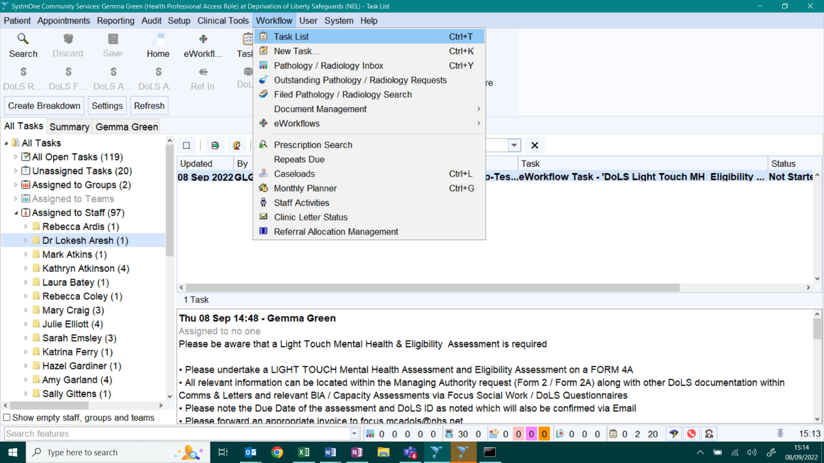
1
4
3
2

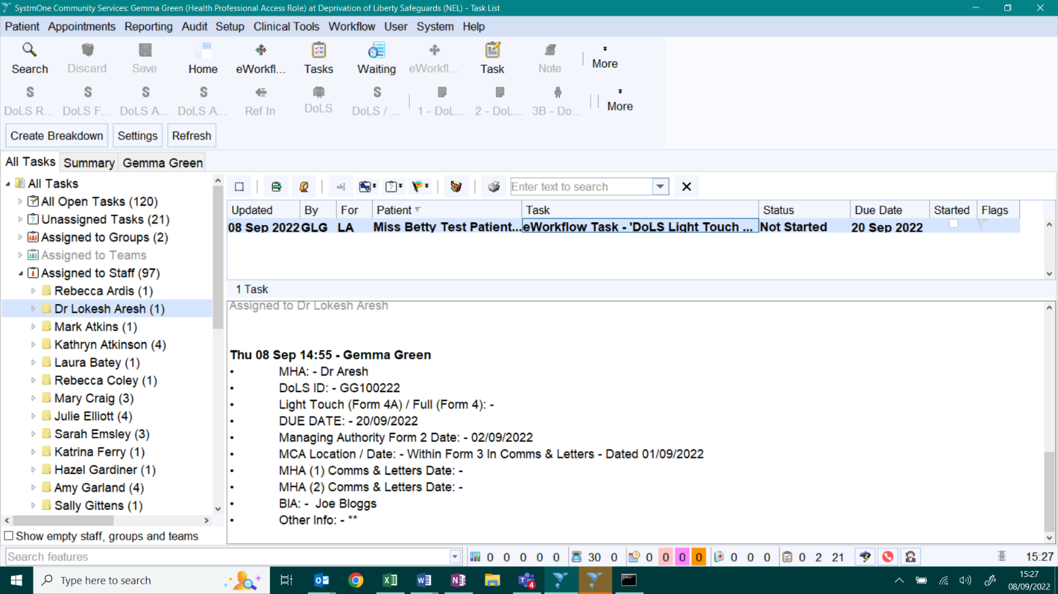

You can see in the Task header if it is a Full or a Lighter Touch – but this can also be seen if you scroll down the task allowing you to see lots of additional information and a reminder of the lighter touch criteria as well as where to locate the documentation that you need to review for the assessment. The list of information referred to in the task will vary dependant on whether the allocation is a FULL or a LIGHTER-TOUCH.
Once you commence on your assessment please: -
- Right-click on the Task and change the Status to Started
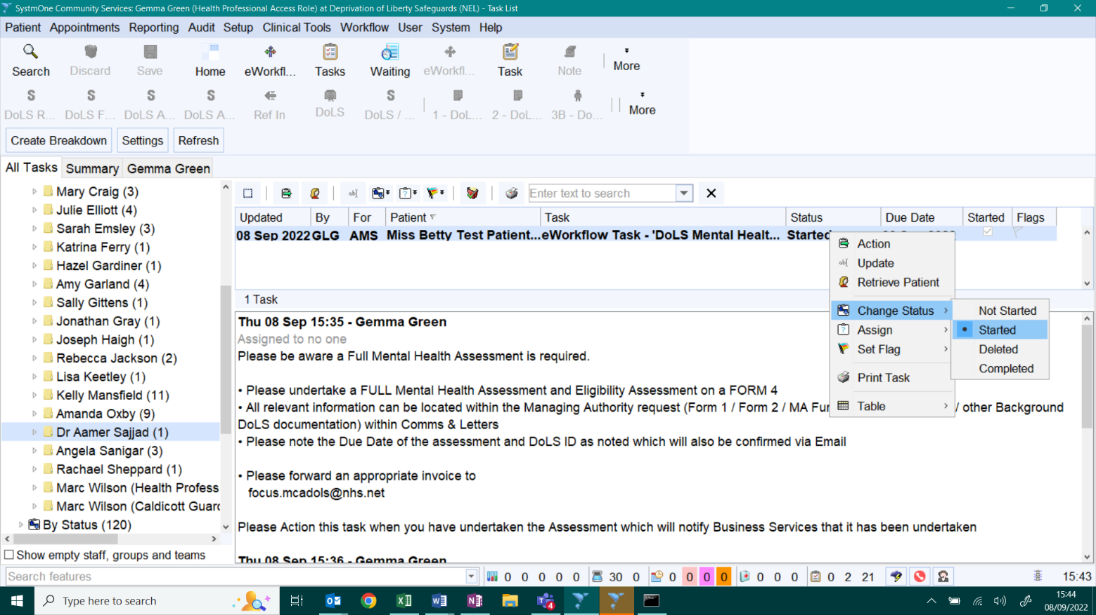

You can retrieve the client either by searching for them from the Home Screen or: -
- Right-click on the Task and click on Retrieve Patient
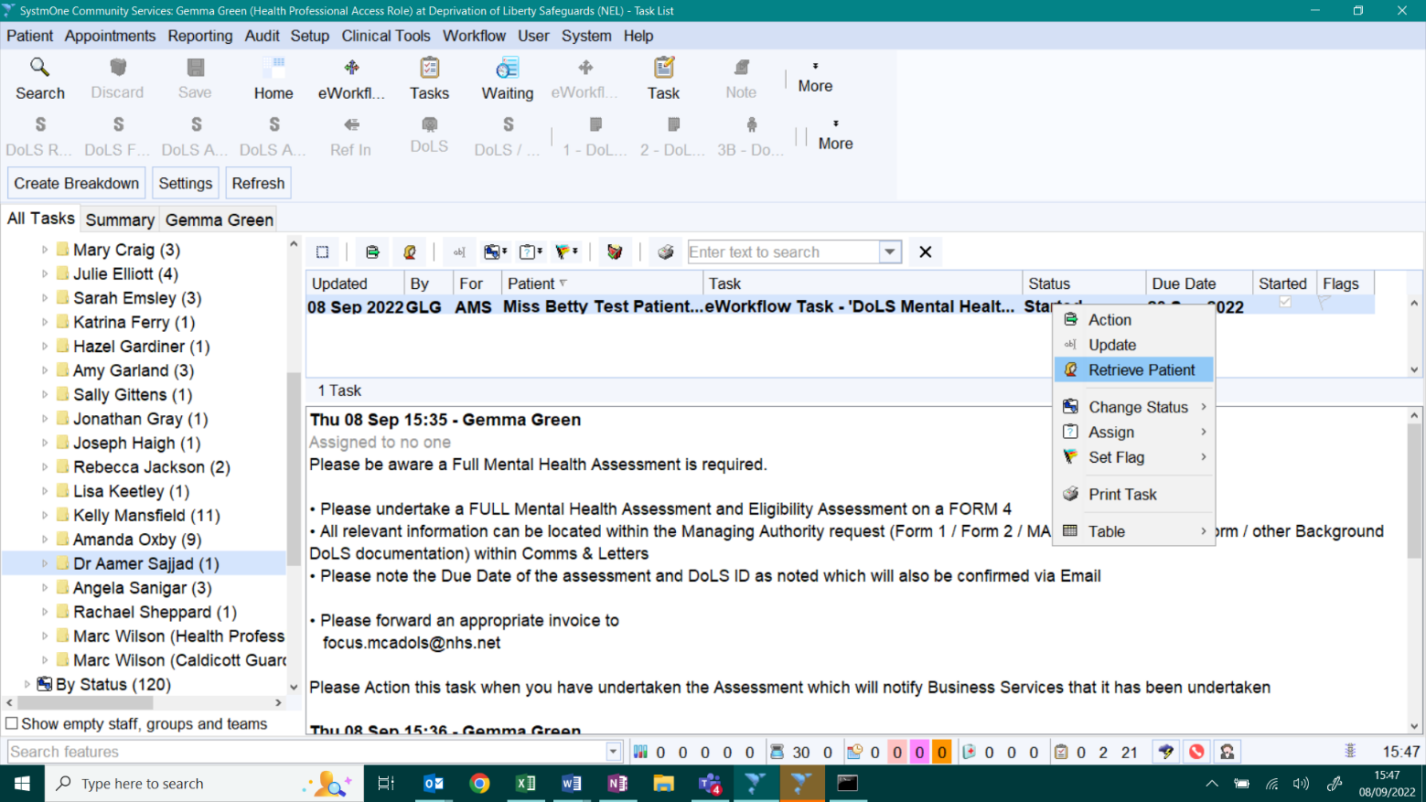

This Guide will show you how to manoeuvre around the DoLS Module and locate all the background information you require.
To commence on typing up your assessment: -
- Scroll down to Communications & Letters on the left hand side Clinical Tree Configuration
- Right-click and move across to New Letter
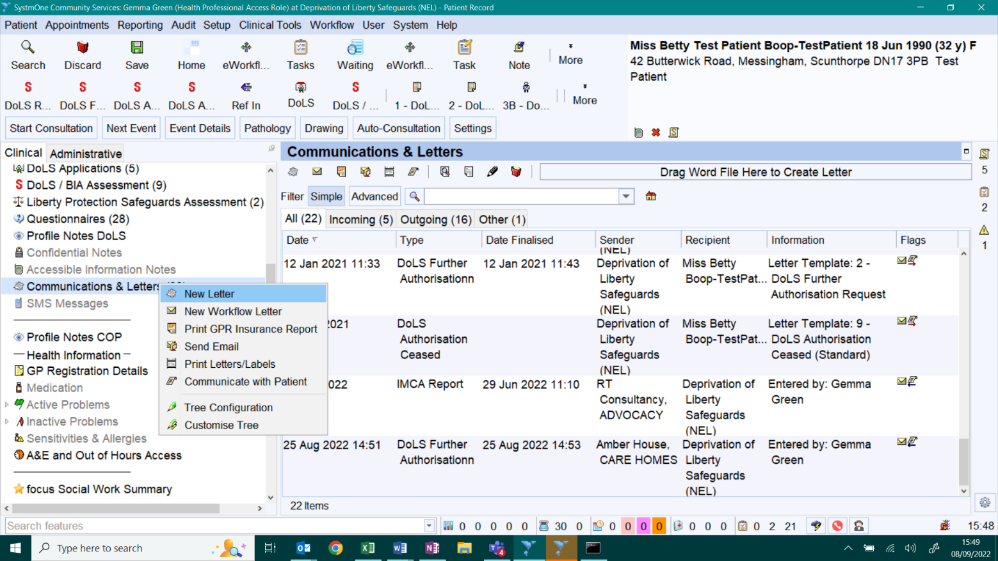

- An additional box then comes up – you just need to Select Okay at the bottom of that box
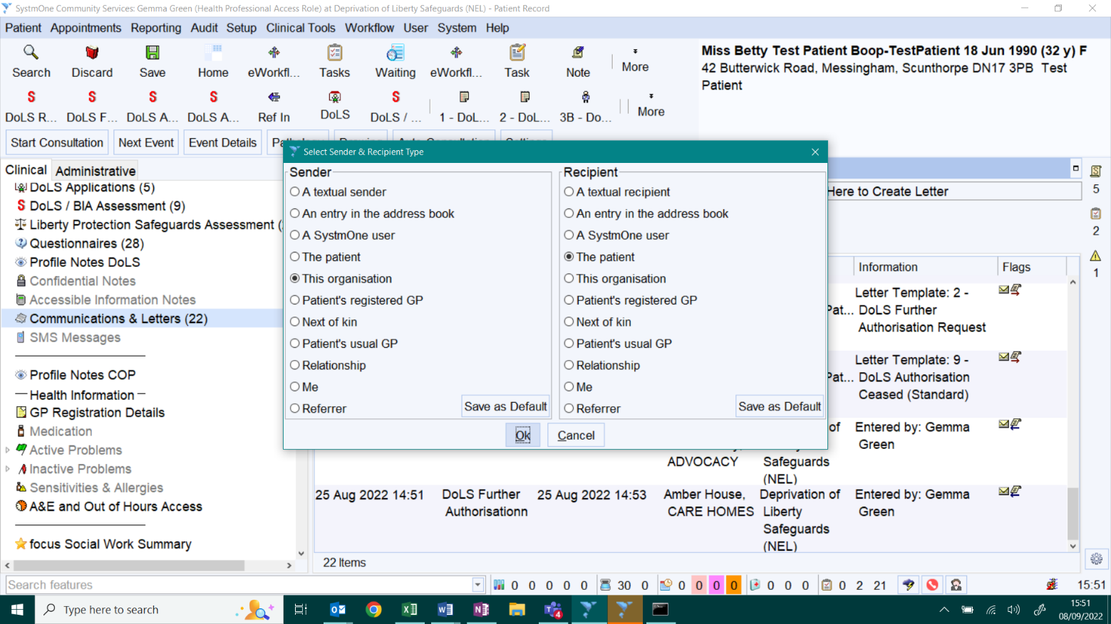
- Scroll down to the Section that says Writing and within that Section click on Template
- This will bring up a list of available letters – you will be selecting either: -
- – DoLS Mental Health Eligibility (i.e. for a FULL), or
4A – DoLS Mental Health Eligibility – Lighter Touch (i.e. for a Lighter Touch)
- Click on the relevant one and then click on Okay at the bottom of that box
- Then Click on Write Now at the bottom of that box
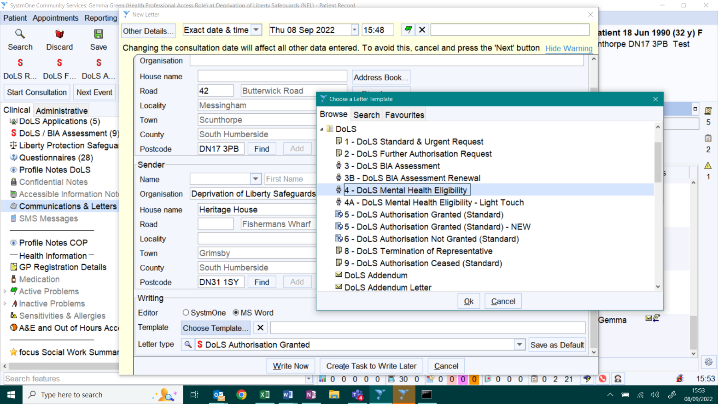
1
4
3
2
- You would then type within your Word Document as you normally would
Once you have checked your document and it is final you would then click on Save Final Version on the top left hand side of the top toolbar and remember to SAVE to Patient Record. 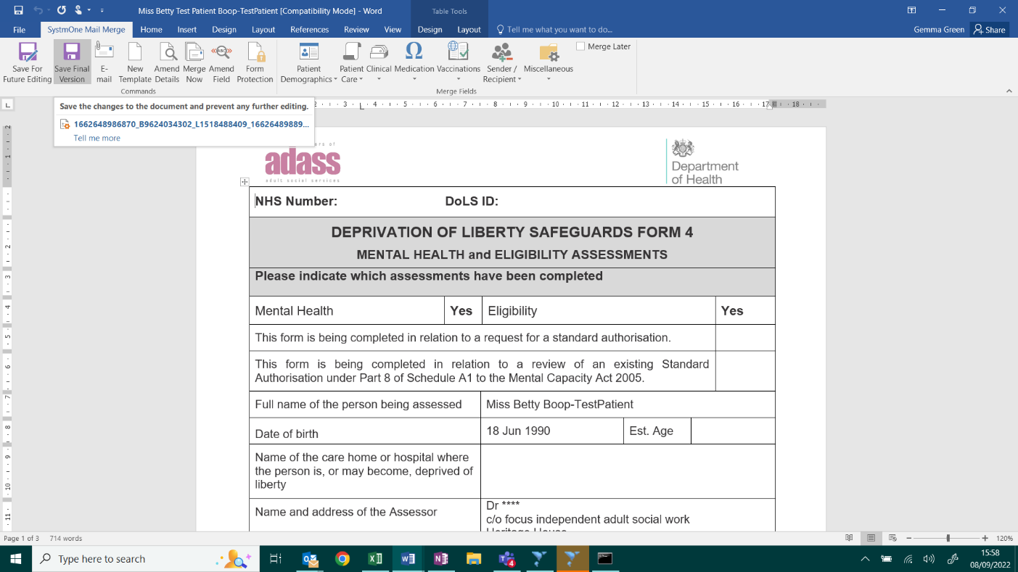
- NB if you haven’t finished your document and you say need to check something or finish it later please ensure you click on Save for Future Editing instead (to the left of Save Final Version). You can then Save the patient record and go back to the document to finish it later – if that was the case you would simply locate the document in Comms & Letters – Right-click on it – move over to Amend Content on that list and then continue as before.
- Once you have completed your document, finalised it - that piece of work / assessment is complete – you would then need to go back to the Task – via the Tasks – Scroll down to your name (as per first page) – then ACTION the task and then click – Okay – this then notifies the DoLS Team that it is complete.
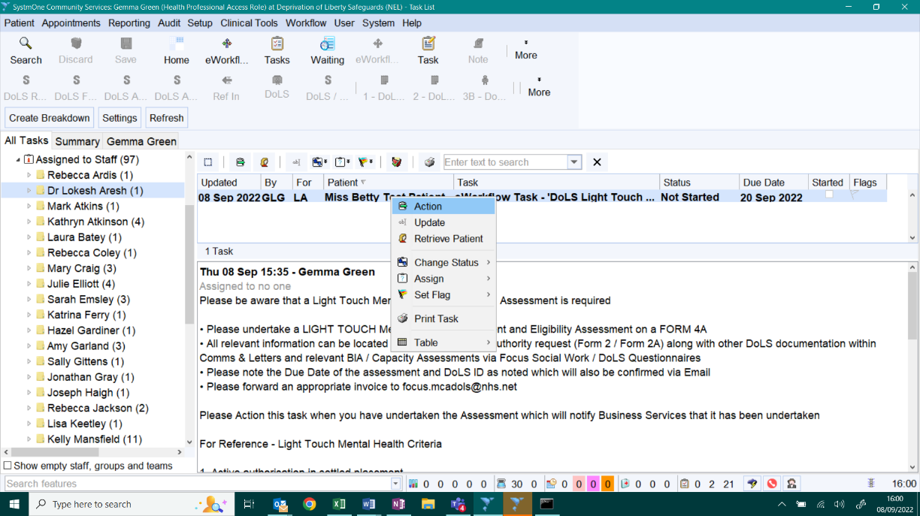
- Please remember at that point to send your completed Invoice through to the DoLS Team mailbox.
The remainder of this guide takes you through manoeuvring through the record

To view DoLS Related Documentation (within the DoLS Module): -
There are various places to check to view DoLS documentation and this is due to a variety of different documentation types being used and how the system and processes have progressed. Some may be a standalone questionnaire, some may be a standalone document in Comms & Letters and some may be both – i.e. a Questionnaire pulled into a Word Document. So viewing the documentation isn’t straight forward but in general these will be either within the QUESTIONNAIRES and/or a Word/PDF Document within COMMUNICATIONS & LETTERS. Please note some useful information on what to view and where to find it will be within the TASK
QUESTIONNAIRES
The majority of the past BIA Assessments (unless it was an independent BIA used generally a long time ago) should be shown in Questionnaires as follows: -
- Click on Questionnaires on the Tree Configuration
- Select Focus Social Work / DoLS on the Filter by Category
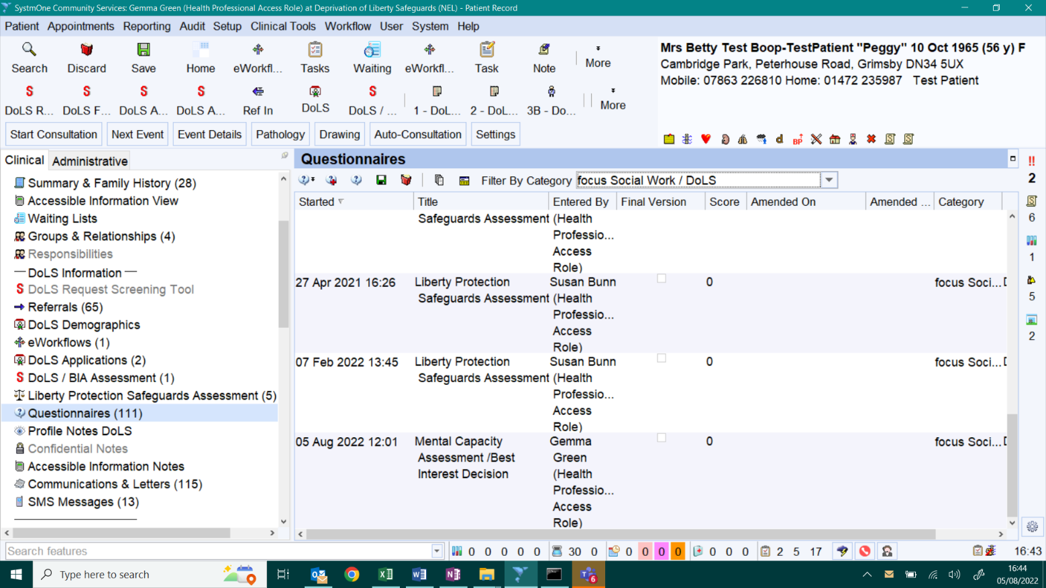
2
1
NB – Previous DoLS Screening Requests (New DoLS – Form 1) and Further Authorisation Requests (Renewal – Form 2) would also be listed here.
Please note that earlier DoLS Requests would only be indicated as scanned in documents in Comms & Letters.
Moving forward DoLS Renewal Requests direct from the Managing Authority (Lighter-Touch only) – Form 2A would only be shown in Comms & Letters.
There may also be some other ad-hoc DoLS questionnaires shown in there (such as the new Mental Capacity Questionnaires).
It may also be useful for you to view Questionnaires from other professionals / organisations and you can do that by selecting the relevant Organisation and/or not selecting any specific organisation (at 2 above).
KEY Questionnaires for you: - DoLS/BIA Questionnaire (Form 3), DoLS/BIA Assessment (Lighter Renewal) (Form 3B), Lighter Touch DoLS/BIA Assessment (Form 3A) (previously trialled as Liberty Protection Safeguards (LPS) (BIA Assessment)), DoLS Screening Tool (Form 1), DoLS Further Authorisation Request (Form 2), some more recent Mental Capacity Assessments.
COMMUNICATIONS & LETTERS
The majority of the other DoLS related documentation will be shown in Communications & Letters. This could include the Word extracted versions of various DoLS Questionnaires such as: -
- DoLS Screening Tool (Form 1), Further Information Request (Form 2), BIA assessments (Form 3, Form 3B / Light Touch). NB the LPS BIA Questionnaire is NOT pulled through in to a Word Form.

It could also include all of the other DoLS associated Word Templates and Scanned in Documents such as: -
- Form 2A (Lighter Touch Further Information Request), MA Further Information Form (further information around changes take since the initial request), Mental Capacity Assessments (Prior to the MCA Questionnaire being developed), MHA Assessment Form (Form 4/4A), DoLS Authorisation Granted Form 5, IMCA/Paid RPR reports, as well as other miscellaneous documentation that is sent in to the DoLS Team such as care plans, objections logs, LPA documentation, GP confirmation of covert meds, etc. Documentation scanned in should be recorded as an appropriate type
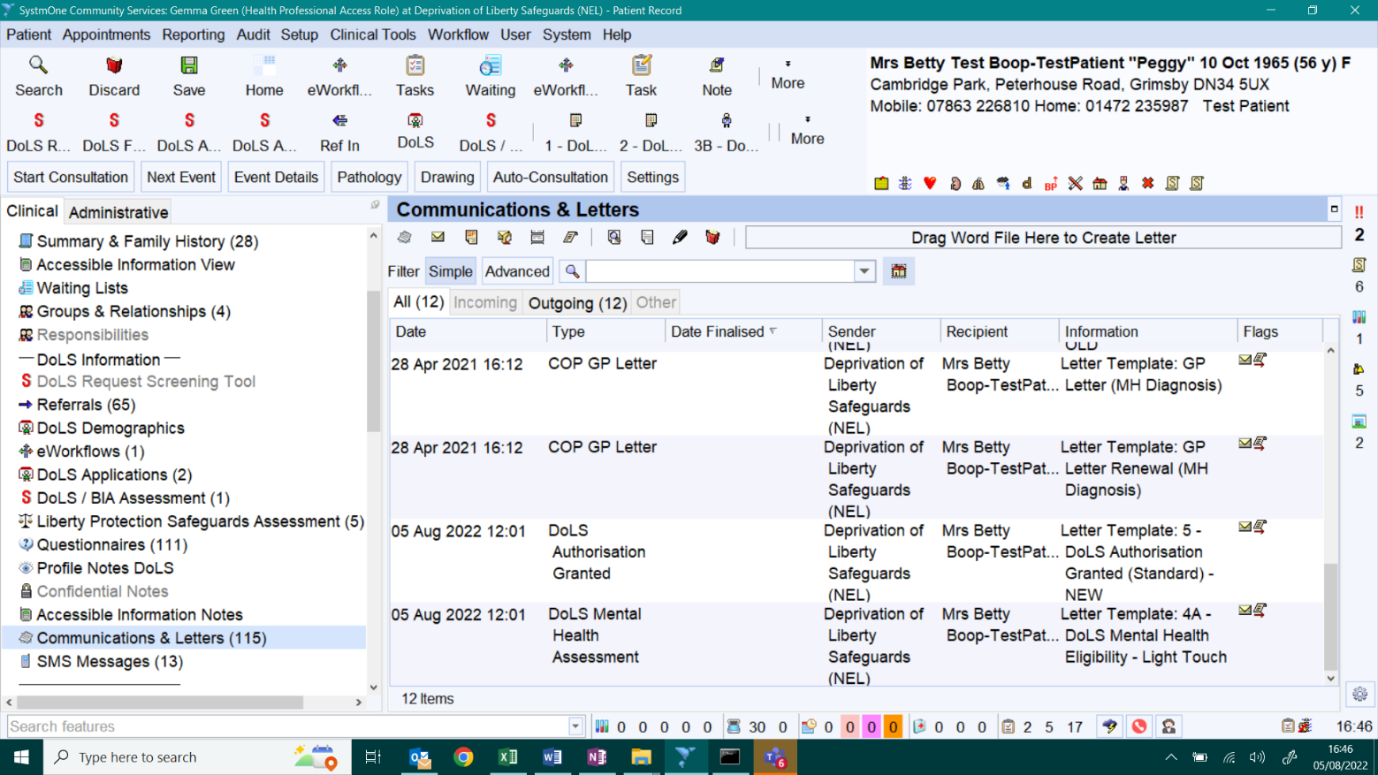
2
1
- You need to Click on Communications & Letters. Generally this list shows ALL documents and generally the most recent at the bottom (if sorted in Date order).
- Then if you Click on the little HOME button – this will show all documentation produced in this DoLS Module – if you unclick the little HOME button it shows all documentation including that from other modules which might be useful too – you can also use the drop-down to filter but this isn’t always that helpful if the document hasn’t been categorised properly.
The KEY documents in Communications & Letters for you would be the Form 5 – DoLS Authorisation Granted along with any Assessment information (Form 3, Form 3B), Mental Capacity Assessment (MCA) and MHA Assessment Form 4 / Form 4A. Remembering that the BIA assessments could be in a combination of either / and Questionnaires and Communications & Letters and so to can the MCA assessments. MCA assessments may also be found contained WITHIN the Form 3 BIA assessment itself. The Form 2A – Lighter Touch Renewal Form will also be found within here.
The Form 5 (DoLS Authorisation Granted) is the ‘DoLS Decision’ Document widely available to all interested parties and this will contain the following KEY Information:-
- Location of the DoLS (Care Home or Hospital), Duration of the DoLS (Start and End Date), Confirmation of Assessments being met, Conditions attached to the DoLS, and Recommendations are being added to this Form also on DoLS authorised from September 2022 as well as details of the Relevant Person’s Representative (RPR) – or Paid RPR. Please note these forms are being more ‘standardised’ forms in August 2022.

SystmOne Quick Guide to Viewing OTHER DoLS Information on SystmOne
The following shows how many DoLS requests (since we went live on SystmOne around 2016) have been applied for on the retrieved patient.
- Go to DoLS Applications on the Tree Configuration and here you will see all the DoLS requests listed as applied for.
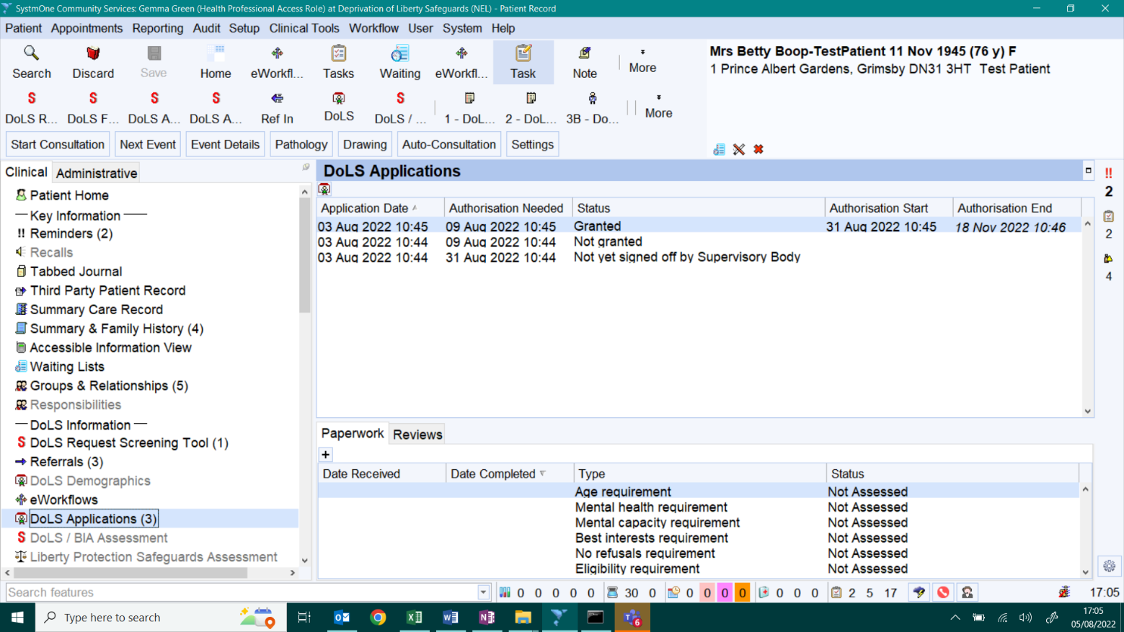
2
4
3
1

- Each line in this DoLS Applications area represents a different DoLS application request.
- NOT YET SIGNED OFF – means it is either on the DoLS Awaiting Allocation List (i.e. a NEW DoLS) or it is a Renewal that has been received and/or is out to allocation.
- GRANTED – means signed off and AUTHORISED – note the Start and End Dates
- NOT GRANTED – this could mean that the person sadly passed away before authorisation, the person has been discharged from the placement before authorisation or that any one of the assessments has FAILED – i.e. DoLS NOT GRANTED. If it is a NOT GRANTED – this would also be Refused on the Authorisation Tab and the paperwork section within the lower part of the screen would be state which assessments were met, not met or not assessed in those instances.
- Here is the Paperwork Section (for the line you are clicked on) which shows which assessments for each application have been assessed and met, have been assessed and not met and those not assessed.
- To View the detail of any of those listed Applications – Right Click – then View and then once you have opened it up it will look like the screen print below

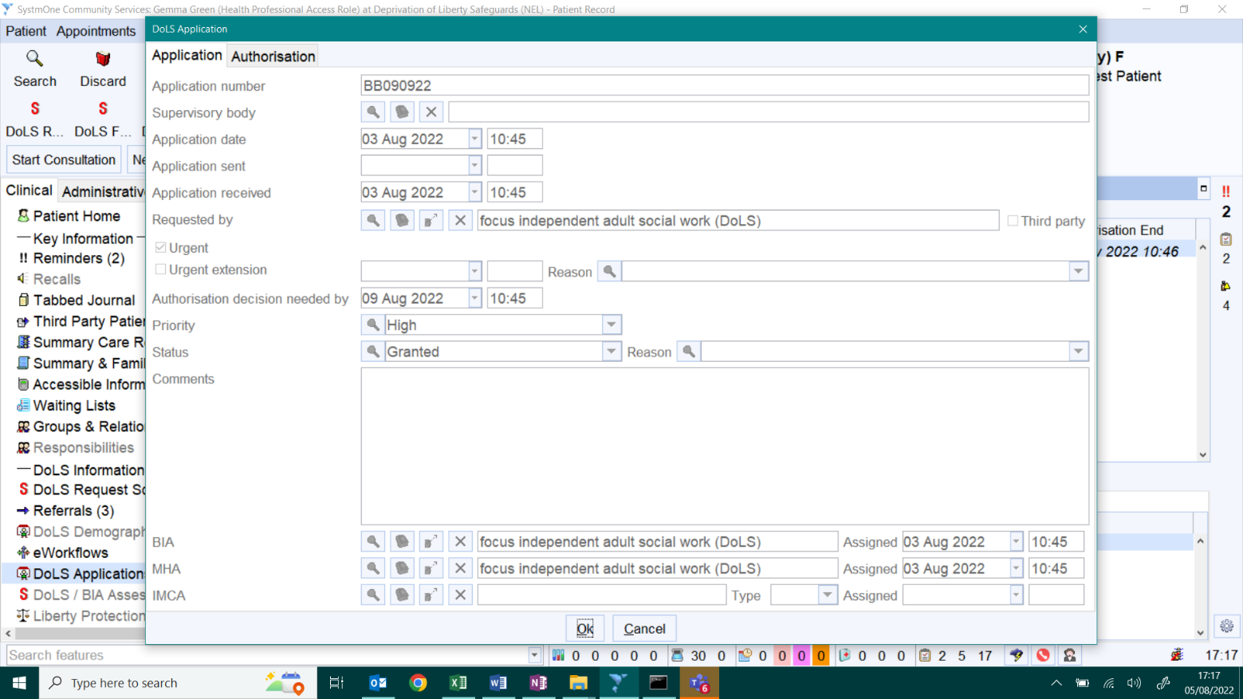
5
4
3
2
1

- Application Number is the DoLS ID
- Requested by is the name of the Care Home / Hospital that applied for the DoLS
- Priority is the Risk Rating
- Status is either Not Yet Signed Off (Waiting List), Granted, or Not Granted
- Allocated Assessors
The remaining fields are self-explanatory
To view a GRANTED ONE – refer to the next page
If the Case is GRANTED further information can be found by clicking on the second Tab – Authorisation: -
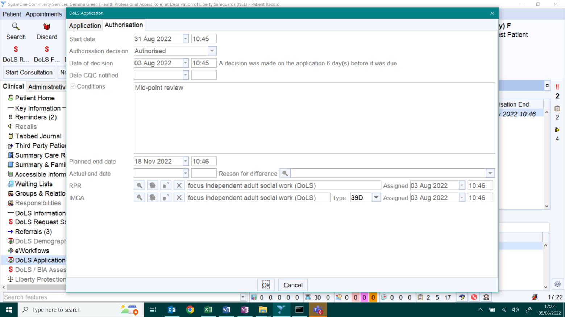
6
4
3
2
1
7
5
- The Second Tab (Authorisation) will show:-
- Authorised - GRANTED
- Date is was Signed off (Decision)
- Start Date
- Planned / Expiry Date
- Conditions (and in the future recommendations will be shown here too from September 2022). Conditions are checked for condition compliance and once complied confirmation will be shown alongside each Conditions (at present recommendations are not shown and we do not check / show compliance of recommendations)
- Relevant Person’s Representative (RPR) and/or Paid RPR/39D information
ALL GRANTED DoLS also have a handy REMINDER set on them:-
- The Patient Home Screen will show a High Priority Reminder with the Expiry Date of the Granted DoLS
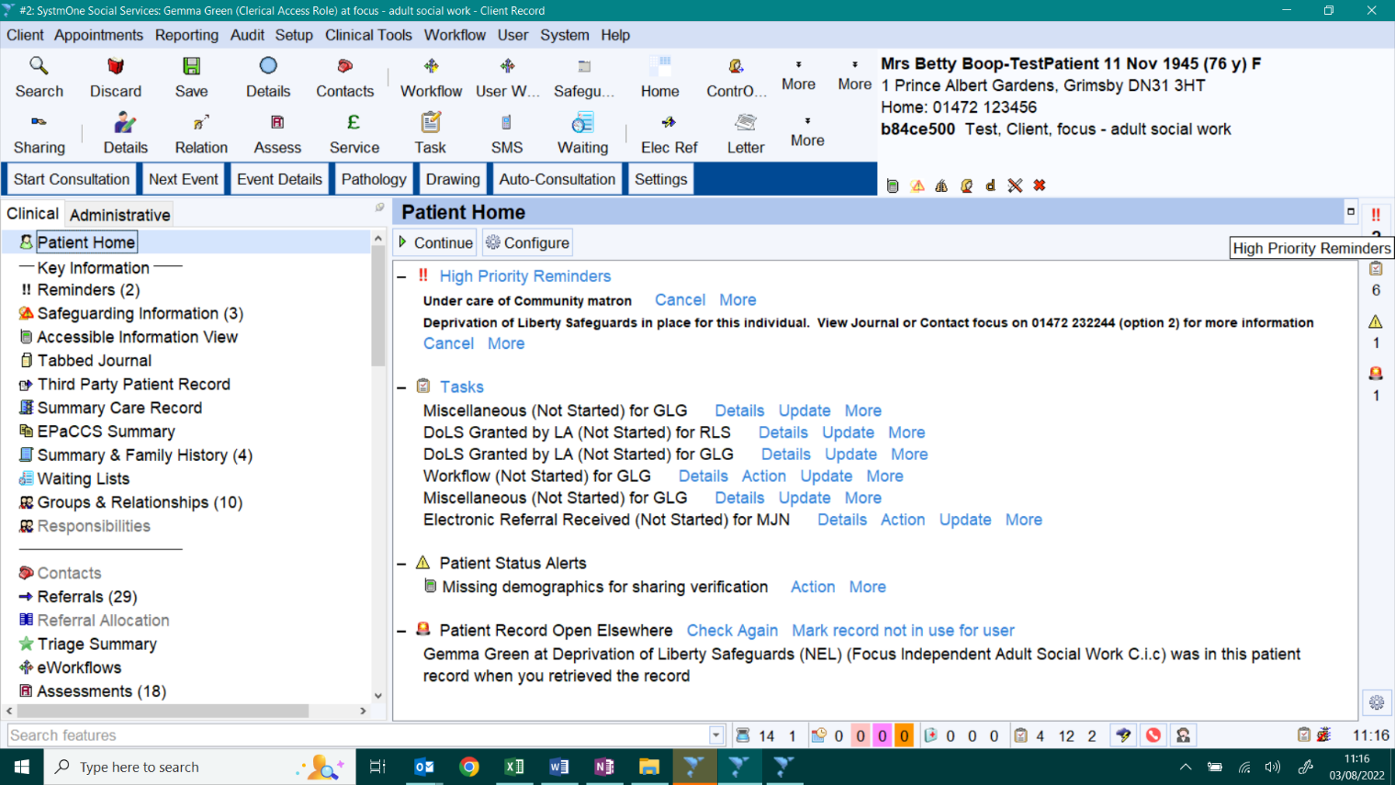
1

END DOCUMENT

