NELC PROPOSED LICENSING POLICY AMENDMENTS 2025

6.12 Safeguarding (Addition)

6.12.1 Licensing Authorities must consider the need to protect children and vulnerable persons from sexual exploitation when undertaking licensing functions. Everyone working in an environment where there may be children present should safeguard and promote the wellbeing of children. Where there is a risk to children, steps should be taken to ensure their safety and well-being. Safeguarding is everyone’s responsibility, and this Authority will work closely with other agencies to promote people’s welfare and protect them from harm by identifying safeguarding concerns, sharing information and taking prompt action when issues are identified. This Authority expects businesses to show that due diligence and all reasonable steps have been taken to manage the risk and keep children safe. Where there are real safeguarding concerns that have not been or cannot be addressed, then this Authority, when considering a premises licence review, will seriously consider revocation of the premises licence. Where appropriate, the Licensing Authority will not wait for a criminal prosecution before deciding on an appropriate course of action in relation to the licensing objectives.

6.12.2 This Authority recommends that all businesses should undertake a premises specific risk assessment regarding the safeguarding of children and vulnerable adults at their premises. Licence holders should ensure the environment to which they allow children access is safe and suitable. All premises licence holders and their staff will be expected to have a basic awareness of child protection issues. This includes:

  - Being alert to the possibility of child abuse and neglect
  - Having enough knowledge to recognise an abusive or potentially abusive event or set of circumstances.
  - Being competent in taking the appropriate immediate or emergency action when issues are identified.

6.12.3 Action should be taken if adults demonstrate irresponsible behaviour, such as showing signs of intoxication, using strong or offensive language, threatening behaviour, or violence towards others. Adults accompanying children should be encouraged to supervise them, to minimise the risk of children being exposed to inappropriate or dangerous behaviour or gaining access to any prohibited areas of the premises.

6.13 Modern Slavery (Addition)

6.13.1 This is a violation of fundamental human rights and can take various forms such as slavery, servitude, forced and compulsory labour and human trafficking. The legal definition includes the following terms - Slavery, where ownership is exercised over a person; Servitude, where a person is obliged to provide services imposed by coercion; Forced or Compulsory Labour, which involves work extracted under the menace of penalty and for which the person has not offered himself voluntarily; and Human trafficking, which involves the movement of people by means such as force, fraud, coercion or deception with the aim of exploiting them. Licensed premises might be unwitting hosts to modern slavery in two ways. Victims and their traffickers visiting the licensed establishment ,with sexual exploitation and forced criminality would be the most common forms identified in this way. Staff may also be being recruited through unscrupulous means, leaving them trapped and/or indebted to a trafficker. This may be in hotels, bars and restaurants, sexual entertainment venues, late night takeaways, off licences or other licensed premises.

6.13.2 Staff at licensed premises may be able to identify and report incidents of exploitation. A licence holder may increase awareness of modern slavery by: identifying any risks at the premises and working with relevant business partners and suppliers (i.e. recruitment agencies) to mitigate such risks; actively informing those working on the premises of their rights and how they can confidentially seek help or advice on modern slavery if required; Providing regular training to all staff on the indicators of modern slavery and how to report concerns; and a establishing strong relationships with local Police and victims service providers, such as the National Modern Slavery Helpline, in advance of any incident.

6.13.3 Having clear and straightforward protocols for when an incident is discovered is crucial to ensure that victims get appropriate support. Where employees identify a potential victim, they should be able to follow a specific internal procedure in order to protect the safety of that individual. This procedure should not be overly complex, should involve senior level staff, and should be clear when reports should go immediately to the Police (i.e. if certain indicators are met, if the potential victim is in immediate danger, or if the potential victim is a child). The 24 Hour Modern Slavery Helpline (0800 0121 700) can provide support to anyone who has a suspicion and would like some guidance on next steps.

6.14 Counter Terrorism (Addition)

6.14.1 Terror attacks have previously occurred in or around bars, pubs and nightclubs in the UK. All premises are expected to have regard to the National Counter Terrorism Security Office (NaCTSO) publication ‘Counter Terrorism Protective Security Advice for Bars, Pubs and Nightclubs’

North East Lincolnshire Council recommends using the Protect UK Website as a reliable source of counter terrorism and security advice.

https://www.protectuk.police.uk/

6.14. Licensing committees will give due consideration to appropriate counter terrorism measures and advice when considering licence applications for high-profile, large premises or events. This is especially the case if they are in receipt of relevant advice from police counterterrorism staff. There is an Annex of the Section 182 guidance in relation to counterterrorism. The Annex references a number of resources relating to public safety at venues which licensing authorities may find helpful in order to consider applications where enhanced security concerns may be relevant.

9.3 Public Safety (Updated)

9.3.1 The safety of those using licensed premises and the night-time economy, is an important factor that the Licensing Authority, licence applicants and licence holders have to take into consideration, especially as national reports of violence against women and girls (the Home Office published the national strategy on tackling this matter on 21 July 2021), the spiking of drinks and spiking by injection are on the increase.
Applicants and licence holders are encouraged to engage in national and local schemes that promote customer safety.
The following schemes are recommended by this Authority:
North East Lincolnshire Pubwatch – A forum for stakeholders of licensed premises which meets regularly and has police and local authority representation.
Ask For Angela - This initiative advises customers through posters in venue toilets that, if they ‘Ask for Angela’ at the bar, staff will be alerted to the fact that the person feels unsafe or threatened. Staff will know that the individual needs support to leave their situation, and can call them a taxi, escort them to their car or call the Police.
Best Bar None - a national award scheme, supported by the Home Office, that aims to improve standards in local night-time economies by sharing and promoting best practice.
Licensing SAVI - a police backed self-assessment tool designed to help licensed premises provide a safer and more secure environment for their managers, staff, customers and local communities.
Community Alcohol Partnerships - retailer-led partnership to tackle issues of underage drinking and promote greater awareness and understanding of alcohol among young people.

9.3.2 Licence applicants and licence holders are also encouraged to:

- make sure staff are trained to identify and report issues, this training should include awareness and safety of lone customers leaving the venue, especially if the customers appear vulnerable (drunk or under the influence of drugs) and unwanted contact (touching) between customers;

- make sure the correct staff are in place, for example in a town centre or coastal resort venue door supervisors may be required, if you are a late night venue a member of staff to deal with customer welfare may also be required.

- make sure staff are aware of the closest taxi rank and licensed vehicles that offer an evening/late night services and have contact details available for taxi and private hire firms - booking a vehicle for customers if needed.

- have a safe place to take customers if required.

- have a zero tolerance towards drugs, having systems in place to prevent drugs from entering the premises and dealing with issues of drug use. This should be included within staff training.

- have signage in place at entrances and within the venue with regards to customer welfare and safety.

9.3.4 This Authority suggests the WAVE initiative as a useful training tool for licensed premises. It is a free tool that aims to increase the skills and knowledge of those working in licensed premises to identify vulnerability and make appropriate interventions to keep people safe.

9.3.5 Drink spiking is when someone puts drugs or alcohol into a person’s drink without their consent. It can include putting alcohol into a non-alcoholic drink, adding extra alcohol to an alcoholic drink or slipping prescription or illegal drugs into an alcoholic or non-alcoholic drink. It can be difficult to tell whether a drink has been spiked, as substances used for spiking usually have no taste, odour or colour. Needle spiking is when someone injects a victim with a substance using a hypodermic needle (or other form of administration such as a combi-pen). Spiking can affect victims’ physical and mental health, their emotional wellbeing, and can have lasting repercussions on their lives. The Home Affairs Select Committee called for urgent improvements in reporting, investigating and prosecuting spiking incidents to improve support for victims and to act as a deterrent. This Authority is supportive of this recommendation and recognises that most licensed premises work hard to ensure that their customers can enjoy a night out safely and deter perpetrators. To support licensed premises, several industry associations have produced a factsheet which includes recommendations and some resources for the hospitality sector on how to respond to and prevent spiking. This Authority recommends that licensed premises:

  - ensure all reports of spiking are acted upon and that all incidents of alleged spiking are recorded and reported to the Police. It is also helpful to the Police if staff at licensed premises obtain full details of the affected person reporting the incident, including a description of what they are wearing as Officers may want to track them on CCTV.
  - provide as detailed a description of the suspected perpetrator as possible, if known, including clothing.
  - provide an approximate time of the incident and the location within the premises where they believe it occurred.
  - secure the drinking vessel(s) that is suspected as containing the ‘drug’ so this can be tested at a later time.
  - seize any drinking vessel that the suspect may have been using
  - Ensure the health and safety of the customer, which could be by calling emergency services, ensuring they are with trusted friends who will look after them, offering assistance if needed, and providing a safe space for the customer.
  - Ensure appropriate training is provided to relevant members of staff.
  - Review searching procedures and amend as necessary, as well as reviewing how often toilets are inspected as victims may be found there.
  - Premises should also review the functionality of any CCTV and ensure it is not obscured.
  - Consider providing information (such as posters) regarding drink spiking in the premises.
  - Consider if it would be useful to provide anti-spiking bottle stoppers and protective drink covers.

9.5 Protection of Children from Harm (Updated)

9.5.16 The Licensing Authority encourages licence holders and operators of licensed premises:

- To ensure that they are fully aware of the signs of child sexual exploitation and to understand that the sexual exploitation of a child is sexual abuse and a crime; and
- To raise the awareness of their staff about child sexual exploitation and provide intelligence to the appropriate authorities about concerns and about perpetrators who may be operating in their areas.

Integrated Front Door, Childrens Services, New Oxford House, 2 George Street, Grimsby, DN31 1HB
Telephone: 01472 326292 (option 2 and option 2 again)
NELCChildrensFrontDoor@nelincs.gov.uk

CUMULATIVE IMPACT (Updated)

10.1 Cumulative Impact has been used as a term to describe the stress that a large number of licensed premises can have on crime and disorder, nuisance and the demand on local services. The guidance describes cumulative impact as ‘the potential impact on the promotion of the licensing objectives of a number of licensed premises concentrated in one area’. It is often not that licensed premises on their own are operating in a way that is detrimental to the licensing objectives, but it is the accumulation of the premises and the people attending them that creates the increased problems and demands on services.
10.2 Cumulative impact can occur either in the area where the premises are located or some distance away from them, for example at public transport locations or fast food premises. The issue of cumulative impact occurs due to the number of people in the area frequenting the licensed premises. The accumulation of licensed premises has a disproportionate demand on local services such as transport, public lavatories, waste collection and street cleaning. There is also a higher level of crime and disorder, often associated with alcohol-related violence that can take place which will create additional demands on the Police as well as the ambulance service. It is also likely that criminal activity is attracted to areas where there are higher concentrations of people and who may be vulnerable to theft or other crimes due to the level of intoxication.
10.3 In CIA’s, there is a presumption that the licensing authority will refuse or impose limitations on applications which are likely to add to the cumulative impact unless the applicant can demonstrate that there will be no negative cumulative impact on the licensing objectives.
10.4 The publication of a CIA does not change how the licensing decisions are made. The Licensing Authority will always consider each application on its merits. However, a CIA is a strong statement of intent about an authority’s approach to licence applications.
10.5 North East Lincolnshire Council Council has had a Cumulative Impact Policy since 2010 and has continued to review the cumulative impact of licensed premises.
10.6 Until 6 April 2018, ‘cumulative impact’ and ‘cumulative impact policies’ were not a statutory requirement under the Act. Prior to this date, ‘cumulative impact’ was only referred to within the statutory guidance issued by the Home Office.

10.7 The government amended the Licensing Act 2003 via the Policing and Crime Act 2017. This amendment made it a requirement that the Licensing Authority must produce a Cumulative Impact Assessment (CIA) if the authority can evidence that there is a cumulative impact within its area. The Licensing Authority must consult on its intention to publish the CIA. The aim of the CIA is to limit the growth of licensed premises where the promotion of the licensing objectives is being compromised.
10.8 The problems associated with cumulative impact cannot be attributed to individual premises, and to mismanagement by individual licensees, and so a collective restraint is required.
10.9 In CIA’s, there is a presumption that the licensing authority will refuse or impose limitations on applications which are likely to add to the cumulative impact unless the applicant can demonstrate that there will be no negative cumulative impact on the licensing objectives.
10.10 The publication of an CIA does not change how the licensing decisions are made. The Licensing Authority will always consider each application on its merits. However, a CIA is a strong statement of intent about an authority’s approach to licence applications.

The Cumulative Impact Areas
10.12 Following a review in 2024, the areas on the attached plans have been identified by North East Lincolnshire Council as being subject to high levels of alcohol related crime or public nuisance. The evidence satisfies the Licensing Authority that the number of existing relevant premises licences in these areas are such that it is likely that it would be inconsistent with the Authority’s duty to promote the licensing objectives to grant any further relevant licences unless it can be satisfied there will no additional negative impact.
10.13 This policy relates to premises licences that permit the sale of alcohol for consumption on and/or off the premises.
10.14 The effect of this assessment is to create a rebuttable presumption that applications for a new premises licence or club premises certificate or the variation of an existing licence or certificate in these areas will normally be refused where:
- Representations have been received and it is anticipated that the application will add to the problems of crime and disorder or/and public nuisance in these areas.
- The applicant has been unable to demonstrate that, within their operating schedule, there will be no significant negative cumulative impact on one or more of the Licensing objectives.
10.15 It is recognised that pubs, nightclubs, restaurants, hotels, theatres, and other clubs all sell alcohol, serve food and provide entertainment, but with contrasting styles and characteristics. Proper regard will be made to those differences and the impact they are likely to have on the local community where the amenity of local residents is being placed under severe pressure. The Licensing Authority will consider the locality and local trading environment when assessing applications. For example, while a large nightclub or high-capacity public house might add to problems, a small restaurant or theatre may not.
Examples of where applications may not have a significant negative impact include:
- Direct replacement for similar licences where impact will be similar or less
- Substitution of activities where the impact will be similar or less
- Replace vertical drinking with seated consumption
- Alcohol is ancillary to other activities or services
- Time limited applications, e.g. events
- Phased closing times for the premises to cause gradual dispersal
- Small maximum occupancies
10.16 In order for this Policy to be utilised it will still be necessary for responsible authorities or other persons to make relevant representations. Anyone making a representation may base it on the evidence published in the CIA, or the fact that a CIA has been published.
It remains the duty on all responsible authorities and other persons to ensure that their representations can withstand the scrutiny to which they would be subject as a hearing. In other words, it would not be sufficient to say that the licence should be refused just because a CIA is in place, the representation must still say how the application would impact on the licensing objectives. If there are no representations the licensing authority must grant the application in terms that are consistent with the operating schedule submitted.
This policy is to be read in conjunction with North East Lincolnshire Council’a Licensing Policy and will be subject to review every three years in accordance with the Licensing Act 2003. If, during any review it is clear that the original concerns regarding crime and disorder and public nuisance are no longer present, the CIA may be amended or removed.

10.17 The three maps shown in Appendix 1 show the broad extent of the cumulative impact zones in North East Lincolnshire. To make it clear, if premises (and any land forming part of the premises) are only partly within the shaded area they will be subject to the special policy.

APPENDIX I

Cumulative Impact Areas Where Special Policy Applies

ZONE 1 – GRIMSBY TOWN CENTRE

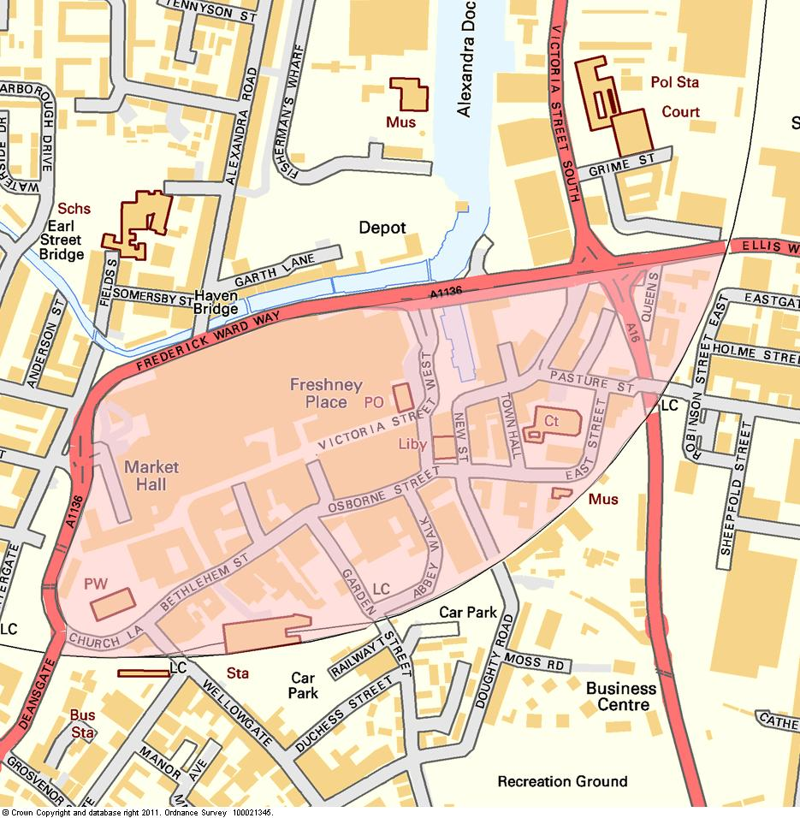

ZONE 2 – FREEMAN STREET / EAST MARSH

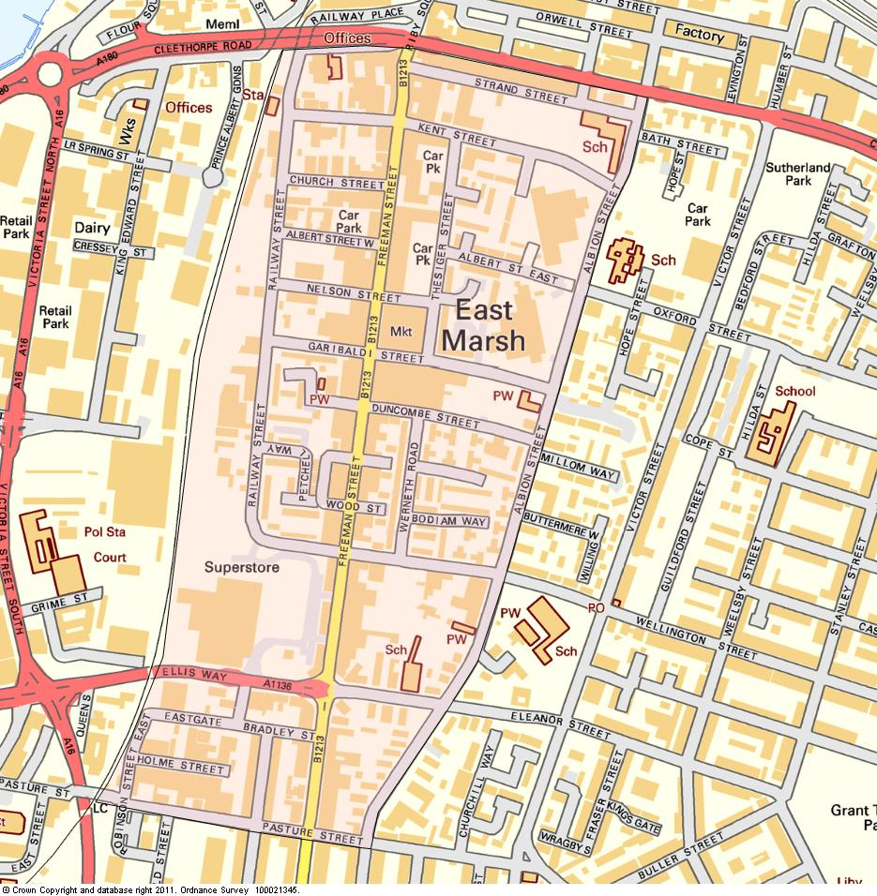

ZONE 3 – CLEETHORPES 